**2021 Final Report: Delaware Soybean Board**

**Evaluation of aggressiveness among *Diaporthe* species isolated from Mid-Atlantic Soybeans**

Dr. Alyssa Koehler, Assistant Professor and Field Crops Extension Specialist, Plant Pathology

Department of Plant and Soil Sciences, University of Delaware, Georgetown, DE

[akoehler@udel.edu](mailto:akoehler@udel.edu) | (302)242-9056 | @UDPlantPath

**Project Overview:**

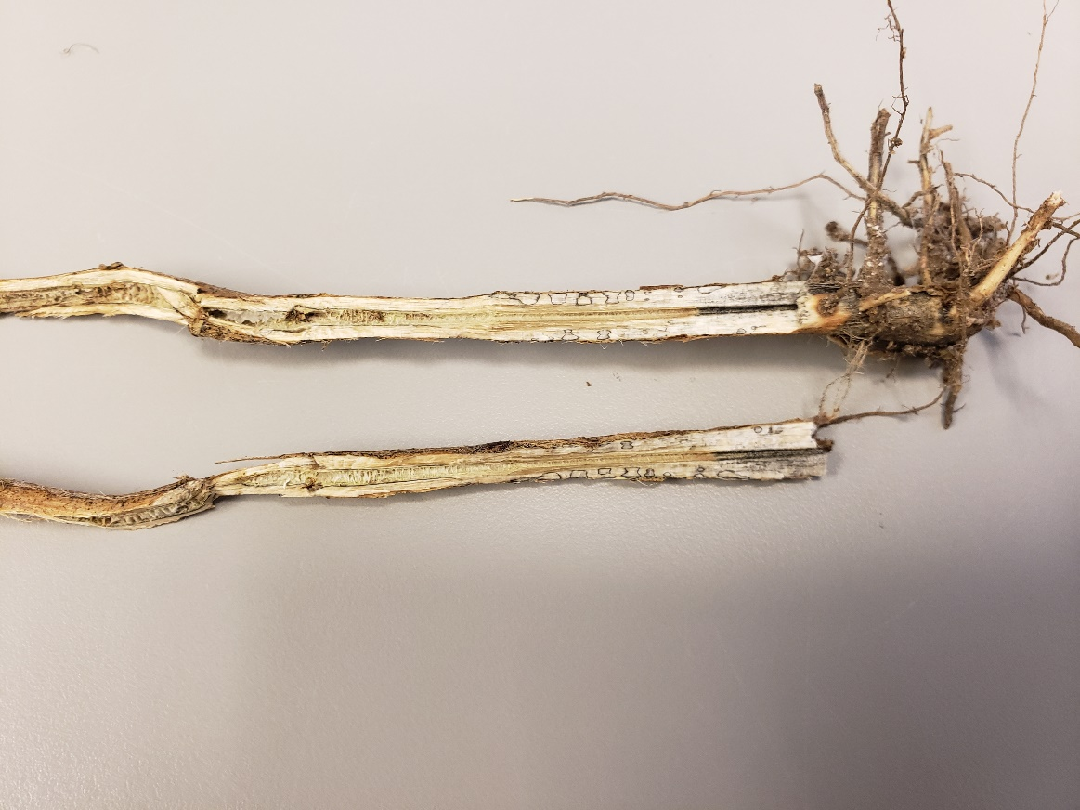Fungal pathogens can be very damaging to soybean (*Glycine max* (L.) Merrill) production reducing both yield and quality. Environmental conditions can increase disease severity and favor the spread of certain pathogens. In the Mid-Atlantic, we continue to observe extreme weather events and periods of prolonged rainfall, that lead to widespread fungal infection and reduced seed quality. Worldwide, *Diaporthe* associated diseases are responsible for more yield and quality losses to soybean production than any other single fungal pathogen or species complex (Udayanga et al. 2015). A survey was established in 2019 to document which soilborne pathogens are most commonly observed across the region. From this work, *Diaporthe longicolla* was found to be the most abundant species of the *Phomopsis/Diaporthe* complex. Species of *Diaporthe* are responsible for numerous diseases of soybean, including seed decay, seed rot, pod and stem blight, and stem canker. *Diaporthe longicolla* (=*Phomopsis longicolla*) is the causal agent of Phomopsis/Diaporthe seed decay, which can reduce yield and cause quality issues with symptomatic seeds that are shriveled, cracked, and often chalky white (Hepperly and Sinclair 1978). Humid environmental conditions and extensive rains that delayed harvest were particularly conducive to the widespread appearance of this disease across Delaware in 2018 and 2020. *D. sojae* (=*D. phaseolorum* var. *sojae*) is the causal agent of soybean pod and stem blight. Stem canker can include southern stem canker caused by *D. aspalathi* (*D. phaseolorum* var. *meridionalis*) or northern stem canker caused by *D. caulivora* (*D. phaseolorum* var. *caulivora*.). Northern stem canker was first reported in Maryland in 1943 (Petty 1943). Since Delaware and Maryland are transition zone states, it is assumed that both northern and southern stem canker species are present in production areas. However, in the 2019-20 surveys, only *D. aspalathi* (southern stem canker) was recovered. Interestingly, the primary species associated with in-season symptoms was *D. longicolla,* showing that this species is also a stem pathogen, and more than just a pathogen of seed. Stem necrosis from this pathogen was reported in Arkansas in 2017 (Tolbert and Spurlock, 2017). A survey of soybean stems across Iowa, Indiana, Kentucky, Michigan, and South Dakota identified *D. longicolla* in 67.1% of isolates collected (Ghimire et al. 2019). *D. longicolla* has also been the primary pathogen associated with zone lines (thin black lines that form at the base of soybean stems) in the Mid-Atlantic (Figure 1). Along with *D. longicolla* and *D. aspalathi,* an isolate of *D. ueckerae* was identified in the 2019 survey. This species was recently reported for the first time on soybeans in the US (Petrovic et al. 2020). Southern stem canker isolates have been reported to be more aggressive and to cause greater economic damage than northern stem canker isolates (Backman et al. 1985), but very little is reported about their aggressiveness in relation to stem symptoms caused by *D. longicolla* or *D. ueckerae*

Figure 1: Zone lines at the base of a soybean stem.

Building from isolates collected in the 2019 and 2020 fungal survey, project objectives included: 1) Assess the aggressiveness of *Diaporthe* isolates collected from Mid-Atlantic soybean fields. 2) Estimate potential yield effects of Mid-Atlantic *Diaporthe* isolates. 3) Share research findings through extension events and use findings to inform future management trials. This project was the first work to investigate differences in *Diaporthe* isolate aggressiveness within the Mid-Atlantic region and to estimate yield effects across species. Improved understanding of each species will aid in variety selection and determining if additional disease management steps could be economically viable.

**Project Activities and Methods:**

Isolates of *D. longicolla, D. ueckerae,* and *D. aspalathi* were collected during 2019 and 2020 field surveys and used to complete 2021 project objectives.

Objective 1. Assess the aggressiveness of *Diaporthe* isolates collected from Mid-Atlantic soybean fields.

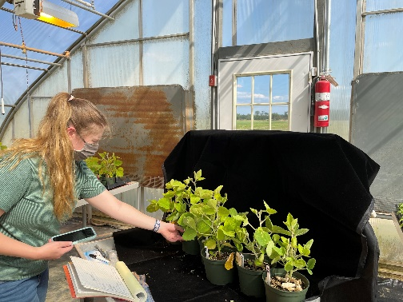Isolates identified from survey work in 2019 and 2020 were screened to evaluate differences in isolate aggressiveness. Soybean seed was sewn in the greenhouse with a single plant per 15 cm pot. Three soybean hybrids Hawkeye (susceptible), GH3934X, and S39G2X were screened for their response to three *Diaporthe* species. At V2-V3, plants were inoculated using the toothpick method (Ghimire et al. 2019). Briefly, autoclaved toothpicks were placed onto culture plates of the *Diaporthe* species of interest (*D. longicolla, D. ueckerae,* and *D. aspalathi*) and incubated for 15 days until toothpicks were fully colonized. Toothpicks were inserted to the stems of soybean plants at a 45-degree angle approximately 5 cm below the first trifoliate node. A sterile toothpick was inserted into a set of stems to serve as a toothpick control and an additional set of plants was used as a non-wounded non-inoculated control. Five replicates of each *Diaporthe* species and the two controls were set up in a randomized block design on a greenhouse bench. All inoculation sites were sealed with petroleum jelly and plants were bagged for the first 2 days after inoculation. Plants were observed for disease severity 37 days following inoculation (Figure 2). Disease severity scores were calculated by observing lesion expansion in comparison to wounded non-inoculated plants. Two runs of the trial were conducted.

Figure 2: Graduate student Lexi Kessler evaluating disease severity after inoculation with various *Diaporthe* species

Objective 2. Estimate potential yield effects of Mid-Atlantic *Diaporthe* isolates.

In outside container-grown plants mimicking field conditions, soybeans were seeded three per pot and inoculated as described above at the V2 growth stage. Treatments included *D. longicolla, D. ueckerae,* *D. aspalathi,* plants wounded with sterile toothpicks, and non-wounded plants; each replicated 5 times and set up in a randomized design. Plants were intended to be monitored throughout the season for number of pods that form, number of seeds per pod, timing of leaf senescence, and end of season seed quality.

Objective 3. Share research findings through extension events and use findings to inform future management trials.

Findings from this project were shared through the University of Delaware’s Weekly Crop Update which reaches over 700 growers, consultants, and stakeholders and provides a platform to discuss disease concerns and other production issues. Data will be discussed during the 2022 Delaware Ag month soybean session and at other spring training meetings.

**Results and Discussion:**

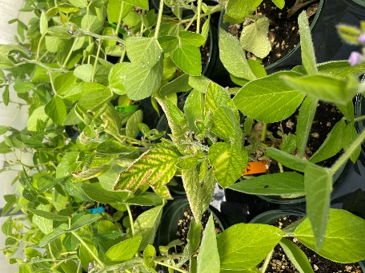Symptoms in inoculated greenhouse trials included interveinal chlorosis, leaf wilting, and plant death (Figure 3). Leaf chlorosis symptoms are common in other soybean diseases like Soybean Sudden Death (SDS) and Brown Stem Rot (BSR), which highlights the importance of proper diagnosis for disease management.

Symptoms were observed across all three *Diaporthe* species, but disease severity was highest in *D. longicolla* and *D. ueckerae* (Figure 4). In S39-G2X, *D. longicolla* had the highest disease severity score (0.9) which was significantly higher than *D. ueckerae* and *D. aspalathi* (Table 1)*.* For GH3934X, *D. longicolla* (0.75) and *D. ueckerae* (0.65) were significantly higher than *D. aspalathi* (0.2). In the Hawkeye variety, *D. longicolla* disease severity (0.7) was higher than *D. aspalathi* (0.3), while *D. ueckerae* fell in the middle (0.45).

Figure 3: Soybean plants with foliar symptoms of *Diaporthe.*

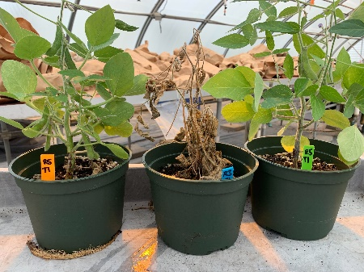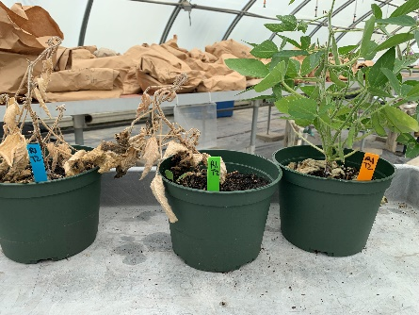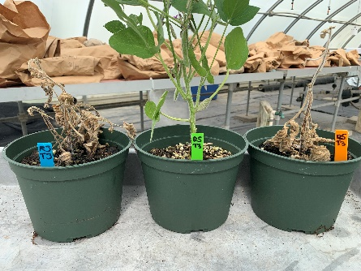

Figure 4: Soybean plants inoculated with *D. longicolla* (left), *D. ueckerae* (middle), and *D. aspalathi* (right)

Table 1: Disease Severity in Soybean Varieties Following Inoculation with Multiple *Diaporthe* species

|  |  |  |  |
| --- | --- | --- | --- |
|  | Disease Severity Scorez | | |
| Inoculation Source | Hawkeyey | GH3934X | S39G2X |
| *D. longicolla* | 0.7 Ax | 0.75 A | 0.9 A |
| *D. ueckerae* | 0.45 AB | 0.65 A | 0.65 B |
| *D. aspalathi* | 0.3 B | 0.2 B | 0.25 C |
| *p*-value | 0.04 | 0.0026 | <0.0001 |
| z Disease severity was measured as 0 = plant showed no lesion expansion beyond toothpick wound; 0.5 = plant showed lesion elongation above or below wound site compared with non-inoculated plants, but no plant death; and 1 = dead plant.  y Varieties included Hawkeye (susceptible), GH3934X (rated for pod and stem blight), and S39-G2X (rated for southern stem canker).  x  Treatment effects were analyzed using PROC GLIMMIX in SAS (9.4); LS Means were separated using paired t tests (α=0.05). Means followed by the same letter within each column are not significantly different. | | | |

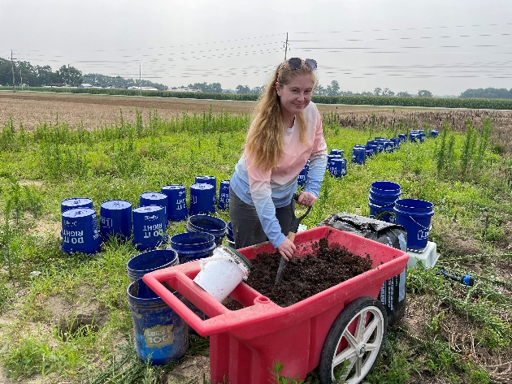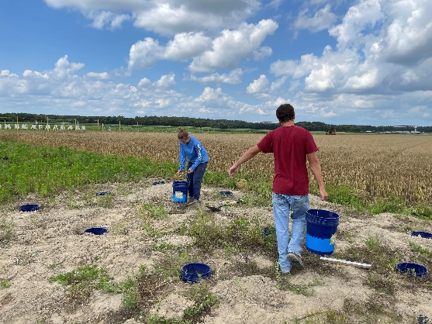Field inoculated trials proved to be challenging. Contained microplots were established by sterilizing field soil and mixing a 1:1 soil and soilless media mixture into 5-gallon buckets (Figure 5). Heavy rainfall after planting led to drainage issues that left soybeans saturated to near anaerobic conditions (Figure 6). The trial was terminated prior to inoculation. In effort to improve drainage, buckets were removed, three holes were drilled in the bottom, and buckets were placed into a second bucket. Saturated soil was mixed with additional 1:1 ratio mixture and redistributed to the new bucket set up (Figure 7). Drainage improved, but the problem was not resolved. Plants were inoculated, but heavy saturation rendered them unratable. No usable data was generated from objective 2.

Figure 7: Remixing after drilling holes in buckets to try a double bucket system.

Figure 8: Saturated double bucket microplot.

Figure 6: Saturated microplot.

Figure 5: Placing buckets into micoplot infrastructure.

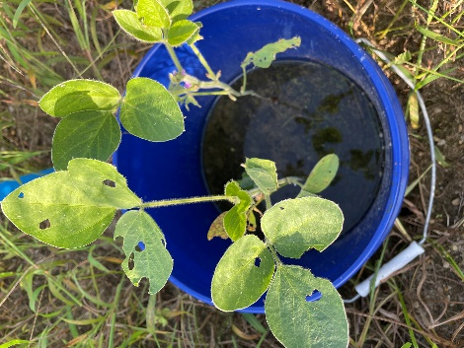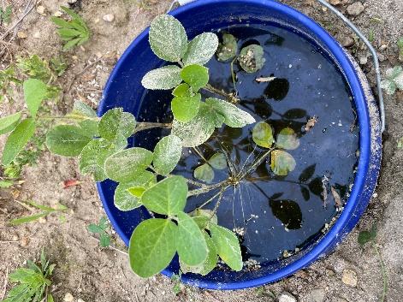

Although data was not obtained from objective 2, important observations on *Diaporthe* species in the region were observed in the greenhouse trials. In 2019-20 surveys, *D. longicolla* was the most frequently isolated *Diaporthe* pathogen. Often *D. longicolla* is associated with Diaporthe/Phomopsis Seed Decay, where seeds are white to chalky in appearance, especially when harvest is delayed. However, in the 2019-20 survey, *D. longicolla* isolations were made from diseased stem and root tissue, indicating that this species may be responsible for more than seed quality issues. Stem necrosis from this pathogen was also reported in Arkansas in 2017 (Tolbert and Spurlock, 2017). Soybeans often have ratings for “pod and stem blight”, “southern stem canker” or other associated diseases in the *Diaporthe* disease complex, but generally, the tested species is not indicated. Having isolates of *D. longicolla, D. ueckerae,* and *D. aspalathi* from our region allowed us to observe differences in disease severity following inoculation of each species. The 2021 greenhouse trials included three soybean varieties: Hawkeye (a known susceptible variety), GH3934X (rated for pod and stem blight), and S39-G2X (rated for southern stem canker). In all three varieties, disease severity was highest when inoculated with *D. longicolla*. A similar response was observed from *D. ueckerae*, which was identified for the first time in the region as part of recent survey work. The southern stem canker isolate, *D. aspalathi*,had the lowest disease severity in the variety rated for southern stem canker as well as the other two varieties screened. Southern stem canker isolates are generally thought to be more aggressive than northern stem canker isolates, but no northern stem canker isolates have been identified to date to be able to compare between the two for the region. The variety rated for southern stem canker did not have resistance to *D. longicolla* or *D. ueckerae*. The variety rated for pod and stem blight was likely screened using *D. sojae*, and did not limit disease from *D. longicolla* or *D. ueckerae*. In summary, *D. longicolla* is the most abundant species in the region and produces the highest level of disease severity on the initial three hybrids screened. Ratings for pod and stem blight or southern stem canker did not provide any disease control for *D. longicolla* or *D. ueckerae.* These findings highlight the importance of continuing to understand pathogen dynamics and distribution of *Diaporthe* species to inform management decisions. Ratings within the Diaporthe Disease Complex may not extend to all species/disease combinations and *D. longicolla* may be of greater yield importance for our region than other *Diaporthe* species.

**References:**

Backman PA, Weaver DB, Morgan-Jones G. 1985. Soybean stem canker: An emerging disease problem. Plant Disease. 69:641-648.

Ghimire, Krishna, Kristina Petrović, Brian J. Kontz, Carl A. Bradley, Martin I. Chilvers, Daren S. Mueller, Damon L. Smith, Kiersten A. Wise, and Febina M. Mathew. Inoculation method impacts symptom development associated with *Diaporthe aspalathi*, *D. caulivora*, and *D. longicolla* on soybean (*Glycine max*). Plant Disease 103, no. 4 (2019): 677-684.

Hepperly PR, Sinclair JB. Quality losses in Phomopsis-infected soybean seeds. 1978. Phytopathology. 68(12):1684-1687.

Petty, MA. 1943. Soybean disease incidence in Maryland in 1942 and 1943. Plant Disease Reports. 27:347-349.

Petrovic, K., Skaltsas, D., Castlebury, L., Kontz, B., Allen, T., Chilvers, M.I., Gregory, N.F., Kelly, H.M., Koehler, A.M., Kleczewski, N.M. and Mueller, D.S., 2020. Diaporthe seed decay of soybean [Glycine max (L.) Merr.] is endemic in the United States, but new fungi are involved. Plant Disease, (ja).

Petty, MA. 1943. Soybean disease incidence in Maryland in 1942 and 1943. Plant Disease Reports. 27:347-349.

Tolbert, A.C. and Spurlock, T.N., 2017. First Report of *Phomopsis longicolla* Causing Stem Necrosis on Soybean in Arkansas. Plant Disease, *101*(12), pp.2147-2147.

Udayanga D, Castlebury LA, Rossman AY, Chukeatirote E, Hyde KD. 2015. The *Diaporthe sojae* species complex: Phylogenetic re-assessment of pathogens associated with soybean, cucurbits and other field crops. Fungal Biology. 119(5):383-407.

**Funded Budget:**

Graduate Student Stipend (0.17% effort) ($26,677/yr) =$4,535

Fringe benefits 10% =$454

Greenhouse supplies (pots, media, speed trays, fertilizer, etc.) =$600

Sequencing (Species confirmation and ID of diagnostic samples) =$400

**Total =$5,989**

**Research Dissemination and DSB Recognition:**

-January 13, 2022: Delaware Ag Month Small Grains/Soybean Session, Virtual

-March 2022: Southern Soybean Disease Workers Conference, tentatively in person

**Public Summary:**

Soilborne pathogens can reduce soybean yield and quality. Field sites across DE and MD were surveyed during 2019-2020 where multiple species of the *Diaporthe/Phomopsis* disease complex were identified. *Diaporthe longicolla* was the dominant pathogen, but *D. ueckerae* and *D. aspalathi* were also collected. Little is known on the differences in relative aggressiveness or yield impacts among these species. Project objectives included: 1) Assess the aggressiveness of *Diaporthe* isolates collected from Mid-Atlantic soybean fields. 2) Estimate potential yield effects of Mid-Atlantic *Diaporthe* isolates. 3) Share research findings through extension events and use findings to inform future management trials. In this trial, *D. longicolla* was shown to have the highest disease severity on all varieties screened. The newly identified *D. ueckerae* had higher disease severity than *D. aspalathi* in two of the varieties screened. These findings highlight the importance of continuing to understand pathogen dynamics and distribution of *Diaporthe* species to inform management decisions.

Please contact Alyssa Koehler ([akoehler@udel.edu](mailto:akoehler@udel.edu)) with any additional questions.