Final report for 2021-2022 Minnesota Soybean Research and Promotion Council Production Action Team

- Project Title: Assessing Management Options and Inputs for Significant Soybean Diseases in Minnesota: Phase 2

- Principle Investigator: Dean Malvick

- Department/Organization: Department of Plant Pathology, University of Minnesota, St. Paul, MN
- Reporting period: May 1, 2021 – April, 30, 2022

The following is a summary of results for this reporting period. Please let me know if you would like additional information about this project and the results. Thank you.

Project Objectives:
- Evaluate inputs and tactics to manage SDS and BSR of soybean
- Determine distribution of Frogeye Leaf Spot in Minnesota and evaluate fungicide efficacy against Minnesota isolates of the causal pathogen
- Conduct extension education and diagnostic activities that address important and unusual soybean disease problems in Minnesota.

Progress Report by Objective

1. Evaluate inputs and tactics to manage SDS of soybean.

Purpose and background of Study: SDS and BSR are often among the top 10 soybean diseases in the NC Region, and are likely among the five most important diseases in Minnesota. SDS is spreading west and north in Minnesota into areas where it was previously uncommon. Thus, SDS is becoming a bigger problem in more areas, including areas where high levels of resistance in locally adapted varieties is limited or absent. Partially resistant varieties and a few seed treatments can be effective for managing SDS. There is a need to understand and compare management options for SDS in Minnesota. Previous work by my research team suggests that some seed treatments can be effective for managing SDS. Additional field studies are required to validate these results and assess the situations where they are most likely to pay-off. The primary goal was to determine the efficacy of four seed treatments (ILeVO®, Saltro®, base fungicide treatment, and Heads-Up®) alone and in combination with resistant and susceptible soybean varieties for management of SDS in different field environments. In addition, BSR is widespread in Minnesota and likely causes more yield loss than is widely recognized. Varietal resistance can be used to manage BSR. However, resistance needs to be evaluated in available public varieties and Minnesota breeding lines to incorporate and maintain resistance to his widespread disease.

Part A. Objective: Determine the benefits of four seed treatments and resistant soybean varieties for management of SDS in different field environments.
Field studies were conducted in fields that were inoculated with the SDS pathogen and irrigated in Rosemount and Waseca, MN in 2021. The studies include two soybean varieties with different levels of resistance to SDS and five seed treatments (untreated, Acceleron base, ILeVO®+base, Saltro®+base, and Heads-Up®+base). The studies were planted and inoculated in May, and were irrigated weekly as needed so the plots received at least 1.5” of water (rain and irrigation combined) to increase SDS. The studies progressed as planned and SDS developed in all studies, although SDS severity was at relatively low levels in 2021. We rated disease development at R5.5 and R6 growth stages and plots were harvested for yield.

Results summary. The foliar SDS disease index (DX) DX scores were below 8 for all treatments at Waseca (this on a 100 pt scale and thus was very low) and between 4 and 24 at Rosemount in 2021. The ILeVO and Saltro seed treatments both consistently reduced SDS relative to the untreated controls in both locations. The Heads-Up treatment had inconsistent effects on SDS and yield. Result summaries are shown below. These results demonstrate the relative efficacy of the three seed treatments for SDS management, and follow a similar trend as seen in studies in 2020.

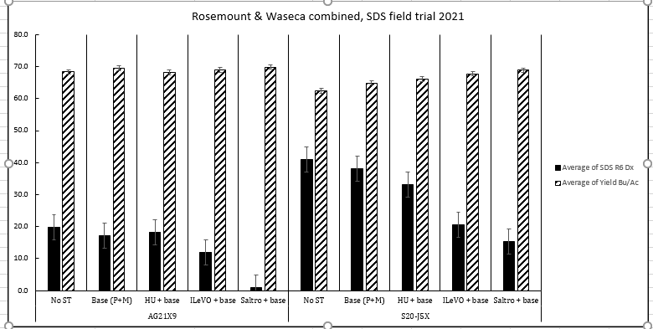

Part B. Objective: Evaluate varieties and soybean breeding lines for resistance to brown stem rot (BSR). Selected varieties and advanced breeding lines from the U of MN soybean-breeding program (n=20) were evaluated for resistance to the A and B types of BSR on the St Paul Campus in the winter. This work was conducted in cooperation with Dr. Aaron Lorenz. The research was conducted in a greenhouse under controlled conditions. Stems of plants at the early V1 growth stage were inoculated in replicated studies with the two prevalent types (A and B) of the BSR pathogen. BSR stem symptom and leaf symptom severity were measured 6-7 weeks later at the R6 growth stage. Few leaf symptoms developed, but low to moderate levels of stem symptoms developed in the inoculated plants. There were two key results. First, the levels of BSR severity fell into a range that represented different levels of resistance to BSR, with some lines very susceptible and some appearing highly resistant. Second, resistance differed to the A and B types of the pathogen, with some varieties susceptible to both types, some resistant to both types, and some with different resistance to the two types. In summary, we have much better BSR disease characterization for an important set of varieties and breeding lines, and the data suggests that resistance to both types of the BSR pathogen should be considered in breeding programs.

2. Determine distribution of Frogeye Leaf Spot in Minnesota and evaluate fungicide activity against Minnesota isolates of the causal pathogen

Background: Frogeye leaf spot (FLS) has been significant soybean disease across much of the southern half of the U.S. for many years, and in the past few years has been increasing in distribution and severity in Minnesota. It now appears to occur over much of southern 2/3 of the state. Additional information on the distribution of FLS and its sensitivity to fungicides in Minnesota is needed.
.
Part A. Objective: Determine the distribution of frogeye leaf spot in MN. Soybean leaf samples with symptoms typical of Frogeye leaf spot were collected in 2021 from scattered fields in southern and central. This disease was less common than in recent years due to the dry weather conditions in 2021. Regardless, it was still found in multiple fields. Leaf samples with symptoms of FLS were collected from multiple fields and taken to my laboratory in St. Paul. After receiving the samples, we isolated and confirmed the disease and pathogen using standard pathogen isolation techniques and DNA sequencing.

Part B. Objective. Evaluate efficacy of fungicides against the FLS pathogen (Cercospora) from soybean leaves in Minnesota. We isolated the FLS pathogen from leaves with FLS symptoms collected from multiple field locations in MN. After the identity of the pathogen was confirmed with DNA sequencing, the isolates of the pathogen were sent to a cooperating laboratory (Dr. Carl Bradley’s lab) at the University of Kentucky and tested for sensitivity to QoI (strobilurin) fungicides. All isolates of the pathogen tested from southern and central MN were resistant to QoI fungicides. This provides further evidence that there is widespread resistance to QoI fungicides in the FLS pathogen across Minnesota. Thus, appropriate fungicides must be chosen and used to manage FLS in Minnesota.

3. Conduct extension education and diagnostic activities that address important and unusual soybean disease problems in Minnesota.

Background: There is an ongoing need to develop and deliver disease management information and new research results for soybean diseases across Minnesota. In addition, unusual disease outbreaks occur in soybean fields across Minnesota each year for which specialized diagnosis and focused efforts are needed to help famers understand the problems and to identify and develop response and management strategies.

We disseminated information and taught and organized specialized meetings and workshops to present information from this project and to address soybean disease information needs for soybean producers.
Specific events are as follows:
- Field day at Rosemount, MN. September 2021
- Bayer Crop Science Roundtable. Shakopee, MN. November 2021
- Prairie Grains Meeting, Grand Forks, MN. December 2021
- Research Updates: Waseca, MN. January 2022
- Research Updates: Rochester, MN. January 2022
- Research Updates: Lamberton, MN. January 2022
- Research Updates: Wilmar, MN. January 2022
- Research Updates: Morris, MN. January 2022
- Crop and Pest Management Update. Cold Spring, MN. March 2022
- Crop and Pest Management Update. Little Falls, MN. March 2022
- Pine-Isanti County Crops Update Meeting. Pine City, MN. March 2022
We also conducted specialized diagnosis focused on frogeye leaf spot, a significant root/stem disease outbreak near Waseca following heavy rains in July, as well as suspected charcoal rot, pod and stem blight, and BSR samples.
Dissemination of data/information from this research during this reporting period. This is noted above.

