Project Title: FY22 Management of Herbicide-Resistant Waterhemp in Minnesota Soybean
Principal Investigator (PI): Debalin Sarangi, University of Minnesota, dsarangi@umn.edu
Co-PI(s):
Thomas J. Peters, University of Minnesota & North Dakota State University, Thomas.J.Peters@ndsu.edu
Ryan P. Miller, University of Minnesota, mill0869@umn.edu

Project Objectives:
1. Survey of herbicide-resistant waterhemp populations in Minnesota soybean
2. Evaluate multi-tactic waterhemp management options in soybean in a soybean-sugar beet rotation

Objective 1: Survey of herbicide-resistant waterhemp populations in Minnesota soybean
Research Questions
The objectives of this research were to evaluate the frequency and distribution of waterhemp accessions resistant to commonly used POST herbicides in Minnesota.
Application/Use
This research will provide information about the presence and frequency of waterhemp accessions resistant to commonly used herbicides in the state, thus, would be useful to identify the effective herbicide options and conserve their utility. Information about distribution patterns of these accessions in the state would help to implement regional management strategies.
Materials and Methods
Some of waterhemp seed samples were submitted by growers and crop consultants, whereas the majority were collected by UMN weed science lab members at the time of crop harvest in 2020 and 2021 from corn, soybean and sugar beet fields in Minnesota. A total of 90 accessions from 47 counties in MN were evaluated as a part of this study. Seeds after threshing were cold stratified to overcome dormancy. Seeds were planted in a germination mix followed by transplanting single plant per cone-tainers™ in the greenhouse. Seven replications (seven plants) of each accession were treated with 1× and 3× labeled doses of eight different herbicides (Table 1) representing seven different herbicide sites of action (SOAs). The whole experiment was conducted twice. Plants were visually evaluated for percent injury at 28 days after treatment (0% represents no injury, 100% represents complete plant death). Plants with ≥ 90% injury generally did not produce seed and were considered dead. Accessions exhibiting ≥ 40 % survival at 3× the labeled dose of a herbicide were classified as ‘highly resistant’, and accessions with < 40% survival at 3× the labeled dose but ≥ 40% plant survival at a labeled dose (1×) were classified as ‘moderately resistant’. Accessions that demonstrated 20 to 39% survival and < 20% survival at labeled dose were classified as ‘less sensitive’ and ‘susceptible’, respectively. Interpolated geographic distribution maps depicting percent survival at 1x recommended label herbicide rate were developed using ArcGIS Pro.
Results:
All accessions were resistant to imazamox and 89% of accessions exhibited moderate to high degree of resistance to glyphosate (Figure 1). Accessions resistant to glyphosate and imazamox were distributed throughout the sampled area in the state (Figure 2). Forty-seven, 31, and 22% of accessions were confirmed to be moderate or highly resistant to atrazine, fomesafen, and mesotrione, respectively (Figure 1). Six and 4% accessions were highly and moderately resistant to 2,4-D (Figure 1). Two percent of accessions exhibited a moderate degree of resistance to dicamba (Figure 1). None of the accessions was classified as resistant to glufosinate but 9% of accessions had 20 to 39% survival at labeled dose (Figure 1). All the accessions resistant to 2,4-D and dicamba were from the southwestern and southcentral parts of Minnesota (Figure 2). Fifteen, 7, and 4 accessions were confirmed to be four-, five-, and six-way resistant to herbicides from six different herbicide SOAs, respectively (data not shown). Two accessions from Lincoln and Lyon County, MN, were resistant to 2,4-D, atrazine, dicamba, fomesafen, glyphosate, imazamox, and mesotrione (data not shown).
Related Research:
The ALS-inhibiting herbicides (e.g., imazamox, or imazethapyr) have been used extensively in the past (Tranel et al. 2011) and resistance in waterhemp to these herbicides is very common. In a study conducted in Wisconsin, Faleco et al. (2022) reported ≥ 50% survival in response to 3× the labeled dose of glyphosate for 88% of waterhemp accessions evaluated. PPO-inhibiting herbicides (fomesafen, lactofen) became popular for weed control with the spread of glyphosate-resistant weeds (Tranel 2021; Salas et al. 2016), and resistance is now reported in several states (Heap 2023). The 2,4-D-resistant waterhemp accessions have been reported from Nebraska, Illinois, Missouri, and Wisconsin (Bernards et al. 2012; Evans et al. 2019; Faleco et al. 2022; Shergill et al. 2018). Similarly dicamba resistant waterhemp has been reported from Illinois and Wisconsin (Bobadilla et al. 2022, Faleco et al. 2022). Glufosinate resistance is not reported in waterhemp in the United States but has been already investigated in closely related species like Palmer amaranth (Amaranthus palmeri) (Heap 2023). Waterhemp resistant to herbicides from six different herbicide SOAs have been reported from Missouri (Shergill et al. 2018)
Publications:
- One Extension article was published in MN Crop News: https://blog-crop-news.extension.umn.edu/2023/06/multiple-herbicide-resistant-waterhemp.html
- Another Extension article and a peer-reviewed journal article is under submission.
References:
Bernards ML, Crespo RJ, Kruger GR, Gaussoin R, Tranel PJ (2012) A waterhemp (Amaranthus tuberculatus) population resistant to 2,4-D . Weed Sci 60:379–384
Bobadilla LK, Giacomini DA, Hager AG, Tranel PJ (2022) Characterization and inheritance of dicamba resistance in a multiple-resistant waterhemp (Amaranthus tuberculatus) population from Illinois. Weed Sci 70:4–13
Evans CM, Strom SA, Riechers DE, Davis AS, Tranel PJ, Hager AG (2019) Characterization of a waterhemp (Amaranthus tuberculatus) population from Illinois resistant to herbicides from five site-of-action groups. Weed Technol 33:400–410
Faleco FA, Oliveira MC, Arneson NJ, Renz M, Stoltenberg DE, Werle R (2022) Multiple herbicide resistance in waterhemp (Amaranthus tuberculatus) accessions from Wisconsin. Weed Technology 36:597–608
Heap I (2023) The International Herbicide-Resistant Weed Database. www.weedscience.org. Accessed: December 5, 2023
Salas RA, Burgos NR, Tranel PJ, Singh S, Glasgow L, Scott RC, Nichols RL (2016) Resistance to PPO-inhibiting herbicide in Palmer amaranth from Arkansas. Pest Manag Sci 72:864–869
Shergill LS, Barlow BR, Bish MD, Bradley KW (2018a) Investigations of 2,4-D and Multiple Herbicide Resistance in a Missouri Waterhemp (Amaranthus tuberculatus) Population. Weed Sci 66:386–394
Tranel PJ, Riggins CW, Bell MS, Hager AG (2011) Herbicide resistances in Amaranthus tuberculatus: A call for new options. J Agric Food Chem 59:5808–5812
Tranel PJ (2021) Herbicide resistance in Amaranthus tuberculatus. Pest Manag Sci 77:43–54

Common name | Trade name | Dose (g ai or ae ha^{–1}) | Site of action (WSSA group) | Adjuvant
2,4-D choline | Enlist One® | 800 (1×)  2,400 (3×) | Auxin mimics (4) | None
Atrazine | Aatrex® 4L | 2,240 (1×)  6,720 (3×) | PSII inhibitor (5) | 2340 g ai/ha1% v/v COC
Dicamba | XtendiMax® | 560 (1x)  1,680 (3×) | Auxin mimics (4) | 1,460 g ai/ha VaporGrip® Xtra +  0.5 % v/v Intact™ DRA
Fomesafen | Flexstar® | 263 (1×)  789 (3×) | PPO inhibitor (14) | 2.5 % v/v AMS +  1 % v/v COC
Glufosinate | Liberty® 280 SL | 656 (1×)  1,968 (3×) | Glutamine Synthetase Inhibitor (10) | 2.5 % v/v AMS
Glyphosate | Roundup PowerMAX® | 1,260 (1×)  3,780 (3×) | EPSPS inhibitor (9) | 2.5 % v/v AMS
Imazamox | Raptor® | 44 (1×)  132 (3×) | ALS inhibitor (2) | 2.5 % v/v AMS+  1 % v/v COC
Mesotrione | Callisto® | 105 (1×)  315 (3×) | HPPD inhibitor (27) | 2.5 % v/v AMS+  1 % v/v COC
Table 1. Doses, adjuvants, and sites of actions for herbicides used in the experiment.

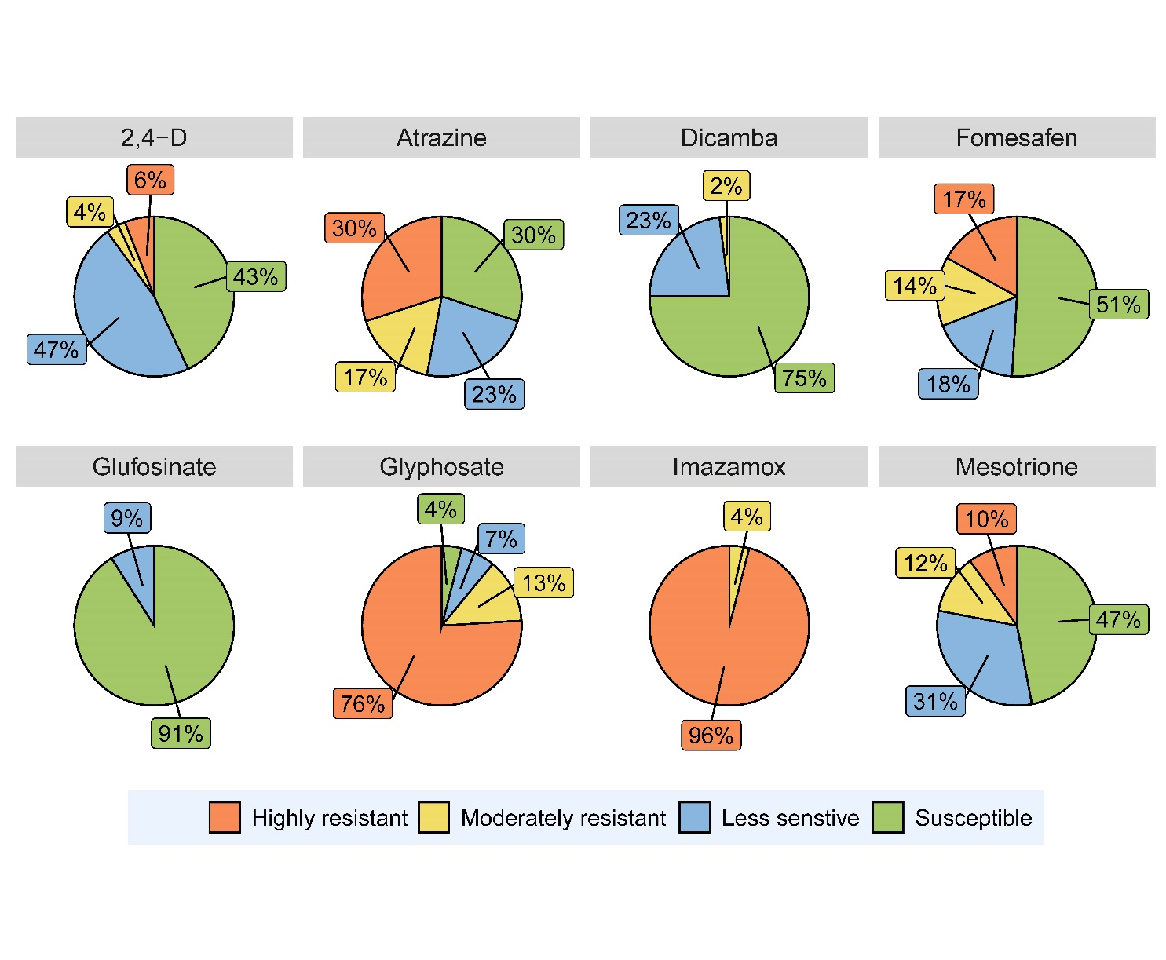
Figure 1. Pie charts depicting percent of accessions classified as highly resistant, moderately resistant, less sensitive, and susceptible to different herbicides used in the experiment.

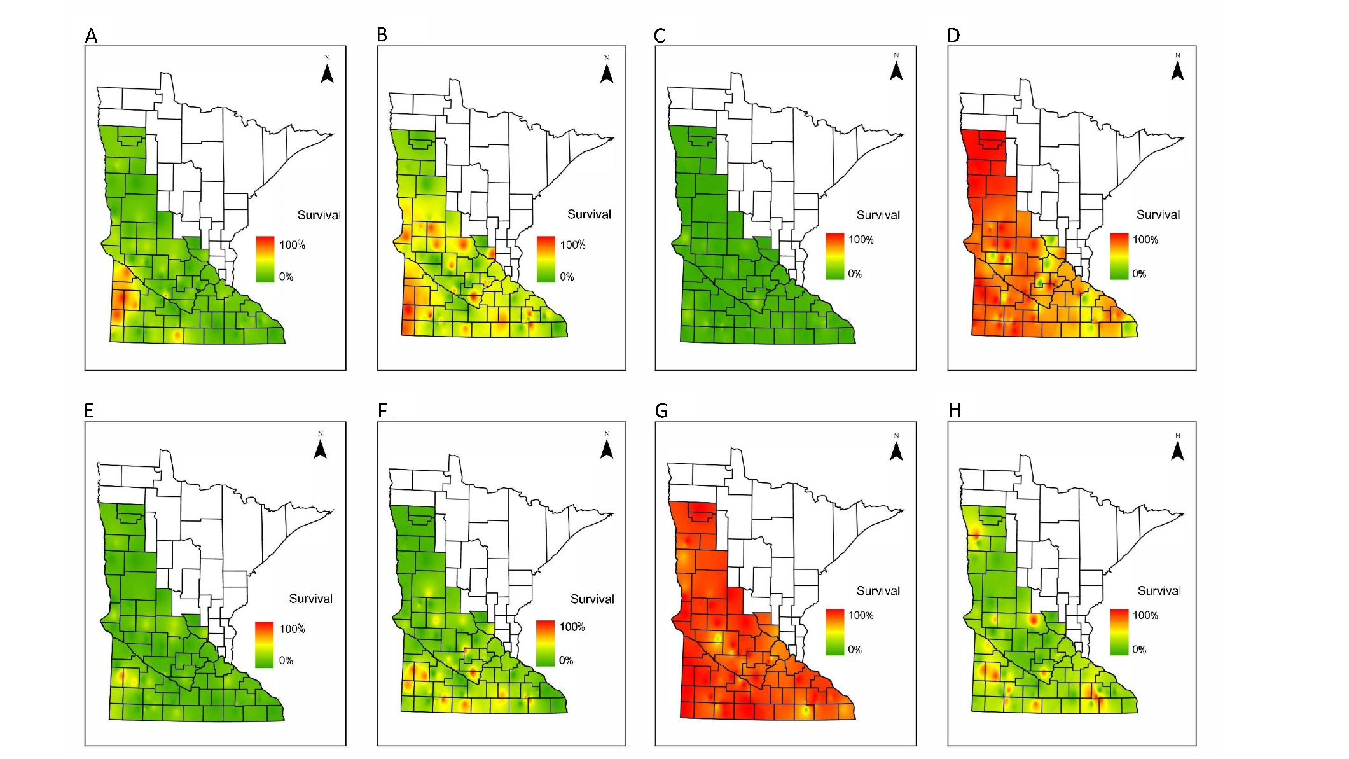
Figure 2. Interpolated geographic distribution of waterhemp survival upon application of labeled dose of (A) 2,4-D, (B) atrazine, (C) glufosinate, (D) glyphosate, (E) dicamba, (F) fomesafen, (G) imazamox, (H) mesotrione.
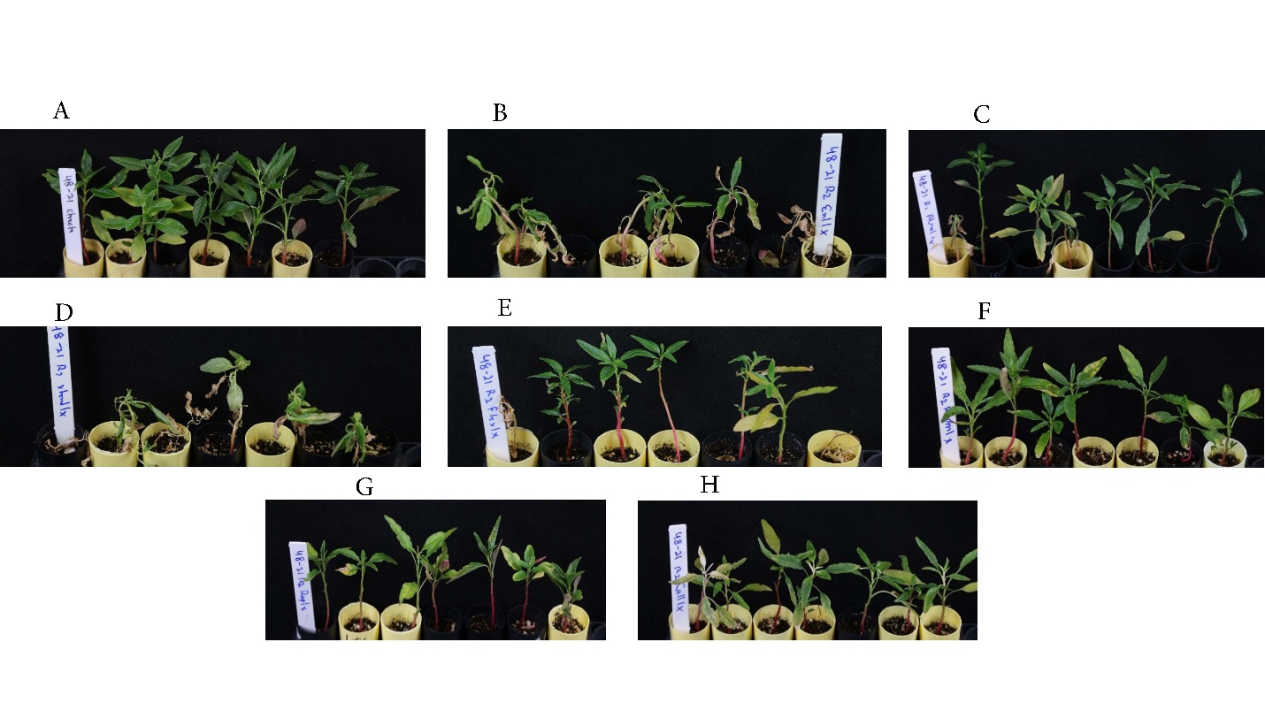
Figure 3. Visual injury for waterhemp accession from Lyon Co. upon treatment with 1x recommended label rate of (A) Nontreated, (B) 2,4-D, (C) atrazine, (D) dicamba, (E) fomesafen, (F) glyphosate, (G) imazamox, and (H) mesotrione.

Objective 2: Evaluate multi-tactic waterhemp control options in soybean in a soybean-sugar beet rotation
Research questions:
To evaluate the impact of soybean row spacing, herbicide programs, and harvest weed seed control (HWSC) on waterhemp control, soybean canopy closure, yield, and waterhemp emergence in the subsequent season.
Application/Use:
Waterhemp control in soybean-sugar beet rotation is difficult due to the spread of herbicide-resistant weeds, crop rotation interval restrictions because of herbicide carryover, and limited POST herbicide options in sugar beet. Thus, this project will help to improve waterhemp control options for soybean and minimize emergence in subsequent sugar beet crops by integrating cultural and mechanical weed management techniques with herbicide-based weed control in soybean.
Materials and Methods:
Soybean:
Field experiments were conducted with Enlist E3® soybean at Franklin, MN (2021), Moorhead, MN (2021 and 2022), and Rosemount (2022). Soybean was planted at narrow (12- or 15-inches) and wide (22-inches) row spacings. Weed management programs included two low-input and two high-input herbicide programs, and also a high-input plus Harvest Weed Seed Control (HWSC) simulation program (Table 1). The PRE, early-POST (EPOST), and late-POST (LPOST) herbicide applications were made at planting, V2, and V5 soybean growth stages, respectively. The experiments were set up using a split-plot design, where soybean row spacing was the main plot factor and weed management programs represented the subplot factor. The HWSC was simulated by removing all the waterhemp seedheads at the time of soybean harvest. Soybean canopy closure differences between narrow and wide row spacing were evaluated by analyzing ground-based RGB images using the Canopeo application and further modeling using four four-parameter Weibull 2 model in R. Waterhemp control was visually estimated (0% meaning no control, 100% meaning complete control) along with measurements of waterhemp seed production and soybean yield.
Sugar beet:
Subplots were conserved after soybean harvesting and planted with sugar beet in subsequent season. Waterhemp emergence was evaluated in sugar beet to assess the impact of last year’s weed management practices.
Results:
Soybean planted at narrow-row spacing achieved 90% green canopy cover by accumulating 400, 158, and 270 less GDD than wide-row spacing at Franklin (2021), Rosemount (2022), and Moorhead (2022), respectively.
Soybean row spacing-by-weed management program interactions were non-significant and additionally, row spacing did not impact waterhemp control and seed production across all the experiments conducted (Table 2 and 3).
In Franklin in 2021, all herbicide programs provided ≥ 96% waterhemp control at 28 DALP (Table 2). The low-input herbicide program of dimethenamid-P as PRE fb glyphosate as LPOST provided < 60% waterhemp control at all the site-years of the experiment except at Franklin. (Table 2). Nontreated control produced > 130,000 seeds whereas flumioxazin applied PRE fb lactofen plus acetochlor as EPOST fb 2,4-D choline plus glyphosate as LPOST resulted in 0 seeds m⁻² at Franklin (2021), Moorhead (2022) and Rosemount (2023) sites (Table 3). Soybean yield in narrow-row spacing was at least 339 kg ha⁻¹ higher than wide-row spacing in Franklin and Rosemount but was comparable in Moorhead in 2022 (Table 3). At Rosemount, all the high input herbicide programs yielded at least 850 kg ha⁻¹ higher than the low-input herbicide programs (Table 3). High-input herbicide programs in soybean reduced waterhemp emergence in subsequent sugar beet by 73 to 90% compared to nontreated control at Franklin sites (Table 4), whereas at Moorhead in 2022 program, flumioxazin applied PRE fb lactofen plus acetochlor as EPOST fb 2,4-D choline plus glyphosate as LPOST resulted in 64% reduction in waterhemp emergence (Table 4).
Related research:
Some previous research also reported earlier canopy closure in soybean at 19- to 38-cm row spacing compared to 76-cm spacing (Dalley et al. 2004; Harder et al. 2007). Past results of soybean row spacing impact on Amaranthus spp. control were variable. For example, in a study conducted in Missouri, Schultz et al. (2015) reported a higher waterhemp control in 38-cm soybean row compared to 76-cm spacing. In contrast, another recent study from Kansas, Lamers CJ (2022) reported similar waterhemp and Palmer amaranth control in 38- and 76-cm soybean row spacing. Past research suggests that the impact of soybean row spacing on yield was dependent on several factors including crop production region, plant population rate, and other environmental conditions, majority of research supported the fact that soybean at narrow-row spacing outyields that at wide row spacing. De Bruin and Pedersen (2008) and Bullock et al. (1998) reported higher soybean yield in 38-cm row spacing compared to 76-cm spacing.
Economic Benefit to a Typical 500-Acre Soybean Enterprise
Use of narrow row spacing would improve soybean yield deriving direct economic benefit to the producer. Similarly, adoption of the high input herbicide programs would help to improve waterhemp control and minimize yield losses from weed competition. Better waterhemp control in soybean could facilitate waterhemp management in subsequent season sugar beet crop by reducing the number of plants that need to be controlled.
Publications:
- One Extension article will be prepared.
- One peer-reviewed journal article is under submission.
References
Bullock D, Khan S, Rayburn A (1998) Soybean yield response to narrow rows is largely due to enhanced early growth. Crop Sci 38:1011-1016
Dalley CD, Kells JJ, Renner KA (2004) Effect of Glyphosate Application Timing and Row Spacing on Corn (Zea mays) and Soybean (Glycine max) Yields. Weed Technol 18:165-176
De Bruin JL, Pedersen P (2008) Effect of row spacing and seeding rate on soybean yield. Agron J 100:704-710
Harder DB, Sprague CL, Renner KA (2007) Effect of Soybean Row Width and Population on Weeds, Crop Yield, and Economic Return. Weed Technol 21:744-752
Lamers CJ (2022) Integrated weed management and herbicide application parameters for herbicide-resistant soybean in Kansas. M.Sc. thesis. Manhattan, KS. Kansas State University. p 58
Schultz JL, Myers DB, Bradley KW (2015) Influence of soybean seeding rate, row spacing, and herbicide programs on the control of resistant waterhemp in glufosinate-resistant soybean. Weed Technol 29:167-176

Table 1 Weed management programs used for waterhemp control in soybean in a soybean-sugar beet rotation.
Weed management program^{a,b} | Herbicide program type | Herbicide trade name^{a,b} | Herbicide application timing^{a,b}
Nontreated control | --- | --- | ---
Weed-free control | --- | --- | ---
Flumioxazin fb  2,4-D choline | Low-input | Valor® SX fb  Enlist One® | PRE fb  LPOST
Dimethenamid-P fb  glyphosate | Low-input | Outlook® fb  Roundup PowerMAX® II | PRE fb  LPOST
Flumioxazin fb  lactofen + acetochlor fb  2,4-D choline + glyphosate | High-input | Valor® SX fb  Cobra® + Warrant® fb  Enlist One® + Durango® | PRE fb  EPOST fb  LPOST
Saflufenacil + dimethenamid-P fb  glufosinate+ acetochlor | High-input | Verdict® fb  Liberty® 280 SL + Warrant® | PRE fb  EPOST
Saflufenacil + dimethenamid-P fb glufosinate + acetochlor fb  HWSC simulation | High-input + HWSC | Verdict® fb  Liberty® 280 SL + Warrant® | PRE fb  EPOST

ªAbbreviations: EPOST, early-POST; fb, followed by; HWSC, harvest-time weed seed control; LPOST, late-POST
^{b}Adjuvants/additives: AMS at 2.5% v/v was added to glufosinate and glyphosate applications; COC at 1.25% v/v was added to lactofen application.

Table 2: Waterhemp control in response to soybean row spacing and weed management programs.
Weed management program | Herbicide application timingª | Herbicide program typeª |  | Waterhemp control^{b}  28 DALP
 |  |  |  | Franklin (2021) | Moorhead (2021) | Moorhead (2022) | Rosemount (2022)
 |  |  |  | ______________ % ________________
Nontreated control | --- | --- |  | 0 | 0 | 0 | 0
Weed-free control | --- | --- |  | 100 | 100 | 100 | 100
Flumioxazin fb  2,4-D choline | PRE fb  LPOST | Low-input |  | 96 a | 94 ab | 95 ab | 91 c
Dimethenamid-P fb  glyphosate | PRE fb  LPOST | Low-input |  | 96 a | 55 d | 52 c | 46 d
Flumioxazin fb  lactofen + acetochlor fb  2,4-D choline + glyphosate | PRE fb  EPOST fb  LPOST | High-input |  | 97 a | 96 a | 96 a | 98 a
Saflufenacil + dimethenamid-P fb  glufosinate + acetochlor | PRE fb  EPOST | High-input |  | 97 a | 84 c | 93 ab | 94 bc
Saflufenacil + dimethenamid-P fb glufosinate + acetochlor fb  HWSC simulation | PRE fb  EPOST | High-input + HWSC |  | 98 a | 88 bc | 91 b | 95 b
Row spacing
Narrow-row |  |  |  | 97 a |  | 90 a | 92 a
Wide-row |  |  |  | 97 a |  | 91 a | 91 a

ªAbbreviations: DALP, days after late-POST application; DAPRE, days after PRE application; EPOST, early-POST; fb, followed by; HWSC, harvest-time weed seed control; and LPOST, late-POST.
^{b}Means within the same column with no common letter(s) are significantly different based on Fisher’s Protected LSD (P < 0.05).
Table 3: Waterhemp seed production and soybean yield in response to soybean row spacing and weed management programs.
Herbicide programª | Herbicide application timingª | Herbicide program type |  | Waterhemp seed production^{b} |  |  |  | Soybean yield^{b}
 |  |  |  | Franklin  (2021) | Moorhead  (2022) | Rosemount  (2022) |  | Franklin  (2021) | Moorhead (2021) | Moorhead (2022) | Rosemount  (2022)
 |  | g ae or ai ha⁻¹ |  | __________ #seeds m⁻² __________ |  |  |  |  | _____________ kg ha^{-1_____________}
Nontreated control | --- | --- |  | 522,566 a | 134,138 a | 151,299 a |  | 1,269 d | 567 c | 883 d | 2,008 c
Weed-free control | --- | --- |  | 0 | 0 | 0 |  | 4,117 bc | 2,512 a | 3,585 a | 3,892 a
Flumioxazin fb  2,4-D choline | PRE fb  LPOST | Low-input |  | 0 b | 14 d | 13 c |  | 4,190 abc | 2,534 a | 3,071 bc | 2,921 b
Dimethenamid-P fb  Glyphosate | PRE fb  LPOST | Low-input |  | 478 b | 56,173 b | 43,220 b |  | 4,041 c | 1,726 b | 2,792 c | 2,772 b
Flumioxazin fb  lactofen + acetochlor fb  2,4-D choline + glyphosate | PRE fb  EPOST fb  LPOST | High-input |  | 0 b | 0 d | 0 c |  | 4,165 abc | 2,414 a | 3,558 a | 3,735 a
Saflufenacil + dimethenamid-P fb  glufosinate + acetochlor | PRE fb  EPOST | High-input |  | 0 b | 62 cd | 250 c |  | 4,423 a | 2,196 ab | 3,183 abc | 3,940 a
Saflufenacil + dimethenamid-P fb glufosinate + acetochlor fb  HWSC simulation | PRE fb  EPOST | High-input + HWSC |  | 0 b | 8,631 c | 223 c |  | 4,351 ab | 2,323 a | 3,272 ab | 3,987 a
Row spacing
Narrow-row |  |  |  | 13,741 a | 15,006 a | 9,987 a |  | 3,963 a | --- | 3,048 a | 3,603 a
Wide-row |  |  |  | 17,197 a | 12,863 a | 12,218 a |  | 3,624 b | --- | 2,764 a | 3,041 b

ªAbbreviations: DALP, days after late-POST application; DAPRE, days after PRE application; EPOST, early-POST; fb, followed by; HWSC, harvest-time weed seed control; and LPOST, late-POST.
^{b}Means within the same column with no common letter(s) are significantly different based on Fisher’s Protected LSD (P < 0.05).

Table 4. Waterhemp emergence in sugar beet as influenced by weed management practices adopted in previous season soybean crop.
Herbicide program ª | Herbicide application timing^{a,b} | Herbicide program type | Waterhemp density^{b}
 |  |  | Franklin 2022 | Moorhead 2022
 |  |  | ___________ plants m⁻² _________
Nontreated control | --- | --- | 188 a | 74 ab
Weed-free control | --- | --- | 54 b | 38 cd
Flumioxazin fb  2,4-D choline | PRE fb  LPOST | Low-input | 48 b | 40 cd
Dimethenamid-P fb  glyphosate | PRE fb  LPOST | Low-input | 39 bc | 110 a
Flumioxazin fb  lactofen + acetochlor fb  2,4-D choline + glyphosate | PRE fb  EPOST fb  LPOST | High-input | 18 d | 27 d
Saflufenacil + dimethenamid-P fb  glufosinate + acetochlor | PRE fb  EPOST | High-input | 15 d | 58 bc
Saflufenacil + dimethenamid-P fb glufosinate + acetochlor fb  HWSC simulation | PRE fb  EPOST | High-input + HWSC | 23 cd | 46 bc
Row spacing
Narrow-row |  |  | 37 a | ---
Wide-row |  |  | 40 a | ---

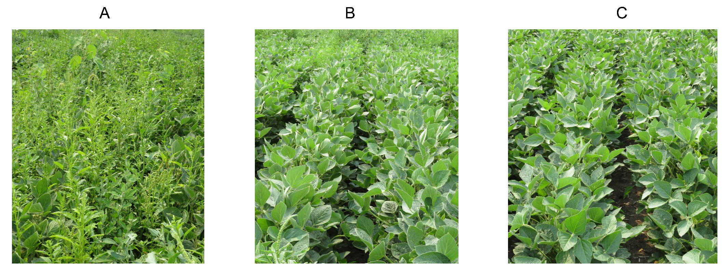
Figure 2 Waterhemp control at Franklin, MN (2021) at 28 DALP; A) Nontreated control; B) Dimethenamid-P (PRE) fb Glyphosate (LPOST); C) Flumioxazin (PRE) fb lactofen plus acetochlor (EPOST) fb 2,4-D choline plus glyphosate (LPOST)

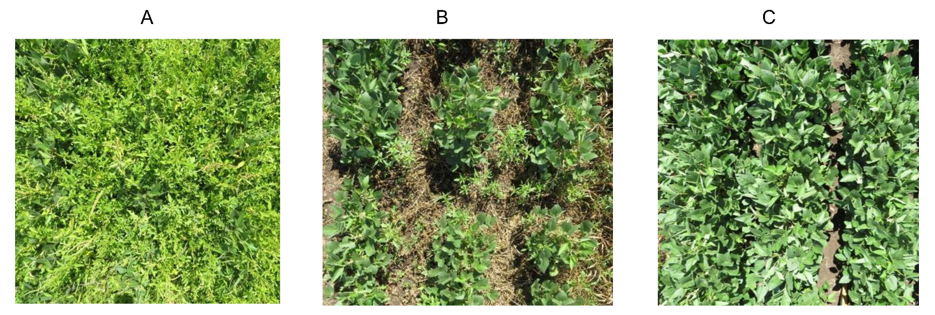
Figure 2 Waterhemp control at Rosemount, MN (2022) at 28 DALP; A) Nontreated control; B) Dimethenamid-P (PRE) fb Glyphosate (LPOST); C) Flumioxazin (PRE) fb lactofen plus acetochlor (EPOST) fb 2,4-D choline

Performance Metrics:
1. Results obtained from this research improve the yield and quality of soybean grown in MN.: The research results will improve weed (waterhemp) control in soybean, thus, will protect the soybean yield and quality of soybean grown in MN.
2. Growers and other stakeholders are educated about herbicide resistance in waterhemp, and integrated weed management.: This research was demonstrated at eight Field Days, on-farm research demonstrations, and Extension events. The research results were presented at seven Extension meetings. Also, in two invited talks, Sarangi presented the research results. One Extension article was published. This research results were presented to more than 2,000 audiences in two years.
3. Results are presented in Extension events attended by the soybean growers.: Described above.
4. One graduate student and one undergraduate student are mentored.: One graduate student (Navjot Singh) did his M.S. thesis work on this research. Several undergraduate students were involved in this research.
5. Peer-reviewed and Extension articles are published containing these results.: One Extension article was published, and peer-reviewed journal articles are under submission.

