**SC Soybean Board Final Report**

**General Information**

**Principal Investigator(s) Name(s):** W. Cory Heaton   
**Organization:** Clemson University Sandhill REC

**Date:** January 11th, 2022

**Quarter:**

**Proposal Information**

**Title: Determining the economical impact of deer populations on soybeans in South Carolina**

**Amount Expended to Date: $9,850.00**

**Project Summary**

*Briefly summarize this project and your final results. Summaries should be brief (limit to one page) and should be written in a way that is easy for our farmer audience to interpret and apply.*

The main goal for this project was to quantify the amount of soybean damage inflicted by varying deer populations in a given area. To accomplish this, spotlight surveys were conducted to estimate white-tailed deer populations, while exclusion cages were used to determine soybean yield in the absence of deer feeding. Data collection began in February of 2021 with spotlight surveys on the north side of Barnwell County in order to estimate the white-tailed deer populations that were surrounding cooperating farmer’s fields. There were four survey routes that averaged about five miles in length for a total of 20.9 miles. The routes were surveyed three times and the average deer population was determined on a square mile basis for each route. Figure 1 shows a portion of the first route with the deer per square mile estimates highlighted in yellow for each roadway along the route. Unfortunately, only one of the four survey routes had soybeans planted along the route, had this been known earlier in the year routes would have been changed to include more soybean fields. In the route containing soybeans, five different fields were included in the study and had exclusion cages placed in them. There were a total of eleven soybean fields with four different cooperating farmers, and two soybean fields on Clemson’s Edisto Research and Education Center enrolled in the project. Each field had four exclusion cages and four plots without exclusion cages for a total of 104 research plots in the study. Based on consultation with the farmers, half of the caged and check plots were placed in high-pressure areas and half in low-pressure areas. Cages were constructed of 48-inch-tall field fence and measure 76 inches by 76 inches since all of the soybeans were planted using a 38-inch row spacing. Weekly aerial pictures were taken of each plot using a drone to determine canopy closure and possible deer damage. The weekly images were analyzed using a software program developed at Clemson to count the number of plant pixels and the number of soil pixels in each picture. Before plots were harvested for yield, plant heights and stand counts were collected. In the original proposal for the project a second round of spotlight surveys was proposed to be conducted in August; however, after conducting a survey of one route it was determined that summer-time/growing season surveys would not yield accurate estimates of deer populations. During this survey, many deer were jumping up from bedding in fields with taller crops; the survey crew was not able to accurately count the number of deer in those fields. It was also during this August survey that a new computer software application was designed by our Precision Ag group to aid researchers in recording and geo-tagging deer populations. The software will reduce labor requirements to survey and help to ensure repeatability between future surveys. The software operates on a tablet in the cab of the survey vehicle with a predetermined route loaded into the software program. As the driver navigates the map a GPS receiver is used to determine the vehicle’s position as the spotlight crew records the deer observed using a manual push button installed on the spotlights.

The 2021 February average deer population for the routes ranged from 108 to 229 deer per square mile; this is about seven times higher than the most recently published SCDNR estimates for Barnwell County according to a [2013 SCDNR deer density map.](2013%20SCDNR%20deer%20density%20map.) Yield data from exclusion cages and control plots suggested that deer were on average responsible for a 14 bu/ac loss as seen in Figure 2. In Figure 3 the yield data is shown by field and excluding the CR field there is a 10.6 bu/ac difference in yield on average. Figure 4 is the same data displayed as a percentage loss per field with an average loss of 18.2% if the CR field is excluded. It should be noted, however, that the CR field was not found to be a statistical outlier.

**Key Performance Indicators**

*What KPI(s) were used to measure project success? How were KPI(s) measured? Were KPI(s) not met? Were KPI(s) exceeded? Explain the key circumstances that impacted achieving or not achieving KPI(s).*

This project evaluated the damage sustained to soybeans by deer throughout the growing season based on the surrounding deer population as estimated by night surveys. To determine the level of feeding damage on the soybeans by deer, plots were compared to adjacent exclusion cages. These exclusion cages provided a predicted yield for nearby areas of the field in the absence of deer feeding. By comparing the actual yield of the plots to the yield inside the exclusion cages we were able to put a dollar value on the effect of varying deer populations for soybeans in a given area.

**Next Steps**

*Explain the next steps of this project (if any) and the implementation of the findings from the project.*

The proposal for this coming year aims to continue this research across the state in order to see greater differences in white-tailed deer populations and further explain the impact of deer feeding on soybeans. Beginning in late January of 2022 night surveys will be conducted again in Barnwell and will include the fields that did not have survey routes in 2021. This data will be used to develop a baseline of the surrounding deer population.

**Additional Information**

*Provide any additional supporting information, facts or figures here.*

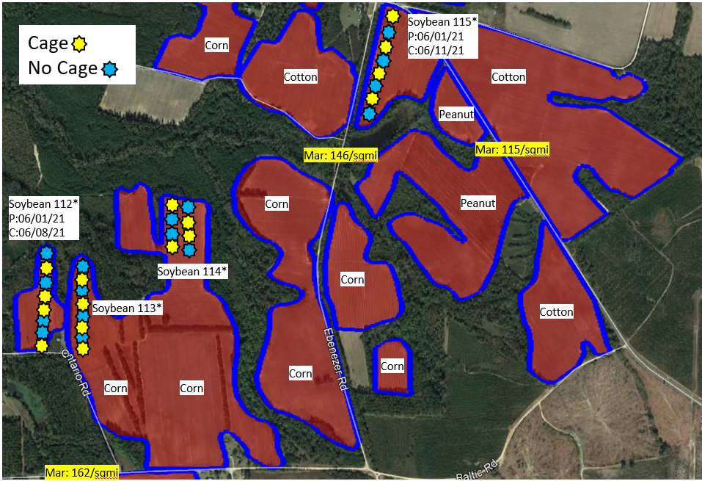

Figure 1. Displays a portion of the first survey route with deer per square mile estimates for each road highlighted in yellow, along with planting dates and cage assignments for research plots.

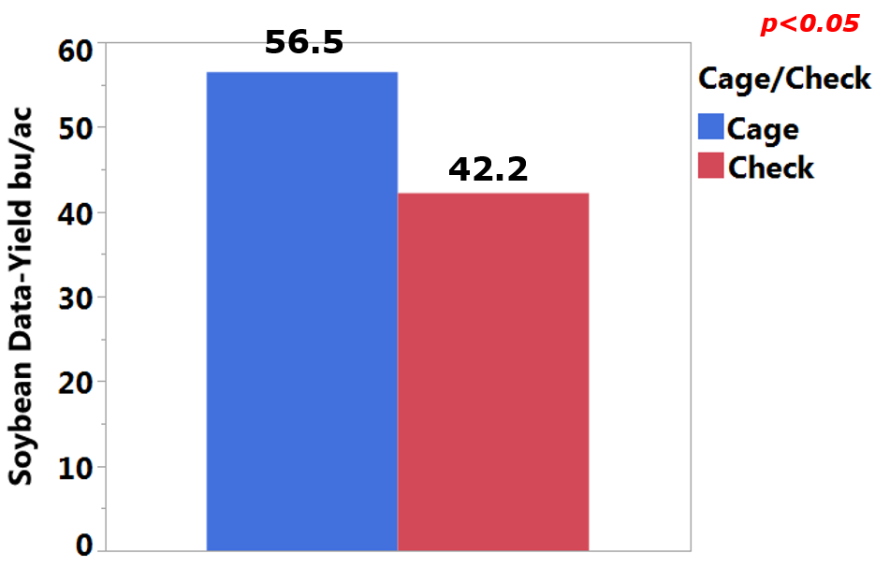

Figure 2. Average soybean yield difference in caged and uncaged (check) plots in bushels per acre.

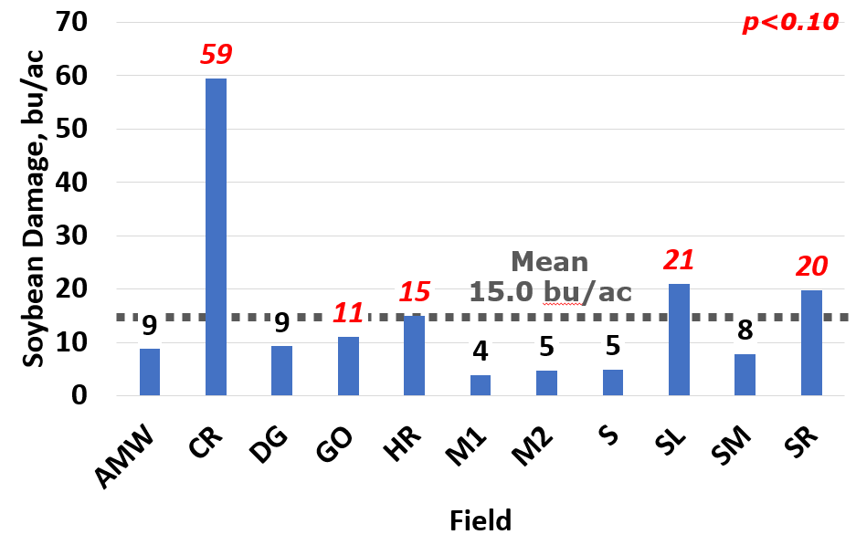

Figure 3. Soybean yield loss in bushels per acre for each field; these estimates were derived by the average yield of caged and uncaged plots.

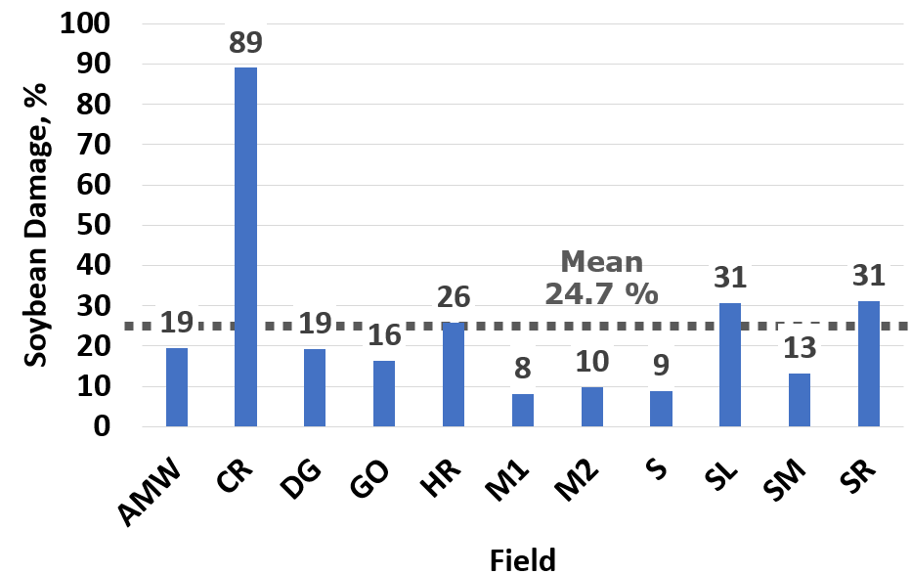

Figure 4. Percentage of soybean yield loss for each field; these estimates were derived by comparing the average yield of caged and uncaged plots.

Prior to submission, reports should be saved as a pdf document using the following naming convention; 2022Date(MMDD)_(PI Last Name)_(Abbreviated Proposal Title)_Final.