**SC Soybean Board Final Report**

**General Information**

**Principal Investigator(s) Name(s):** Michael Plumblee  
**Organization:** Clemson University

**Date: 1/17/2022**

**Quarter: Final**

**Proposal Information**

**Title:** Determining the Optimum Soil Moisture Sensor Threshold in Soybean

**Amount Expended to Date:** $6,996

**Project Summary**

*Irrigated row crop acres in South Carolina have steadily increased over the last 10 years. Furthermore, groundwater regulation in SC has also increased with regard to well permitting. To maximize soybean yield while reducing water usage an appropriate irrigation schedule coupled with a scheduling tool needs to be incorporated into irrigation strategies. By determining appropriate soil moisture sensor thresholds specific to SC coastal plain soil textures and soybean, growers who adopt these technologies and recommendations can maximize profit by maximizing yield and improving irrigation water use efficiency. Irrigation was applied with an overhead lateral move irrigation system. Irrigation was then scheduled with Watermark soil moisture sensors installed at depths to monitor soil moisture within the top 24 inches of the rooting zone. All soil moisture sensors were installed within the planted row after planting. Treatments consisted of three thresholds 1). 25% Maximum Allowable Depletion (MAD), 2). 50% MAD, 3). 75% MAD, and a non-irrigated treatment for comparison purposes.*

*The 2021 growing season would be considered an above-average rainfall for Blackville, SC. Even with good rainfall throughout most of the growing season, all three soil moisture sensor thresholds were met and irrigation applications went out. Plots that were held to a -15 kPa threshold received 5 inches of irrigation, -30 kPa received 3 inches of irrigation, and the -60 kPa received 1.5 inches of irrigation. All of these irrigation applications occurred during the months of August and September, until that point soil moisture levels never met the threshold in any of the plots. During these months is when soybean reaches its maximum water use, so it is not surprising that sensor thresholds were triggered at that point in time.*

*After harvesting soybean on November 12th all data was analyzed. From the 2021 trial, similar results were obtained to the 2020 trial where no significant differences in plant height or total nodes were measured at the mid-season (7/23) or harvest timings (11/3) regardless of how the treatments were irrigated (Figures 1 and 2). Furthermore, no significant yield differences were observed among treatments, and soybean yield ranged from 57 bushels/ac to 65 bushels/ac including the non-irrigated treatment (Figure 3). Taking into account the amount of water applied for each irrigation treatment, the -60 kPa threshold provided the greatest irrigation water use efficiency (IWUE) compared to both the -30 and -15 kPa thresholds, and the -30 kPa threshold out preformed the -15 kPa threshold. This is not surprising since more water was applied at the -15 and -30 kPa threshold compared to the -60 kPa threshold and no significant yield differences were obtained. Last, when comparing the irrigation water use efficiency of each treatment to the net return above irrigation costs associated with each of the three threshold treatments, this data suggests that the -60 kPa threshold would use the least amount of irrigation water while providing the most profit for the producer at $12 per bushel soybean price. Given that in both 2020 and 2021, rainfall was above average for the area, these results may differ in a below-average or dry year.*

**Key Performance Indicators**

Key performance indicators for this study were determined at harvest (to determine if irrigation treatment and threshold value had any direct yield benefit). The water use efficiency data and yield data from this trial helped determine if there was an optimum soil moisture threshold that can be utilized for irrigated soybean. These data were compared with the data collected and generated in the 2020 growing season. This research helps develop irrigation scheduling recommendations where soil moistures sensors are incorporated. Furthermore, this research allows for a threshold to be selected that maximized yield and water use efficiency. Factors that impacted this research in 2021 were similar to the 2020 growing season, where timely and above-average rainfall resulted in crop water use demand being met through rainfall rather than supplemental irrigation. An additional site-year during a dry year would be beneficial to this data set.

**Next Steps**

*The next steps in this project would be to implement similar treatments again in a year where below-average rainfall occurs to compare the results of the 2020 and 2021 growing seasons to that particular year. If such a year were to occur it would help validate the sensor threshold recommendation for soybean in a year where significant quantities of irrigation water are being applied to soybean. Additionally, these results will be shared with consultants, soybean farmers, and other irrigators throughout the region to reiterate the fact that in an above-average rainfall year soybean does not need to be irrigated excessively and a threshold of -60 kPa would result in the most profitable threshold that could be used. This research has been presented at the Edisto REC field days, CCA training, and will be written in an Extension report/bulletin and shared on the SC Crops Blog. With an additional year of data, the PI would like to publish the findings in an appropriate academic journal.*

**Additional Information**

*The following figures are from data collected during the 2021 growing season and supplement the previously mentioned report.*

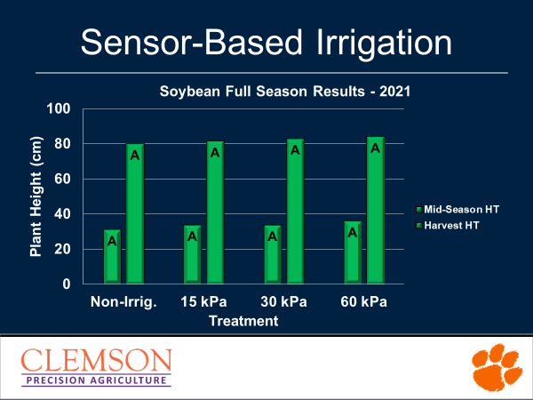

*Figure 1. Plant Heights as a Function of Soil Moisture Sensor Threshold*

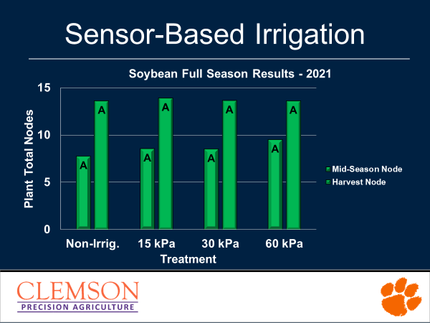

*Figure 2. Total Plant Nodes as a Function of Soil Moisture Sensor Threshold*

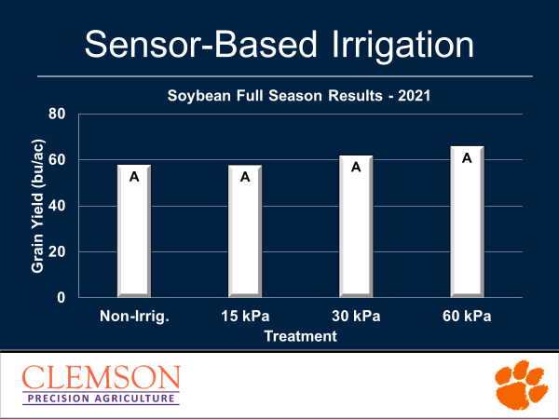

*Figure 3. Soybean Grain Yield by Soil Moisture Sensor Threshold*

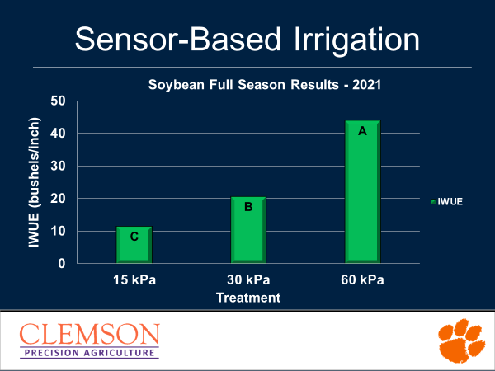

*Figure 4. Irrigation Water Use Efficiency by Soil Moisture Sensor Threshold*

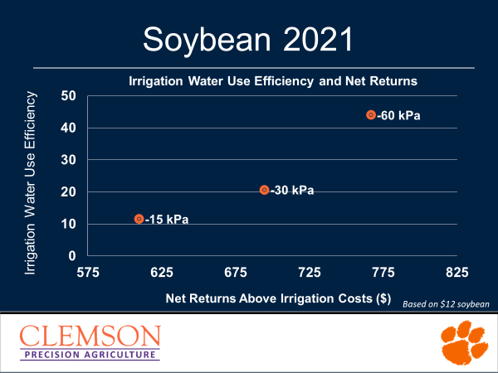

*Figure 5. Irrigation Water Use Efficiency compared to Net Returns Above Irrigation Costs.*

Prior to submission, reports should be saved as a pdf document using the following naming convention; 2022Date(MMDD)_(PI Last Name)_(Abbreviated Proposal Title)_Final.