**Resistance to Important Diseases**

**FY 2021 Technical Report for North Dakota Soybean Council**

**June 30, 2021**

**Principal Investigator:** Dr. Berlin D. Nelson Jr., Plant Pathology, NDSU

Cooperators: Dr. Carrie Miranda, NDSU Soybean Breeder, Plant Sciences.

Dr. Sam Markell, NDSU Extension Pathologist

The objectives of this research program were to work with the NDSU soybean breeder to incorporate resistance to important diseases into public germplasm and cultivars and test material for resistance to fungal diseases, monitor soybean for new pathogens and new virulent strains of established pathogens and continue studying ways to manage important soybean diseases. An important emphasis in 2020-2021, was to determine if there were new soybean fields in Richland County showing symptoms of sudden death syndrome (SDS) and to continue our efforts to screen for resistance to SDS and identify resistance sources in maturity groups that can be used in the NDSU soybean breeding program.

In August of 2020 a survey for sudden death syndrome (SDS) was conducted in soybean fields in Richland County to determine if the disease has spread since it was first identified in 2018. This was conducted in areas around where the first field with SDS was found in August 2018. In the 2019 survey, we did not find any new fields with symptoms. The 2020 survey covered an area of approximately 400 square miles which was about 28% of the county. Some fields within this area were brought to the attention of the survey crew by crop scouts working in the area. Plants with typical SDS symptoms were collected from fields and the DNA was extracted from root tissue. The DNA was then tested for evidence of *Fusarium virguliforme* by PCR analysis using F6-3 and R9 primers specifically for this pathogen. Positive and negative controls were used in the analysis. The PCR test verified 12 fields in Richland Co. were positive for SDS (Figures 1 and 2). In addition, a field in Cavalier County, ND, was also observed with SDS symptoms by extension agents in the area and plants were sent to be analyzed using PCR. That field was also verified to have SDS. Although most of the fields observed in this survey had small patches of plants showing foliar symptoms of SDS, several of the fields had large areas with symptoms. The results from this research point out that SDS is a potential future problem for soybean growers in North Dakota. The disease is now well established in the area and because this is a soil borne pathogen, it will readily spread from field to field by agricultural equipment and the natural movement of soil by environmental conditions. It will be important that growers, crop scouts, and others managing soybean fields can identify this disease when it first appears. An important management tool that will likely be needed in the future will be SDS resistant soybean varieties. Currently, in our maturity groups, there are no commercial cultivars that we are aware of with resistance to SDS.

In May of 2020, we initiated a field experiment to test the resistance of soybean varieties for resistance to sudden death syndrome. This was part of our effort to identify sources of SDS resistance that the NDSU breeding program could use in development of SDS resistant lines. A principle objective was to identify a susceptible and a resistant cultivar in the maturity class for North Dakota that we could use a control for future SDS screening. We identified five SDS resistant and three susceptible varieties from published research with seven of them in maturity groups I and 0. Five of the resistant to moderately varieties (MN302, Evans, Merit, CV15A and CV19A and three susceptible varieties (Spencer, Barnes and McCall) were planted into soil infested with *F. virguliforme* in large plastic pots. CV15A and CV19A (maturity group 1) were varieties from a private company that we used only as highly resistant checks in the experiment. The inoculum (isolate P10-2 from North Dakota) was wheat seed colonized by the pathogen over three weeks, then mixed into La Prairie silt loam. A 9.5 liter plastic pot was filled with 4 liters of La Prairie silt loam. Then, a layer of 800 ml of soil plus 400 ml of inoculum was placed over the 4 liters of soil, covered with a layer of soil without inoculum and the seeds was planted above that layer so roots would grow down through the inoculum layer. A known SDS positive control (isolate 13FV mol) was also included in the test, but was only used with Barnes soybean. There were ten seeds per pot and four replications per soybean variety. A non-inoculated control for each variety was included in the test. The seed was planted May 18 and plants were kept in the greenhouse for 10 days until seedlings were established then the pots were taken to the field. The pots were buried in Fargo clay with part of the bottom removed so roots could grow into the soil under the pots. Emergence was recorded at 9 days following planting, the number of plants with the first true leaves were counted at 16 days and the number of plants with the second trifoliate leaves were counted at 21 days. Then plants were thinned to 6 plants per pot. Plants were watered each week for 6 weeks to maintain high soil moisture and promote SDS infection and disease development. Plant height was recorded at 7 weeks after planting and roots were sampled at harvest.

The results of the 2020 field tests showed that soil infested with *F. virguliforme* significantly reduced germination on some varieties and retarded plant growth (Figure 3). The resistant varieties CV19A and MN0302 had the highest germination in the infested soil compared to the other varieties. CV19A averaged 9 plants per pot while Spencer, the susceptible, averaged 3.5 plants per pot. CV19A also had the greatest number of plants with true leaves after 16 days. The SDS resistant varieties, however, did not have the highest number of plants with the second trifoliate leaves after 21 days. At 7 weeks following planting, infected plants that were still growing averaged six inches shorter than those growing in non-infested soil. All plants were monitored for foliar symptoms throughout their growth, but typical foliar SDS symptoms did not develop in this experiment. The reasons for that are unknown as the soil had a high level of inoculum. Unfortunately, we were unable to score the plants for foliar symptoms and therefore could not evaluate them for resistance to the foliar phase of the disease. Plants were harvested on October 7 and the number of pods and the seed weights per plant were determined. CV19A and Evans had the highest number of pods per plant and CV19A had the highest seed weight per plant in the inoculated plants. In the uninoculated plants, CV19A also had the greatest number of pods per plant and the highest seed weight. The results, however, were mixed in the inoculated plants as the SDS resistant varieties did not always trend toward higher yield compared to the susceptible varieties. The resistant varieties tended to have a lower percentage of root rot on the tap root compared to the susceptible varieties Barnes and McCall. For example, surviving plants of McCall averaged 90% of the tap root with symptoms, those of Barnes 60%, MN0302 15% and Evans 17%.

During the winter of 2020 to 2021 a greenhouse experiment was conducted to test the same soybean varieties again for resistance to SDS. One of the susceptible varieties, Spencer, was not included in the test. Soil from an SDS infested field in Richland County ND, was collected in the fall of 2020. The area of soil collection had over 90% of the plants with SDS, so there was a high inoculum density in the soil. The soil was mixed using a cement mixer and then placed in 9.5 liter plastic pots. Fifteen seeds of each cultivar were planted in pots on December 21 with eight replications and placed in the greenhouse. There was some pre-emergence damping off and pots with less than 8 plants per pot were seeded again with extra seed. All pots were thinned to 8 plants per pot, fertilized and watered daily for 6 weeks to promote development of SDS foliar symptoms. Foliar symptoms began appearing on plants February17 (58 days from planting) in McCall and soon after most varieties were showing foliar symptoms which progressed rapidly. On March 30 a final count of the number of plants showing SDS foliar symptoms was recorded along with notes on the symptoms. Because McCall is a 00.7 maturity, it matured very fast in the greenhouse and the SDS symptoms became less pronounced as the entire plant started to turn strongly chlorotic. The two resistant checks CV15A and CV19A maintained a robust growth and showed little evidence of foliar symptoms until the end of March while the susceptible cultivars began showing classic foliar symptoms by the end of February and beginning of March. The results are shown in Table 1 and Figure 4. The greenhouse test did result in strong foliar symptoms of SDS, but none of the varieties in maturity groups 0 to 00 showed a high level of resistance. Barnes appears to be a good choice for a susceptible check in future experiments. There is a lack of data on resistance to SDS in the early maturity groups and further testing will be necessary to identify a variety that can be used as a resistant check and as resistance sources useful for the NDSU breeding program. Another field experiment is currently in progress as of May 2021 testing six additional cultivars in the early maturity groups for resistance to SDS.

In cooperation with Dr. Miranda, the soybean breeder, we screened 148 advanced breeding lines for resistance to *Phytophthora sojae* races 3 and 4. Most of the screening was for Race 4 resistance since the source of resistance in the breeding lines is primarily from the *Rps* 6 gene. Over 66% of the lines tested were resistant to Race 4. One of the breeding lines resistant to race 4 was released in 2021 as ND21008GT20 a 00.8 maturity glyphosate tolerant soybean.  We maintain a variety of races of *P. sojae* in storage and each year the races we use for screening are grown in the laboratory, inoculated onto a set of plants with known resistance and susceptibility, and then re-isolated from infected plants to make sure they have maintained their known virulence.

During August of 2020, soil was collected from 147 soybean fields in nine counties of SE North Dakota to initiate a study on the virulence of *Phytophthora sojae*, the cause of Phytophthora root rot of soybean. This soil is stored in the greenhouse and will be used to bait *P. sojae* from soil and then test virulence of the isolates on a set of eight differential cultivars. In the summer of 2021, soil will be sampled from other soybean producing counties. This information has a direct impact on the types of resistance that will be needed in future soybean varieties for North Dakota. A grant from the ND Soybean Council to support this research begins July 1, 2021.

We continued studies on Fusarium root rot of soybean caused by *Fusarium solani* and *F. tricinctum*, two common pathogens in North Dakota. The objective was to examine the interaction between soil type, temperature and soil moisture on the development of root rot. Soil type significantly affected disease development, with higher severity in the lighter soils of Glyndon sandy loam and La Prairie silt loam compared to Fargo clay. Soil type also interacted with *Fusarium* species, in which the maximum severity was observed in Glyndon sandy loam for *F. solani*, and in La Prairie silt loam for *F. tricinctum*. Significant reductions in emergence by pre-emergence damping-off occurred at 10°C in treatments with *F. solani* and *F. tricinctum*, but there was no significant difference among three soil types. Infection was visible at temperatures of 10-20°C for *F. solani* and15-20°C for *F. tricinctum.*  *Fusarium solani* caused the greatest infection at 20°C in Glyndon sandy loam, while it was at 15°C in La Prairie silt loam for *F. tricinctum*. The two *Fusarium* species were able to cause root rot in soil moisture ranging from 20% to 100% water holding capacity (WHC). The biggest reduction of emergence was observed at 80% WHC in silt loam and clay soils and 40% WHC in sandy loam soil. Ranges of soil moisture causing infection were negatively correlated with temperature: at lower compared to higher temperatures there was a broader range of soil moistures resulting in infection. At 18oC, most infection occurred at soil moistures of 20-80% WHC, while it was 40-80% WHC at 28oC. Disease caused by *F. solani* was favored by low temperature (18oC) with high soil moisture (60-80% WHC) or high temperature (28oC) with low soil moisture (20-40% WHC) while *F. tricinctum* was favored by cooler temperature and lower soil moisture.

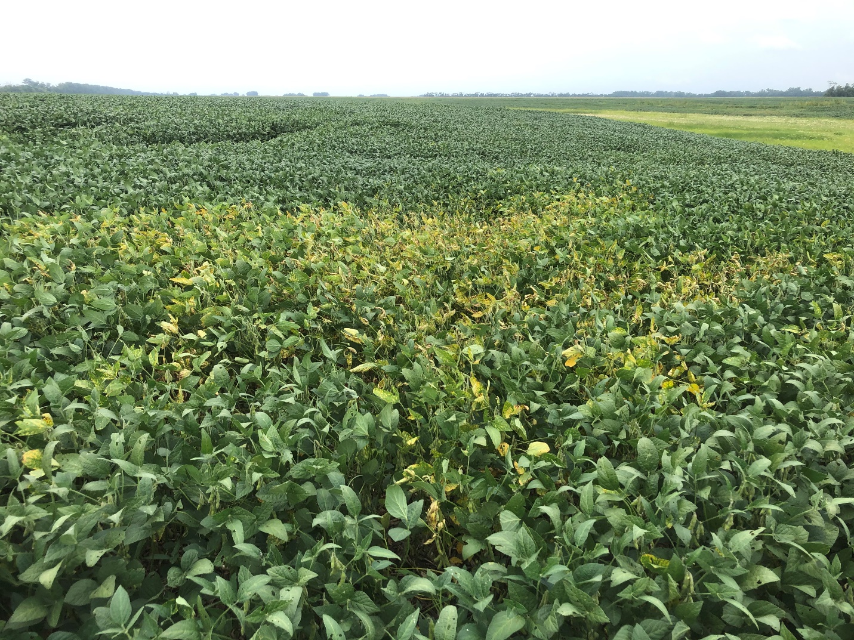

Figure 1. Patch of SDS infected soybean plants in Richland County ND, in 2020. Note the chlorotic plants. Twelve fields with SDS were identified in the county.

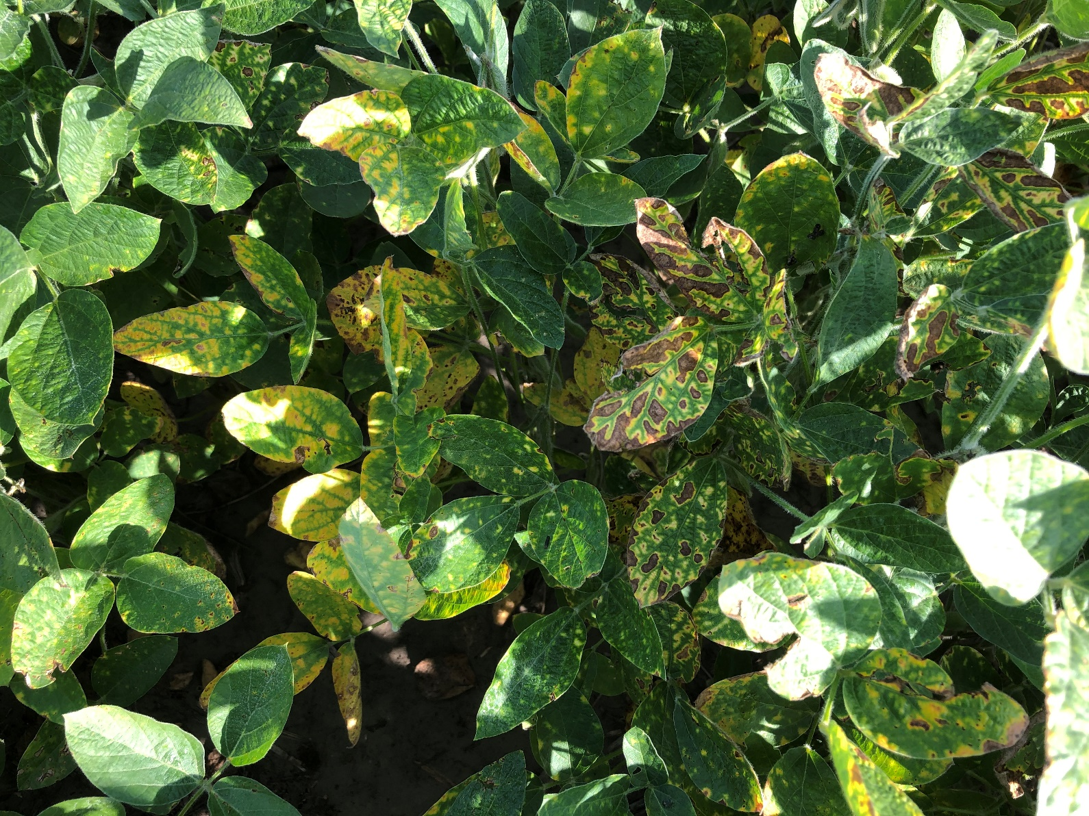

Figure 2. Classic foliar symptoms of SDS in soybean in ND in 2020.

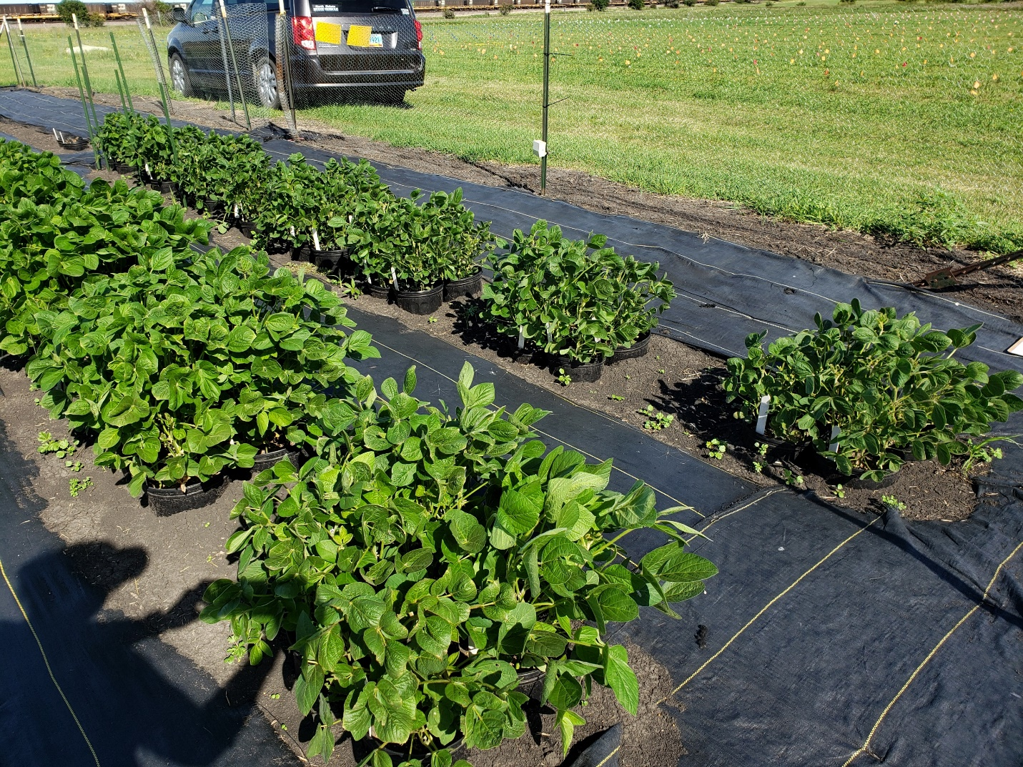

Figure 3. Testing the resistance of soybean varieties to sudden death syndrome in the field in 2020. Plants growing in soil infested with *Fusarium virguliforme* on the right side and plants growing in soil with no pathogen on the left side. Notice the marked stunting of plants on the right due to infection of roots. Photo taken in July, 2020.

**Table 1. Results of screening soybean varieties for reaction to sudden death syndrome.**

|  |  |  |  |  |
| --- | --- | --- | --- | --- |
| Variety | Maturity | SDS%a | CLP%b | HP%c |
| CV19A | 1.9 | 3 | 2 | 95 |
| CV15A | 1.5 | 9 | 2 | 89 |
| McCall | 00 | 23 | 77 | 0 |
| MN0302 | 0.3 | 47 | 9 | 44 |
| Merit | 0 | 51 | 16 | 33 |
| Evans | 0 | 65 | 6 | 29 |
| Barnes | 0.3 | 95 | 5 | 0 |

a Percent of plants with classic SDS symptoms (based on 64 plants per variety).

Planted December 21, rated for SDS on March 30

b CLP = Percent of plants entirely chlorotic

c HP= Percent of healthy plants with no SDS foliar symptoms

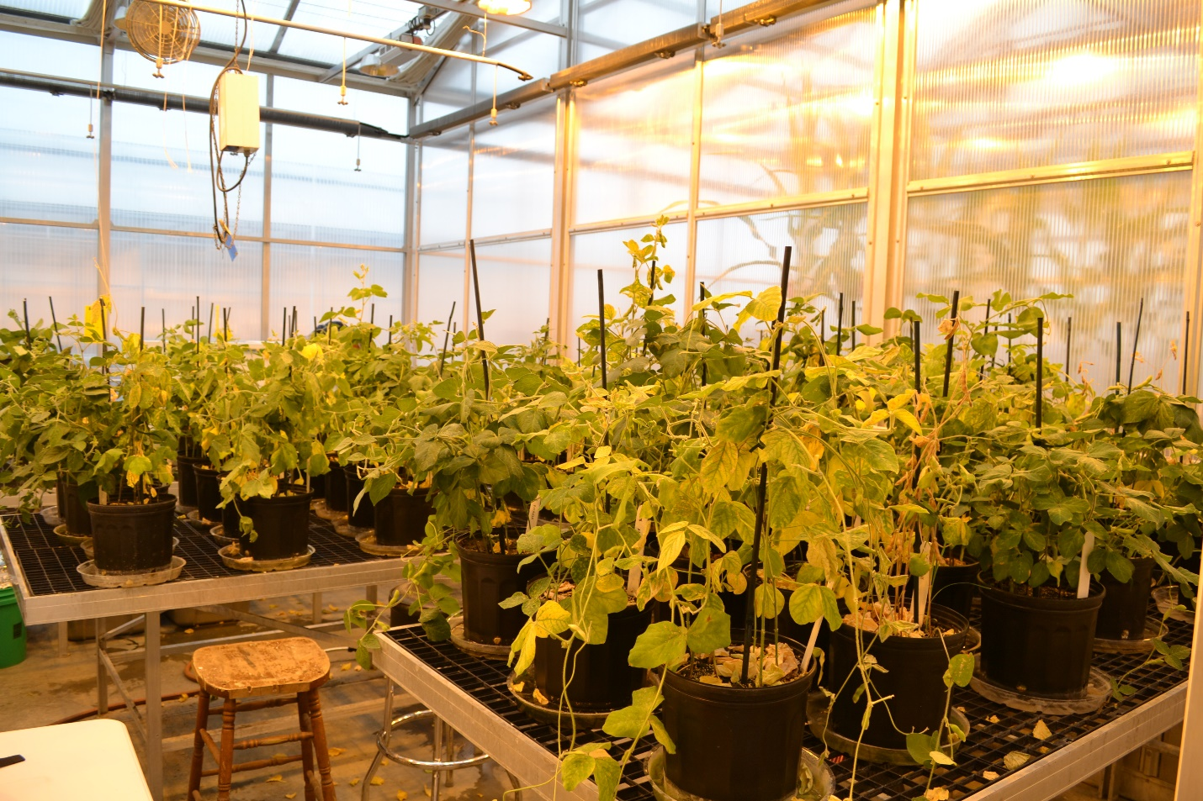

Figure 4. Greenhouse testing for resistance in soybean to sudden death syndrome (SDS). Plants showing strong chlorosis had classic symptoms of SDS while more resistant varieties still had green leaves (March 30, 2021)