Managing salinity with cover crops: A whole system response (year 4)
Caley Gasch, Sam Banerjee, Jason Harmon, Tom DeSutter, Abbey Wick
North Dakota State University, Fargo, ND

North Dakota Soybean Council – FY2021 final report

Situation
Soil salinity is a persistent problem across North Dakota and soybean is susceptible to salinity-caused yield reductions. In 2017, we initiated a project to evaluate the use of cereal rye (Secale cereal) cover crop as a tool for managing soil water to reduce salinity and improve soil health and soybean yields. For four years, we monitored many soil, plant, and insect properties across four field sites that host salinity gradients and cereal rye treatment strips. Ultimately, our goal has been to understand the uses and limitations of cereal rye in soybean rotations, particularly as a tool for managing soil water, maximizing soil cover, and reducing effects of salinity. We were also particularly interested in understanding how both beneficial and pest soil organisms and insects are affected by salinity and cereal rye.

The final growing season of this project (2020) faced many challenges. Difficult planting conditions prevented planting at three of our four field sites, so we did not collect crop or cover crop growth data at the sites in 2020. We did take final soil samples from field locations where we took baseline soil samples in 2017, with the goal to identify any changes in soil salinity level over the duration of the project. In this final report, we summarize some of the main findings from these field studies as well as a few findings from the 2019 growing season that have not been presented previously.

Objectives
For this report, we focus on three objectives:

Objective 1: compare soil salinity levels in 2017 to those in 2020, across field locations that span initial salinity levels and cereal rye strips that were maintained for the duration of the project.

Objective 2: characterize water use by cereal rye, both in the field and in controlled greenhouse settings, to provide recommendations to farmers about the water-using capabilities of rye.

Objective 3: characterize soil microbial diversity across soil salinity levels.

Methods
Field site description:
In 2017, we formed cooperative agreements with farmers, on four working farms that host saline patches. These field sites are located near Aneta, Northwood, and Jamestown, North Dakota. In the spring of 2017 and prior to planting, we Veris mapped and ground-truthed each field, which provides a map of apparent electrical conductivity, an indicator of soil salinity. From this map, we located four replicated sets of plots that span saline and non-saline areas in each field.

The Aneta and Northwood sites were planted to corn in 2017, soybean in 2018, and corn in 2019. The two Jamestown sites were planted to soybean in 2017, corn in 2018, and soybean in 2019. Only Aneta was planted (soybean) in 2020. Mid-season each year, we broadcasted treatment strips of cereal rye into growing corn (early- to mid-July) and soybeans (September) at 45 kg/ha (40 lbs/ac) in 2017 and 2018, and at 90 kg/ha (80 lbs/ac) in 2019. The rye was terminated before, or around planting time the following spring. Thus, across each field, we had four replicates of plots with and without cover crop, and in either low saline soils (electrical conductivity (EC_{1:1}) < 1 mmhos/cm), or moderately saline soils (EC_{1:1}= 2-4 mmhos/cm).

Objective 1:
To meet the first objective, we sampled soils to 120 cm depth at all 64 plot locations in 2017 at the initiation of this project, and again in 2020. We used a hydraulic probe to remove an intact soil core from each location and divided the core into the following depth increments (0-15, 15-30, 60-90, and 90 – 120 cm). We analyzed these soils for electrical conductivity (EC_{1:1}), with a handheld probe on a 1:1 soil:water solution. We compared the values from soils sampled in 2017 to those sampled in 2020.

Objective 2:
To monitor soil water content in the field, we sampled soil (0-15 cm depth) at each plot, at multiple times throughout the 2019 growing season. Soil water content was determined by mass. To complement the field surveys, we also grew cereal rye at four different seeding rates (40, 80, 120, and 240 lb/ac, or 45, 90, 135, and 269 kg/ha) in replicated pots in the greenhouse with access to unlimited water supply for five weeks. We quantified rye growth and water use (by mass) in the pots under non-saline conditions to identify relationships between seeding rate and water use.

Objective 3:
Soil samples (0-15 cm depth) were collected from each plot location during the 2019 growing season and analyzed for soil microbial diversity via sample processing at the University of Minnesota Genomics Center.

Results
Objective 1:
We compared the EC_{1:1} measured in 2017 and again in 2020 as a percent increase or reduction relative to the 2017 value for each sample location and depth. Overall, the Aneta field (all plots and all depths) had an average reduction of EC_{1:1} of 12%, while the other three fields had minor increases in EC_{1:1} (Eldridge = 2%, Midway = 5%, and Northwood = 3%). The only soils that did not experience a mean reduction in EC_{1:1} at Aneta were the saline plots that did not have a cover crop. This is the response that we would expect, based on the idea that the cover crop removes more water from the profile than bare ground, and increases the likelihood that salts will migrate lower into the profile. However, we did not observe this response in the other three fields. The Northwood site had variable changes in EC_{1:1} that did not align with cover crop presence or salinity level. The Eldridge and Midway sites were also variable, but both experienced the largest increases in salinity in the non-saline soils that had cereal rye. Even so, the final EC_{1:1} values in those plots were still below 1 mmhos/cm and considered non-saline. It is important to note that in 2020, prior to the final sampling event, Aneta was the only site that was planted and produced a cash crop, which may have contributed to these results.

Objective 2:
During the growing season of 2019, soil water content was consistent throughout the season, without large seasonal fluctuations, and without any difference between cereal rye and control strips. Soil water tended to be a little higher in saline soils throughout the season, and saline soils produced less cereal rye biomass than non-saline soils (see Figure 1).
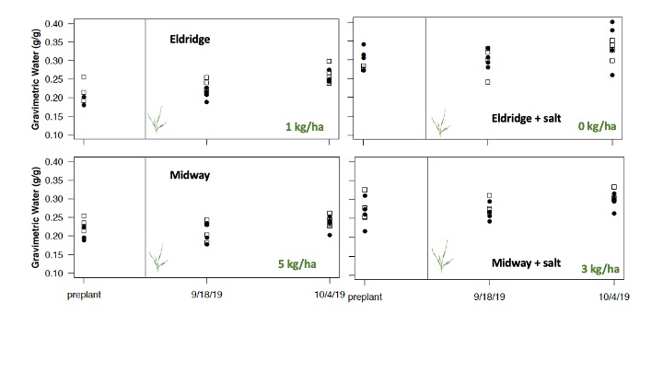
Figure 1: Soil water content (0-6”) in two fields (Eldridge and Midway) under strips of cereal rye interseeded in soybean (80 lb/ac, dots) or under soybean without cereal rye (squares) throughout the 2019 growing season. Charts on left are for non-saline locations within the field, and charts on the right are for saline locations. The vertical line indicates cereal rye interseeding, and the green numbers are average shoot biomass production of cereal rye until fall freeze at sample locations.

Under optimum growing conditions in the greenhouse, we found that cereal rye biomass production and water use increased as seeding rate increased to 120 lb/ac but were not different between the 120 and 240 lb/ac seeding rates (see Figure 2). The highest seeding rate (240 lb/ac) had more plants than the 120 lb/ac rates, but the plants were smaller, and the cumulative water use was not different between the two highest rates.

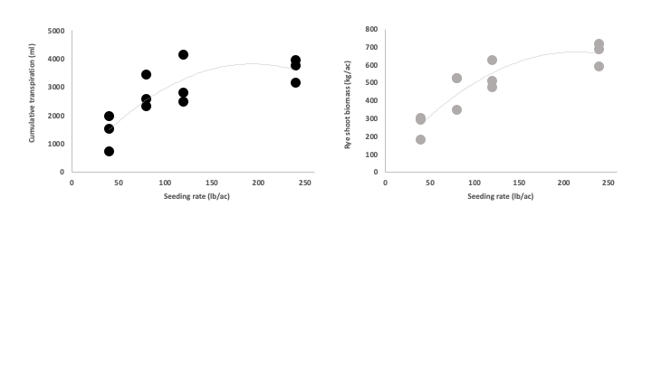
Figure 2: Cumulative water use (left) and rye shoot biomass production (right) across four seeding rates of cereal rye, grown in a greenhouse with an unlimited water supply for five weeks. Data collected by graduate student Alec Deschene.

Objective 3:
Soil microbial diversity was characterized using three different diversity indices, from data pooled across all four fields. Larger diversity index values indicate more types of microbes, and more microbial groups in the soil are generally considered to be more beneficial. Diversity indices were slightly higher in soils from cereal rye strips in both saline and non-saline soils, and the lowest diversity (by all three measures) occurred in the saline soil without cereal rye (Figure 3). We don’t know yet how these levels of diversity translate to soil function or crop growth, but that is an area to potentially explore in the future.

Figure 3: Soil microbial diversity indices collected from saline and non-saline soils (0-15 cm depth) that were from either a cereal rye strip, or a no cover crop strip. Bars represent all observations across four fields and within each of the four treatments (n = 16). Figure prepared by graduate student Lennel Camuy-Velez.

Conclusions
Over the four-year study, we have made the following general observations:
- We have not observed differences in crop yield (for either corn or soybean) between strips with interseeded cereal rye, or no cover crop. We did observe predictable declines in crop productivity as salinity level in the soil increases.
- Cereal rye establishment in the field is patchy depending on seeding method and climate. We observed very little growth of cereal rye when interseeded into soybean, and do not recommend that practice. Our farmer cooperators were comfortable seeding rye at a relatively low rate at the beginning of this project. After disappointingly low rye growth, and increased comfort with using rye, we increased the rate (more details above in methods).
- We did not observe elevated insect pest threats associated with cereal rye.
- Based on initial microbial community analysis, we did not observe drastic differences in total abundance of soil microbes, or major microbial groups (total bacteria, total fungi) across salinity levels or cereal rye treatment strips.

In this final report, we present a few additional findings based on field sampling and activities in the 2019 growing season. First, only one field demonstrated a consistent reduction in soil salinity levels in response to the cereal rye treatment. We recognize that salinity migration in the profile likely requires more time to occur, but based on this study, we cannot say that the cover crop alleviated salt problems at these sites.

If excess water use is the main goal of interseeding cereal rye (for salt management or otherwise), we recommend using the highest seeding rate within a farmer’s comfort level. We found that a seeding rate (drilled) between 120 – 240 lb/ac would provide the most water use, and that there are trade-offs between plant density and plant size, but water use was similar at those two rates. These studies quantified water use by cereal rye in the summer and fall, but cereal rye is a winter annual and will resume growth in the spring. While we did not measure spring water use, the water use rates by the cereal rye are similar to those of winter barley and winter wheat (25 inches of water per year), so we might assume that cumulative annual water use for cereal rye is similar to other winter small grains. Future field studies should evaluate how much water cereal rye can use in the spring and on an annual cycle.

The microbial community analysis deserves more attention, but we were relieved to find that none of the soils were drastically depleted of microbial diversity. Soil microbial communities are resilient, and we are confident in concluding that saline soils have active microbial communities which may assist plants in surviving in the presence of salts.

Finally, we have created a large data set, and while the field work and data collection activities have been completed for this project, we will continue to analyze and summarize the data. Specifically, we will be examining the deep soil samples for microbial and soil chemical properties in more detail. Finally, this project has given rise to additional questions related to cover crop use in corn-soybean rotations in ND, salinity management, and the biological nature of saline soils.

We thank the ND Soybean Council for supporting this research, and the students, research specialists, technicians, and cooperating farmers who made this research possible.

