1. **Project Title:** An integrated approach to enhance durability of SCN resistance for long-term, strategic SCN management (Phase II)
2. **Principle and Co-Principle Investigators:** Dr. Andrew Scaboo (PI), Dr. Melissa Mitchum, Dr. Brian Diers, Dr. Thomas Baum, Dr. Gregory Tylka, Dr. Matthew Hudson
3. **Brief Description of Accomplishments:**

A description of relevant progress for principal and co-principal investigators is below for each objective and sub objective in our proposal. Our team has made tremendous progress in accomplishing our research goals, conducting field experiments, publishing refereed journal articles, and communicating our results to scientists and soybean producers. We had a group meeting in March of 2022 to discuss current research progress and goals and we are on track to continue our cutting-edge research in soybean cyst nematode biology, management, and breeding for novel resistance.

***Objective 1: Identify SCN virulence genes to better understand how the nematode adapts to reproduce on resistant varieties.***

***Sub-objective 1.1: Combine, compare, and catalogue the genomes that compromise the SCN pan-genome. (Hudson, Baum, Mitchum)***

The Baum group has accomplished an analysis of gene expansions and contractions, as well as the presence and absence of gene families in *H. glycines* compared to 13 related species in the Tylenchomorpha. We are functionally characterizing these gene families and their association with previously published *H. glycines* effectors, as well as their secretory status, expression, nuclear localization, and impact of their variability across 15 populations of *H. glycines*. We have shown that 551 gene expansions in sedentary nematodes differentiate them from migratory nematodes, 124 gene expansions in cyst nematodes differentiate them from root-knot nematodes (*Meloidogyne*), and 1,100 gene expansions in *H. glycines* differentiates it from *Globodera* cyst nematode species. We have also shown a number of gene gain and loss events that have directly impacted the *H. glycines* genome, many of which have shown an atypical inheritance pattern across related species. In one instance, we show 175 gene families that are only shared between *H. glycines* and *Meloidogyne* species, 15 of which are targeted to the secretory pathway, including two predicted *H. glycines* effectors. Using effectors from relatively closely related species, we have identified 405 putative effector families present in *H. glycines*, though only 137 of these families contain a gene that produces a protein with a signal peptide for secretion. Of these 137 putative effectors, 11 were associated with gene expansions in sedentary nematodes compared to migratory nematodes, 6 were associated with the expansions of gene families in cyst nematodes versus root-knot nematodes, and 24 were associated with the expansion of *Heterodera* gene families in comparison to *Globodera*. Using population variation from 15 distinct populations of *H. glycines*, we were able to show which genes typically produce secreted proteins across the assayed SCN lines. In this respect, we show that 59 gene expansion families have consistent signals for secretion across multiple populations, even though they were not predicted to be secreted in the previously published TN10 genome. These results warrant further research into gene evolution. We also have developed plans to update SCNBase with new RNAseq data from the recently published J2 gland RNAseq and will integrate gene family criteria. To complement the methods of identifying genes involved in the parasitism of *H. glycines*, we have undertaken a genome assembly and annotation project of male and female specimens. Males and females dramatically change their parasitic behavior with the onset of adulthood and, thus, studying their genomes and transcriptomes will reveal insights into gene functions, particularly for effectors. We sequenced male and female genomes using nanopore long reads and added male and female specific RNA-seq to this analysis to better predict the gene variation among the sexes. Since the last report we have scaffolded these male and female genomes with HiC to obtain nine pseudomolecules for each genome. Interestingly, we found large differences in genome size between these nanopore genomes (male: 115.5Mb, female: 112.6Mb) and our previously published TN10 genome (158Mb), which is likely attributable to the differences in sequencing technology and assembly software. Subsequently, we used male and female RNAseq with Braker to annotate genes in each genome, finding that the disparity continues between these nanopore genomes and TN10 genome at the genic level. In the male and female gene annotations, we found 16,421 genes and 16,530 genes, respectively. These gene annotation totals are substantially reduced from our previous annotation of the TN10 genome at 22,465 genes, though the gene copy number reduction is in proportion with the genome size reduction. We have begun to compare the genomes at the level of gene structure and expression using Orthofinder and differential expression analyses. Thus far we have found that 9-10,000 of differentially expressed genes cluster to the same orthologue family, leaving slightly more than half of the genes with significant divergence between the sexes. Continuation of gene expansion and contraction as well sex-specific genomic differences will further refine these early findings.

The Mitchum group submitted the following manuscript during the past quarter - Verma A, Lin M, Smith D, Lee C, Walker JC, Hewezi T, Davis EL, Hussey RS, Baum TJ, Mitchum MG. A novel cyst nematode effector (2D01) targets the Arabidopsis HAESA receptor-like kinase. Mol. Plant-Microbe Interact.

***Sub-objective 1.2: Resequencing of the genomes and transcriptomes of virulent SCN populations and conduct comparative analyses. (Hudson, Mitchum, Baum)***

Phase II of this project saw the Baum group developing further resources to expand the toolbox that will aid us in understanding SCN virulence. Focusing once again on the three gland cells that SCN uses to produce the tools (effectors) required for establishment of successful infection, as well as defense suppression, we have improved on the technology. Taking advantage of recent developments toward single cell sequencing, and specifically new technology available for the generation of single cell RNA-seq libraries, we have applied these technologies to our work with gland cell isolation and transcriptomics in SCN. We successfully generated single cell RNA-seq libraries for our avirulent (PA3) and virulent (MM10) SCN populations at different time points. These libraries represented four biological replications of 5 dorsal and subventral gland cells per rep. This was our group’s first attempt at applying single cell sequencing technologies to SCN transcriptomics and required a fair amount of optimization. Through this process, we developed a technique for live gland cell collection, versus fixed tissue collection, which improved the quality of RNA collected and allowed us to collect picogram quantities of RNA from individual gland cells. The overall coverage of genes identified within these new J3 single cell libraries, with reference to the SCN TN10 genome is slightly greater than the coverage of genes identified with our previous pooled gland cell parasitic J2 libraries. We identified a total of 14,667 and 14,000 genes at a normalized read count of at least 5 counts from the SCN PA3 J3 and MM10 J3 libraries, respectively. This is compared to a total of 12,495 and 12,289 genes at the same read count cutoff for the respective SCN populations with our older technology. While we cannot rule out that this could be due to life stage differences, it certainly points to the fact that this new technology can yield similar, if not better numbers of identified genes from lesser amounts of material. We are currently working on the transcriptomics to generate both broad and specific comparisons of both the life stages and virulence differences that exist in our two SCN reference populations. This will provide an extensive and novel look at SCN virulence at this level.

All seven of the genomes of the additional Hg types are now assembled, and the assemblies are completed and frozen. They are ready to distribute or submit to NCBI, however we need to annotate and analyze them before publishing a paper on the genomes, and to make them useful to more people in the group.

The Hudson group has been proceeding with analysis in several ways. Firstly, genome synteny for the 7 newly assembled SCN strains was compared with mummer (dotplots) and circos (BLAST hits) to the chromosome level SCN assembly TN10 (Masonbrink et al 2021). These data showed that the assembled 9 chromosomes were in similar structure with the previously reported TN10, although not identical. We started the genome functional and structural annotation. Repetitive elements modeled with RepeatModeler and quantified repetitive content with RepeatMasker. The repeat analysis showed repeat content was similar across strains with respect to repeat class and quantity. Subsequently, we began gene prediction using RNAseq evidence (previously reported Gardner et al 2018 & Lian et al 2019) and protein models (from previously reported TN10 Masonbrink et al 2021) and other cyst nematodes including *Globodera pallida* (Cotton et al 2014) and *Globodera rostochiensis* (Eves-van den Akker 2016). Preliminary gene models show similar structure to the previous assemblies’ gene models. Our future work will include refinement of gene models and subsequent functional annotation of the gene models.

The Mitchum group has concluded the RNA-seq analysis for the purpose of identifying soybean cyst nematode genes potentially responsible for overcoming the Peking-type resistance. This led us to identify 14 genes of special interest categorized into three subgroups: (1) putative effectors involved in defense suppression, (2) putative enzymes related to reactive oxygen species, and (3) putative vitamin B-associated genes. Additionally, the Mitchum lab collected sufficient genetic material of two pairs of SCN populations (unadapted or adapted to reproduce on resistant soybeans) and optimized their DNA extraction procedure to meet the stringent requirements necessary for the Pool-Seq strategy. The Pool-Seq approach should help guide us toward the candidate virulence regions in the SCN genome important for breaking the Peking-type (Rhg4-mediated) resistance. We have completed the Pool sequencing and bioinformatic analysis is currently underway. We expect that some of the identified from the RNAseq analysis may also appear in the Pool-seq analysis providing a stronger support for their potential importance in virulence. For the most promising genes, we are currently testing correlation to virulence in other SCN populations with known HG types, prior to embarking on functional characterization.

***Sub-objective 1.3: Validate and characterize genes associated with SCN virulence and evaluate their utility as novel resistance targets. (Mitchum, Baum)***

The Baum group has indicated that characterization of the function of 28B03 effector family has been advanced to a natural stopping point to publish the first extensive report on this effector’s function during parasitism. A complete manuscript has been written and all data compiled. We are waiting on last additions and reviews from co-authors and then will submit the manuscript to start the publication process. Given the thorough study of this effector, this manuscript is a very extensive and thorough functional assessment of this effector and its ability to interfere with a plant signal transduction pathway. In short, 28B03 targets a novel plant kinase protein, which in turn cooperatively with another plant kinase leads to the initiation of signal transduction processes that initiate a subset of plant defense responses. We have shown that the 28B03 effector interferes with this signal transduction, thus, compromising plant defenses and leading to increased host susceptibility. Through our confocal experiments utilizing co-localization studies of 28B03 and the identified kinases, we can infer that our proposed cascade model is valid, as the effector and kinases are co-localized together in these assays. This work identifies a potential plant target to increase plant resistance (i.e., one can now devise mechanisms to interfere with the inhibitory function of 28B03 to prevent the nematode from inactivating a plant defense signal transduction kinase).

The Mitchum group has characterized the function of the 2D01 effector, which was found to represent a novel, highly diversified effector gene family in the soybean cyst nematode genome that may function in SCN virulence. A potential plant protein target of this nematode effector protein was identified, which is a well-known component of a signaling pathway regulating the expression of cell wall modifying genes important for various aspects of plant development. We determined that the plant target protein is expressed in the developing nematode feeding sites where cell wall modification is critical for their establishment and the parasitic success of the nematode. Our findings indicate the nematode may be using this effector as a means to co-opt this host signaling pathway to promote parasitism. Thus, this work has identified a nematode effector-host protein interaction for which targeted disruption has the potential to enhance plant resistance. The following manuscript describing this work has been submitted for publication- Verma A, Lin M, Smith D, Walker JC, Hewezi T, Davis EL, Hussey RS, Baum TJ, Mitchum MG. A novel cyst nematode effector (2D01) targets the HAESA receptor-like kinase.

***Objective 2:******Complete the evaluation of how rotations of various resistance gene combinations impact SCN field population densities and virulence profiles. (Diers, Scaboo, Tylka, Mitchum)***

The Diers group is preparing and distributing seed for all collaborators for the 2022 SCN resistance source rotation study. This will be the fourth year of the rotation study and we will be rotating the plots back to what was grown in them during 2020. We now have egg numbers from the plots grown in 2019-2021 and HG type values from 2019-2020. These results show that continuous planting of PI 90763 had the lowest egg number increases in plots across the three years. However, the continuous production of this source of resistance is selecting nematodes that can overcome this resistance and the female index (FI) in plots grown with PI 90763 was 41 after 2020, which indicates that the nematode population in these plots may start increasing. The rotation that had the lowest increase in egg numbers over the three years is rhg1b+soja+ch10 in 2019 followed by PI 90763 in 2020 and then rhg1b+soja+ch10 in 2021. This rotation also showed a low increase in egg numbers in other states and did not increase the FI on PI 88788 or Peking. The study will be repeated in 2022 to provide further insight into these resistance sources.

The Scaboo group processed soil samples for determining egg density and HG types for each microplot. The egg density results showed that there is an increasing trend in SCN population density in the third year of rotation except for plots with continuous PI 90763 and *rhg1-b*+G. soja+10 rotated with PI 90763 (Figure 1A). There was also a significant reduction in the percentage change in the egg count for these two treatments (Figure 1B). The HG type data also showed that the continuous *rhg1-a* + r*hg4* and continuous PI 90763 treatments facilitated the development of more virulent nematode populations with HG type (HG type: 1.2.3-; race 4), where nematode had adapted on the Peking type resistance sources (PI 90763, Peking and Pickett) (Figure 2A). Similarly, nematode populations from treatments involving rotations of *rhg1-b* (and/or stacked resistances) with PI 90763 showed to have reduced female index on PI 88788, PI 90763, and Peking indicator lines (Figure 2B). We look forward to the upcoming planting season where we plan on rotating an additional cycle of continuous and rotated schemes as conducted previously in 2020.

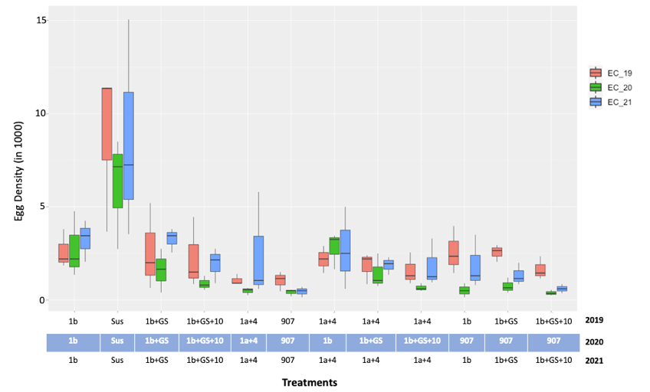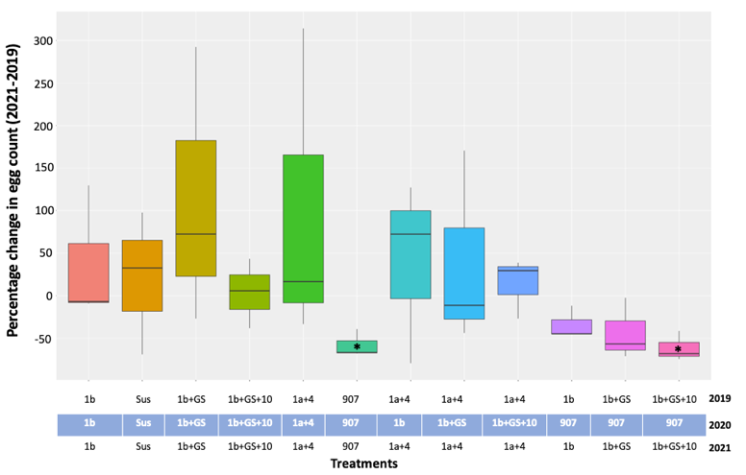

**A**

**B**

Figure 1. (A) Soybean cyst nematode (SCN) egg density from 12 treatments (6 continuous and 6 rotated) for three years of rotation schemes (2019-21) (B). Percentage changes in egg counts before and after rotations across 12 treatments. X-axis represents egg density in (1000); Y-axis represents three-year treatments; (*) represents treatments significantly different treatments.

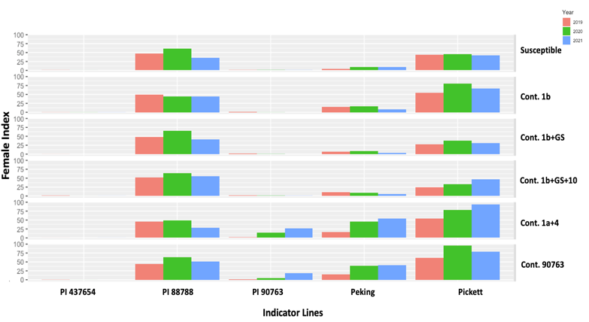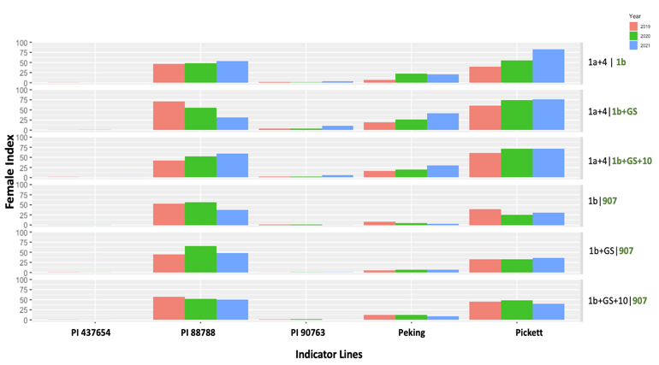

**A**

**B**

Figure 2. Reproduction of soybean cyst nematode (SCN) populations on indicator lines. (A) SCN populations from continuous treatments (B) SCN populations from rotated treatments. X-axis represents indicator lines from the modified HG test; Y-axis represents female index; Horizontal blocks on Y-axis represents different treatments as indicated.

The Mitchum group was sent SCN material recovered from the continuous and rotation microplots and they were increased, processed for eggs, and archived as part of a *wormplasm* collection for future sequencing efforts to pinpoint virulence genes.

At the conclusion of the 2021 growing season, The Tylka group collected two separate multi-core soil samples from each microplot in the experiments conducted in central Iowa and north central Iowa. One set of soil samples from each experiment were processed at Iowa State University to determine the end-of-season SCN egg population density in each microplot. The second set of soil samples were sent to the University of Missouri for HG Type testing to determine how the soybean genotypes grown in the microplots in 2021 have affected or shifted the virulence profiles (HG types) of the SCN populations from the 2020 growing season and from the initial SCN populations that were added to the microplots in the spring of 2019.

Preliminary data analysis show some trends in changes SCN population densities. In both experiments, the greatest SCN population densities occurred in microplots in which the susceptible soybean variety was grown. Most of the microplots that had continuous cropping of the same resistance in 2019, 2020, and 2021 had greater SCN population densities than microplots in which resistant genotypes were rotated in 2019, 2020, and 2021. The lowest population densities occurred in microplots where soybeans with SCN resistance from PI 90763 were grown. The microplots in which soybeans with rhg1-b, rhg1-b + soja, and rhg1-b + soja + ch10 SCN resistance were grown (collectively referred to as genotypes having “PI88788-type” resistance) in 2019, rotated to soybeans with PI 90763 SCN resistance in 2020, and then rotated back to the same resistance as in 2019 had increased SCN population densities in 2021 compared to population densities at the end of both previous years. Even though SCN population densities declined after rotating from genotypes with  PI88788-type resistance in 2019 to rhg1-a + rhg4 (or “Peking-type”) resistance in 2020, population densities increased to levels greater than in 2019 and 2020 when genotypes with PI88788-type resistance were again grown in the microplots in 2021. Similarly, plots in which rhg1-a + rhg4 or Peking-type resistance was grown in 2019 then rotated to rhg1-b, rhg1-b + soja, or rhg1-b + soja + ch10 SCN (PI88788-type resistance) resistance in 2020, and then back to rhg1-a + rhg4 resistance in 2021 had greater SCN population densities at the end of the 2021 growing season than in the previous two years.

The results of the HG Type tests on the SCN populations in the microplots at harvest in 2020 revealed that almost all of the SCN populations at both experimental locations had increased virulence from 2019, with the SCN populations in each plot having elevated female indices (FI) on Peking and most having increased FIs on PI 88788. SCN populations in the two experiments were HG Type 1.2 or 1.2.3 and the FIs ranged from 9-33% on Peking in Kanawha, 18-53% on Peking in Ames, 40-64% on PI 88788 in Kanawha and 33-64% on PI88788 in Ames. In both experiments, the SCN populations in microplots in which PI 90763 or rhg1-a + rhg4 (Peking-type) resistance was grown had elevated FIs on PI 90763, with a range of 0%- 23% in Kanawha and 2%-32% in Ames. The SCN populations in microplots that were rotated from rhg1-a + rhg4 resistance to the three different genotypes containing rhg1-b (namely rhg1-b, rhg1-b + soja, and rhg1-b + soja + ch10) had decreased FIs on PI 90763 from 2019 to 2020. Changes in virulence (FIs) on PI437654 were not detected in SCN populations in any of the microplots with any of the cropping sequences. HG Type test results of the SCN populations in soil samples collected from the microplots at harvest in 2021 are not yet available.

***Objective 3: Translate the results of objectives 1-3 to the SCN Coalition to increase the profitability of soybean for producers and inform growers on effective rotation schemes designed to protect our resistant sources. (Tylka, Mitchum)***

Greg Tylka conducted 19 interviews with radio and newspaper/magazine journalists and gave 12 presentations (in person and virtual) from October 2021 through March 2022. The loss of effectiveness of PI88788 SCN resistance was discussed in every interview and presentation, and this current NCSRP-funded research project was mentioned and described whenever time/space permitted.

Melissa Mitchum is serving as the Chair of the organizing committee for the 2022 National Soybean Nematode Conference (NSNC). The location, venue, and draft schedule was developed. Save the date flyers were distributed and the development of the scientific program was initiated.

***Objective 4: Organize tests of experimental lines developed by public breeders in the north central US states and Ontario******. (Diers)***

The Diers group has continued to organize these tests. During the period of the grant we managed the Northern Regional Soybean Cyst Nematode Tests, which it is a cooperative test of publicly developed experimental lines with SCN resistance. The lines were developed by university breeding programs and these breeders grew locations of the test. Our role was to organize the tests; distribute seed to the breeders who grew the tests; obtain, organize, and analyze the data from the test locations; and assemble and distribute reports based on these test results. The results from these tests are important for breeders to help them decide what experimental lines to release as new varieties. During 2020 these tests included 184 lines that were evaluated in 27 locations, in 2021 there were 242 lines evaluated in 30 locations, and in 2022 there are 225 lines being evaluated in 29 locations.

***Objective 5: Diversify the genetic base of SCN resistance in soybean by developing and evaluating germplasm and varieties with new combinations of resistance genes in high-yielding backgrounds. (Diers, Scaboo)***

The Diers and Scaboo groups have continued to advance breeding efforts towards the development of cultivars with novel SCN resistance. For this reporting period, we are excited to report that we have now completed successful crossing attempts (3 backcrosses) using PI 90763 as a donor parent, and LD11-2170 and SA13-1385 as recurrent parents, for three major genes associated with resistance to virulent nematode populations (rhg1-a, rhg2, and Rhg4). For each crossing attempt, we have identified desirable F1 plants using marker assisted selection, and we have sped up the process by utilizing our winter nurseries in Hawaii and Puerto Rico for the last two years. As I type this report, our staff and student are in Kekaha Kauai Hawaii tissue sampling BC3F2 plants to identify homozygous individuals with desired combinations of our target genes. During the summer of 2022, we will grow plant rows derived from selected plants, and our first yield trials of this material will be in the summer of 2023.