**Project Title- Integrated agricultural systems to promote soil health and environmental resilience**

In 2021, the research site was established and the treatments were initiated with our first soybean crop (Fig 1). The plots were established with funding from the Iowa Egg Council while the funding for the research was provided by Iowa Soybean Association. The system considers manure application timing, cover crops, strip till, and nutrient application timing. This unique study will provide important information to farmers on how to best manage these systems for a range of environmental benefits, including soil health and resiliency to climate change. The following sections summarize our year one activities and results. 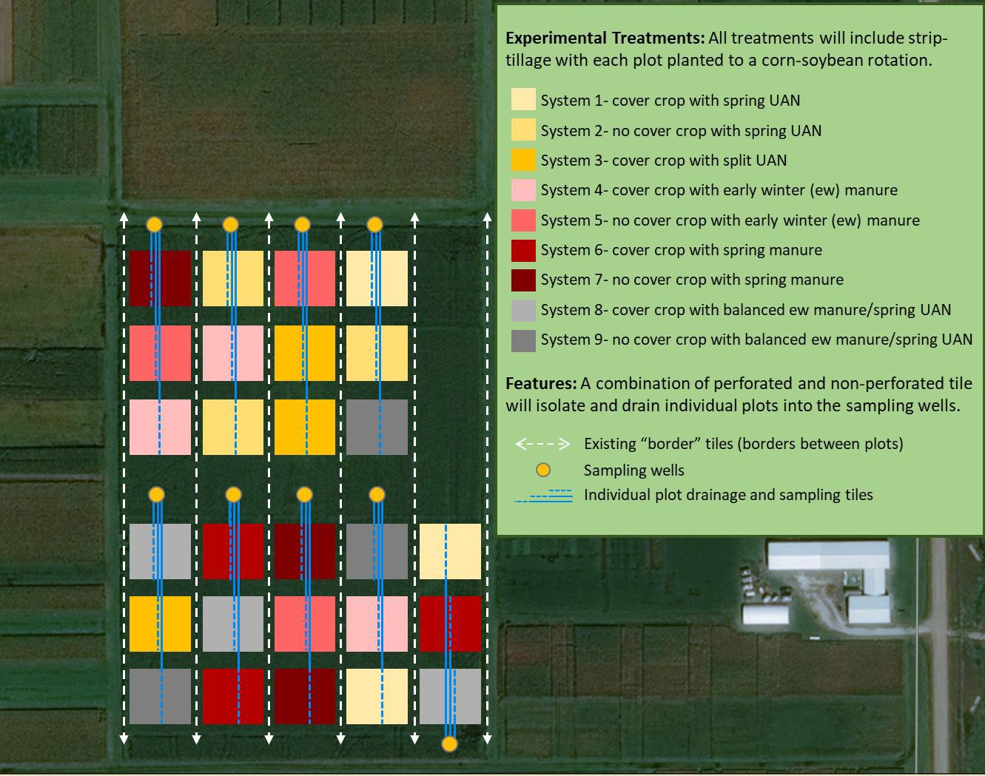

***Figure 1. Schematic illustrating the plot layout and features****. The experimental treatments (System 1-9) were randomly assigned in a block design determined by site soil characteristics. Treatments include manure or chemical fertilizer (UAN) application before corn, with early winter or spring poultry manure at 150 lbs N/acre; spring UAN at 150 lbs N/acre; balance poultry manure with UAN with an early winter poultry manure at 150 lbs N/acre followed by UAN at 150 lbs N/acre; and split UAN with 100 lbs N/acre spring applied and 50 lbs N/acre as sidedress.*

Each of the nine system treatments are replicated in triplicate. The spring UAN treatments, with and without cover crops, serve as the experimental control. Supplemental nutrients, such as phosphorus, will be applied as field conditions indicate. An additional UAN treatment includes a split UAN application with spring side dress to address concerns with yield loss due to potential low nitrogen availability following cover crops. The manure application treatments allow for a side by side comparison of early winter and spring manure application with and without cover crops. We also include a balanced manure treatment with manure applied every 5 years (early winter application after soybeans in years 1 and 3). The plot installation was completed in June 2021.

**Plot level soil samples were collected to evaluate the baseline conditions.**

Plot level topsoil (0-12”) and Uhland cores (0-6”) were collected October 20-22 of 2021 (fig 2), and have been processed and analyzed similarly to the fall 2020 samples for detailed evaluation of soil health characteristics and nutrients (Fig. 3). Additional soil analysis at the site includes a field level analysis of extreme deep core samples (8-9’ depth, divided into 1’ increments) (Fig. 3).

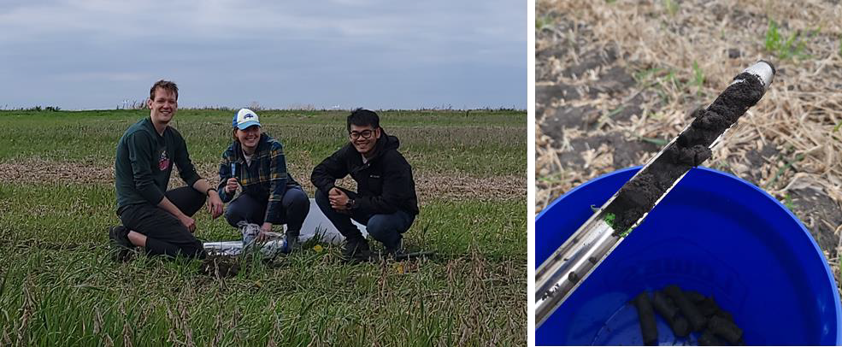

***Figure 2. The WQRL research team collected Uhland cores and topsoil samples in the fall of 2021 for plot level nutrient and soil health analysis.*** *Three Uhland core samples were collected per plot, then processed and composited in the lab for analysis. The topsoil samples were divided into 0-6” and 6-12” increments in the field, with 4-6 samples collected at each plot depending of the diameter of the probe used for collection to ensure an adequate volume of sample for analysis.*

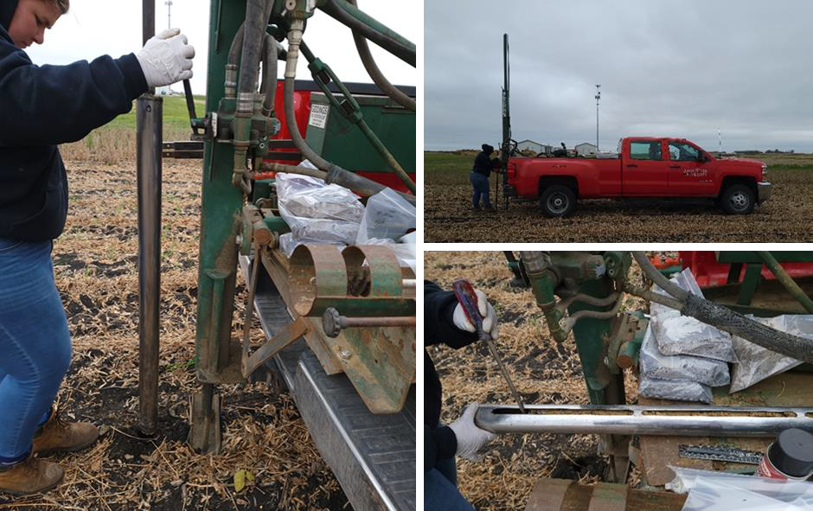

***Figure 3. Soil characterization samples were collected to a depth of 9’ at four plots.*** *Our research group has partnered with Dr. Sotirios Archontoulis’ (Integrated Cropping Systems Lab, Iowa State University) research group for additional analysis at the site. Extreme deep core samples were collected to a depth of 8-9’ for analysis of various soil characteristics, which will provide a detailed soil profile for the field.*

**Field level soil sampling and analysis was conducted before plot treatment assignments were finalized in 2021.** The field level soil analysis in 2020 (Table 1) indicated variability in soil characteristics with field location. The field level soil analysis, along with the USDA Web Soil Survey mapping, informed the treatment blocking design for this experiment.

**Table 1. Fall 2020 field level soil analysis results.** Differences were observed at the different field locations, supporting the need to assign blocking to the plots to better distribute the treatments.

|  |  |  |  |  |
| --- | --- | --- | --- | --- |
| **Field Location** | **OM %** | **Mehlich 3-P** | **Sand %** | **pH** |
| north-west | 4.5 | 18 | 31 | 8 |
| north-center | 4.3 | 28 | 37 | 7 |
| north-east | 2.7 | 17 | 44 | 6 |
| center-west | 2.9 | 26 | 42 | 6 |
| center-center | 4.9 | 62 | 23 | 6 |
| center-east | 4.6 | 29 | 25 | 7 |
| south-west | 3.1 | 41 | 37 | 5 |
| south-center | 4.0 | 44 | 26 | 6 |
| south-east | 4.7 | 44 | 25 | 7 |
| average | 4.0 | 34 | 32 | 6 |
| stdev | 0.8 | 15 | 8 | 1 |
| median | 4.3 | 29 | 31 | 6 |

**Plot level results identify soil characteristic differences to consider with future analysis.** The 2020 fall field level and 2021 plot level soil analysis indicated similarities and differences in soil characteristics. The initial plot level soil analyses at the site, before manure treatments were initiated, allowed us to identify and consider existing variation as environmental samples are collected throughout the study. Overall, the baseline measured available nitrogen levels were similar between the plots regardless of the landscape position. There was considerable variation in the soil P measurements, with Mehlich-3 levels characterized as low to very high. The estimated plant available nitrogen, Mehlich 3- P, and organic matter are illustrated at each plot location in Figure 4. The treatment blocking is depicted with the light grey, white, or dark grey shading (Fig. 4). Each of the nine system treatments were assigned within the blocks.

**Table 2. Fall 2021 plot level soil analysis results.** Differences were observed at the different field locations, supporting the need to assign blocking to the plots to better distribute the treatments. Characteristics by block and system are shown below. Figure 4 shows the distribution of the systems/blocks at the field scale.

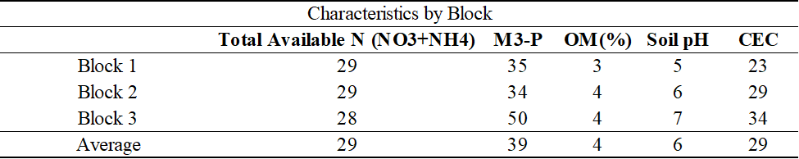

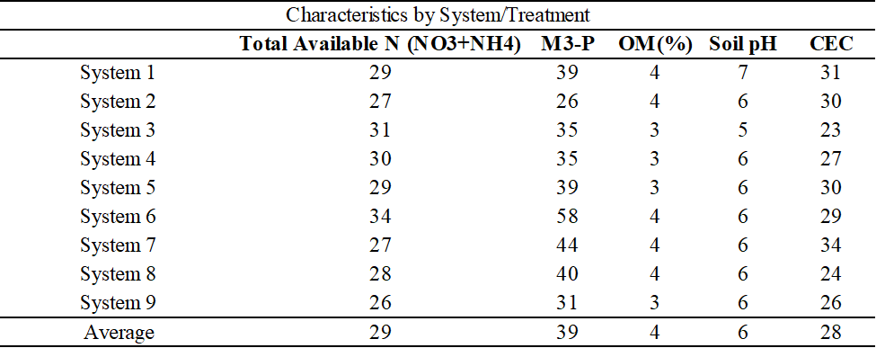

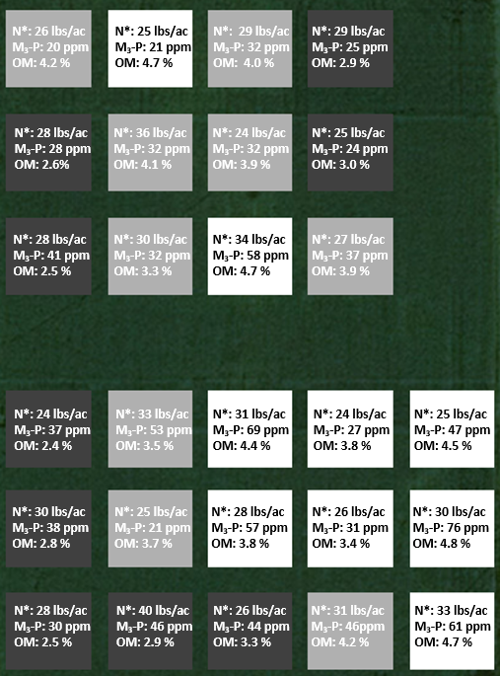

**Figure 4. Plot layout schematic with select soil characteristics.** Each system treatment is assigned within the three treatment blocks are shown in dark grey, light grey, and white.

**Additional Year 1 Field Activities and Sample Collection**

**Soybeans were planted late in the season.**

The Research Farm was able to keep our original year 1 plan of planting soybeans, although soybeans were planted late in the season after the tile installation was complete. The soybeans were planted on June 30th, and were harvested on October 19th. The late season planting and dry weather conditions resulted in very low average yields of 19 bushels per acre compared to the county average of 63 bushels per acre in 2021.

**Volunteer oat coverage was recorded.**

Before installation of the center plot tile lines in the spring of 2021, the plots at field 40 were planted to oats so there would be vegetative coverage until the tiles were installed. After installation in mid-June, soybeans were planted. The soybeans were harvested on October 19th before soil sample collection from October 20th-22nd. There was considerable volunteer oat coverage in the plots noticeable after the soybeans were harvested. The vegetation coverage app, Canopeo, was used to document the volunteer oats coverage in each plot on November 4th and 5th. The average coverage per plot ranged from 6% to 16%, with an overall field average of 11%. The oats did not cover the plots evenly, but were stripped throughout the plots (fig. 2). The planned cover crop, winter rye, was planted on November 5th.

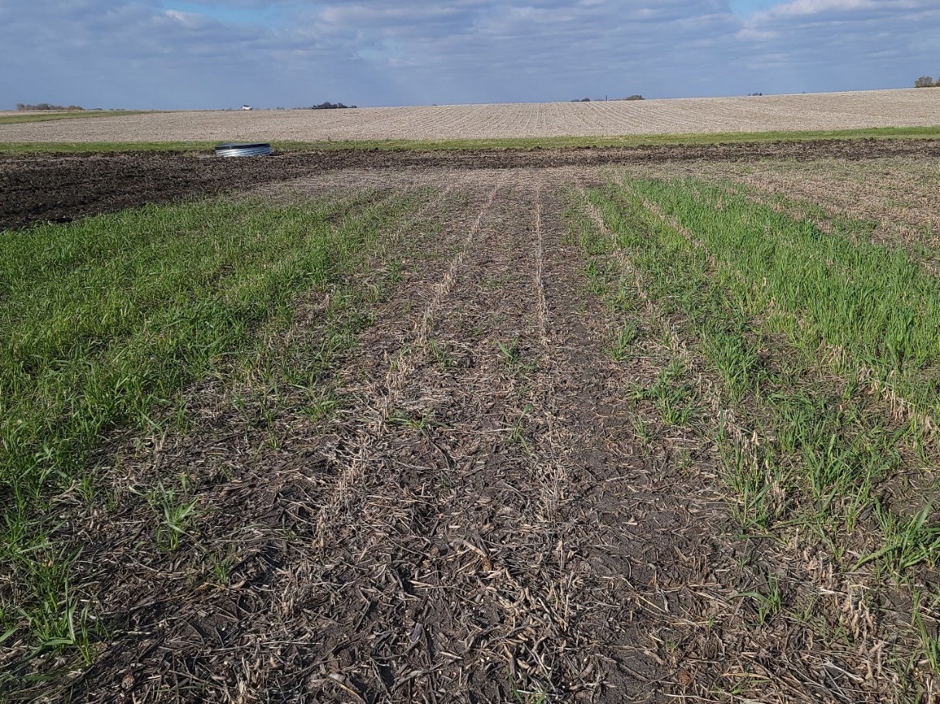

***Figure 5. Photograph of volunteer oat coverage in a field 40 plot on Nov. 20, 2021.*** *There was considerable oat coverage in the field 40 plots after soybean harvest, with strips of heavier coverage within the plots.*

**Cereal rye was planted at the designated treatment plots.**

Due to wet conditions in the field and the late soybean harvest, winter cereal rye was planted at the designated plots after soybean harvest on November 5th (Fig. 6). We did not see emergence of the cereal rye in the fall. There has been some germination observed in early spring. The spring cereal rye coverage and biomass will be evaluated in early May, 2022.

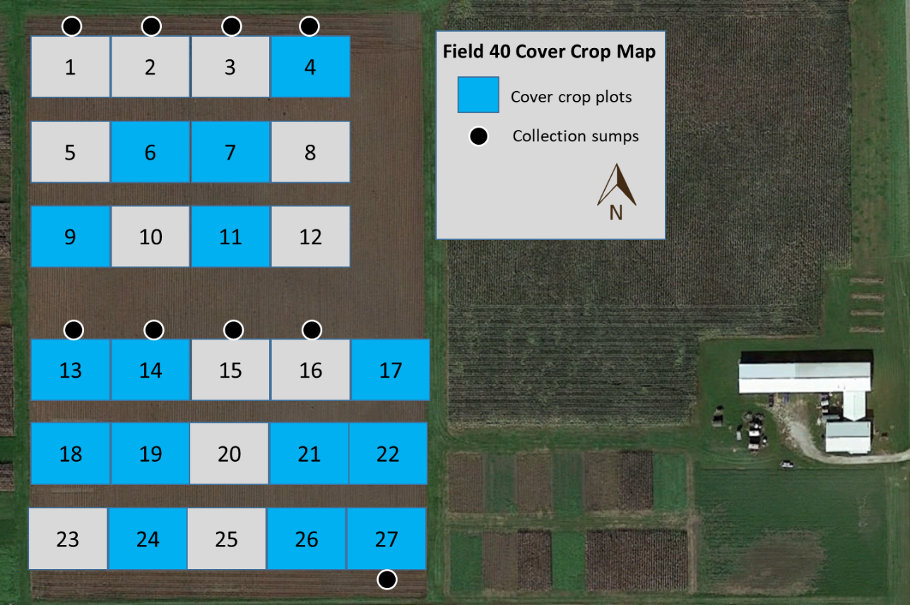

***Figure 6. Updated research site cover crop map. Cover crops will be planted each year at the designated plots.***

**The early winter poultry manure treatments were applied in 2021.**

Poultry manure, which was donated by Farm Nutrients, was delivered and stockpiled for fall 2021 (early winter treatment) and spring 2022 (Fig. 7).

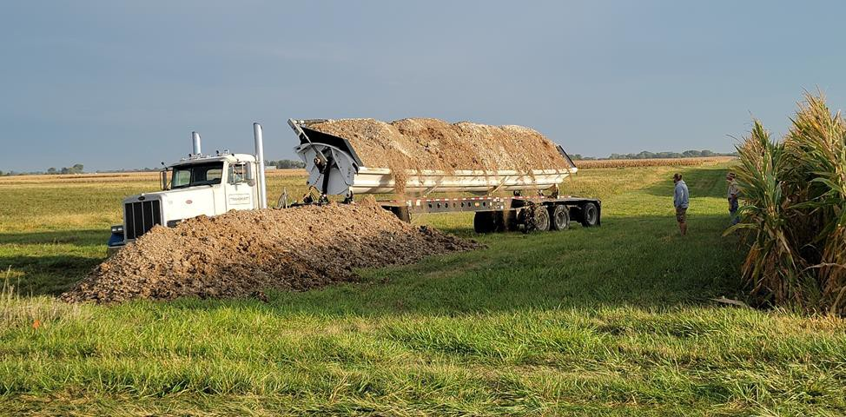

## *Figure 7. Poultry manure delivery for 2021 early winter and 2022 spring manure applications.*

The bulk manure was analyzed before application to estimate application rates. At the time of application, plot level samples will be collected from the manure wagon for analysis to calculate the achieved nutrient application rate at each plot.

The spring year 2 (2022) field activities will include UAN and poultry manure application at the designated plots (Fig. 1). All plots will then be planted to corn in 2022.

Drainage samples and flow volume measurements will be collected at all plots throughout the drainage season while the plots are actively draining. These samples will be collected as grab samples with manual flow rate measurements at least once per week.

**Progress Toward Project Metrics**

KPI #1 Field level soil samples were collected in the fall of 2020 and plot level samples were collected in the fall of 2021. The samples have been processed and analyzed for various soil health and nutrient parameters. Additional analysis is ongoing to provide a robust baseline for comparison with future results. The samples have been processed and analyzed in the ISU-Water Quality Research Lab (WQRL) for bulk density, texture, and aggregate size distribution. Soil nutrient level analysis was completed by AgSource Laboratories (Ellsworth, IA), and additional POM analysis is being completed by Kansas State University.

KPI #2- Improved understanding of manure integrated cropping systems and their impact on crop yield and water quality will be achieved through continued progress on KPI #1 and additional years of monitoring and data collection. The tiles have begun flowing with the continued spring 2022 rain, and the first comparative water quality samples from spring and fall manure application will be collected throughout the year two (2022) drainage season, which will reflect water quality impacts from the early winter 2021 spring manure application and the spring 2022 poultry manure application.

**Final Project Results (layman's terms for all audiences)**

Iowa State University has partnered with Iowa Soybean and Iowa Egg Council to explore integrated agricultural systems to promote soil health and environmental resilience. This is a unique, long-term study that included the establishment of new field plots in 2021. After plots were planted soil analysis was conducted to inform the treatment layout and design moving forward. The new field site includes 27 plots with the following treatments:

1. Cover crop with spring UAN
2. No cover crop with spring UAN
3. Cover crop with split UAN with 100 lbs N/acre spring applied and 50 lbs N/acre as sidedress
4. Cover crop with early winter manure
5. No cover crop with early winter manure
6. Cover crop with spring manure
7. No cover crop with spring manure
8. Cover crop with balanced early winter manure and spring UAN
9. No cover crop with balanced early winter manure and spring UAN

All plots will be managed using strip till. In the first-year, baseline soil health analysis was conducted and all plots were planted to soybeans. Because of dry conditions, initial yields were low and water samples were not collected (tiles did not flow). Moving forward, this study will provide practical guidance to farmers interested in maximizing yield, resiliency to varying climatic conditions, and protecting downstream water quality.