Developing an interactive web app for calculating soybean crop budgets
Alan Leslie, Shannon Dill, Benjamin Beale
February 1, 2022
Final Report
A refined version of the online web tool has been created and published. A description of the new web app was published in the statewide extension newsletter “Agronomy News,” and the new web-based tool has been published on the extension website alongside the previous Excel-based tool. The web app includes all of the functions of the previous excel-based budget tool, with additional flexibility in the choices that can be made. This budget tool includes vastly more pest management options for farmers to consider, which anecdotally has been useful this winter season with threats of pesticide shortages, and the possibility that alternative chemicals must be used. At least one user was able to use the budget app to consider the impact on production of increased chemical costs compared to available alternatives. Another improvement of this budget tool is that all of the different options are available on the same page for ease of comparison. The former budget tool required multiple spreadsheets to compare production costs of growing soybeans with different herbicide tolerance packages. This version also includes the capability of downloading all of the information entered into the budget in PDF format to save for later reference. This PDF printout includes additional information related to pest management that changes depending on the choices selected in the online application.
An online (Qualtrics) survey was circulated to collect feedback from users to determine how to modify and improve the tool in the future. Links to the survey were posted on the app itself, on the extension website, and in the “Agronomy News” article. Information about the web app and links to the survey were circulated among approximately 100 farmers at a winter grain production meeting in late November 2021. The web app will continue to be circulated among farmers at other grain production meetings through the winter, and will be accompanied by a truncated survey form to collect feedback. Currently there are only 8 complete responses to the survey, likely in part because of the length of the survey. However, from these limited responses, there has been positive feedback about the utility of the web app and the likelihood that they will use it in the future. Additionally, some recommendations have been made for ways to improve the app, which will be incorporated into subsequent revised versions.
In addition to developing the web-based tool, we conducted a survey of existing budget tools produced by other land-grant institutions across the state to determine what options are most often included in budgets, and what other options might be included in subsequent versions of this budget tool. Similar budget tools were found from 29 of the 50 states. Results of this survey show that the most common budgeting system has been to use interactive Excel spreadsheets to allow farmers to calculate costs, returns, prices, etc. New Jersey seems to be the only state to have released an online budget tool, but it is incredibly generic. The most common variables in order from most to least common are seed cost, yield goal, harvest cost, fertilizer, labor, insecticide, insurance, machinery fuel, repairs, herbicide, land, interest on loans, fungicide, and drying fuel (Table 1). The main difference between many of these budgets and the current UMD budget tool is in the calculation of field operations. Other tools use direct measures of labor, fuel, and machinery maintenance, while the UMD tool uses average rates from local operations offering custom planting and harvesting services as a proxy for the direct measures. Using custom rates simplifies the input, but may not be an accurate representation of actual costs, and may not be useful for predicting input costs with changing fuel and labor prices. Costs of drying fuel and irrigation are two additional variables that we would consider adding to future versions of the budget.
Table 1. Variables included in soybean crop budgets from across the country and the number of budgets (out of 29 total) that included them
Variable | Frequency
Seed | 23
Yield (Goal) | 23
Harvest Price | 22
Fertilizer | 22
Labor | 20
Insecticide | 18
Insurance | 17
Machinery Fuel | 16
Machinery Repairs | 16
Herbicide | 16
Land | 13
Interest | 12
Fungicide | 12
Drying | 10
Miscellaneous | 9
Hauling | 9
Machinery | 7
Machinery Ownership | 7
Irrigation | 7
Harvesting | 6
Govt. Payment | 5
Storage | 5
Harvest Aid | 4
Real Estate | 4
Machinery Depreciation | 3
Inoculant | 3
Utilities | 2
Crop Contribution Margin | 1
Vaccine | 1
Soil Testing | 1

Currently the online soybean budget is in its fourth version, and is hosted on the shiny app servers (www.shinyapps.io). Built-in metrics for the website show that the online budget tool has been accessed and used on a regular basis over the last three months (Fig. 1) and has logged approximately 10 hours of use in the last week. The budget tool was programmed using the open source software R v. 4.0.3 (R Core Team 2020). The shiny package was used to build the web page that users actually interface with to enter different variables into the budget model (Chang et al. 2020). The R Markdown package was used to render the PDF output where users can save their budget inputs to a downloadable document (Allaire et al. 2019). Pesticide options and default rates were determined from multiple agronomic production guides (Lou et al. 2020, Williamson and Lingenfelter 2019). Costs for different agrichemicals were determined from average market rates from local agrichemical dealers, and costs for other inputs are taken directly from the surveys done to parameterize the UMD Excel-based crop budget tool. Keeping this budget tool current will require adjusting average prices for field operations, fertilizers, and other inputs. These prices can be updated simply by uploading a spreadsheet containing new updated prices to the server. In addition, agrichemical options may need to be adjusted in the future, as new chemicals become available (especially herbicides), and others may lose their label.
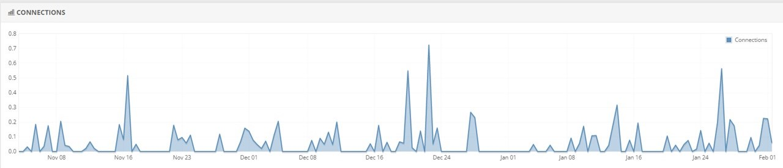
Figure 1. Usage of the new online budget tool for the time period Nov 2021 - Feb 2022
Currently all of the files containing codes used in the construction of this online tool have been published in a public digital repository under a GNU General Public Use license (https://github.com/awleslie/soybean-budget). This will allow other users to discover and share the code and potentially modify it for use in other states or for other crops. The repository recognizes the role that the MD Soybean Board has played in funding the start of this tool, and the license will ensure that subsequent versions remain free and open-source for others to use. As the code is updated through subsequent versions of the web app, these revised codes will also be uploaded to the repository and be made available to the public.

References
R Core Team (2020). R: A language and environment for statistical computing. R Foundation for Statistical Computing, Vienna, Austria. URL https://www.R-project.org/.
Winston Chang, Joe Cheng, JJ Allaire, Yihui Xie, and Jonathan McPherson (2020). shiny: Web Application Framework for R. R package version 1.5.0. URL https://CRAN.R-project.org/package=shiny
JJ Allaire, Jeffrey Horner, Yihui Xie, Vicent Marti, and Natacha Porte (2019). markdown: Render Markdown with the C Library 'Sundown'. R package version 1.1. URL https://CRAN.R-project.org/package=markdown
Mark M. Loux, Doug Doohan, Anthony F. Dobbels, William G. Johnson, Bryan G. Young, Marcelo Zimmer, and Aaron Hager (2020) Ohio State University Extension Weed Control Guide. The Ohio State University.
Jessica Williamson and Dwight D. Lingenfelter (2019) The Agronomy Guide 2019-2020. Penn State Extension.

