Report to the Maryland Soybean Board – April 1, 2022

Identification of new sources of resistance/tolerance to Sclerotinia sclorotiorum among soybean germplasm showing resistance to Phytophthora sojae

Habtamu B. Demissie, Behnam Khatabi, and Kathryne L. Everts

Epidemics caused by S. sclerotiorum occur worldwide in more than 400 plant species (Boland and Hall, 1994). On soybean plants, the disease is referred to as Sclerotinia stem rot (SSR). In the United States, S. sclerotiorum has been reported in 44 states in the northern, southern, central, eastern, and western regions (Saharan and Mehta 2008). Sclerotinia stem rot (SSR) of soybean caused by Sclerotinia sclerotiorum (Lib.) de Bary is an important disease in soybean-production areas of the United States (Willbur et al. 2019; Koga et al. 2014; Yang et al. 1999; Hartman et al. 1998).
SSR caused estimated yield loss of 235 kg/ha and 2-5 bu acre⁻¹ (Peltier et al. 2012; Chun et al. 1987; Grau et al. 1982) and SSR ranks fifth after Soybean Cyst Nematode, Phytophthora root rot, seedling diseases, and brown stem rot (Wrather and Koenning 2006). SSR can cause as much yield loss as soybean cyst nematode and Phytophthora root and stem rot when environmental conditions are conducive (Grau et al. 2004; Arahana et al. 2001). SSR also causes a significant reduction in seed size, seed oil content, seed germination, and seed quality (Hoffman et al. 1998). Disease management is complicated due to the long-term survival of sclerotia in the soil and the absence of resistance in elite, commercial cultivars (Willbur et al. 2019). S. sclerotiorum's lifecycle in soybean fields is extremely reliant on weather conditions that might result in random disease recurrence over seasons and an aggregated distribution within fields (Willbur et al. 2019).
Disease management includes a combination of partially resistant cultivars with cultural practices, such as altering row spacing and planting population, along with chemical fungicides (boscalid), biocontrol (Contans). Host resistance is an effective management strategy that is economical for controlling Sclerotinia stem rot in soybean (Grau et al., 1982). Differences in susceptibility to S. sclerotiorum of soybean germplasms have been reported both under field and greenhouse trials (Boland and Hall 1987; Hoffman et al. 2002). No soybean cultivars show complete resistance to SSR. Some soybean cultivars show partial resistance to SSR. Advantage of disease management technology using resistant cultivars include reduction of the cost of soybean production, providing improved disease management tools, and protection of the environment by reducing the use of chemical fungicides.
Variability of pathogenicity within the S. sclerotiorum population under field conditions is important to recognize in the screening of tolerant or resistant germplasm. Soybean germplasm should be screened against diverse population of S. sclerotiorum isolates, preferably genetically distinct and collected from different regions. Aggressiveness of S. sclerotiorum isolates on different hosts has been the subject of several studies and was reported to significantly vary among different isolates (Willbur et al. 2017; Zancan et al. 2015; Attanayake et al. 2013; Otto-Hanson et al. 2011; Ekins et al. 2007; Kull et al. 2004). Therefore, the evaluation of plant germplasm is of great importance in finding new sources of disease resistance. The objectives of the current project were to characterize S. sclerotium isolates from soybean and other crops in the DELMARVA region and to evaluate soybean germplasm for resistance to SSR under greenhouse condition. We screened 207 soybean genotypes for their susceptibility to two isolates of S. sclerotiorum and included NKS1990 and Williams82 soybean cultivars as resistant and susceptible reference genotypes, respectively.

Characterize S. sclerotiorum isolates from soybean and other crops in the Delmarva region

Forty S. sclerotiorum isolates were tested in 2018 for mycelial compatibility. Mycelial compatibility group (MCG) testing is a method to determine relatedness of fungal isolates, and how genetically homogenous the pathogen population is within a region. The MCGs were determined by pairing the isolates in all possible combinations on Diana Simmons (DS) medium (Cubeta et al., 2001) as described in Mandal and Dubey, 2012 and Zancan et al, 2015. A total of 750 combinations were obtained from 40 isolates and each pair was replicated twice. In addition, each isolate was paired with itself and a control (i.e. pure PDA plug). Before then MCG test, the isolates were grown on regular PDA and incubated at 24 ± 1 ^{O}C for one week. Mycelial discs (5 mm diameter) were taken from approximately 1 mm behind the advancing edge of actively growing mycelial colony on PDA and placed upside down on a plate of DS medium in Petri dishes (90 mm diameter) at 2.5 cm apart. Mycelial reactions were recorded after 7 days as incompatible when an apparent line of demarcation, a barrage zone, or a mycelia free zone is observed between the confronting paired isolates, and as compatible if there is no line of demarcation observed between the isolates (Figure 1). Radial growth of each isolate was also recorded to determine the growth or expansion performance of each isolate in the presence of the other isolate. The experimental design was completely randomized design (CRD) with 2 replications.

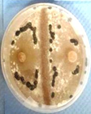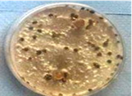
Figure 1. Incompatible (left) and compatible (right) reactions of S. sclerotiorum isolates on Diana Simmons media.

The MCG tests may indicate that isolates in different regions comprise a heterogeneous mix of MCGs. Of the forty isolates we tested, none were found to be compatible or incompatible with all other isolates. Compatible isolates were from different locations and hosts. MCGs on cultivated hosts are reported to be more complex, indicating that agricultural practices influenced MCG frequencies and patterns. In our experiment, out of 42 isolates collected from different locations/states and crops in the US, 12 major MCGs were identified.

Evaluate soybean germplasm for resistance to Sclerotinia stem rot under greenhouse condition.
At the beginning of our study, we obtained approx. 200 seeds of each of the requested germplasm lines from Dr. Saghai Maroof (Virginia Tech), including several Phytophthora sojae resistant lines and several other elite cultivars, which were used as controlled comparison lines (for a total of 52 PI accessions and named lines).
To obtain preliminary data on susceptibility of lines to endemic disease in Maryland, seeds were planted in the field at the University of Maryland’s Lower Eastern Shore Research and Education Center (LESREC) on June 14 in 5 ft. plots with 30 seed per plot in three replicates. The field had a moderate population of Rhizoctonia solani. Although evaluation of these lines for resistance to R. solani was not in the proposal, this was an opportunity to obtain additional information on these lines for this soil-borne disease and any other disease present in the field. We also collected plant heights, and made observations on leaf and stem disease presence.
Field Evaluation: Plants were visually assessed in the field for any above-ground disease symptoms and plant vigor. A rating scale was used to assess individual plants. Plants were ranked on a disease severity index on a 1-5 scale, where 5 was the best (least disease symptoms) score. Disease severity and disease incidence were assessed by calculating the number of plants affected and the number of healthy-looking plants. The scale was: 5= Healthy plants throughout the plot, 4= Slight chlorosis, leaf spots and no impact on plant growth and few plants exhibiting symptoms, 3= Moderate chlorosis and disease symptoms several plants affected in the plot, 2= severe root rot disease symptoms and most or all plants affected. If a plot received a rating of 2, plants were selected and were subjected to the pathogen isolation (see below).
Table 1. Field symptoms of soybean lines assessed in the field. Soybean lines are sorted from fewest to most symptoms present on the first rating date.
Germplasm Line | First field score^{z} |  | second field score |  | Height (cm)
Jack | 4.2^{y} | A | 3.3 | ABCDE | 35.8 | ABC
Pl88788 | 4.2 | A | 2.3 | EFGH | 30.2 | DEFGHIJKL
36T36 | 4.0 | AB | 3.7 | ABC | 33.5 | ABCDEF
L29 | 4.0 | AB | 3.0 | BCDEF | 32.0 | ABCDEFGHI
Pl408132 | 4.0 | AB | 3.7 | ABC | 33.0 | ABCDEF
48T27 | 3.8 | ABC | 4.3 | A | 33.0 | ABCDEF
Lee68 | 3.8 | ABC | 4.3 | A | 35.3 | ABCD
Pl408015 | 3.8 | ABC | 3.3 | ABCDE | 32.5 | ABCDEFGH
39T28 | 3.7 | ABCD | 3.0 | BCDEF | 31.8 | ABCDEFGHIJ
45T48 | 3.7 | ABCD | 3.7 | ABC | 30.8 | BCDEFGHIJK
48A60 | 3.7 | ABCD | 4.0 | AB | 32.8 | ABCDEFG
Pl96983 | 3.7 | ABCD | 3.7 | ABC | 34.7 | ABCDE
V94-5152 | 3.7 | ABCD | 4.0 | AB | 36.0 | AB
11_Pl398 | 3.5 | ABCDE | 2.0 | FGHI | 28.7 | FGHIJKLMN
12_Pl398 | 3.5 | ABCDE | 2.5 | DEFG | 25.5 | KLMNOPQ
44T63 | 3.5 | ABCDE | 3.3 | ABCDE | 27.5 | GHIJKLMNO
46T59 | 3.5 | ABCDE | 3.7 | ABC | 33.3 | ABCDEF
Pl361103 | 3.5 | ABCDE | 3.3 | ABCDE | 29.8 | EFGHIJKL
Pl399073 | 3.5 | ABCDE | 2.0 | FGHI | 27.5 | GHIJKLMNO
Pl399079 | 3.5 | ABCDE | 3.7 | ABC | 34.8 | ABCDE
94Y23 | 3.3 | BCDEF | 3.3 | ABCDE | 30.5 | CDEFGHIJKL
P408020A | 3.3 | BCDEF | 2.3 | EFGH | 29.5 | EFGHIJKLM
Pl341264 | 3.3 | BCDEF | 3.7 | ABC | 36.3 | A
Pl407985 | 3.3 | BCDEF | 2.0 | FGHI | 25.3 | LMNOPQR
Williams | 3.3 | BCDEF | 2.3 | EFGH | 32.5 | ABCDEFGH
Essex | 3.2 | CDEFG | 2.7 | CDEFG | 27.3 | HIJKLMNO
P408319C | 3.2 | CDEFG | 3.7 | ABC | 31.5 | ABCDEFGHIJ
Pl319531 | 3.2 | CDEFG | 3.3 | ABCDE | 34.7 | ABCDE
Pl408029 | 3.2 | CDEFG | 3.0 | BCDEF | 28.8 | FGHIJKLMN
Pl408111 | 3.2 | CDEFG | 3.0 | BCDEF | 30.0 | DEFGHIJKL
Pl424477 | 3.2 | CDEFG | 4.0 | AB | 33.3 | ABCDEF
P424237A | 3.0 | DEFGH | 3.3 | ABCDE | 31.8 | ABCDEFGHIJ
P424237B | 3.0 | DEFGH | 3.3 | ABCDE | 30.0 | DEFGHIJKL
Pl157432 | 3.0 | DEFGH | 3.7 | ABC | 32.7 | ABCDEFGH
Pl200543 | 3.0 | DEFGH | 3.7 | ABC | 29.7 | EFGHIJKLM
Pl398666 | 3.0 | DEFGH | 2.3 | EFGH | 24.3 | MNOPQRS
Pl398996 | 3.0 | DEFGH | 1.0 | I | 15.7 | TU
Pl408097 | 3.0 | DEFGH | 3.0 | BCDEF | 30.0 | DEFGHIJKL
Pl408287 | 3.0 | DEFGH | 1.7 | GHI | 23.7 | NOPQRS
Pl200553 | 2.8 | EFGH | 4.3 | A | 33.7 | ABCDEF
P567139B | 2.7 | FGH | 4.3 | A | 34.8 | ABCDE
Pl423741 | 2.7 | FGH | 2.0 | FGHI | 13.7 | U
CNS | 2.5 | GH | 3.7 | ABC | 25.8 | KLMNOP
Parker | 2.5 | FGH | Missing data |  | 20.0 | RST
Pl398440 | 2.5 | GH | 2.0 | FGHI | 20.2 | QRST
Pl399004 | 2.5 | GH | 2.7 | CDEFG | 26.7 | IJKLMNOP
York | 2.5 | FGH | 3.5 | ABCD | 28.8 | EFGHIJKLMNO
Pl274508 | 2.3 | H | 2.3 | EFGH | 26.5 | JKLMNOP
Pl398775 | 2.3 | H | 1.3 | HI | 19.5 | ST
Pl398791 | 2.3 | H | 1.3 | HI | 21.8 | PQRS
Pl398946 | 2.3 | H | 2.3 | EFGH | 23.2 | OPQRS
P value^{x} | 0.0001 |  | 0.0001 |  | 0.0001
^{z}Rating scale 5= Healthy plants throughout the plot, 4= Slight chlorosis, leaf spots and no impact on plant growth and few plants exhibiting symptoms, 3= Moderate chlorosis and disease symptoms several plants affected in the plot, 2= severe root rot disease symptoms and most or all plants affected.
^{y}Means within a column followed by the same letter are not significantly different according to Fisher’s protected LSD test (α = 0.05).
^{x}P value < 0.05 indicates significant differences among treatments.

Evaluation of soybean germplasm for reduced susceptibility in greenhouse “straw” tests.

We conducted experiments in the Plant Science and Landscape Architecture greenhouse at University of Maryland College Park in 2018, 2019, 2020 and 2021. Germplasm lines were grown in the research greenhouse, in controlled conditions, inoculated with S. sclerotiorum and rated for the disease severity. We used the same lines previously described in 2018 and 2019 tests. In 2020 additional lines were included.

Evaluation of the resistance/susceptibility of germplasm lines against two S. sclerotiorum isolates collected from the DELMARVA region: 2018

In addition to the lines we received from Dr. Maroof, an extra 30 soybean accessions were requested from the USDA Soybean Germplasm Collection through the Germplasm Resources Information Network (GRIN) website and were used to score the lines for susceptibility to Sclerotinia stem rot. Seed of seventy-nine soybean lines were planted during fall of 2018 in the greenhouse (Table 2). Six seed of each germplasm line; one seed per pot were planted. The soilless mix contained perlite and peat in sterile pots of 15 cm size were placed on a greenhouse bench. After germination, plants were fertilized with a solution of 15-5-15 100ppm fertilizer and water at 250 ppm three times per week until the plants were developed. The greenhouse temperatures were maintained at 20 ± 1°C (night, 12 h) and 26 ± 1°C (day, 12 h). Supplemental greenhouse daylight of 12 hours each day was maintained. We planted the lines at 4-day intervals and three plants of each line were inoculated with one of two isolates of S. sclerotiorum after one month, or when plants start developing the 5th node. The days were considered blocks and the experimental design was a randomized complete block design with three replicates of each line and isolate. Aggressiveness or straw test was conducted as described by Otto-Hanson et al. (2011) and modified by Zancan et al, 2015.

Table 2. Planting date, disease inoculation date and measurement date of greenhouse evaluation.

Lines | Replication | DAY OF PLANTING | DAY OF INOC. | DAY OF DISEASE MEASU.
from 1 - 52 | 1 | 9/14/2018 | 10/14/2018 | 10/22/2018
 | 2 | 9/17/2018 | 10/17/2018 | 10/25/2018
 | 3 | 9/18/2018 | 10/18/2018 | 10/26/2018
 | 4 (control) | 9/25/2018 | 10/25/2018 | 11/2/2018
53 - 79 | All (1 - 4) reps | 10/24/2018 | 11/24/2018 | 12/2/2018

For inoculation, sterile drinking straws of approximately 5 mm in diameter and 2 cm long were used. One end of the straw was heat sealed and the other end was used to bore into the leading edge of a growing culture of S. sclerotiorum. The open end of the straw was infiltrated into the reverse side of seven days old S. sclerotiorum culture on PDA at the advancing edge of the mycelia of each isolate. The stem of each plant was cut 2 cm above the fourth node (i.e. the internode between the fourth and fifth node) and the straw containing agar and fungal mycelium was placed over the cut stem. During and after inoculations, we maintained 20°C nighttime and 26°C daytime temperatures in greenhouse. The inoculated plants were incubated for 8 days. During the first 48 hours they were misted to keep the leaves wet. The development of lesions was evaluated by measuring the lesion length/size using a ruler (Figure 2). The mean of 3 plants was used for the analysis of variance.

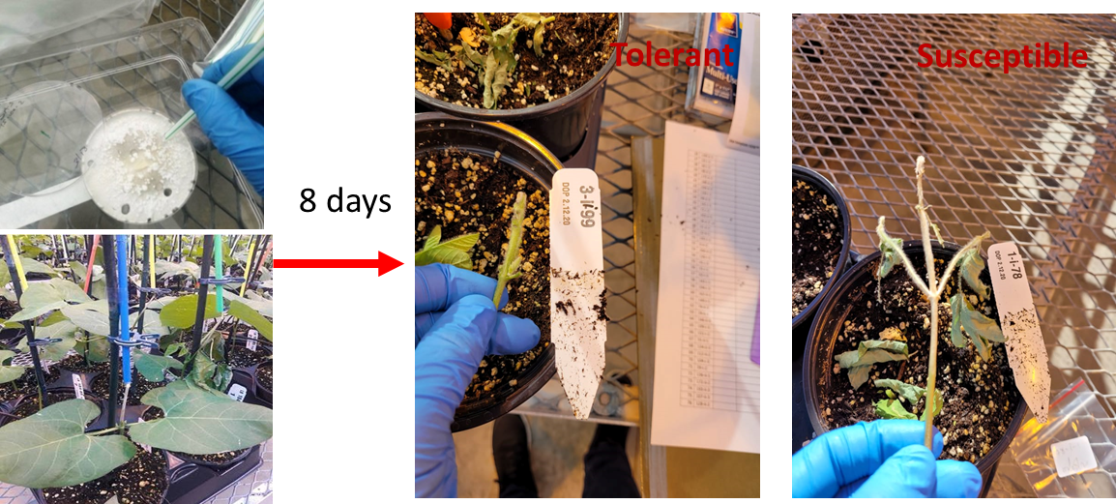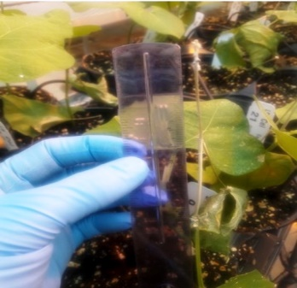

Figure 2. Straw test inoculation of S. sclerotiorum on soybean plants. The lesion length of the stem of each plant was measured using a scale/measuring ruler.
Three plants of each germplasm line were inoculated with one of two isolates, which varied in aggressiveness. SS27 was originally isolated from lima bean and SS29 was originally isolated from tomato.

The soybean germplasm lines varied in susceptibility to the two S. sclerotiorum isolates. Some lines were very susceptible to one isolate and not the other. However, several lines had relatively small lesions when inoculated with either isolate SS27 or SS29. For example, PI 398249, PI 96983, PI 398666, and V945152 had shorter lesion lengths than Williams, the susceptible control, to both isolates (Figure 3).
Second evaluation of the resistance/susceptibility additional germplasm lines against two S. sclerotiorum isolates collected from the DELMARVA region: 2019
A greenhouse trial conducted in 2019 resulted in little and no lesion development on stems. Therefore the results are not reported here.
2020/21 Screening of additional soybean accessions from the USDA’s Soybean Germplasm Collection database (Beltsville, Maryland) (207 total): A total of 207 soybean lines including the checks (Williams 82, susceptible and NKS1990, resistant) were planted in the greenhouse. The inoculation and lesion length measurement was conducted as previously described. Each line was planted one seed per pot to six pots. Three of the plants were inoculated with SS29, which is a highly aggressive isolate, and three with SS2, which is a less aggressive isolate. There were significant differences in lesion length among lines (Figure 4).

Table 3. Planting, pathogen inoculation, and measurement dates
Lines | Greenhouse bench No. | Planting date | Inoculation date | Lesion measurement date
All | 1 to 3 | 12/29/2020 | 01/29/2021 | 02/05/2021
>> | 3 to 5 | 12/30/2020 | 01/30/202 | 02/06/2021
>> | 5 to 7 | 12/31/2021 | 01/31/2021 | 02/07/2021
>> | 7 to 10 | 01/01/2021 | 02/01/2021 | 02/08/2021

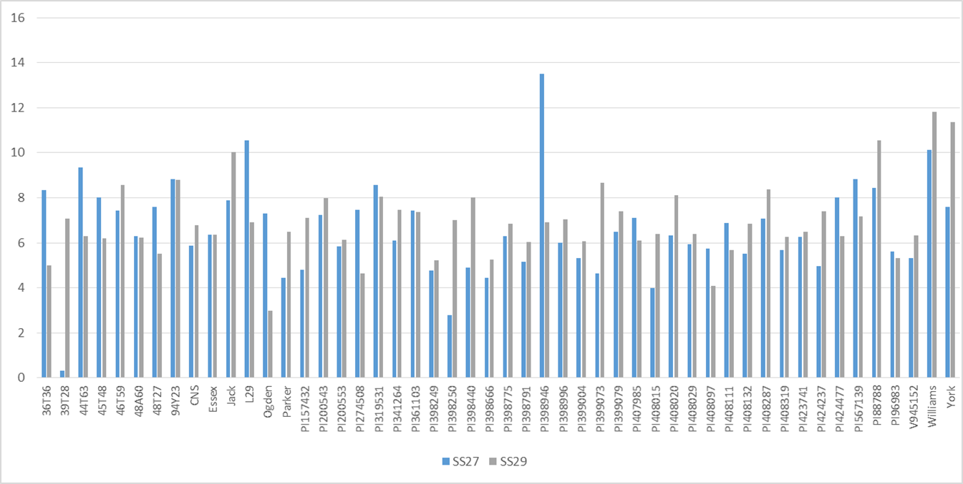 Figure 3. Length of lesions on soybean germplasm lines inoculated with S. sclerotiorum isolates SS27 or SS29 and incubated in the greenhouse for 8 days in the fall of 2018.

Figure 4. Mean lesion length of soybean germplasm lines challenged with two S. sclerotiorum isolates, SS2 and SS29, in 2021.

Selected lines rescreened 2021
A final greenhouse trial was conducted at the University of Maryland’s Greenhouse Complex in December 2020 through February 2021. Soybean lines were selected for this trial based on their performance in fall season of 2018 (screening test 1) or in winter 2021 (screening test 2). Of the seventy nine soybean lines in screening test 1, four lines that developed significantly shorter lesions in the straw test than the susceptible check, ‘Williams 82’, were selected and retested. An additional seven lines identified in screening test 2 that had also developed lesions that were significantly shorter than the lesions that developed on ‘Williams 82’ were also selected. The resistant and susceptible checks were ‘NKS1990’ and ‘Williams 82’, respectively. Two lines that had developed long lesions that were similar to ‘Williams 82’ in screening trial 2 were also included as susceptible checks.
On Dec. 29 to Jan. 1, soybean seeds were directly planted to a substrate mix that contained 15% perlite and 85% Canadian Sphagnum peat moss potting mix (Sun Gro Horticulture®, Silver St. Agawam, MA 01001-2907, US) in sterile 15 cm pots. Twelve seeds of each line were planted, one seed per pot. After germination, plants were fertilized with a solution of 15N-5P-15K 100 ppm fertilizer at 250 ppm two to three times before inoculation. After one month or when plants started developing the 5th node each plant was inoculated with Sclerotinia sclerotiorum.
Inoculations were conducted with two Sclerotinia sclerotiorum isolates with six plants of each germplasm line inoculated with SS2 and six with SS29. Inoculations and lesion length measurement were conducted as described previously. During and after inoculations, we maintained temperatures at 20 ± 1°C (night, 12 h) and 26 ± 1°C (day, 12 h) in greenhouse. The inoculated plants were incubated for 8 days during which the first 48 hours they were misted to keep the humidity high.
There were no significant differences in lesion length by isolate. However the lines differed significantly (P<0.0001; F=3.59). Six lines had lesion lengths significantly shorter than the susceptible cultivar ‘Williams’ and not significantly different than the resistant check ‘NKS1990’ (Table 4).
Table 4. Selected lines from trials in 2018, and 2020 challenged with Sclerotinia sclerotiorum using the “straw” test and the year when the line was previously tested.
Line | Lesion length (cm) |  | Year
PI378702 | 1.4^{x} | F | 2020-2021
PI417015 | 1.7 | F | 2020-2021
PI407162 | 2.2 | EF | 2020-2021
PI567336 | 2.6 | DEF | 2020-2021
NKS1990 | 2.6 | DEF | 2020-2021
PI96983 | 2.7 | CDEF | 2018,2020-2021
PI603170 | 2.7 | BCDEF | 2020-2021
Parker | 3.2 | ABCDE | 2018,2020-2021
V945152 | 3.9 | ABCD | 2018,2020-2021
PI398666 | 4.1 | ABC | 2018,2020-2021
PI438258 | 4.2 | AB | 2020-2021
PI398249 | 4.2 | AB | 2018,2020-2021
PI561398 | 4.2 | AB | 2020-2021
Williams ^{y} | 4.3 | A | 2018,2020-2021
PI647086 | 4.4 | A | 2020-2021
^{x}Means within a column followed by the same letter are not significantly different according to Fisher’s protected LSD test (α = 0.05).
^{y} Williams is the susceptible check.

Brief Conclusions:

Of the 40 isolates of S. sclerotium from soybean and other crops in the DELMARVA region, the MCG of the population appears similar to those in other regions. The similarity of the population, at least for MCG, to other populations is important for guiding management decisions. It is an indication that our populations of S. sclerotiorum in the Mid-Atlantic region may be genetically similar to populations in other areas of the country.

Among the P. sojae-resistant soybean germplasm lines that we evaluated, we identified lines that appear less susceptible to Sclerotinia stem rot. Germplasm that developed significantly shorter stem lesions than the susceptible check, Williams, include PI378702, PI417015, PI407162, PI567336, PI96983 and PI603170.

References:
Arahana, V. S., Graef, G. L., Specht, J. E., Steadman, J. R. and Eskridge, K. M. 2001. Identification of QTLs for resistance to Sclerotinia sclerotiorum in soybean. Crop Sci. 41(1): 180 - 188.
Attanayake, R. N., Carter, P. A., Jiang, D., del Río-Mendoza, L., and Chen, W. 2013. Sclerotinia sclerotiorum populations infecting canola from China and the United States are genetically and phenotypically distinct. Phytopathol. 103: 750 - 761.
Boland, G. J., and Hall, R. 1994. Index of plant hosts for Sclerotinia sclerotiorum. Can. J. of Plant Pathol. 16(2): 93 - 108.
Cubeta, M. A., Sermons, D. N., Cody, B. R. (2001). Mycelial interactions of Sclerotinia minor. (Abstr.). Phytopathology, 91: S19.

Chun, D., Kao, L. B., Lockwood, J. L. and Isleib, T. G., 1987. Laboratory and field assessment of resistance in soybean to stem rot caused by Sclerotinia sclerotiorum. Plant Dis. 71(9): 811 - 815.
Ekins, M. G., Aitken, E. A. B., and Goulter, K. C. 2007. Aggressiveness among isolates of Sclerotinia sclerotiorum from sunflower. Australas. Plant Pathol. 36: 580 - 586.
Grau, C. R., Radke, V. L., Gillespie, F. L. 1982. Resistance of soybean cultivars to Sclerotinia sclerotiorum. Plant Dis. 66: 506 – 508.
Grau, C. R., Dorrance, A. E., Bond, J. and Russin, J. S. 2004. Fungal diseases. Soybeans: Improvement, production, and uses, 16: 679 - 763.
Hadziavdic, K., Lekang, K., Lanzen, A., Jonassen, I., Thompson, E. M., & Troedsson, C. (2014). Characterization of the 18S rRNA gene for designing universal eukaryote specific primers. PloS one, 9, e87624.
Hartman, G.L., Kull, L.I.N.D.A. and Huang, Y.H. 1998. Occurrence of Sclerotinia sclerotiorum in soybean fields in east-central Illinois and enumeration of inocula in soybean seed lots. Plant Dis. 82(5): 560 - 564.
Hoffman, D. D., Hartman, G. L., Mueller, D. S., Leitz, R. A., Nickell, C. D. and Pedersen, W. L. 1998. Yield and seed quality of soybean cultivars infected with Sclerotinia sclerotiorum. Plant Dis. 82(7): 826 - 829.
Koga, L. J., Bowen, C. R., Godoy, C. V., Oliveira, M. C. N. D. and Hartman, G. L., 2014. Mycelial compatibility and aggressiveness of Sclerotinia sclerotiorum isolates from Brazil and the United States. Pesq. Agr. Brasileira, 49: 265 - 272.
Kull, L. S., Pedersen, W. L., Palmquist, D., and Hartman, G. L. 2004. Mycelial compatibility grouping and aggressiveness of Sclerotinia sclerotiorum. Plant Dis. 88: 325 - 332.
Mandal, A. K., and Dubey, S. C. (2012). Genetic diversity analysis of Sclerotinia sclerotiorum causing stem rot in chickpea using RAPD, ITS-RFLP, ITS sequencing and mycelial compatibility grouping. World J. Microbiol Biotechnol, 28: 1849 – 1855.
Otto-Hanson, L., Steadman, J. R., Higgins, R., and Eskridge, K. M. 2011. Variation in Sclerotinia sclerotiorum bean isolates from multisite resistance screening locations. Plant Dis. 95:1370-1377.
Peltier, A. J., Bradley, C. A., Chilvers, M. I., Malvick, D. K., Mueller, D. S., Wise, K. A. and Esker, P. D., 2012. Biology, yield loss and control of Sclerotinia stem rot of soybean. J. of Int. Pest Man. 3(2): B1 - B7.
Saharan, G. S., and Mehta, N. 2008. Sclerotinia diseases of crop plants: biology, ecology and disease management. Springer Saharan GS,Mehta N (2008) Sclerotinia diseases of crop plants: biology, ecology and disease management, Springer.
Willbur, J., Ding, F. S., Marks, M. E., Lucas, H., Grau, C. R., Groves, C. L., Kabbage, M., and Smith. D. L. 2017. Comprehensive Sclerotinia Stem Rot Screening of Soybean Germplasm Requires Multiple Isolates of Sclerotinia sclerotiorum. Plant Dis. 101(2): 344 - 353.
Willbur, J., McCaghey, M., Kabbage, M., amd Smith, D. L. 2019. An overview of the Sclerotinia sclerotiorum pathosystem in soybean: impact, fungal biology, and current management strategies. Tropical Plant Pathol. 44(1): 3 - 11.
Wrather, J. A. and Koenning, S. R. 2006. Estimates of disease effects on soybean yields in the United States 2003 to 2005. J. of Nematology 38(2): 173.
Yang, X. B., Lundeen, P. and Uphoff, M. D., 1999. Soybean varietal response and yield loss caused by Sclerotinia sclerotiorum. Plant Dis. 83(5): 456 - 461.
Zancan, W. L. A., Steadman, J. R., Higgins, R., Jhala, R., Machado, J. da C. (2015). Genetic and aggressiveness variation among Sclerotinia sclerotiorum dry bean isolates from Brazil fields. Biosci. J., Uberlândia, 31(4), 1143 – 1151.

