Project final Report

REPORT SUBMITTED TO
Jennifer Reed-Harry
Pennsylvania Soybean Board
2215 Forest Hills Drive, Suite 40
Harrisburg, PA 17112-1099
Office: 717-651-5922; Fax: 717-651-5926
Email: jrharry@pasoybean.org

PROJECT TITLE
Studies on Control Measures for Avian Reovirus Variants and Other Enteric Viruses
in Poultry Flocks

INSTITUTION
The Pennsylvania State University,
College of Agriculture Sciences
Department of Veterinary Sciences
Animal Diagnostic Laboratory, University Park, PA 16802

Principal Investigator
Huaguang Lu, DVM, MS, MPVM
Clinical Professor in Veterinary Science, Avian Virologist
Department of Veterinary and Biomedical Sciences
College of Agriculture Sciences
The Pennsylvania State University, University Park, PA 16802
Tel: (814)863-4369; Fax: (814)865-4717
Email: hxl15@psu.edu; https://vbs.psu.edu/directory/hxl15

DATE OF SUBMISSION
May 6, 2022

PERIOD OF THIS PROJECT
April 1, 2020 to March 31, 2022

- Research Objectives and Approaches

This research project, titled “Studies on Control Measures for Avian Reovirus Variants and Other Enteric Viruses in Poultry Flocks”, has been conducted during the last two years, April 2020 – March 2022. Research results have been achieved towards meeting the two project objectives.
- Evaluate efficacy of non-metallic or “soft” disinfectants for prevention of avian reovirus (ARV) and other enteric virus infections in broiler and layer production flocks.
- Develop more effective control measures and strategies for better control and prevention of ARV variants and other enteric viruses in poultry flocks.
The Pennsylvania Poultry Industry of layers, broilers and turkeys together would consume at least 500,000 tons of soybean annually. Therefore, avian disease studies are critical not only to keep healthy poultry productions, but also to keep constant soybean consumptions to promote healthy soybean industry.
In this research project, we have focused on applying “soft” disinfectants against avian enteric virus infections in poultry flocks, which shall be the effective and economic approach for enhancement of the routinely control measures (diagnostic surveillance, virus isolation and identification and vaccination strategies) to prevent poultry from viral pathogen/variant infections.

- Results

Two non-metallic or “soft” disinfectant products of Shield Plus (Timac Agro, USA, www.us.timacagro.com), Assist NPS’s solution (Assist Natural Products and Services, LLC, www.assist-nps.com) have been used and evaluated for their effectiveness on avian virus inactivation and disinfections. Research results obtained during the two-year research period are summarized as the followings.

- Results of the “Shield Plus” disinfectant tests
  - Test procedures of the Shield Plus disinfectant for virus inactivation tests
- Preparation of “Shield Plus” powder for different % concentrations were prepared as the Table 1-1.
- Because the SPP will start reaction when it mixes with liquid/water, so do not add the test virus to the tubes until an incubation time count is ready.
- The 50 ml tubes containing the 25 ml of the powder and virus mix need to keep mixing (place on a shaker plate) during the entire incubation time at room temperature.
- Watch the incubation time, take supernatant samples from the reaction tubes at 5 min, 10 min, 15 min, and 30 min to inoculate LMH cells, inoculate 4 wells per sample in a 24-well cell culture plate, 0.1 ml inoculum per well.
- The inoculated cell culture plates are incubated at 37C/CO2 incubator for 30 min, then 1.0 ml of 2% FBS maintenance medium is added to each well, the plates are placed in 37C/CO2 incubator.
- Daily observation of the inoculated LMH cells, record the occurrence of viral cytopathic effect (CPE) cells.
- The inoculated LMH cell cultures are terminated after 6 days post incubation.
- If no CPE observed, the inoculated LMH cells are harvested for a secondary cell passage.
- Examine the 2nd cell pass as the above 7 - 9 steps.

Table 1-1. Preparation of the “Shield Plus” powder in different concentrations (%) for inactivation tests on avian viruses (e.g., ARV, FAV, IBDV, IBV)
 | 1% | 2% | 3% | 4% | 5% | 6% | 8% | 10% | 15% | 20%
SPP | 0.25g | 0.5g | 0.75g | 1.0g | 1.25g | 1.5g | 2.0g | 2.5g | 3.25g | 5g
virus | 24.75ml | 24.5ml | 24.25ml | 24ml | 23.75ml | 23.5ml | 23ml | 22.5ml | 21.75ml | 20ml
total | 25ml | 25ml | 25ml | 25ml | 25ml | 25ml | 25ml | 25ml | 25ml | 25ml
Note: (1) weight the SPP and place into 50ml centrifuge tube; (2) add the 1:10 diluted stock virus into each of the 50ml centrifuge tubes containing SPP.

  - Shield Plus disinfectant for virus inactivation tests on avian reovirus (ARV) and fowl adenovirus (FAV)
The “Shield Plus” powder product was prepared in serial concentrations of 5%, 8%, 10%, 15% and 20% in cell culture medium for Avian Reovirus (ARV) and Fowl Adenovirus type 1 (FAV-1) inactivation studies using LMH cell cultures.

Three ARV strains (S1133 vaccine strain, Reo/PA/Layer/29730/11 (genotype 2), and three FAV-1 strains (CELO, KR5, C229) were newly propagated for this study. Each of these virus strains was tested in each concentration of the Shield Plus for 5 min and 15 min reaction times, respectively.
The Shield Plus powder disinfectant effectively inactivated or killed ARV and FAV-1 strains at 8%, 10%, 15% and 20% concentrations when dissolved in PBS or water within 5 or15 min reaction time in a laboratory condition (Table 1-2).
Table 1-2. Results of Shield Plus disinfectant for inactivation tests on Avian Reovirus (ARV), Fowl Adenovirus type 1 (FAV-1: CELO, KR5 and C229 strains).
Avian Virus | Concentration (%) of Shield Plus on avian virus inactivation tests
 | 5% |  | 8% |  | 10% |  | 15% |  | 20%
 | 5 m | 15 m | 5 m | 15 m | 5 m | 15 m | 5 m | 15 m | 5 m | 15 m
ARV (S1133) | 0% | 50% | 100% | 100% | 100% | 100% | 100% | 100% | 100% | 100%
AIV (PA29730/11) | 0% | 50% | 100% | 100% | 100% | 100% | 100% | 100% | 100% | 100%
ARV (PAxxxxx/xx) | 0% | 50% | 100% | 100% | 100% | 100% | 100% | 100% | 100% | 100%
FAV-1 (CELO) | 0% | 50% | 100% | 100% | 100% | 100% | 100% | 100% | 100% | 100%
FAV-1 (KR5) | 0% | 25% | 100% | 100% | 100% | 100% | 100% | 100% | 100% | 100%
FAV-1 (C229) | 0% | 25% | 100% | 100% | 100% | 100% | 100% | 100% | 100% | 100%
Note: 100% = 100% virus inactivation results; 0% = the virus was not inactivated.

  - Shield Plus disinfectant for virus inactivation tests on infectious bursa disease virus (IBDV)
- The Shield Plus powder at 8% and 10% concentrations inactivated most (>90%) IBDV after 10-30 min reaction time, since no viral cytopathic effects (CPE) cells were seen during the observation period of 6 days post inoculation; however, some residual virus (not killed) was amplified at the second cell passage in causing CPE cells at 4-6 days pi.
- The Shield Plus powder at 3% to 6% concentrations could kill at least 50% of the virus within 10-30 min, since no CPEs were seen in the first 3 days pi.
- The Shield Plus powder at 1% and 2% concentrations appeared little effect on IBDV inactivation in 10-30 min reaction time.
- The effectiveness of the “Shield Plus” powder disinfectant on virus inactivation could be increased along with increasing the reaction time. We plan to extend reaction times of the virus inactivation results in next study period.
- A Table Summary of Results (Table 1-3).
Table 1-3: Results “Shield Plus” Powder Disinfectant on Infectious Bursa Disease Virus (IBDV) Inactivation Studies
Shield Plus (%) | Reaction time with IBDV | 1st cell passage |  | 2nd cell passage |  | Result of  % effective
 |  | 3 dpi | 6 dpi | 3 dpi | 6 dpi
1% | 10min | 2(±)/2 | 2(+)/2 | Because the 1st cell passage showed IBDV was not completely inactivated, thus there was no need for the 2nd cell passage to test. |  | ~ >20%
 | 15min | 2(±)/2 | 2(+)/2 |  |  | ~ >20%
 | 30min | 2(±)/2 | 2(+)/2 |  |  | ~ >20%
2% | 10min | 2(±)/2 | 2(+)/2 |  |  | ~ >20%
 | 15min | 2(±)/2 | 2(+)/2 |  |  | ~ >20%
 | 30min | 2(±)/2 | 2(+)/2 |  |  | ~ >20%
3% | 10min | 0/4 | 4(+)/4 |  |  | ~ >50%
 | 15min | 0/4 | 4(+)/4 |  |  | ~ >50%
 | 30min | 0/4 | 4(+)/4 |  |  | ~ >50%
0%, BDV+ | 30min | 4(+)/4 | 4(+)/4 | 4(+)/4 | 4(+)/4 | (+) control
0%, PBS | 30min | 0/4 | 0/4 | 0/4 | 0/4 | (-) control
4% | 10min | 0/4 | 4(+)/4 | Because the 1st cell passage showed IBDV was not completely inactivated, thus there was no need for the 2nd cell passage to test. |  | ~ >50%
 | 15min | 0/4 | 4(+)/4 |  |  | ~ >50%
 | 30min | 0/4 | 4(+)/4 |  |  | ~ >50%
5% | 10min | 0/4 | 4(+)/4 |  |  | ~ >50%
 | 15min | 0/4 | 4(+)/4 |  |  | ~ >50%
 | 30min | 0/4 | 4(+)/4 |  |  | ~ >50%
6% | 10min | 0/4 | 4(+)/4 |  |  | ~ >50%
 | 15min | 0/4 | 4(+)/4 |  |  | ~ >50%
 | 30min | 0/4 | 4(+)/4 |  |  | ~ >50%
8% | 10min | 0/4 | 0/4 | 0/4 | 4(+)/4 | ~ >90%
 | 15min | 0/4 | 0/4 | 0/4 | 4(+)/4 | ~ >90%
 | 30min | 0/4 | 0/4 | 0/4 | 4(+)/4 | ~ >90%
10% | 10min | 0/4 | 0/4 | 0/4 | 4(+)/4 | ~ >90%
 | 15min | 0/4 | 0/4 | 0/4 | 4(+)/4 | ~ >90%
15% | 10min | 0/4 | 0/4 | 0/4 | 0/4 | 100%
 | 15min | 0/4 | 0/4 | 0/4 | 0/4 | 100%
20% | 10min | 0/4 | 0/4 | 0/4 | 0/4 | 100%
 | 15min | 0/4 | 0/4 | 0/4 | 0/4 | 100%
0%, BDV+ | 15min | 4(+)/4 | 4(+)/4 | 4(+)/4 | 4(+)/4 | (+) control
0%, PBS | 15min | 0/4 | 0/4 | 0/4 | 0/4 | (-) control
Note: (1) 100% = 100% virus inactivation results; 0% = the virus was not inactivated.

- Results of the “Assist NPS’s solution” tests
  - Preparation of the Assist NPS’s Solution
The stock solution at 5000 PPM concentration was provided by the Assist Natural Products and Services LLC.
A serial of dilutions was prepared in deionized water (dH2O), the solution and dH2O ratios were made to yield serial PPM concentrations in the solution, see Table 2-1.
Table 2-1. Preparation of serial PPM concentrations of the Assist NPS’s stock 5000 solution
Volume of stock solution (ml) | Volume of dH2O diluent (ml) | Total volume  (ml) | The solution concentration (PPM)
12.8 | 0 | 12.8 | 5000
10.0 | 2.8 | 12.8 | 4000
7.5 | 5.3 | 12.8 | 3000
5.0 | 7.8 | 12.8 | 2000
2.5 | 10.3 | 12.8 | 1000
1.8 | 11.0 | 12.8 | 700
1.3 | 11.5 | 12.8 | 500
1.0 | 11.8 | 12.8 | 400
0.75 | 12.05 | 12.8 | 300
0.5 | 12.3 | 12.8 | 200
0.25 | 12.55 | 12.8 | 100
0.125 | 12.675 | 12.8 | 50
0.025 | 12.775 | 12.8 | 10

  - Safety test of the Assist NPS’s solution to chicken embryos
The Assist NPS’s solution at a concentration of 1000 PPM is safe to ≥9-day-old embryonating chicken eggs (ECEs) at 0.2ml/ECE, and at the stock solution concentration of 5000 PPM is safe to ≥15-day-old ECEs at 0.2ml/ECE (Table 2-2).

Table 2-2. Safety test of the Assist NPS’s Solution on chicken embryo’s tolerance
PPM concentration in the solution | 9-day-old chicken embryo |  | 15-day-old chicken embryo
 | dead/total | death rate | dead/total | death rate
5000 | 5/5 | 100% | 0/5 | 0%
4000 | 5/5 | 100% | 0/5 | 0%
3000 | 1/5 | 20% | 0/5 | 0%
2000 | 2/5 | 40% | 0/5 | 0%
1000 | 0/5 | 0% | 0/5 | 0%
700 | 0/5 | 0% | 0/5 | 0%
H2O | 0/5 | 0% | 0/5 | 0%
Note: 100% = virus was completely inactivated; 0% = virus was not inactivated.

  - Effects of the Assist NPS’s Solution on avian influenza virus (AIV) inactivation
The Assist NPS’s solution at 400-500 PPM effectively inactivated AIV subtypes H1N1, H3N2, H5N2 and N7N2 in 5 min tested in lab condition (Table 2-3).

Table 2-3. The Assist NPS’s Solution on AIV inactivation results
PPM concentration in the solution | H1N1 |  | H3N2 |  | H5N2 |  | H7N2
 | 5min | 10min | 5min | 10min | 5min | 30min | 5min | 10min
500 | 100% | 100% | 100% | 100% | 100% | 100% | 100% | 100%
400 | 100% | 100% | 100% | 100% | 100% | 100% | 100% | 100%
300 | 80% | 80% | 100% | 100% | 100% | 100% | 60% | 80%
200 | 60% | 60% | 100% | 100% | 100% | 100% | 0% | 20%
100 | 20% | 20% | 20% | 20% | 0% | 20% | 0% | 0%
50 | 0% | 0% | 0% | 0% | 0% | 0% | 0% | 0%
10 | 0% | 0% | 0% | 0% | 0% | 0% | 0% | 0%
H2O | 0% | 0% | 0% | 0% | 0% | 0% | 0% | 0%
Note: 100% = virus was completely inactivated; 0% = virus was not inactivated.

  - Effects of the Assist NPS’s Solution on infectious bronchitis virus (IBV) and Newcastle disease virus (NDV) inactivation.
The Assist NPS’s solution in 300-500 PPM effectively inactivated or killed both IBV and NDV in 5 min tested in lab condition (Table 2-4).

Table 2-4. The Assist NPS’s Solution on IBV and NDV inactivation results
PPM concentration in the solution | IBV-Mass |  | NDV
 | 5min | 10min | 5min | 10min
500 | 100% | 100% | 100% | 100%
400 | 100% | 100% | 100% | 100%
300 | 100% | 100% | 100% | 100%
200 | 0% | 0% | 0% | 0%
100 | 0% | 0% | 0% | 0%
50 | 0% | 0% | 0% | 0%
10 | 0% | 0% | 0% | 0%
H2O | 0% | 0% | 0% | 0%
Note: 100% = virus was completely inactivated; 0% = virus was not inactivated.

- ARV infectious parameters in egg-laying hens

  - Experiment design
During this research period, we have conducted three clinical bird trials in studying avian reovirus (ARV) infectious parameters in egg-laying hens at 20-weeks old, 30-weeks old and 80-weeks old, respectively. We collected cloacal swab samples at the 2nd, 3rd, 5th, 7th, 9th, 12th, and 14th days post inoculation (pi) in each trial experiments. The swabs were collected from each bird individually and tested individually by virus isolation (VI) in LMH cell cultures.
  - Results
The VI results indicated that the ARV-infected hens started virus shedding via intestine/feces as early as 24 hours pi, heavy shedding at 2nd (Fig.1, VI(+)/CPE+ cell culture images) and 4th days pi, light shedding at 5th and 7th days pi, and rarely shedding 2 weeks pi.
The egg-laying hens of each age group in the three trials were all equally susceptible to ARV infections, they started shedding virus via intestine/feces as early as 24 hours post inoculation (pi), heavy virus shedding occurred at 2-4 d pi, then were light shedding at 5-7 d pi, and were rarely shedding after 12-14 d pi. These experimentally ARV-infected hens remained normal egg productions, and no observable clinical signs except some watery droppings during the 1st week pi.
In each ARV variant-infection experiment, the ARV infected hens were given a second ARV challenge at 3-4 weeks pi, swab and manure samples were collected in the same fashion as the first inoculation. Our research findings indicated that the hens previously exposed to ARV were all well protected against challenge, without virus shedding.

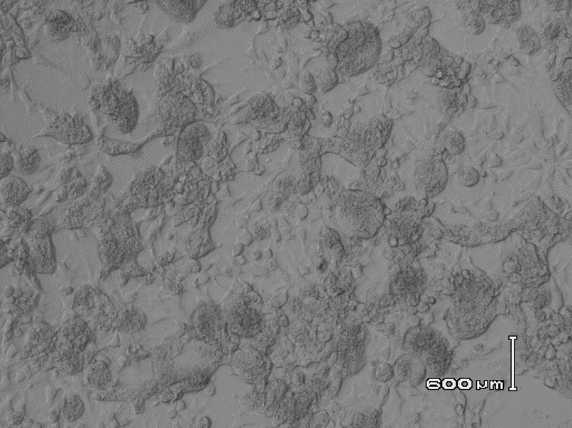 | 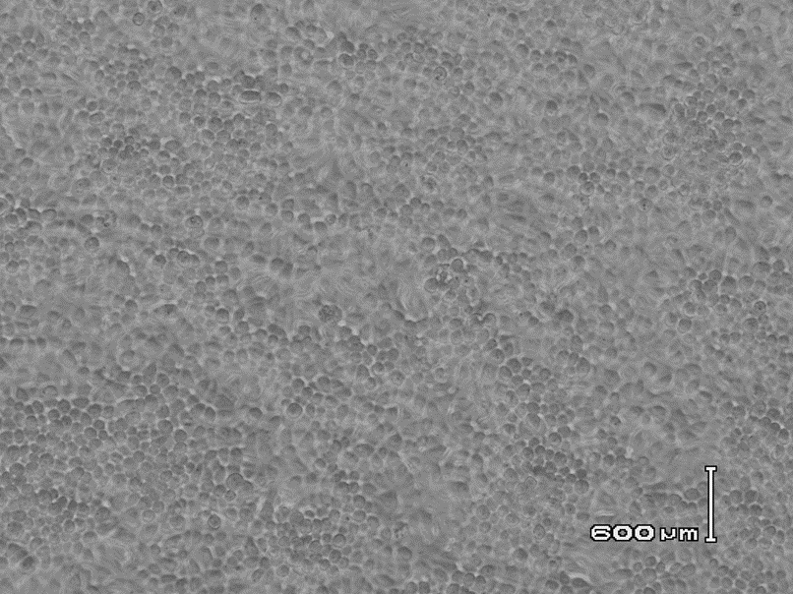
Hy-Line Brown hen, ARV-infected, cloacal swab 2dpi, VI(+) in LMH cell culture | Hy-Line Brown hen, (-) control  Cloacal swab, VI(-) in LMH cell culture
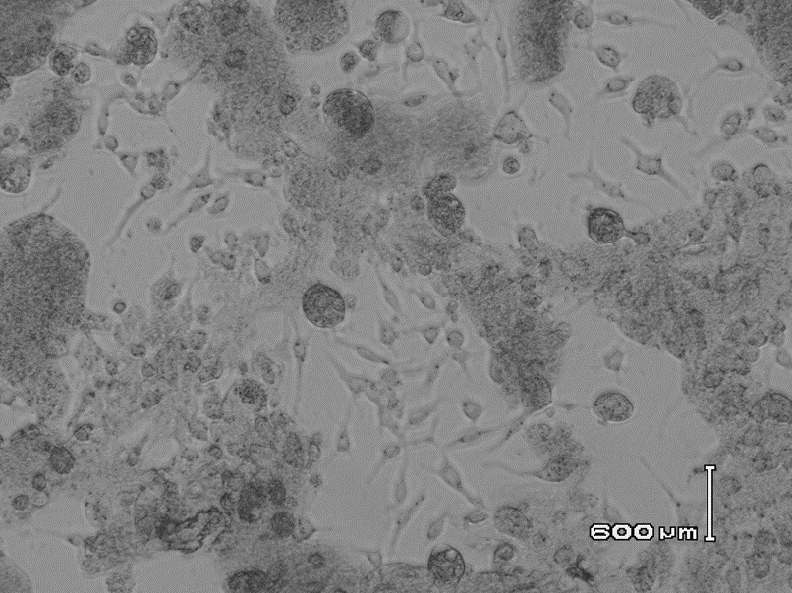 | 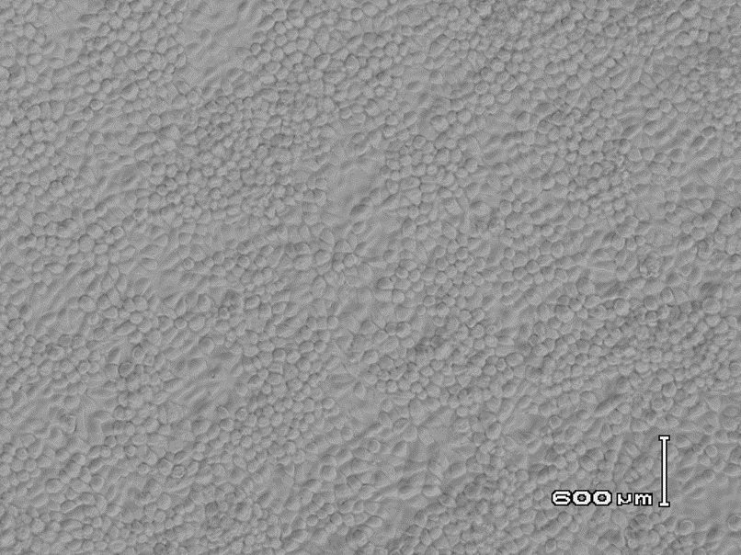
white leghorn W30, ARV-infected, cloacal swab 2dpi, VI(+) in LMH cell culture | white leghorn W30, (-) control  Cloacal swab, VI(-) in LMH cell culture
Fig.1. Hens’ ARV-infectious experiment 3, cloacal swabs collected 2 day pi for detection of virus shedding by virus isolation (VI) in LMH cell cultures.
The left: VI(+) indicated virus shedding of the ARV-infected hens;
The right: VI(-) indicated no virus shedding of the no-infection control hens.

- Clinical trials in applying “soft” disinfectants in egg-laying hens

  - Experiment design
We have conducted four clinical trials in egg-laying hens to assess the potential role of applying the “soft” disinfectant of sodium dichloroisocyanurate (NaDCC) tablets (same as the liquid form of Assist NPS’s Solution) in drinking water and cage spray against avian virus infections (i.e., Avian reovirus, Reo/Layer/29730/11, TCID50 = 107.5/mL; and Fowl adenovirus, KR55, TCID50 = 106.37/mL).
Each trial had a minor modification in terms of initial dosage of virus infection and application of disinfectants to the birds. Trial # 1 and #2 were conducted with Hy-Line brown layers at 21–26 weeks of age, while Trial # 3 and #4 with W-36 layers at 30 – 34 weeks of age. After virus inoculation, both cloacal and tracheal swabs were collected for virus screening in accordance with the experiment protocol (Table 4-1).
Table 4-1. Clinical trials in applying “soft” disinfectants in egg-laying hens
 | Study group | Avian virus,  TCID₅₀/mL (1mL/bird) | NaDCC tablet treatment
Trial #1 | 6 hens, Hy-Line brown egg-laying hens, 21-weeks-old | ARV  1st inoculation: TCID₅₀=10^{4.5}/mL  2nd challenge: TCID₅₀=10^{6.5}/mL | - Dilute @ 538 ppm in drinking water  - Dilute @1076 ppm in dH₂O for daily spray (directly on birds and cage manure)
Trial #2 | 4 hens, Hy-Line brown egg-laying hens, 26-weeks-old | FAV  1st inoculation TCID₅₀=10^{5.3}/mL  2nd challenge TCID₅₀=10^{5.3}/mL
Trial #3 | 4 hens, White Leghorn W-36, 30-weeks-old | FAV  1st inoculation TCID₅₀=10^{4.3}/mL,  no challenge
Trial #4 | 6 hens, White Leghorn W-36, 34-weeks-old | FAV  1st inoculation TCID₅₀=10^{6.3}/mL  2nd challenge TCID₅₀=10^{5.3}/mL
Note: 1) each trial had un-treated control group, 2~4 birds; 2) the 2nd challenge was given at 4 weeks pi; 3) cloacal swabs from each bird, cage manure and filter dust swabs were collected at 3-4 times per week for virus detection; 4) blood and egg yolk samples were collected for antibodies assessment by ELISA test.

  - Results
The experiment hens in each treatment group of the four trials did not show clinical symptoms upon initial ARV or FAV inoculation and the second challenge. However, hens in the NaDCC-treatment group showed a relatively reduced feed and water intake than the control group, and egg production was inconsistent in the treatment group.
After virus challenge to the NaDCC-treatment and un-treatment groups, both group hens showed shedding of virus. Sample collections started from 24 hours pi till 7–8 d pi, and they were tested positive (shedding virus in the samples) by virus detection test in cell cultures. Cage manure samples remained positive till 10 d pi. Birds received 2nd challenge did not show virus shedding in two more weeks till the end of the experiment.
Although there were not significantly differences on positive shedding of viruses observed in treatment and control group by the initial virus inoculation, it was relatively heavier virus shedding in control group than treatment group, which indicated some effectiveness by the NaDCC-treatment.
In summary, “soft” disinfectants are safe and effective to use in live poultry flocks and house environments. Although the current “soft” disinfectants are not feasible or questionable to add/use in drinking water, they shall be effective measures and together with the common approaches of diagnostic surveillance for virus detection and vaccination strategies to prevent poultry from virus infections.

