Monitoring for Soybean Cyst Nematode: Getting Ahead of the Pest (2020)
Investigators: Jaime Cummings, Kevin Ganoe
Collaborators: Mike Stanyard, Aaron Gabriel, Kitty O’Niel, Jeff Miller, Janice Degni, Marion Zuefle, Mike Hunter, Josh Putman, Jodi Putman, Ken Wise, and Erik Smith

KPI #1: Project investigators and collaborators will identify soybean growers willing to participate, and 5-10 soybean fields to monitor and sample for SCN testing.
KPI #2: Project investigators and collaborators will collect soil samples from 5-10 soybean fields at the end of the growing season and submit to SCN Diagnostics Laboratory testing facility.
For this project, 13 total investigators and collaborators sampled 78 fields in 35 counties. Of these, 33 fields were positive in 22 counties, revealing 15 counties where SCN had not previously been recorded. Most fields sampled (32) had what are considered low SCN egg counts (less than 500 per cup of soil), one field was considered moderate (500 – 10,000 eggs/cup), and no fields in this study yielded high populations (greater than 10,000 eggs/cup).
Together with a similar study also conducted in 2020, SCN-positive soil samples were collected from fields in 29 of 41 NY counties in 2020 (Table 1), including another two samples in the moderate egg range, and one in the high range (20,000 eggs/cup) (Table 2). Counting all available data from previous years, SCN has now been found in 30 of 42 counties sampled in NY since 2016 (Figure 1). Only 11 upstate counties (north of Rockland and Westchester) remain unsampled, most of which we hope to sample in 2021.
Continued monitoring of this pest provides farmers with the information needed to mitigate yield loss based on SCN population levels. Low/moderate populations may be managed with crop rotation and SCN-resistant soybean varieties, while high populations may require more costly strategies such as nematicidal seed treatments.

KPI #3: Results from the testing facility will be shared with growers and summarized for sharing via websites, extension meetings, reports, and articles.
These results and ensuing recommendations are being shared with hundreds of stakeholders at 8 extension meetings across NYS this winter, and there is much grower interest. There was also a newsletter article published in What’s Cropping Up (http://blogs.cornell.edu/whatscroppingup/2020/12/04/soybean-cyst-nematode-the-greatest-threat-to-ny-soybean-production-is-here-to-stay-now-what/), and it was re-published in a number of regional extension newsletters by cooperators. Individual farmers with SCN-positive fields were contacted and given a document detailing management options. The survey will continue in 2021 thanks to continued funding support from NYCSGA.

Table 1. Detection of SCN in New York soybean fields in 2020 (all studies)
 | Fields | Counties
Sampled | 104 | 41
SCN+ | 51 | 29
Percent+ | 49.04% | 70.73%
Table 2. SCN populations in sampled soybean fields in New York in 2020 (all studies)
SCN population (eggs/cup of soil) | Fields
Not detected* | 53
Low (<500) | 47
Moderate (500-10,000) | 3
High (>10,000) | 1
*SCN populations may be present at levels that were not detectable, or in areas of fields that were not sampled

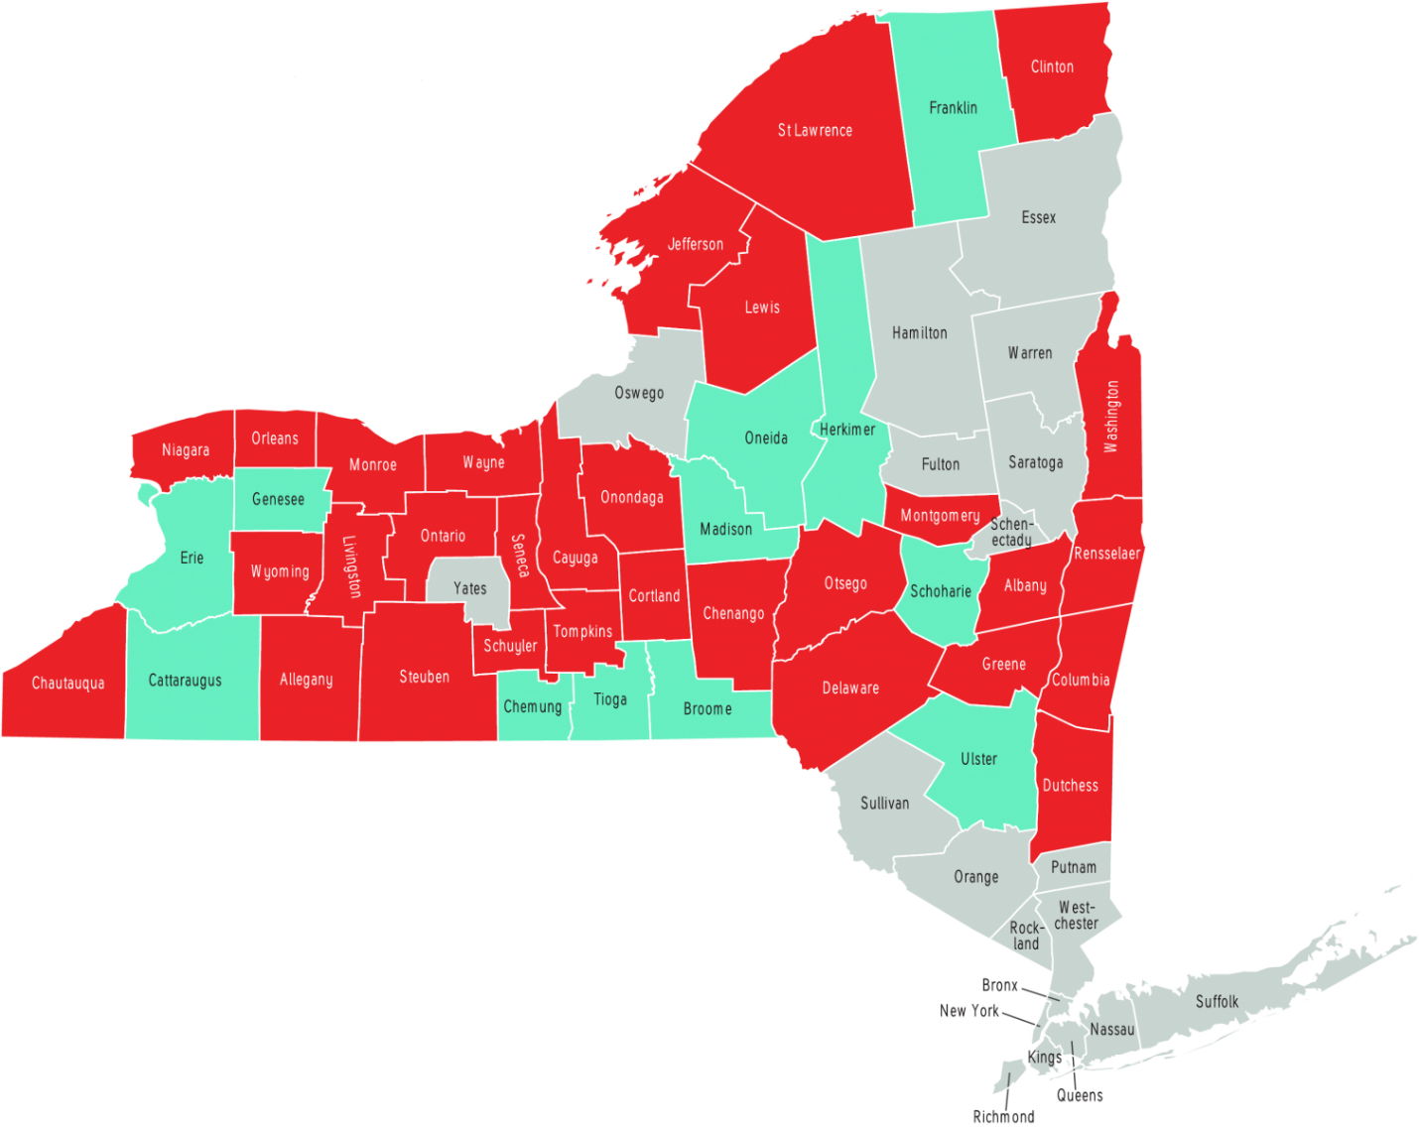

Figure 1. Confirmed detection of SCN in New York counties since 2016. Red = SCN detected in soil samples; Green = SCN not detected in soil samples; Grey = no samples tested.

