United Soybean Board Domestic Programs
Report Form
Project # and Title
USB Project number 1640-512-5289 MA 2016, UI/Soy Aquaculture Alliance, Task Order #16098
Improving aquaculture sustainability by developing rainbow trout with enhanced capacity to utilize omega-3 fatty acids in plant oils to increase EPA and DHA in fillets

Reporting Period
April 1, 2016 through December 31, 2016

This project was built upon and involved activities that took place prior to the start of the funding period that were not charged to the project, but that had to occur to create experimental animals (trout) for the project. The antecedent to the project is the observation by the PI in a large number of research studies starting in the early 1980s that whole body and fillet fatty acid profiles of rainbow trout, Pacific salmon and Atlantic salmon vary significantly among fish fed the same diet. This factor presents a significant challenge to researchers studying the effects of alternative oil sources in fish feeds. In short, for any research study, the variation of a response variable, such as an individual tissue fatty acid, between treatment groups, such as fish fed diets differing in oil source, must be greater than the variation of the same response variable within a treatment, meaning replicate tank average values or individual fish. Most researchers deal with this problem by pooling fish within replicate tanks (or tissue samples from fish within replicate tanks, then analyzing the pooled sample for fatty acid composition. In such cases, the tank becomes the unit of observation for statistical purposes.

The innovation upon which this project was based was the realization that that variation in tissue (fillet) fatty acid profile among fish fed the same diet could be a positive attribute if it could be shown to be a trait under genetic control, rather than the result of differential feed intake or physiological differences caused by rearing conditions or some other external factor. To test whether or not a trait is under genetic control requires access to a breeding program to produce sibs and half-sibs. Establishment of the UI/ARS rainbow trout breeding program provided such a resource and in 2013, initial work in this area was initiated by rearing families (25 in total) of trout on a diet containing only linseed oil as the lipid source. This diet did not contain long-chain, highly unsaturated omega-3 fatty acids that are only present in marine oils from fish, shellfish, etc., but did contain high levels of the only omega-3 fatty acid found in plant oils, alpha-linolenic acid (C18:3). Fish from the 25 families were reared for three months (initial weight 10g), then 10 fish from each family (mixed sex) were implanted with PIT tags and subjected to a punch biopsy of muscle tissue to analyze for fatty acid content. Based upon these results, the families were assigned one of three categories, high, medium and low, based upon muscle long-chain, highly unsaturated, omega-3 fatty acids (EPA and DHA) levels. These fish were then reared to maturity in late fall, 2014, using a commercial trout diet. Single-parent crosses were made to generate full and half-siblings. Eggs and fry from crosses were reared as individual units to preserve their identity, and after reaching 5g, they were transitioned from a commercial starter trout feed to an experimental diet in which linseed oil was the sole lipid source. Fifty fish from each of 27 crosses were reared individually until they reached an average weight of 250g. Fish were subjected to punch biopsy procedure to obtain a small sample of muscle tissue for fatty acid analysis by LC-MS. After analyses were completed, 12 individuals from each group (high, medium and low responders) were sacrificed to provide samples for the analyses described in this proposal, namely RNA sequencing and proteomics. These samples were taken in late 2015. Samples intended for RNA sequencing were held in RNAlater to preserve them until the start of the current project (April 2016). RNA was extracted and purified from tissue samples. RNA extracts were prepared for analysis (library preparation) using standard protocols routinely used in this laboratory. Samples intended for proteomic analysis were snap-frozen in liquid nitrogen and stored at -70C in liquid nitrogen until the SAA project funding was in place.
RNA was isolated from these samples and evaluated for quantity using a Nanodrop 2000 and qualitatively using a BioAnalyzer 2100. The process of preparing libraries from RNA extracts was started, first with removal of ribosomal RNA in all samples, and complete libraries generated for liver and muscle samples. When library preparation was completed, samples were pair-end sequenced. Data generated by high-throughput sequencing was further processed to clean and trim sequences. Sequences were aligned with a reference rainbow trout transcriptome, quantitated and annotated. When this process was completed, transcriptomic and proteomic data were analyzed further by contrasting and comparing fish from each treatment group. Using this approach, markers associated with elevated DHA levels in muscle tissue of trout fed soy oil were identified.
For proteomics, liver and muscle issues from sampled fish were shipped on dry ice to Dr. Kueltz at UC Davis for proteomic analysis by liquid chromatography – mass spectrophotometry. After analysis, data was subjected to bioinformatics evaluation to identify significant differences between treatment groups.
Results and Discussion:
Background:
Prior to this study, we measured expression levels of genes in the pathway of conversion of linolenic acid to EPA and DHA in rainbow trout liver samples. This metabolic pathway has been well characterized for decades and involves several desaturation and chain elongation steps (Figure 1). The working hypothesis of our previous work was that differences among individual fish in conversion efficiency of linolenic acid to EPA and DHA was due to differences in expression level of several of the enzymatic genes involved with fatty acid elongation and desaturation in the conversion pathway (Figure 2). We compared gene expression levels several genes, including delta-5-dehydrogenase (FAD 5 in Figure 2) and delta-6-dehydrogenase (FADS6 in Figure 2), in fish that had high levels of EPA and DHA in their muscle tissues. These genes are responsible for inserting a double bond at the 5 and 6 carbon positions to make C:20:5 (EPA,) and C22:6 (DHA). Surprisingly, expression levels of these genes or others in the pathway were not correlated with muscle EPA or DHA level. For this reason, we proposed to look at the entire transcriptome of these fish. The transcriptome is a term used to describe all expressed genes and it is measured by sequencing RNA. This differs from DNA sequencing, which enumerates all genes encoded in DNA. Not all genes are active in regulating cellular metabolism at any given time, just those that are transcribed to make RNA in response to cellular needs.
RNA-sequencing results
RNA sequencing was conducted on both liver and muscle samples from 10 fish from each group (low, medium and high responders), for a total of 72 fish. The quality of the RNA extracts was excellent as assessed by various tests, resulting in very high quality ‘reads’ from sequencing. We compared differentially-expressed genes in liver and muscle between groups (high vs low, high vs medium and medium vs low). Only seven genes showed common expression levels in all groups. These genes are involved in fatty acid synthesis, protein turnover and immune system modulation. The seven genes were:
  - deltex-3-like isoform X1 [Salmo salar]
  - E3 ubiquitin- ligase Topors-like
  - 4-hydroxyphenylpyruvate dioxygenase
  - fish virus induced TRIM
  - interferon-induced very large GTPase 1-like isoform X2
  - poly [ADP-ribose] polymerase 14-like isoform X2
  - PREDICTED: uncharacterized protein LOC106612891 [Salmo salar]
Differentially-expressed genes in liver (L) and muscle (M) between groups were as follows:
- High vs low responders – 81 genes (L) and 23 genes (M)
- High vs medium responders – 9 genes (L) and 15 genes (M)
- Medium vs low responders – 30 genes (L) and 25 genes (M)
Not all the same genes were different between groups. To put this another way, the genes that were differentially expressed between high and low responders were not all the same as those between high and medium responders or medium and low responders. Interestingly, even though by measuring the transcriptome which should detect differences in gene expression linked to physiological changes in fatty acid metabolism, we did not observe differences in expression levels in any genes known to be involved with fatty acid conversion. This led to the conclusion that differences between groups were not connected to differences in gene expression along the entire transcriptome.
Proteomic analysis results
Proteomic analysis measured levels of individual proteins synthesized in cells as a result of RNA transcription. In other words, this analysis measured the proteins that were actually produced in high, medium and low responding trout. These proteins can be enzymes, structural proteins or regulatory proteins associated with any or all aspects of cellular metabolism. After conducting bioinformatics analysis that involved, among other things, establishing a threshold to identify significant differences between fish groups, we identified over 400 proteins that differed in liver or muscle tissue. These can be visualized by producing a ‘heat map’ where high levels of individual proteins are shown in red and low levels are shown in green. A small sample of heat maps for liver and muscle tissue between high and low responders is shown in Figure 3. Further analysis of the data revealed a number of different proteins that differed between groups in liver (Figure 4). Fewer differences were found in muscle (Figure 5). The most significant finding pertained to fatty acid binding protein. This protein is associated with fatty acid metabolism in the liver and had the highest significant difference between high and low responders, and medium and low responders. No differences in muscle fatty acid metabolism associated with high or low levels of EPA or DHA were found. Similarly, no differences were found in any proteins that could be related to preferential deposition of fatty acids in muscle tissue. Fatty acid bioconversion takes place primarily in the liver, whereas in the muscle the only significant fatty acid metabolism that takes place involves the utilization of stored fats for energy through ß-oxidation.
Conclusions and Impact
This work builds upon earlier research at our laboratory that estimated heritability values for EPA and DHA levels in muscle (fillet) of rainbow trout, and demonstration that selective breeding can enhance EPA and DHA levels by about 30% after a single generation. This work paves the way to utilize selective breeding to enhance this trait in farmed fish, but more importantly, it provides a foundation to produce farmed fish for consumers that contain healthful fatty acids using feeds containing soy oil.
The research done in this project has provided new knowledge that overturns previous concepts regarding mechanisms that control or regulate bioconversion of linolenic acid, the only omega-3 fatty acid found in plant oils, to EPA and DHA, essential dietary nutrients for fish and healthful fatty acids for humans. Knowledge of these mechanisms will be used to identify genetic markers for use in selective breeding programs for salmon, trout and other farmed fish species to enhance fillet levels of EPA and DHA, and lead to higher use levels of soy oil in feeds for farmed fish to replace costly fish oil, and contribute to the production of sustainable aquaculture feeds.

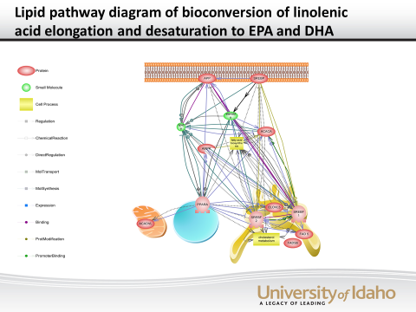

Figure 2. Diagram of the interaction of enzymes associated with conversion of linolenic acid to EPA and DHA in cells. This diagram is based on conventional biochemistry of cells and the pathway diagram in Figure 1. Two enzymes in lower right insert double bonds and were those assessed in preliminary studies.

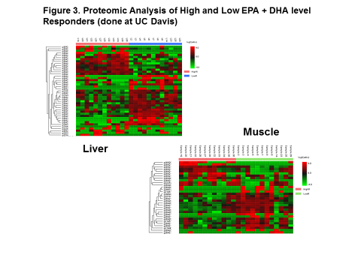
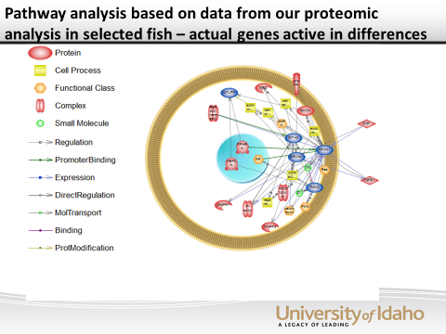

Figure 4. Pathway analysis of bioconversion of linolenic acid to EPA and DHA based upon results of the current project. This differs significantly from previous understanding and will be the basis of future selective breeding programs to enhance fillet EPA and DHA levels in farmed fish fed diets containing soy oil.

