COLOR AND QUALITY CHANGES OF IMMATURE SOYBEANS DURING FIELD DRYING AND DIFFERENT STORAGE CONDITIONS
Ibukunoluwa Ajayi-Banji¹, Ewumbua Monono¹, Kenneth Hellevang¹*, Jasper Teboh² and Szilvia Yuja²,
- Department of Agricultural and Biosystems Engineering, North Dakota State University, Fargo, North Dakota
- Carrington Research and Extension Center, NDSU, Carrington, ND
*Corresponding author: kenneth.hellevang@ndsu.edu
Abstract
Farmers experience a significant amount of green or semi-green soybeans in their harvested soybean if frozen before maturity resulting in market discounts and increased processing cost. This research provides helpful information for farmers on how to manage green and semi-green soybeans in the field prior to harvest and during storage.
Soybeans were grown on two plots with one planted two weeks before the other. A killing frost was mimicked by killing the soybean plants using a herbicide at the growth stages of full seed development (R6) and beginning maturity (R7). The killed plants were left out in the field to dry and harvested on the same day along with mature soybeans (R8). The seeds were dried and conditioned to 12% and 17% moisture. The conditioned seeds were put in airtight plastic bags and stored in opaque plastic pails at 4 °C (39 °F) and 23.5 °C (74 °F) for six months. The moisture and color of the seeds were checked during field drying. In addition to color and moisture, mold counts and quality of oil were evaluated during storage at 0, 8 and 24 weeks.
Weather conditions after plants are frozen impacts the color of harvested soybeans. Despite the green seed color observed after field drying, no green color was observed in the extracted oil from the seeds indicating that the chlorophyll content levels were low. Little change in the green tone was observed for 17% R6 and R7 seeds during 4 °C storage. Mold development was observed on 17% moisture seeds at 23.5 °C before the end of one month of storage. Both peroxide and free fatty acids of the oil extracted from all seeds were at acceptable levels during storage. Farmers can effectively manage the presence of green and semi-green soybeans prior to harvest and during storage, enabling them to reduce price discounts when marketed.
Introduction
Weather conditions impact the development to full maturity of the soybean plants. The growth stages of interest are R6 (full seed in pods), R7 (beginning maturity) and R8 (fully matured seeds). Unfavorable weather conditions such as freezing temperatures, rain and cloudy conditions, and even very dry summer and fall (Barker, 2017) impede significantly the development of the seeds at the R6 and R7 growth stage. This affects the yield and quality prior to maturation. Early freezing temperatures was reported to result in low oil yield and seed quality. Quality factors impacted by this condition include the presence of immature (green and semi-green) soybeans, high moisture, and high chlorophyll content in the seeds at harvest.
According to a Wisconsin study in 1998, soybeans on frost-damaged plants showed quicker maturity and color change earlier than those on undamaged plants under different freezing treatments. The weather conditions after the treatment was however not known. Some studies (Adams et al., 1983; Cenkowski et al., 1993) claim that ambient air-drying of the seeds after harvesting will almost totally eradicate the green color retention in the seeds. A University of Minnesota laboratory study, reported that immature green soybean seeds showed only minimal change to yellow color during storage (Wilcke, 2009). Likewise, (Maier and Parsons, 1996) in their study of storage of frost-damaged soybeans also stated that surface color did not significantly change in storage. Yet, there were no data provided to support this claim and about the inner cotyledon color . However, (Barker, 2017) claimed that green soybeans probably caused by rapid drydown of the soybean crop during a very dry summer will change color to that of a mature soybean after a month in storage. Some studies also reported that freezing conditions will have minimal effect on the quality of the soybeans at the R7 growth stage. However, little has been presented on the effect of weather after frost on the color of the field-dried soybean seeds. Also, little is reported regarding the effect of green seed coat color and inner cotyledon color impacting the chlorophyll quantity and development of free fatty acids. Green soybeans caused by frost is reported to mostly have been associated with the cotyledon green or greenish brown color (Barker, 2017). Discoloration of the cotyledon during field drying and during storage is yet to be ascertained. Finally, the attributes of the seeds and its extracted oil during storage is yet to be properly understood.
Therefore, the objective of this research was to evaluate the effect of a frost (by killing the plants with an herbicide at the R6 and R7 maturity stage) and field drying on the color and quality of harvested soybeans. The impact of different storage conditions on the color, chlorophyll, microbial and oil quality of the stored soybeans was also studied.
Materials and Methods
Soybean seed variety Proseed 30-20 was planted and grown in 2 plots at the NDSU Carrington Research and Extension Center (Carrington, North Dakota, USA). An early frost was mimicked at the R6 and R7 growth stages of the soybean plants by killing the plant with a “Reglone” herbicide. The plants killed by the herbicide were left in the field to dry prior to harvesting. The desiccated plants at the R6 and R7 stage were harvested at the same time as the R8, mature (control) soybeans. Harvesting was done using a research plot harvester. Mature seeds were harvested at the R8 stage; however, an early frost before the October 8, 2020 harvest date prevented the full maturity of the seeds. Due to this, an earlier planted variety on another field that yielded mature, R8, seeds were used as the control. The seeds were stored in large, approximately 5-gallon, plastic pails and transported to the NDSU Pilot plant. Upon receipt, the soybeans were immediately stored in a refrigerator prior to the experimental setup. Soybeans subjected to the early frost prior to maturity were used as another treatment during the experiment. The grains were dried in a drying cabinet at a temperature of 25 ± 2 °C. The drying was done on mesh trays in batches to approximately 10% moisture wet basis. The cleaned seeds were conditioned to 12% and 17% by adding a calculated amount of distilled water. The conditioned seeds were thoroughly mixed manually and temporarily stored in the refrigerator for 24 h to allow for moisture equilibration prior to storage.
Experimental setup About 400g of the desiccated and conditioned R6 and R7, and R8 control were placed in transparent “Plymor” heavy-duty plastic reclosable (0.004 thick) LDPE polyethylene zipper bags. The bagged beans were placed into plastic 5-gallon storage pails with sealed lids and stored at 4° and 23.5 °C. Hobo data loggers was inserted into each pail throughout the experiment period to monitor the temperature and relative humidity profiles of the seed samples in storage.
Color analysis Color of stored seeds was determined using a Konica Minolta Colorimeter that records values in L*, a*, and b*. The values of L (100-White, 0-black), a (-green to +red) and b (-blue to +yellow) were determined according to Hunter L*a*b* color scale (2° standard observer, D65 Illuminant). For reproducibility purposes, samples were run in triplicates for each analysis.
Oil quality analysis An oilseed screw press (Komet, Germany) was used for expelling oil from the soybean seed samples at a temperature of 62 ± 1 ºC. The crude oil was then centrifuged using a Jouan CR 412 centrifuge at room temperature for 7 minutes and a speed of 4,500 rpm. After centrifugation, the clear supernatant was poured into a 50 mL black plastic vial for oil quality analysis. The oil was then subjected to chlorophyll, peroxide, free fatty acids, and p-anisidine tests.
Microbial analysis Soybean seed samples from each storage bag were plated in duplicates onto Dichloran-Glycerol DG-18 Agar base (Oxiod Ltd, Basingstoke, Hampshire England) to determine yeast and mold counts. Mold counts was recorded in average number of mold and log transformed (CFU/g).
Results and Discussions

Effect of weather after killing (desiccation) on quality of R6 and R7 soybean seeds
Color and chlorophyll
Table 1 shows the different planting, spraying/desiccation, and harvesting dates for the soybeans at the R6 and R7 growth stages on both Plots 1 and 2. R8 was not desiccated and was intended to serve as the control for both plots. However, soybean seeds were not harvested from plot 1 at R7 and R8 stages due to rapid maturity due to weather prior to desiccation for the R7 stage. In addition, due to freezing temperatures prior to harvest of R8 on plot two, an earlier planted variety from another field was utilized as the mature R8 control in the study.
Table 1: Planting, desiccation, and harvest dates of soybean plants from two different plots
Plot | Planted | Desiccated/Sprayed | Harvested
Plot 1 - R6 | May 21 | Sept 6 | Sept 16
Plot 1 - R7 | May 21 | * | *
Plot 1 - R8 | May 21 | Not desiccated | *
Plot 2 - R6 | June 6 | Sept 17 | October 8
Plot 2 - R7 | June 6 | Sept 25 | October 8
Plot 2 - R8 | June 6 | Harvested after frost | October 8
* Represents no desiccation and harvesting took place due to weather conditions that affected the sampling for the growth stages
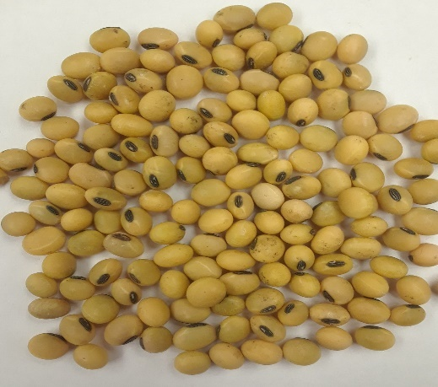
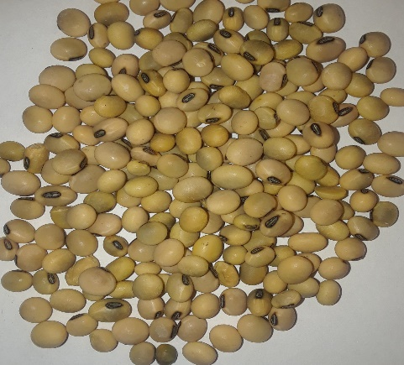
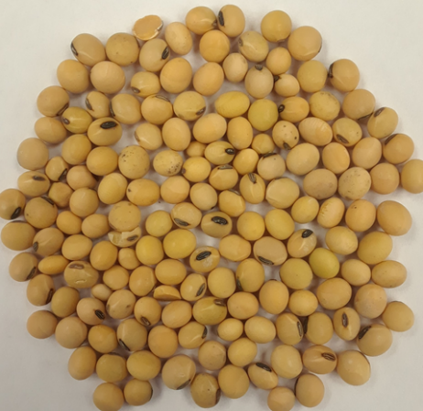
After desiccation and field drying, sampling of soybean seeds for R6 was done at three different locations (North, Middle and South) on both plots.

Fig. 1a: Plot 1 – R6 desiccated Fig. 1b: Plot 2 – R6 desiccated Fig 1c: R8 Control
Plot 1 soybean seeds desiccated at the R6 growth stage had good weather conditions with exposure to sunlight after killing until harvest. Fig. 1a shows that there was significant change in the color of the seed coat with a golden yellow tone approaching that of mature soybean (R8-control) after field drying. This was also indicated in the color (L* a* b*) values recorded (L 61.43 ± 0.12, a +0.19 ± 0.18, and b +18.12 ± 0.06). However, R6 harvested in plot 2 shown in Fig. 1b had a green tone to the golden color that was also indicated in color values of L 61.09 ± 0.22, a +2.04 ± 0.02, and b +15.30 ± 0.26, respectively. This was likely due to the freezing temperatures, snow and rain, and lack of sun after desiccation.
The control sample in Fig. 1c had color values of L 64.25 ± 0.02, a +2.95 ± 0.16, and b +18.93 ± 0.19. The “b” value in Plot 1 R6 (Fig. 1a) was close to that of the control (Fig. 1c), while Plot 2 values differed from the control values. This shows weather after desiccation greatly influence the color change during field drying. Chlorophyll content for the desiccated and field dried R6 seeds from both plots were very similar at about 1.27 ± 0.09 mg/kg of oil and near that of the control. Despite the green tone of the seeds in Fig 1b, very low chlorophyll content was observed in the oil.
Effect of storage on the quality of stored seeds
Color
Color change of stored soybeans was analyzed for R6 and R7 seeds from plot 2 and mature R8 – control from another field. It was observed that moisture content did not have any significant effect on the color “a” value of the stored soybeans over the 6 months period (p <0.05); therefore, only 17% Moisture data is shown in Fig 2.
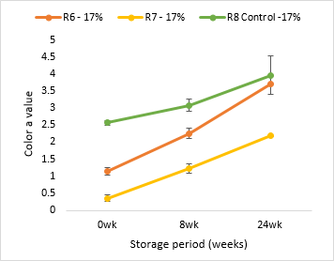
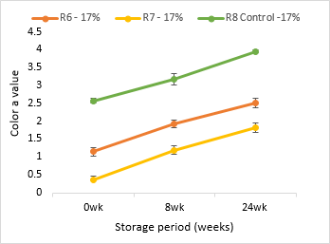
Fig. 2a: Color of stored soybeans at 4 °C Fig. 2b: Color of stored soybeans at 23.5 °C
Fig 2 shows that the color “a” values were different and increased a small amount during storage. A lower value indicates that there is more green tone. As the value increases, it indicates that the green tone is fading during storage. This trend was same in both storage conditions in Fig 2a and 2b. At the end of the sixth month of storage, the color of the R6 and R7 stored soybeans reflected “a” values of +2.32 ± 0.01 and +1.82 ± 0.12, respectively, approaching that of the initial mature R8 - control. In contrast, a green tone still existed in the visual observation of stored soybeans at the end of the sixth month. The color change observed in the warm storage was likely influenced by mold growth on the seeds.
Chlorophyll
Even though the graphs in Fig 3 show changes in chlorophyll content, this change was minimal throughout the cold and room temperature storage.
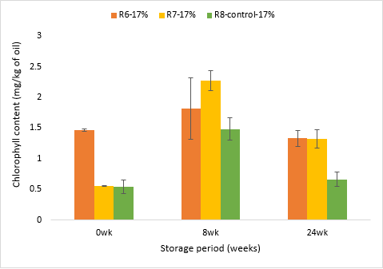
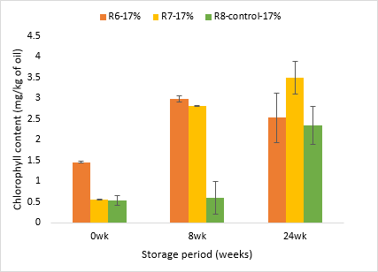
Fig 3a: Chlorophyll content at 4 °C Fig 3b: Chlorophyll content at 23.5 °C
Initial chlorophyll contents at the beginning of storage for all the samples (R6, R7, and R8) were below 1.5 mg/kg of oil, which is within the recommended value for chlorophyll in crude oil. This indicated a low chlorophyll content after field drying. Despite the green seed coat color, the chlorophyll content of the oil still was very low and close to that of the mature R8-control. Despite the snow and rain encountered prior to harvesting the desiccated seeds, leaving the seeds out on the field likely aided the natural ripening causing degradation of chlorophyll pigments in the seeds.
Mold counts
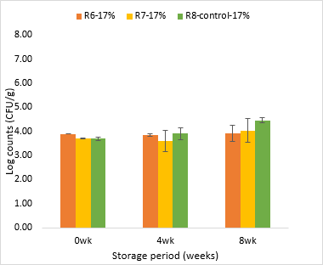
The seeds stored at 12% moisture levels did not show any mold growth throughout storage even at 74 ºF (23.5 °C). However, there was an increase in mold count during the second week in storage of 17% moisture soybean stored at room temperature (23.5 °C). see Fig. 4a.

Fig. 4a: Mold counts at 23.5 °C Fig. 4b: Mold counts at 4 °C
Average counts of 5.51 ± 0.05, 6.81 ± 0.00, and 6.41 ± 0.57 log CFU/g were obtained for the R6, R7 and mature R8 control at the end of the eighth-week (Fig. 4a) of 17% moisture soybean with high mold development on the soybeans. R6 stored soybeans however, showed slightly lower mold counts compared to R7 and mature R8 – control stored at 74 °F (23.5 °C). For 17% seeds stored at cold temperature, mold development was minimal throughout the eight weeks of storage for all treatments, R6, R7 and, mature R8 – control (Fig. 4b). However, log counts values were higher than obtained for soybeans stored at 12% at both cold and room temperature.
Peroxide and free fatty acid of the stored oil
Peroxide value (PV) of oil extracted from the soybeans showed minimal changes during storage for R6, R7 and mature R8- control. The PV of soybean seeds stored at room temperature and at 17% moisture had increased values but were still within standard acceptable limits. Free fatty acid contents of the oil at both storage temperatures and moisture levels were also within acceptable limits.
Conclusion
Field-drying conditions had a significant effect on the color and chlorophyll levels of the harvested soybeans after desiccation. Chlorophyll values were low after field drying. Moisture and storage temperature affect mold development. Chlorophyll change was minimal during storage. Peroxide and FFA values were within acceptable levels during storage.
References
Adams, C.A., Fjerstad, M.C. and Rinne, R.W. (1983). Characteristics of soybean seed maturation; necessity for slow dehydration. Crop Sci. 23, 265-267
Agronomy department (1998) Early frost effects on Soybean In Soybean and small grains, University of Wisconsin-Madison. http://www.coolbean.info/pdf/soybean_research/library/grain_production/Early_frost_effects_on_soybean_new.pdf
Barker, B. (2017) Soybean Green seed and Pulse seed quality. In Saskatchewan pulse growers https://saskpulse.com/files/newsletters/171106_Soybean_Green_Seed_and_Pulse_seed_quality.pdf
Cenkowski, S. and Jayas, D.S. (1993). Potential of infield and low temperature drying for reducing chlorophyll contents in canola (Brassica napus L). J. Sci. Food Agric. 63:377-383\
Maier, D. E. and Parsons, S. D. (1996), Harvesting, drying and storing frost- damaged corn and soybeans. Grain quality, Fact sheet 27. Purdue University, pp.1-8 Mair and Parsons
Use caution when drying soybeans (2018). https://www.no-tillfarmer.com/articles/919-use-caution-when-drying-soybeans

