**Determining suitable planting date and soil temperature for enhanced growth and yield of soybean under no-till semi-arid condition**

**(Technical Report – 2019/20)**

Gautam Pradhan*, Jerald Bergman, and James Staricka

NDSU Williston Research Extension Center, Williston, ND 58001

*Corresponding author: gautam.pradhan@ndsu.edu

**Situation statement**

Planting date plays a crucial role in the performance and success of a field crop. Early or late planting may decrease grain yield and quality of a crop due to increased biotic (insect, disease, weed), and abiotic (frost, drought, and high temperature) stress. Kandel (2013) noted that soybean is susceptible to frost and prolonged exposure to near-freezing conditions in the spring and fall, and recommended that soybean be planted in North Dakota and Northwestern Minnesota when the soil temperature is >50°F. Western North Dakota has a cool semi-arid climate with annual precipitation of <15 inches, which is at least 5 inches lower than the eastern part of the state. In this part of the state, the last spring freeze may occur in May and the first fall freeze in September. Thus, there is a need of determining optimal soybean planting dates and soil temperature for the western part of North Dakota that provide optimum growing period, decrease chances of frost and/or drought damage, and enhance grain yield.

**Objectives of the research project**

The overall goal of the project is to enhance soybean growth and yield under no-till semi-arid conditions of western North Dakota by finding suitable planting date and soil temperature. The secondary objectives are to determine the effect of planting date on soybean growth, physiology, and yield and find out whether variety and seed treatment affect the effects of planting date on those traits.

**Description of the research conducted**

Two glyphosate tolerant soybean varieties were seeded at Williston Research Extension Center, Williston (103.7397705°W 48.1337712°N), North Dakota. A GPS based autosteered seven rows no-till plot seeder was used that maintained a row to row distance of seven inches. The treatments comprised of seven planting dates (pd: 2nd, 9th, 16th, 23rd, and 30th of May, and 6th and 13th of June 2019) as main plots; two varieties (v: ‘ND17009GT’ and ‘ND18008GT’) as subplots, and two seed treatments (st: Treated with fungicide Obvious @ 6.4 oz/100 lb seed and Untreated as control) as sub-sub plots. Varieties ND17009GT and ND18008GT were developed by the Soybean Breeding Program at North Dakota State University and the relative maturity of these varieties is 00.9 and 00.8, respectively. The soil temperature data at 4” depth was downloaded from NADWN weather station located 715 feet southeast of the experimental field. At maturity, plant height was recorded, biomass was collected, and the crop was harvested using a plot combine. Soybean grain protein and oil content were estimated using InfratecTM 1241 Grain Analyzer and adjusted to 13% moisture. The data were analyzed using Proc GLIMMIX Procedure and means were separated at *p = 0.05* (Littell et al. 2006).

**Findings**

There was no effect of variety and seed treatment on days to seedling emergence. The planting dates, corresponding days to emerge, and soil temperature at 4” depth during emergence are given in Table 1. There was a significant effect of planting date (*p = 0.030*) and variety (*p = 0.006*) on above ground biomass. When averaged across other treatments, soybean planted on June 6th produced the highest biomass, however, it was significantly different than the one planted on May 16th only (Table 2). The variety ND18008GT produced 374 more lb/ac of biomass compared to the variety ND17009GT (Table 3).



There was a significant effect of variety (*p =0.025*) and interaction effect of pd×v×st (*p=0.012*) on plant height. When averaged across the other two treatments, ND17009GT was 1.1 inches taller than ND18008GT (Table 3). The effect of planting date on plant height was evident in treated ND17009GT, ND18008Gt, and untreated ND18008GT, but not in untreated ND17009GT (data not presented).



There was a significant effect of planting date (*p<0.001*), variety(*p≤0.001*), and pd×v (*p<0.001*) on grain yield. When averaged across other treatments, soybean planted on May 9th had the highest grain yield and the one planted on May 16th and June 13th had the lowest yield (Table 2). Variety ND18008GT produced 4.7 bu more grain per acre than ND17009GT (Table 3). The differential behavior of varieties to planting dates showed that, when averaged across seed treatment, ND18008GT consistently yielded higher when planted in May compared to June planting and ND17009GT produced higher yield when planted in June than in May (Figure 1). There was an exception that ND17009GT planted on May 9th produced as similar yield as of June planting. Between varieties, May planted ND18008GT had a higher yield than May planted ND17009GT except that there was no statistical difference in yield between two varieties planted on May 9th.

There was a significant interaction effect of pd×st on grain yield (*P=0.043*). Averaged across the varieties, soybean planted on May 9th produced the highest, and those planted on May 16th and June 13th produced the lowest grain per acre irrespective of seed treatment (Table 5).

There was a significant effect of planting date (*p<0.001*), variety (*p≤0.001*), and pd×v (*p<0.001*) on test weight. When averaged across other treatments, the highest and the lowest test weight was observed in soybeans planted on May 23rd and June 13th, respectively (Table 2), and ND17009GT had 0.36 lb/bu more test weight than ND18008GT (Table 3). The differential response of varieties to planting dates for test weight showed that, when averaged across seed treatment, May planting was better than June planting and May planted ND17009GT had a higher test weight than May planted ND18008GT (Figure 2).



There was a significant effect of variety (*p<0.001*) and seed treatment (*p=0.008*) on thousand grain weight (TGW). When averaged across other treatments, TGW of ND17009GT was 19 g heavier than ND18008GT (Table 3), and TGW of untreated seed was 1.9 g heavier than the treated seed (Table 4).



There was a significant effect of planting date on soybean grain protein and oil content. When averaged across other treatments, the highest and the lowest grain protein was observed in soybeans planted on May 23rd and June 13th, respectively; and the highest and the lowest grain oil content was observed in soybeans planted on May 16th and May 30th, respectively (Table 2). There was a significant effect of variety ((*p<0.001*) and seed treatment (*p=0.02*) on oil content. When averaged across other treatments, ND17009GT had 0.31% more oil content than ND18008GT (Table 3), and the untreated soybean had 0.12% more oil content than the treated (Table 4).



**Summary/recommendations to North Dakota soybean Farmers and industry**

The outcomes of this project showed that under no-till dryland conditions of western North Dakota, there was a differential response of soybean varieties to planting dates for grain yield. Variety ND18008GT may be planted up to June 6th to avoid 9 bu/ac of yield loss if planting is delayed to June 13th; whereas ND17009GT shall be planted in June than in May to avoid similar loss. There is a need for further investigation to determine the high yield performance of ND17009GT, when planted on May 9th. The experiment will be repeated next year to validate the findings.

**Acknowledgments**

We acknowledge the financial support of the North Dakota Soybean Council. Mention of trademark or proprietary product does not constitute a guarantee or warranty of the product by North Dakota State University and does not imply its approval to the exclusion of other products which may also be suitable.

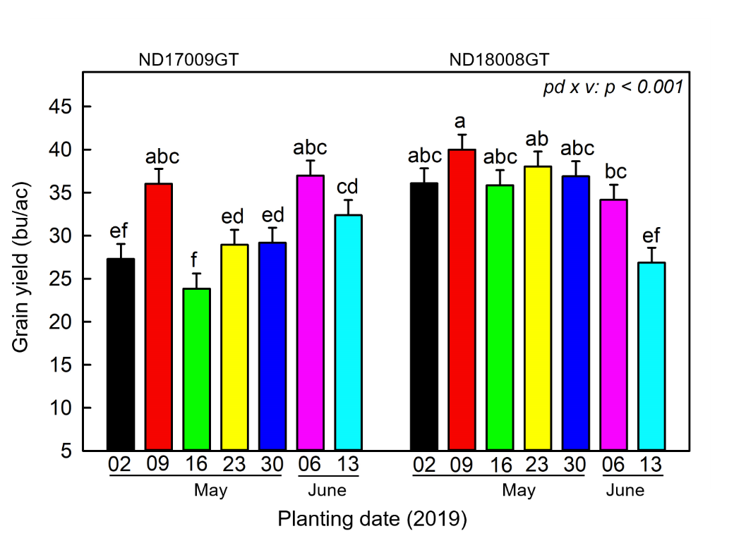**Figure 1. Interaction effect of planting date × variety on soybean grain yield**§**.**

§The data are averaged across seed treatment. LS-means on top of the bar with the same letter are not significantly different.

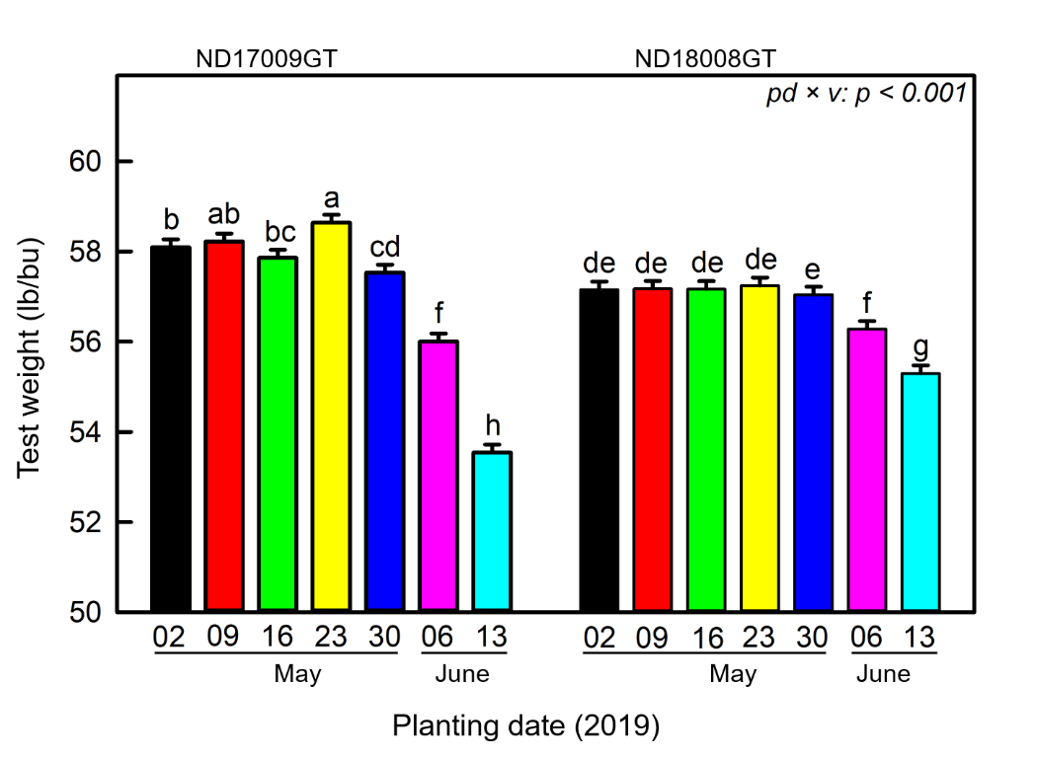**Figure 2. Interaction effect of planting date × variety on soybean test weight**§**.**

§The data are averaged across seed treatment. LS-means on top of the bar with the same letter are not significantly different.