SCREENING COVER CROPS FOR MANAGING SOYBEAN CYST NEMATODE AND OTHER NEMATODES IN INFESTED SOILS

TECHNICAL REPORT

NORTH DAKOTA SOYBEAN COUNCIL
JUNE 2020

Dr. Guiping Yan, Principal Investigator, Dept. Plant Pathology, NDSU
Co-investigators: Dr. Marisol Berti, Dept. Plant Science, NDSU and Dr. Sam Markell, Dept. Plant Pathology, NDSU

Soybean cyst nematode (SCN), Heterodera glycines, is one of the most important pests of soybean production in North Dakota (ND). It is an endoparasitic nematode, which infects soybean roots, causes colonization of roots and ultimately affects growth and yield of the soybean crop. This nematode not only infects soybean, but also invades other leguminous crops and weed species which play an important role in nematode survival and population increase in fields. Limited sources of resistance that have been utilized for developing resistant cultivars for managing this nematode cause the virulence changes in nematode populations, so an integrated management strategy is necessary for sustainable management of this devastating soybean pest. Cover crops that are non-hosts to SCN and have the ability to reduce SCN population can be integrated in the management practice as an alternative means.
Previous studies have shown that cover crops could suppress plant-parasitic nematode populations such as root-knot nematode (Meloidogyne spp.), root-lesion nematodes (Pratylenchus penetrans), sugar beet cyst nematode (Heterodera schachtii), and potato cyst nematode (Globodera spp.). Cover crops may reduce SCN populations by three ways, such as non-host with encouraging SCN egg hatching, producing toxic biochemical compounds, and acting as a trap crop. In ND, some cover crops that are being used or could be used have not been tested for SCN, and limited information is available about the interaction between cover crops and SCN. The overall goal of this research is to sustainably manage SCN by utilizing cover crops as an alternative means. The specific objectives of this research were to 1) screen twenty entries of cover crops for hosting ability to SCN in controlled greenhouse conditions; and 2) evaluate ten cover crops for their effects on reducing SCN and vermiform (motile) plant-parasitic nematodes in infested soils in external environment (microplot).
Soil samples were collected from two SCN-infested fields in Cass and Richland counties of North Dakota based on our previous work. Nematodes were extracted from soil and counted under a microscope to determine the initial population densities of SCN and other vermiform plant-parasitic nematodes. The soil samples collected from these two fields were used for the greenhouse and microplot experiments.
Twenty-one cover crop species and cultivars plus two susceptible soybean cultivars (Barnes and Sheyenne) and two common rotational crops (wheat and corn) were tested in the naturally infested soils from two fields in the greenhouse. Experimental design was a completely randomized design (CRD) with 5 replications. Plants of the 25 entries were grown in a growth chamber for 35 days at 27º C. After 35 days of growth, cysts were extracted from roots and soil in each pot and white females (cysts) were identified and counted under a microscope. The host status was determined by comparing number of white females in each of the cover crops with the susceptible soybean check Barnes.
Out of the 21 cover crops tested in the greenhouse, 18 crops [Alfalfa (cv. Bullseye), Balansa clover, Berseem clover, Brown mustard (Kodiak), Daikon radish (Eco-Till), Faba beans (Petite and CNS), Flax (Carter), Forage oat, Japanese millet, Oilseed radishes (Concorde, Control and Image,), Pennycress, Sunnhemp, White mustard (Master), White proso millet, and Winter camelina (Joelle)] did not show any reproduction for the two SCN populations from the fields (Table 1). As expected, two common rotational crops, Corn (DKC44-13) and Wheat (Glenn) did not support any SCN reproduction. The results indicated that these crops were non-hosts of SCN. Two cover crops, Chickling vetch (Pulse) and Crambe (Belann) showed limited reproduction with average numbers of white females from 5 to 13 for the SCN population (Soil 2W) from Cass County and from 1-3 for the population (Soil 103) from Richland County, suggesting they were poor hosts. However, one cover crop, White lupine showed considerable reproduction with 177 white females for Soil 2W and 60 white females for Soil 103, suggesting as a suitable host. SCN reproduced less in all the tested crops compared with the susceptible soybean cultivars Barnes and Sheyenne with white females from 560 to 888 and from 450 to 676, respectively (Table 1).
Ten cover crops including Alfalfa, Chickling vetch, Daikon radish, Faba bean (Petite), Flax, Oilseed radish (Concorde, Control, Image), Sunnhemp, and White mustard were selected for the microplot experiments using the infested soils from these fields along with the soybean check Barnes and a non-planted natural soil (fallow). The crops were planted in large plastic pots each having 5 kg of soil from each of the fields (Figure 1). After germination, standard seeding rates were used to keep required number of plants per pot. Plants were grown in the greenhouse for two weeks for better establishment before they were moved to the microplot in natural field conditions. The microplot experiments were set up on August 14. Pots were buried into soil leaving approximately 10 cm of pot remaining above the soil surface. Experimental design was a randomized complete block design (RCBD) with 5 replications. After 75 days of plant growth in the microplot, three soil cores were taken from each pot to make a composite sample (October 28) before the snowfall killed the plants. All the soil samples were stored in a cold room until SCN and vermiform nematodes were extracted and counted to determine the final population densities. The reproductive factor (RF) was determined for each treatment by dividing the final nematode population density by the initial population density. Population reduction (%) of SCN was also calculated [(initial population on tested cover crop-final SCN population on tested crop)/initial SCN population on tested cover crop x 100].
In naturally infested soils from both fields, the average reproductive factor (RF) of SCN in all cover crops was significantly (P < 0.05) lower than the susceptible soybean check Barnes (Figure 2), showing that soybean significantly increased the SCN populations. All cover crops and non-planted natural soil (fallow) were able to reduce the SCN populations. The average RF among the cover crops ranged from 0.14 to 0.34 (Figure 2).
All cover crops significantly reduced the initial population of SCN 103 as compared to the non-planted natural soil control whereas for SCN 2W only Sunnhemp significantly reduced the initial SCN population as compared to the non-planted natural soil (Figure 3). Among all the cover crops tested, Sunnhemp (cultivar not stated, CNS) was found to have the greatest reduction for both SCN populations, with the population reduction of 86.3% and 82.1% for SCN 2W and SCN 103, respectively. Three oilseed radish cultivars (Concorde, Control, and Image) along with Daikon radish (Eco-till) and Alfalfa (Bullseye) also consistently reduced the SCN populations from both fields (Figure 3). Faba bean (Petite) was also among the cover crops with a great population reduction for both SCN populations. The average population reduction percentage among the cover crops ranged from 66.4% to 86.3% (Figure 3).
Among vermiform plant-parasitic nematodes, stunt nematode, spiral nematode, and root-lesion nematode were detected in SCN 103 but not in SCN 2W. However, none of the cover crops showed significant difference in reproductive factor as compared to the soybean and non-planted natural soil controls (P > 0.05) (Figure 4).
In conclusion, all the cover crops tested in microplot conditions were able to suppress the nematode populations in naturally infested soils from two different fields of North Dakota as compared to the susceptible soybean Barnes and non-planted natural soil (fallow). Sunnhemp with the highest population reduction significantly reduced the initial SCN egg numbers in both field soils. Good SCN reproduction in the susceptible soybean cultivar Barnes demonstrated the suitability of the environment for nematode development and measurement, which further supports the data for suppression of SCN by the cover crops. This experiment will be repeated in 2020 to further validate the findings. The cover crops that are non-hosts with higher population reduction ability will be recommended to farmers for management of SCN. Mechanisms of SCN suppression by the cover crops will be studied to further help to develop an integrated management strategy for SCN. The research findings are useful to navigate the selection and use of cover crops for farmers for reducing SCN damage to increase soybean yield in ND.

Table 1. Reproduction of soybean cyst nematode (SCN) in different crops planted in naturally infested soil with each of the SCN populations (Soil 103 and 2W).
 |  |  | No. of white females per plant
Cropª | Scientific Name | Family | Soil 2W^{b} | Soil 103^{c}
Soybean (Barnes) | Glycine max | Leguiminosae | 888 | 560
Soybean (Sheyenne) | Glycine max | Leguiminosae | 676 | 450
White lupine (CNS) | Lupinus albus L. | Fabaceae | 177 | 60
Chickling vetch (Pulse) | Vicia villosa | Fabaceae | 13 | 3
Crambe (Belann) | Crambe abyssinica | Brassicaceae | 5 | 1
Alfalfa (Bullseye) | Medicago sativa L. | Fabaceae | 0 | 0
Balansa clover (CNS) | Trifolium michelianum Savi | Fabaceae | 0 | 0
Berseem clover (CNS) | Trifolium alexandrinum L. | Fabaceae | 0 | 0
Brown mustard (Kodiak) | Brassica juncea L. | Brassicaceae | 0 | 0
Corn (DKC44-13) | Zea mays L. | Poaceae | 0 | 0
Daikon radish (Eco-Till) | Raphanus sativus L. | Brassicaceae | 0 | 0
Faba bean (Petite) | Vicia faba Roth | Fabaceae | 0 | 0
Faba bean 1 (CNS) | Vicia faba Roth | Fabaceae | 0 | 0
Flax (Carter) | Linum usitatissimum L. | Linaceae | 0 | 0
Forage oat (CNS) | Avena sativa L. | Poaceae | 0 | 0
Japanese millet (CNS) | Echinochloa esculenta L. | Poaceae | 0 | 0
Oilseed radish (Concorde) | Raphanus sativus L. | Brassicaceae | 0 | 0
Oilseed radish (Control) | Raphanus sativus L. | Brassicaceae | 0 | 0
Oilseed radish (Image) | Raphanus sativus L. | Brassicaceae | 0 | 0
Pennycress (CNS) | Thlaspi arvense | Brassicaceae | 0 | 0
Sunnhemp (CNS) | Crotolara juncea L. | Fabaceae | 0 | 0
Wheat (Glenn) | Triticum aestivum L. | Poaceae | 0 | 0
White mustard (Master) | Sinapis alba L. | Brassicaceae | 0 | 0
White proso millet (CNS) | Panicum miliaceum | Poaceae | 0 | 0
Winter camelina (Joelle) | Camelina sativa (L.) Crantz | Brassicaceae | 0 | 0
ª Crop (Cultivar or Cultivar Not Stated = CNS)
^{b} Initial population density for Soil 2W from Cass, ND was 5,000 eggs and juveniles/100 cm³ of soil
^{c} Initial population density for Soil 103 from Richland, ND was 3,100 eggs and juveniles/100 cm³ of soil

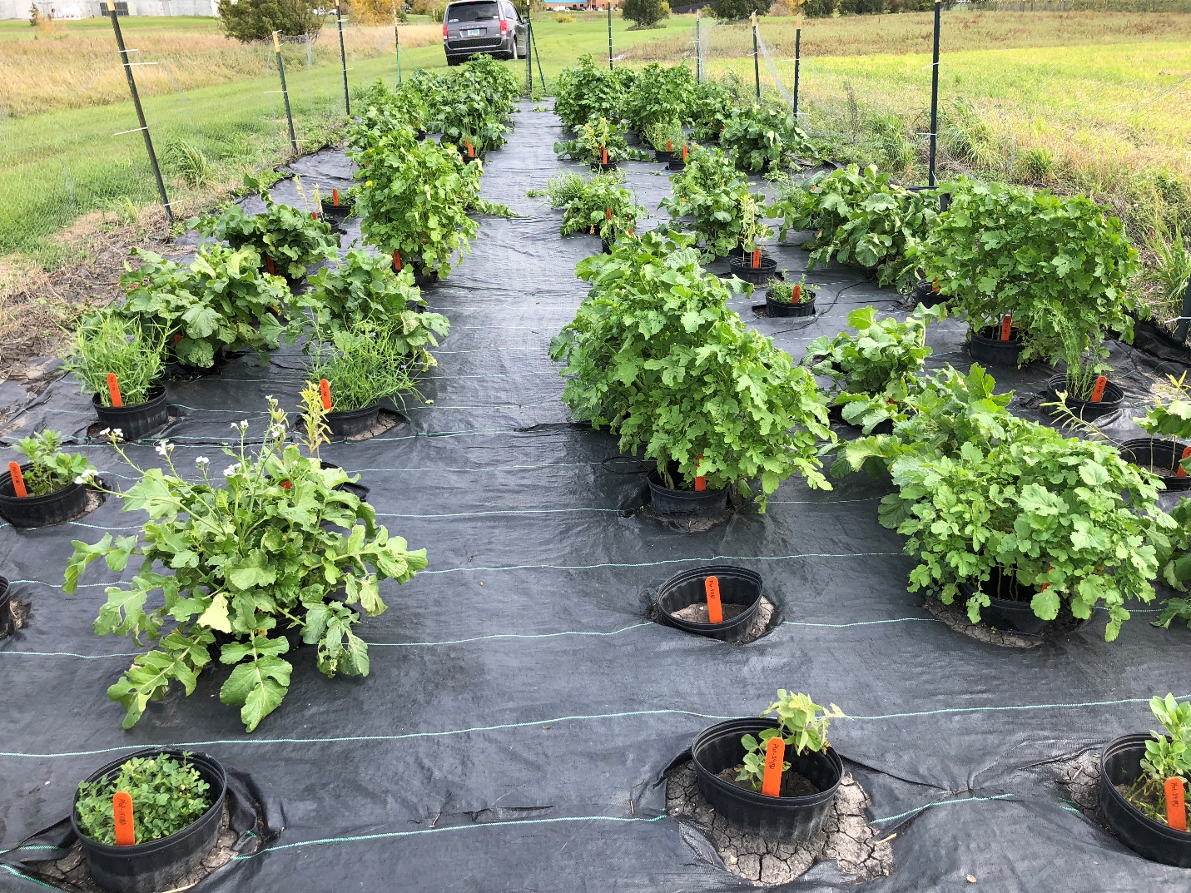

Figure 1. Cover crops grown in plastic pots each containing 5 kg of naturally infested soil in the microplot.

Figure 2. Average reproductive factor (RF) of SCN on cover crops, soybean, and non-planted natural soil (fallow) in microplot conditions with infested field soils SCN103 and SCN2W. Average RF is average of RF values from five replications for each treatment. RF values with same letters are not significantly different (P > 0.05).

Figure 3. Population reduction (%) of SCN by cover crops and non-planted natural soil (fallow) in microplot conditions with infested field soils SCN 2W and SCN 103. Population reduction of SCN is the mean of five replications from each treatment.
Figure 4. Reproductive factor of vermiform plant-parasitic nematodes (stunt, spiral, and root-lesion nematodes) on cover crops and controls tested in the microplot with field soil (Soil 103).

