Planting Green - Getting More Payback from Cover Crops
Report on Experiments and Results Completed Through March 2018

Ray Weil, University of Maryland

Beltsville Research Station Experiments
At a research farm in Beltsville, operated by the University of Maryland, a replicated interseeding study is being performed on multiple sites to determine the best seeding time for a legume, grass, brassica mixture
- On two fields (one with sandy soil, one silty soil) a mix of rye, crimson clover, and daikon radish was interseeded into standing soybeans on two dates (9/11, 9/22) and air-seeded after soybean harvest (on 10/6 for one field, 10/23 for the other) with a control of no cover crop. Corn was planted on these fields in the spring. This experiment was repeated for 2018-2019 (see Figure 1).
- On two other fields (also one with sandy soil, one silty soil) a mix of triticale, crimson clover, and daikon radish was drilled into a field where wheat was harvested in July and which was treated with dairy manure slurry in early August. Cover crops were drilled with 4 planting dates (9/12, 9/21, 10/3, and 10/17) with a control of no cover crop. In early April, a random half of each plot was sprayed with herbicide, while the other half was allowed to grow until cash crop planting in early May. Corn was planted on these fields in the spring. This experiment was not repeated for 2018-19.
By conducting this study with a variety of planting dates on smaller scale replicated plots, we could more precisely control the conditions of the study, include more treatments and make more statistically confident statements about our results.

The corn yields from the wheat stubble experiment provided interesting insight into how effectively our methods can benefit yields. These results made up the bulk of a presentation Nathan gave to the American Society of Agronomy conference in November 2018. During a dry summer (Figure 2) the corn began to tassel. On the sites with a larger cover crop, corn yields were higher, the soil was better protected (Figure 3), and the soil moisture was higher (Figure 2).

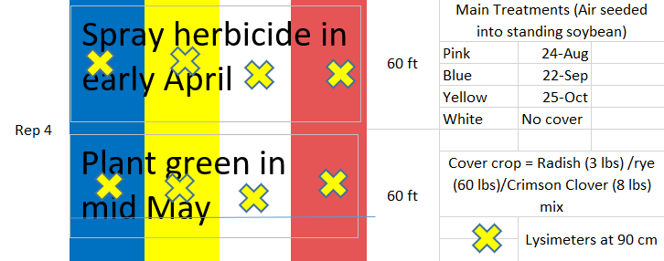
Figure 1: Example layout of a plot for the soybean interseeding study. Each color represented a different planting date, and the location for different planting and kill date treatments were determined randomly.

Figure 2: Volumetric water content of soil at 40 cm over a summer drought on a sandy soil. The second y-axis shows total daily rainfall. Soil moisture was substantially higher on the treatments where the cover crop was killed late.
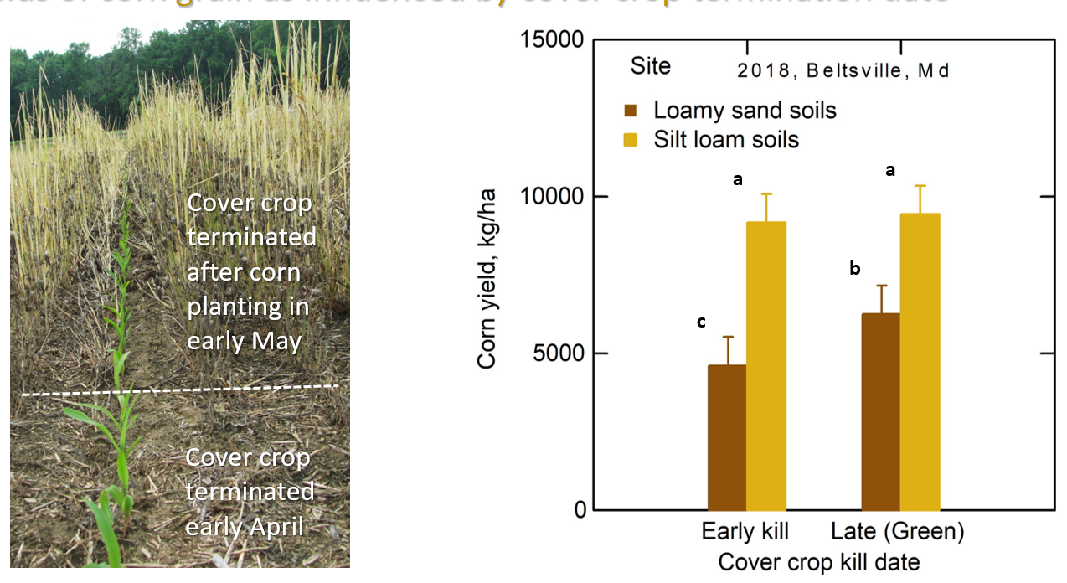
Figure 3: Photo (left) showing the differences between the cover crop terminated in early April versus early May and the difference in soil cover. Graph (right) shows the corn yield based on cover crop kill time and how it differences by soil type. The yields on the loamy sand where the cover crop was killed early were significantly lower than the yields for the late killed cover crop.

The soybean experiment at Beltsville provided important insight for cover crop interseeding in winter 2018. This fall had very high rainfall, which provided good conditions for interseeded cover crops, but poor conditions for drilling a cover crop. Under these conditions, the differences between treatments were dramatic. However, as our 8/24 seeding date shows, it is possible to interseed a cover crop too early in the year (Figure 4).

Figure 4: Results from soybean interseeding experiment in Fall 2018. October results were drilled after harvest and biomass was substantially lower than the interseeding results. Earliest interseeding results showed that the ideal planting window likely exists in between the 8/24 and 9/22 date, when soybean leaves are all yellow, but before they begin dropping.

As of March 2019, biomass was harvested from field sites at Beltsville and the Eastern Shore, but the kill date treatments had not yet been applied. Current plans are to harvest cover crop biomass from each treatment in the first week of April, followed by herbicide application on early killed treatments. Biomass will be harvested from late killed treatments in the first week of May, followed by herbicide treatment and corn planting.

