FINAL TECHNICAL REPORT TO THE NORTH DAKOTA SOYBEAN COUNCIL
For work performed on the project:

Soybean Soil Fertility in North Central and Northwest North Dakota, 2016-2018

D.W. Franzen, Professor Soil Science, Extension Soil Specialist, North Dakota State University, Fargo, ND 58103. 701-799-2565. david.franzen@ndus.edu
Chris Augustin. Extension Soil Health Specialist, North Central Research & Extension Center, Minot, ND and PhD candidate, Soil Science, NDSU. Chris.augustin@ndus.edu

Introduction
Prior to these experiments, there were few soybean soil fertility studies from north central and northwest North Dakota. The NDSU soybean soil fertility circular and recommendations in place in June, 2019 were developed from previous work in the traditional soybean growing region of southeast North Dakota. This research is designed to fill a knowledge gap from north central and northwest ND and provide confidence to soybean growers in those regions that practices offered as nutrient and soil amendment options are valid and cost-effective. The results of this research will provide information that will increase soybean grower profitability in the region.
Objectives:
1. Determine major nutrient requirements of soybean in north central and northwest North
Dakota.
2. Determine response of soybean to sugar beet waste lime for pH improvement in acid soils of
north central North Dakota.
3. Determine the starter fertilizer response of soybean in north central and northwest North
Dakota.
4. Determine the foliar fertilizer response of soybean in north central and northwest North
Dakota.

Methods

Over 3 years (2016-2018), 6 sites were established in northwest (NW) and north central (NC) North Dakota (Figure 1). One site each year was located in the NW on soils with pH > 7, and one site was located each year in the NC region on soils with slightly to moderately acid pH (< 6). Six cores across the intended experimental area at each site were collected at the 0-6 inch and 6-24 inch depth using a hand soil probe with a 1-inch tip. The cores were composited and sent to the North Dakota State University Soil Testing Laboratory, Fargo, ND for analysis (Table 1). All soil tests were conducted using approved and standard practices recommended for North Dakota crops. More than one possible experimental location in the north and the south were annually sampled, and the results were screened and selected for the experiments using early spring soil analysis results.

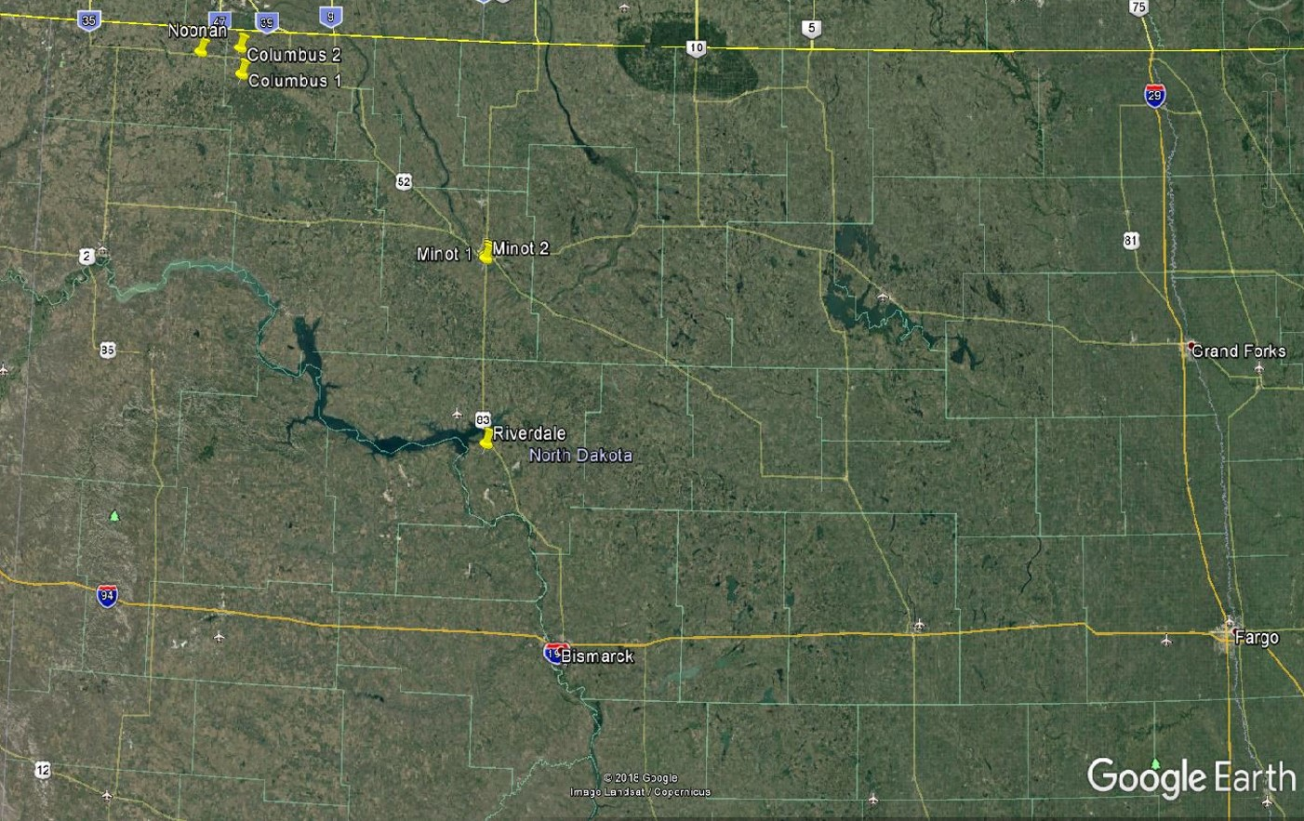

Figure 1. Locations of experiments from 2016-2018. For latitude and longitude, see Table 1.

Each experiment was designed as a randomized complete block with 12 treatments (13 in 2018) and 4 replications. The treatments were as follows:

1. Check (no fertilizer)
2. Seed Bradyrhizobium inoculated (on seed)
3. 100 pounds per acre of 11-52-0 broadcast (preplant)
4. 3 gallon per acre 10-34-0 (in-furrow at planting)
5. 3 gallon per acre 6-24-6 (in-furrow at planting)
6. 50 pounds of N per acre as urea (preplant broadcast)
7. South only-Sugar beet waste lime @2 tons per acre (preplant broadcast)
7. North only-Iron ortho-ortho-EDDHA seed applied (in-furrow at planting)
8. South only-Sugar beet waste lime @ 4 tons per acre (preplant broadcast)
8. Naked ortho-ortho-EDDHA seed applied (Levesol- in-furrow at planting)
9. Foliar 3-18-18 at V5
10. Foliar 3-18-18 with S at V5
11. Foliar 3-18-18 at R2
12. Foliar 3-18-18 with S at R2
13. (2018 only) Cobalt, preplant broadcast (sprayed)

The 11-52-0, urea and lime treatments were hand-applied. The urea was treated with an NBPT 26.7% a.i. at a rate of 3 qts/ton urea to prevent ammonia volatilization. The iron ortho-ortho-EDDHA (Soygreen™) at 2 qt/acre and Levesol™ at 2 qt/acre were mixed with water and applied at a 3 gal/acre rate in-furrow at seeding. The foliar treatments were a manufactured liquid originating from the reaction of anhydrous ammonia and potassium hydroxide with white phosphoric acid (9-18-9) and for the w/S treatment, 9-18-9 was mixed with ammonium sulfate (1 pound per acre) applied at a rate of 3 gallon per acre broadcast with a hand-held sprayer. Cobalt in 2018 was applied at 1 lb Co per acre as cobalt sulfate, and broadcast sprayed preplant using 10 gallon per acre water total mix.

Table 1. Location and soil nutrient values at experimental locations.
Site |  | Year | GPS location | NO₃-N |  | P† | K | Zn | Fe | EC | pH
 |  |  |  | 0-15 cm depth | 15-60 cm depth | ------------- 0-15 cm depth -------------
 |  |  | latitude, longitude | - lb/acre - |  | -------- ppm ------- |  |  |  | mmoh/cm
Columbus |  | 2016 | 48.795444ºN, 102.853044ºW | 33 | 81 | 6 | 224 | 0.29 | 11 | 0.35 | 7.6
Minot | 2016 |  | 48.179167ºN , 101.316367ºW | 9 | 33 | 8 | 316 | 0.29 | 48 | 0.47 | 6.2
Columbus |  | 2017 | 48.8891ºN , 102.8701ºW | 30 | 48 | 5 | 276 | 0.48 | 7 | 0.20 | 7.2
Riverdale |  | 2017 | 47.5018ºN, 101.2781ºW | 33 | 44 | 7 | 223 | 0.69 | 56 | 0.31 | 5.8
Noonan |  | 2018 | 48.866667ºN, 103.114722ºW | 22 | 44 | 14 | 338 | 0.67 | 14 | 0.46 | 7.3
Minot |  | 2018 | 48.169111ºN, 101.316320ºW | 19 | 8 | 7 | 315 | 1.01 | 54 | 0.28 | 5.8
†P determined using the Olson procedure. K determined using 1-N Ammonium acetate solution on a dried sampled; Zn and Fe determined using DTPA extractant. Electrical conductivity (EC) and soil pH was determined on a 1:1 soil to water dilution.

Table 2. Experimental location soil series.
Site | Soil Series | NRCS designation of series
Columbus 2016 and 2017 | Williams loams | Fine-loamy, mixed, superactive frigid Typic Argiustolls
Minot 2016 and 2018 | Aastad loams | Fine-loamy, mixed superactive, frigid Pachic Argiudolls
Riverdale | Wilton loams | Fine-silty, mixed superactive frigid Pachic Haplustolls
Noonan | Williams loams | Fine-loamy, mixed, superactive frigid Typic Argiustolls

Soybean cultivars were chosen based on maturity and iron deficiency chlorosis (IDC) rating as published by Kandel et al., 2015; Kandel et al., 2016; Kandel et al., 2017. Soybeans planted at the Columbus sites were IDC tolerant (Table 3).
Experimental units were 10 feet wide and 30 feet long. Soybeans were seeded at a rate of 150,000 pure live seeds per acre using a single disk opener cone plot planter (Figure 1). The planter row spacing was 16.8 cm.
Pesticide treatments were based on present weed species at each location and applied according to their respective label and recommendations (Zollinger et al., 2016; 2017; 2018).

Table 3. Soybean cultivar selected per site with dates for planting, foliar fertilizer application and harvest.
Site | Seed  Company | Soybean Cultivar | Planting | V5 Foliar Application | R2 Foliar Application | Harvest
 |  |  | ---------------------------Date----------------------------
Columbus | NorthStar Genetics | NS0081NR2 | 5/30/2016 | 7/8/2016 | 7/27/2016 | 9/23/2016
Minot | Proseed | 20-30 | 5/29/2016 | 7/8/2016 | 7/28/2016 | 9/25/2016
Columbus | Legend | 009R20 | 5/22/2017 | 7/6/2017 | 8/4/2017 | 9/29/2017
Riverdale | Hefty | H009R3 | 5/24/2017 | 7/8/2017 | 8/5/2017 | 10/1/2017
Noonan | Peterson | 17x009 | 5/24/2018 | 7/3/2018 | 7/18/2018 | 9/26/2018
Minot | NDSU | ND17009GT | 5/25/2018 | 7/3/2018 | 7/19/2018 | 10/6/2018

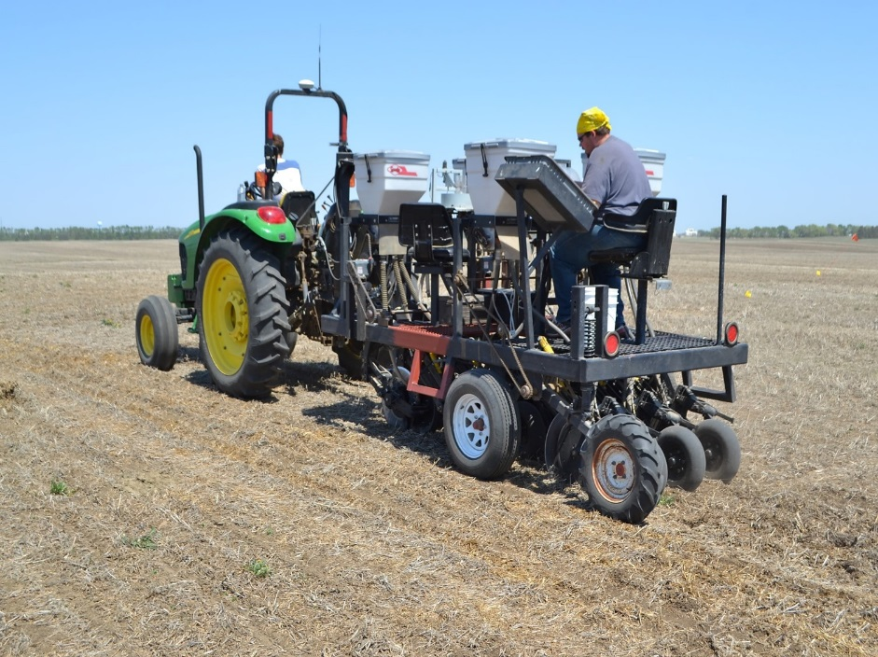

Figure 2. Seeding and amendment application in-furrow apparatus used in these experiments.

Table 4. Herbicide use by site and date.
Site | Herbicide Application Date | Chemical Common Name | oz/a active ingredient
Columbus | 6/10/2016 | Glyphosate | 18
Minot | 6/20/2016 | Glyphosate | 11
Columbus | 6/21/2017 | Glyphosate | 18
Riverdale | 6/10/2017 | Imazethapyr | 0.75
 |  | Glyphosate | 18
Noonan | 6/4/2018 | Glyphosate | 18
 | 6/19/2018 | Glyphosate | 18
Minot | 5/29/2018 | Glyphosate | 11
 |  | Carfentrazone | 0.2
 |  | Saflufenacil | 0.4
 | 6/8/2018 | Bentazon | 8
 |  | Glyphosate | 22
 | 6/14/2018 | Bentazon | 8

Soybeans were harvested using a small plot combine and cleaned using a vacuum-type seed cleaner before yield, protein, and oil content were determined. Oil and protein content were measured using a DA 7200 NIR analyzer (Perten Instruments Incorporated, Hagersten, Sweden).

Statistical Analysis
Analysis of variance was performed using the PROC GLM procedure of SAS software version 9.4 (SAS Institute Incorporated, 2012). Environments were considered homogenous when the variance across sites were less than a factor of 10 (Tabachnick and Fidell, 2001). Environments were treated as a random effect.

Results
2016
At Columbus, there were no differences in yield or grain protein compared to the check. Yield averaged about 32 bu/acre. There was a small difference in oil concentration between N application and Levesol treatments and the 3 gal/acre 10-34-0 and foliar 3-18-18 R2 treatments.
At Minot, the lowest yield of any treatment was the foliar 3-18-18 application at R2, which treatment also resulted in the lowest seed oil concentration and greatest protein content (Table 5). Highest yield was obtained with inoculation, which was surprising, since the site had been in soybean within the past 4 years.

Table 5. Effect of treatment on soybean yield, protein and oil concentration at Minot, 2016.
Treatment | Yield, bu/a | Protein, % | Oil, %
Check | 39.5 ab | 34.5 abc | 14.9 ab
Inoculation | 43.5 a | 33.9 c | 14.9 ab
50 lb/acre urea, preplant broadcast | 39.7 ab | 34.6 abc | 14.6 b
100 lb/acre 11-52-0, preplant broadcast | 38.4 ab | 34.9 ab | 14.6 b
3 gal/acre 10-34-0 in-furrow | 39.9 ab | 34.3 abc | 15.2 a
3 gal/acre 6-24-6 in-furrow | 36.2 ab | 34.0 bc | 15.0 ab
2 ton/acre sugarbeet waste lime | 35.3 ab | 34.5 abc | 14.9 ab
4 ton/acre sugarbeet waste lime | 40.3 ab | 34.5 abc | 14.8 ab
Foliar 3-18-18 V5 | 32.8 ab | 34.5 abc | 14.9 ab
Foliar 3-18-18 R2 | 31.4 b | 35.1 a | 14.6 b
Foliar 3-18-18+S R2 | 33.8 ab | 34.4 abc | 14.7 ab
Foliar 3-18-18 + S V5 | 38.6 ab | 34.1 bc | 14.9 ab
LSD 5% | 10.8 | 0.6 | 0.5

2017
The 2017 growing season was drier than in 2016 and yields were 20-30% lower. The Riverdale yields (Table 6) averaged about 27 bu/acre while the Columbus yields were about 30 bu/acre (Table 7).

Table 6. Effect of treatment on soybean yield, protein and oil concentration, Riverdale, 2017.
Treatment | Yield, bu/a | Protein, % | Oil, %
Check | 26.3 | 35.0 | 14.7
Inoculation | 27.5 | 34.6 | 14.7
50 lb N/acre, urea, preplant broadcast | 26.4 | 35.2 | 14.4
100 lb N/acre 11-52-0, preplant broadcast | 28.6 | 35.0 | 14.6
3 gal/acre 10-34-0 in-furrow | 29.6 | 34.6 | 14.8
3 gal/acre 6-24-6 in-furrow | 27.5 | 34.7 | 14.9
2 ton/acre sugarbeet waste lime | 29.0 | 34.8 | 14.7
4 ton/acre sugarbeet waste lime | 27.0 | 35.1 | 14.6
Foliar 3-18-18 V5 | 27.5 | 34.9 | 14.5
Foliar 3-18-18 R2 | 28.3 | 35.1 | 14.8
Foliar 3-18-18 w/S V5 | 25.6 | 34.9 | 14.7
Foliar 3-18-18 w/S R2 | 27.9 | 34.8 | 14.5
LSD 5% | NS | NS | NS

Table 7. Effect of treatment on soybean yield, protein and oil concentration, Columbus, 2017.
Treatment | Yield, bu/a | Protein, % | Oil, %
Check | 28.4 | 31.7 | 15.8
Inoculation | 32.3 | 32.2 | 15.6
50 lb N/acre, urea, preplant broadcast | 30.8 | 32.0 | 15.8
100 lb/acre 11-52-0, preplant broadcast | 30.9 | 31.0 | 16.1
3 gal/acre 10-34-0, in-furrow | 29.2 | 32.1 | 15.7
3 gal/acre 6-24-6, in-furrow | 28.7 | 31.5 | 15.8
Soygreen, in-furrow | 25.9 | 31.4 | 16.0
Levesol in-furrow | 30.1 | 31.5 | 15.9
Foliar 3-18-18 V5 | 30.6 | 32.3 | 15.8
Foliar 3-18-18 R2 | 31.9 | 31.5 | 15.9
Foliar 3-18-18 w/S V5 | 30.5 | 31.5 | 15.9
Foliar 3-18-18 w/S R2 | 29.8 | 31.6 | 15.7
LSD 5% | NS | NS | NS

There were no significant differences in yield, protein or oil concentration with treatment in 2017. The check values were similar to any of the treatment values.

2018
Due to exploratory parallel soybean studies in 2017, a cobalt (Co) treatment was added to the 2018 experiments. Cobalt is not an essential nutrient for the production of soybean or any crop grown in North Dakota, but it is an essential nutrient for N-fixing bacteria. Before this study, there were no experiments in any crop with Co application. Due to the successful inoculation and N-fixation in all of North Dakota perennial and annual legume crops, as well as the activity of asymbiotic N-fixing organisms, there was no reason outside of curiosity for including Co in the suite of 2018 treatments.
There were no yield differences from the check for any treatment at the Noonan (Table 8) or Minot (Table 9) sites in 2018. Average yields at Noonan were about 22 bu/acre, and yields at Minot averaged about 19 bu/acre.

Table 8. Effect of treatment on soybean yield, protein and oil concentration, Noonan, 2018.
Treatment | Yield, bu/a | Protein, % | Oil, %
Check | 18.9 | 30.7 | 16.5
Inoculation | 23.1 | 31.9 | 16.3
50 lb N/acre, urea, preplant broadcast | 20.8 | 32.5 | 16.6
100 lb/acre 11-52-0, preplant broadcast | 21.9 | 31.3 | 16.7
3 gal/acre 10-34-0, in-furrow | 22.7 | 31.5 | 16.3
3 gal/acre 6-24-6, in-furrow | 24.7 | 31.5 | 16.3
Soygreen, in-furrow | 22.5 | 31.2 | 16.3
Levesol in-furrow | 22.2 | 30.7 | 16.6
Foliar 3-18-18 V5 | 22.8 | 30.8 | 16.4
Foliar 3-18-18 R2 | 22.8 | 31.8 | 16.4
Foliar 3-18-18 w/S V5 | 21.6 | 31.5 | 16.7
Foliar 3-18-18 w/S R2 | 23.1 | 31.5 | 16.3
Cobalt, preplant broadcast | 19.6 | 31.6 | 16.5
LSD 5% | NS | NS | NS
Table 9. Effect of treatment on soybean yield, protein and oil concentration, Minot, 2018.
Treatment | Yield, bu/a | Protein, % | Oil, %
Check | 19.7 | 34.8 | 16.3
Inoculation | 18.6 | 34.5 | 16.3
50 lb N/acre, urea, preplant broadcast | 17.5 | 35.5 | 15.8
100 lb/acre 11-52-0, preplant broadcast | 16.9 | 35.0 | 16.1
3 gal/acre 10-34-0, in-furrow | 16.1 | 35.5 | 15.9
3 gal/acre 6-24-6, in-furrow | 19.9 | 35.3 | 15.9
2 ton/acre sugarbeet waste lime | 19.1 | 35.7 | 15.8
4 ton/acre sugarbeet waste lime | 20.0 | 35.6 | 15.8
Foliar 3-18-18 V5 | 18.2 | 34.6 | 16.1
Foliar 3-18-18 R2 | 16.3 | 34.9 | 16.3
Foliar 3-18-18 w/S V5 | 18.4 | 33.7 | 16.5
Foliar 3-18-18 w/S R2 | 16.3 | 35.3 | 15.9
Cobalt, preplant broadcast | 21.0 | 35.2 | 16.0
LSD 5% | NS | NS | NS

Conclusions

These studies confirm that unless soil nutrients are extremely low, there is nothing to gain by applying N fertilizer to soybean, P fertilizer to soybean in the west when soil Olson P values are 7 ppm or greater, applying lime to soils with pH 5.7 or greater, applying Soygreen or iron-less EDDHA to seed at planting even on high pH soils provided they seed an IDC tolerant cultivar, and there is no value to the soybean grower to foliar fertilizer application in-season. The inclusion of a cobalt treatment in 2018 confirmed that cobalt is not an amendment that will help improve soybean yield or protein content. This work is important because it indicates that in the west highest profit will be made by soybean growers who just plant the soybean, inoculating in early years, but thereafter even that is an unnecessary expense. Soybean profits will increase if soybean growers understand that fertilizer inputs of soybean in the west are generally not necessary, and that variety selection, attention to weed control, disease and occasionally insect control, and careful planter and combine settings will produce a better income stream.

