Optimizing fungicide applications for management of Sclerotinia in soybeans

Principal investigator:
Michael Wunsch, Ph.D. / plant pathologist, NDSU Carrington Research Extension Center
PO Box 219 / 663 Hwy. 281 N. / Carrington, ND 58421-0219
701.652.2951 office / 701.652.2055 fax / michael.wunsch@ndsu.edu

Co-investigator:
Kelly Cooper / agronomist, NDSU Robert Titus Research Farm, Oakes, ND

Introduction
Management of Sclerotinia stem rot (white mold), caused by the fungal pathogen Sclerotinia sclerotiorum, in soybeans is constrained by difficulties achieving satisfactory fungicide deposition to the lower canopy where most infections begin. Most Sclerotinia infections are initiated on dead blossoms on the lower half to lowest quarter of the main stem, and it is difficult to achieve satisfactory fungicide deposition to this target at the R2 to R4 growth stages when soybeans are most susceptible to Sclerotinia. Fungicide coverage is optimized with spray nozzles that deliver small droplets, but small droplets lack the velocity to efficiently penetrate dense canopies. Fungicide deposition to the lower canopy is typically optimized with medium-size droplets that have velocity to penetrate the canopy but still confer acceptable coverage (Derksen 2008). Further gains in fungicide coverage can be made by utilizing a canopy opener (Derksen 2008) or drop nozzles (Rüegg et al. 2006; Rüegg and Total 2013) that facilitate the delivery of fungicides directly into the lower canopy. The delivery of fungicides through drop nozzles permits the delivery of pesticides directly into the crop canopy between crop rows and has been shown to improve disease and insect control in vegetable production in Europe (Rüegg et al. 2006; Rüegg and Total 2013).
This is the first study to assess fungicide application methods, including the use of drop nozzles, to improve Sclerotinia disease control in soybeans. Fungicide application technology research has been conducted in soybeans targeting rust (Derksen 2008), but fungicide deposition patterns required for successful control of rust are different from the fungicide deposition patterns required for successful control of Sclerotinia: Control of rust requires good fungicide deposition to leaves in the interior of the canopy, while control of Sclerotinia requires good fungicide deposition to dead blossoms on stems in the lower canopy. The impact of nozzle spray patterns on Sclerotinia control in canola has been assessed (Kutcher and Wolf 2006), but differences in crop architecture make it difficult to translate those results to soybeans.
The objectives of this project were (1) to quantify the impact of spray pattern, droplet size, spray volume, boom height and adjuvants on the performance of fungicides applied through traditional boom-mounted nozzles and through drop nozzles; and (2) to evaluate the impact of delivering fungicides through drop nozzles, which sharply increases the delivery of fungicides to the lower canopy where white mold develops, on fungicide efficacy against white mold. Field trials were conducted in Carrington and Oakes, ND on land with a previous history of white mold, with supplemental overhead irrigation utilized to facilitate disease pressure.
Methods
Soybeans were seeded at 165,000 pure live seeds per acre in rows 21 inches apart on May 11 in Carrington and May 16 in Oakes. Plots were 5 feet wide and approximately 19 feet long at harvest, with an 11-foot non-harvested transition zone established between plots for starting and stopping fungicide treatment imposition. To prevent edge effects, alleys were not cut between plots until shortly before harvest. In Oakes, the 1.1-maturity variety Pioneer ‘P11A95X’ was seeded. In Carrington, the 0.6-maturity variety Peterson Farms ‘18X06N’ was seeded to the study evaluating the impact of nozzle droplet size, spray pattern and nozzle placement on the performance of drop nozzles; the 0.4-maturity variety ProSeed ‘XT60-40RR2Y’ was seeded to the studies evaluating nozzle spray pattern (standard flat fan versus air-induction flat fan nozzles, flat-fan versus twin-jet nozzles) and evaluating the impact of boom height on the performance of drop nozzles; the 0.9-maturity variety Peterson ‘17X09N’ was seeded to the study evaluating the impact of drop nozzles on fungicide efficacy; and Peterson ‘18X06N’, ProSeed ‘XT60-40RR2Y’, Peterson ‘17X09N’, and the 0.9-maturity variety Dairyland ‘DSR-0904’ were seeded to studies evaluating the impact of spray droplet size on fungicide performance. The study evaluating the impact of drop nozzles on fungicide efficacy was established as a randomized complete block design with a split-plot arrangement (main factor = fungicide application method and number of fungicide applications, sub-factor = fungicide) and six replicates. All other studies were established as randomized complete block designs with five to seven replicates. All soybeans were seeded with a granular Rhizobium inoculant applied in-furrow with the seed, and supplemental fertilization was applied as needed on the basis of soil tests. Weeds were managed with registered pre-emergence herbicides applied on the basis of previous weed history and with post-emergence herbicides applied on the basis of the weeds present. Supplemental hand weeding was conducted to eradicate any weeds that escaped herbicides. In Oakes, supplemental irrigation was delivered through a linear overhead irrigation system as needed to optimize yield potential, with 0.75 inches of water delivered each time the crop was irrigated; to facilitate white mold pressure during the R2 to R4 growth stages, each irrigation event was supplemented with a second application of 0.25 inches of water a day after the first application. In Carrington, supplemental irrigation was delivered through micro-sprinklers with a 20-foot radius established on a 20-foot offset grid. Irrigation commenced at the late R2 growth stage and continued through the R6 growth stage, approximately 1 inch of water delivered over a 24-hour period as needed to keep the soil profile moist 1 inch below the surface.
In applications with standard boom-mounted nozzles, fungicides were applied with a tractor-mounted boom equipped with five Spraying Systems TeeJet flat-fan nozzles (TeeJet Technologies, Spraying Systems Company; Glendale Heights, IL) equally spaced 20 inches apart and equipped with pulse-width modulation system (Capstan AG; Topeka, KS). The boom was equipped with five nozzles, with the first and last nozzles centered approximately over the edges of the treatment plots. Boom height was set in accordance with the manufacturer’s recommendations: 20 inches above the canopy for 110-degree nozzles, and 30 inches above the canopy for 80-degree nozzles.
In applications through drop nozzles, four '360 Undercover' drop nozzles (360 Yield Center; Morton, IL) were spaced 21 inches apart, with the tractor driven such that the drop nozzles were centered between soybean rows. Except in the study optimizing nozzle selection and placement, TeeJet XR11001VS flat-fan nozzles were mounted on the side ports and a TX-VK3 hollow-cone nozzle on the lower rear port of each drop nozzle. Except in the study optimizing drop nozzle height, boom height was set such that nozzles (mounted on the side or rear ports of the drop nozzles) were approximately 8 inches above the ground.
Spray volume in all studies was 15 gal/ac, and pulse width was established on the basis of measured nozzle output, assessed with water using the sprayer calibrator ‘Spot-On’ SC-1 (Innoquest, Inc.; Woodstock, IL). Pulse width varied from a minimum of 28% to a maximum of 100% across the various studies. Applications through boom-mounted nozzles were made at 6.7 mph in all studies except the assessment of standard flat-fan versus air-induction flat-fan nozzles, in which applications were made at 4.75 mph, and the assessment of flat-fan verus twin-jet nozzles, in which applications were made at 5.5 mph. Applications through drop nozzles were made at 3.8 mph in all studies.
In Carrington, fungicides were applied on July 13 and 16 at the full R2 to late R2 growth stage. In studies involving a second fungicide application, the second application was made July 27 at the R3 growth stage. In Oakes, fungicides were applied on July 12 at the late R2 growth stage. In studies involving a second fungicide application, the second application was made July 23 at the late R3 to early R4 growth stage. At each application, canopy height was measured and closure was visually estimated.
Water- and oil-sensitive spray cards (5 cm x 7.5 cm) for assessing spray deposition (Syngenta Corp.; Basel, Switzerland) was utilized to assess fungicide deposition within the soybean canopy in all studies evaluating the impact of spray droplet size and nozzle spray pattern except the droplet size study conducted in Oakes, where humid conditions precluded their usage. Spray coverage was assessed in four replicates of each study with three cards per replicate placed horizontally 10 cm (4 inches) above the ground to simulate a lower leaf, three cards placed horizontally 20 cm (8 inches) above the ground to simulate leaf, and three cards placed vertically and centered 15 cm (6 inches) above the ground to simulate stem tissue. The cards were mounted on aluminum stands placed between soybean plants within the seeded row, with each stand holding a lower ‘leaf’ card pointed to in one direction, an upper ‘leaf’ card pointed in the other direction, and the vertical ‘stem’ card mounted on the aluminum stand above the lower ‘leaf’ card. Spray cards were fastened to coin envelopes (2.25 in. x 3.5 in.) using double-sided tape, and the coin envelopes were slid onto rigid 2 in. x 3 in. plastic tabs fastened onto brackets attached to aluminum rods. The aluminum rods were constructed with (1) a 90-degree bracket without a plastic tab placed 2 inches from the end, (2) 90-degree brackets with attached 2 in. x 3 in. rigid plastic tabs placed 6 and 10 inches from the end of the rod and situated such that the lower bracket (to assess deposition to leaves in the lower canopy) and the upper bracket (to assess deposition in the upper canopy) faced in opposite directions so that a spray card mounted on the upper bracket would not interfere with spray deposition to a spray card mounted on the lower bracket, (3) a folding hinge bracket with an attached 2 in. x 3 in. rigid plastic tab placed between the oposing 90-degree brackets such that the plastic tab hung downwards, was centered 8 inches from the end of the rod, and was not shaded by the upper 90-degree bracket. After coin envelopes with spray cards were slid onto the plastic tabs, the aluminum rods were driven 2 inches into the ground until the 90-degree bracket 2 inches from the end of the rod was flush with the ground. Aluminum rods were placed within the soybean row at the ends of the plot, with 90-degree brackets pointing at right angles from the seeding direction. Three sets of spray cards (mounted on three separate aluminum rods) were placed at one end of the plot in each of four replicates of each study. To quantify spray deposition to lower leaves, water-sensitive paper was upward-facing and placed 4 inches above the ground. To quantify spray deposition to upper leaves, water-sensitive paper was upward-facing and placed 8 inches above the ground. To quantify spray deposition to stems, water-sensitive paper was side-facing and placed 6 inches above the ground. To confirm that the pulse width calibration was correct and spray volume reaching the crop canopy was consistent across boom-mounted nozzle treatments, spray cards were placed at the top of the canopy parallel to the ground. Spray cards (5 cm x 7.5 cm) were fastened to coin envelopes (2.25 in. x 3.5 in.) and slid onto an aluminum tab affixed to a thin piece of wood, with the wood clipped to a plant at the end of the plot such that the spray card was at canopy height. One spray card was placed at the end of the plot in each of four replicates of the study. Spray deposition to the water- and oil-sensitive paper was evaluated with the Java-based computer program DepositScan (Zhu et al. 2011; Computers and Electronics in Agriculture 76:38-43.) modified to permit batch-processing of spray cards. This program evaluates the following parameters: DV 1 (the distribution of droplet diameters such that droplets with a diameter smaller than D_{V.1} compose 10% of the total liquid volume), DV 5 (the distribution of droplet diameters such that droplets with a diameter smaller than D_{V.5} compose 50% of the total liquid volume), DV 9 (the distribution of droplet diameters such that droplets with a diameter smaller than D_{V.9} compose 90% of the total liquid volume), coverage (the percent of the spray card surface that received fungicide product; an average 36.3 cm² was evaluated in each card), deposits per unit area (the number of spray droplets per square centimeter), and spray deposition (µL/cm²; the calculated spray deposition volume; assessed with the formula D_{d} = 1.06*A_{s}^{0.455}).
Sclerotinia stem rot incidence and severity were assessed when soybeans were at the R8 to R9 growth stage (beginning maturity to full maturity). Plants were individually assessed for white mold severity using a 0 to 5 scale representing the percentage of the plant impacted by Sclerotinia stem rot, where 0 = 0%, 1 = 1-25%, 2 = 26-50%, 3 = 51-75%, 4 = 76-99%, 5=100% of the plant impacted by white mold. Plant tissue was considered to be impacted by Sclerotinia stem rot if it exhibited symptoms of Sclerotinia and/or exhibited unfilled pods due to one or more Sclerotinia lesions that girdled the stem below the pods. In the studies evaluating the impact of fungicide droplet size and adjuvants on fungicide performance and in the studies optimizing spray nozzle selection and placement on drop nozzles, every plant in each plot was individually assessed for white mold severity. In the studies evaluating flat-fan versus twin-jet nozzles, drop nozzle height and the impact of fungicide application method (boom-mounted nozzles versus drop nozzles) on fungicide efficacy, all plants in the two rows farthest from the sprayer driving pass were individually assessed for white mold severity. In the study evaluating standard versus air-induction flat-fan nozzles, all plants in middle row of each plot were individually assessed for white mold severity.
Soybeans were harvested on October 22 in Oakes and October 19, 20, 21, 22, and 28 in Carrington. Yields were calculated on the basis of a 5-ft plot width and the measured plot length, and seed moisture was assessed after grain was cleaned. Seed yield and test weight were adjusted from the grain actual moisture to a standard 13% moisture level.
Data were evaluated with analysis of variance. Seed moisture levels were assessed during grain processing after harvest, and seed yield and quality results were adjusted to 13.5% grain moisture. (1) The assumption of constant variance was assessed with Levene's test for homogeneity of variances and visually confirmed by plotting residuals against predicted values. (2) The assumption of normality was assessed the Shapiro-Wilk test and visually confirmed with a normal probability plot. (3) The assumption of additivity of main-factor effects across replicates (no replicate-by-treatment interaction) was evaluated with Tukey's test for nonadditivity. All data met model assumptions. Combined analyses in studies with a split-plot design: Combined analyses of treatment effects across fungicide treatments were conducted with replicate and fungicide as main-factor effects and application timing/method as a sub-factor and controlling for replicate by main-factor and main-factor by treatment interactions. F-tests for the combined analysis of the main factor (fungicide) and the sub-factor (application timing & method) were conducted utilizing replicate-by-main-factor interaction for the error term. Treatment contrasts: Single-degree-of-freedom contrasts were performed for all pairwise comparisons of treatments; to control the Type I error rate at the level of the experiment, the Tukey multiple comparison procedure was employed. Analyses were implemented in PROC UNIVARIATE and PROC GLM of SAS (version 9.4; SAS Institute, Cary, NC).
Results
Impact of droplet size on fungicide performance
In field trials conducted in Carrington and Oakes, ND in 2018, spray droplet size was an important determinant of the effectiveness of fungicides against white mold in soybeans. When the soybean canopy was open (average canopy closure <90%) when fungicides were applied, Sclerotinia control and soybean yield were optimized when the fungicide Endura (5.5 oz/ac) was applied with nozzles emitting medium droplets. When the soybean canopy was at or near closure (average canopy closure >90%) when fungicides were applied, Sclerotinia control and soybean yield were optimized when the fungicide Endura (5.5 oz/ac) was applied with nozzles emitting coarse droplets (Table 1). The impact of spray droplet size on the percent of the canopy exhibiting white mold (Sclerotinia severity index) was due primarily to reductions in disease incidence (Table 1); spray droplet size generally had little impact on the amount of disease that developed on those plants that developed disease.
The impact of spray droplet size on fungicide coverage in the lower crop canopy (where most white mold infections begin) was not successfully differentiated with water- and oil-sensitive spray cards (Table 2). Fungicide deposition to spray cards was strongly influenced by canopy characteristics directly above the cards, and variability in spray deposition was high across individual spray cards and across experimental replicates. Statistically significant differences in fungicide deposition were observed for only 2 of 15 comparisons (Table 2), and the coefficient of variation (CV), a measure of the consistency of results across experimental replicates, averaged 77.4. While there is some disagreement as to what magnitude of CV is considered acceptable, the range of CVs observed with the spray coverage data suggests that the variability in results across replicates was too high to reach rigorous conclusions on spray coverage to the lower canopy.
Most of the fungicide deposited to the lower canopy was delivered with coarse droplets irrespective of the droplet spectrum utilized in the fungicide application (Tables 3, 4). When fungicides were applied at 50 psi with XR8003 flat-fan nozzles delivering predominately fine droplets, 50 percent of the spray volume deposited on spray cards placed in the lower canopy was delivered with coarse droplets (diameters of approximately 320 µm or greater) in 12 of 15 assessments across five studies (Table 3), and the DV 0.1 values (Table 4) suggest that only a little over 10% of the spray volume delivered to the lower canopy was deposited with fine droplets (diameters of approximately 225 µm or smaller). When fungicides were applied at 40 psi with XR8006 nozzles delivering predominately medium droplets, 50 percent of the spray volume deposited on spray cards placed in the lower canopy was delivered with very coarse droplets (diameters of approximately 400 µm or greater) in 12 of 15 assessments across five studies (Table 3).
Impact of drop nozzles on fungicide performance
In comparison to applications with standard boom-mounted nozzles, applying the fungicide Endura (5.5 oz/ac) with drop nozzles improved white mold control and soybean agronomic performance under white mold pressure in Oakes, where the soybean canopy was at or near closure (97-100% canopy closure) when fungicides were applied. The use of drop nozzles did not improve fungicide performance in Carrington, where the canopy was open (80-95% canopy closure) when fungicides were applied (Table 5). Placement of XR11002 flat-fan nozzles on the side ports of the drop nozzles optimized drop nozzle performance in Oakes (Table 5), and white mold control was optimized when the nozzles on the side ports of the drop nozzles were 14 inches above the ground, correspondingly to approximately the canopy mid-point (Table 6).
The use of drop nozzles sharply increased fungicide deposition to the lower canopy. Applying fungicides with drop nozzles versus boom-mounted nozzles increased fungicide deposition to water- and oil-sensitive spray cards placed horizontally in the lower canopy (to simulate leaves) by 7 to 9 times at the R2 growth stage in Carrington and by 45 to 48 times at the R3 growth stage in Oakes (Table 7). Applying fungicides with drop nozzles versus boom-mounted nozzles increased fungicide deposition to water- and oil-sensitive spray cards placed vertically (simulating stem tissue) in the lower canopy by 116 times at the R2 growth stage in Carrington and by 228 times at the R3 growth stage in Oakes (Table 7).
The increase in fungicide deposition to the lower canopy facilitated by applying fungicides with drop nozzles improved the efficacy of all fungicides tested, with the strongest response to using drop nozzles observed when two sequential fungicide applications were made 11 days apart at the R2 and R3 growth stages (Table 8). In Carrington, where conditions favored late white mold disease onset, a single application of Endura (8 oz/ac) conferred statistically significant reductions (P < 0.05) in the percent of the canopy exhibiting white mold (Sclerotinia severity index) when applied with drop nozzles, but not boom-mounted nozzles. Sequential applications of Omega (16 fl oz/ac), Topsin (20 fl oz/ac), Endura (8 oz/ac), and Proline (5 fl oz/ac) at R2 and R3 growth stages conferred significant reductions in white mold severity index when applied with drop nozzles, and only Endura and Omega provided significant reductions in white mold in applications with boom-mounted nozzles. Soybean yields closely paralleled disease levels. In Oakes, where conditions favored early white mold disease onset, Topsin, Endura and Proline all provided statistically significant reductions in white mold when applied as a single application at R2 with drop nozzles, and only Endura provided a significant reduction in white mold when applied at R2 with boom-mounted nozzles. Sequential applications of Omega, Topsin, Endura, and Proline at R2 and R3 growth stages conferred significant reductions in white mold severity index when applied with drop nozzles, and only Proline provided a significant reduction in white mold when applied with boom-mounted nozzles. Soybean yields closely paralleled disease levels. At both study locations, the off-patent fungicide Topsin (20 fl oz/ac) applied with drop nozzles at the R2 and R3 growth stages exhibited comparable efficacy to the much more expensive on-patent fungicides Proline (5 fl oz/ac), Endura (8 oz/ac), and Omega (16 fl oz/ac).
Impact of adjuvants on fungicide performance
The addition of the organosilicone non-ionic surfactant ‘Silkin’ (Winfield United; River Falls, WI) had no impact on the efficacy of Endura (5.5 oz/ac) for white mold control in soybeans (Table 9).
Impact of nozzle spray pattern on fungicide performance
In the studies evaluating the delivery of fungicides through twin-jet, extended-range flat fan and air-induction flat fan nozzles, spray droplet size was the primary predictor of white mold control and soybean yield (Tables 11, 12, 13, 14). Nozzles and application pressures were selected with the goal of having pairs of nozzles emitting similar droplet size spectrums; the distribution of droplet sizes deposited on spray cards within and above the canopy suggest that this goal was met for the air-induction nozzles but not the twin-jet nozzles (Table 12). In the study comparing air-induction versus extended-range flat-fan nozzles, analysis of fungicide deposition patterns to spray cards placed above the canopy and in the lower canopy indicates that the droplet size spectrum from each nozzle was very similar (Table 14), and nozzle type had no impact on white mold control or soybean yield (Table 13). In the study comparing twin-jet versus extended-range flat-fan nozzles, analysis of fungicide deposition patterns to spray cards placed in the lower canopy indicates that the twin-jet nozzles emitted more medium droplets than the flat-fan nozzles (Table 12). The twin-jet nozzles conferred better white mold control than the flat-fan nozzles (Table 11), but the difference in droplet size spectrum makes it unclear whether the improved disease control was due to spray pattern or droplet size. In droplet size studies (Figure 1) conducted on the same soybean variety (ProSeed ‘XT60-40’) exhibiting a similar degree of canopy closure, a significant reduction in white mold (P < 0.05) was observed when fungicides were applied with nozzles emitting medium droplets but not with nozzles emitting coarser droplets.
Discussion and conclusions:
Spray droplet size strongly influenced fungicide performance against white mold in soybeans, with disease control and yield optimized with medium droplets when fungicides were applied to soybeans with an open canopy (average canopy closure <90%) and disease control and yield optimized with coarse droplets when fungicides were applied to soybeans at or near canopy closure (90-100% canopy closure). These results correspond closely to findings from a preliminary study conducted on soybeans in Carrington in 2017.
The strong influence of spray droplet size on fungicide performance made it difficult to evaluate the impact of nozzle spray pattern on white mold control due to the inherent difficulty of pairing nozzles with different spray patterns with appropriate pressures such that the droplet size spectrum emitted by each nozzle type does not become a confounding variable.
The gain in white mold control associated with applying fungicides through drop nozzles was greatest when applications were made to a soybean canopy that was at or near closure (90-100% canopy closure), and drop nozzles provided opportunities to achieve strong, consistent disease control with a broader range of fungicides, including low-cost applications of the off-patent fungicide Topsin. Evaluations with drop nozzles were conducted with the boom height set so that spray nozzles mounted on the side ports of the drop nozzles were 8 or 9 inches above the ground. In the study evaluating drop nozzle height, white mold control increased as nozzle height increased from 8 to 14 inches above the ground, suggesting that higher placement of drop nozzles within the canopy may facilitate further gains in disease control.

Literature cited:
Derksen et al. 2008. Transactions of the American Society of Agricultural and Biological Engineers 51:1529-1537.
Kutcher, H.R. and Wolf, T.M. 2006. Crop Protection: 640-646.
Rüegg et al. 2006. Outlooks on Pest Management 17:80-84.
Rüegg and Total 2013. Dropleg – Application technique for better targeted sprays in row crops. Agroscope; Swiss Confederation Federal Office of Agriculture.

Table 1. Impact of spray droplet size on the efficacy of 5.5 oz/ac of the fungicide Endura (boscalid) applied at the R2 growth stage for white mold management in soybeans.
Asterisks (*): Within-column means followed by different letters are significantly different (P<0.05; Tukey multiple comparison procedure). Asterisks followed by ǂ: To meet model assumptions of normality and/or homoskedasticity, analysis of variance was conducted on data subjected to a systematic natural-log transformation. For ease of interpretation, treatments means are presented for the non-transformed data.
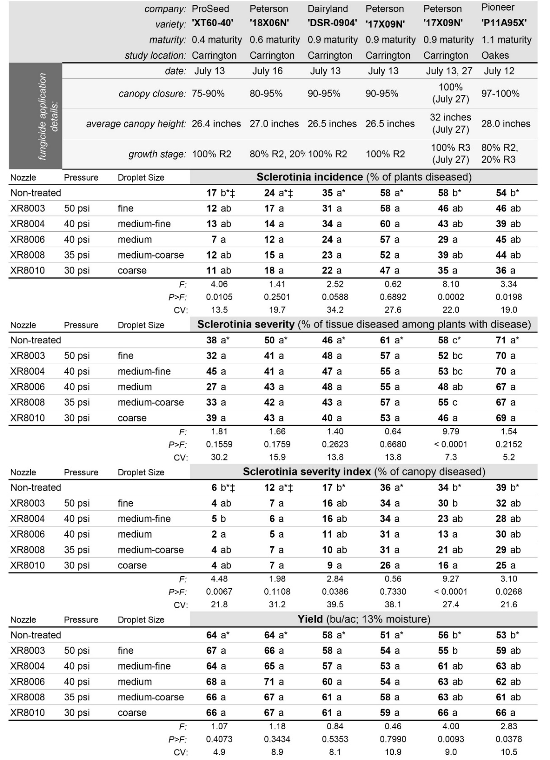
Table 2. Impact of spray droplet size on fungicide coverage to the lower soybean canopy, as assessed by fungicide deposition to water- and oil-sensitive spray cards placed horizontally 10 and 20 cm (4 and 8 inches) above the ground to simulate lower leaves and vertically centered 15 cm (6 inches) above the ground to simulate stem tissue.
Asterisks (*): Within-column means followed by different letters are significantly different (P<0.05; Tukey multiple comparison procedure). Asterisks followed by ǂ: To meet model assumptions of normality and/or homoskedasticity, analysis of variance was conducted on data subjected to a systematic natural-log transformation. For ease of interpretation, treatments means are presented for the non-transformed data.

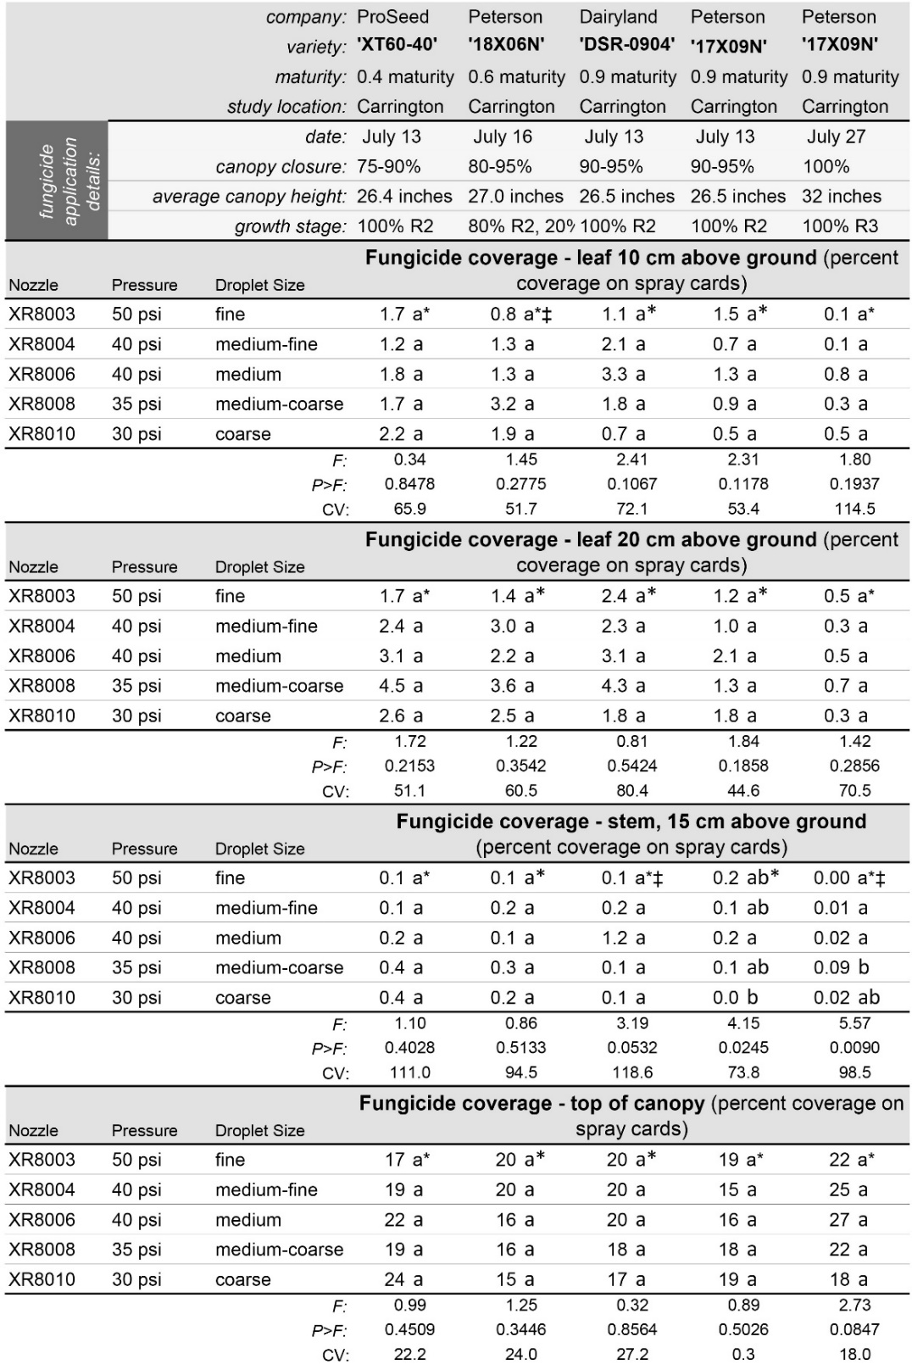
Table 3. Droplet size distribution observed in spray droplets deposited on water- and oil-sensitive spray cards placed horizontally 10 and 20 cm (4 and 8 inches) above the ground to simulate lower leaves and vertically centered 15 cm (6 inches) above the ground to simulate stem tissue. DV 0.5 values represent the distribution of droplet diameters such that droplets with a diameter smaller than DV 0.5 compose 50% of the total liquid volume deposited.
Asterisks (*): Within-column means followed by different letters are significantly different (P<0.05; Tukey multiple comparison procedure). Asterisks followed by ǂ: To meet model assumptions of normality and/or homoskedasticity, analysis of variance was conducted on data subjected to a systematic natural-log transformation. For ease of interpretation, treatments means are presented for the non-transformed data.

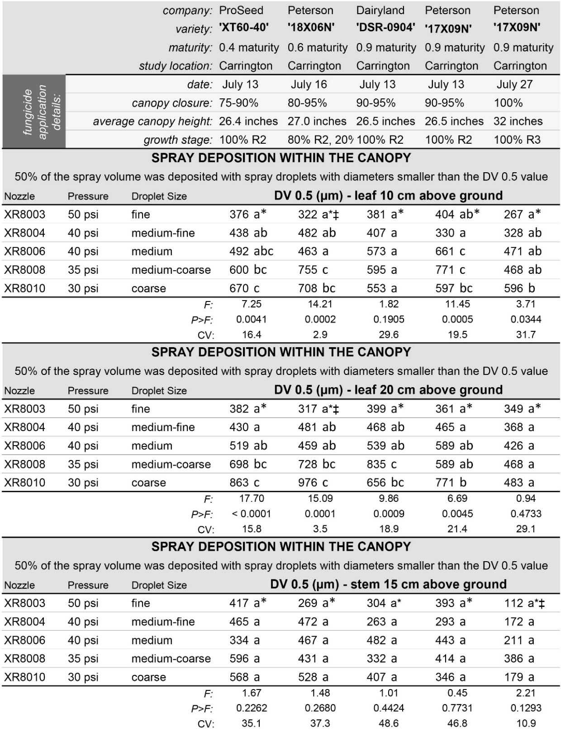
Table 4. Droplet size distribution observed in spray droplets deposited on water- and oil-sensitive spray cards placed horizontally 10 and 20 cm (4 and 8 inches) above the ground to simulate lower leaves and vertically centered 15 cm (6 inches) above the ground to simulate stem tissue. DV 0.1 values represent the distribution of droplet diameters such that droplets with a diameter smaller than DV 0.1 compose 10% of the total liquid volume deposited.
Asterisks (*): Within-column means followed by different letters are significantly different (P<0.05; Tukey multiple comparison procedure).

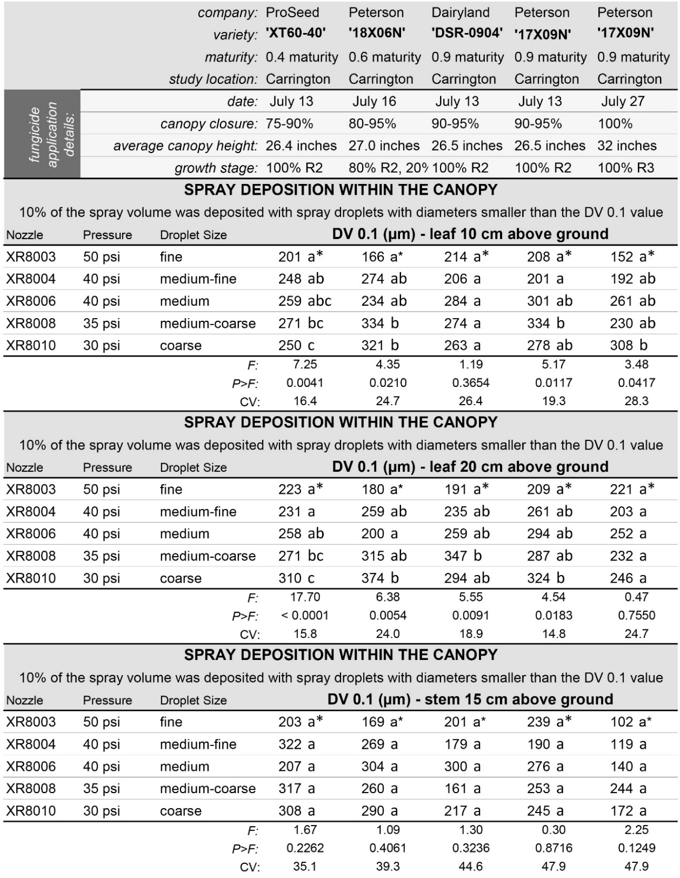

Table 5. Impact of nozzle placement (boom-mounted nozzles versus side ports or side ports plus lower rear port of ‘360 Undercover’ drop nozzle) and nozzle selection on the efficacy of 5.5 oz/ac Endura applied at the R2 growth stage for white mold management in soybeans.
Asterisks (*): Within-column means followed by different letters are significantly different (P<0.05; Tukey multiple comparison procedure). Asterisks followed by ǂ: To meet model assumptions of normality and/or homoskedasticity, analysis of variance was conducted on data subjected to a systematic natural-log transformation. For ease of interpretation, treatments means are presented for the non-transformed data.

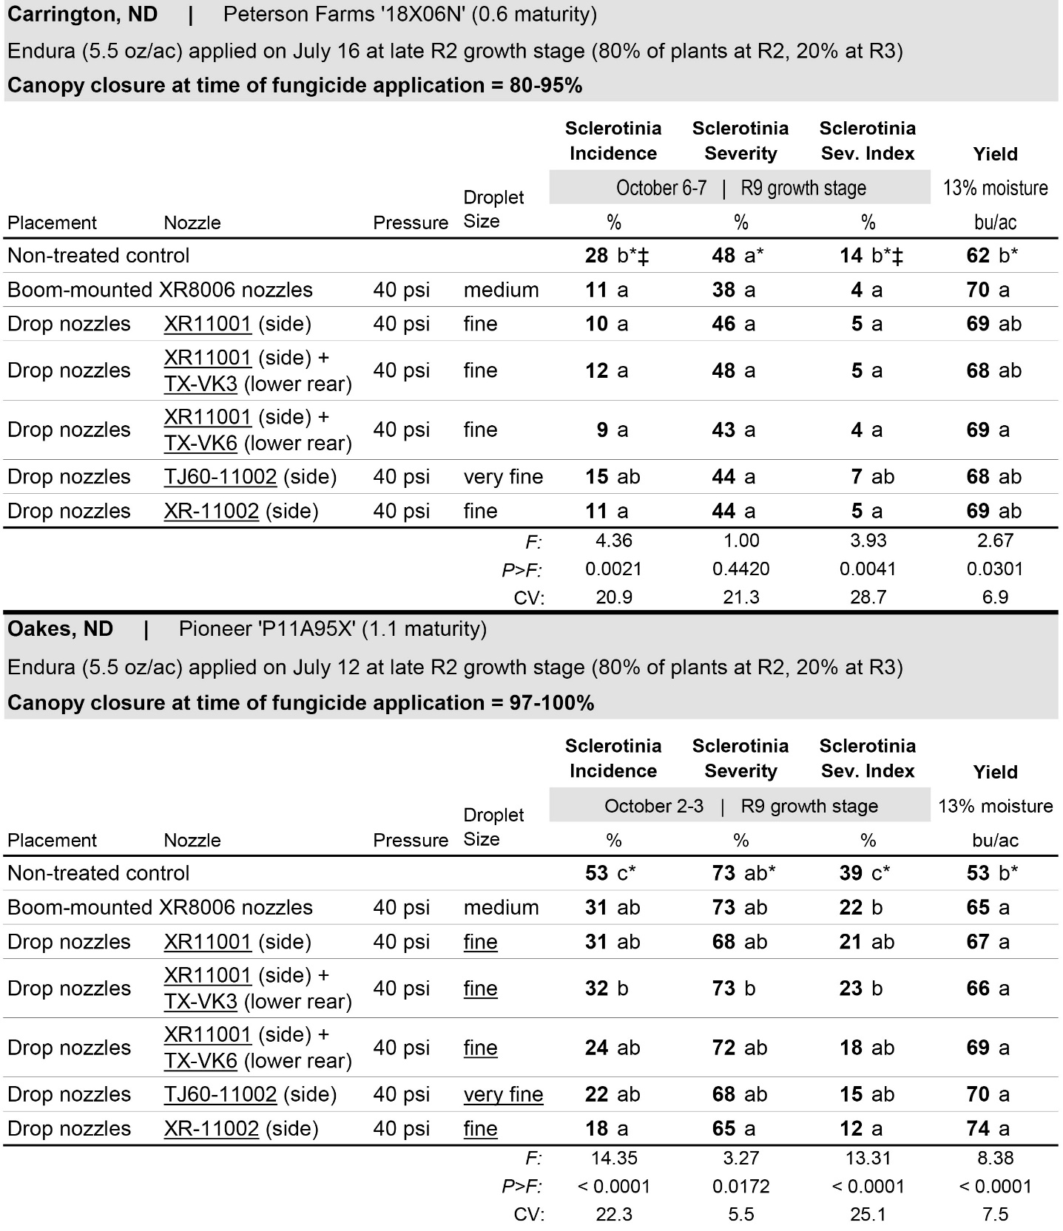
Table 6. Impact of drop nozzle height on the efficacy of 5.5 oz/ac Endura applied at the R2 growth stage for white mold management in soybeans.
Asterisks (*): Within-column means followed by different letters are significantly different (P<0.05; Tukey multiple comparison procedure). Asterisks followed by ǂ: To meet model assumptions of normality and/or homoskedasticity, analysis of variance was conducted on data subjected to a systematic natural-log transformation. For ease of interpretation, treatments means are presented for the non-transformed data.

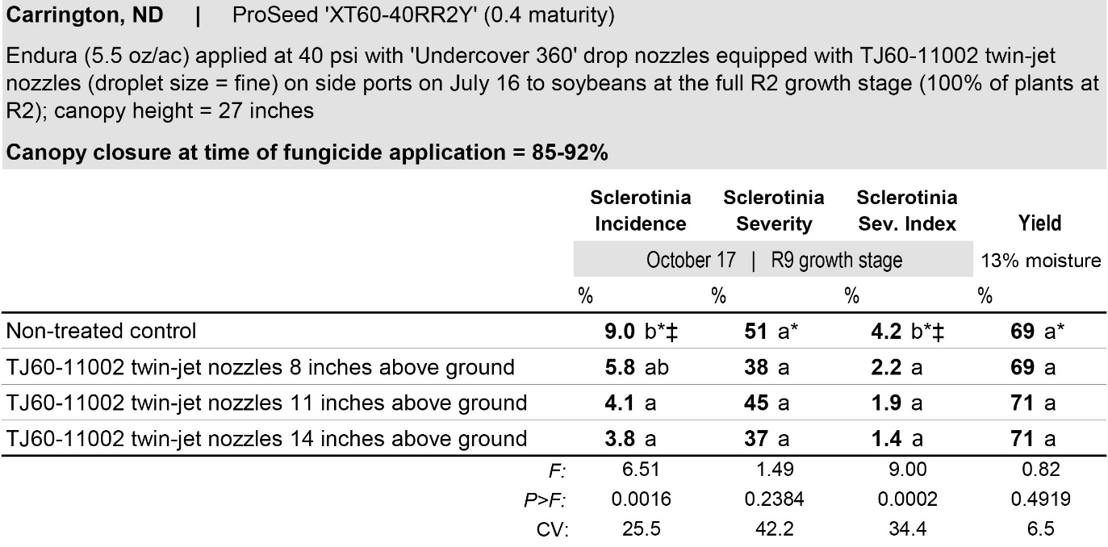
Table 7. Fungicide deposition to water- and oil-sensitive spray cards placed horizontally (to simulate leaves) or vertically (to simulate stems) in the lower soybean canopy in applications made at 40 psi with boom-mounted TeeJet XR8006 flat-fan nozzles (medium droplets) versus ‘Undercover 360’ drop nozzles with TeeJet XR11001 flat-fan nozzles on the side ports and a TX-VK3 hollow cone nozzle on the lower rear port (fine, very fine droplets). Deposition data represent combined results across four fungicides (Omega, Topsin, Endura and Proline).

Asterisks (*): Within-column means followed by different letters are significantly different (P<0.05; Tukey multiple comparison procedure).  Asterisks followed by ǂ: To meet model assumptions of normality and/or homoskedasticity, analysis of variance was conducted on data subjected to a systematic natural-log transformation. For ease of interpretation, treatments means are presented for the non-transformed data. | 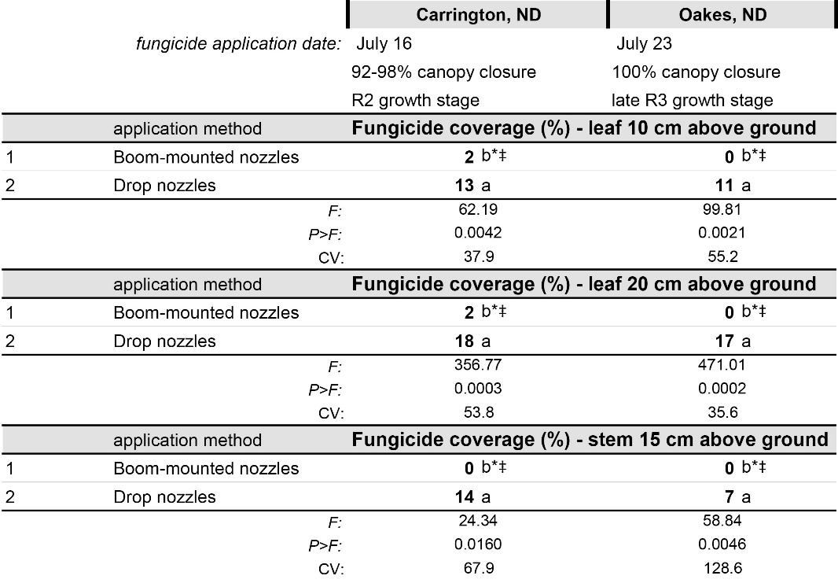
Table 8. Comparative efficacy of four fungicides against white mold in soybeans with a single versus two sequential fungicide applications delivered with boom-mounted nozzles (XR8006 flat-fan nozzles, 40 psi; medium droplets) or drop nozzles (XR11001 flat-fan nozzles on side ports, TX-VK3 hollow-cone nozzles on lower rear port, 40 psi; fine and very fine droplets).
Asterisks (*): Within-column means followed by different letters are significantly different (P<0.05; Tukey multiple comparison procedure). Asterisks followed by ǂ: To meet model assumptions of normality and/or homoskedasticity, analysis of variance was conducted on data subjected to a systematic natural-log transformation. For ease of interpretation, treatments means are presented for the non-transformed data.

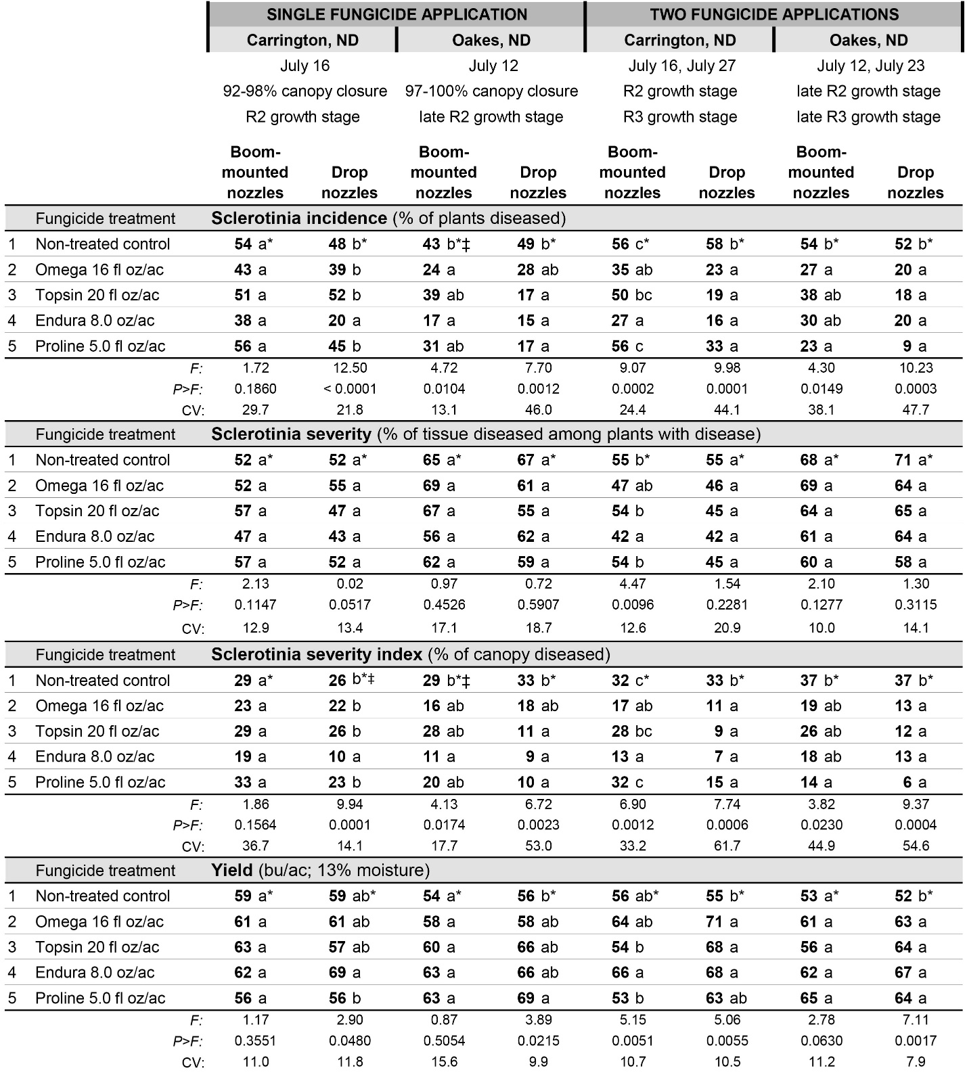
Table 9. Impact of ‘Silkin’, an organosilicone non-ionic surfactant manufactured by Winfield United (River Falls, WI), on efficacy of the fungicide Endura for control of white mold in soybeans. Applications were made at the R2 growth stage to soybeans with 97-100% canopy closure using boom-mounted TeeJet XR8006 flat-fan nozzles at 40 psi (medium droplets); Oakes, ND (2018).
Asterisks (*): Within-column means followed by different letters are significantly different (P<0.05; Tukey multiple comparison procedure). Asterisks followed by ǂ: To meet model assumptions of normality and/or homoskedasticity, analysis of variance was conducted on data subjected to a systematic natural-log transformation. For ease of interpretation, treatments means are presented for the non-transformed data.

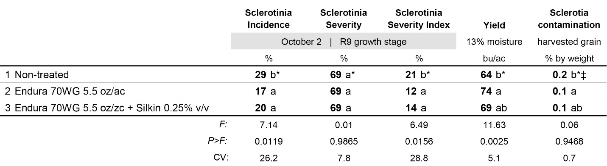
Table 10. Impact of twin-jet versus flat-fan nozzles on efficacy of the fungicide Endura for control of white mold in soybeans. Applications were made at the R2 growth stage to soybeans with 85-92% canopy closure using boom-mounted TeeJet XR8008 flat-fan nozzles at 40 psi and TJ60-8010 twin-jet nozzles; Carrington, ND (2018).
Asterisks (*): Within-column means followed by different letters are significantly different (P<0.05; Tukey multiple comparison procedure). Asterisks followed by ǂ: To meet model assumptions of normality and/or homoskedasticity, analysis of variance was conducted on data subjected to a systematic natural-log transformation. For ease of interpretation, treatments means are presented for the non-transformed data.

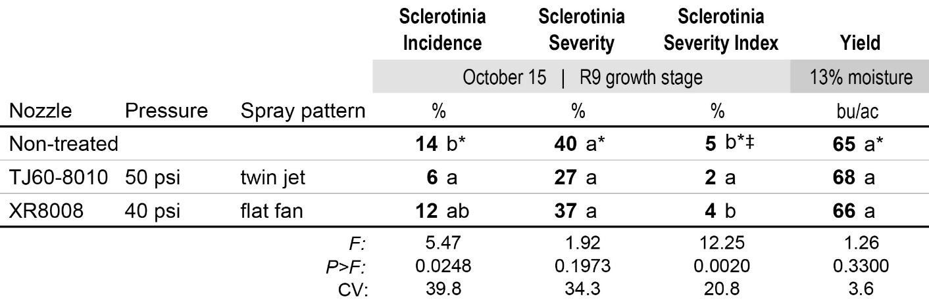

Table 11. Percent coverage and the distribution of spray droplet sizes deposited on water- and oil-sensitive spray cards placed within and above the soybean canopy in a field study evaluating the impact of nozzle spray pattern on white mold management in soybeans. Applications were made at the R2 growth stage to soybeans with 85-92% canopy closure using boom-mounted TeeJet XR8008 flat-fan nozzles at 40 psi and TJ60-8010 twin-jet nozzles; Carrington (2018).
Asterisks (*): Within-column means followed by different letters are significantly different (P<0.05; Tukey multiple comparison procedure). Asterisks followed by ǂ: To meet model assumptions of normality and/or homoskedasticity, analysis of variance was conducted on data subjected to a systematic natural-log transformation. For ease of interpretation, treatments means are presented for the non-transformed data.

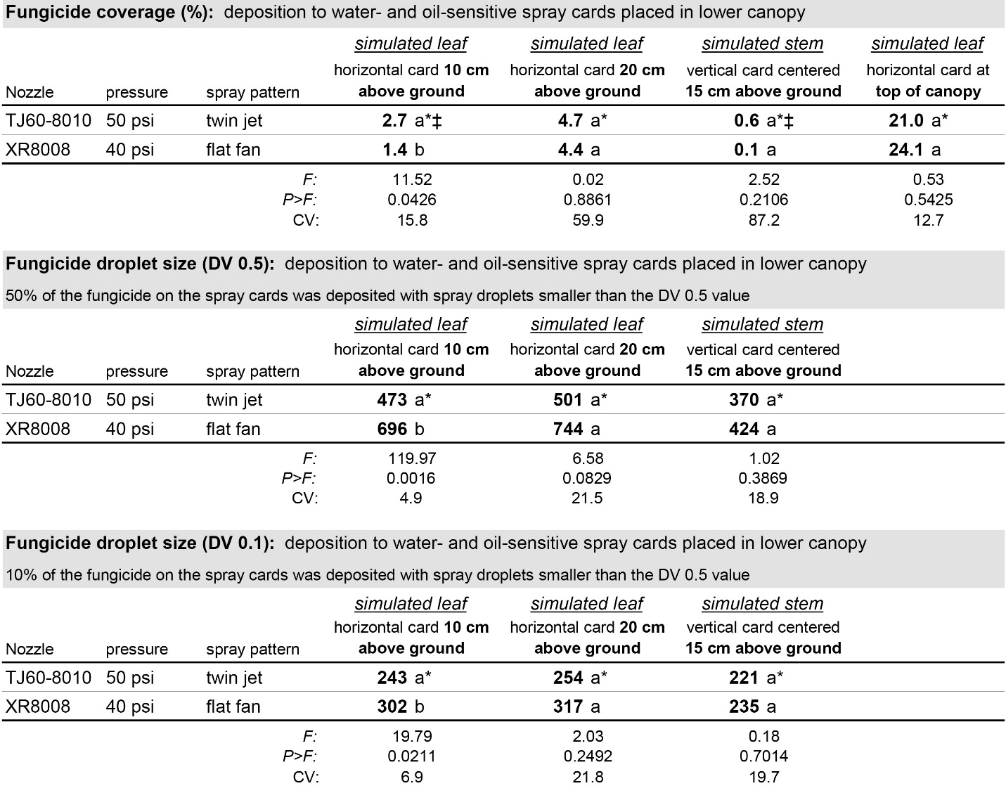

Table 12. Impact of air-induction versus extended-range flat-fan nozzles on efficacy of the fungicide Endura for control of white mold in soybeans. Applications were made at the R2 growth stage to soybeans with 75-90% canopy closure using boom-mounted TeeJet AIXR11002 nozzles at 60 psi and XR11008 nozzles at 30 psi; Carrington, ND (2018).
Asterisks (*): Within-column means followed by different letters are significantly different (P<0.05; Tukey multiple comparison procedure). Asterisks followed by ǂ: To meet model assumptions of normality and/or homoskedasticity, analysis of variance was conducted on data subjected to a systematic natural-log transformation. For ease of interpretation, treatments means are presented for the non-transformed data.

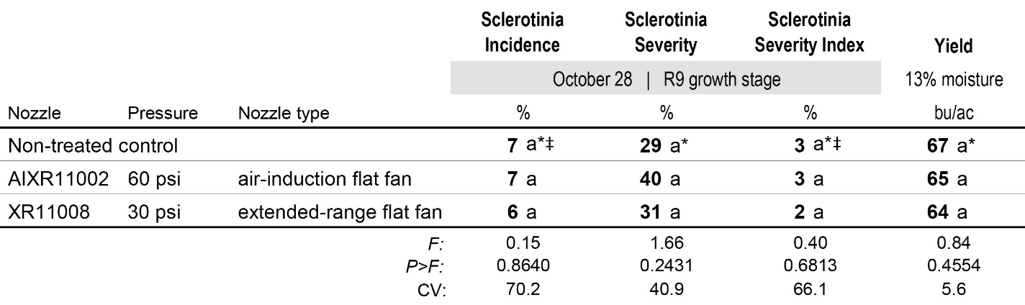
Table 13. Percent coverage and the distribution of spray droplet sizes deposited on water- and oil-sensitive spray cards placed within and above the soybean canopy in a field study evaluating the impact of air induction nozzles on white mold management in soybeans. Applications were made at the R2 growth stage to soybeans with 75-90% canopy closure using boom-mounted TeeJet AIXR11002 nozzles at 60 psi and XR11008 nozzles at 30 psi; Carrington, ND (2018).

