Technical Report

Maximizing Soil Warming and Health under Different Tillage Practices in a Corn-Soybean Rotation

*Dr. Aaron Daigh, NDSU Soil Science Dept., Principle Investigator*

*Jodi DeJong-Hughes, UMN Extension,*

*Dr. Abbey Wick, NDSU Soil Science Dept.*

**Introduction**

Advantages to a reduction in tillage can include improved aggregation and water infiltration, reduced soil loss, and increased organic matter content and biological populations and diversity in the soil. However, concern about yield reductions due to cool and wet soil conditions may limit adoption of reduced-tillage systems for corn-soybean rotations on the poorly-drained soils that dominate much of North Dakota and Minnesota. Soil tillage benefits crop production by decreasing soil density and aerating the soil. Both of which benefit germination and root development. However, different tillage practices vary in how aggressive they disturb the soil and where the disturbance occurs. Therefore, different tillage practices differ in how they accomplish this decrease in soil density and enhanced aeration. Ultimately, this translates into how a soil warms up and dries down in the spring months during and after soil thaw. Tillage practices allow an increased rate of soil warming due to: (1) lowering soil moisture content and reducing solid-soil particle contact points, which otherwise would conduct greater quantities of heat deep into the soil profile away from the seedbed and (2) decreasing soil residue cover allowing mineral soil to absorb greater quantities of solar radiation. Since tillage type varies in how they decrease soil density, the rate of soil warming is expected to vary with tillage type.

Therefore, we started a multi-state effort in fall 2014, involving North Dakota and Minnesota, to address the following producer questions:

1. What are the benefits of using chisel plow, vertical tillage, strip till with shank, and strip till with coulters on clayey, loamy, and sandy soils when I have concerns about warm up and dry out in the spring?
2. How do I manage residue in each type of tillage system?
3. Can I achieve the same yields under all these tillage options?
4. Are there differences in yields for these tillage strategies on subsurface drained soils compared to naturally drained soils?
5. How do different tillage practices influence soil health in Red River Valley soils?
6. How does my choice in tillage practice affect the bottom line of my farming operation?

Historically, we have had limited information pertaining to these important questions that are key to understanding how to build soil health and what tillage management practices to recommend for the different soil types.

**Goals/Objectives**

The ultimate goal of this project is to improve yields while at the same time building soil health. We evaluate which tillage approach (chisel plow, shallow vertical tillage, strip till with shank, and strip till with coulters) maximizes early-season soil warming and crop yields while at the same time improving soil health on subsurface drained and naturally drained soils in the Red River Valley where growing degree units are a primary consideration for soil management selection.

The objectives of this research are to:

* Monitor soil warming and water contents under chisel plow, vertical tillage, strip till with shank, and strip till with coulters on various soil series with a range in texture
* Evaluate soil health parameters and crop emergence and yields, and
* Transfer the information to producers in several formats, including but not limited to, inclusion in field days, winter programming, videos and circulars.

*This report* delivers data and information over the four growing seasons, 2015-2018.

**Methods**

*General Setup*

Four on-farm locations are included in the ongoing study. Each site is under a corn-soybean rotation and rotates each year. At each site, the chisel plow, vertical tillage, strip till with shank, and strip till with coulter systems are demonstrated in a replicated design (three replicates at each on-farm location). All tillage operations were completed using full-sized equipment in plots of 40 feet wide that extent the full length of the field (~1800 feet long). This allows us to get an accurate representation of these tillage practices so that producers will be able to visualize the implementation of each practice on their own farm. The four on-farm locations have the following soil series: Fargo silty clay, Lakepark clay loam, Barnes-Buse loams, Delamere fine sandy loam, and Wyndmere fine sandy loam. These soil series cover over 67 million acres of prime farmland in the Northern Great Plains regions.

Soil monitoring for temperature, moisture, thermal properties, water retention, bulk density, crop residue cover, microbial properties (a suite of enzyme essays and phospholipid fatty acid analysis for soil microbial community structures) and chemical properties (macro- and micro-nutrients, organic matter, carbon concentrations) were performed, whereas plant monitoring included population counts, plant height, growth stage and grain yields. All plots were planted to either corn or soybean each year.

Plant populations and crop residue cover were measured near V3 to V4 for corn and after the first trifoliate for soybean. Plant populations were determined along eight 1m transects per plot. Crop residue cover was determined along eight transects per plot using the rope method (i.e., residue presence at 100 points along 15m oriented 45º to plant rows). Crop yields were determined by combining the middle 6 plant rows along the entire plot length (~ 800m), weighting the grain in calibrated weigh wagons, determining grain moisture, and adjusting yields to 13 and 15% moisture-basis for corn and soybean, respectively.

*Targeted study for soil warming and drying*

Soil temperature and moisture were measured near the soil surface via biweekly readings with handheld sensors in 2015 and 2016 at each farm and at each sampling transect. Measurements were taken from pre-planting through post-harvest at all three farms. Measurements were taken in the Wyndmere and Delamere soil series sampling transects at the Barney farm, in the Barnes and Lakepark soil series sampling transects at the Fergus Falls farm, and in the Fargo soil series sampling transection with surface drainage ditches and nonsaline soil at the Mooreton farm.

Among the farms, the handheld biweekly soil temperature and moisture measurements were taken while soils were not frozen for a total of 24,624 measurements at depth across all farms. Soil moisture was measured using Decagon GS3 sensors with ProCheck meters. Soil temperature was measured using a nickel-chromium (type K) thermocouple probe with a digital display. Immediately before each soil temperature and moisture measurement, the crop residue was moved and the soil’s mineral surface was exposed. The GS3 sensor’s needles were then vertically inserted normal to the soil surface. Then, soil temperature was measured at 0.25, 1, 2, and 5 inch depths with the thermocouple out of direct sunlight. Soil temperature and moisture were taken in triplicate for each plot for both CP and VT treatments. In both strip tills, soil temperature and moisture was measured in triplicate for both the tilled soil strip and in the between areas (i.e., zones untouched by tillage). These measurements taken in triplicate for each experimental plots and strip tillage zone allows for period, but relatively high spatial representation of soil temperature and moisture in these producer’s fields. At conclusion of all measurements, crop residue was placed back to where it was initially removed.

In order to supplement the handheld measurements of soil temperature and moisture, one monitoring station was deployed in each plots of two blocks for one transect at each farm to monitor soil temperature and moisture on a near-continuous basis using Decagon 5TM sensors with Em50 dataloggers for a total of >7 million measurements at depth across all farms between 2015 to 2018. Prior to field deployment, soil sensors were calibrated in the laboratory with soils collected from each of the three farms. Once calibrations were obtained for each soil series and each 5TM sensor, the sensors were deployed in the field at 2, 4, 10, and 16 inch depths with measurements recorded at 30-minute intervals. Both strip till treatments had sensors deployed in and between the tilled strips. Due to the monetary expense of the soil temperature and moisture monitoring systems, sensors were deployed in two of the three replicates at each of the three farms. Soil temperature and moisture were monitored at the Mooreton farm in the surface-drained nonsaline soil quadrant of the Fargo soil series starting in the fall of 2015. At the Barney farm, soil temperature and moisture were monitored in the Wyndmere soil series transect starting in the fall of 2015. At the Fergus Falls farm, soil temperature and moisture were monitored in the Barnes soil series transect starting in the spring of 2016.

Soil penetration resistance was measured using a FieldScout CS 900 static cone penetrometer (Spectrum Technologies, Inc., Aurora, IL) during 2016 for all soil series at the Barney and Fergus Falls farms and for the surface-drained nonsaline soils at the Mooreton farm. Soil penetration resistance was measured at 2.5 cm increments to a depth of 18 inches. Soil penetration resistance was measured in triplicate for each plot for both chisel plow and vertical till. In both strip tills, soil penetration resistance was measured in triplicate for both the tilled soil strip and in the between areas (i.e., zones untouched by tillage). Measurements were taken three times during the 2016 growing seasons: near planting, shortly after full canopy and near harvesting for a total of 5,832 measurements at depth across all farms.

Soil samples were collected during June for chemical analysis. Soil samples were air dried, ground, and analyzed for NO3-N, NH4-N, Olsen soil test P, K, S, Zn, Fe, Mn, Cu, Ca, Mg, and Na. A 50 g subsample was ground to pass through a 0.250 mm sieve and analyzed for total carbon (TC) and inorganic carbon (IC) using a PrimacsSLC TOC analyzer; the differences in TC and IC was used to estimate total organic carbon (TOC) concentrations.

A repeated measures mixed model analysis of variance (ANOVA) was used to determine the effects of tillage, date, depth, and their interactions on the handheld soil temperature measurements. Measurement date and depth were both set as repeated measures with compound symmetry covariance structure. The handheld soil moisture data was also measured with the same repeated measures mixed model ANOVA with the exclusion of the depth main effect and interactions and depth repeated measures command. To analyze the near-continuous soil temperature and moisture datasets, the 30-minute interval data was first summarized by calculating daily mean soil temperature and moisture as well as daily maximum and minimum soil temperature. These daily summarized values were then analyzed similar to the handheld soil temperature measurements using a repeated measures mixed model ANOVA with date and depth as repeated measures and compound symmetry covariate structures. However, due to the computational intensity and long run times (i.e., > 4 days) to analyzed these daily values (i.e., hundreds of treatment levels in the date main effect and date interactions with tillage treatment and depth), the datasets were divided into months and each month for each soil series sampling transect was analyzed separately. Due to some issues with datalogging at the Barney farm resulting in missing data, the near-continuous soil temperature and moisture data could not be statistically separated due to missing data causing issues with estimating treatment means. A repeated measures mixed model ANOVA was used to determine the effects of tillage, date, depth, and their interactions on soil penetration resistance. Measurement depth was set as repeated measures with compound symmetry covariance structure. A mixed model ANOVA was used to determine the effects of tillage, depth, and their interaction on soil chemical properties. Crop residue cover, plant height, population counts, and crop yields were all analyzed using a mixed model ANOVA to determine effects of tillage. All soil and crop parameters in each model was analyzed individually for each soil series sampling transect at each farm since data was not always measured on the same dates within each parameter. Means for each parameter were separated using Tukey’s Honest Significant Difference (HSD) test at an alpha level of 0.05 and all analyses were performed using SAS version 9.4.

*Targeted study for within-season changes in soil microbial community*

In 2017 and 2018, soil samples were collected every Monday and Friday (approximately every 3.5 days) at the farm near Mooreton, ND. Soil samples were taken from the quarter row position between plants to a depth of 6 inches using a bucket auger. Two auger samples were taken immediately next to each other in each plot and composited for laboratory analysis. Soil samples were then split up into two subsamples for storage and analyses: 1) fresh, field moist soil sample placed in a -15 o C freezer for up to three weeks before being shipped to Microbial ID Laboratories, where samples were freeze dried for PLFA analysis, and 2) air-dried, ground, and sieved for physical and chemical analyses. In addition to the high frequency sampling, stratified bulk density and composite samples of 0-2, 2-4, and 4-6 inches where taken periodically for more intensive profile description and data collection. Crop parameters and *in situ* field conditions were monitored throughout the growing season. From vegetative emergence, soybean and spring wheat growth stage and height were collected approximately every 3.5 days until harvest. Ten observations for plant height and stage were taken in each plot and averaged. Em50 and Em60 data loggers with 5TM soil moisture and temperature sensors (METER, Inc., Pullman, WA) at depths of 2, 4, 6, and 8 inches were deployed in each plot to record soil conditions at 30 minute intervals throughout the year. In 2018, Em60 data loggers were additionally used so that MPS-6 soil matric potential sensors could be deployed at the 2 and 8 inch depths along with the 5TM sensors. A North Dakota Agricultural Weather Network (NDAWN) weather station was located approximately 200 yards away from sampling locations. Due to their short degradation period after the death of the organism (King et al., 1977; Zelles, 1997), phospholipids can be used as reliable biomarkers for microbial community shifts. Phospholipid fatty acid analysis is completed through a series of extractions, separations, transesterification, and gas chromatography described by Buyer and Sasser (2012). The standard methods now include a four-step process for the quantification of microbial community structure: 1) a single phase chloroform mixture is used to extract lipids from soil samples, 2) fractionation to isolate phospholipids from other lipids using solid phase extraction columns, 3) production of fatty acid methyl esters through methanolysis, and 4) fatty acid methyl ester analysis by gas chromatography with flame ionization detector. By using a high PLFA extraction method coupled with MIDI Inc.’s Sherlock PLFA Analysis Software, Microbial ID was able to create a highly sensitive, automated process that creates easy to use data with reduced error from human performance. The Sherlock system uses a peak naming table to identify peaks into microbial groups, and the total abundance was calculated as the sum of all biomarkers identified within a sample. For fungal to bacterial concentrations and ratios, summed biomarkers will be used for both fungi and bacteria. All high-frequency soil samples were sent to Microbial ID, Inc. in Delaware, USA for PLFA analysis.

For each soil sample collected, an array of chemical properties was measured. Measurements on pH (1:1 suspension), EC (1:1 suspension), and TOC were completed in lab with a HACH sens-ion378 EC electrode, an Accumet Basic pH electrode, and a PrimacsSLC TOC analyzer. Air-dried soil samples were sent to the NDSU Soil Testing lab for the following analyses as described in Grafton (2012). These analyses included NO3--N (trans-nitration of salicylic acid method), NH4+-N (Berthelot Reaction/ Indophenol Reaction), TN (Vario Macro Cube CHNOS analyzer), extractable Mn (DPTA .033 M H3PO4 extraction), extractable S (monocalcium phosphate extraction), and available P (Olsen Method). As a preliminary assessment of the microbial community structure to indicate if data variations tended to be more strongly associated with spatial or temporal processes, we graphed the spatial (i.e., across replicates for each sample date) and temporal (i.e., across time within a plot) coefficient of variations (sd/mean) for each PLFA biomarker category. These six PLFA biomarker categories included total microbial abundance (TMA), arbuscular mycorrhizal fungi (AMF), bacteria, fungi, fungal to bacterial ratio (F:B), and actinomycetes.

We performed a repeated measures mixed linear model for effects of time, tillage disturbance levels, and their interaction for each year separately. Time and tillage disturbance levels were set as fixed effects with block as random. The covariate structure of the repeated factor was determined as a heterogeneous first-order auto regressive function based on smallest Akaike information criterion value. Mean separations were performed using Tukey's Honest Significant Differences (THSD) tests at an alpha level of 0.05. These analyses were performed in SAS version 9.4.

Graphs of the repeated measures linear mixed model showed what appears to be cyclical structure across time. Therefore, we then performed a spectral analysis using PROC Spectra in SAS on the PLFA biomarker categories to test if temporal variations contained cyclical structures at distinct frequencies or were white noise using Bartlett’s Kolmogorov-Smirnov statistic (Bartlett, 1966). The spectrum is calculated using a finite Fourier transform and then smoothed by a moving average to estimate the spectral densities. The input data for the spectral analysis was first spatially detrended and made stationary using static variables (i.e. total carbon or particle density). This was done by calculating the population mean of the raw data and then subtracting by the error of a fitted linear regression for the PLFA data and the static variable. Then near continuous simulations of biological (as well as the chemical and physical where needed) states, across the season-long sampling period, were splined to daily intervals. The spectral analysis involves decomposing the data into the sums of sine and cosine waves of differing amplitudes and wavelengths.

When the spectral analysis passed the white noise test (i.e., reject the null hypothesis that the time series is noise), then 95% confidence intervals (CI) were determined to indicate the frequencies with the strongest spectral densities that differ from white noise. Then, a cross spectral analysis was performed on the PLFA data with each chemical and physical properties and states listed in the previous sections. This evaluates if strong cyclical patterns among the PLFA and chemical/physical properties and states occur at the same frequencies when densities also occur beyond a 95% CI. The cross spectral densities above 95% CI were considered as only meaningful for frequencies where the PLFA spectral densities also indicated strong signals that differed from white noise. When such cross spectral densities were detected, we then extracted the phase lag between oscillations for those frequencies. We observed considerably more time series, than originally expected, that passed the white noise test and frequencies with spectral densities which indicated cyclical patterns. This is the reason we decided to focus our discussion on the frequencies with the strongest signals. To do so, we choose spectral densities above a 95% CI as a convenient (but arbitrary) way of isolating such frequencies. We further isolated the frequencies by focusing on those with spectral densities >95% CI which were observed at all moments in spaces (i.e., reps). These conditions for isolating a subset of the strongest signals likely ignore some important information about temporary processes occurring in the soil. However, this also allows us to focus on the most dominate temporal structures that appear to be generalized with space.

*Soil health evaluation after 4 continuous years of tillage systems*

After 4 years since initiating the tillage systems, soils were sampled at 0-6 and 6-12 inch depths near harvest in 2018 at the farm near Barney, ND, and near Fergus Fall, MN. Soil pH was determined on a 1:1 soil-to-water suspension. Total nitrogen was determined by combustion with an automated Elementar rapid N Cube combustion analyzer (Elementar Americas Inc. Ronkonkoma, NY) as describe in Bremner (1996). Total organic C was determined as the difference between total carbon with Elementar vario MAX CN analyzer and inorganic carbon as described in Nelson and Sommers (1996) and Loeppert and Suarez (1996), respectively. Active C was determined by oxidation with KMnO4 as described in Weil et al. (2003). Microbial biomass, percent soil microbial community as arbuscular mycorrhiza, total fungi, eukaryotes, actinomycetes, gram+ and gram- bacteria, fungi:bacteria ratios, cyclopropane:gram- bacteria stress ratios were determined by phospholipid fatty acid analysis and the SherlockTM Microbial Identification System at MIDI laboratories (MIDI, 2019). Water aggregate stability was determined as described in Moebius et al. (2007). Bulk and particle densities were determined using the core method and water pycnometers, respectively, and used to calculate total porosity. Field capacity and permanent wilting point were determined as gravimetric water contents at -33 and -1500 kPa, respectively, using pressure plates. In-situ steady state infiltration was determined using double ring infiltrometers as described in Bodhinayake et al. (2004).

A mixed linear model was used to determine the effects of tillage system, site, and their interaction on the crop residue cover, plant populations, and crop yields for each year individually. Similarly, a mixed linear model was used to determine the effects of tillage system, site, soil depth, and their interactions on soil properties after four years of initiating each tillage system. All analyses were performed in SAS® version 9.4 with means separated using Tukeys at the 0.05 level (SAS Institute, Inc., Cary, NC).

The mean custom machinery rates for chisel plow, strip till, and vertical till systems were estimated for corn and soybean based on the 2018 Iowa Farm Custom Rate Survey (DeJong-Hughes and Daigh, 2017; Plastina and Johanns, 2018). These estimates include fuel, repairs, depreciation, interest, and labor for tractor and implements regarding tillage, fertilizer application, planting, herbicide/pesticide applications, and combining. These estimates do not include material costs for fertilizers and herbicides/pesticides. In the study presented here, all tillage systems had the same fertilizer, herbicide, and pesticide rates.

**Results and Discussion**

In the targeted study looking soil temperature and moisture, soil temperatures were highest and moisture lowest in the strip till berms and chisel plowed strips as compared to the vertical till and undisturbed areas between the strip till berms. These differences were largest in sandy soils, but rarely observed in clay soils. The vertical till tended to warm and dry approximately midway between that observed for chisel plow and areas with no-tillage. A significant three-way interaction among tillage, date, and depth was evident at the Barney, Fergus Falls, and Mooreton farms. Across all farms, differences in soil temperature due to tillage were evident at various times throughout the annual observation periods (i.e., when soils were not frozen). More technical details and data presentation can be found in Rashad Alghamdi’s Masters Thesis, “Soil warming and drying and the consequence to crop yields among conservation tillage practices in frigid corn-soybean fields” at the NDSU Library, online at ProQuest, or by contacting the PI (Aaron Daigh).

In the targeted study looking at within season changes in soil microbial communities, soil microbial communities showed distinct biweekly and bimonthly cyclical patterns that were also not affected by tillage system. The coefficient of variation analyses revealed an equal or higher variability of microbial community groups over time as compared with spatial replicates. Repeated measure mixed linear model analysis detected significant differences within some of the studied PLFA categories over time, providing some of the first evidence of microbial fluctuations at short time intervals. Finally, the spectral analyses uncovered that not only do patterns of abundance in microbial communities shift throughout the growing season, but they display cyclic patterns at various frequencies with chemical, physical, and environmental covariates. Most notably, bacteria cycle at shorter periods and are primarily associated with weather conditions, whereas the fungal categories cycle over longer periods and are primarily associated with chemical properties. Additionally, it was speculated that fertilization in the second year of the study may have caused substantial changes in the microbial community’s temporal characteristics. With this information we can gain new insight on the use of PLFA analyses as a soil health indicator and our current assessment methods of the microbial community. More technical details and data presentation can be found in Zach Leitner’s Masters Thesis, “Soil biological temporal variability as functions of physiochemical states and soil disturbance” at the NDSU Library, online at ProQuest, or by contacting the PI (Aaron Daigh).

During the 4 years at the farms near Barney and Fergus Falls, tillage significantly affected crop residue cover in 2017 and a tillage-by-site interaction significantly affected crop residue cover for 2015, 2016, and 2018. This interaction manifested as some tillage treatments differing within and between the two sites. In general, chisel plow tended to be significantly lower than strip tills and vertical till. Whereas, strip tills and vertical till were often similar for both sites with few exceptions. Crop residue cover ranged from 25.6 to 50.0% for chisel plow among years and sites; whereas, strip tills and vertical tills ranged from 48.3 to 82.5%.

Site significantly affected plant populations in 2015 and 2017 during the corn phases of the rotation; whereas, a tillage-by-site interaction and tillage significantly affected plant populations in 2016 and 2018, respectively, during the soybean phases of the rotation. The interaction in 2016 manifested as strip till with shanks in Barney having significantly higher populations than vertical till in Barney and all tillage treatments in Fergus Falls. Similarly, the tillage effect in 2018 occurred with STs having significantly higher populations than chisel plow and vertical till.

Site significantly affected crops yields in 2015. Whereas, a tillage-by-site interaction significantly affected crop yields for 2016, 2017, and 2018. This interaction manifested as some tillage treatments differing between the two sites. For, example, soybean yields in strip till with coulters at the Barney farm were significantly higher than in chisel plow at the Fergus Falls farm during 2016. However, tillage treatments did not differ among each other within each site for any year. In contrast, when sites were analyzed separately, strip till with shanks corn yielded significantly less than all other tillage systems at Fergus Falls in 2015; whereas both strip till soybeans yielded significantly higher than the other tillage systems at Barney in 2018.

A tillage-by-site interaction significantly affected fungi:bacteria ratios. This interaction manifested strip till with shanks having significantly higher ratios than strip till with coulters at the Barney site; whereas, ratios did not differ among tillage systems at the Fergus Falls site. Tillage did not affect any other soil properties. Numerous site, depth, and site-by-depth interactions were observed for soil properties, but none that included a tillage effect with exception of fungi:bacteria ratios.

This study compared on-farm conservation tillage systems during the initial four years after implementation. Farmers often find these initial years the most challenging due to numerous real and perceived concerns (Bohman et al., 2018). However, our study provided production-scale empirical data that suggest these concerns do not necessarily translate into yield losses when compared to their standard chisel plow system. Tillage effects within a site were few and mixed (3-5 bu ac-1 differences); whereas, site effects were common (8-48 bu ac-1 differences). Similar to other on-farm studies with multiple sites, the cause of the site effects are likely due to differences in (or combination of) soil type/texture, weather, or the individual farmers. Additionally, only the fungi:bacteria ratio was significantly affected by tillage systems. This indicates that biological variables (including crop parameters) may be more responsive to reduced tillage, on agricultural fields with a history of tillage, than other soil properties. Therefore, economics and crop-residue cover level for protecting against soil erosion among the tillage practices compared here should guide farmer preferences rather than yield alone. The mean custom machinery rates for chisel plow, strip till, and vertical systems were estimated at $114, $93, and $115 USD ac-1, respectively, for corn and $93, $82, and $78 USD ac-1, respectively, for soybean. Therefore, even though most soil properties did not differ after 4 years, the lower on-farm costs and lower socio-economic externalities (e.g., wind/water erosion, surface nutrient transport, long-term soil productivity losses, etc.) of strip till and vertical till should ease farmer’s concerns (Stonehouse, 1997).

This research represents production systems where farmers use one tillage system per field. However, there is a growing interest for variable type/rate tillage implements. Several equipment manufacturers have recently developed such variable type/rate tillage implements. Therefore, future research efforts should evaluate these new technologies on landscapes well known to have low crop productivity.

In summary of the 4 years at the farms near Barney and Fergus Falls, crop residue cover among tillage systems ranged from 25-83%. Tillage did not affect plant populations within sites, but strip till (shanks) had lower corn yields at one farm in 2015, whereas both strip tills had higher soybean yields at one farm in 2018. Otherwise, yields did not differ among tillage practices. Strip till was estimated to have the least costs among the systems, with $10-22 less per acre than chisel plow. Among 19 soil properties for soil health, only one (fungal/bacteria ratio) slightly differed among tillage systems for one farm after four years. However, More technical details and data presentation can be found in the open-access journal article “Crop and soil responses to on-farm conservation tillage practices in the upper Midwest” by contacting the PI (Aaron Daigh) or online at: https://dl.sciencesocieties.org/publications/ael/abstracts/4/1/190012.

**Conclusions**

Our results suggest that reduced tillage does not necessarily translate to yield reductions, but are typically more economical, even though some practices leave >80% crop residue cover and are somewhat wetter and cooler. We recommend that economics and desired erosion control among tillage systems, rather than yield alone, be used to guide tillage preferences. This research also suggests that quantifiable changes to soil health may take >4 years to be observable in the region. Lastly, the weekly-to-monthly cycles in soil microbial communities need to be considered if used as a measure of soil health.

**Education and Outreach**

To date, the study’s findings have been disseminated in:

1. YouTube videos (>10,000 views),
2. >70 field days, presentations, and other university events,
3. The Upper Midwest Tillage Guide
4. >60 publications, news articles, and other media sources

Major publications include:

DeJong-Hughes, J. and A.L.M. Daigh. 2017. Upper Midwest Tillage Guide, University of Minnesota Extension Service and North Dakota State University. 4 chapters available online at <http://www.extension.umn.edu/agriculture/soils/tillage/>

Daigh, A.L.M., J. DeJong-Hughes, D.H. Gatchell, N.E. Derby, R. Alghamdi, Z.R. Leitner, A. Wick, and U. Acharya. 2019. Crop and soil responses to on-farm conservation tillage systems in the Upper Midwest. Agricultural and Environmental Letters. 4:190012. doi:10.2134/ael2019.03.0012.

Leitner, Z. 2019. Soil biological temporal variability as functions of physiochemical states and soil disturbance. Master’s Thesis, North Dakota State University Available on ProQuest.

Daigh, A.L.M., U. Ghosh, J. DeJong-Hughes, and R. Horton. 2018. Spatial response of near-surface soil water contents to newly imposed soil management. Agricultural & Environmental Letters 3:180032. doi:10.2134/ael2018.06.0032.

Alghamdi, R. 2017. Soil warming and drying and the consequences to crop yields among conservation tillage practices in frigid corn-soybean fields. Master’s Thesis, North Dakota State University. Available on ProQuest.

Daigh A.L.M.and J. DeJong-Hughes. 2017. Fluffy Soil Syndrome: When tilled soil does not settle. Journal of Soil and Water Conservation 72(1):10A-14A

Three extension videos were made in 2015 for producers and the general public and continue to be made available on the UMN Soil Health website [www.extension.umn.edu/agriculture/soils](http://www.extension.umn.edu/agriculture/soils) and the NDSU Soil Health website <https://www.youtube.com/watch?v=_-8gAfTYktg> and <https://www.youtube.com/watch?v=9XywM4AMExM> These videos have received over 10,000 views from around the world. From the Tillage and Technology Field Day we have received over 37,000 views from around the world <https://www.youtube.com/watch?v=SWvjsa5_k-E>

**Acknowledgements**

This research was partially funded by the North Dakota Soybean and Corn Councils, Minnesota Soybean and Corn Research and Promotion Councils, North Dakota Agricultural Experiment Station, University of Minnesota Extension, North Dakota Extension, USDA-NRCS Conservation Innovation Grant 69-3A75-17-282, and USDA-NIFA Hatch project 1005366. The authors thank the farmers Charlie and Carol Piekarski, Mike and Chandra Langseth, and Ken Johnson for allowing this research to take place on their land as well as their assistance establishing and maintaining the sites. We also thank the representatives from Kuhn Krause, Gates Manufacturing, Environmental Tillage Systems, Dawn Equipment Company, and Salford for graciously letting us use their tillage implements and for making implement adjustments for the on-site moisture conditions. Technical work and significant contributions to this project were provided by Rashad Alghamdi, Zach Leitner, Dorian Gatchell, Radu Carcoana, Nathan Derby, Umesh Acharya, Upasana Ghosh, and many others not listed here.

**Figure and Tables**

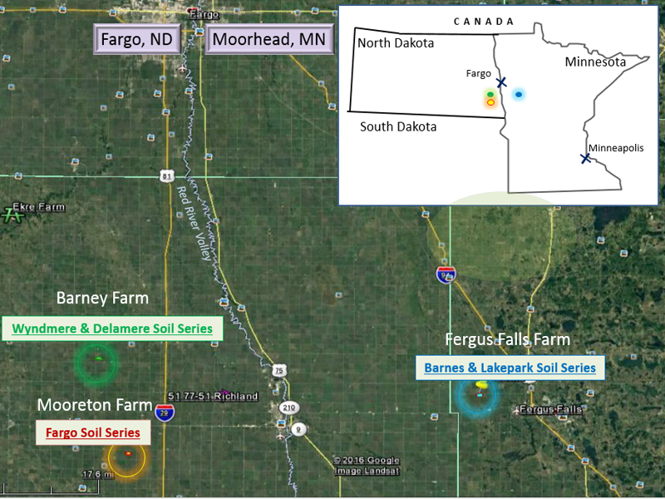

Field site locations and soil series in Mooreton, ND (Fargo soil series), Barney, ND (Wyndmere and Delamere soil series), and Fergus Falls, MN (Barnes and Lakepark soil series).

|  |  |  |  |  |
| --- | --- | --- | --- | --- |
| Soil taxonomical information and characteristics of three farm locations in North Dakota and Minnesota | | | | |
| Location | Soil series | Soil classification | Dominant soil texture | Geographic extent (hectares) |
| Mooreton, ND | Fargo clay | Fine, smectic, frigid Typic Epiauerts | Silty Clay | 3.8 million |
| Barney, ND | Wyndmere | Coarse-loamy, mixed, superactive, frigid Aeric Calciaquolls | Fine Sandy Loam | 1 million |
|  | Delamere | Coarse-loamy, mixed, superactive, frigid Typic Endoaquolls | Fine Sandy Loam | 204,747 |
| Fergus Falls, MN | Lakepark | Fine-loamy, mixed, superactive, frigid Cumulic Endoaquolls | Clay Loam | 168,325 |
|  | Barnes | Fine-loamy, mixed, superactive, frigid Calcic Hapludolls | Loam | 15.2 million |

Plant populations and percent crop residue cover of the soil surface as affected by conservation tillage systems [chisel plow (CP), fall strip till with shanks (STs), spring strip till with coulters (STc), and shallow vertical till (VT)].

|  |  |  |  |  |  |  |
| --- | --- | --- | --- | --- | --- | --- |
| Variable | Site | Year/crop | CP | STs | STc | VT |
| Plant population (1000 plants ac-1) | Barney, ND | 2015/corn | 24.1b | 25.7b | 25.5b | 24.5b |
| Fergus Falls, MN |  | 32.6a | 32.0a | 32.3a | 32.9a |
| Barney, ND | 2016/soybean | 148.3ab | 154.5a | 141.4abc | 130.5c |
| Fergus Falls, MN |  | 134.1bc | 135.6bc | 134.6bc | 135.8bc |
| Mooreton, ND | 2016/corn |  |  |  |  |
| NW drained/salty |  | 30.8a | 30.7a | 31.2a | 30.3a |
| NE drained |  | 31.0a | 32.5a | 33.5a | 32.2a |
| SW salty |  | 29.7a | 29.7a | 29.3a | 30.9a |
| SE |  | 29.3a | 30.9a | 30.3a | 29.3a |
| Barney, ND | 2017/corn | 35.2a | 36.0a | 35.5a | 34.4a |
| Fergus Falls, MN |  | 30.5b | 29.3b | 28.8b | 28.3b |
| Mooreton, ND | 2017/soybean |  |  |  |  |
| NW drained/salty |  | 143.4abc | 139.5abc | 145.3a | 141.9abc |
| NE drained |  | 146.8a | 150.7a | 144.9ab | 143.9abc |
| SW salty |  | 139.5abc | 127.8c | 136.1abc | 143.4abc |
| SE |  | 137.6abc | 140.9abc | 145.8a | 128.3bc |
| Barney, ND | 2018/soybean | 117.4b | 131.7a | 123.8ab | 113.5b |
| Fergus Falls, MN |  | 120.1b | 126.0a | 128.3ab | 123.8b |
| Crop residue cover (%) | Barney, ND | 2015/corn | 26c | 50ab | 51ab | 49ab |
| Fergus Falls, MN |  | 42b | 48ab | 52ab | 60a |
| Barney, ND | 2016/soybean | 31e | 60bcd | 52cd | 61bcd |
| Fergus Falls, MN |  | 50d | 68bc | 65ab | 79a |
| Mooreton, ND | 2016/corn |  |  |  |  |
| NW drained/salty |  | 15c | 28b | 42a | 42a |
| NE drained |  | 28b | 32a | 42a | 33a |
| SW salty |  | 33a | 41a | 51a | 43a |
| SE |  | 19c | 32a | 48a | 44a |
| Barney, ND | 2017/corn | 30b | 53a | 49a | 52a |
| Fergus Falls, MN |  | 28b | 61a | 59a | 48a |
| Mooreton, ND | 2017/soybean |  |  |  |  |
| NW drained/salty |  | 24d | 54b | 52b | 53b |
| NE drained |  | 30c | 65a | 65a | 56a |
| SW salty |  | 42c | 63a | 64a | 65a |
| SE |  | 33c | 67a | 62a | 63a |
| Barney, ND | 2018/soybean | 48d | 65c | 73b | 78ab |
| Fergus Falls, MN |  | 49d | 76ab | 83b | 80ab |

‡Difference letters within a year and across both sites are significantly different at the 0.05 level using Tukey’s. A mixed linear model was used to test fix effects of tillage system, site, and their interactions for each year individually. Mooreton site analyzed separately.

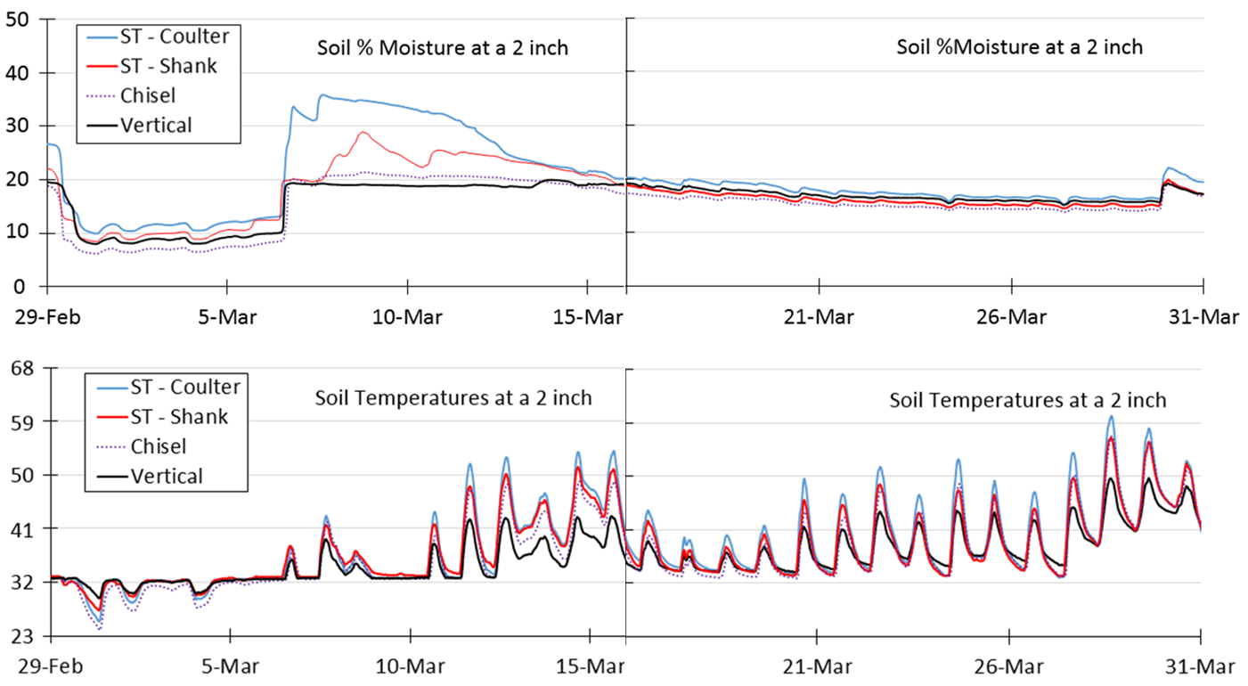

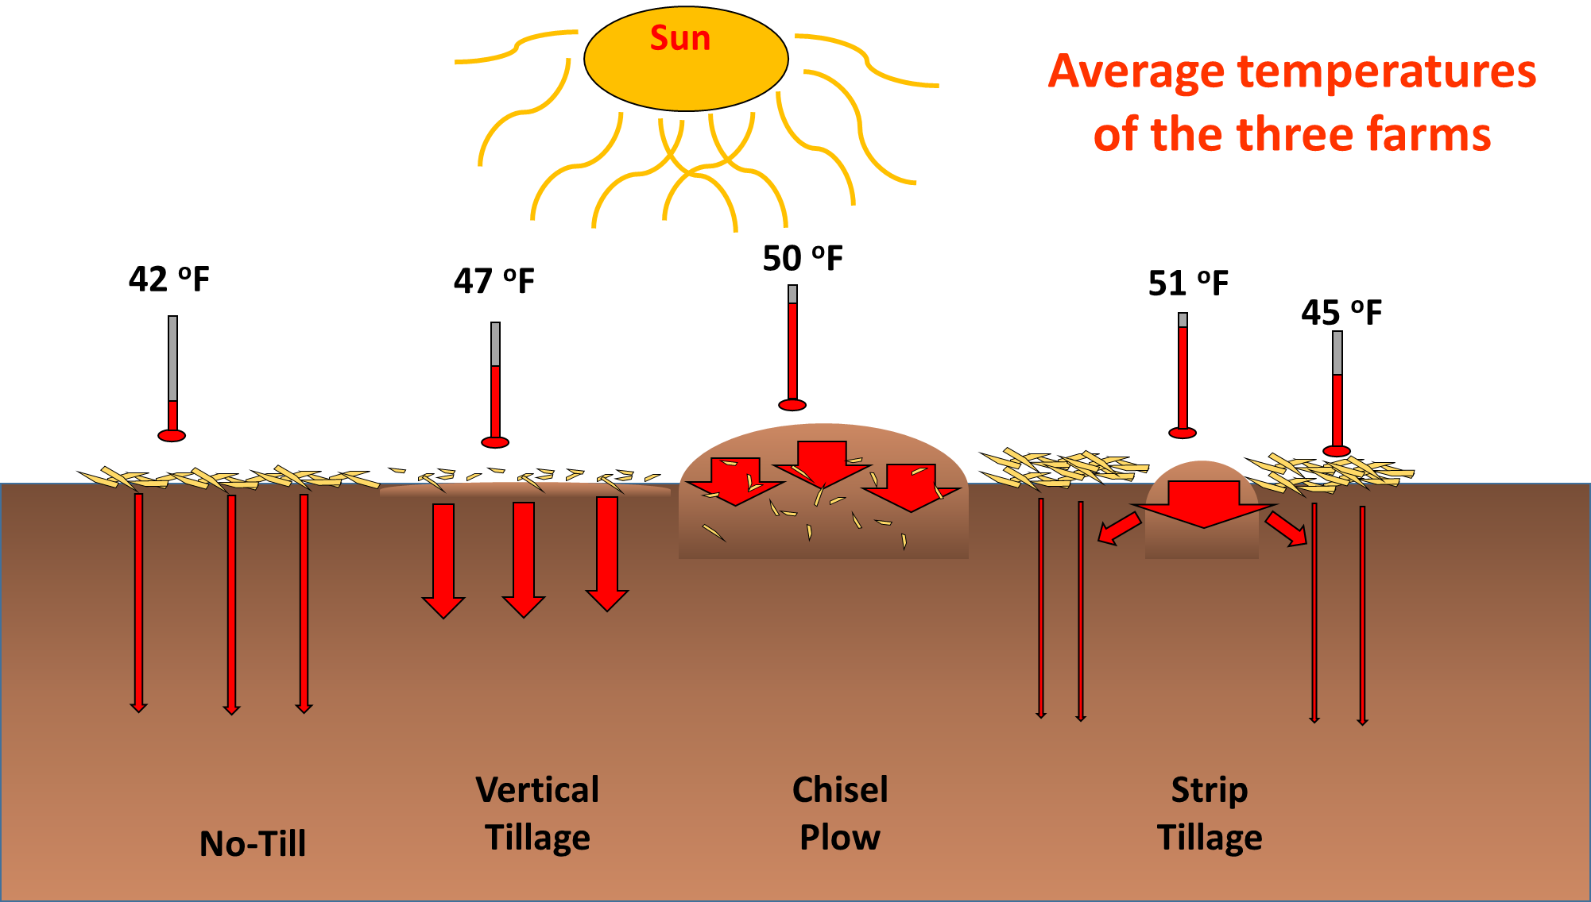

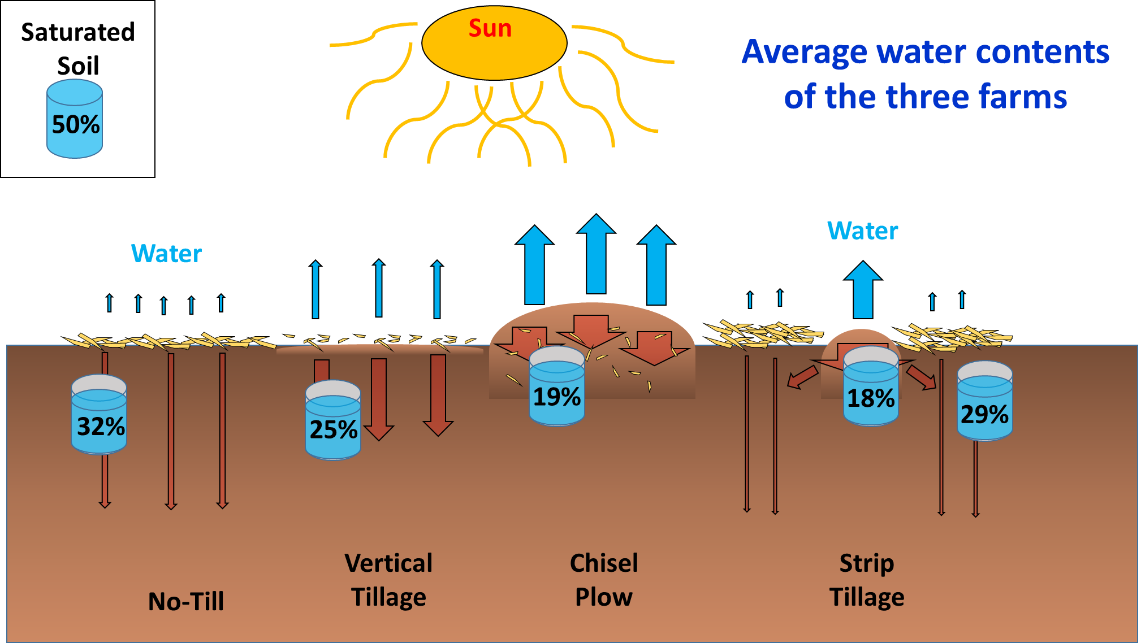

|  |  |  |  |  |  |  |  |  |
| --- | --- | --- | --- | --- | --- | --- | --- | --- |
| Summary of the mean soil temperature for dates that handheld measurements for the Barney farm in the Wyndmere and Delamere soil series sampling transects in 2015 and 2016 and depths were significantly affected by reduced tillage practices [chisel plow (CP), vertical tillage (VT), strip tillage with coulter in the tilled berm (STC-IN), strip tillage with coulter between the tilled berm (STC-BT), strip tillage with shank in the tilled berm (STS-IN), and strip tillage with shank between the tilled berm (STS-BT)]. | | | | | | | | |
| Farm | Date | Depth | CP | VT | STC-IN | STC-BT | STS-IN | STS-BT |
|  |  | cm | ----------------------------------°C---------------------------------- | | | | | |
| Barney | 3/17/2015 | 0.5 | 13.5a† | 3.2b | 12.7a | 3.7b | 11.2a | 3.6b |
|  | 2 | 12.4a | 3.6b | 7.9a | 4.0b | 7.5ab | 3.9b |
| 4/03/2015 | 0.5 | 9.7a | 3.3b | 8.9a | 4.2ab | 8.3ab | 4.1b |
| 4/23/2015 | 0.5 | 12.1a | 2.1b | 9.5a | 4.4ab | 10.8a | 3.8b |
|  | 2 | 10.2a | 0.2b | 8.5a | 1.4b | 8.0a | 1.0b |
|  | 5 | 6.2a | -0.6b | 5.5a | -0.1b | 4.1a | 0.0b |
|  | 12 | 5.8a | -0.6b | 5.9a | -0.1b | 4.0a | -0.1b |
| 6/03/2015 | 5 | 12.7a | 8.1b | 11.5a | 9.0b | 11.0a | 8.7b |
| 7/09/2015 | 0.5 | 42.4a | 34.8b | 36.8ab | 35.4b | 37.4ab | 36.9ab |
|  | 5 | 35.1a | 27.9b | 31.0a | 28.9b | 30.0ab | 28.4b |
| 7/19/2015 | 0.5 | 37.4a | 27.7b | 33.8a | 27.5b | 33.1a | 28.1b |
|  | 2 | 38.4a | 30.4b | 32.2ab | 31.0b | 31.0b | 31.0b |
| 8/26/2015 | 12 | 19.9a | 17.6b | 17.9ab | 17.6b | 18.1ab | 18.0ab |
|  |  |  |  |  |  |  |  |
| 3/11/2016 | 0.5 | 17.2a | 9.1b | 9.0b | 12.9ab | 6.3b | 15.9a |
|  | 2 | 12.8a | 4.9b | 9.0a | 5.6b | 11.4a | 3.4b |
|  | 5 | 6.2a | 2.4b | 4.9a | 2.8b | 5.6a | 1.7b |
| 3/28/2016 | 0.5 | 15a | 3.2b | 10.3a | 3.9b | 9.1a | 3.8b |
|  | 5 | 2.3a | 0.9b | 2.6a | 2.0a | 2.3a | 1.7ab |
| 5/04/2016 | 0.5 | 33.6a | 27.3ab | 30.2a | 21.0b | 34.2a | 19.3b |
|  | 2 | 32.0a | 23.0b | 24.3ab | 18.1b | 31.1a | 17.6b |
|  | 5 | 27.1a | 19.0b | 20.1a | 16.8b | 24.6a | 16.4b |
|  | 12 | 27.9a | 20.9b | 22.7a | 17.8b | 26.9a | 17.0b |
| 5/14/2016 | 0.5 | 23.1a | 14.1b | 18.4a | 11.3b | 19.9a | 13.9b |
|  | 2 | 20.6a | 12b | 12.3b | 10.3b | 19.7a | 11.6b |
|  | 5 | 15.1a | 9.4b | 12.7a | 9.1b | 14.7a | 9.9b |
| 6/02/2016 | 0.5 | 24.7a | 18.4b | 22.8a | 18.5b | 21.1a | 18.1b |
| 6/16/2016 | 0.5 | 33.0a | 23.3b | 27.1a | 23.5b | 26.6a | 23.1b |
| 7/04/2016 | 0.5 | 45.6a | 34.0b | 35.5b | 34.6b | 33.1b | 36.3b |
|  | 2 | 42.9a | 30.4b | 33.4ab | 31.6b | 30.9b | 34.4ab |
|  | 12 | 38.2a | 28.3b | 30.2a | 29.5ab | 31.2a | 28.5b |
| 8/09/2016 | 0.5 | 26.2a | 19.9b | 23.2ab | 22.1b | 22.1b | 21.4ab |
|  | 2 | 24.5a | 19.2b | 20.6ab | 20.4ab | 20.5ab | 20.2ab |
|  | 5 | 22.1a | 18.3b | 19.4ab | 19.4ab | 19.4ab | 19.2ab |
| †Different letters within a row are significantly different at the 0.5 level using Tukey’s HSD test. | | | | | | | | |
| † Different letters within a row are significantly different at the 0.5 level using Tukey’s HSD test. | | | | | | | | |

|  |  |  |  |  |  |  |  |  |
| --- | --- | --- | --- | --- | --- | --- | --- | --- |
| Summary of the mean soil temperature for dates that handheld measurements for the Fergus Falls farm in the Barnes and Lakepark soil series sampling transects in 2015 and 2016 and depths were significantly affected by reduced tillage practices [chisel plow (CP), vertical tillage (VT), strip tillage with coulter in the tilled berm (STC-IN), strip tillage with coulter between the tilled berm (STC-BT), strip tillage with shank in the tilled berm (STS-IN), and strip tillage with shank between the tilled berm (STS-BT)]. | | | | | | | | |
| Farm | Date | Depth | CP | VT | STC-IN | STC-BT | STS-IN | STS-BT |
|  |  | cm | ---------------------------------------°C-------------------------------------- | | | | | |
| Fergus Falls | 4/27/2015 | 2 | 17.9a† | 13.1b | 17.0a | 11.3b | 16.8a | 12.8b |
| 6/10/2015 | 0.5 | 33.8a | 28.0b | 32.7a | 30.0a | 32.3a | 29.5ab |
| 7/21/2015 | 0.5 | 32.7a | 29.7ab | 31.5a | 28.7b | 32.0a | 29.0b |
|  | 5 | 24.55a | 21.45b | 23.59a | 21.34b | 23.17a | 20.90b |
|  | 12 | 25.6a | 21.9b | 24.0ab | 22.60b | 25.11a | 22.84b |
| 8/27/2015 | 12 | 20.6a | 16.7b | 16.9b | 16.8b | 16.9b | 16.8b |
|  |  |  |  |  |  |  |  |
| 4/04/2016 | 0.5 | 13.3a | 10.4a | 11.8a | 3.1b | 10.3a | 1.6b |
|  | 2 | 3.9a | 2.8a | 5.4a | 1.1b | 3.7a | 0b |
| 4/16/2016 | 0.5 | 24.2a | 14.7ab | 14.9ab | 12.8b | 15.9ab | 12.1b |
|  | 2 | 16.9a | 11.6b | 12.4ab | 10.5b | 12.3ab | 10.9b |
| 5/05/2016 | 0.5 | 37.6a | 29.24ab | 32.8ab | 24.6b | 33.4a | 26.1b |
|  | 5 | 25.34a | 16.2b | 17.61a | 16.4b | 19.52a | 17.3ab |
|  | 12 | 16.4a | 11.7b | 14.3a | 12.5b | 14.8a | 12.5b |
| 5/19/2016 | 0.5 | 19.6a | 12.9b | 17.6a | 13.3b | 18.1a | 13.3b |
|  | 2 | 18.1a | 12.0b | 14.8a | 12.7ab | 15.7a | 12.7ab |
|  | 5 | 14.5a | 11.5b | 21.0a | 17.4ab | 21.4a | 16.6ab |
| 6/05/2016 | 0.5 | 30.0a | 19.7b | 27.3a | 21.2b | 29.0a | 19.7b |
|  | 2 | 28.2a | 18.3b | 25.4a | 23.1b | 27.4a | 18.5b |
|  | 5 | 23.7a | 16.3b | 21.0a | 17.4b | 21.4a | 16.6b |
| 7/02/2016 | 0.5 | 33.8a | 27.9b | 30.7a | 28.6b | 30.6a | 28.3b |
|  | 2 | 32.0a | 26.7b | 29.4a | 27.5b | 29.1a | 27.3b |
|  | 5 | 29.3a | 23.9b | 26.6a | 25.6a | 26.3a | 25.1ab |
| 8/05/2016 | 0.5 | 31.2a | 26.6b | 29.4a | 28.5b | 30.0a | 29.8b |
|  | 2 | 30.5a | 25.8b | 27.7ab | 27.6ab | 28.1ab | 27.7ab |
|  | 5 | 19.9a | 19.6ab | 19.4b | 19.4b | 19.5ab | 19.6ab |

|  |  |  |  |  |  |  |  |  |
| --- | --- | --- | --- | --- | --- | --- | --- | --- |
| Summary of the mean soil temperature for dates that handheld measurements for the Mooreton farm in the Fargo NE soil series sampling transects in 2016 and depths were significantly affected by reduced tillage practices [chisel plow (CP), vertical tillage (VT), strip tillage with coulter in the tilled berm (STC-IN), strip tillage with coulter between the tilled berm (STC-BT), strip tillage with shank in the tilled berm (STS-IN), and strip tillage with shank between the tilled berm (STS-BT)]. | | | | | | | | |
| Farm | Date | Depth | CP | VT | STC-IN | STC-BT | STS-IN | STS-BT |
|  |  | cm | ---------------------------------------°C------------------------------------- | | | | | |
| Mooreton | 3/14/2016 | 0.5 | 17.1a† | 14.0a | 16.0a | 11.0b | 12.44ab | 12.1b |
|  | 12 | 9.6a | 6.9b | 9.3a | 9.0ab | 9.6a | 9.4a |
| 3/28/2016 | 0.5 | 14.0a | 14.0b | 14.2ab | 12.9b | 15.3a | 13.8b |
|  | 12 | 5.7a | 4.0b | 5.2a | 3.5b | 4.3ab | 3.8b |
| 4/15/2016 | 0.5 | 16.2a | 13.9b | 14.3ab | 12.9b | 15.3a | 13.8ab |
| 5/04/2016 | 0.5 | 35.4a | 32.1a | 30.8a | 24.3b | 33.2a | 27.6b |
|  | 2 | 31.4a | 27.6a | 26.8a | 22.2b | 28.8a | 25.8ab |
|  | 5 | 25.0a | 22.0b | 22.8a | 19.3b | 23.1a | 21.9b |
|  | 12 | 28.3a | 24.2b | 24.1b | 20.8b | 26.0a | 23.5b |
| 6/16/2016 | 0.5 | 27.7a | 23.5b | 24.5a | 23.2b | 25.2a | 23.6b |
|  | 2 | 27.0a | 22.5b | 23.3b | 22.3b | 24.4a | 22.7b |
|  | 5 | 23.9a | 19.7b | 21.8a | 20.0b | 20.1ab | 18.9b |
| 7/05/2016 | 0.5 | 33.7a | 29.3b | 30.7a | 29.4b | 31.4a | 30.1ab |

† Different letters within a row are significantly different at the 0.05 level using Tukey’s HSD test.

|  |  |  |  |  |  |  |  |  |
| --- | --- | --- | --- | --- | --- | --- | --- | --- |
| Summary of mean soil volumetric water content for dates that handheld measurements were significantly affected by reduced tillage practices [chisel plow (CP), vertical tillage (VT), strip tillage with coulter in the tilled berm (STC-IN), strip tillage with coulter between the tilled berm (STC-BT), strip tillage with shank in the tilled berm (STS-IN), and strip tillage with shank between the tilled berm (STS-BT)]at the Barney, Fergus Falls, and Mooreton farms in 2015 and 2016. | | | | | | | | |
| Farm | Date | Depth | CP | VT | STC-IN | STC-BT | STS-IN | STS-BT |
|  |  | cm | -------------------------------------θ------------------------------------ | | | | | |
| Barney | 4/23/2015 | 0 - 5 | 0.10b† | 0.23a | 0.15b | 0.19a | 0.15b | 0.20a |
| 6/03/2015 | 0 - 5 | 0.19b | 0.37a | 0.21b | 0.31a | 0.23b | 0.32a |
| 9/25/2015 | 0 - 5 | 0.19b | 0.29a | 0.20b | 0.23ab | 0.19b | 0.25ab |
| 4/26/2016 | 0 - 5 | 0.39b | 0.42a | 0.36b | 0.43a | 0.42b | 0.45a |
| 5/04/2016 | 0 - 5 | 0.26b | 0.34a | 0.28b | 0.38a | 0.31ab | 0.36a |
| 5/14/2016 | 0 - 5 | 0.22b | 0.27a | 0.25b | 0.30a | 0.26ab | 0.28a |
| 6/16/2016 | 0 - 5 | 0.19b | 0.40a | 0.32a | 0.39a | 0.31a | 0.28a |
| 7/04/2016 | 0 - 5 | 0.26b | 0.34a | 0.24b | 0.33a | 0.21b | 0.30a |
| 7/25/2016 | 0 - 5 | 0.20b | 0.27a | 0.18b | 0.25a | 0.18b | 0.24a |
|  |  |  |  |  |  |  |  |  |
| Fergus Falls | 4/27/2015 | 0 - 5 | 0.13b | 0.29a | 0.13b | 0.15b | 0.13b | 0.16b |
| 6/10/2015 | 0 - 5 | 0.20b | 0.31a | 0.23b | 0.29a | 0.23b | 0.32a |
| 7/21/2015 | 0 - 5 | 0.23b | 0.35a | 0.25b | 0.33a | 0.23b | 0.32a |
| 8/27/2015 | 0 - 5 | 0.16b | 0.37a | 0.18b | 0.21b | 0.18b | 0.32a |
| 9/25/2015 | 0 - 5 | 0.20b | 0.32a | 0.21ab | 0.30ab | 0.21ab | 0.26ab |
| 4/04/2016 | 0 - 5 | 0.19b | 0.26a | 0.30a | 0.31a | 0.25ab | 0.27a |
| 4/16/2016 | 0 - 5 | 0.18b | 0.22b | 0.27a | 0.34a | 0.26a | 0.32a |
| 4/23/2016 | 0 - 5 | 0.14b | 0.27a | 0.28a | 0.34a | 0.25ab | 0.36a |
| 5/05/2016 | 0 - 5 | 0.14b | 0.20b | 0.26a | 0.29a | 0.28a | 0.30a |
| 5/16/2016 | 0 - 5 | 0.20b | 0.37a | 0.24b | 0.32a | 0.25b | 0.39a |
| 6/05/2016 | 0 - 5 | 0.23b | 0.39a | 0.25b | 0.36a | 0.25b | 0.38a |
| 7/02/2016 | 0 - 5 | 0.15b | 0.21ab | 0.19b | 0.26a | 0.21ab | 0.26a |
| 7/21/2016 | 0 - 5 | 0.30b | 0.46a | 0.36ab | 0.44a | 0.39ab | 0.43a |
| 9/07/2016 | 0 - 5 | 0.28b | 0.34a | 0.34a | 0.38a | 0.34a | 0.37a |
|  |  |  |  |  |  |  |  |
| Mooreton | 4/28/2016 | 0 - 5 | 0.26b | 0.29a | 0.27ab | 0.34a | 0.29ab | 0.33a |
| 5/04/2016 | 0 - 5 | 0.19ab | 0.21a | 0.14b | 0.21a | 0.15b | 0.22a |
| 5/11/2016 | 0 - 5 | 0.13b | 0.25a | 0.18b | 0.24a | 0.13b | 0.26a |
| 6/01/2016 | 0 - 5 | 0.21b | 0.17b | 0.21b | 0.30a | 0.20b | 0.29a |
| 6/16/2016 | 0 - 5 | 0.11b | 0.21ab | 0.19b | 0.31a | 0.20ab | 0.26a |
| 7/22/2016 | 0 - 5 | 0.13b | 0.18a | 0.17ab | 0.20a | 0.14b | 0.18a |
| 7/29/2016 | 0 - 5 | 0.19b | 0.24a | 0.21b | 0.33a | 0.25b | 0.31a |
| 8/10/2016 | 0 - 5 | 0.28b | 0.36a | 0.39a | 0.35a | 0.40a | 0.41a |

†Different letters within a row are significantly different at the 0.05 level using Tukey’s HSD test.

|  |  |  |  |  |  |  |  |  |
| --- | --- | --- | --- | --- | --- | --- | --- | --- |
| Summary of the daily mean soil temperature for near continuous measurements for soil series and depths that were significantly affected by reduced tillage practices [chisel plow (CP), vertical tillage (VT), strip tillage with coulter in the tilled berm (STC-IN), strip tillage with coulter between the tilled berm (STC-BT), strip tillage with shank in the tilled berm (STS-IN), and strip tillage with shank between the tilled berm (STS-BT) and depth interactions]. | | | | | | | | |
| Farm | Time | Depth | CP | VT | STC-IN | STC-BT | STS-IN | STS-BT |
|  |  | cm | ------------------------------------°C---------------------------------- | | | | | |
| Barney | Nov 2015 | 5 | 11.58ab† | 12.65a | 11.44b | 11.24b | 11.60ab | 11.38b |
|  | 10 | 12.24ab | 12.76a | 11.76ab | 11.58b | 11.72ab | 11.96ab |
|  | 40 | 14.41a | 12.68b | 13.85ab | 13.93ab | 13.93ab | 14.28a |
| Dec 2015 | 5 | 9.82b | 10.81a | 10.29ab | 10.25ab | 10.13ab | 9.96b |
|  | 10 | 10.36ab | 10.92a | 10.40ab | 10.45ab | 10.07b | 10.40ab |
|  | 40 | 11.90a | 10.91b | 11.72ab | 11.81a | 11.62ab | 11.95a |
|  | Jan 2016 | 5 | 6.90b | 9.03a | 9.67a | 9.73a | 8.94a | 8.12ab |
|  |  | 10 | 7.54b | 9.13ab | 9.79a | 9.91a | 8.90ab | 8.86ab |
|  | May 2016 | 5 | 28.33a | 26.54b | 27.97a | 27.51ab | 28.68a | 28.33a |
|  |  | 40 | 25.34ab | 26.22ab | 25.68ab | 25.25b | 26.55a | 25.51ab |
|  | June 2016 | 5 | 32.34a | 30.56b | 31.88a | 31.71ab | 32.68a | 32.08a |
|  |  | 40 | 29.63ab | 30.46a | 29.87ab | 29.33ab | 30.49a | 29.45b |
|  | Oct 2016 | 5 | 20.91ab | 21.32a | 20.80ab | 20.36b | 20.75ab | 20.94ab |
|  |  |  |  |  |  |  |  |  |
| Mooreton | Sept 2016 | 25 | 33.02a | NA‡ | 32.32b | 32.37b | 32.40b | 32.29b |
| †Different letters within a row are significantly different at the 0.05 level using Tukey’s HSD test.  ‡ NA-Not Available due to dysfunctional datalogger | | | | | | | | |

|  |  |  |  |  |  |  |  |  |
| --- | --- | --- | --- | --- | --- | --- | --- | --- |
| Summary of the mean volumetric water contents for near continuous measurements as significantly affected by reduced tillage practices [chisel plow (CP), vertical tillage (VT), strip tillage with coulter in the tilled berm (STC-IN), strip tillage with coulter between the tilled berm (STC-BT), strip tillage with shank in the tilled berm (STS-IN), and strip tillage with shank between the tilled berm (STS-BT) and depth interactions] at Barney and Mooreton farms in 2016. | | | | | | | | |
| Farm | Time | Depth | CP | VT | STC-IN | STC-BT | STS-IN | STS-BT |
|  |  | cm | ------------------------------------θ----------------------------------- | | | | | |
| Barney | Jan 2016 | 5 | 0.06b† | 0.09a | 0.07b | 0.10a | 0.09b | 0.08a |
|  | 10 | 0.07b | 0.08b | 0.13a | 0.09a | 0.098a | 0.06b |
|  | 25 | 0.09b | 0.10ab | 0.13ab | 0.14a | 0.12ab | 0.10ab |
|  | 40 | 0.09b | 0.08b | 0.16a | 0.14a | 0.10ab | 0.11ab |
| Feb 2016 | 10 | 0.08b | 0.09ab | 0.16a | 0.01ab | 0.14ab | 0.09ab |
|  | 40 | 0.08b | 0.08b | 0.17a | 0.13a | 0.12ab | 0.12ab |
| May 2016 | 5 | 0.14ab | 0.20a | 0.18ab | 0.12b | 0.18ab | 0.18ab |
| June 2016 | 5 | 0.13ab | 0.19a | 0.16ab | 0.12b | 0.17ab | 0.15ab |
| July 2016 | 5 | 0.12ab | 0.20a | 0.16ab | 0.09b | 0.14ab | 0.16ab |
|  |  |  |  |  |  |  |  |  |
| Mooreton | May 2016 | 40 | 0.36ab | NA‡ | 0.24b | 0.33ab | 0.38a | 0.28ab |
| June 2016 | 5 | 0.31a | NA | 0.19b | 0.21ab | 0.20ab | 0.26ab |
|  | 40 | 0.37a | NA | 0.25b | 0.33ab | 0.40a | 0.33ab |
| July 2016 | 40 | 0.38a | NA | 0.26b | 0.32ab | 0.41a | 0.35ab |
| Aug 2016 | 40 | 0.38a | NA | 0.25b | 0.34ab | 0.43a | 0.37ab |
| †Different letters within a row are significantly different at the 0.05 level using Tukey’s HSD test.  ‡ NA-Not Available due to dysfunctional datalogger | | | | | | | | |

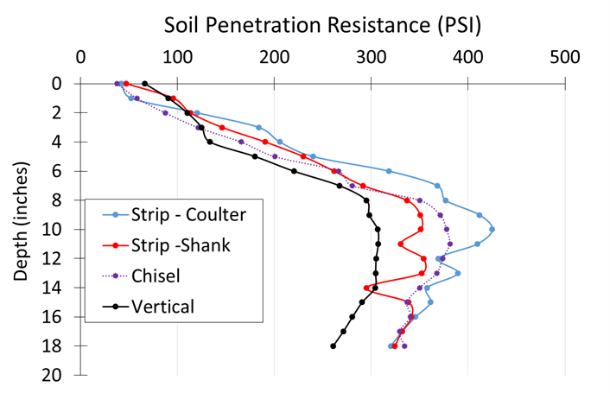

Sandy Loam near Barney, ND. Measured at Planting.

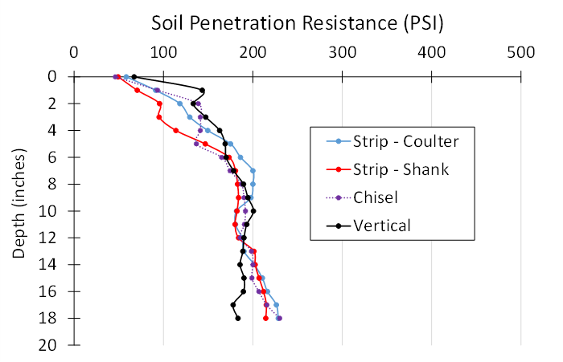

Silty Clay near Mooreton, ND. Measured at Planting.

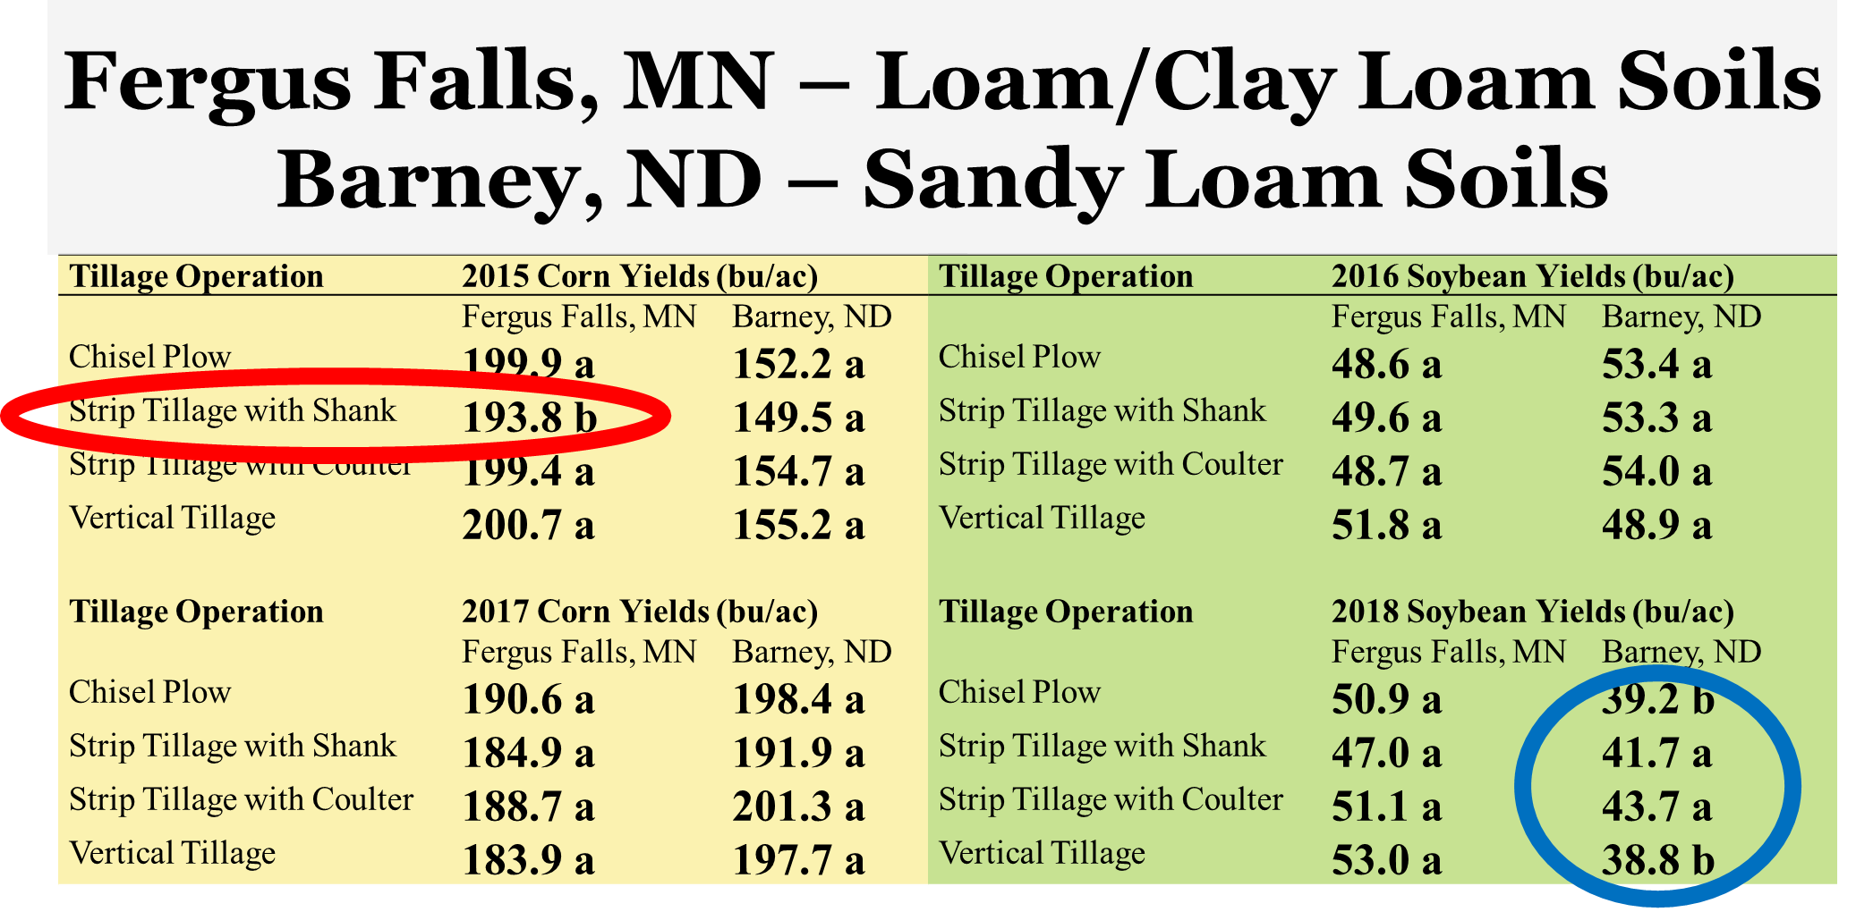

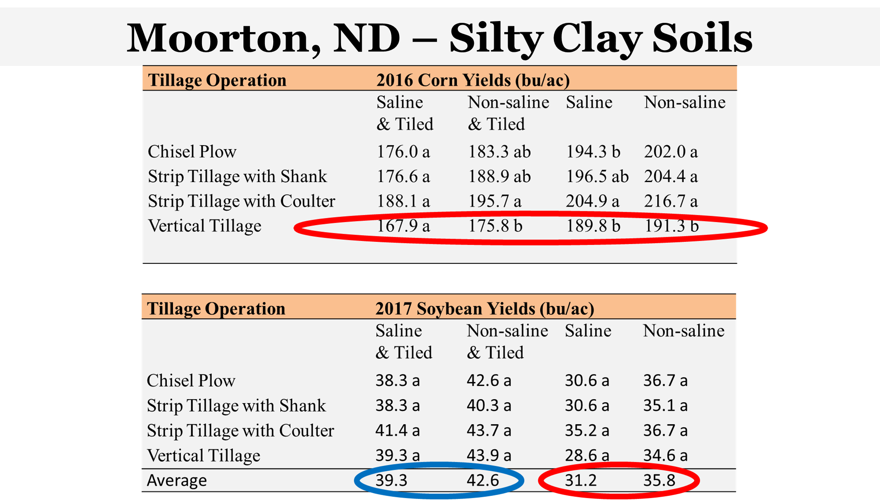

Soil properties as affected after 4 years of implementing conservation tillage systems [chisel plow (CP), fall strip till with shanks (STs), spring strip till with coulters (STc), and shallow vertical till (VT)] at two on-farm sites near Barney, ND, and Fergus Falls, MN.

|  |  |  |  |  |  |
| --- | --- | --- | --- | --- | --- |
| Soil variable† | Site | CP | STs | STc | VT |
| pH | Barney, ND | 5.79b‡ | 5.85b | 5.95b | 5.90b |
|  | Fergus Falls, MN | 8.23a | 8.12a | 8.25a | 8.15a |
| TN (%) | Barney, ND | 0.12b | 0.11b | 0.11b | 0.11b |
|  | Fergus Falls, MN | 0.16a | 0.17a | 0.14a | 0.17a |
| TOC (%) | Barney, ND | 1.12b | 1.05b | 1.10b | 1.08b |
|  | Fergus Falls, MN | 2.07a | 2.20a | 2.12a | 2.27a |
| Active C (%) | Barney, ND | 298b | 297b | 286b | 264b |
|  | Fergus Falls, MN | 405a | 409a | 321a | 409a |
| Microbial biomass (nmol g-1) | Barney, ND | 38.1b | 34.4b | 36.2b | 32.9b |
|  | Fergus Falls, MN | 43.0a | 41.6a | 42.5a | 46.6a |
| Arbuscular mycorrhiza (%) | Barney, ND | 3.83b | 3.96b | 3.64b | 3.62b |
|  | Fergus Falls, MN | 4.29a | 4.03a | 4.29a | 4.42a |
| Total fungi (%) | Barney, ND | 1.71a | 1.75a | 1.16a | 1.55a |
|  | Fergus Falls, MN | 1.20b | 0.97b | 0.96b | 0.97b |
| Eukaryotes (%) | Barney, ND | 2.35a | 1.50a | 1.98a | 2.07a |
|  | Fergus Falls, MN | 1.07b | 1.07b | 1.20b | 1.01b |
| Actinomycetes (%) | Barney, ND | 19.6b | 19.1b | 20.2b | 19.3b |
|  | Fergus Falls, MN | 21.0a | 22.8a | 21.6a | 21.5a |
| Gram+ bacteria (%) | Barney, ND | 37.3a | 36.5a | 36.2a | 37.3a |
|  | Fergus Falls, MN | 37.3a | 37.3a | 37.8a | 38.1a |
| Gram- bacteria (%) | Barney, ND | 36.4a | 37.2a | 37.8a | 36.5a |
|  | Fergus Falls, MN | 34.9b | 33.7b | 34.b | 33.8b |
| Fungi:bacteria ratio | Barney, ND | 0.076ab | 0.078a | 0.066b | 0.071ab |
|  | Fergus Falls, MN | 0.077ab | 0.071ab | 0.073ab | 0.076ab |
| Cyclopropane:gram- stress ratio | Barney, ND | 1.35b | 1.42b | 1.50b | 1.21b |
|  | Fergus Falls, MN | 1.75a | 1.51a | 1.71a | 1.72a |
| Water stable aggregates (%) | Barney, ND | 8.17b | 9.48b | 10.3b | 8.83b |
|  | Fergus Falls, MN | 22.7a | 20.9a | 24.5a | 28.1a |
| Bulk density (g cm-3) | Barney, ND | 1.42a | 1.43a | 1.38a | 1.43a |
|  | Fergus Falls, MN | 1.35b | 1.31b | 1.40b | 1.38b |
| Total porosity (cm3 cm-3) | Barney, ND | 0.43a | 0.43a | 0.45a | 0.43a |
|  | Fergus Falls, MN | 0.45a | 0.47a | 0.43a | 0.44a |
| Field capacity (g g-1) | Barney, ND | 0.13b | 0.12b | 0.12b | 0.13b |
|  | Fergus Falls, MN | 0.26a | 0.26a | 0.28a | 0.28a |
| Permanent wilting (g g-1) | Barney, ND | 0.06b | 0.07b | 0.06b | 0.07b |
|  | Fergus Falls, MN | 0.13a | 0.14a | 0.13a | 0.15a |
| Steady-state infiltration (cm d-1) | Barney, ND | 78b | 80b | 44b | 42b |
|  | Fergus Falls, MN | 763a | 482a | 732a | 880a |

†Means pooled across the 0-6 and 6-12 inch soil depths.

‡Difference letters for a soil property and across both sites are significantly different at the 0.05 level using Tukeys. A mixed linear model was used to test fix effects of tillage system, site, soil depth, and their interactions.

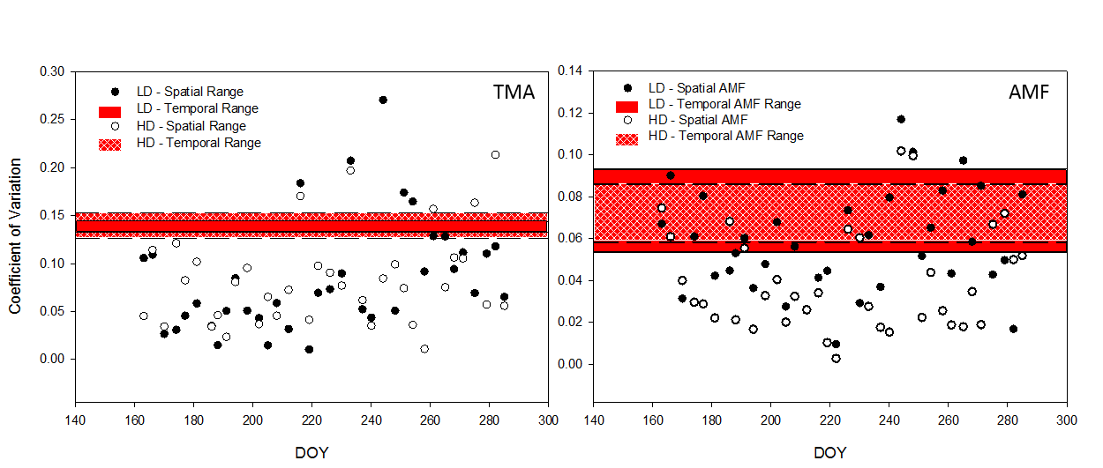

An example of 2017 Total Microbial Abundance (TMA), left, and Arbuscular Mycorrhizal Fungi (AMF), (right), coefficient of variation diagrams. Individual dots represent spatial variability for individual dates and treatments [High Disturbance (HD), and Low Disturbance (LD)], while horizontal bars represent temporal treatment variability ranges.

2017 p-values for six PLFA biomarkers across date, tillage, and date by tillage interaction effects.

|  |  |  |  |  |  |  |
| --- | --- | --- | --- | --- | --- | --- |
| **Effect** | **TMA†** | **AMF** | **Fungi** | **Bacteria** | **F:B** | **Actinomycetes** |
| **Date** | **0.001\*\*** | **0.001\*\*** | 0.243 | 0.254 | 0.113 | 0.080 |
| **Tillage** | 0.648 | 0.732 | **0.002\*\*** | 0.566 | **0.004\*\*** | 0.529 |
| **Date*Tillage** | 0.289 | 0.072 | 0.649 | 0.967 | 0.632 | 0.716 |

*Significant at *P* < 0.05

**Significant at *P* < 0.01

***Significant at *P* < 0.001

† TMA: total microbial abundance, AMF: arbuscular mycorrhizal fungi, Fungi: total fungi, Bacteria: total bacteria, F:B: fungal to bacterial ratio, Actinomycetes: total actinomycetes.

2018 p-values for six PLFA biomarkers across date, tillage, and date by tillage interaction effects.

|  |  |  |  |  |  |  |
| --- | --- | --- | --- | --- | --- | --- |
| **Effect** | **TMA†** | **AMF** | **Fungi** | **Bacteria** | **F:B** | **Actinomycetes** |
| **Date** | **0.0001\*\*\*** | 0.064 | 0.563 | **0.022\*** | 0.503 | 0.250 |
| **Tillage** | 0.061 | 0.630 | 0.540 | 0.078 | 0.650 | 0.086 |
| **Date*Tillage** | 0.170 | 0.872 | 0.316 | 0.962 | 0.294 | 0.175 |

*Significant at *P* < 0.05

**Significant at *P* < 0.01

***Significant at *P* < 0.001

† TMA: total microbial abundance, AMF: arbuscular mycorrhizal fungi, Fungi: total fungi, Bacteria: total bacteria, F:B: fungal to bacterial ratio, Actinomycetes: total actinomycetes.



Heat map of 2017 Fourier analysis PLFA group spectral densities. Total Microbial Abundance (TMA), Fungal to Bacterial Ratio (F:B), Arbuscular Mycorrhizal Fungi (AMF), Actinomycetes (Actino.), High Disturbance (HD), Low Disturbance (LD). Colored boxes indicate frequencies above the 95% CI, and boxed areas represent replication consistency for refinement of scattered cyclical frequencies.



Heat map analysis of 2018 Fourier analysis PLFA biomarker spectral densities. Total Microbial Abundance (TMA), Fungal to Bacterial Ratio (F:B), Arbuscular Mycorrhizal Fungi (AMF), Actinomycetes (Actino.), High Disturbance (HD), Low Disturbance (LD).Colored boxes indicate frequencies above the 95% CI, and boxed areas represent replication consistency for refinement of scattered cyclical frequencies.

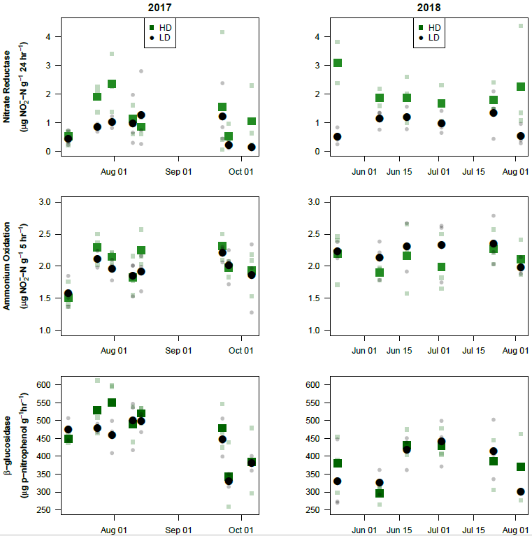

Nitrate Reductase, Ammonium Oxidation, and β-glucosidase enzyme activities across selected dates. Disturbance levels are represented with treatment means (bolded) and plot replications (faded).

2017 Friedman non-parametric repeated measures results.

|  |  |  |  |  |  |
| --- | --- | --- | --- | --- | --- |
| Effects | Variable | | AO† | NR | BG |
| Treatment | DOY‡ | μg NO2-- N g-1 5h-1 | | μg NO2- - N g-1 24 h-1 | μg p-Nitrophenol - g-1 1 h-1 |
| HD§ | 191 | 1.51 (0.18) | | 0.52 (0.22) | 448.6 (10.2) |
| LD | 191 | 1.58 (0.20) | | 0.42 (0.22) | 475.8 (25.4) |
|  | Pr > F | N/A | | 1 | 0.4 |
| HD | 205 | 2.30 (0.20) | | 1.90 (0.38) | 528.6 (62.0) |
| LD | 205 | 2.12 (0.11) | | 0.84 (0.12) | 478.5 (25.4) |
|  | Pr > F | 0.4 | | 0.1 | 0.7 |
| HD | 212 | 2.15 (0.08) | | 2.35 (0.83) | 551.0 (64.7) |
| LD | 212 | 1.96 (0.13) | | 1.02 (0.17 | 459.3 (37.6) |
|  | Pr > F | 0.2 | | 0.1 | 0.4 |
| HD | 222 | 1.83 (0.25) | | 1.13 (0.41) | 489.6 (40.5) |
| LD | 222 | 1.85 (0.23) | | 0.97 (0.72) | 500.3 (58.8) |
|  | Pr > F | N/A | | 1 | 1 |
| HD | 226 | 2.25 (0.23) | | 0.85 (0.25) | 520.3 (19.7) |
| LD | 226 | 1.92 (0.23) | | 1.26 (1.11) | 498.6 (22.0) |
|  | Pr > F | 0.4 | | 1 | 0.4 |
| HD | 265 | 2.31 (0.16) | | 1.54 (1.86) | 479.3 (51.0) |
| LD | 265 | 2.21 (.011) | | 1.22 (0.84) | 448.2 (43.9) |
|  | Pr > F | 0.4 | | 0.7 | 0.7 |
| HD | 268 | 1.98 (0.11) | | 0.51 (0.34) | 343.9 (73.9) |
| LD | 268 | 2.02 (0.22) | | 0.20 (0.09) | 330.8 (14.8) |
|  | Pr > F | 0.7 | | 0.4 | 1 |
| HD | 279 | 1.93 (0.29) | | 1.05 (0.90) | 348.7 (74.8) |
| LD | 279 | 1.86 (0.44) | | 0.14 (0.06) | 381.3 (16.7) |
|  | Pr > F | 1 | | 0.1 | 1 |
| Treatment x DOY | Pr > F | 0.06439 | | 0.1982 | 0.1247 |

*Significant at *P* < 0.05

**Significant at *P* < 0.01

***Significant at *P* < 0.001

N/A: cannot compute exact p-values with ties

† Ammonium Oxidation (AO); Nitrate Reductase (NR); β-glucosidase (BG)

‡ Day of Year (DOY)

§ HD: High Disturbance; LD: Low Disturbance

2018 Friedman non-parametric repeated measures results.

|  |  |  |  |  |
| --- | --- | --- | --- | --- |
| Effects | Variable | AO† | NR | BG |
| Treatment | DOY‡ | μg NO2- - N g-1 5h-1 | μg NO2- - N g-1 24 h-1 | μg p-Nitrophenol - g-1 1 h-1 |
| HD§ | 141 | 2.19 (0.34) | 3.09 (0.59) | 380.5 (64.2) |
| LD | 141 | 2.23 (0.11) | 0.49 (0.25) | 330.2 (83.0) |
|  | Pr > F | 0.7 | 0.1 | 0.4 |
| HD | 158 | 1.91 (0.09) | 1.87 (0.25) | 296.2 (22.2) |
| LD | 158 | 2.13 (0.25) | 1.14 (0.28) | 326.6 (28.0) |
|  | Pr > F | 0.4 | 0.1 | 0.4 |
| HD | 169 | 2.16 (0.45) | 1.87 (0.66) | 431.7 (31.3) |
| LD | 169 | 2.31 (0.31) | 1.18 (0.32) | 417.2 (39.7) |
|  | Pr > F | 0.7 | 0.4 | 1 |
| HD | 183 | 1.99 (0.37) | 1.67 (0.51) | 430.1 (33.8) |
| LD | 183 | 2.33 (0.41) | 0.96 (0.33) | 441.5 (52.9) |
|  | Pr > F | 0.4 | 0.2 | 1 |
| HD | 204 | 2.27 (0.22) | 1.78 (0.44) | 386.7 (59.1) |
| LD | 204 | 2.35 (0.32) | 1.34 (0.69) | 414.2 (68.4) |
|  | Pr > F | 1 | 1 | 1 |
| HD | 214 | 2.11 (0.23) | 2.27 (1.51) | 370.6 (76.0) |
| LD | 214 | 1.98 (0.11) | 0.54 (0.30) | 300.2 (1.1) |
|  | Pr > F | 1 | 0.1 | 0.7 |
| Treatment x DOY | Pr > F | 0.1907 | 0.8871 | 0.09314 |

*Significant at *P* < 0.05

**Significant at *P* < 0.01

***Significant at *P* < 0.001

N/A: cannot compute exact p-values with ties

† Ammonium Oxidation (AO); Nitrate Reductase (NR); β-glucosidase (BG)

‡ Day of Year (DOY)

§ HD: High Disturbance; LD: Low Disturbance

2017 covariate summaries of seasonal enzyme empirical models.



*Significant at *P* < 0.05

**Significant at *P* < 0.01

***Significant at *P* < 0.001

X *P* > .05

† Ammonium Oxidation (AO); Nitrate Reductase (NR); β-glucosidase (BG)

‡ High Disturbance (HD); Low Disturbance (LD)

2018 covariate summaries of seasonal enzyme empirical models.



*Significant at *P* < 0.05

**Significant at *P* < 0.01

***Significant at *P* < 0.001

X *P* > .05

† Ammonium Oxidation (AO); Nitrate Reductase (NR); β-glucosidase (BG)

‡ High Disturbance (HD); Low Disturbance (LD)

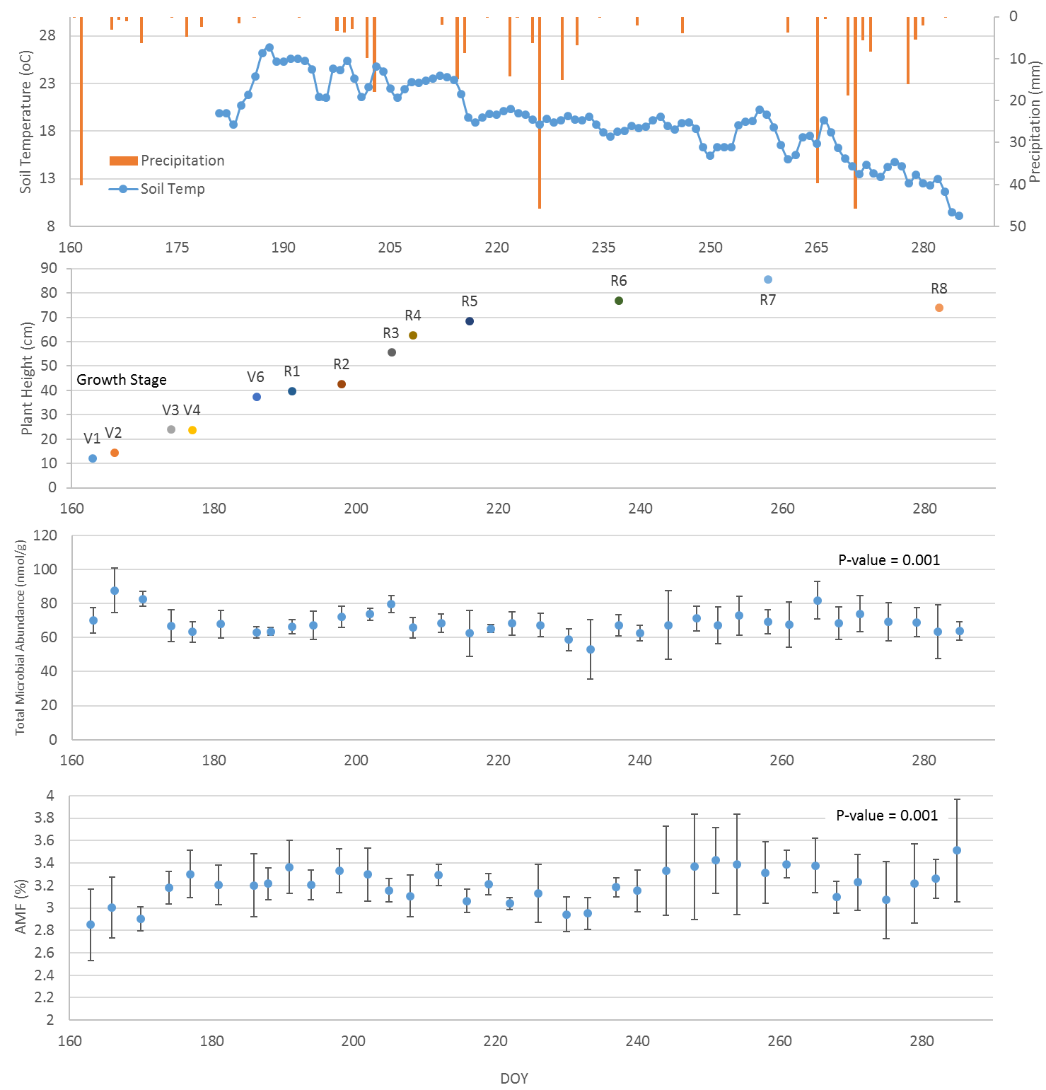

Representation of 2017 Total Microbial Abundance (TMA) and Arbuscular Mycorrhizal Fungi (AMF) seasonal means plotted with physical conditions (i.e. precipitation and soil temperature) and plant growth stages. Error bars represent standard deviations (n = 6).

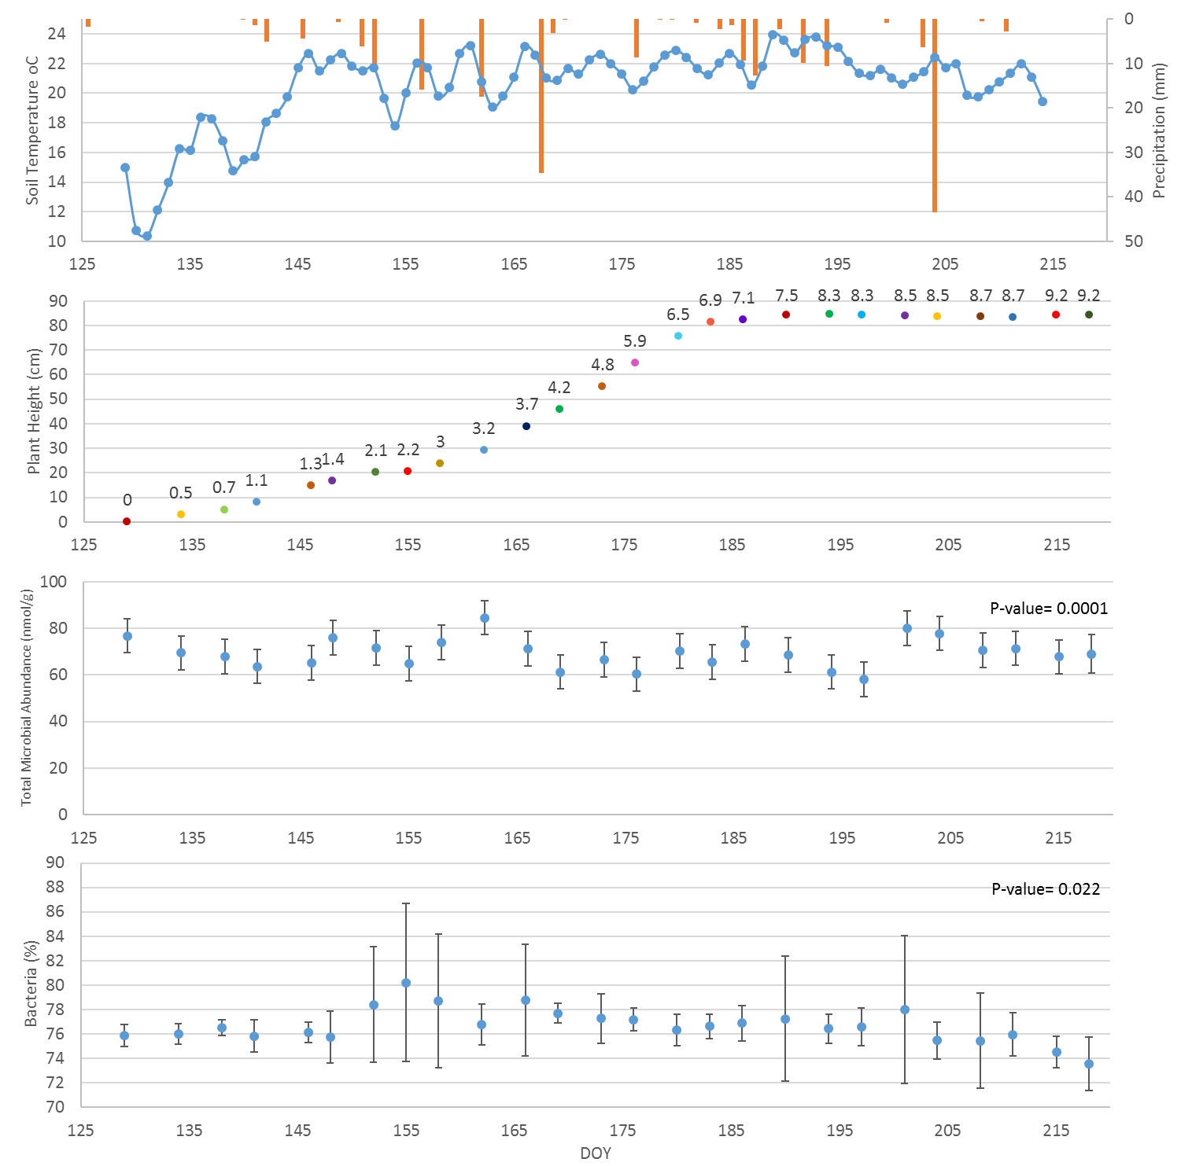

Representation of 2018 Total Microbial Abundance (TMA) and Bacteria seasonal means plotted with physical conditions (i.e. precipitation and soil temperature) and plant growth stages. Error bars represent standard deviations (n = 6).