Effect of plant population and row spacing on physiology, water use efficiency, and yield of no-till dryland soybean
(A Technical Report – 2018/19)
Gautam Pradhan*, Jerald Bergman, and James Staricka
NDSU Williston Research Extension Center
Williston, ND
*Corresponding author: gautam.pradhan@ndsu.edu

Situation statement
North Dakota is the fourth largest soybean growers in the nation. Recently, the state has a tremendous increase in soybean acreage (227% more in 2015 from 1.85 million acres in 2000), which is due to increases in acreage in all parts of the state including the western region. Drought is one of the main abiotic stresses affecting soybean yield in the USA. In North Dakota, 99% of soybean is produced under dryland condition, and the crop is highly vulnerable to drought stress during the reproductive phase of crop development. The western ND has exceptionally drier climate than the eastern part. It receives <15 inches of precipitation annually as compared to about 21 inches in the east, and average annual evapotranspiration is 5 inches higher than the east. There is a need for a soybean production management guideline suitable for no-till dryland soybean producers of western ND, and there is a lack of information on suitable soybean planting geometry for this part of the state. Determination of suitable plant population and row spacing is crucial to have a sustainable higher soybean yield and the farm income under no-till dryland condition, as these agronomic parameters affect resource use efficiency, growth, and yield of every field crop including soybean.

Objectives of the research project
To determine suitable dryland soybean plant population and row spacing that has
  - higher grain yield, grain quality, and farm income
  - favorable morpho-physiological traits such as greater chlorophyll, cooler canopy temperature, and
  - higher water use efficiency

Description of the research conducted
A Roundup Ready 2 Yield (RR2Y) soybean variety with a maturity group of 0.3 was planted at the Williston Research Extension Center on May 30, 2018 using a SRES (Seed Research Equipment Solutions) precision planter. The row spacing of 7½, 15, 22½, and 30 inches were maintained as main plots and plant population (seeding rate) of 90, 120, 150, and 180 thousand pure live seed number per acre were considered sub-plots. A roundup herbicide was applied as per the manufacturer’s instructions to keep the plots free of weeds. Canopy temperature and normalized difference vegetation index (NDVI) were measured weekly with a FLIR® E60 Thermal Imaging Camera and a Modified NDVI Sony a6000 Camera; respectively. Soil moisture was recorded from each plot using a neutron moisture meter. The crop was harvested using a plot combine and biomass were collected four days before harvest.

Findings
This year, the trial received heavy rain, wind and hailstorms that damaged the crop and adversely affected yield (June 23: wind speed=46 mph, precipitation = 1.53”; June 28: wind speed = 61 mph, precipitation = 0.94”, hailstorm; July 9: wind speed = 48 mph, precipitation = 1.67”). There was no effect of plant population, row spacing, and interaction effect of plant population × row spacing on normalized difference vegetation index (NDVI), canopy temperature (CT), available soil moisture, plant height, test weight, grain protein, grain oil, and 1000 grain weight. On August 22, 2018, the average NDVI of soybean canopy was 0.65, and canopy temperature was 32.3 °C. The averaged plant height, test weight, grain protein, grain oil, and 1000 grain weight were 17”, 58 lb bu⁻¹, 36%, 15%, and 119 g, respectively.
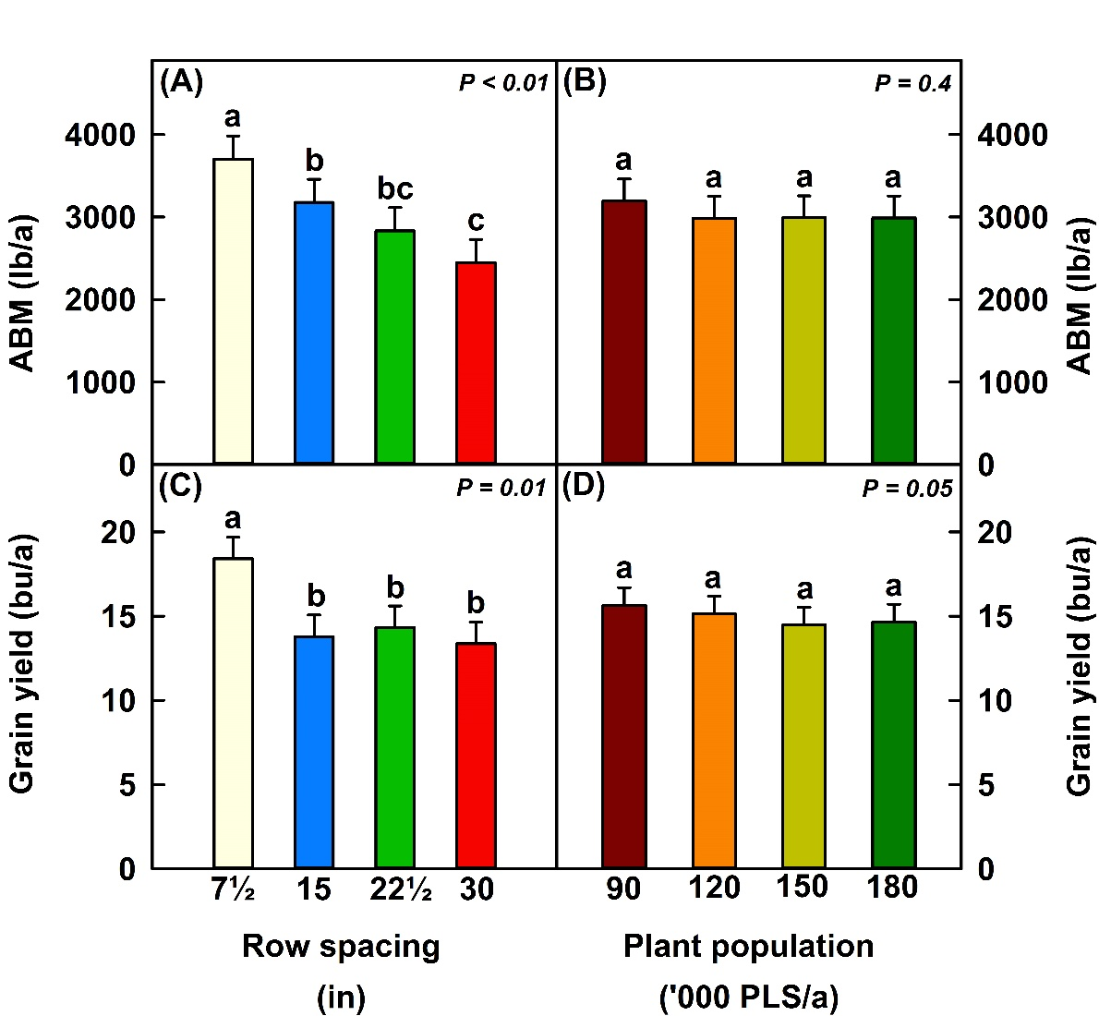

Figure 1. Above ground biomass (ABM) and grain yield under different plant populations and row spacings.

When averaged across the row spacing, there was no effect of plant population on above ground biomass (ABM) and grain yield (Fig. 1B, 1D); however, when averaged across the plant population, a row spacing of 7½” produced 525 to 1250 more lb/a of biomass (Fig. 1A) and 4 to 5 more bu/a of grain (Fig. 1C) than the wider row spacings. There was an evidence of the interaction effect of plant population × row spacing on grain yield; but, as 90 thousand plant population produced higher or equal bushels of grain at different row spacings, and 7½” row spacing produced higher or equal bushels of grain at different plant population, the interaction effect was not further elaborated.

Conclusion
This experiment confirmed our findings in 2016 and 2017 that a row spacing of 7½” and 90 thousand plant population per acre (seeding rate) is a suitable planting geometry for no-till dryland soybean production in western ND. The study recommends planting soybean at a lower seeding rate and narrow rows, which reduces expensive seed cost, enhances yield, and increases the farm income of ND soybean producers.

Acknowledgements
We would like to thank the North Dakota Soybean Council for financial support. Mention of trademark or proprietary product does not constitute a guarantee or warranty of the product by NDSU Williston Research Extension Center and does not imply its approval to the exclusion of other products which may also be suitable.

