Project Number: | 1820-162-0144
Project Title: | Development and commercialization of advanced high oleic germplasm lines with natural mutations
Organization: | Michigan State University
Principal Investigator Name: | Dechun Wang

Project Status - What key activities were undertaken and what were the key accomplishments during the life of this project? Please use this field to clearly and concisely report on project progress. The information included should reflect quantifiable results (expand upon the KPIs) that can be used to evaluate and measure project success. Technical reports, no longer than 4 pages, may be included in this section.
Over 500 high oleic lines were selected from the greenhouse based on gas chromatography measurements of their fatty acid profiles. These lines were planted in single row yield plots in the spring of 2018 and are currently being harvested. From the 2017 single row plots, 145 lines were selected with target maturity and high yield potential. These lines were planted in preliminary yield trials in 2018 with multiple replications at 3 locations and are currently being harvested. From the 2017 preliminary yield trials, 27 non-GMO, high oleic soybean lines were selected based on high yield and other agronomic traits. These lines were planted in advanced yield trials in 2018 at 6 locations across Michigan and have all been harvested. All yield data will be/has been collected, and the highest yielding lines in each trial will advance to the next stage of the breeding program.

Zeeland Farm Services (ZFS) planted 5 non-GMO, high oleic lines from MSU for half-acre seed increases. These lines had good yield (See Table 1), good agronomic quality, good oil quality, and fit the maturity groups targeted by ZFS. Two of the five lines were selected for winter nursery increase in Argentina. The seed is currently being shipped to Argentina by airfreight. These two lines will be increased in Michigan in 2019, and available for commercial production by 2020.

TABLE 1 – Yield Trial for MSU’s non-GMO, high oleic soybean varieties
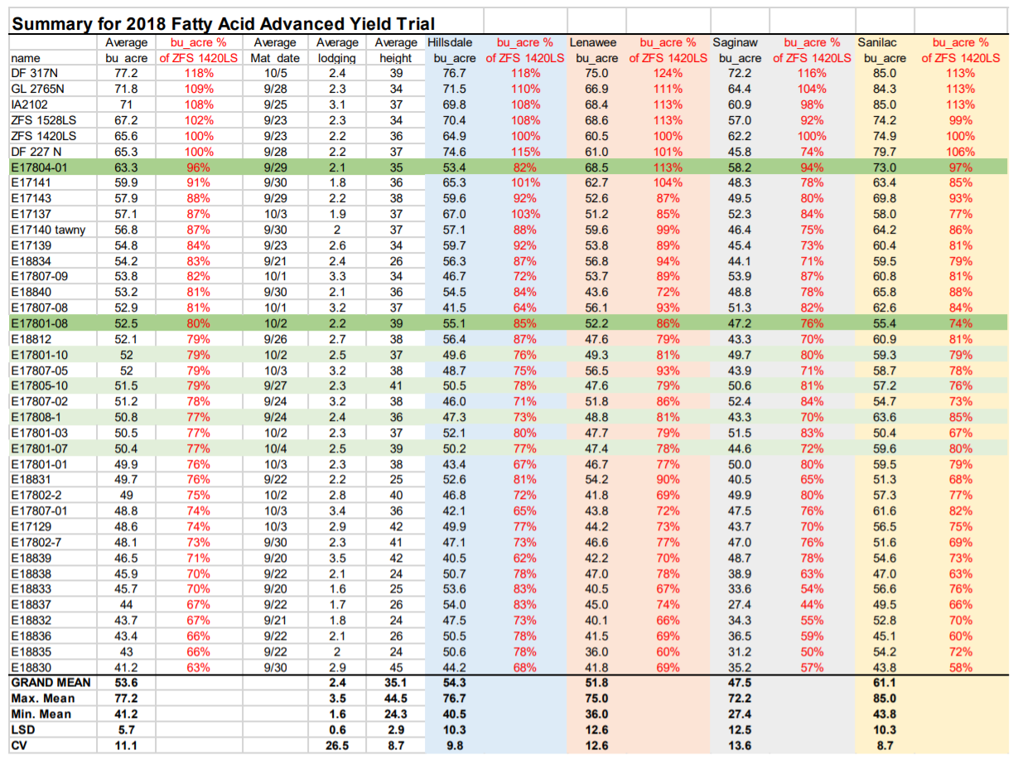

The yield data above shows the performance of MSU’s non-GMO, high oleic soybean varieties at four of the six locations. The data from the last two locations is currently being analyzed. A line name beginning with an “E” indicates that it is an MSU variety. An MSU line with an “8” as the third numerical digit indicates that it is a non-GMO, high oleic line. None of the non-GMO, high oleic lines exceeded the yield of the conventional soybean checks. However, E17804-1 averaged 96% of the yield of ZFS’ commercial check. This line will be increased in Argentina during the winter of 2018/19. E17801-08 and E17808-1 will also be increased in Argentina this winter. Although the yield on these lines is significantly lower than the commercial check, ZFS believes that they can be profitable with for farmers and for processors within an identity preserved system.

Did this project meet the intended Key Performance Indicators (KPIs)? List each KPI and describe progress made (or not made) toward addressing it, including metrics where appropriate.
At least one non-GMO, high oleic commercial line ready for commercial production by 2019

We did not meet this indicator. The original proposal was written under the timeline that by the end of 2018, we would have two years (2017 and 2018) of yield data for our non-GMO, high oleic lines. However, the yield trials for 2017 had to be thrown out due to poor germination (See unforeseen events section below). Despite this setback we were still able to collect one year of yield data and begin pre-commercial increases. With the addition of winter nursery increases during the winter of 2018/19, we would expect commercial production of MSU non-GMO, high oleic soybean varieties by 2020.

At least eight additional non-GMO high oleic lines will be tested in commercial variety trials in 2018 and at least two of these eight lines will be selected by 2019 for future commercial releases

We did meet this indicator. Our 2018 Fatty Acid Advanced Yield Trial included 27 non-GMO, high oleic soybean varieties from MSU. This trial was planted with four replications and six locations across the state of Michigan. Based on this data, ZFS has selected three lines for winter nursery increase in Argentina for the winter of 2018/19. These lines will continue to be increased until enough seed is available for commercial production (likely by 2020).

Expected Outputs/Deliverables - List each deliverable identified in the project, indicate whether or not it was supplied and if not supplied, please provide an explanation as to why.
1 or 2 high yielding, non-GMO, high oleic MSU germplasm lines (MG II and/or MG III) will be ready for commercial production through ZFS by 2019

This deliverable was not met due to poor germination in the 2017 yield trial (see unforeseen events section below). However, this deliverable will be met by 2020 (one year delay).

8-10 non-GMO, high oleic lines will be tested in commercial variety trials

This deliverable was exceeded. 27 non-GMO, high oleic lines were tested in the 2018 Fatty Acid Advanced Yield Trial. This trial had four replications at six locations across the Michigan soybean growing region.

Over 2000 additional non-GMO, high oleic lines will be tested in various pre-commercial yield trials

This deliverable was exceeded. The total sum of single row yield plots, preliminary yield trial, advanced yield trials, and commercial yield trials exceeds this metric.

Describe any unforeseen events or circumstances that may have affected project timeline, costs, or deliverables (if applicable.)
There was one primary setback to meeting the KPI and Deliverables. The seed used for the 2017 non-GMO, high oleic yield trials had uneven germination. This was due to poor seed handling at a winter nursery in Costa Rica. Based on visual inspection, it appears that the seed was harvested wet and dried at too high of a temperature. This severely affected the germination of many of the non-GMO, high oleic lines. Due to the extremity of the germination problems, yield comparisons from this trial were not valid. This delayed the project by a full year. Instead of having two years of yield trial data from the 2017 and 2018 field seasons, we will have two years of yield trial data from the 2018 and 2019 field seasons. Instead of commercial release by 2019, this has delayed commercial release until 2020.

What, if any, follow-up steps are required to capture benefits for all US soybean farmers? Describe in a few sentences how the results of this project will be or should be used.

The commercialization steps should continue. Funding for yield trials and pre-commercial seed increase has been secured for 2019. Additional projects to encourage commercialization are described below.
List any relevant performance metrics not captured in KPI’s.
MSU Technologies has filed an invention disclosure for our non-GMO, high oleic lines and other intellectual property is being negotiated with Missouri Soybeans and Iowa State University. MSU collaborated with the Iowa Grain Quality Lab to acquire NIR models for ZFS to test high oleic shipments of grain at their elevators. MSU gave ZFS non-GMO, high oleic seed samples to ensure the NIR model is adequately calibrated. The MSU Soybean Breeding and Genetics Lab secured a $75,000 grant to extract oil from our non-GMO, high oleic varieties and evaluate analytical and sensory properties of French fries fried in our oil, in contrast to other commercially available fry oils. This grant was co-funded by the Michigan Translational Research and Commercialization agency (MTRAC), the Michigan Soybean Promotion Committee, and Zeeland Farm Services. The fry tests will be conducted in early 2019. We are also applying for an additional MTRAC award to test extruded soybean meal from our non-GMO, high oleic varieties in a dairy feeding study. We have established Adam Locke, associate professor from the MSU Department of Animal Science, and Travis Luke, owner of Tri-State Crush, LLC, as collaborators on the new MTRAC proposal. Tillerman Seeds, LLC has expressed interest in the dairy feeding proposal, and may co-fund the project with MTRAC. Pending funding, the dairy feeding study would be conducted in late 2019 / early 2020.

