ISA Final Research Progress Report
Project Title: Drainage water quality from manure-treated soybean crops: Bio-electrical modification of woodchip bioreactors for enhanced performance. Michelle Soupir (Iowa State University) (msoupir@iastate.edu)
Principal investigators:

Michelle Soupir, Iowa State University, Water Quality Research Lab, Dept. of Agricultural and Biosystems Engineering, 3163 NSRIC Bldg., msoupir@iastate.edu, 515-294-2307

Natasha Hoover, Iowa State University, Water Quality Research Lab, Dept. of Agricultural and Biosystems Engineering, 3145 NSRIC Bldg., nlhoover@iastate.edu

Thomas Moorman, USDA-ARS National Laboratory for Agriculture and the Environment
2110 University Boulevard, Ames, IA 50011, Tom.moorman@usda.ars.gov 515-294-2308

Co-investigator:

Keegan Kult, Watershed Management Specialist, ISA Environmental Programs & Services, 1255 SW Prairie Train Pkwy, Ankeny, IA 50023

- Investigate bioreactor performance (for removal of nutrients and bacteria) at manure amended field sites
We completed our final year of bioreactor monitoring in 2017 and the results are summarize below in Table 1. Overall, the field bioreactors were successful in removing bacteria, however concentration increases were measured at various times for each bioreactor and these instances influenced overall average values. Our laboratory experiments showed that bacteria removal is possible by bioreactors under controlled conditions, especially when receiving higher concentrations. Below is a written summary of bacteria results from 2017 monitoring.
Story County Bioreactor- (no manure)
E. coli and Enterococcus were monitored in 2017 influent and effluent samples. Bacteria concentrations at Story County were typically low during the 2017 sampling and drainage season, with average influent concentrations of 6 cfu/100 ml (E. coli) and 102 cfu/100 ml (Enterococcus), and average effluent concentrations of 11 cfu/100 ml (E. coli) and 61cfu/100 ml (Enterococcus). Influent E. coli concentrations were below 5 cfu/100 ml on 8 of the 17 samples dates, and below 5 cfu/100 ml on 5 sample dates. In general, bacteria concentrations decreased from influent to effluent, with the exception of two sample dates for both E. coli and Enterococcus. Average percent removals were 13% and 45% for E. coli and Enterococcus, respectively. Median removal values are more reflective of the actual bioreactor performance, with 100% E. coli removal, and 67% Enterococcus removal. E. coli removal ranged from an increase of 617% and removals of 100%, with all but two sample dates experiencing removals of at least 50%. Enterococcus removal was more variable, and ranged from an increase of 108% to removals of 100%.
Dyersville Bioreactor- Manured site, pasture
Samples were collected and analyzed for five sample dates for the Dyersville bioreactor, with a relatively even distribution of increased and decreased concentrations comparing influent and effluent samples. Bacteria concentrations were relatively low for influent and effluent samples, with most samples measured below the maximum contaminant level. The average influent concentrations were 122 cfu/100ml and 92 cfu/100 ml for E. coli and Enterococcus, respectively. On average, effluent concentrations increased compared to influent concentrations. Average effluent concentrations were 137 and 229, increases of 40% and 94%, respectively.
Crooked Creek- manured site
Bacteria concentrations were higher and more variable for the Crooked Creek bioreactor, with lower concentrations measured early in the drainage season and much higher E. coli concentrations beginning mid-May. Increases in E. coli and Enterococcus were measured on seven and three sample dates, respectively. Median values are most representative of the bioreactor function due to uneven distribution of the data, with median removals of 51% and 59% for E. coli and Enterococcus, respectively.

Table 1. Summary of field bioreactor performance over the project period.
Contaminant |  | 2015 |  |  | 2016 |  |  | 2017
 |  | Greene | Dyersville | Story | Greene | Dyersville | Story | Dyersville | Story | Crooked Creek
Nitrate-N (mg/L) | IN | 30.67 | 30.36 | 9.2 | 17.27 | 26.3 | 5.16 | 19.71 | 6.27 | 7.94
 | OUT | 21.8 | 22.49 | 0.35 | 10 | 17.28 | 0.49 | 15.52 | 0.89 | 1.55
 | Reduction | 8.87 | 7.88 | 8.85 | 7.27 | 9.02 | 4.67 | 4.18 | 5.94 | 6.67
 | %-reduction | 29% | 26% | 96% | 42% | 34% | 91% | 20% | 96% | 85%
Dissolved Reactive Phosphate (mg/L) | IN | 0.05 | 0.075 | 0.034 | 0.044 | 0.066 | 0.041 | 0.058 | 0.027 | 0.066
 | OUT | 0.047 | 0.003 | 0.194 | 0.064 | 0.045 | 0.035 | 0.063 | 0.099 | 0.009
 | Reduction | 0.003 | 0.072 | -0.16 | -0.02 | 0.02 | 0.01 | -0.005 | -0.071 | 0.058
 | %-reduction | 6% | 96% | -466% | -45% | 32% | 15% | -10% | -225% | 78%
Enterococcus (cfu/100mL) | IN | 2 | 6 | 42 | 43 | 607 | 1037 | 92 | 73 | 96
 | OUT | 4 | 2 | 36 | 45 | 241 | 429 | 229 | 72 | 100
 | Reduction | -2 | 4 | 6 | -2 | 366 | 608 | -137 | 30 | -4
 | %-reduction | -100% | 67% | 14% | -5% | 60% | 59% | -94% | 35% | -21%
E. coli (cfu/100mL) | IN | 28 | 26 | 15 | 67 | 337 | 394 | 122 | 100 | 3687
 | OUT | 2 | 28 | 30 | 73 | 653 | 242 | 137 | 14 | 2685
 | Reduction | 26 | -2 | -15 | -6 | -316 | 152 | -15 | -7 | 1573
 | %-reduction | 93% | -8% | -100% | -9% | -94% | 39% | -40% | -12% | -42%

We further analyzed the nitrate removal by assessing relationships between NO₃-N and temperature. The water temperature was retrieved from HOBO dataloggers when available, or estimated from the equation below, which was used to relate observed soil temperature to drainage water temperature.
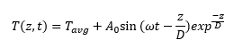
Parameter | Value | Unit | Note
T_{avg} | 11 | ºC | avg Iowa soil temperature @1m obtained from Fig 7 (Hu and Feng 2003)
$$ω$$ | 0.017 | 1/day | $ω$ = 2π/# days, where # of days modeled = 365
z | 1 | m | Z represents “depth of interest”, we assumed that tile depth =1m, and soil temp = water temp at same depth
D | 1 | m | D represents “damping depth” This assumes that temperature does not fluctuate at 1m, which is reasonable since drainage water temperature (@1m) does not fluctuate.

Figure 1. shows the relationship between NO₃-N removal and drainage water temperature. While a relationship between temperature and bioreactor performance is present, differences between bioreactors are still present. The poor performance of the Greene Co. bioreactor inspired the replacement of the woodchips in fall 2016. Dyersville bioreactor is a relatively new bioreactor but is has never performed as well as other systems.
Story County Bioreactor N removal summary
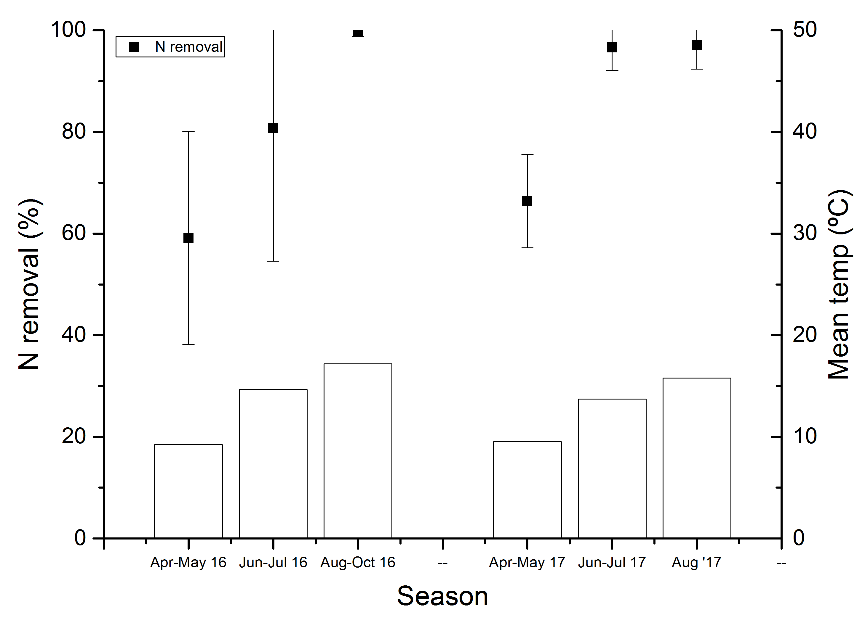

Dyersville Bioreactor N removal summary

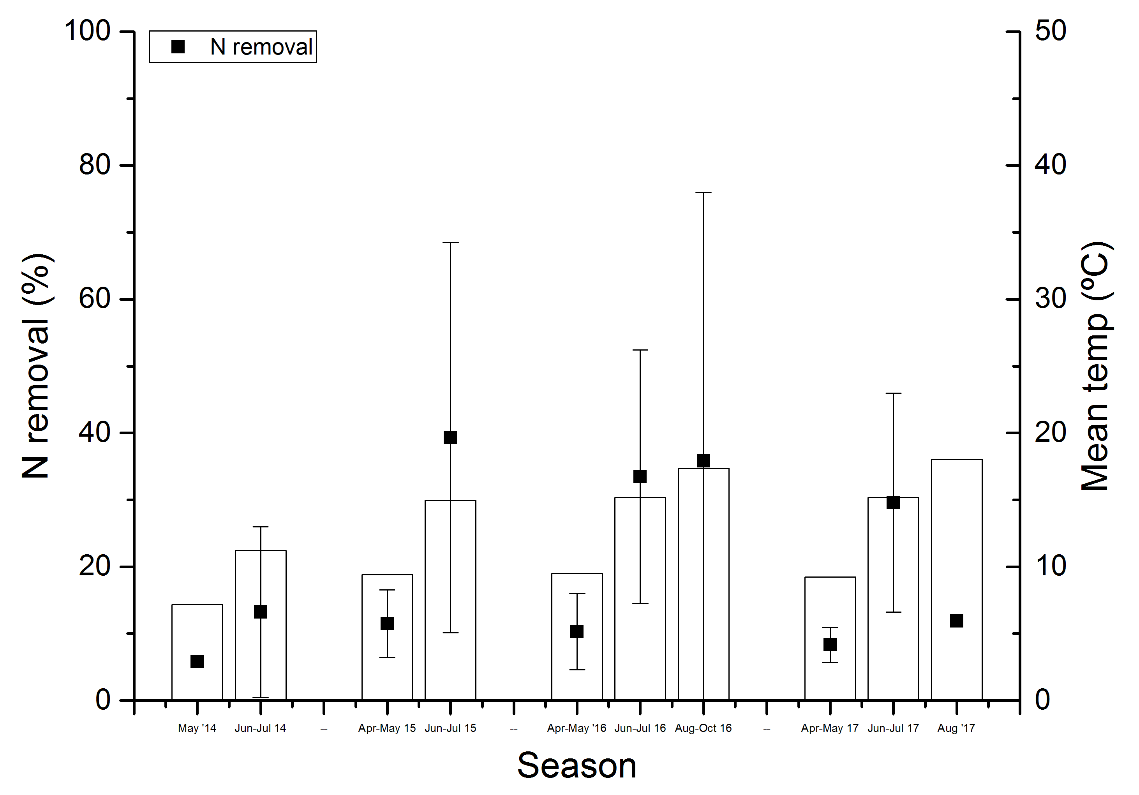
Greene County Bioreactor N removal summary
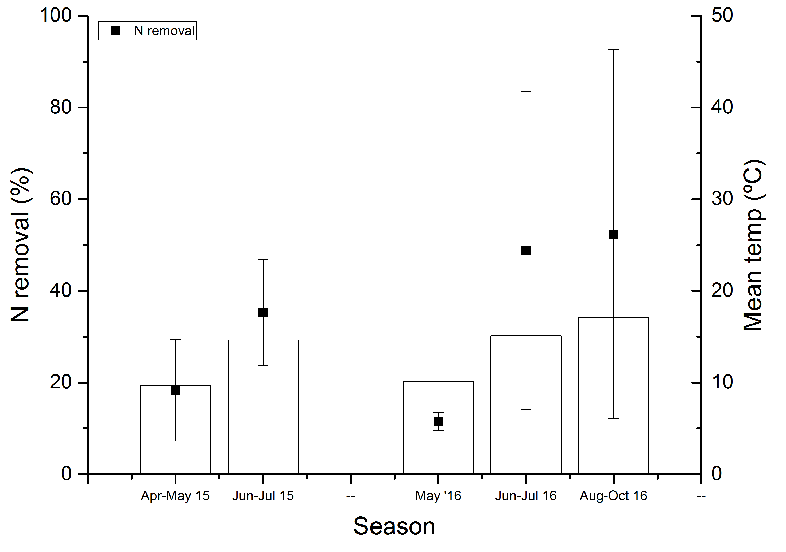

Crooked Creek Bioreactor N removal summary
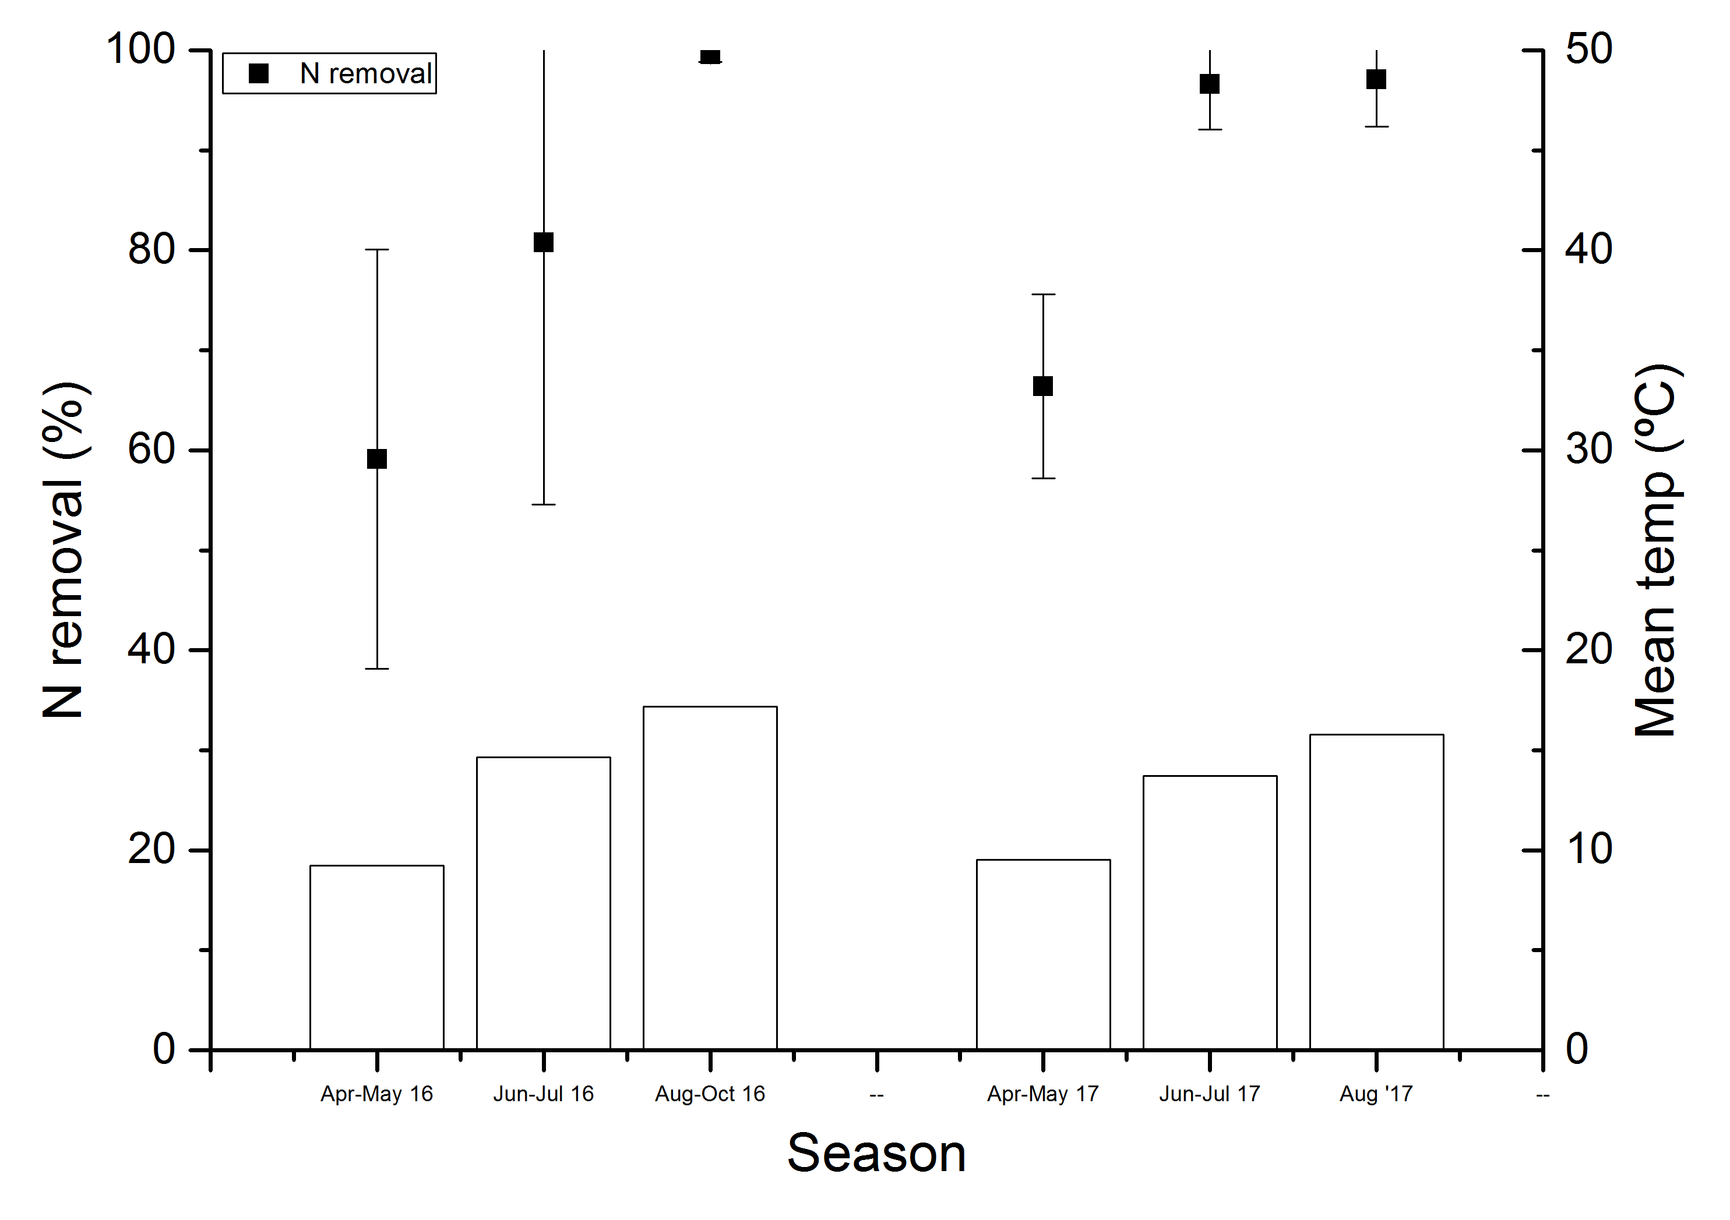
Figure 1. NO₃-N removal in the A) Story, B) Dyersville, C) Greene Co, and D) Crooked Creek bioreactors and observed water temperature for monitoring for 2015 - 2017.

- Determine hydraulic retention time and flow path analysis for selected ISA woodchip bioreactors and relate the hydrologic analysis to bioreactor performance.
Potassium bromide (KBr) tracer studies were conducted in summer and fall of 2016 at the bioreactor sites listed below, and Br⁻ analysis was conducted by the USDA ARS lab managed by Dr. Moorman. Tracer studies were conducted late in the summer when bypass flow was not present. For each test, flow was monitored using pressure transducers and samples were collected at 20 minute increments for the first 24 to 48 hours, depending upon flow conditions. In some cases additional samples were collected at 2 hr increments to ensure that all of the tracer was collected. The hydraulic properties will be analyzed from the data, including tracer residence time, Morrill Dispersion Index (MDI), hydraulic efficiency, and the potential for short circuiting (S). In Table 2 we present two parameters used to assess flow, MDI, and S. An MDI value of 1.0 indicates ideal plug flow and MDI greater than 2 indicates increasing amounts of preferential flow within the reactor. Short circuiting is indicated by values closer to zero, whereas a value of 1.0 indicates more ideal flow. The likely consequences of preferential flow (or short circuiting) are decreased effective HRT and reduced nitrate removal. Tracer studies were successfully completed for three of the bioreactors in 2016 and three additional tracer tests were in summer 2017.

Three tracer tests were successfully completed in the summer of 2017, under various flow conditions. The Story County bioreactor experienced an unusual period with no bypass flow, so a second tracer test was conducted at that site to achieve better tracer recovery. The second tracer test indicated more mixing than the 2016 test, and similar short circuiting results. The Crooked Creek bioreactor was added to the tracer test schedule, and results indicate near plug flow and ideal characteristics. The drainage season in Wright County ended abruptly, and tracer tests were not able to be completed at UWFC and LWFC. The LEC2 tracer was completed, but adjustments at a second upstream inline water control structure needed to be made throughout the test to maintain flow to the bioreactor, therefore the results should be considered approximations only. An additional test under better flow conditions would be needed for accurate results.

Table 2. Tracer study bioreactor locations and summary of results.
Bioreactor Location (ID) | Justification for Tracer Study | MDI | Short Circuiting (S)
Greene County | Installed in 2008, oldest bioreactor | 3.01 | 0.69
Wright Co. UWFC | Large dimension bioreactor
Wright Co. LWFC | Appears to have slow flow
Wright Co., LEC 2 | Large dimension bioreactor | 2.97 | 0.83
Polk Co, Tes | Potentially short-circuited flow
Dyersville | Poor performing bioreactor | 2.49 | 0.76
Story Co (2016 test) | High removal | 3.94 | 0.53
Story Co (2017 test) | High removal | 5.47 | 0.55
Crooked Creek | High removal | 3.10 | 0.64

- Determine if denitrification in woodchip bioreactors can improved by electrical stimulation
We have successfully demonstrated in the laboratory that electrical stimulation of woodchip bioreactors leads to an increase in NO₃-N removal. This work has resulted in one published paper and a second manuscript which is currently under review. The results of the first paper have been reported in detail in our previous progress reports and the key findings are summarized below:

- Higher denitrification efficiency was observed in electrically stimulated woodchip bioreactors
- Oxidation of graphite anode into carbon dioxide gas bubbles helped to regulate changes in pH and DO resulted from electrolysis of water
- Current-denitrification efficiency decreased as current increased, leading to higher electricity requirements and nitrate removal cost

Based on the results of this study we next re-designed the electrical system and also conducted a scenario analysis to assess the conditions under which the cost for NO₃-N removal could be minimized. The resulting data was used to model costs and denitrification efficiency in 75 scenarios, covering a range of bioreactor volumes, HRTs, current densities, and annual durations of electrical stimulation periods. For each scenario, we reported the estimated annual NO₃-N load reduction and NO₃-N removal cost. We found that electrically stimulated woodchip bioreactors may remove an additional 37 to 72% annual NO₃-N load than a traditional woodchip bioreactor, but at the expense of higher NO₃-N removal costs, which were increased by 138 to 194%. Smaller electrically stimulated reactors are more cost effective on a $/kg-N removed basis as shown in Fig 2.

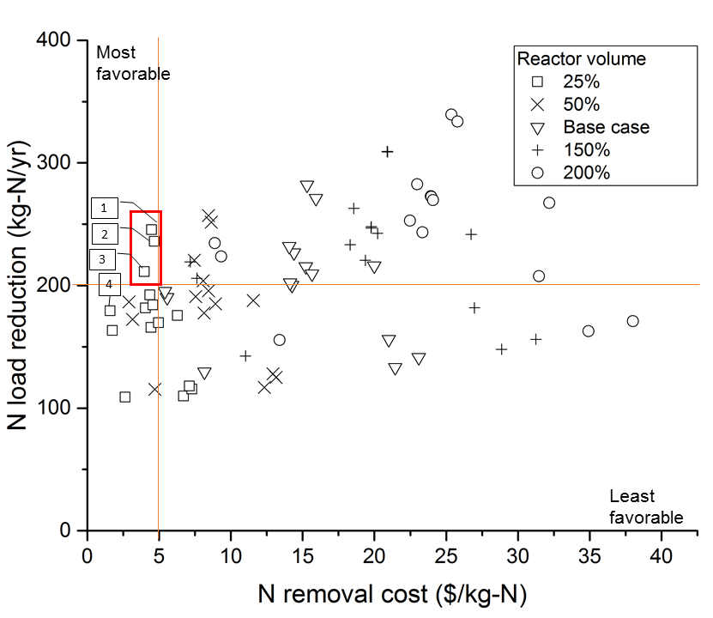
Figure 2: Annual NO₃-N load reduction and NO₃-N unit removal cost for the 75 scenarios modeled. Symbols represent design volume relative to base case (646 m³). The top left corner represents ideal performance: high NO₃-N load reduction at low cost, while scenarios toward bottom right corner are less favorable. Three scenarios (in red box) were considered most promising, as follow: Scenario 1: 25% volume, 8-hr HRT, 2.05 A/m², 25% elec. stimulation period; Scenario 2: 25% volume, 6-hr HRT, 2.05 A/m², 25% elec. stimulation period; Scenario 3: 25% volume, 8-hr HRT, 1.25 A/m², 25% elec. stimulation period. Lastly, scenario 4 (25% volume, 8-hr HRT, no electrical stimulation) was selected for discussion representing scenarios with low NO₃-N load reduction and cost.
With a different bioreactor design, we achieved even greater denitrification efficiencies in electrically stimulated woodchip bioreactors than our previous study (Law et al., 2018). We also utilized lower current densities (at least 3 times lower), thus reducing the additional cost needed for electrical stimulation in a woodchip bioreactor. Although few of the most promising electrical stimulation scenarios may remove an additional 37 to 72% annual NO₃-N load than traditional woodchip bioreactors, the NO₃-N removal costs increased by 138 to 194% respectively. The NO₃-N removal cost may be reduced in scenarios where the influent NO₃-N load is higher. As the NO₃-N removal cost ($4.49/kg-N) using electrically stimulated woodchip bioreactor is still within the range of other BMPs costs ($0.12 to $36.00), this treatment also may be a viable alternative when the NO₃-N load reduction has a higher priority than NO₃-N removal cost.
Outreach
In addition to publishing our results, this work has been highlighted at several conferences including the Annual International Meeting of ASABE and at several drainage conferences. Most recently, Dr. Soupir presented this concept to a joint meeting of the Natural Resources and Environment Committee and Agriculture Committee Senate Members at the Iowa Legislature.
Soupir, M.L. 2018. Woodchip bioreactors for removing nitrate from artificial subsurface drainage. Presented to Natural Resources and Environment Committee and Agriculture Committee Senate Members at the Iowa Legislature on 1/16/18.
Soupir, M.L. 2017. Woodchip Bioreactors: Strategies for enhanced performance and multi-contaminant removal. Oral Presentation at the Iowa-Minnesota Drainage Research Forum, Ames, Iowa. 11/15/17
Soupir, M.L. 2017. Woodchip Bioreactors: Strategies for enhanced performance and multi-contaminant removal. Oral Presentation at the Iowa Section-American Water Works Association in Council Bluffs, Iowa. 10/11/17
Soupir, M.L. 2017 Denitrifying Woodchip Bioreactors: Opportunities for Enhanced Performance. Presented to CE 591 Graduate Seminar. 9/12/17. Iowa State University.
Law, J.Y., M.L. Soupir, D. R. Raman, T.B. Moorman, S.K. Ong. 2017. Opportunities and Challenges to use electrical stimulation in nitrate-removal woodchip bioreactors. Oral presentation at the ASABE AIM in Spokane, Washington. 7/17/17 to 7/19/17.
Law, J.Y., M.L. Soupir, T.B. Moorman. 2016. Bioelectrical modification of woodchip bioreactors for improved denitrification. 10th International Drainage Symposium in Minneapolis, MN. 9/7/16 to 9/9/16

Final project results (layman’s terms for all audiences)
This project assessed the potential of woodchip bioreactors to remove multiple water quality contaminants, including nitrogen, phosphorus and bacteria, which are especially important in agricultural landscapes with integrated livestock and cropping systems. While much emphasis in Iowa has been focused on nitrate removal, it is equally important to consider removal of phosphorous and bacteria to meet the goals of the nutrient reduction strategy and to address impaired waters across the state. We addressed this goal by monitoring several field bioreactors located on private land and also by conducting laboratory experiments. Our field results generally showed reduction of fecal indicator bacteria concentrations, but we found mixed results for phosphorus removal. New studies are suggesting that materials designed to sorb phosphorus such as steel slag need to be added to bioreactors for consistent phosphorus removal to be achieved. Both our field monitoring and laboratory experiments show that woodchip bioreactors have potential to remove bacteria.
The second phase of the project addressed a new method to increase nitrate removal in woodchip bioreactors through electrical stimulation. As this practice has not been previously studied in a woodchip environment, our work was conducted in the laboratory. From our work we have shown that the electrical stimulation does indeed lead to increased nitrate removal and we also identified design parameters under which the electrical stimulation is likely to be most cost effective. The NO₃-N removal cost ($4.49/kg-N) using electrically stimulated woodchip bioreactors is still within the range of other BMPs costs ($0.12 to $36.00), and thus we conclude that this treatment is a viable alternative when nutrient removal is of high priority.

Performance metrics
KPI #1: Improved understanding of performance of woodchip bioreactors for removal of phosphorous and bacteria. As more livestock are reintegrated into the Iowa landscape, we need to improve understanding of the strategies available to remove multiple contaminants prior to tile drainage discharge to surface waters.
This objective was achieved during the study period. We confirm that woodchip bioreactors have potential for reducing fecal indicator bacteria concentrations. We also report mixed results when it comes to phosphorous removal.
KPI #2: Data on measured hydraulic retention times in ISA demonstration bioreactors to determine of actual retention times differ from theoretical retention times based on reactor size. Measured by information generated to inform future bioreactor design.
Tracer studies were conducted at many of the sites to provide information on mixing and short circuiting in the bioreactors. This information will be shared with our ISA colleagues so that it can be analyzed along with bioreactor performance.
KPI #3: Proof-of-concept data on electrical augmentation of woodchip bioreactors for improved NO3-N removal. Potential for reduced cost for nitrate removal on a per pound basis. Measured by the next step which is application of the concept at the pilot scale or as an on-farm demonstration.
Proof-of-concept for electrical stimulation of woodchip bioreactors has been established along with conditions under which this modification is most cost effective. We are actively seeking funding to demonstrate this concept at the pilot scale or at a private farm.
Our work provides guidance to inform design recommendations for wood chip bioreactors installed in agricultural landscapes where multiple contaminants are of concern (nitrogen and bacteria). We also developed a novel modification to woodchip bioreactors and demonstrate improved nitrate removal. Our work has been shared with the scientific community through two peer reviewed manuscripts and a third manuscript is currently under review. These efforts will lead to fewer impaired waters, healthier animals, protected public health, and more sustainable agricultural systems.
This information is useful for producers who are making management decisions and for state agencies that have responsibility for water quality. Producers will have valuable information to help guide selection, design and implementation of bioreactors to remove contaminants from tile drainage water. Policy makers will have new information on a popular management practice when impaired waters require multiple strategies to improve water quality as part of a watershed management plan.

