MONITORING VIRULENCE CHANGING OF SOYBEAN CYST NEMATODE IN NORTH DAKOTA

TECHNICAL REPORT

NORTH DAKOTA SOYBEAN COUNCIL
June, 2017

Principal Investigator: Dr. Guiping Yan, Dept. Plant Pathology, NDSU
Co-investigator: Dr. Sam Markell, Dept. Plant Pathology, NDSU

Soybean cyst nematode (SCN; Heterodera glycine Ichinohe) is the greatest threat to soybean production in the world. Annual yield losses in soybean caused by SCN have been estimated to be more than one billion dollars in the US alone. In North Dakota, the disease had already spread to at least twelve soybean producing counties before 2015. By 2015, 19 counties were confirmed to be infested with this nematode disease. It continues to be the greatest threat to soybean production in North Dakota.

Cultivar resistance is the primary management tactic used against this pathogen and PI 88788 is the major source of resistance which is widely used in ND. However soybean cyst nematode populations are known to be genetically diverse, which can develop new virulent forms over time due to continuous use of the same source of resistance. Thus monitoring the virulence changing of SCN is of paramount importance in order to navigate the use of resistance sources for farmers and the new resistance sources that should be introduced to ND.

One way to scientifically characterize this virulence change is through the HG type testing bioassay using seven Plant Introduction lines with different sources of resistance. HG refers to Heterodera glycines and the type refers to seven different Plant Introduction (PI) lines with various forms of resistance. For example, HG 1.2.3 refers to a strain of the nematode that is capable of reproducing on PI 54840 (Peking) (#1 PI line), PI 88788 (#2 PI line) and PI90763 (#3 PI line). And so, that strain is not controlled by the resistance genes in those three PI lines.

Prior to 2015, SCN populations with only HG type 0 (this population does not reproduce well in any of the PI lines) was reported to infest North Dakota soybean fields. However, during the last funding cycle we reported several HG types: HG 2.5.7, HG 5, HG 7, HG 2.7 and HG 2.5. We also found one field SCN population from Cass County that reproduced well on the replicated PI 88788 plants grown in growth chamber, indicating a new virulent type of SCN may exist in North Dakota. Thus the goal of this study was to expand HG type testing by sampling the new virulent type’s location and nearby fields to confirm the new virulent type and determine its distribution in the surrounding areas. In order to achieve this research objective we proposed to perform HG type testing on 20 SCN field populations.

To characterize the virulence diversity (HG type) in these SCN populations, a total of forty-one greenhouse HG type bioassays were performed to achieve the main goal of this study. The assay was conducted with seven different soybean Plant Introduction lines [PI 548402 (#1), PI 88788 (#2), PI 90763 (#3), PI 437654 (#4), PI 209332 (#5), PI 89772 (#6) and PI 548316 (#7)) used as test lines and the local cultivar, Barnes, used as a susceptible check. Inoculated plants were grown in four replicates in a growth chamber at the NDSU Greenhouse Complex for approximately 30 days at 27° C (Figure 1). To date, thirty-one of these SCN populations were assayed for HG types using 200 grams of naturally infested soil for each replicate. Each of these naturally infested soils was first thoroughly mixed for at least an hour to evenly distribute nematode population in soil, as a result consistent nematode population for both test lines as well as susceptible checks were ensured.

In order to conduct the HG type bioassays on three field samples with low numbers of eggs, inoculum was first increased by incubating the populations on susceptible cultivars for 90 days at the same controlled conditions of the growth chamber. Cysts were extracted from the susceptible plants and crushed to release eggs for inoculum. Then, HG type bioassays were performed on these populations by inoculating 200 grams autoclaved river sand soil with 2,000 eggs for each plant. Both naturally infested soil and artificially inoculated soil were used for the first iteration of HG type testing experiments. To confirm new HG type results from the first iteration of the experiments, seven experiments were repeated. The repetition experiments were performed by collecting the eggs from the cysts produced in the first iteration of each experiment and inoculating 200 grams of autoclaved river sand with 2,000 eggs per plant. These plants were also incubated in the growth chamber under the same condition and period.

Eighty-eight percent of the first iteration of these experiments had greater than 100 SCN white females formed on the susceptible check. Six percent of these experiments had less 100 but greater than 50 SCN white females on the susceptible check. Only six percent of the experiments did not succeed since the SCN field populations were not able to produce well (less than 50 SCN white females) on the susceptible check. Thus this allows us to conclude that the experimental conditions were optimal for SCN reproduction and majority of the experiments were successful. Among the successful experiments (Table 1), the most common HG types were HG 7 (frequency rate: 34%) and HG 2.5.7 (22%). Other HG types included HG 0 (19%), HG 5.7 (16%), HG 2.7 (6%) and HG 5 (3%). By repeating the experiments we were able to confirm SCN populations from ND fields had HG type designation of HG 2.5.7 and HG 2.7. Thus we are able to validate that there are populations of soybean cyst nematode in North Dakota fields that are able to reproduce on PI 88788, PI 209332 and PI 548316.

During 2016-2017 funding cycle, HG type 2.5.7 was the second most prevalent HG type in our results, which confirms that there are several SCN field populations in North Dakota that have evolved into new virulent strains that reproduce well on one of the major sources of resistance (PI88788) that has been used in ND (90%). Although our research did find several SCN field populations that attack and overcome the major source of resistance used in ND, these populations were only detected in Cass and Richland counties. Thus in the 2017-2018 funding cycle we intend to continue to sample and perform HG type testing bioassay on SCN field populations from seven other counties to determine its spread.

Knowledge of virulence types of SCN within the state should influence the choice of populations and HG types used in the resistance assay of new soybean cultivars and breeding lines. These research findings are important to navigate the use of alternative resistance sources for growers and new resistance sources that should be introduced to ND for soybean breeding programs to develop new resistant cultivars to combat these new virulent types and increase soybean production.

Table 1. 2016 virulence evaluation of soybean cyst nematode from successful HG type bioassays.

Sample ID | Field County |  | Initial Inoculum | HG Type**
Y2 SCN HG 2 WF | Cass | 17,200 |  | HG 7
Y2 SCN HG 2 EF | Cass | 4,200 |  | HG 0
Y2 SCN HG 3 | Cass | 9,600 |  | HG 7
Y2 SCN HG 4 | Cass | 13,600 |  | HG 7
Y2 SCN HG 16 | Cass | 6,000 |  | HG 5.7
Y2 SCN HG 22 | Cass | 1,800 |  | HG 7
Y2 SCN HG 38 | Cass | 880 |  | HG 2.5.7
Y2 SCN HG 46 | Richland | 690 |  | HG 5.7
Y2 SCN HG 48 | Richland | 1,435 |  | HG 7
Y2 SCN HG 50 | Richland | 690 |  | HG 7
Y2 SCN HG 52 | Richland | 2,700 |  | HG 7
Y2 SCN HG 52* | Richland | 3,800 |  | HG 5.7
Y2 SCN HG 55* | Richland | 12,300 |  | HG 2.5.7
Y2 SCN HG 61 | Richland | 660 |  | HG 7
Y2 SCN HG 62 | Richland | 2,700 |  | HG 5.7
Y2 SCN HG 63 | Richland | 1,050 |  | HG 2.5.7
Y2 SCN HG 78 | Richland | 1,368 |  | HG 2.5.7
Y2 SCN HG 79 | Richland | 3,630 |  | HG2.5.7
Y2 SCN HG 81 | Richland | 1,260 |  | HG 0
Y2 SCN HG 101 | Richland | 4,252 |  | HG 7
Y2 SCN HG 102 | Richland | 7,800 |  | HG 7
Y2 SCN HG 103 | Richland | 7,800 |  | HG 0
Y2 SCN HG 131 | Cass | 400 |  | HG 0
Y2 SCN HG 154 | Cass | 500 |  | HG 0
Y2 SCN HG 156 | Cass | 8,700 |  | HG 5.7
Y2 SCN HG 157 | Richland | 2,000 |  | HG 5*
Y2 SCN HG 180 | Cass | 664 |  | HG 2.5.7
Y2 SCN HG 182 | Cass | 2,000 |  | HG 0
Y2 SCN HG 220 | Cass | 2,000 |  | HG 7*
Y2 SCN HG 246 | Cass | 340 |  | HG 2.7
SCN Nelson 32 | Richland | 12,200 |  | HG 2.7
SCN Nelson 48 | Cass | 12,200 |  | HG 2.5.7

**HG type is designated when Female Index (FI = number of females on the test line divided by number of females on susceptible check) is greater than 10 on a PI line.
So for example HG 1.2.3 refers to a strain of the nematode that is capable of reproducing on PI 54840 (#1), PI 88788 (#2) and PI 90763 (#3).
*HG type where average number of nematode on susceptible check was lower than 100 but higher than 50.

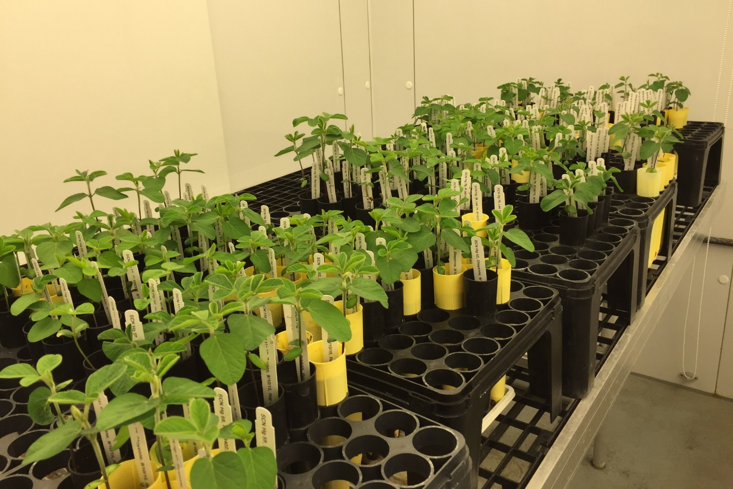

Figure 1: Growth chamber. A consistent temperature of 27 °C was maintained in the growth chamber, ensuring SCN virulence tests were performed under the optimum condition.

