# CCSP Large Plot Conversion

The Conservation Cropping Systems Project (CCSP) is located on a 130-acre tract of farm land two miles south of Forman, ND, along Highway 32. We also are doing work south of Oakes, North Dakota as well. A 14 member Board of Directors composed of local producers in northeastern South Dakota and southeastern North Dakota advises the CCSP staff. In 2016 the farm has gone to predominantly large plots for cost savings and efficiency.

The effective use of crop rotations to break weed, disease, and insect cycles is demonstrated.  The placement of legumes in rotations reduces dependence on fertilizer Nitrogen. Recent work by Dr. Dave Franzen of NDSU has shown that long term no-till requires 50 lbs. less nitrogen fertilizer to grow the same crop as conventional tillage when organic matter is 5% or greater.

This project is a living classroom to demonstrate that agriculture can produce food, fuel and fiber in an environmentally favorable manner, preserving and enhancing soil, wildlife habitat and water quality, while providing producers with competitive to superior economic returns.

Map of 2016 CCSP Farm.



PROJECT PURPOSE

Our goal is to demonstrate profitable farming methods, machinery, and philosophies that promote soil and water conservation.

Soybeans: Pioneer P09T74R2 soybeans were planted May 7, 2016 at 150,000 population on the rotation plots. Eight gallons/acre of 10-34-0 applied 2X2 for 32 lbs. P/acre. The planter was 7200 John Deere Planter pulled by CaseIH MX340 with RTK autosteer. The combine was a 4400 John Deere with 15 ft flexhead.

Rye was spread by airplane 8/22/16 at 70 lbs/acre.

Inputs.

|  |  |  |  |  |  |  |
| --- | --- | --- | --- | --- | --- | --- |
|  | **Planting** | **Harvest** |  |  |  |  |
| **Soybean** | **5/7/2016** | **9/26/2016** | **150,000** | **3 oz Fierce+0.5 pt 2-4-D** | | **05/01/16** |
| **Pioneer P09T74R2** |  |  |  | **Roundup Ultra Max II** | **32 oz** | **06/28/16** |
|  |  | **`** |  | **Interlock** | **4 oz** | **06/28/16** |
| **rolling 6/8/16** |  |  |  | **Preference** | **1 pt** | **06/28/16** |
|  |  |  |  | **Ultra Blazer** | **1/2 pt** | **06/28/16** |
|  |  |  |  | **Roundup Ultra Max II** | **32 oz** | **06/28/16** |
|  |  |  |  | **Cadet- spot spray** | **0.5 oz** | **07/15/16** |

Crop and Weather Discussions 2016.

2016 was the best year for growing corn and soybeans I have seen in my 58 years of living in Sargent County. Location was still important, as most areas in the state of North Dakota were much wetter than Forman. Initially, we had perfect planting conditions. It was dry enough to plant, but there was good moisture. As the spring progressed into May, the topsoil began to dry and planting depths were increased. At CCSP, going to a planting depth of 2.0 inches for soybeans did not affect our stands. I had uniform stands of beans. Soybean aphids were not a problem. When it did rain, we received rather large amounts that came slow enough to soak in nicely. There was no hail or high winds to report this year. Temperature and sunshine were also near perfect. Bad weather was not too far away as a major storm did serious damage 15 miles north. The NDAWN site at Brampton, 11 miles southwest recorded a wind gust in July at 72 mph. In a nutshell you could say we were lucky, but the luck was rather widespread. Harvest across the area reflected the good growing conditions with large amounts of crop coming into the elevators creating the issue of multiple grain piles on the ground. Both corn and soybeans had problems spoiling in the piles.

Precision farming has been around for quite a while. Some of the things that have been determined indicate that good soils are more efficient at producing bushels than poor soils. I think the same goes with weather. Good weather adds to the efficiency. It really explains the spots in the fields where yield monitors were insanely high. Again, we are looking at a year where we wonder what information we can take away and trust to use next year.

2016 Research and Demonstration

In 2016 we transitioned to predominantly large plots of several acres, while keeping 25 small plots. Small plots have inherent edge effect issues and are not conducive to using large equipment. We want to get closer to actual farm field situations while still having the ability to do research and demonstration projects. Having a mix of different size plots will help us achieve those goals. We seeded soybeans in the large plot, which crossed over the small plots from the past. I was able to isolate and harvest beans according to their old plot numbers. You can see the results below indicating the high yields. All of the beans were no-tilled in. The large plots of soybeans as indicated on the map as LP3 were seeded across old crops of soybeans, wheat, corn, and alleys. Yields were good no matter what the cropping history.



The results show that we can successfully no-till soybeans into the stubble of wheat and corn; as well as sod and actively growing winter annuals. We apply pre herbicides in these situations and get good weed control. Soybeans grown in this manner have high enough residue to limit soil erosion throughout the winter if the ground is not worked afterward. We spread DDG’s or dried distiller’s grain on a small portion of plot 22 calling it 22s4. In this side by side demonstration there was little difference in yield’s between the two plots. We had rye spread by airplane August 22. We had a significant amount of rye grow from this operation. Results are difficult to quantify but the results were encouraging. There are many variables with rain following the application being one of the most significant issues. In our work at Oakes, we have found working up the rye to be difficult the following spring and can be an issue for attracting seed corn maggots. At Forman, where we have no-tilled crops into rye, seed corn maggots have not been an issue, and the rye is easy to no-till into. We will be looking at these items in the future. Rye offers weed control and disease control options important to growing soybeans. It also has the ability to ease planting issues in wet springs. Caution must be exercised when utilizing tillage as a method to terminating the rye in the spring as it does increase the chances of seed corn maggot infestation in crop fields.

4 beans per pod.

Education and Field Day

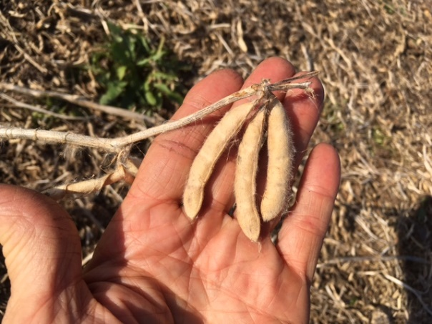

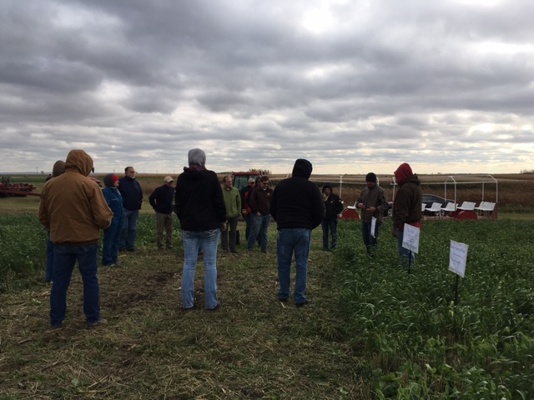In 2016 the outreach of the farm was done by the Wild Rice SCD. They included CCSP on the Cover Crop tour conducted Friday October 7. It was a cold windy day but we had a great group of speakers who went through the highlights of this year’s work at the farm. Abbey Wick did the soil pit that was dug in the middle of a full season cover crop. We looked at the airplane broadcast rye flown on to soybeans and corn. We looked at the cover crop seeded into the spring wheat stubble utilizing Fava beans in the mix with several other species. It was noted the frost the previous night had not damaged the Fava beans. Melissa Geiszler talked about her project involving the planting of cover crops into corn. And finally, Jasper Teboh talked about his corn plots where he looked at various rates of nitrogen and sulfur. I must add the high nitrogen plots in his trial averaged 275 bushels. It was an outstanding corn year!