Soybean Response to Nitrogen and Sulfur Fertilization

Principle Investigator
Hans Kandel, Ph.D. NDSU Extension Agronomist Broadleaf Crops, North Dakota State University, Department of Plant Sciences, NDSU Dept. 7670, Loftsgard Hall 166E,
Box 6050 Fargo ND 58108-6050, Telephone 701-231-8135, Fax 701-231-8474
hans.kandel@ndsu.edu
Research Assistant
Benjamin Cigelske, North Dakota State University, Department of Plant Sciences

Abstract
To obtain higher soybean yields it may be possible to apply fertilizers. This study was conducted to determine whether Nitrogen and Sulfur fertilizer would have an effect on soybean plant density, vigor, plant height, yield, protein and oil content and nodulation. The experiment was conducted as a factorial arrangement within a RCBD. Factors included were two soybean varieties, three N rates (0, 25, and 50 lb/a), and three S fertilizer rates (0, 10, and 20 lb/a) and there were 10 environments during 2015 and 2016. The addition of N fertilizer at the rate of 50 lb per acre resulted in about a 5% lower established plant density but had more vigorous plants. Plants with application of 25 or 50 lb N per acre were taller than the control. Both rates of N resulted in a significant seed yield increase, 1.5 and 2.6 bu per acre respectively, compared with the control. There were no significant difference in protein or oil content due to N application. There were no significant differences in plant density, vigor, height, yield and oil content among the three sulfur levels across all other factors. Nitrogen influenced nodulation at the V4 and R4 stages. As the N rate increased at both growth stages, average nodule number per plant decreased. If farmers look at economics, they need to consider their own production level and do the calculations on a potential yield increase of 5%, based on this study, using their traditional obtained soybean yields. The potential benefit of N application and net profit depends on fertilizer cost, application cost, commodity price, and yield level.

Benefit of the research to ND soybean farmers
From the 1990’s through 2016 excess water has significantly impacted crop production in the region. Besides acres not seeded due to water logged conditions excess water caused yield losses on acres that were harvested. Excess rainfall may cause some of the nutrients like Nitrogen (N) and Sulfur (S) to move down in the soil profile. In the last few years Sulfur deficiency has been noticed in corn. With increased yields of all crops and a reduction in S deposition through rainfall it is likely that S may become a yield limiting factor in soybean. Soybean grown in North Dakota has yet to reach its genetic yield potential. Fertilization is a farm-level practice that can still be improved upon to increase North Dakota soybean yields.

Ongoing projects in this area
Nitrogen is on top of the list of essential plant nutrients. Nitrogen is an important component of chlorophyll. It is also a key part of amino acids, the building blocks of protein molecules and DNA, without which, there would be no life on earth; plant or human. Salvagiotti et al. reported in 2009 that N fertilization may be required to attain maximum yield of soybean when soil and biological N₂ fixation provide an inadequate N supply. However, high N levels in the soil are also associated with increased expression of iron deficiency chlorosis (IDC) in soybeans. In a study focused on tile drainage practices, Drury et al. (2009) reported that soybean yielded significantly higher when fertilized with 56 lb N per acre across three different drainage systems (unrestricted tile drainage, controlled drainage, and controlled drainage with subirrigation).
In a 2011 study at NDSU, when no N was applied, soybean yield was 49.3 bu/a, compared with 51.7 bu/a when N was applied. Additional research conducted at NDSU in 2014 showed an increased yield in soybean treated with N and S fertilizer and the yield increase was statistically different compared with the untreated check. In Ohio in 2000, the application of gypsum at rates of 18 lb S per acre and 75 lb S per acre increased the yield of soybean by 4.8% and 11.6%, respectively (Chen et al., 2005).
It is important for growers to know if the application of additional N or S (or both) to soybean will provide economic benefits. It is known that the protein content of soybean in North Dakota is lower than other states. Protein content may be related to the N and/or S available to the plant.

Description of the Research

This study was conducted to understand the relationship between N and S and the impact of the nutrients on soybean plant population, vigor, height, nodulation, yield, protein and oil content. The overall objective of this research was to enhance the understanding of best management practices with regards to soybean fertilization in North Dakota. Specifically, the study was designed to provide research-based results to support future economic and environmentally conscious fertilizer decisions to improve the sustainability of soybean production in North Dakota. The trial was designed as a randomized complete block experiment with a factorial arrangement of two varieties, three N rates (0, 25, and 50 lb/a), and three S fertilizer rates (0, 10, and 20 lb/a). The N and S fertilizers selected were urea and gypsum, respectively. The fertilizer treatments applied to experimental plots are summarized in Table 1.

Table 1. Fertilizer treatments in factorial arrangement.
Fertilizer | lbs N A⁻¹ | lbs S A⁻¹
Check | 0 | 0
Urea | 25 | 0
Urea | 50 | 0
Urea+gypsum | 25 | 10
Urea+gypsum | 25 | 20
Urea+gypsum | 50 | 10
Urea+gypsum | 50 | 20
Gypsum | 0 | 10
Gypsum | 0 | 20

The study was conducted over 10 environments across southeast North Dakota in 2015 and 2016 with a total of 34 replications. Sites were located in Cass, Richland, Sargent, Ransom, and Steele Counties (Figure 1).

Plot size was 5 x 25 feet at seeding with an established plant density of 150,000 plants per acre. Two soybean varieties with similar maturity ratings (0.7 and 0.8) but significantly different in IDC scores were utilized. Both varieties were inoculated with Bradyrhizobium japonicum bacteria and seed had standard fungicide seed treatments. The soybean seed was planted with a small plot seeder with 14 inch row spacing and harvested with a plot combine. Weed and insect management took place to eliminate weed and insect competition as required. Data was collected throughout the 2015 and 2016 growing seasons to assess crop establishment, vigor, plant height, nodulation, yield and protein content.

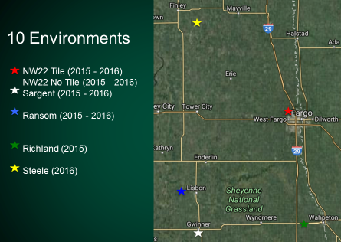
Figure 1. Locations of the 10 Environments of the N x S experiments in 2015 and 2016.

Results

Nitrogen
The addition of N fertilizer at the rate of 50 lb per acre resulted in about a 5% lower established plant density compared with the control. Although the N was broadcasted and worked in before planting and not applied near the seed, the negative effect on plant stand was significant (Table 2). As expected the plants with application of N were more vigorous early in the season. The vigor score with 50 lb N was statistically higher compared with the 0 (control) lb N application. At the end of the season the plants with application of 25 or 50 lb N per acre were taller than the control. Both rates of N resulted in a significant seed yield increase compared with the control (Table 2). There were no significant difference in protein or oil content.

Table 2. Rate of N application, plants per acre, early season vigor, end of the season plant height.
Rate |  | Density |  | Vigor¹ |  |  |  |  |  | Height |  |  |  |  | Yield
lb N acre⁻¹ |  | plants acre⁻¹ |  | (1-9) |  |  |  |  |  | inch |  |  |  |  | bu acre⁻¹
0 |  | 198800a² |  | 5.2a |  |  |  |  |  | 28.7a |  |  |  |  | 48.5a
25 |  | 197200a |  | 5.6ab |  |  | 29.3b |  |  |  | 49.4b
50 |  | 188300b |  | 5.9b |  |  |  |  | 29.5b |  |  |  |  | 50.3b
¹Vigor was scored visually on a scale of 1-9 (9 = most vigorous).
²Means in a column followed by the same letter are not significantly different at (p≤0.05).

Sulfur
There were no significant differences in plant density, vigor, height, yield or oil content among the three sulfur levels across all other factors. The only significant difference was in protein content. Average seed protein concentration for the treatment of 0, 10, and 20 kg S per acre was 33.73, 33.65, and 33.57%, respectively. These differences when expressed as rounded numbers 33.7, 33.7 and 33.6, respectively, appear not to be meaningful. However, the result of this study disagree with those by Bellaloui et al. (2011) who reported that seed protein consistently increased in field trials when fertilized with S or N and S.

N x S
Understanding the relationship between N and S and the influence of the two nutrients on yield was a main objective of this study. The yield response to N and S are presented in Figure 2.

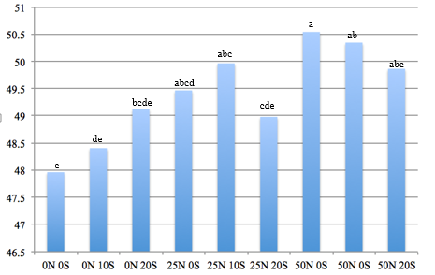
Figure 2. Soybean yield in bushel per acre for factorial N x S fertilizer application averaged across 10 enviroment in North Dakota, 2015 and 2016. Application rates 0, 25 or 50 lb N per acre and 0, 10 and 20 lb S per acre, 0N 0S is the control. Yields for fertilizer treatments with no letter in common are significantly different at p≤0.10.

The control treatment was the lowest yielding of all the treatments but not significanlty different from 0N+10S, 0N+20S, and 25N+20S. All 25 and 50 lb N treatments with or without S yielded more that the control. The graph is indicating some visual trends (increased yield with application of S without N and decrease of yield with application of S at the higher level of N) but no significant statement can be made about the effect of S. It is suggested to continue research on S rates and possibly use other sources of S to determine if there might be a benefit of a low amount of fertilizer S.

Nodulation study
In addition to the yield trial, observational plots were included in the experiment for the purpose of destructive sampling (removing the plants) and data collection. Plants from observational plots were used to determine the effect of N and S application on plant biomass and nodulation. Soybean nodulation was assessed by uprooting plants from the observational plots, counting the number of nodules and rating the nodules for size. Plants were removed from 2 feet of the center two rows at approximately R1 and R4.

Table 3. Fertilizer treatments applied to observational plots.
lb N Acre⁻¹ | lb S Acre⁻¹
0 | 0
125 | 0
250 | 0
125 | 100
250 | 100
0 | 100

Results
Environment played a key role in the magnitude of plant response to N x S treatments. For example, average nodule number per plant was highly variable between environments at the V4 and R4 growth stage (Figure 3) regardless of treatment.
In 2016, the average nodule number per plant increased 5% and 73% in the Ransom County and Steele County environment, respectively, comparing the count at V4 and R4. Possible explanations for differential environmental response include factors such soil type and previous crop, weather conditions and level of soil N at the start of the experiment. In addition, the soil in the 2016 Ransom County environment was extremely dry and compacted at the R4 growth stage, which caused root damage during sample collection.
Average nodule number per plant was significantly different at the V4 stage between varieties (24 and 30 nodules). However, by the R4 stage variety had no significant impact on average nodule number per plant (37 and 40 nodules). This indicates that the two varieties evened out in average nodule number per plant during the growing season. A significant difference in root mass between varieties was also observed at the V4 growth stage, but evened out by the R4 growth stage.

Figure 3. Average number of soybean nodules per root, from replicated trials with the same treatments, at Fargo, and Ransom, Sargent and Steele County plots, 2016.

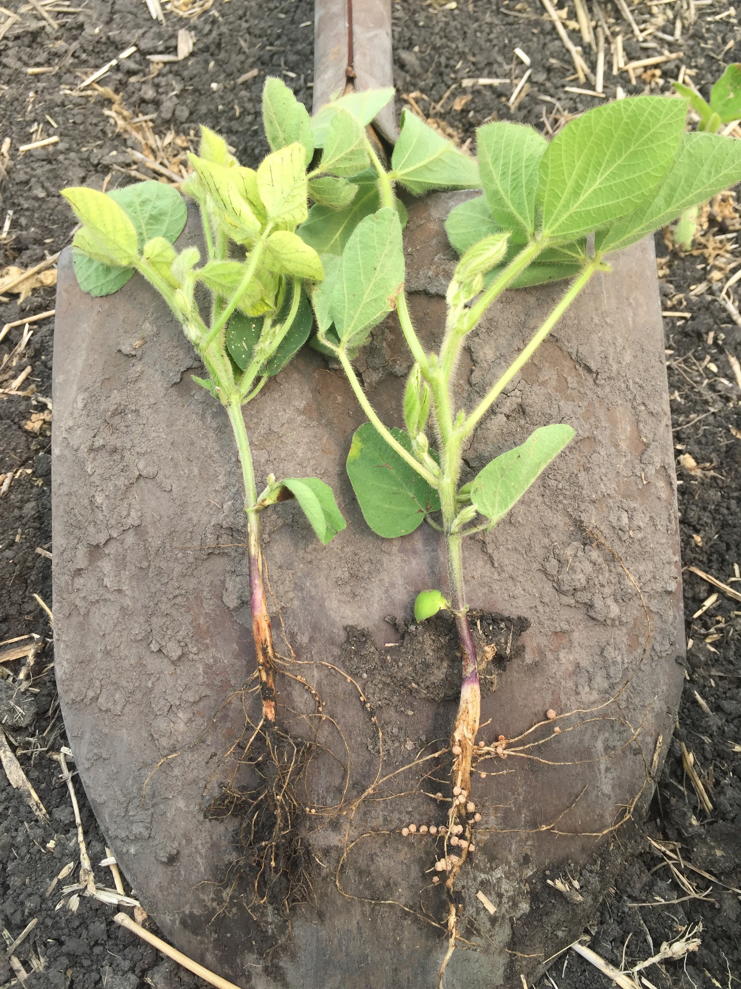
Figure 4. On the left a plant with 250 lb N per acre and right a plant received 0 lb N per acre.

Figure 5. Nitrogen effect (0, 125 and 250 lb N per acre) on average nodules per plant.
Bars with the same color and the same letter are not significantly different at (p≤0.05).

Nitrogen influenced nodulation at the V4 (Figure 4) and R4 stage. As the N rate increased at both growth stages, average nodule number per plant decreased (Figure 5). Nodule number per root for 0 lb N per acre was significantly higher than when N was applied. Results agree with those by Streeter (1988) as well as Gibson and Harper (1985) and Laysell and Moloney (1994) who indicated a strong inhibition of nodulation and N fixation activity under high nitrate conditions.
There were no significant differences in nodule number for the two S rates. There were 27 nodules for the control and 100 lb S per acre rate at the V4 and 38 nodules at the R4 stage for both rates.

Summary
The results of this study indicate that N application significantly increased vigor, height and yield, but reduced plant stand and nodulation. Compared to the control (0 N) treatments of 25 or 50 lb N acre increased yield by 0.9 and 1.8 bu per acre, respectively, when averaged across all S treatments (Table 2). Compared to the control (0 N) treatments of 25 or 50 lb N acre increased yield by 1.5 and 2.6 bu per acre respectively, when no S was applied (Figure 2). The 50 lb N per acre application level (based on Figure 2) was yielding about 5% more compared with the control. The average yield, 49 bu per acre of the combined trial results for 2015 and 2016 was substantially higher than the North Dakota state soybean yield average of 37 bu per acre for the same period. If farmers look at economics, they need to consider their own production level and do the calculations based on a potential yield increase of 5% using their traditional obtained soybean yields. For instance, if the North Dakota State average 37 bu per acre would be used the anticipated yield increase would be approximately 1.9 bu per acre with the application of 50 lb N per acre.
The potential benefit of N application and net profit depends on fertilizer cost, application cost, commodity price, and yield level.
Nitrogen fertilizer was a more dominant factor for impacting soybean yield and nodulation than S fertilizer. The experimental sites in this study were not specifically selected for a potential N and S response but were located on commercial farmers’ fields at the County sites. A main goal of this study was to understand the relationship between N and S and soybean yield and growth. A relationship appears to exist between N and S for soybean yield (Figure 2), which should be investigated in more detail. Future research should focus on understanding genotypic variations in response to N and S fertilizer, soil-specific response to N and S application, and different forms of N and S fertilizer at various application timings to maximize the sustainability of soybean production practices in North Dakota.

Acknowledgement
This research was conducted as a research project in partial fulfillment of the requirements for the degree of Master of Science by B. Cigelske (2016) funded by the North Dakota Soybean Council in 2016 and North Dakota Experiment Station.

References
Bellaloui, N., M.W. Ebelhar, A.M. Gillen, D.K. Fisher, H.K. Abbas, A. Mengistu, K.N.
Reddy, and R.L. Paris. 2011. Soybean seed protein, oil, and fatty acids are altered by S and S + N fertilizers under irrigated or non-irrigated environments. Agric. Sci. 2:465-476.
Chen, L., W.A. Dick, and S. Nelson Jr. 2005. Flue gas desulfurization products as
sulfur sources for alfalfa and soybean. Agronomy Journal 97:265-271.
Cigelske, B.D. 2016. Soybean response to nitrogen and sulfur fertilization. Master
Thesis, North Dakota State University, Fargo, ND.
Drury, C.F., C.S. Tan, W.D. Reynolds, T.W. Welacky, T.O. Oloya, and J.D. Gaynor.
2009. Managing Tile Drainage, Subirrigation, and nitrogen fertilization to enhance crop yields and reduce nitrate loss. J. Environ. Qual. 38:1193–1204.
Gibson, A.H., and J.E. Harper. 1985. Nitrate effect on nodulation of soybean by
Bradyrhizobium japonicum. Crop Sci. 25:497-501.
Laysell, D.B., and A.H.M. Moloney. 1994. Dinitrogen fixation. p. 311-336. In: Boote,
K.J., J.M. Bennett, T.R. Sinclair, and G.M. Paulsen, editors. Physiology and determination of crop yields. ASA, CSSA, SSSA, Madison, WI.
Salvagiotti, F., J.E. Specht, K.G. Cassman, D.T. Walters, A. Weiss, and A.
Dobermann. 2009. Growth and nitrogen fixation in high-yielding soybean: Impact of nitrogen fertilization. Agronomy J. Vol. 101, 4: 958-970.
Streeter, J.G. 1988. Inhibition of legume nodule formation and N₂ fixation by nitrate.
Plant Sci. 7:1-23.

