PROGRESS REPORT

Techniques For rapid Data analytic of remotely sensed data for phenotypic and precision agriculture applications

Ashvi Dua, Ajay Sharda, and William Schapaugh

Extraordinary advances over the last 10 -15 years in the field of precision agriculture in terms of crop monitoring and management have geared towards automated crop monitoring through remote sensing platforms. Recently, remote sensing technology with its various platforms such as satellites, and mostly recently drones has given researchers many advantages of data collection in large open field conditions. When adopting remote sensing techniques in precision agriculture, there are two main areas to consider: data acquisition systems and data analysis methodologies. Many successful pieces of research have been done in the area of data acquisition systems and data analysis from the detection of pests and diseases, growth, water stress in crops, yield estimation, irrigation status, and nutrient availability to specific biotic and abiotic stresses. However, a major limitation of the widespread adoption of this technology in agriculture is the complex data processing systems and data analysis of big data using multiple inputs to estimate specific numerical targets. The main disadvantage is the delineation of plot boundaries within the orthomosaic image of field experiments.
From a review of the literature, it was found that manual plot delineation is the simplest form of plot extraction used in the UAS imagery analysis, where plots are manually tagged and identified within the image. For large-scale data, this task becomes tedious and time-consuming., simultaneously, this also gives low accuracy in the maps as images do not align with the actual field without GCPs and RTK GPS planting. The second most used method is the grid-based method, and it is usually done either on Arc-GIS or QGis software. In this above-mentioned method, outlining of large fields with regular rectangular or square dimensions is done. Simultaneously, unique identifiers are assigned to each polygon. However, manual plot adjustments are required as fields are not geometrically uniform. The third method is the computer vision-based method, many researchers have used this method for the delineation of plot boundaries but it requires images from a specific development stage where plots are visibly differentiated. Every method has its limitations from field uniformity to manual adjustments of plot boundaries and unique identifier names for each plot.
Therefore, a workflow was planned in which RTK GPS planting coordinates and canopy multispectral and thermal profiles are recorded to generate plot boundaries. In the study, a script will be developed in which both planter data and image data from the drone are georeferenced with cm level accuracy after which they should spatially align.
In the workflow, a clean data file of the GPS location of each seed for the center row of the 16-row seed planter was taken. It was given in the WGS 1984 coordinate system and it gave values of longitude and latitude in decimal degrees. The GPS location of data of a center row of seed planter with WGS 1984 coordinate system was converted into NAD 1983 UTM zone 14N. In the next step GPS location of each row of the 16-row planter was determined using the known GPS location of the center row of the planter. The row spacing of the seed planter is 35 cm. Afterward, the data was copied into the coordinate system extrapolator data file in excel format for extrapolation of coordinates of all the rows in a 16-row planter. The output file was obtained in .xlsx format and then it was converted into .csv format as we cannot use
.xlsx data files in Arc GIS pro. For one row (center line of 16-row planter), the data file containing the GPS location table was added to the contents of Arc GIS pro and it was displayed on the map using the display x-y coordinates tool. In this step, the row values given in the attribute table were displayed as a point feature class in the ArcGIS pro screen. The further methodology is shown in Fig.1.

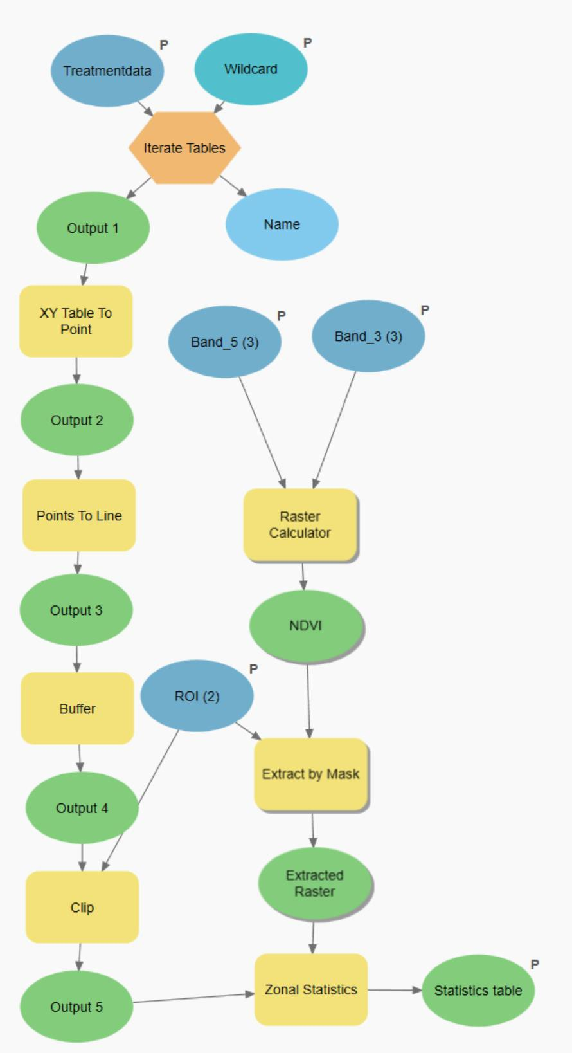

Fig1. Flowchart of methodology implemented

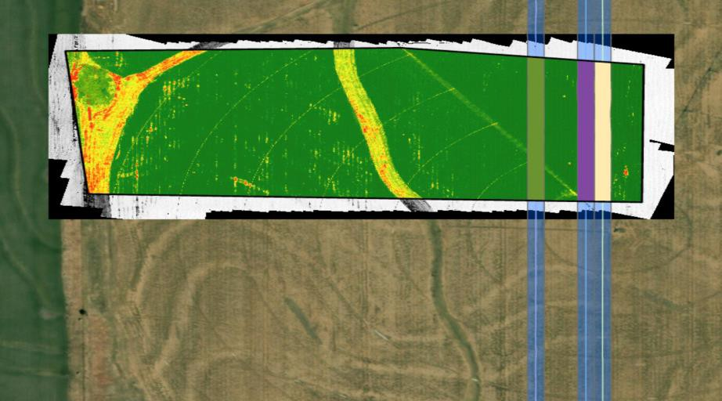

Fig. 2. A 3-row polygon layer (BUFFER) overlaid on the NDVI-mapped layer methodology shown in Fig. 1
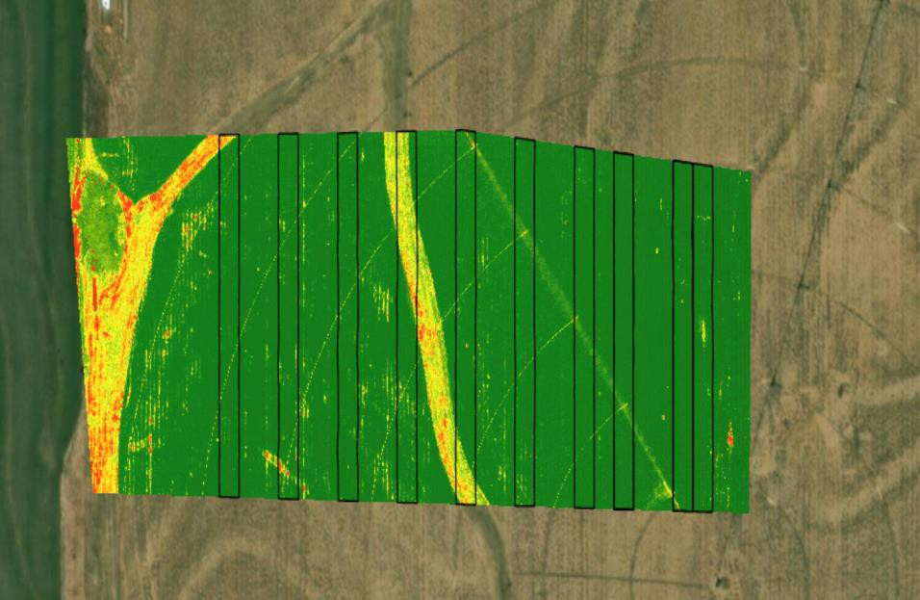

Fig. 3 Final row polygon layer (BUFFER) overlaid on the NDVI-mapped layer methodology shown in Fig. 1
The points were converted into a line feature using point to line geoprocessing tool and in this case, a new attribute table along with a polyline feature was formed. Afterward, a polygon feature class was made around the centerline with spacing equal to a 16-row planter using the buffer tool. In the next step, a polygon layer (BUFFER) was overlaid on the NDVI-mapped layer to identify the pixel value of every single buffer. The pixel value helps us to analyze the healthiness of the matured crop. In the last step, Zonal statistics as a table tool was used to summarize the values of NDVI within the rows zone dataset and the result was reported in the table. For other treatments, with different CSV files (having values GPS location 16-row planter), the iterate table tool was used to repeat the same process for multiple plots with just one click. After the process, the files were saved with different names in sequence using inline substitution. To remove outliers of points and images, the area of interest was also specified in further models. After creating a region of interest, all the processes were performed in that region only.

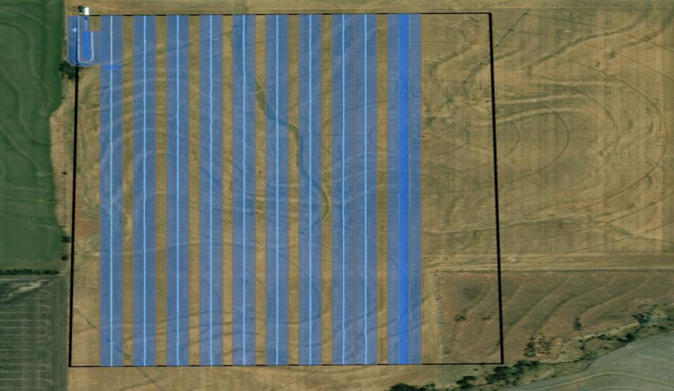

Fig. 4 Buffer on different rows after modify ROI (region of interest)

Limitations
There were limitations with this methodology with certain datasets, when the data was continuous as shown in the Fig 5, only one average attribute value was obtained in the zonal statistics table for this continuous type of data with 10 different rows.
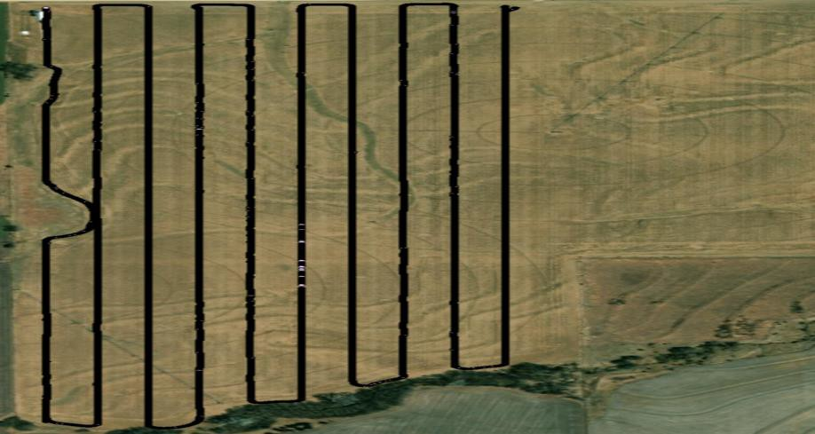
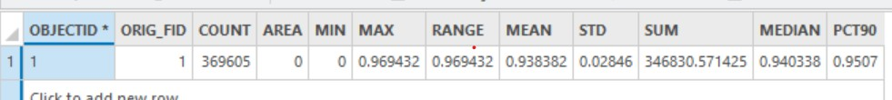

Fig 5. Continuous data of 10 rows in single attribute table
Future work
- For this workflow, there is a need to standardized this workflow for different types of feature data sets. The CSV file will be manipulated through scripting in order to fit in this data set.
- Unique Plot IDs will be assigned automatically

- Nested loop will be used to separate individual rows inside the polygon with its unique labels
- Currently different tables are obtained from different plot data set. All tables will be merged into single csv file with its unique names.

a

