Developing an interactive web tool combining integrated pest management recommendations and production costs for pesticide selection
Alan Leslie
April 25, 2023
Final Report

Soybean farmers have many considerations to make when choosing pesticides to control different pest complexes, and herbicides provide farmers with the most options, and the most factors to consider. The factors to consider include (but are not limited to) cost on a per acre basis, efficacy against the specific weeds in the field, resistance issues both within a season and across seasons, herbicide tolerance traits of soybean varieties, and timing of application. Even with many different herbicide options available to them, many farmers will tend to use the same herbicide regime across years, unless forced to change by drastic changes, such as the introduction of a new resistant weed species, or unavailability of standard chemicals due to global supply chain issues. This project was designed to develop a web-based app that would help farmers to navigate the different herbicides options available, and tailor their herbicide programs based on published efficacy values against key target weeds.
Currently, the best published resource for deciding between different herbicide options are the agronomy production guides published by different state Extension departments. Examples of these guides are the Penn State Agronomy Guide, the Ohio State Weed Guide, and the Illinois Agronomy Handbook. These guides contain detailed information on herbicide options for soybeans, including product-specific information that will help farmers to make safe and effective pesticide applications. With all of the detail included in these guides, they are an invaluable resource to farmers, but they can also be overwhelming when trying to develop a new spray program, or to decide between multiple chemical options.
The current soybean pesticide selection tool aims to help farmers to develop herbicide spray programs by narrowing down chemical options based on their specific weed problems. In doing so, this tool condenses the most pertinent information contained in large production guides into a format that is much simpler to navigate, read, and understand. In addition, this tool contains prices for each of the chemicals, and recommended rates, so that costs on a per acre basis can be compared directly. The soybean pesticide selection tool is a web app that was developed using the shiny package in the statistical software program R. The tool is hosted on the shiny servers at https://awleslie.shinyapps.io/Pesticide_tool/.
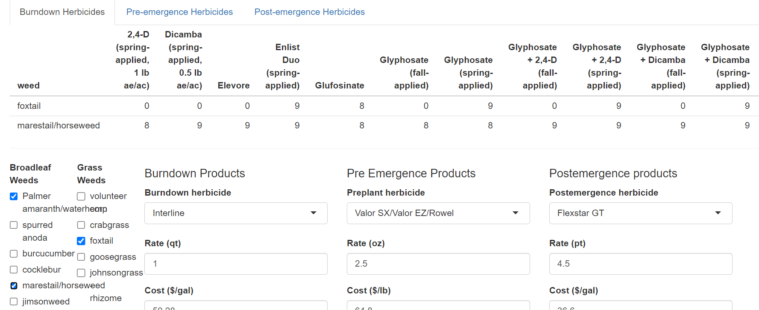
Figure 1. Screenshot of the pesticide selection tool, showing options to select weed species, tabs for three tables of efficacy, and three columns where herbicides can be selected.
To use the app, users first select their major weed species from the lists on the left-hand side of the screen. Weed options are separated into broadleaf and grass weed species, and users are able to select as many or as few weeds as necessary. Once the main weed species are selected, choices of herbicides will appear in the tables at the top of the page. There are three tables: burndown herbicides, pre-emergence herbicides, and post-emergence herbicides. These tables become populated with herbicide options that are effective against at least one of the weed species selected. This effectively narrows down the choices available based on the input from the user. Below the table, in the main area of the web page, users can select their burndown, pre-emergence, and post-emergence herbicides. Users can select between zero and three chemicals for each application, based on recommendations from the efficacy tables. Once selections are made, the page is pre-populated with recommended rates and estimated costs. Actual rates and costs can be inputted by the user if they have their own real-world values to use. After all of this information is entered, users can click the button to generate a report of everything they entered.
The “generate report” button automatically saves all of the user inputs as a pdf report locally on the user’s computer. No information is stored in the system of user inputs. The report contains all of the information that the user selected for the three applications, including a list of key weed species selected, and the names of all herbicides selected for each spray application. The report also contains additional information about each product, including the names of the active ingredient(s) of the chemicals and the WSSA group number(s), to better track the different modes of action applied during the year. From there, the information from this report can be used to enter herbicides into the web-based soybean budget tool to analyze the economic impact of the different herbicide choices on the projected profit for that cropping season.
Figure 2. Example of table output summarizing the user's inputs.
This tool is meant to serve as a companion to the soybean budget tool, which was also updated for 2023 with a new revised layout and updated herbicide pricing. The new soybean budget tool gave users much more flexibility in terms of the products that they could enter for pest management, but did not include any guidance or tools for making those selections. So although users could select from among over 100 different pesticide options, the ability of users to effectively weigh pros and cons of different choices were limited. This new tool gives users three means of selecting herbicides: by target weed, by relative efficacy, and by price. The main limitation of this new tool is that it does not contain all of the information that users will need to be able to make safe pesticide applications. This tool is not a substitute for the information contained in the pesticide labels, and users are instructed to refer to the label for additional information before making any application.
The files containing programming codes and spreadsheets containing efficacy data have been published in a public digital repository under a GNU General Public Use license (https://github.com/awleslie/soybean-pesticide). These files make it possible for anyone to use and modify the codes to adapt this pesticide selection tool for other states or for other crops. The repository recognizes the role that the MD Soybean Board has played in funding the start of this tool, and the license will ensure that subsequent versions remain free and open-source for others to use. The pesticide selection tool is likely to be a much more easily adapted tool for other crop systems, as the main changes needed to adapt this app to other crops would be changing the spreadsheets with efficacy data and available pesticides.
References
Chang W, Cheng J, Allaire J, Sievert C, Schloerke B, Xie Y, Allen J, McPherson J, Dipert A, Borges B (2022). shiny: Web Application Framework for R_. R package version 1.7.4, <https://CRAN.R-project.org/package=shiny>.
R Core Team (2023). R: A language and environment for statistical computing. R Foundation for Statistical Computing, Vienna, Austria. URL https://www.R-project.org/.
Allaire J, Xie Y, Dervieux C, McPherson J, Luraschi J, Ushey K, Atkins A, Wickham H, Cheng J, Chang W, Iannone R (2023). _rmarkdown: Dynamic Documents for R_. R package version 2.21, <https://github.com/rstudio/rmarkdown>.
Mark M. Loux, Doug Doohan, Anthony F. Dobbels, William G. Johnson, Bryan G. Young, Marcelo Zimmer, and Aaron Hager (2020) Ohio State University Extension Weed Control Guide. The Ohio State University.
Charles White and Dwight D. Lingenfelter (2023) The Agronomy Guide 2023-2024. Penn State Extension.

