Delaware Soybean Board

Report/Summary Submitted by Naveen Dixit

Title of Planned Research: Management of Herbicide Resistance in Palmer Amaranth (Amaranthus palmeri).
Summary: Non-target-site herbicide resistance was evaluated in commercially available herbicides labeled for the management of Palmer Amaranth (Amaranthus palmeri). Eight treatments (T1: Control, T2: Flexstar (22.1%), T3: Buccaneer 5 Extra (53.8%), T4: Flexstar (5.88%) GT3.5 with Glyphosate (22.40%), T5: Defy LV-6 (88.4%): 2,4-D, T6: Enlist Duo (Glyphosate: 22.1% + 2,4-D: 24.4%), T7: Dicamba, and T8: VISOR S-MOC (83.7%) were used with recommend rates as per label. Glutathione-S-Transferase (GST) and Glutathione Reductase (GR) activity was determined in leaf samples in all the treatments after 15 min of exposure in herbicides followed by incubation in water for 1 hr. GST activity was the highest in glyphosate treated leaves and followed by Glyphosate > Fomesafen > Fomesafen + Glyphosate > 2,4-D > Dicamba > 2,4-D + Glyphosate > Metolachlor. The lowest GST activity was observed in T6 (2,4-D + Glyphosate) and T8 (Metolachlor). Levels of GST were higher in herbicide treatments with single mode of action except T8 (Metolachlor) while lower in herbicide treatments with more than one mode of action. Treatments with lower levels of GST can slow down the evolution of non-target-site resistance in comparison to treatments with higher GST levels. Higher GR levels were also associated with the lower levels of GST except in T8 (Metolachlor). Based on these findings, it is evident that the use of herbicides with single mode of action must be avoided while a mixture application is beneficial to slow down the occurrence of non-target site resistance in Palmer Amaranth.
Overview of Activities/Project: Palmer Amaranth seeds were collected from the soybean field at UMES and grown in a greenhouse using germinating trays. Once seedlings reached 2 to 4 leaf stages were transferred to individual pots containing potting medium. Leaf samples were collected at 4-leaf stage and incubated for 15 min. in commercially available herbicides ((T1: Control, T2: Flexstar (22.1%), T3: Buccaneer 5 Extra (53.8%), T4: Flexstar (5.88%) GT3.5 with Glyphosate (22.40%), T5: Defy LV-6 (88.4%): 2,4-D, T6: Enlist Duo (Glyphosate: 22.1% + 2,4-D: 24.4%), T7: Dicamba, and T8: VISOR S-MOC (83.7%) recommended for the control of Palmer Amaranth. Leaf samples were exposed to herbicides in petri dishes in laboratory conditions followed by incubation in distilled water for 1 hr at 450 µ mole photons m⁻² s⁻¹ (Fig.1). 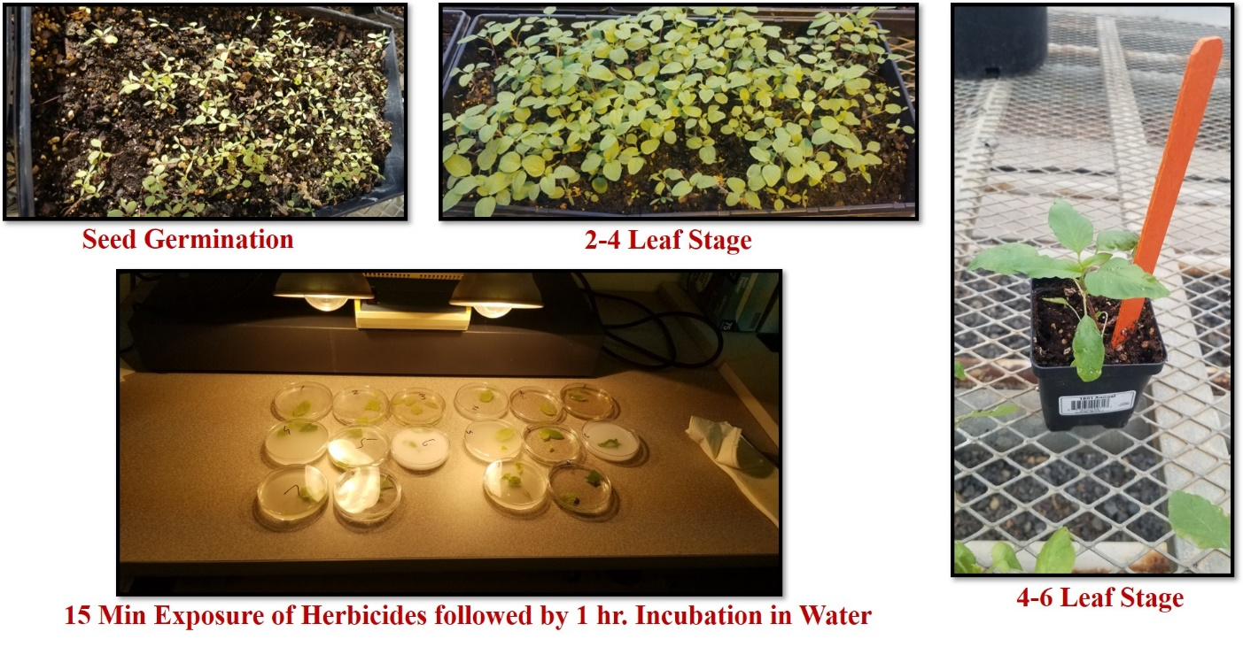
Fig.1. Palmer Amaranth seed germination, seedling growth, and herbicide treatment.
Leaf samples were prepared for the estimation of GST and GR activities. Leaf samples (0.25 g) were macerated in 10 ml 0.1 M potassium phosphate buffer, pH 7.5 containing 0.5 mM EDTA and filtered through cheesecloth. The filtrate was centrifuged at 15,000g for 15 min. GST activity was measured using 2,4-Dinitrochlorobenzene (CDNB) in a 1-mL reaction mixture containing 20 μL of leaf extract, 1.0 mm GSH, 1.0 mm CDNB, and 0.1 m potassium phosphate buffer (pH 7.5). The protein extract was added in last and absorption was measured at A340 for 300 s using a spectrophotometer. GR activity was assayed in a reaction mixture containing 50 mM potassium phosphate buffer (pH 7.5), 3 mM DNTB (5,5-dithio-bis-2-nitrobenzoic acid), 0.1 mM EDTA, 2 mM NADPH, and enzyme. The reaction was initiated by adding 0.67 mM GSSG (oxidized glutathione). The increase in absorbance at 412 nm was recorded at 25°C over a period of 5 min. GR specific activity was expressed as nmole min⁻¹ mg⁻¹ protein. Protein content was determined by the method of Bradford (1976) using BSA as the standard. Three experiments were conducted as a completely randomized design and fifteen replicates. All biochemical assays were repeated 3 times with five replicates on each plant (n = 15). The means per plant were determined and subjected to analysis of variance (SAS OnDemand for Academics) and separated using a protected least significant difference (LSD) at P < 0.05. The standard error (SE) of the mean was also calculated
Detailed Description of How Objectives Have Been Met: GST activity increased in all the treatments in comparison to control (Fig.2). The highest GST activity (36.98 nmole min⁻¹ mg⁻¹ protein) was observed in T3 (Buccaneer 5 Extra (53.8%). The activity was 67.5% more in the leaves of T3 plants in comparison to control. The lower increase in GST was observed in T6 (Enlist Duo (Glyphosate:22.1% + 2,4-D: 24.4%); 18.49 nmole min⁻¹ mg⁻¹ protein) and T8 (VISOR S-MOC (83.7%), Metolachlor; 18.23 nmole min⁻¹ mg⁻¹ protein). The GST activity was higher in the herbicide treatments with single mode of action such as in T2 (Flexstar (22.1%); 30.75 nmole min⁻¹ mg⁻¹ protein), T5 (Defy LV-6 (88.4%) 2,4-D; 26.81 nmole min⁻¹ mg⁻¹ protein), and T7 (Dicamba (48.2%); 26.91 nmole min⁻¹ mg⁻¹ protein) except T8. However, the GST activity was low in herbicide mixtures with more than 1 mode of action in comparison to herbicide with single mode of action such as in T4 (Flexstar (5.88%) GT3.5 with Glyphosate (22.40%); 28.73 nmole min⁻¹ mg⁻¹ protein) and T6 (Enlist Duo (Glyphosate:22.1% + 2,4-D: 24.4%); 18.49 nmole min⁻¹ mg⁻¹ protein).

Fig.2. Effect of herbicides on GST activity in Palmer Amaranth.
Higher GR activity observed in treatments T5 (433 nmole min⁻¹ mg⁻¹ protein) and T6 (441 nmole min⁻¹ mg⁻¹ protein) with minimum GST (T5 (26.81 nmole min⁻¹ mg⁻¹ protein) and T6 (18.49 nmole min⁻¹ mg⁻¹ protein) activity except in T8 (Metolachlor). Higher GR levels indicate the use of reduced glutathione (GSH) in removal of Hydrogen Peroxide, therefore diverting GSH away from GST and keeping its activity at lower levels.

Fig.3. Effect of herbicides on GR activity in Palmer Amaranth.
Correlation between GST and GR showed the dependence of GST on GR as GR generates reduced glutathione (GSH), which is used by GST. GR produced reduced glutathione, which can be diverted to scavenge reactive oxygen species such as H₂O₂ and thus can cause a reduction in GST activity and concomitant decline in herbicide partitioning towards cell vacuole. Herbicides with higher reactive oxygen species (ROS) production can slow non-targeted herbicide resistance in weeds. A combination of single, double and triple herbicide mixture with higher ROS generation capacity can slow down herbicide resistance. In conclusion, single herbicide use causes higher GST activity except Metolachlor and can promote non-target herbicide resistance. Mixture of herbicide treatment showed lower GST activity. GR activity was higher in treatments with lower GST except in T8 (Metolachlor). Based on this data, it is evident that the use of herbicide with a single mode of action must be avoided to slow down the evolution of non-target-site resistance. It is also advised to use the glyphosate in association with other herbicides.

