FY2022 Final Report – Managing Iron Deficiency Chlorosis with Agronomics, Economics, and Remote Sensing
Maykon da Silva and Seth Naeve

Summary
The present study evaluated the effectiveness of variety selection (highly tolerant [MT] vs. moderately tolerant [MT]), iron chelate application (0, 2, and 4 lbs. Fe-EDDHA A⁻¹), and increased seeding rates (125,000 and 175,000 seeds A⁻¹) as management strategies for soybean iron deficiency chlorosis. Further, profitability and risk analysis were conducted to assess the impact of each of the management practices on overall economic returns. Planting a highly tolerant variety, applying iron chelate in furrow at planting, and increasing the seeding density were all effective at mitigating IDC. As IDC severity increased by one-point in a 1 to 5 visual scale to rate symptoms, the HT variety yielded 5 bu A⁻¹ more, on average, than the MT variety. A similar trend was found with the application of Fe-EDDHA in furrow at planting. Soybean yield increments averaging 6.5 and 7.5 bu A⁻¹ were observed with the application of 2 and 4 lbs. Fe-EDDHA A⁻¹ for every one-point increase in IDC intensity, respectively, relative to the untreated plots. When IDC was severe (average visual chlorosis score of 4 at R5.5 growth stage), iron chelate application at rates of 2 and 4 lbs. A⁻¹ increased yield by 21 and 25 bu A⁻¹, respectively, on average. A smaller but consistent effect was found for increased seeding rates. Compared to 125,000 seeds A⁻¹, increasing the seeding density to 175,000 seeds A⁻¹ significantly increased grain yield by 2.2 bu A⁻¹, regardless of IDC severity or treatment combinations. Our risk efficient frontier analysis revealed that the best management alternative in terms of risk to reward for low-moderate IDC conditions was the combination of a HT variety with 2 lbs. Fe-EDDHA A-1 planted at 125,000 seeds A-1. Conversely, the single best option for severe IDC, both in terms of risk and expected returns, was the combination of a HT variety with 4 lbs. Fe-EDDHA A-1 planted at 175,000 seeds A-1. This study also investigated the utility of UAV-based vegetation indices for estimating grain yield of soybean grown under IDC stress conditions as a tool to aid growers, researchers, industry and policy makers with crop management, market planning, market research, and policy writing. In order to develop the yield estimation model, the most relevant VI’s for soybean yield estimation had to be determined. For that, a path analysis was performed, and indicated that NDRE at R5.5, OSAVI at R5.5, and NDVI at R1 had the strongest positive direct effect on soybean yield under IDC stress conditions. The three VI’s indicated by the path analysis as the most important for yield estimation were used as independent explanatory variables in a regression tree algorithm with grain yield as the principal dependent variable. The resulting regression tree algorithm was able to predict soybean yield with a relatively low RMSE (7.88 bu A-1) and MAE (6.7 bu Aa-1), while explaining more than 93% of the yield variability. Results from this study can help soybean growers increase productivity, improve economic returns while controlling economic risk, and provide an advantage when it comes to agricultural decision making.

Study 1 - Soybean Iron Deficiency Chlorosis Management Strategies for High Yield and Profitability

  - Introduction
Iron Deficiency Chlorosis (IDC) is a soil borne abiotic stress caused by a lack of soluble iron (Fe²⁺) to the plants (Inskeep and Bloom, 1987). In soybean, IDC is characterized by interveinal chlorosis of the leaves, and overall stunting of the growth, both of which lead to significant yield reductions (Hansen et al., 2003). In the US alone, IDC is estimated to cause soybean yield reductions totaling $260 million annually (Peiffer et al., 2012).
Due to the large impact of IDC on soybean production, growers have adopted several management strategies to mitigate IDC. Among the most often used ones are variety selection, iron chelate application, and increased seeding rates (Hansen et al., 2003). Highly tolerant varieties possess an increased capacity to reduce insoluble ferric iron (Fe³⁺) to more soluble ferrous iron (Fe²⁺), enhancing iron uptake under iron limiting conditions (Ellsworth et al., 1998). Iron chelates are synthetic or naturally derived compounds that bind Fe at multiple sites, keeping iron soluble and available in the soil for plant uptake (Wittwer et al., 1965). Increased plant populations increase the quantity of exudates (H+ and organic acids) being released into the rhizosphere, enhancing the reductive capacity of the soil surrounding the roots, and converting greater amounts of non-available iron into a more available form (Rengel and Marschner, 2005).
While producers seek management strategies that mitigate IDC, they are primarily concerned with inputs that maximize economic returns and minimize risks. Because different management strategies can come at significant expense to soybean growers, the tradeoffs in cost and yield associated with their utilization may not maximize economic returns and may increase risk. As such, in order to overcome the problem and ensure profitability, effective and economical solutions are needed.
Therefore, the objectives of this research were (1) to evaluate the impact of variety selection, seeding densities, and iron chelate rates on soybean grain yield across a range of IDC levels, and (2) to define optimum combinations of these three management strategies based on profitability, risk, and expected IDC severity.

  - Materials and Methods
1.2.1 Research environments, treatments, experimental design, and measurements
On-farm paired factorial experiments were conducted in Western Minnesota, on soils where soybean has historically exhibited mild to severe iron deficiencies. In 2021, the experiment was planted at three locations (Danvers, Graceville, and Foxhome), while in 2022 the same experiment was conducted at two locations (Danvers and Foxhome). In addition, to vary the intensity of IDC, this study was planted in two areas within each producer field, referred to as site. One site was planted in the “hotspot” IDC part of the field, where IDC symptoms were expected to be severe, and the other site was nearby the “neutral” IDC part of the field, where IDC symptoms were expected to be lower. This resulted in a total of 10 unique field sites/environments.
The present study evaluated 24 treatments, representing the combination of four main factors and their levels: two varieties (moderately tolerant and highly tolerant), two seeding rates (125,000 and 175,000 plants acre⁻¹), three rates of iron chelate (0, 2, and 4 lbs. Fe-EDDHA acre⁻¹), and two levels of IDC intensity by supplemental nitrogen application (0 N vs 69 lbs. urea acre⁻¹). The application of supplemental N is an efficient protocol developed to increase the intensity of IDC symptoms and thus to create a range in IDC stress conditions within environments and it has been successfully used by the Naeve Lab in previous IDC studies.
The experimental design was a randomized complete block with split plot treatment design and four replications, where the levels of iron chelate comprise the main plots and the combination of varieties, seeding rates and N the sub plots. Plots were 40 x 10 ft with 4 rows spaced 2.5 ft apart from each other. All field sites were planted with a precision research planter that allowed both seeding rates to be accurately planted. Iron chelate rates were applied in-furrow at the time of planting as liquid suspension. The in-furrow application of Fe-EDDHA (Soygreen® AST, CHS Inc., Inver Grove Heights, MN) was accomplished with the use of an in-furrow tubular system attached to the planter behind the seed tube that drizzles the product on the seed. Nitrogen was manually applied soon after planting when environmental conditions that minimize N losses prevailed. Standard agronomic practices for soybean production in Western MN were used, such as for weed control.
After emergence, each plot was weekly evaluated for IDC symptoms using a 1 to 5 visual rating system, popularly called greenness scores. In such system, a rating of “1” indicates a plot that is 100% green (no yellowing), a score of “2” indicates slight yellowing most likely in the upper part of the canopy where IDC initiates, a score of “3” indicates chlorosis throughout the canopy with most plants turning yellow in the plot, a score of “4” indicates severe chlorosis where all plants are yellow and some are becoming stunted and necrotic, and a score of “5” indicates most severe IDC symptoms where the entire plot is damaged and dying or completely dead (Goos and Johnson, 2000). The center two rows of each plot were harvested with a small plot combine (Almaco SPC40, Almaco, IA, USA) at maturity stage (R8 according to Fehr et al., 1971) and the weight of each sample was converted to yield (bu/A) and adjusted to a 13% moisture basis.

1.2.2 Statistical analysis
Because Hotspot and Non-Hot-Spot is not a perfect way to classify IDC intensity across environments, that is – IDC intensity varies from a non-hotspot in Danvers to a non-hotspot in Foxhome, an Environmental Index (EI) was created to better account for this variation in IDC symptoms. Therefore, the environmental index was calculated as the average greenness scores at R5.5 for the control treatment (moderately tolerant variety without iron chelate and planted at a lower seeding rate) with or without N application. EI can also be defined as a measure of how severe IDC was at each environment based on the average greenness score of the control treatment, with or without N application. This approach allowed for the evaluation of the effects of all three management strategies based on a continuous measure of IDC severity and not only as Hotspot and non-Hotspot conditions.
All statistical analyses were performed with R statistical software version 4.1.2 (R Core Team, 2020) and considered significant at P < 0.05. An ANOVA using a linear mixed effects model was performed, which accounted for the split plot treatment structure of the randomized complete block experimental design of the study. All three management strategies (varieties, iron chelate rates, and seeding rates) plus the environmental index were treated as fixed effects and block, block within environment, and iron chelate rates within block as random effects. In addition, residual plots were examined to confirm model assumptions of normality and homogeneity.
Partial Budget Analysis (PBA, Kay et al. [2020]) was used to evaluate the net economic return of each of the treatment combination relative to the control treatment (MT variety, 0 Fe-EDDHA and 125,000 seeds acre⁻¹), and this was done separately within each of the IDC severity conditions. In this study, for the purpose of profitability and risk analysis, all IDC environments were grouped into three classifications based on their EI values. As such, an EI less than 1.5 was considered low IDC, an EI between 1.5 and 2.5 was considered moderate IDC, and an EI greater than 2.5 was severe IDC. Furthermore, Mean net economic returns were combined across low and moderate IDC conditions because an ANOVA for grain yield showed that management strategies responded similarly within these classes.
For the PBA, net cost was considered the change in seed cost for each variety and seeding rate plus the change in iron chelate cost for each Fe-EDDHA rate. In western Minnesota, retail prices for a seed unit (140,000 seeds) from Bayer/Asgrow was $49.62 for AG13XF0 and $51.36 for AG12XF1 in 2022 (personal communication, 2022). The average grower price in 2022 for the Fe-EDDHA used (Soygreen® AST) was $19.85 kg⁻¹ (personal communication, 2022). Net revenue was considered as the change in revenue from change in grain yield and sale price. The average Minnesota soybean price for the marketing year of 2022 was $0.558 kg⁻¹ (USDA-NASS, 2022). The profitability (or net economic return) was calculated as the difference between the net cost and net revenue. A positive profitability indicates that farm income would increase due to the change, while a negative profitability indicates the change would decrease farm income.

  - Results and Discussion
For every one-point increase in IDC severity, measured by the environmental index, the yield of the MT variety was reduced by an average of 4.05 bu/A, while the yield of the HT variety was reduced by an average of 0.9 bu/A (Figure 1). Under severe IDC conditions (EI of 4), a 13 bu/A yield difference was observed between the two varieties (46.9 bu/A for the HT and 34.2 bu/A for the MT varieties). These results support previous research that growing a highly tolerant variety should always be the first line of defense against IDC (Goos and Johnson, 2000; Helms et al., 2010).

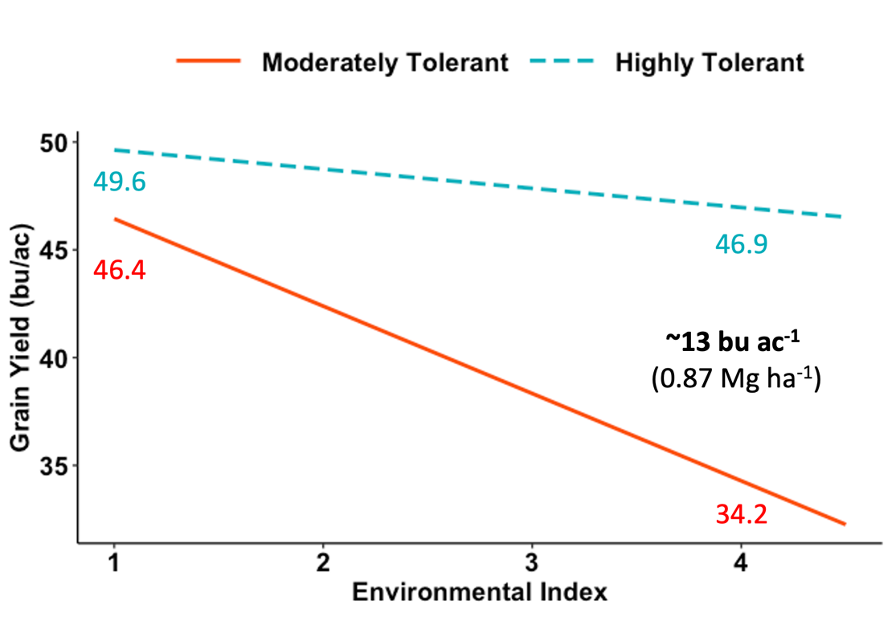
Figure 1.1. Decline in soybean grain yield in response to the interaction between varieties (MT and HT) and IDC severity measured by EI.

As shown in Figure 1, even when EI was 1, the HT variety tended to yield more than the MT one (~3 bu/A). Consequently, it is important to note that, in the present study, a visual chlorosis score (VCS) of 1 at R5.5 does not indicate that IDC was not present, IDC occurred in all environments with different intensities. A VCS of 1 at R5.5 after symptoms were apparent earlier in the season is associated with the fact that soybean plants can partially recover from IDC, resulting in an average VCS of 1 at R5.5. Recovering, however, does not imply that plants will yield the same as they would if IDC had not occurred. Therefore, adopting management strategies that are effective at mitigating IDC even where IDC is low, and where plants might recover is extremely important to eliminate losses.
Figure 1 also shows that even the highly tolerant variety experienced yield reductions when IDC was severe (about 4 bu/A at an EI of 4). As such, when severe IDC conditions prevail, growing a highly tolerant variety alone may not be enough to achieve high yields. Consequently, the overall best way to manage severe IDC is to pair a HT variety with another management strategy that minimizes losses.
Another management strategy shown to be effective in the present study was iron chelate application (Figure 2). For every one-point increase in IDC intensity, the yield was decreased by 7.35 bu/A, on average, when Fe-EDDHA was not supplied. At the same time, average yield reductions of less than 1 bu/A occurred with the application of 2 lbs. Fe- EDDHA A⁻¹. In the present study, soybean grain yield was not negatively affected by increases in EI when Fe-EDDHA was provided at a rate of 4 lbs. A⁻¹. Such positive grain yield responses indicate that Fe-EDDHA application was highly effective at reducing or even avoiding yield losses due to IDC.
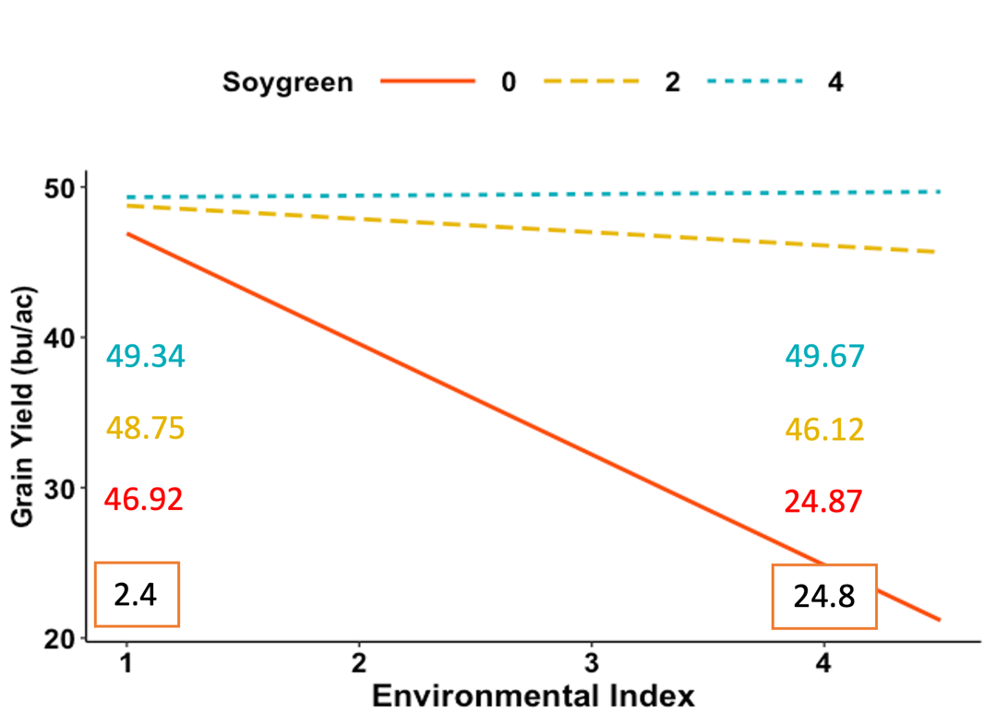
Figure 1.2. Soybean grain yield in response to the interaction between Fe-EDDHA rates (0, 2, and 4 lbs. Soygreen® AST A⁻¹) and IDC severity measured by EI.

Although the largest yield differences among Fe-EDDHA rates were seen at high IDC intensities, our results indicate that Fe-EDDHA application, regardless of rate, also increased yield at lower EI values. This means that Fe deficiency limited plant growth and grain yield even at low to moderate IDC conditions when Fe was not supplied in the soil in the form of Fe-EDDHA, which reinforces our previous findings that, even though soybean plants can, in some cases, effectively overcome IDC towards the end of the growing season, it may only reduce the yield loss, but it will not eliminate it.
While positive results for varieties and iron chelate rates varied based on the intensity of IDC, their interactive effects were similar whether utilized under low, moderate, or severe IDC conditions. Figure 3 shows that the yield of both varieties was significantly increased by Fe-EDDHA application, regardless of rate. Applying 4 lbs. of Fe-EDDHA per acre tended to result in highest yields, but not enough evidence was found to determine that they were significantly higher than applying 2 lbs. Fe-EDDHA per acre.

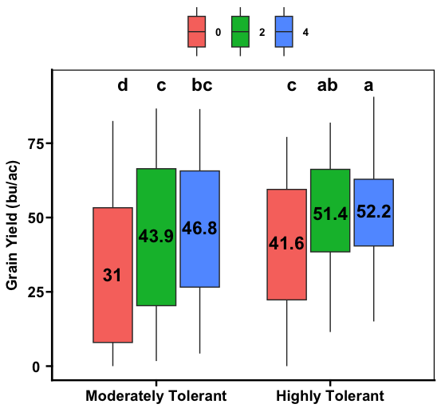
Figure 1.3. Distribution of grain yield as related to Fe-EDDHA rates for both varieties. Numbers inside the boxplots indicate the average grain yield. Black letters on top denote significant differences in grain yield (P < 0.05) across varieties and Fe-EDDHA rates.

It is important to note that, although the effect of Fe-EDDHA application was greater for the MT variety than for the HT variety, the overall highest yields were produced by having a HT variety combined with iron chelate application. These results are very important as they highlight that combining these two strategies is a very good alternative to achieve high yields in soybean grown under IDC stress conditions.
In the current research, significant yield differences were also found due to the main effect of seeding rates. As shown by Figure 4, increasing the seeding density from 125,000 to 175,000 seeds A⁻¹ significantly increased grain yield by 2.1 bu/A. Although this was a small effect, more importantly, this effect was consistent across IDC intensities and across management strategy combinations. Such findings may be a result of a larger exploitation of the rhizosphere, which along with the chemically reducing processes that soybean plants activate while growing under iron deficient conditions, improves iron uptake and reduces symptoms (Rengel and Marschner, 2005).

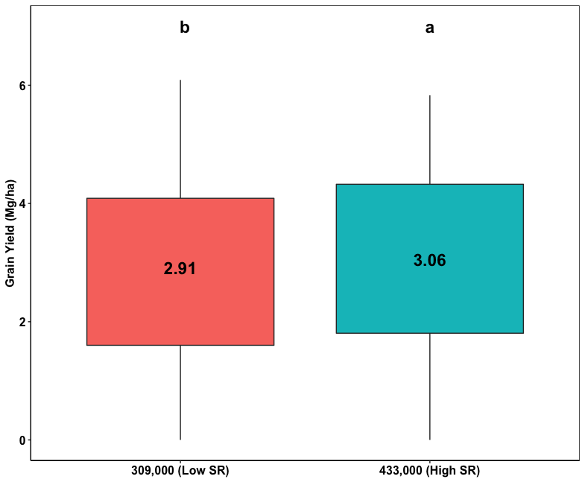
Figure 1.4. Distribution of grain yield as related to seeding rates. Numbers inside the boxplots indicate the average grain yield. Black letters on top denote significant differences in grain yield (P < 0.05) between seeding rates tested.

Although evaluating the effects of genetic tolerance, iron chelate rates, and plant populations on soybean yield is of high importance, it is critically essential to determine how these management strategies, individually and collectively, impact overall on-farm profitability. Our PBA showed that (Figure 5), when IDC was low to moderate, only four treatments had a significant positive net benefit compared to the control treatment, meaning that not all management strategies that increase yield will create a significant positive net benefit when Fe-stress conditions are not severe. However, what is most important in low-moderate IDC is that all four treatments with a significant positive net economic return included the HT variety with at least one of the other management strategies, either Fe-EDDHA application or increased seeding rate. This result reinforces our previous findings that planting a HT variety should be the first line of defense against IDC, both in terms of yield and profitability. Figure 5 highlights that planting a MT variety never resulted in significantly higher net economic returns than the base treatment, regardless of other management strategies used in combination. These findings suggest that, although Fe-EDDHA application and increased seeding rates are effective at increasing the yield of the MT variety, the yield differences were not enough to significantly increase profitability when low to moderate IDC conditions prevail.

Figure 1.5. Mean net economic returns of varieties [Moderately Tolerant (MT) and Highly Tolerant (HT)], Fe-EDDHA rates (0, 2 and 4 lbs. Soygreen® A⁻¹) and seeding rate (125,000 and 175,000 seeds A⁻¹) combinations compared to the control treatment of (MT variety with 0 Fe-EDDHA at 125,000 seeds A⁻¹).

Under severe IDC conditions, all management strategies significantly increased profitability, except for the combination of a MT variety without Fe-EDDHA application, planted at a higher seeding rate, in which the net economic return was positive ($72) but not statistically significant. The greater number of treatment combinations being significantly more profitable than the control treatment may result from the need for alternatives to minimize the effects of severe Fe deficiency. Without any management treatments to restrain symptoms, severe IDC can result in a complete crop failure. Thus, by adopting at least one management strategy shown to be effective in minimizing IDC losses, growers can significantly positively affect net economic returns as environments become less favorable. Overall, the most significant net economic return under high Fe-chlorosis stress conditions was provided by the combination of a HT variety, with 2 lbs. Fe-EDDHA A⁻¹, planted at 175,000 seeds A⁻¹ ($540 A⁻¹).

  - Conclusions
Soybean Iron Deficiency Chlorosis (IDC) is a major yield-limiting factor for soybean grown in the calcareous soils of the North Central United States. This study evaluated three of the most often used management strategies for IDC from a farmer’s standpoint: variety selection, iron chelate application, and increased seeding rates. Overall, our research results confirm the effectiveness of variety selection, Fe-EDDHA application, and increased seeding rates to improve soybean yield on IDC-prone soils. Special attention should be given to costs associated with their utilization to maximize economic returns as profitability changes according to the severity of IDC.

Study 2 - Application of UAV Imagery-Derived Vegetation Indices for Estimating Soybean Yield Grown Under IDC Stress Conditions

2.1 Introduction
Iron deficiency chlorosis (IDC) can significantly limit soybean yield, especially on calcareous soils, where it usually occurs in complex, discontinuous, and unpredictable patterns. Given that IDC is a serious management issue for soybean growers in the US Upper Midwest, accurate yield predictions of soybean cultivated under such stress conditions could serve as a management, marketing, and policy making tool for farmers, soybean-related industries, and governmental agencies. The goal of this study was to develop a model to predict the yield of soybean affected by IDC using UAV-based vegetation indices as explanatory variables.

2.2 Materials and Methods
2.2.1 Research environments, and data acquisition
Five of the ten research environments described in Study 1 were used in this study (environments 1, 3, 5, 7, and 9). All five field sites were established in the “hotspot” IDC part of commercial farmer’s fields, where IDC was expected to be severe.
Drone imagery was acquired with a RedEdge-MX sensor (MicaSense Inc., Seattle, WA, USA) mounted on a DJI Inspire 2 (DJI Technology Co. Ltd., Shen Zhen, China). This sensor captures the five following spectral bands: blue (475 nm x 32 nm), green (560 nm x 27 nm), red (668 nm x 14 nm), red-edge (717 nm x 12 nm) and near- infrared (842 nm x 57 nm). The drone was programmed to fly the field autonomously with the assistance of Pix4D Capture at a ground speed of 2.2 miles per hour and at 75 ft AGL (above ground level).
Final yields were recorded for every single plot. Yield data was collected by harvesting the center two rows of each plot with a small plot combine (Almaco SPC40, Almaco, IA, USA) at maturity stage (R8 according to Fehr et a., 1971). The weight of each sample (total grain mass plot⁻¹) was converted to yield (bu A⁻¹) and adjusted for a 13% moisture basis.
The image orthomosaics and reflectance maps were generated from the raw imagery (16-bit TIF format) using Pix4D Mapper. The processing option "Ag Multispectral" was selected for generating the geo-referenced orthomosaic using a projected coordinate system of UTM zone 15 N. Each reflectance map was loaded into QGIS where the following vegetation indexes were created using the raster calculator tool: NDVI, NDRE, ENDVI, OSAVI, and SAVI. Plot segmentation and plant vs soil masking were also performed in QGIS to extract information from each plot separately without background interference. Plots were segmented using the create grid tool in QGIS. Thresholding was done to mask plants from soil (background). The threshold value was created by observing the image's histogram and it was set as NDVI > 0.5. Mean NDVI, NDRE, ENDVI, OSAVI, and SAVI were extracted from each plot using zonal statistics in QGIS.
A path analysis was used to identify which VI’s were most relevant for estimating soybean yield. The best VI’s for yield estimation were then used as predictors in a regression tree algorithm with grain yield as the dependent variable.

2.3 Results and Discussion
Results from the path analysis showed that NDRE at R5.5 had the strongest positive direct effect on grain yield (path coefficient = 0.92), followed by OSAVI at R5.5, and NDVI at R1 (path coefficient = 0.8 and 0.42, respectively) (Figure 2.1). NDRE, ENDVI, OSAVI and SAVI at R1 and NDVI, ENDVI, and SAVI at R5.5 were not found to have a prominent positive direct contribution to grain yield.
Figure 2.1. Path diagram from a path analysis for soybean grain yield (YI_) as a function of vegetation indices. One directional arrows represent direct paths and two directional arrows represent correlations. Path coefficients are represented by the numbers in the middle of the one directional arrows and correspond to assumed direct effects of each of the vegetation indices on yield.

The resulting regression tree using VI’s indicated by the path analysis as most important for yield estimation is composed of 10 inner nodes and 11 terminal nodes (Figure 2.2), with NDRE at R5.5 as the most important variable for the prediction model. The regression tree shows that, if NDRE at R5.5 is lower or equal to 0.521, grain yield is predicted to be lower than 29.7 bu A⁻¹ (average of 25.3 bu A⁻¹). If NDRE values at R5.5 are greater than 0.521, soybean yield is estimated to range from an average of 2.38.7 bu A⁻¹ to 68.4 bu A⁻¹, depending on other NDRE values at R5.5 and NDVI values at R1. Furthermore, the decision tree was able to predict grain yield of soybean grown under IDC stress conditions with a relatively high accuracy (RMSE of 7.88 and MAE of 6.7 bu A⁻¹), accounting for 93.5% of the yield variability. These results are of great value because they demonstrate that the VI’s indicated by the path analysis and used in the regression tree were able to accurately predict soybean yield.
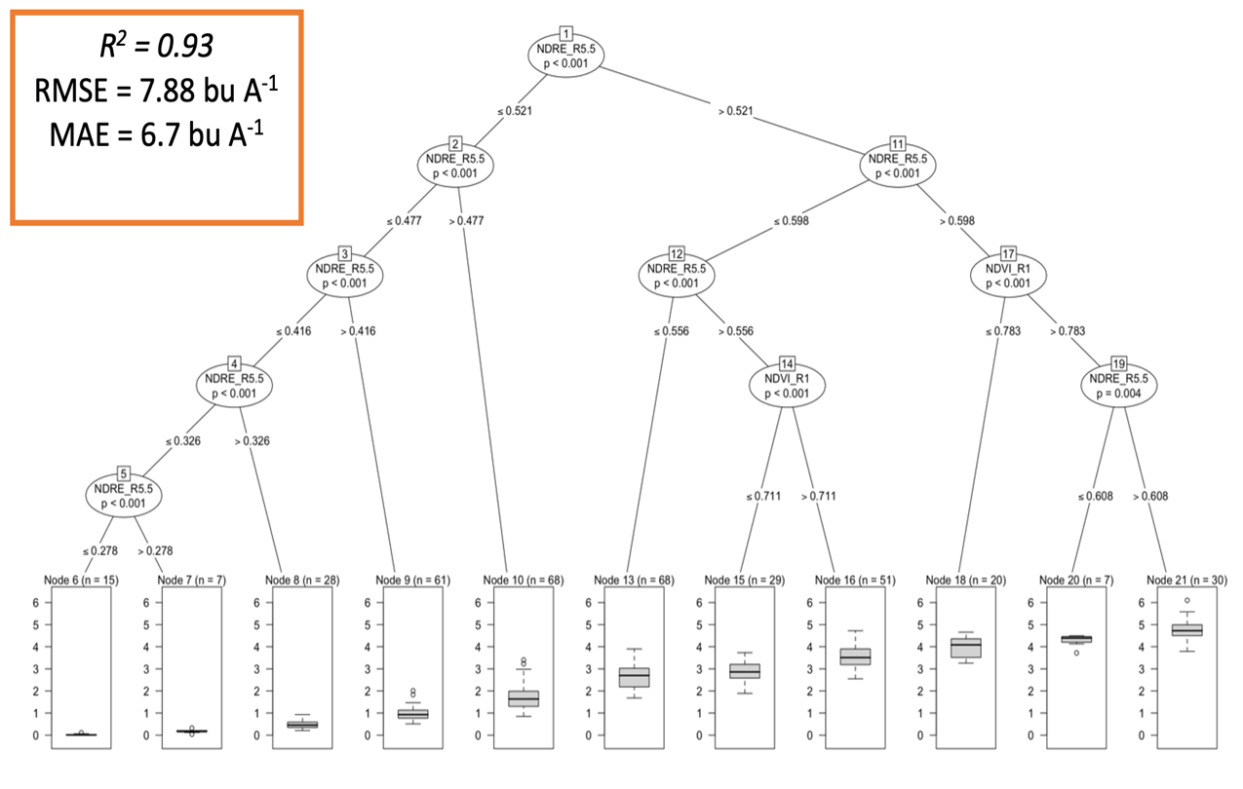
Figure 2.2. Decision criteria of the regression tree algorithm generated with NDRE at R5.5 and NDVI at R1 selected by a path analysis. Two sub-nodes are derived from each node, and the one that is derived to the left of the node represents the true evaluation of the parent node’s condition.

2.4 Conclusions
Knowing which VI and growth stage is best for yield estimation is important for precision agriculture applications, such as mapping the extent and severity of IDC areas. Developing a model that can accurately predict yield has a practical value as it can be used by growers, researchers, industry, and policy makers to support agricultural decisions.
Combining VI’s indicated through a path analysis as most prominent for yield estimation in a regression tree algorithm suggests that soybean yield can be predicted with reasonable accuracy (RMSE of 7.88 and MAE of 6.7 bu A⁻¹), while explaining more than 93% of the yield variability. As such, this model has the potential to be a useful tool to guide soybean management and marketing at the farm level, as well as aid the projection of market behavior, and provide information to support governmental policies.

Literature Cited
Ellsworth, J.W., Jolley, V.D., Nuland, D.S., & Blaylock, A. D. (1998). Use of hydrogen release or a combination of hydrogen release and iron reduction for selecting iron- efficient dry bean and soybean cultivars. Journal of Plant Nutrition, 21, 2639–2651.
Fehr, W. R., Caviness, C. E., Burmood, D. T., & Pennington, J. S. (1971). Stage of development descriptions for soybeans Glycine max (L.) Merrill. Crop Science, 11, 929– 931
Goos R. J., & Johnson, B. E. (2000). A comparison of three methods for reducing iron deficiency chlorosis in soybean. Agronomy Journal, 92, 1135–1139. https://doi.org/10.2134/agronj2000.9261135x
Hansen, N. C., Schmitt, M. A., Anderson, J., & Strock, J. S. (2003). Iron Deficiency of Soybean in the Upper Midwest and Associated Soil Properties. Agronomy Journal, 95, 1595-1601. https://doi.org/10.2134/agronj2003.1595
Helms T. C., Scott, R. A., Schapaugh, W. T., Goos, R. J., & Franzen, D. W. (2010). Soybean iron-deficiency chlorosis tolerance and yield decrease on calcareous soils. Agronomy Journal, 102, 492–498. https://doi.org/10.2134/agronj2009.0317
Inskeep, W. P., & Bloom, P. R. (1987). Soil chemical factors associated with soybean chlorosis in Calciaquolls of Western Minnesota. Agronomy Journal, 79, 779–86.
Kay, R., Edwards, W., & Duffy, P. A. (2020). Farm management (9th ed.). McGraw- Hill.
Peiffer, G. A., King, K. E., Severin, A. J., May, G. D., & Cianzio, S. R. (2012). Identification of candidate genes underlying an iron efficiency quantitative trait locus in soybean. Plant Physiology, 158, 1745–1754. https://doi.org/10.1104/pp.111.189860
R Core Team. R: A Language and Environment for STATISTICAL computing; R Foundation for Statistical Computing: Vienna, Austria, 2020. Available online: https://www.R-project.org/ (accessed on 16 Nov 2022).
Rengel, Z., & Marschner, P. (2005). Nutrient availability and management in the rhizosphere: Exploiting genotypic differences. New Phytologist, 168, 305–312.
USDA-NASS (2022). United States Department of Agriculture (USDA), National Agricultural Statistics Service. Quick Stats: Soybeans – Price Received in Minnesota. https://quickstats.nass.usda.gov/#5CFDF6CC-25FB-3160-A921-F01A4F8DE743
Wittwer, S. H., Jyung, W. H., Yamada, Y., Bukovac, M. J., Kannan, R. De S., Rasmussen, H. P., & Haile-Mariam, S. N. (1965). Pathways and mechanisms for foliar absorption of mineral nutrients as revealed by radioisotopes. p. 387– 403. In Isotopes and radiation in soil plant nutrition studies. Proc. Symp. IAEA (Vienna), Ankara, Turkey. 28– 2 July. Int. Atomic Energy Agency, Vienna, Austria.

