Final Report: The SCN Coalition: Building on Economic Impact

Date: October 26, 2022

Prepared by: Sam Markell, NDSU

Background
The SCN Coalition is a Public-Private Partnership (PPP) of soybean checkoff, private companies and universities. The mission of The SCN Coalition is to conduct an SCN Resistance Management and Awareness Campaign to educate growers and industry on the reality of soybean cyst nematode (SCN) resistance development, to slow the development of highly aggressive SCN populations, and to minimize increasing levels of yield loss. The North Central Soybean Research Program (NCSRP) provides foundational funding that has led to one of the largest and most effective PPPs ever developed to manage an agricultural pest. NCSRP’s funds allow for the communications and management of partner relations that makes The SCN Coalition work.

Impact prior to FY2022. Market research was conducted in 2015 and 2020 to assess the impact of the SCN Coalition. Market research demonstrated that SCN Coalition message recall was over 50% on key messaging targeted growers, statistically significant increases in active SCN management were reported by growers, and a very high economic return on The SCN Coalition investments was demonstrated. Specifically, message recall of “rotation to non-host crop” was 76%, “rotate resistant varieties” was 65%, “consider a nematode-protectant seed treatment” was 65% and “actively manage SCN” was 55%. A statistical increase (5% or greater) from 2015 to 2020 was reported in some active SCN management tools/strategies, including a 10% increase in growers rotating sources of resistance, an 18% increase in growers using nematicide protectant seed treatments, a 10% increase in growers using Peking resistance in soybean rotation, a 6% increase in growers rotating non-host crops, and a 7% increase in growers planting SCN-resistant varieties. Surveyed growers report capturing an additional 5.1 bushels per acre by actively managing SCN, adding $48.45 per acre to their bottom line based on the average price of soybeans of $9.50 during that time.

Mission and Activities in FY2022
To accomplish our mission, we aim to increase active management of SCN, and encourage growers to talk to their advisors about the four primary management actions (testing, rotation, resistance, seed treatments) so they can develop a strategy that best fits their farm. We have leveraged NCSRP funding from multiple sources; all funding is complementary and not codependent. Funding from the NCSRP supports the communication and partner relations of The SCN Coalition (it is central to everything The SCN Coalition does). Leveraged funding received from corporate private partners supports primarily national activities of The SCN Coalition. In FY2022, this included the expansion of the video series: “Let’s Talk Todes.” In addition, in-kind funding from private corporate partners (media, advertising, etc.) multiplies The SCN Coalition messages. In FY2022, leveraged funding from private partners, the United Soybean Board (USB) supported state-specific Extension activities in support of The SCN Coalition (‘SCN Coalition: Building on Economic Impact – led by Dr. Carl Bradley at the University of Kentucky).

Award and Recognitions in FY2022
The SCN Coalition’s “Let’s Talk Todes” media relations campaign was awarded first place at both the Regional and National NAMA awards ceremonies in 2022. In addition, the SCN Coalition’s public relations campaign to move more soybean farmers to actively manage the soybean cyst nematode (SCN) was the recipient of the Public Relations Society of America’s (PRSA) prestigious Silver Anvil Award in the “Issues Management” category during an awards ceremony held in May.

Media Highlights in FY2022
Highlights for FY2022 include: news releases generating 6.2 million potential online impressions in ag media consisting of 6.7% of the share of SCN discussion, over 1,284,010 impressions in Twitter, 746,776 impressions in Facebook, and 40,103 total visits (sessions) to The SCN Coalition website, and the establishment of LinkedIn page in July 2022.

Partnership Highlights in FY2022
In FY2022, UPL become a member of the SCN Coalition, expanding agrochemical company partnership to nine (Figure 1). A full list of university, grower checkoff organizations and corporate partners is available at www.thescncoalition.com. Major specific partnership programs included and expansion of the ‘Let’s Talk Todes’ and ‘Let’s Talk Todes Together’ the new Valent sponsored – “SCN Root Check”.
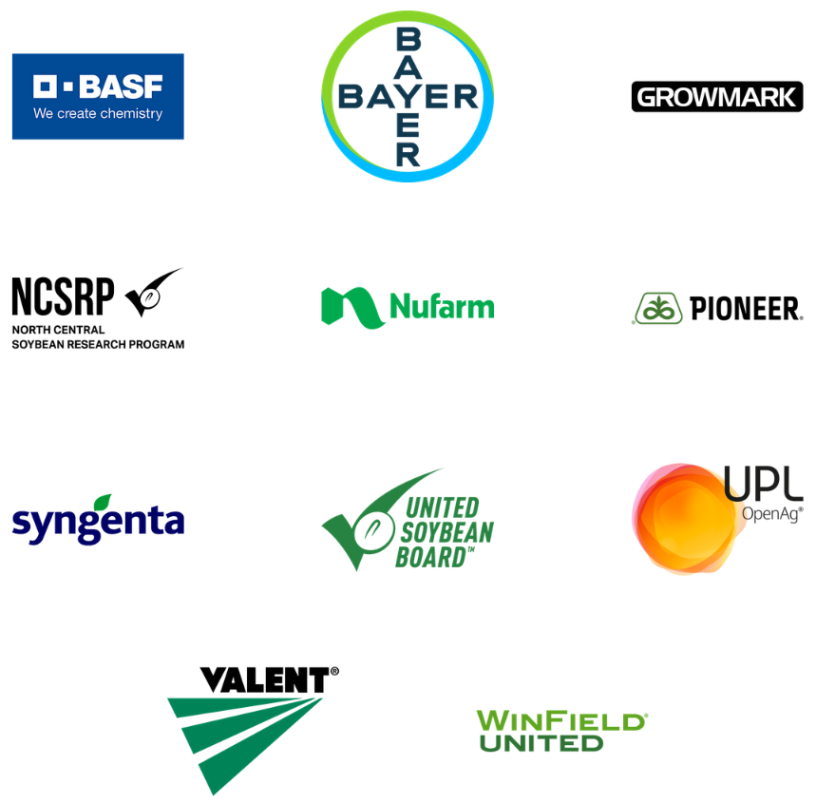
Figure 1. Agrochemical company and national/regional soybean checkoff partners of the SCN Coalition.

Programmatic Highlights in FY2022
Two large programs were initiated or expanded in FY2022. “The SCN Root Check”, a program with Valent earned an amazing 48.4 million impressions through broadcasts, 2.7 million impressions in online and print media, and 306,000 impressions in social media. The expansion of the “Let’s Talk Todes” video series program included 913,070 video views and 1,722,315 impressions, and the associated messaging lead to an additional 1,248,983 potential impressions from 81 online articles. The “Let’s Talk Todes Research Collection” earned 969,057 video views and 2,656,014 impressions, with an additional 998,145 potential impressions from 29 online articles.

Media Metrics
We report both the cumulative metrics since the official launch of the SCN Coalition in February 2018, and specific metrics in FY2022 (October 1, 2021 – September 30, 2022).
- Article Count and Potential Impression Summary
  - In FY2022, 137 online articles garnered 6,248,842 potential impressions through the ag media, representing 6.7% of the share of conversation.
  - Since the launch, 832 articles generated 34,416,909 potential impressions, representing 13.02% share of the total SCN conversation (Figures 2 and 3).

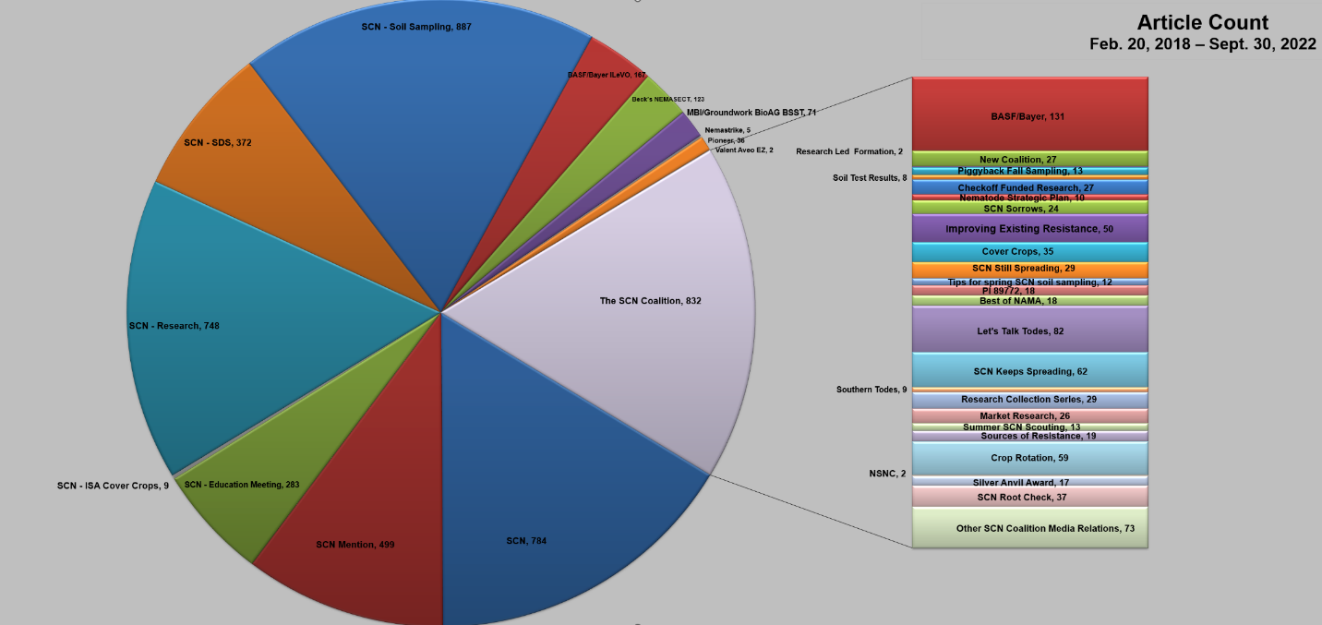
Figure 2. Media activity report February 20, 2018 to September 30, 2022; article count.

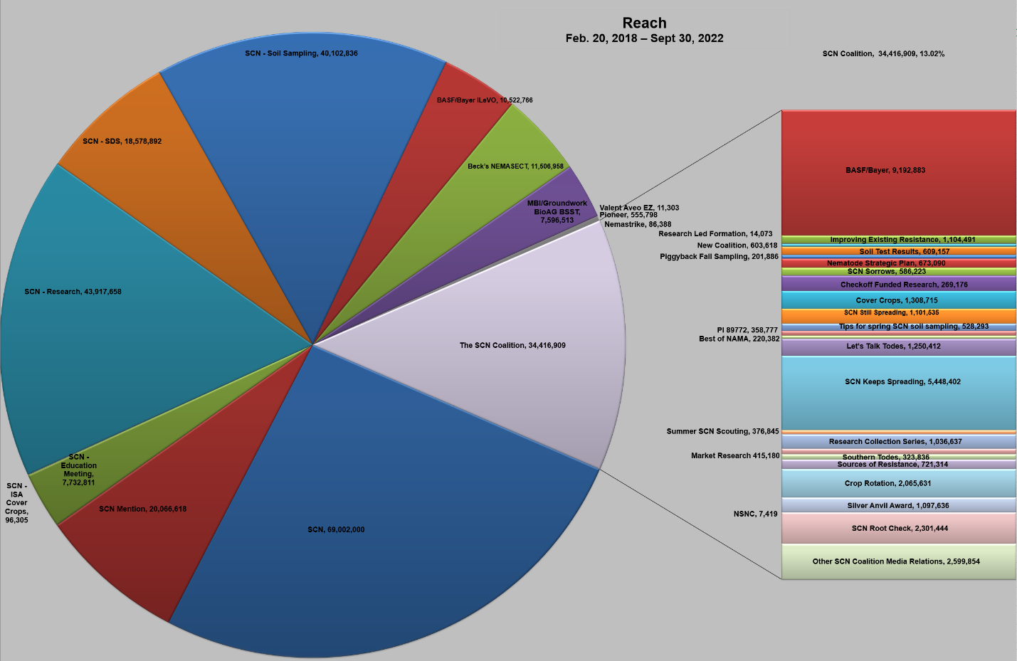
Figure 3. Media activity report February 20, 2018 to September 30, 2022; potential impressions (reach).
- News/press releases:
Cumulatively, since the launch in February 2018, The SCN Coalition has been mentioned in 832 online articles resulting in 34.4 million potential impressions in ag media. Several of these were directly funded by USB, as indicated. We currently have 13.02% of the total share of discussion on SCN. Specific news releases and associated reach since the launch of the coalition include:
- The SCN Coalition encourages piggybacking on fall fertility sampling (Distributed October 9, 2018: 13 articles, 201,886 potential impressions)
- The SCN Coalition recommends using soil test results to develop a management
strategy (Distributed December 11, 2018: 8 articles, 609,157 potential impressions)
- Checkoff-funded researchers finding solutions to SCN resistance (Distributed
January 15, 2019: 27 articles, 269,176 potential impressions)
- Soybean checkoff organizations team up to tackle nematodes (National Soybean Nematode Strategic Plan) (Distributed February 28, 2019: 10 articles, 673,090 potential impressions)
- Have our SCN sorrows been drowned? (Distributed June 26, 2019: 24 articles, 586,233 impressions; in addition, the Coalition arranged ag media interviews for Dr. Tylka with AgriTalk, American Ag Network and Brownfield Network)
- Checkoff-funded soybean breeders improving several sources of SCN resistance (Distributed July 31, 2019: 50 articles, 1.104 million impressions; in concert with the release, the Coalition arranged ag radio interviews for Dr. Brian Diers, plant breeder at the University of Illinois, on the American Ag Network, KQLX, and WTAD)
- Use caution choosing cover crops for SCN-infested fields (Distributed
September 10, 2019: 35 articles, 1.31M potential impressions; Coalition leader
Dr. George Bird, nematologist at Michigan State University, has delivered radio interviews to: Brownfield Network, Farm to Fork/Northshore Productions and Michigan Ag Network)
- SCN keeps spreading – there’s still time to test fields this fall (Distributed
November 12, 2019: 29 articles, 1.1M potential impressions)
- Tips for spring SCN soil sampling and seed selection (Distributed March 3, 2020: 12 articles, 528K potential impressions; Kaitlyn Bissonnette was interviewed by Brownfield Ag News, and during Commodity Classic 2020, Greg Tylka and Kaitlyn were interviewed by Successful Farming, DTN/Progressive Farmer, Farm Journal/AgDay TV, Michigan Ag Today, and AgNews 890. Tylka was also interviewed by MP Ag Radio, Adams on Agriculture, WNAX, Iowa Agribusiness, RFD Radio (Illinois), KICD Radio (Iowa) and WHOW (Illinois))
- Nematologists eager to study a new soybean variety with SCN resistance (Distributed March 31, 2020: 18 articles, 358K potential impressions; Melissa Mitchum was interviewed by KICD Radio, AgriTalk, Adams on Agriculture and Brownfield Ag News)
- The SCN Coalition Wins Best of Show NAMA Award in Public Relations (Distributed August 12, 2020: 18 articles, 220K potential impressions)
- A four-part series of press releases was distributed to ag media during the 2020 soybean harvest promoting the management video collection. The releases promoted the SCN management video series and included one page of additional quotes from experts so editors could personalize their stories. Releases included:
  - SCN Thrives in Hot and Dry Soils – “Let’s Talk Todes” video series highlights how weather impacts SCN (Distributed October 6, 2020)
  - Successful Management of SCN Starts with a Soil Test – “Let’s Talk Todes” video series highlights the importance of testing soil for SCN (Distributed
October 20, 2020)
  - SCN is the Most Damaging Soybean Pathogen in North America – “Let’s Talk Todes” video series highlights why SCN is the No. 1 yield-grabbing pest of soybeans (Distributed November 10, 2020)
  - SCN Resistant Variety Selection is Crucial – “Let’s Talk Todes” video series highlights how variety selection impacts soybean growers’ bottom line (Distributed November 17, 2020)
Cumulatively, the “Let’s Talk Todes” campaign garnered 82 articles and 1,250,412 potential media impressions.
- A three-part series of press releases was distributed to ag media in the spring of 2021 that promoted the research video collection. These also included an additional page of quotes from experts so editors could personalize their stories. Releases included:
- Understanding Nematode Spit is Key in Fight Against Virulent Nematodes (Distributed March 23, 2021)
- Diverse Nematode Collection Aids Researchers (Distributed April 12, 2021)
- Gene Editing is a New Tool to Combat Virulent Nematodes – ‘Let’s Talk Todes’ video series highlights what the future holds in nematode management (Distributed May 3, 2021)
Cumulatively, the Research Collection Series garnered 29 articles and 1,036,637 potential media impressions.
- SCN Keeps Spreading (Distributed January 25, 2021: 62 online articles, 5,448,402 potential impressions)
- Southern Soybean Growers Face Multiple Nematode Threats – The SCN Coalition expands education to other plant-parasitic nematodes impacting soybean production (Arkansas video collection) (Distributed February 9, 2021: 9 online articles, 323,836 potential impressions)
- New Study: Up to 18% More Soybean Growers are Now Actively Managing SCN Resistance (Market Research) (Distributed June 9, 2021: 26 online articles, 415,180 potential impressions)
- Time to Scout for SCN Females and Other Associated Plant Diseases (Link to Weather Impacts video) (Distributed July 13, 2021: 13 online articles, 376,845 potential impressions)
- Know Your SCN Risks Before Planting Soybeans Back-to-Back (Distributed
February 15, 2022: 59 online articles, 2,065,631 potential impressions)
- Join Us for the National Soybean Nematode Conference (Distributed April 11, 2022: 2 online articles, 7,419 potential impressions)
- The SCN Coalition Honored by the Public Relations Society of America (Distributed
May 23, 2022: 17 online articles, 1,097,636 potential impressions)
- The SCN Coalition and Valent Join Forces to Encourage Farmers to Check Roots for Soybean Cyst Nematode (Distributed July 11, 2022: 37 online articles, 2,301,444
potential impressions)
- Media Invited to the Premier National Soybean Nematode Conference (Media Alert distributed September 19, 2022: 0 online articles, 0 potential impressions)

- Media interviews:
Interviews were conducted with SCN Coalition leaders following distribution of press releases, video shoots, the UGA Research Tour, Tote Tour, Farm Progress Show, Commodity Classic and many other events and programs. NOTE: Interviews include activities in addition to the scope of this project and include the Tode Tour projects funded in part by the private sector and USB. Since the launch of the coalition, 11 coalition leaders have delivered 77 coordinated interviews (38 in FY2022) supporting programs and messaging.
- Greg Tylka
  - 10/6/2020: Anna Hastert, Iowa Agribusiness Radio – “Let’s Talk Todes: Weather Impacts” video, https://www.iowaagribusinessradionetwork.com/battle-against-scn-becomes-more-complex/
  - 10/6/2020: Mark Dorenkamp, Brownfield Ag News - “Let’s Talk Todes: Weather Impacts” video, https://brownfieldagnews.com/news/dry-hot-conditions-generate-scn-concerns/
  - 10/6/2020: Mike Adams, American Ag Network/Adams on Agriculture - “Let’s Talk Todes: Weather Impacts” video, https://adamsonag.podbean.com/e/adams-on-agriculture-oct-6-2020/
  - 10/12/2020: DeLoss Jahnke, Illinois Farm Bureau – “Let’s Talk Todes: Weather Impacts” video
  - 10/13/2020: Ashley Davenport, Michigan Ag Today – “Let’s Talk Todes: Weather Impacts” video
  - 10/20/2020: Jeff Nalley, Cromwell Ag Network (Illinois, Kentucky, Indiana) – “Let’s Talk Todes: SCN Soil Test Management”
  - 10/21/2020: Pam Smith, DTN – SCN Weather Impacts/Soil Testing
  - 10/22/2020: Tom Rider, WNAX Radio – ISU Nematologist Says Farmers Need to Do Soil Testing for SCN, https://wnax.com/news/180081-isu-nematologist-says-farmers-need-to-do-soil-testing-for-scn/
  - 11/20/2020: Mike Adams, American Ag Network/Adams on Agriculture - Rotating sources of SCN resistance and selecting SCN resistant varieties, https://adamsonag.podbean.com/e/adams-on-agriculture-nov-20-2020/
  - 11/23/2020: Joe Stachler, AgriTalk – How hot/dry conditions impact SCN and what they mean for the future. Also, how soybean seed variety selection impacts a farmer’s bottom line, and Active management starts with a soil test
  - 1/26/2021: Bob Quinn, WHO Big Show – SCN Keeps Spreading, report findings
  - 1/26/2021: Mike Adams, American Ag Network/Adams on Agriculture – SCN Keeps Spreading, report findings, https://adamsonag.podbean.com/e/adams-on-agriculture-january-26-2021/ (starts at -7:51)
  - 1/26/2021: Chip Flory, AgriTalk – "Unidentified" soybean disease in Brazil and SCN Keeps Spreading, report findings, https://omny.fm/shows/agritalk/agritalk-january-26-2021?t=34m14s
  - 1/26/2021: Tom Rider, WNEX – SCN map (taped 10-minute interview)
  - 1/28/2021: Jared White, WHOW/WTIM/IllinoisFarmRadio.com – SCN Keeps Spreading, report findings
  - 1/28/2021: Mark Dorenkamp, Brownfield Ag News – SCN Keeps Spreading, report findings, https://brownfieldagnews.com/news/dry-2020-likely-exacerbates-soybean-cyst-nematode-pressure-going-forward/
  - 1/29/2021: Tammi Arender, RFD-TV – SCN Keeps Spreading, report findings
  - 2/11/2021: Ashley Davenport, Michigan Ag Today – Published findings on SCN spreading, https://www.michiganagtoday.com/scn-keeps-spreading-new-form-of-resistance-available-for-2021-growing-season/
  - 4/29/2021: Dennis Michelsen, WITY Radio – Economic importance of actively managing SCN
  - 5/6/2021: George Bower, Spencer Radio Group - Gene Editing/New Tool to Combat Virulent Nematodes (Let's Talk Todes" CRISPR release)
  - 5/28/2021: WNAX - Greg Tylka will be sharing his management ideas and the latest SCN information at a field day at the Research Farm near Kanawha on June 23, https://wnax.com/news/180081-isu-professor-says-soybean-cyst-nematode-building-up-resistance/
  - 7/13/2021: Andy Peterson, The Big Show – Summer SCN Scouting (live interview during 12:35 p.m. show)
  - 7/19/2021: Tammi Arender, RFD-TV Market Day Report – Summer SCN Scouting (interview featured in 1:30 p.m. broadcast)
  - 8/10/2021: Mark Dorenkamp, Brownfield Ag News – Summer SCN Scouting, https://brownfieldagnews.com/news/drought-conditions-lead-to-increased-soybean-cyst-nematode-reproduction/
  - 10/7/2021: Julie Harker, Brownfield Ag News Network – Fall SCN Soil Sampling, https://brownfieldagnews.com/news/scn-action-month-underway/
  - 10/12/2021: Mike Adams, Adams on Agriculture – Fall SCN Soil Sampling, https://adamsonag.podbean.com/e/adams-on-agriculture-october-12-2021/
  - 3/10/2022: Mike Pearson, Agriculture of America – Double-crop soybeans, https://americanagnetwork.podbean.com/e/commodity-classic-2022-talking-scn-with-greg-tylka/
  - 3/10/2022: Gil Gullickson and Chelsea Dinterman, Successful Farming – “Talking Todes Together” and December Nematode Conference, https://www.agriculture.com/crops/soybeans/consider-scn-before-planting-soybeans
  - 3/10/2022: Emily Unglesbee, DTN/Progressive Farmer – SCN-related questions, https://www.dtnpf.com/agriculture/web/ag/crops/article/2022/04/22/soybean-yield-losses-pile-growers
  - 3/10/2022: Dustin Hoffman, Iowa Agribusiness Radio – SCN-risks associated with beans-on-beans
  - 3/10/2022: DeLoss Jahnke, Illinois – RFD Radio Network – SCN-risks associated with beans-on-beans
  - 3/10/2022: Ashley Davenport, Michigan Ag Today/Hoosier Ag Today – SCN-risks associated with beans-on-beans, Online: https://www.michiganagtoday.com/economic-impacts-of-scn-when-prices-are-high/; Podcast: https://michiganagtoday.podbean.com/e/march-30-2022/
  - 3/10/2022: Willie Vogt, Farm Progress - “Talking Todes Together” and December Nematode Conference
  - 3/14/2022: Bob Quinn and Andy Peterson, The Big Show – SCN and beans-on-beans, and active management of SCN, aired 12:30 p.m., https://www.iheart.com/podcast/the-big-show-podcast-20710704/episode/looking-at-the-condition-of-the-94128683/
  - 3/30/2022: Dustin Hoffman, Iowa Agribusiness Radio – Growing/weather conditions and SCN, https://www.iowaagribusinessradionetwork.com/iowa-conditions-ripe-for-high-scn-population-in-2022/, https://www.iowaagribusinessradionetwork.com/weekend-ag-matters-4-2-22/
  - Spring 2022: Chelsea Dinterman, Successful Farming – SCN and alternatives to PI88788 resistance
  - 6/3/2022: George Bower, Spencer Radio Group (KICD) – Agronomy story – SCN Coalition/topics, https://kicdam.com/news/170071-update-from-the-soybean-cyst-nematode-coaltion/
  - 7/12/2022: George Bower, Spencer Radio Group (KICD) – SCN Root Check Campaign
  - 7/12/2022: Jesse Allen, American Ag Network – SCN Root Check Campaign, https://markettalkag.com/2022/07/13/wednesday-july-13th-2022-video-and-audio-program/; aired on American Ag Today podcast/Sirius XM program July 20, 2022; shared on website, https://americanagnetwork.com/2022/07/discussing-scn-and-mid-season-scouting/
  - 7/14/2022: Chip Flory, Farm Journal/AgriTalk – SCN Root Check Campaign, https://farmjournal.zoom.us/j/97085527447?pwd=ZGJ1QWEzaGUreTgxSDcrTExqSnV6UT09 and https://www.thedailyscoop.com/news/retail-industry/new-program-tackles-15-billion-bite-scn-takes-out-us-soybeans-annually?mkt_tok=ODQzLVlHQi03OTMAAAGFxME5W-NoTAzYEJKLoLvXlLC7kESPIdcsfVemtd-lfloKmQoww83xZl99NlpKfTJkSgetuFTqA_NjJqbjDxAXfm0abwSWPvpqsWfpTng4JrLebvveAg
  - 8/17/2022: Jesse Landolt, Top Deck Media (interviewees also included Dan Ory, Dan Ory Farm, and Troy Bauer, BASF) – BASF-sponsored video shoot conducted by The SCN Coalition to provide education to farmers about active SCN management.
  - 8/17/2022: Michelle Rook, AgDay TV – Unspoken Truth About Pests – Soybean Cyst Nematodes, Soil Sampling, Peking Resistance, https://www.agweb.com/news/crops/soybeans/nows-time-dig-roots-look-most-costly-soybean-pest. Also aired on AgDay TV, https://video.farmjournal.com/detail/videos/agday/video/6310965759112/agday-08-17-22
- Sam Markell
  - 10/21/2020: Pam Smith, DTN – SCN Weather Impacts/Soil Testing
  - 11/30/2020: Hefty Brothers, AgPhD – SCN
  - 1/27/2021: Mick Kjar, Farm Talk Radio – SCN Keeps Spreading, map
  - 4/14/2022: Jared White, WHOW/WTIM/IllinoisFarmRadio.com – SCN tips to keep in mind this spring and NSNC
  - 7/13/2022: Brent Barnett, Brownfield Ag News Network – SCN Root Check, SCN/Valent sponsorship
  - 7/13/2022: Mick Kjar, Ag Central Radio Network/AgNews – SCN Root Check Campaign
  - 7/13/2022: Jared White, WHOW/WTIM/IllinoisFarmRadio.com – SCN Root Check Campaign
  - 7/13/2022: Rusty Halverson, Fargo radio/KFGO – SCN Root Check Campaign
  - 7/13/2022: Susan Alexander, RFD-TV – SCN Root Check Campaign, https://www.rfdtv.com/story/46869316/scanning-for-yieldrobbers-scn-council-discusses-soybean-cyst-nematode-detection-and-prevention
- Kaitlyn Bissonnette (Coalition leader October 2018 – December 2021)
  - 10/21/2020: Pam Smith, DTN – SCN Weather Impacts/Soil Testing
  - 5/11/2021: Amy Winder, Brownfield Ag News – Free soil testing for Missouri farmers, https://brownfieldagnews.com/2021/05/free-soil-testing-available-for-a-difficult-to-detect-pest/ and https://kgfw.com/2021/05/11/free-soil-testing-available-for-a-difficult-to-detect-pest/
  - 10/27/2021: Ashley Davenport, Michigan Ag Today/Hoosier Ag Today – Fall SCN Soil Sampling, https://www.michiganagtoday.com/scn-survey-shows-more-growers-are-increasing-primary-management-strategies/, https://hoosieragtoday.com/scn-survey-shows-more-growers-are-increasing-primary-management-strategies/
- Melissa Mitchum
  - 4/23/2021: Pam Smith, DTN - Let's Talk Todes Research Collection NR #3 (Breeding/CRISPR)
  - 6/14/2021: Mark Dorenkamp, Brownfield Ag News - "Let's Talk Todes: "Research Collection,” https://brownfieldagnews.com/news/dry-conditions-aid-in-proliferation-of-soybean-cyst-nematode/
  - 6/14/2021: Mike Adams, Adams on Ag (live) - "Let's Talk Todes: "Research Collection,” https://adamsonag.podbean.com/e/adams-on-agriculture-june-14-2021/
  - 6/17/2021: Ashley Davenport, Michigan Ag today – “Let’s Talk Todes: Research Collection,” https://www.michiganagtoday.com/gene-editing-is-newest-tool-to-combat-scn-resistance/
  - 6/17/2021: Dustin Hoffman, Iowa Agribusiness Radio Network – “Let’s Talk Todes: Research Collection,” https://www.iowaagribusinessradionetwork.com/scn-coalition-highlights-checkoff-funded-research-accomplishments/
  - 11/15/2021: Jodi Henke, Successful Farming Radio – SCN Sources of Resistance, https://www.agriculture.com/podcast/successful-farming-radio-podcast/the-tode-farm
  - 11/16/2021: Chip Flory, Farm Journal/AgriTalk – SCN Sources of Resistance, https://omny.fm/shows/agritalk/agritalk-11-16-21-dr-melissa-mitchum
  - 11/29/2021: Pamela Smith, DTN/Progressive Farmer – SCN numbers/photo request, https://agfax.com/2021/11/17/soybeans-keep-scn-numbers-in-mind-when-selecting-seed-dtn/
  - 11/29/2021: DeLoss Jahnke, Illinois – RFD Radio Network, SCN Sources of Resistance
  - 12/1/2021: George Bower, Spencer Radio Group (KICD) – SCN Sources of Resistance
- Gary Carlton Bergstrom
  - Darrell Anderson, Farm to Fork – Published findings on SCN spreading, http://www.northshoreproductions.com/affiliate-downloads.htm
- Martin Chilvers
  - Jared White, WHOW/WTIM/IllinoisFarmRadio.com – Summer SCN Scouting
  - 7/21/2021: Nicole Heslip, Brownfield Ag News – Summer SCN Scouting
  - 7/27/2021: Mike Adams, Adams on Ag (live) – Summer SCN Scouting, https://adamsonag.podbean.com/e/adams-on-agriculture-july-27-2021/
- Paul Kassel
  - WNAX - … soybean cyst nematode … Greg Tylka is our expert on that …, https://wnax.com/news/180081-soybean-management-to-be-discussed-at-isu-research-farm-field-day/
- Tamra Jackson-Ziems
  - 8/31/2022: Chelsea Dinterman, Successful Farming – SCN Action Month (interviewees also included Troy Bauer (BASF), Dylan Mangel and Monica Pennewitt)
  - 8/31/2022: Willie Vogt, Farm Progress – SCN Action Month and SCN journey/sampling story series (Interviewee also included Troy Bauer (BASF)
  - 8/30/2022: Greg Horstmeier, DTN/Progressive Farmer (interviewees also included Dylan Mangel and Monica Pennewitt) – SCN Action Month, the importance of soil testing and answer questions about active SCN management
- Monica Pennewitt
  - 8/30/2022: Dustin Hoffman, Iowa Agribusiness Radio – Importance of SCN soil sampling, how to sample and answer questions about active SCN management, https://www.iowaagribusinessradionetwork.com/scn-coalition-encourages-you-to-scout-for-2023/
- Will Griffin
  - 7/15/2022: Dustin Hoffman, Iowa Agribusiness Radio – SCN Root Check Campaign
- Dylan Mangel
  - 8/31/2022: Brent Barnett, Brownfield Ag News – Importance of SCN soil sampling, how to sample and answer questions about SCN management, https://brownfieldagnews.com/news/scn-coalition-explains-proper-soil-testing-procedures-at-fps/
  - 8/31/2022: Brent Adams, Rural Strong Media – SCN Actin Month, the importance of soil testing and answer questions about active SCN management
  - 8/30/2022: Jesse Allen, American Ag Network – Importance of SCN soil sampling, how to sample, and answer questions about active SCN management
- Twitter:
  - 4,333,403 impressions, 70,723 engagements and 52,475 link clicks (Oct. 1, 2018 –
Sept. 30, 2022.)
- Facebook:
  - The Coalition launched a Facebook page in November 2019, generating: 2,643,538 impressions, 18,271 engagements and 13,869 link clicks through Sept. 30, 2022.
- LinkedIn
  - In July 2022, the Coalition launched a LinkedIn page, generating: 130 total followers, 60 new followers, 75,956 impressions, 2,051 total engagements, 17 shares, 70 reactions, and 270 link clicks.
- Website:
  - Total visits (Oct. 1, 2018 – Sept. 30, 2022) were 73,780, with 59,580 total users, 57,183 new users, 120,399 page views, an average session visit of 4 minutes and 55 seconds and 5.23 page views per session.
  - A checkoff-funded research tab was added to TheSCNcoalition.com site in August 2020. The information about SCN research studies is pulled directly from soybeanresearchinfo.com, and links back to both soybeanresearchinfo.com and the National Soybean Checkoff Research Database.
  - The SCN Coalition website was redesigned in early-2022, providing an easy-to-use experience with updated content and videos to raise awareness about SCN and encourage farmers to reevaluate their active SCN management strategies. The target audience is Checkoff partners, media partners, private partners, public partners, agribusiness associations, ag industry stakeholders, soybean growers, agronomists and crop consultants who advise them. Since the website redesign, total visits increased 89.03%, total users has increased 80.74% and direct traffic has increased 180.35%.

Programmatic Focus: ‘Let’s Talk Todes” and “The SCN Root Check”

”Let’s Talk Todes” Program
The SCN Coalition’s “Let’s Talk Todes” Program (formerly called Tode Tour) was designed to let the soybean growers be a voice and proponent of SCN Management. Funding for the program is entirely leveraged and fully funded by private corporate partners and the United Soybean Board. While the program was designed to be an ‘in person’ event, the COVID-19 situation in 2020/2021 presented us with the opportunity to reach more growers as the world become virtual. To date, we have 32 “Let’s Talk Todes,” Research Collection and state-specific videos at https://www.thescncoalition.com/lets-talk-todes.

- Digital promotions of the active SCN management video series generated 913,070 video views and 1,722,315 impressions. During the campaign window, the “Let’s Talk Todes” page was the most visited on the SCN Coalition website with 3,355 page views. The top source driving people to the page was from the pre-roll video ads, with 1,356 users.
- The pre-roll video ads were viewed the most across all campaign content. These videos earned 570,359 impressions and a majority of the total video views with 557,151 views.
- The Facebook videos earned 651,451 impressions, 249,660 video views and a view rate of 44%. Audience interest grew throughout the campaign with view rate increasing each week. The highest view rate earned was during the last week of the campaign with 48%.
- Digital promotions of the Research Collection generated 969,057 video views and 2,656,014 impressions. During the campaign window, the Research Collection page was the most visited on The SCN Coalition site with 2,105 page views.
- The display banners and pre-roll video ads were the top sources in driving people to the site, with 1,686 users coming from this source. Additionally, the pre-roll video ads performed strongly in terms of video views. These ads earned the most views with 560,772 and a video completion rate of 79%.
- The Facebook videos were well received by the audience, earning 546,785 impressions and 361,327 video views and an average view rate of 66% – more than double the industry standard of 30%.
- We tracked The SCN Coalition’s potential impressions with message recall. During the “Let’s Talk Todes” program, soybean producers were exposed to:
- 1,248,983 potential impressions from 81 online “Let’s Talk Todes” articles.
- 998,145 potential impressions from 29 online “Research Collection video series” articles in agriculture media; Brownfield Ag News, DTN/Progressive Farmer, Iowa Agribusiness Radio Network, Successful Farming, Wisconsin Agriculturist, and Wallaces Farmer.

“The SCN Root Check” Program
In 2022, The SCN Coalition and Valent joined forces to encourage soybean farmers to check for SCN females attached to roots during the growing season. The joint sponsorship activated an earned media blitz to both bring awareness to the issue of SCN resistance and give farmers the tools to get their fields and profits back on track. Checkoff partners, media partners, private partners, public partners, agribusiness associations, agriculture industry stakeholders, soybean farmers, agronomists and crop consultants who advise them were the primary audience for the “SCN Root Check” campaign. The campaign included:
- Social media campaign:
  - Co-branded campaign-specific social media content and visual assets.
  - Schedule and promote SCN Root Check messages on The SCN Coalition’s Facebook, Twitter and LinkedIn channels.
  - Provide assets for Valent U.S.A. to use on their social channels.
- Press release and media outreach:
  - “The SCN Coalition and Valent Join Forces to Encourage Farmers to Check Roots for Soybean Cyst Nematode” press release was placed on The SCN Coalition’s website and distributed to the media on July 11, 2022.
  - The SCN Coalition issued an audio report via NAFB on July 14, 2022.
  - The SCN Coalition expanded the broadcast outreach to regional/national radio and TV.
- Blog series placed on Valent U.S.A.’s Coalition partner page:
  - Valent U.S.A. identified three topics and technical experts for The SCN Coalition to interview for information on the tools Valent U.S.A. provides soybean farmers to actively manage SCN
    - “Consider a Nematode-Protectant Seed Treatment to Shield Roots Against SCN” was published July 13, 2022
    - “Consider Combining Protections Against SCN and Common Soybean Pathogens” was published July 25, 2022
    - “SCN Management Is Critical to Farm Profitability and Sustainability” was published Aug. 10, 2022
Results of The SCN Root Check campaign were as follows:
- Broadcast: 48.4 Million Impressions:
  - The SCN Root Check campaign resonated with agriculture broadcasters. Interviews with The SCN Coalition and Valent U.S.A. experts included: RFD-TV, U.S. Farm Report and AgDay TV, AgriTalk, American Ag Network, Brownfield Ag News, and Iowa Agribusiness Radio Network.
- Online and Print Media: 2.7 million Impressions:
  - Articles featuring how to detect SCN females on roots during the growing season were written by the editors of Successful Farming, Farm Progress, Farm Journal, DTN/Progressive Farmer and more.
- Social Media: 306,000 Impressions
  - On Twitter, Facebook and LinkedIn, The SCN Coalition deployed #SCNRootCheck posts that linked to the press release and blogs.
    - Facebook: 194,717 impressions, 2,873 engagements and 909 link clicks.
    - Twitter: 74,808 impressions, 3,524 engagements and 3,174 link clicks.
    - LinkedIn: 36,559 impressions, 445 engagements and 42 link clicks.

Acknowledgements
The SCN Coalition is a true public-private partnership that could not have been established had it not been for the financial support and foresight of the NCSRP. Their heavily leveraged investment has resulted in outputs far greater than any one partner could have produced. We thank the NCSRP and the QSSB’s that support the NCSRP.

