Executive Summary
- Research project title: Anaerobic Digestion of Defatted Soybean Meal for Biogas and Biofertilizer Productions
Principal Investigator: Iris (Xiaoyu) Feng and Co-PI: Ademola Ajayi-Banji

- Why the Research is Important to North Dakota Soybean Farmers
This innovative research offers North Dakota soybean farmers a sustainable way to convert defatted soybean meal (DSM), a by-product of soybean oil production, into a valuable resource. By providing an alternative use for excess soybean meal, this project helps reduce environmental impact and improve farm profitability through waste management and renewable energy production.
- Research Conducted: (brief description of materials and method)
Led by Dr. Feng and her team in the Department of Agricultural and Biosystems Engineering at North Dakota State University, the research involved a series of lab-scale anaerobic digestion (500 mL) experiments to optimize methane production using DSM as feedstock. The team experimented with various particle sizes, temperature settings, alkali pretreatments, and DSM to inoculum mixing ratios. They also explored the effects of co-digesting DSM with manure to enhance biogas output. Data on biogas production, methane yield, chemical components of DSM, and nutrient contents of slurry residues were collected and analyzed.
- Findings of the Research
The experiments yielded encouraging results: breaking the DSM down to a particle size of 0.48–0.70 mm, setting the operation temperature at 35°C, and mixing the DSM with the inoculum at a 1:2 ratio resulted in the greatest methane yield. Additionally, incorporating manure with DSM feedstock significantly increased biogas production. The residual material from this process, known as digestate slurry, has shown potential as a high-quality biofertilizer, beneficial for soil health and crop growth.
- Benefits and Recommendation to North Dakota Soybean Farmers and the Industry
This breakthrough provides multiple benefits to the local farming community. The DSM-based biogas production process offers an efficient solution to manage soybean by-product waste and supports the creation of renewable energy. The resulting digestate slurry from this process acts as an excellent candidate for biofertilizer, enhancing soil quality and supporting sustainable agricultural practices. North Dakota soybean farmers are encouraged to consider adopting this biogas production technique, integrating it into their farming operations to reap its dual benefits: reducing environmental impacts and increasing profitability. This approach not only meets environmental needs but also strengthens local agriculture, creating a mutually beneficial situation for farmers and the surrounding environment.

- Captions for graphs, figures, or pictures
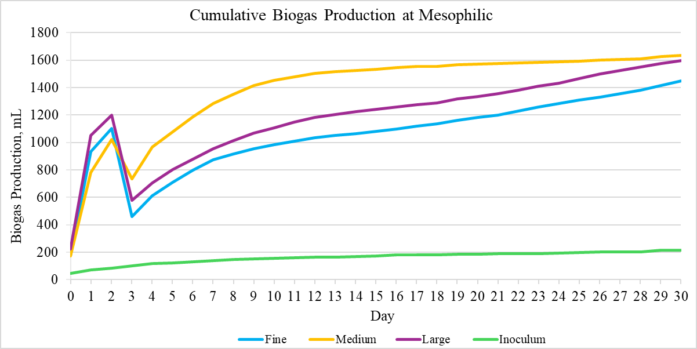
Fig a. Cumulative biogas production of three particle sizes at mesophilic for F:I=1:2.

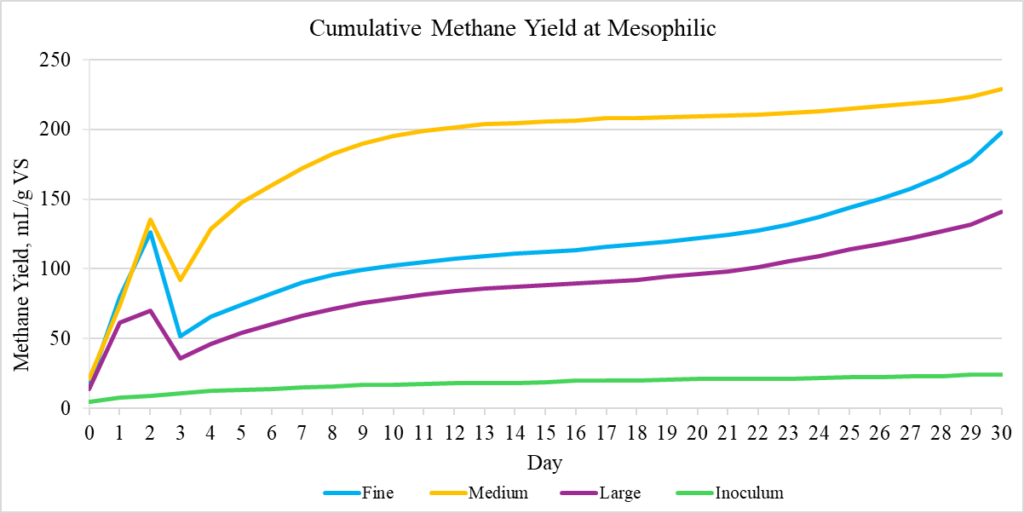
Fig b. Cumulative methane yield of three particle sizes at mesophilic for F:I=1:2.

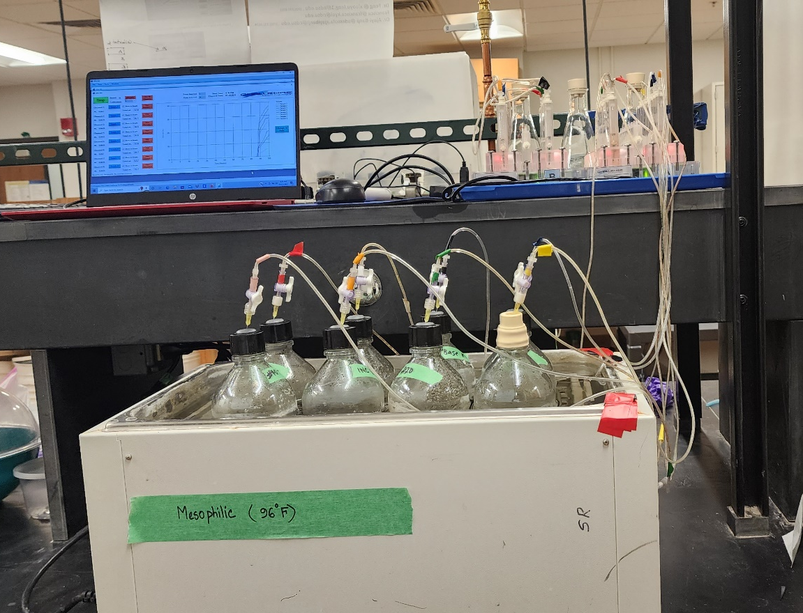
Fig c. Anaerobic digestion lab-scale setup.

