Improving Phosphorus Management for Soybean: Integrating Cover Crops and Fertilizer Placement and Time

Progress Report, April 2024
D. A. Ruiz Diaz and J.O. Demarco,
Kansas State University, Manhattan, KS
SUMMARY
This study aimed to maximize the soybean crop's phosphorus (P) use efficiency by using cover crops (CC) planting as a window of opportunity for better P fertilizer placement and timing. Specifically, P fertilizer can be combined with cereal CC seeds to place the fertilizer below the soil surface, and two operations (CC planting and fertilizer application) can be combined in one pass. Other benefits include eliminating the environmental risk of P fertilizer runoff and potentially creating a synergistic benefit of the CC and fertilizer combination on P availability to the soybean crop. The specific objectives of this study were to improve phosphorus management for soybean production in Kansas, increase yields using improved diagnostic tools and fertilization strategies and leverage opportunities for application placement with a CC in the rotation. Nine sites were established during the project, with five locations under supplemental irrigation and four rainfed locations. Phosphorus treatments included a control with no P application and three P rates of 40, 80, and 120 lbs P2O5/acre, using mono-ammonium phosphate (MAP). Cover crop treatments included oat and triticale with no P application and with P application of 45 Kg P2O5/ha. Cover crop samples were collected before soybean planting to measure biomass and P uptake. Soybean whole plant samples were collected at the V3-V4 stage for P Uptake analysis. At harvest, grain yield was recorded for each plot. The results obtained with this research showed that there was no significant response to CC treatments in locations that are non-responsive to P fertilization. In responsive locations to P fertilization, there was a penalty in soybean growth and yields when adding CC. However, results showed that excessive CC growth ahead of soybean could be detrimental to soybean yields, and CC termination should be timed to minimize potential yield penalty. Large water use by the CC could have affected the soybean growth and yield when biomass in the CC was excessive.

BACKGROUND

Phosphorus is an essential nutrient for plant development and can be scarce in some ecosystems, in addition to being an important cost for agricultural production and being a non-renewable resource. Phosphorus management can alter plant use efficiency, just as tillage and fertilizer placement can alter nutrient availability and stratification in the soil (Mallarino and Borges 2006).
The creation of many agricultural best management practices have been proposed to reduce fertilizer P losses, and their implementation is important since most fertilizer recommendation systems for agricultural crops were developed based on maximizing yields and not on avoiding possible environmental impacts (Withers et al. 2014).
Keeping the soil exposed, in the period without crops growing, can cause soil disaggregation by the impact of rain, and consequently runoff of soil and nutrients by water or even losses by wind (Havlin et al. 2005). Cover crops have been encouraged to be used before crops such as corn and soybeans, seeking the principles of a more conservationist agriculture. Cover crops can decrease sediment losses as they cover the soil surface during the time when there are no crops growing in the field, reducing the energy of raindrops and the speed of water runoff, increasing water infiltration into the soil and avoiding nutrient losses (Blanco‐Canqui et al. 2011).
The soybean crop provides one of the best opportunities to include a cool season cover crop before planting. Combining P fertilizer with cereal cover crop seeds will place the fertilizer below the soil surface and combine two operations (cover crop planting and fertilizer application). This study aims to maximize phosphorus use efficiency by the soybean crop by using cover crop planting as a window of opportunity for better P fertilizer placement and timing. The hypothesis of this study was that, in locations responsive to P application (low P levels in the soil), CC would be beneficial for soybeans as it would act as a slow-release source of P into the soil.

METHODS

This study was conducted in 2022 and 2023 at nine locations across Kansas. Among the nine locations, five were established under supplemental irrigation and four rainfed locations. Before fertilizer application, soil samples were collected at a depth of 0 to 15 centimeters using a hand probe. The average soil test P (Mehlich 3 and Bray 1), pH, and organic matter (OM) are presented in Table 1.
Phosphorus treatments included a control with no P application and three P rates of 40, 80, and 120 lbs P2O5/acre, using mono-ammonium phosphate (MAP). CC treatments included triticale (planted in fall) and oat (planted in spring) with no P application and with P application of 40 lbs P2O5/acre. P rates and CC were arranged in a factorial combination of treatments.

Table 1: Average soil test P, pH, and organic matter (OM) by location.
 |  | Soil test values
Site | Year | STP-M3 | STP-B1 | pH | OM
 |  | - - - - mg kg⁻¹ - - - - |  |  | g kg-1
1 | 2022 | 79 | 84 | 5.3 | 33
2 | 2022 | 17 | 19 | 5.7 | 27
3 | 2022 | 3 | 6 | 5.8 | 37
4 | 2023 | 10 | 18 | 6.5 | 16
* 5 | 2023 | 5 | 13 | 6.0 | 31
6 | 2023 | 9 | 14 | 7.1 | 22
* 7 | 2023 | 3 | 8 | 6.1 | 33
* 8 | 2023 | 7 | 14 | 5.9 | 25
9 | 2023 | 18 | 30 | 6.8 | 19
* Yield was not included for this analysis.
CC samples were collected before soybean planting to measure biomass and P uptake. Soybean whole plant samples were collected at the V3-4 growth stage to be analyzed for P uptake. The plant tissue samples were digested using nitric-perchloric acid digestion and analyzed using Inductively Coupled Plasma Optical Emission Spectroscopy (ICP-OES). At harvest, grain yield was recorded for each plot.
Data was analyzed by location and combined using lmer4 package in R 4.3.1, using RStudio (Version 2023.06.1+524), assuming block as a random factor in the model. When locations were combined, it was also considered as a random effect.

RESULTS

This study looked at how adding different cover crops (CC) before planting soybeans affected their growth and yield, especially when combined with phosphorus fertilizer use. When comparing oats and triticale (the two cover crops), we found that triticale produced more biomass (plant material) in part because it had more time to grow before soybeans were planted. When phosphorus fertilizer was used, the biomass increased even more.

The study also looked at how early in the season the plants took up phosphorus. In some locations where the soybean didn't respond much to phosphorus fertilizer (Non-Responsive), adding cover crops didn't show a significan effect on soybean. However, in locations where phosphorus fertilizer was needed (Responsive), adding cover crops seemed to slow down phosphorus uptake in soybean, especially with triticale cover crops.

Cover crops break down over time, releasing nutrients into the soil. In places where phosphorus is limited, this breakdown may be too slow, which could penalize soybean growth early in the season when the phosphorus demand is high. In locations with low soil phosphorus levels, adding cover crops seemed to penalize soybean yields. This might be because the cover crops didn't break down fast enough to provide phosphorus when the soybeans needed it early in the season.

Overall, adding cover crops didn't show a significant effect in locations where soil phosphorus wasn't a limiting factor. However, in locations where soil phosphorus was low, adding cover crops seemed to contribute to lowering soybean growth and yield. Dry conditions in Kansas might have also played a part in this, affecting how quickly the cover crops broke down and how much water the soybeans could access after CC termination.

Even though adding cover crops might not always help soybean yields, they can contribute to overall soil health and preventing weeds, especially in locations where soil phosphorus isn't a limiting factor. Additional studies should explore in more detail the effects on soil health and soil carbon as key components of sustainability in soybean production.

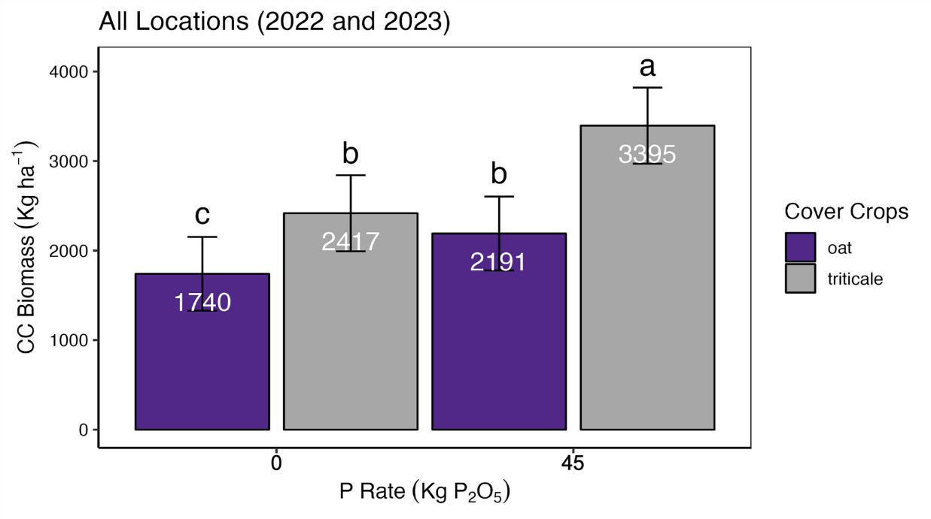
Figure 1: Cover crop biomass (Kg ha-1) as affected by different P rates and cover crop species across 9 locations.

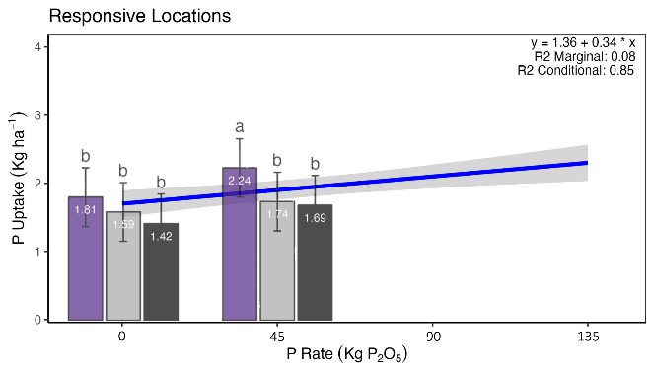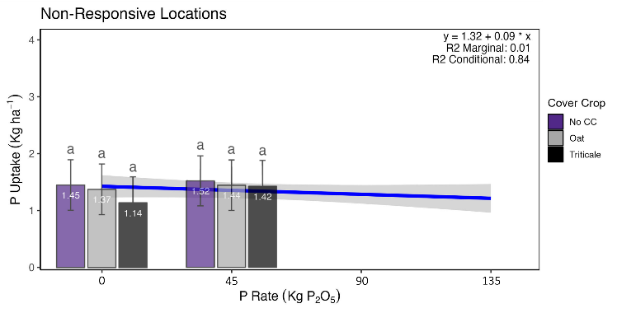
Figure 2: Phosphorus uptake (Kg ha-1) as affected by different P rates (regression line) and Phosphorus uptake (Kg ha-1) as affected by different P rates and cover crop species (bars) in responsive and non-responsive locations to P fertilizer.

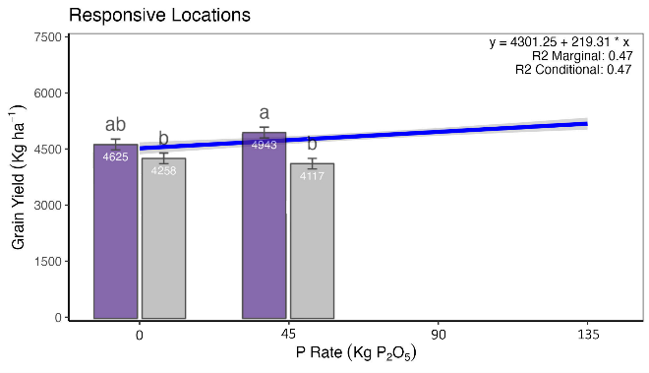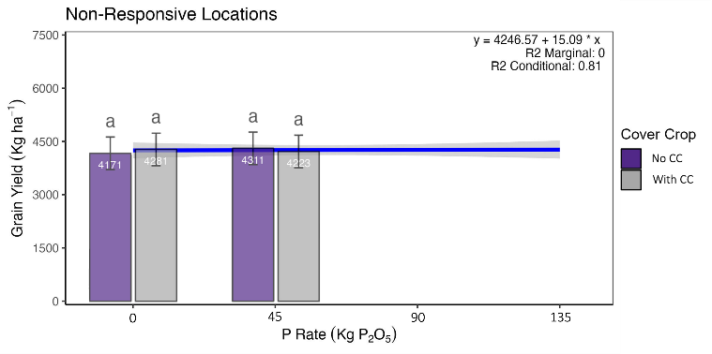
Figure 3: Grain yield (Kg ha-1) as affected by different P rates (regression line) and grain yield (Kg ha-1) as affected by different P rates and cover crop species (bars) in responsive and non-responsive locations to P fertilizer.

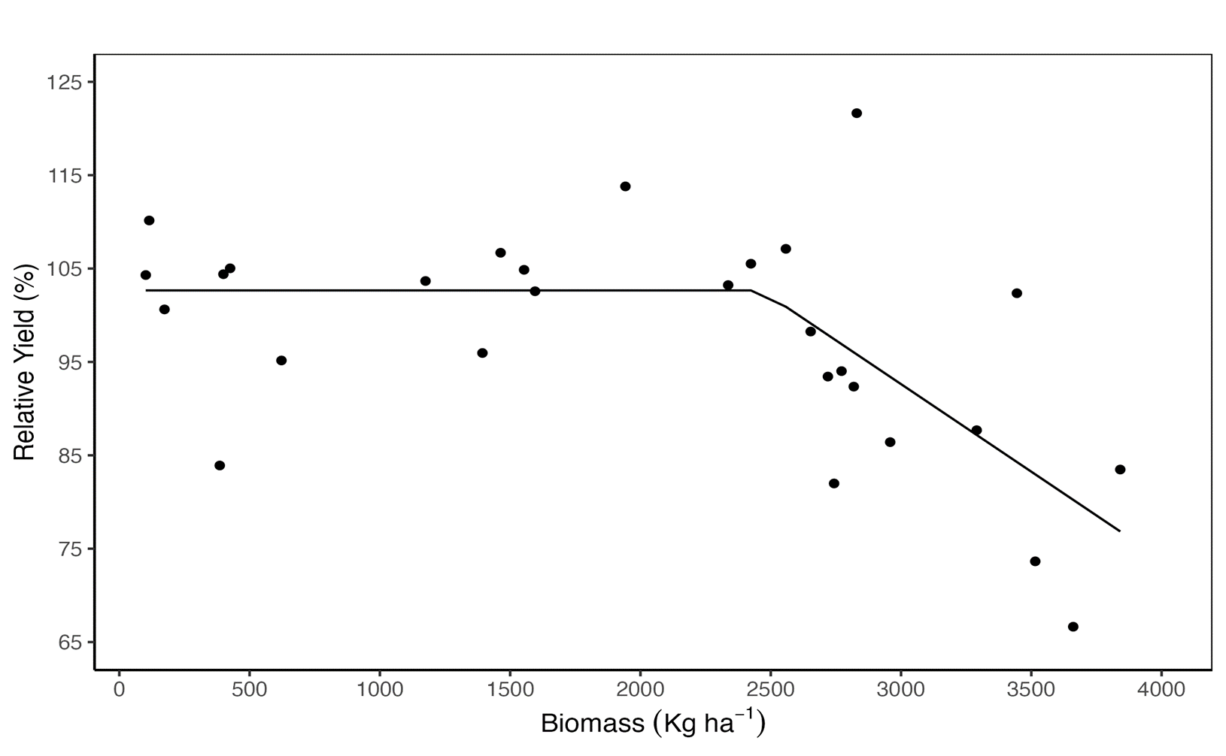
Figure 4: Relative yield (%) as affected by cover crop biomass (Kg ha-1 ) across 6 locations.

