Composite Materials from Soy Meal and Soy Hulls both modified with Soy-Based Polymers

PI: Andriy Voronov, Professor, Coatings and Polymeric Materials, NDSU, Dep.2760, PO Box 6050, Fargo, ND 58108, phone 701 231 9563, andriy.voronov@ndsu.edu
Dates of Project: July 1st, 2023 – June 30th, 2024

Background Information
During soybeans crushing process, first, soy hulls (SH) are removed, then soybean oil is extracted from the rolled flakes, followed by the flakes drying, toasting and grounding into soy meal (SM). One can say that SH and SM are both similar in terms of their chemical composition, primarily containing mixtures of soy protein (SP) and various carbohydrates, at very different ratios. While SM mainly contains 40 to 55 % SP and up to 35 % carbohydrates (polysaccharides and various mono-, di- and oligosaccharides), the SH has up to 86% carbohydrates (including polysaccharides and oligosaccharides, as well) and some small amount 9 to 12% of SP. It is important to understand and realize that SM and SH properties (composition) will most probably vary depending on the soybean source.
This proposal’s goal is to explore suitability of using various ratios of SM and SH simultaneously (and, perhaps, synergistically) for making composite polymeric materials, thermoplastics or thermosets. We foresee that blends where SM is presented in excess can be more suitable for thermoplastics applications, while materials with a higher concentration of SH will be feasible for polymer composites.

Research Objectives
We targeted three interconnected objectives to develop sustainable technology for the biobased polymeric composites from SM and SH.
1. Synthesize high oleic soybean oil-based (HO-SBM) monomer. The samples of the synthesized HO-SBM were used for the next objective. 2. Develop procedure of SM and SH modification with HO-SBM- based polymers. Those experiments result in modified SM and SH with the targeted mechanical and film-forming properties by introducing side chains of HO-SBM that bear plasticizing hydrophobic fatty acid fragments. As a result, SM and SH become processable thermoplastics, while retaining their natural biodegradability. The resulted modified SM and SH were used for next objective. 3. Formulation and characterization of composite polymeric films from modified SM and SH. We prepared the series of formulations from modified SM and SH and formed 20 - 60 µm thick films to obtain knowledge on their structure-properties relationships, processability and mechanical performance.

Materials and Methods.
Materials. High-oleic soybean oil, N-(hydroxyethyl) acrylamide (stabilized with MEHQ, >98 %), magnesium sulfate (anhydrous, reagent grade), soybean hulls (SH, Northern Crops Institute), soybean meal (SM, Owensboro Grain, KY, USA), azobisisobutyronitrile (AIBN; [(CH₃)₂C(CN)]₂N₂, 98%), maleic anhydride (99%). The driers and curing catalysts used were cobalt Ten-Cem (12%), zirconium Hex-Cem (12%), calcium Hydro-Cem (5%) and Dri-Rx HF. All used solvents were reagent grade or better and used as received.
Preparation of SH and SM. To increase the accessibility of functional groups, raw SH and SM were milled and dried before maleinization. A grinding machine was used to mill SM directly, while SH brittleness was increased by freezing it in liquid nitrogen before milling. After that, SH and SM were sieved through a standard test sieve (ASTM E-11 standard) with a sieve size of 106 µm (#140). To remove excess water naturally present in SH and SM, freeze-drying was performed using Labconco FreeZone 2.5L freeze dryer for 72 h.
Maleinization of SH and SM. To conduct a maleinization reaction, SH or SM were mixed with maleic anhydride at 1:10 weight ratio and dispersed in dimethylformamide (DMF) at 1 wt.% solid content with vigorous steering (about 800 rpm) for 30 min. The reaction mixture was purged with UHP Nitrogen for 10 min and reaction was carried out at 90ºC for 4h and magnetic stirring at 800 rpm. After the reaction was complete, the mixture was washed on the paper filter, first with an excess of methanol and then water to remove unreacted maleic anhydride. SH or SM were collected from a paper filter and dried in the oven at 90ºC for 5h.
Grafting of high-oleic soybean oil-based polymer onto SH and SM. First, HO-SBM was mixed with AIBN (1.5 wt.% per oil phase) and stirred until complete dissolution. Then, under mechanical stirring at 200 rpm maleinized SH or SM were added to the mixture of monomer and initiator (HO-SBM to SH or SM weight ratio was 1:10 and 1:5). Reaction was conducted at 80ºC for 8h. After polymerization, mixture was precipitated in methanol to remove unreacted monomer. Supernatant was collected and after evaporation of solvent residual monomer amount was measured to calculate monomer conversion. Pure polymer and SH or SM were dried under nitrogen flow and dissolved in toluene for further film preparation.
Composite film preparation. To facilitate the crosslinking process through autoxidation of HO-SBM double bonds, primary and secondary driers and catalysts were added at the necessary level to the polymer solution. Then, the polymer solution was drawn down on the polytetrafluoroethylene (PTFE) substrate to ensure easy release after curing. A dry film thickness of 100 µm was targeted, and the wet film thickness was adjusted accordingly based on the solid content of the formulation. Toluene was allowed to evaporate to obtain a solid tack-free film, and subsequent curing for 5 h at 100°C at each side of the free film was performed. After curing, the samples were cooled down and stored under ambient conditions before testing.
Characterization. The chemical composition of SH, maleinized SH, homopolymer and cross-linked thermoset films was confirmed using FTIR spectroscopy. For mechanical characterization (tensile test), cured polymer films were cut into rectangle-shaped samples with dimensions of 25 × 5mm. The thickness of the films was measured using a digital micrometer before each test. The reported Young’s modulus and elongation at break values were the averages of at least five measurements. Composite toughness was calculated as the area under stress-strain curve and is an average of five measurements. To perform dynamic mechanical analysis and determine composite storage modulus and glass transition temperature (Tg), the sample preparation procedure was the same as for the tensile test. The dynamic mechanical analysis (DMA) measurements were performed by heating the sample from −70 to 150°C at a rate of 5°C/min under a constant frequency of 1 Hz. Thermogravimetric analysis (TGA) was employed to evaluate thermal stability of prepared composite films. A sample of cross-linked polymer film was heated from 25 to 600ºC at temperature ramp of 20ºC/min in Platinum crucible under nitrogen atmosphere. The reported value is a temperature of a 5% weight loss of the composite.
Research Results, Discussion and Outcomes
SH and SM consist of a complex mixture of hydrophilic biopolymers, primarily hemicellulose, cellulose, and proteins, with a negligible fraction of lignin and lipids. Even though these biopolymers have high rigidity, they are too brittle to be film-forming and excessively hydrophilic to incorporate into the polymer matrix as reinforcing agents. To enhance the compatibility of SH and SM constituents, maleinization reaction and subsequent grafting of HO-SBM-based polymers was performed (Scheme 1). A high abundance of hydroxyl groups was used in reaction with maleic anhydride.
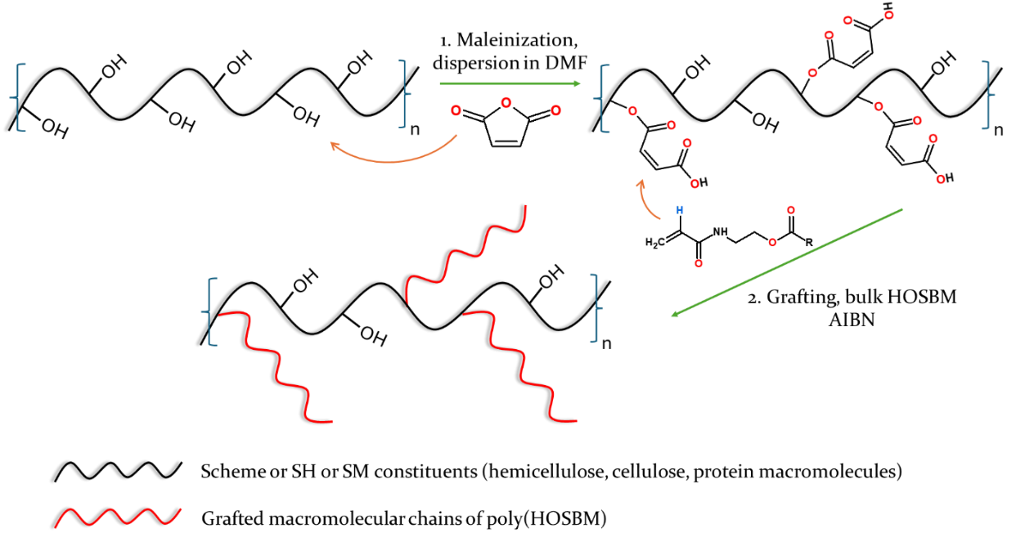

Scheme 1. Maleinization of SH and SM constituents (hemicellulose, cellulose, proteins) (1); Grafting reaction of HO-SBM onto maleinized SH and SM via maleic anhydride double bonds (2)
After ring opening, maleic anhydride is converted into maleic or fumaric acid, depending on the reaction conditions. In our case, maleic acid is primarily formed; it contains two carboxyl groups, one of which is reacting with the SH or SM hydroxyl group. The carbon-carbon double bond in maleic acid is reactive in free radical polymerization and can be utilized as a reactive center for “grafting from” reaction. Two products are formed during grafting polymerization – grafted SH or SM and a homopolymer of HO-SBM. The latter plays the role of a continuous polymer matrix, while the former acts as a reinforcing agent. Long grafted chains of HO-SBM enhance intermolecular interactions with homopolymers and thus facilitate compatibility between the dispersed phase (grafted SH or SM) and the dispersion medium polyHO-SBM. Moreover, allyl double bonds of HO-SBM remain intact during the grafting process and are further used for post-polymerization cross-linking to form thermoset films.
To confirm that grafting reaction was successful, ATR-FTIR technique was used. It can be observed that after grafting there is a significant increase in the intensity of alkane peak at 2930 cm⁻¹, compared to pristine SH (black curve) and maleinized SH (red curve), which corresponds to the macromolecular chains of grafted polyHO-SBM (Figure 1A). Important to note that for the sample of grafted SH (blue curve) all homopolymer was removed.

A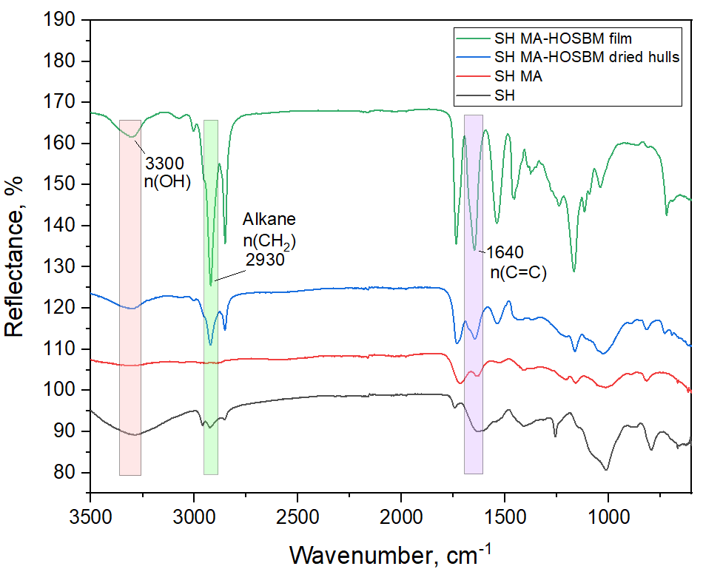B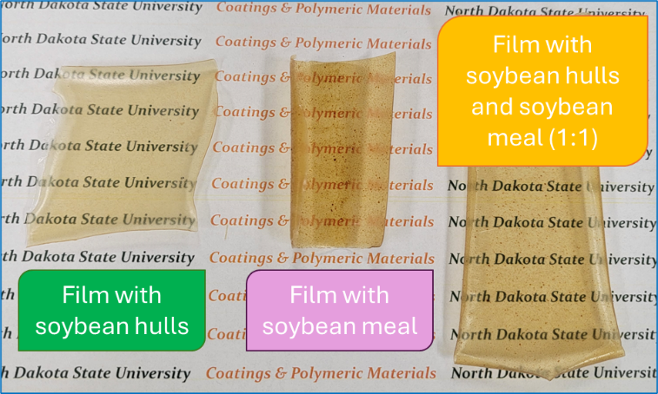
Figure 1. ATR-FTIR spectra of pristine SHs, maleinized SH, grafted SH and composite film with homopolymer and grafted SH (uncross-linked) (A); appearance of cross-linked polymer films made with SH, SM and both SH and SM (B).

All composite polymer films were optically transparent with yellow discoloration caused by the driers (primarily Cobalt) added to facilitate cross-linking process (Figure 1B). At the same time, composite with SH as a filler has the least discoloration and the most even distribution of filler within the polymer film.
The grafting process was performed using bulk polymerization in monomer without any solvent present. Such an approach not only allows to reduce VOC content but also enhance grafting efficiency, due to higher availability of monomer next to the reactive centers (maleinized SH and SM). The monomer conversion after grafting process was 61-71 %, is comparable to currently used industrial processes and is reasonable for further implementation (Table 1). Removing unreacted monomers from the system increases the filler content from theoretical 1:10 (9 wt.%) to 12.5 wt.% and from 1:5 (16.7 wt.%) to 24.6 wt.% respectively. Based on the obtained results, we can claim that we currently achieved a 25 wt.% substitution of polymer matrix with a biobased filler (SH). These results are promising as a cost reduction of final composite, as well as finding a practical use for the biobased resource currently considered an agricultural waste (SH) and significantly improve the performance of prepared thermoset polymer films.

Table 1. Monomer conversion and filler content after grafting
Sample | Calc. filler content in composite, wt.% | Exp. filler content in composite after grafting, wt.% | Monomer conversion in grafting, %
SHm-H 1:10 | SH, 9.1% | 12.4% | 70.8
SHm-H 1:5 | SH, 16.7% | 24.6% | 61.3
SMm-H 1:10 | SM, 9.1% | 12.7% | 68.4
SH:SM (1:1)m-H 1:10 | SH+SM, 9.1% | 12.8% | 68.0
SHm+SMm (1:1) – H 1:10 (mixed) | SH+SM, 9.1% | 12.5% | -
A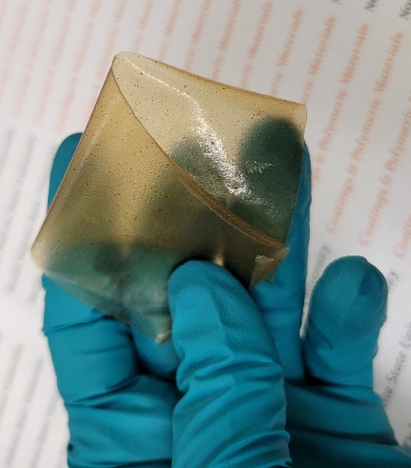 B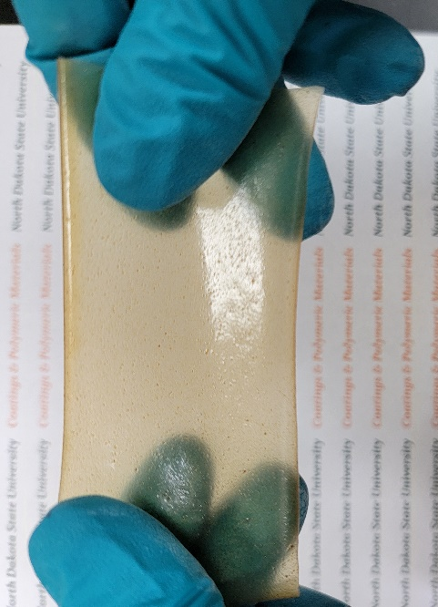
Figure 2. Appearance of cross-linked polymer films after bending, demonstrating high flexibility (A); the visual assessment of filler distribution within cross-linked polymer film (B).
Table 2. Thermomechanical performance of thermoset films
Sample | Young’s modulus, MPA | Ebr, % | Toughness, MJ/m³ | Tensile strength, MPa | Storage modulus (DMA), MPa | Tan del, ºC | TGA, 5% weight loss, ºC
SHm-H 1:10 | 66.6±4.6 | 22±5 | 0.37±0.18 | 2.43±0.35 | 2150 | 43 | 189
SHm-H 1:5 | 106.9±7.8 | 18±4 | 0.47±0.23 | 2.87±0.37 | 2400 | 41 | 164
SMm-H 1:10 | 76.8±7.2 | 19±7 | 0.35±0.14 | 2.40±0.20 | 1950 | 41 | 161
SH:SM (1:1)m-H 1:10 | 81.5±13.2 | 23±5 | 0.48±0.17 | 2.67±0.47 | 3200 | 29 | 174
SHm+SMm (1:1)– H 1:10 (mixed) | 59.0±3.2 | 22±4 | 0.35±0.09 | 2.10±0.24 | 2150 | 49 | 183
SH – Soybean hulls; SM – Soybean meal; SHm – maleinized SH; SMm – maleinized SM; SHm-H grafted SH; SMm-H – grafted SM; ratio between filler/poly(HOSBM) matrix was 1:10 or 1:5; ratio between SH/SM was 1:1.

The results of mechanical and thermomechanical characterization of cross-linked polymer films are presented in Table 2. It can be seen that all films despite filler type (SH or SM) and content (1:10 or 1:5) have similar elongation at break about 20 %, typical for brittle polymers. However, all films possess the necessary level of flexibility to bend without fracture, which is characteristic for tough plastics (Figure 2A). The same trend is observed for toughness value – amount of dissipated energy before mechanical failure which is 0.35 - 0.48 MJ/m³. Tensile strength (maximum load material can withstand) is also similar for different composites, about 2.1 - 2.9 MPa. Interesting is the result of Young’s modulus – stress during elastic deformation of the material, and twice increase in filler content provides significant increase in modulus, from 66.6 to 106.9 MPa. This is a remarkable result as polymer cost is much higher than the filler, especially when SH are used. Therefore, increasing filler content without compromising the performance of composite can lead to sufficient economic benefit.
Dynamic mechanical analysis (DMA) results provide an important insight on mechanical performance of prepared composites. It is apparent that combination of SH and SM at 1:1 ratio on the stage of maleinization and their further grafting allows to achieve the highest value of storage modulus (3200 MPa), while simple mixing of separately grafted SH and SM leads to lower modulus value of 2150 MPa.
These results allow us to assume that there are synergistic effects of using both SH and SM simultaneously in the preparation of the composite, which also requires further investigation. Lastly, the thermal stability of cross-linked films is similar despite the fillers used and 5% mass loss occurring in the region of 161-189 ºC. This value is lower than for synthetic thermoplastics such as polypropylene and polyethylene terephthalate and is explained by the lower thermal stability of SH and SM in the prepared bio-based composite.

Benefits to Soybean ND farmers and industry
The developed technology targets to demonstrate feasibility of using soybeans produced in the state of North Dakota for high value and high profit composite polymeric materials. Using soy meal and soy hulls for making new biobased thermoplastics and thermosets has the ability to add more value to the crop, thereby make it more profitable for farmers.
Ability to combine soy hulls and soy meal with soy-based biodegradable polymers from soy oils from crop grown in state of North Dakota is a key benefit of the developed materials. Obtained results demonstrate that the developed composite materials may diversify soy-based polymeric products market with increased demand for soy hulls and soy meal and thus benefit North Dakota soybean farmers. In particular, the developed soy-based thermoplastics may succeed at the market of packaging. The latter helps the state of North Dakota economy to involve investors and other soy processing industries.

