Enhancing Profitability of Soybean Production and Soil Health through Livestock Integration
Joshua Wianecki¹, Miranda Meehan¹, Lindsay Chamberlain Malone², Zachary Carlson¹, Kevin Sedivec^{2,3}, Colin Tobin⁴, Michael Ostlie⁴
¹Department of Animal Sciences, North Dakota State University, Fargo ND. ²School of Natural Resource Sciences, North Dakota State University, Fargo ND. ³Central Grasslands Research Extension Center, Streeter ND. ⁴Carrington Research Extension Center, Carrington ND.

Why the Research is Important to ND Soybean Farmers
Integrated crop livestock systems (ICLS) may provide additional income and soil health benefits to producers utilizing winter cover crops. The impact of ICLS on row crop production has been demonstrated to be influenced by both crop and livestock management strategies with previous research showing both crop rotation and seasonality of grazing can sway the production benefits of ICLS. This project aims to determine the effects of ICLS and cover crop management on soil health, crop production, and livestock performance within North Dakota.
Research Conducted
Two locations were selected to integrate livestock grazing into winter cover crop management. Management strategies include dual season (fall and spring) grazing, spring grazing, no grazing, and no cover crop. Soil health was evaluated through nutrient analysis and physical health indicators including bulk density and aggregate stability. Soybean production was evaluated through soybean yield. Livestock performance was determined by average daily gain during the grazing period.
Findings of Research
Grazing livestock caused no negative impacts to crop production or soil health. Soil nutrients and aggregate stability did not differ between strategies. Only the spring graze treatment saw statistically higher bulk density, however all bulk densities were below levels that may harm root growth. Despite soybeans within the no cover crop plots attaining larger size during staging, soybean yield (Figure 1) did not differ; likely due to soil moisture and nutrients being retained within cover crop residues during late season. Grazing duration and animal performance was variable, being highly dependent on precipitation and temperature during the cover crop growing season.
Benefits and Recommendations to North Dakota Soybean Farmers and Industry:
Livestock integration did not negatively affect soil health prior to soybean planting. Both cover crop practices and livestock integration have been shown to positively impact soil physical health over extended periods of time, which may not have been captured within this study. Planting date, temperature, and precipitation all heavily influenced rye stands and the duration of grazing. Rye provided up to 0.84 animal use months per acre during early spring, which can reduce pressure on other grazing systems and increase flexibility to producers interested in both crop and livestock production.

Figure 1 Soybean Yield in Streeter N.D. and Carrington N.D.
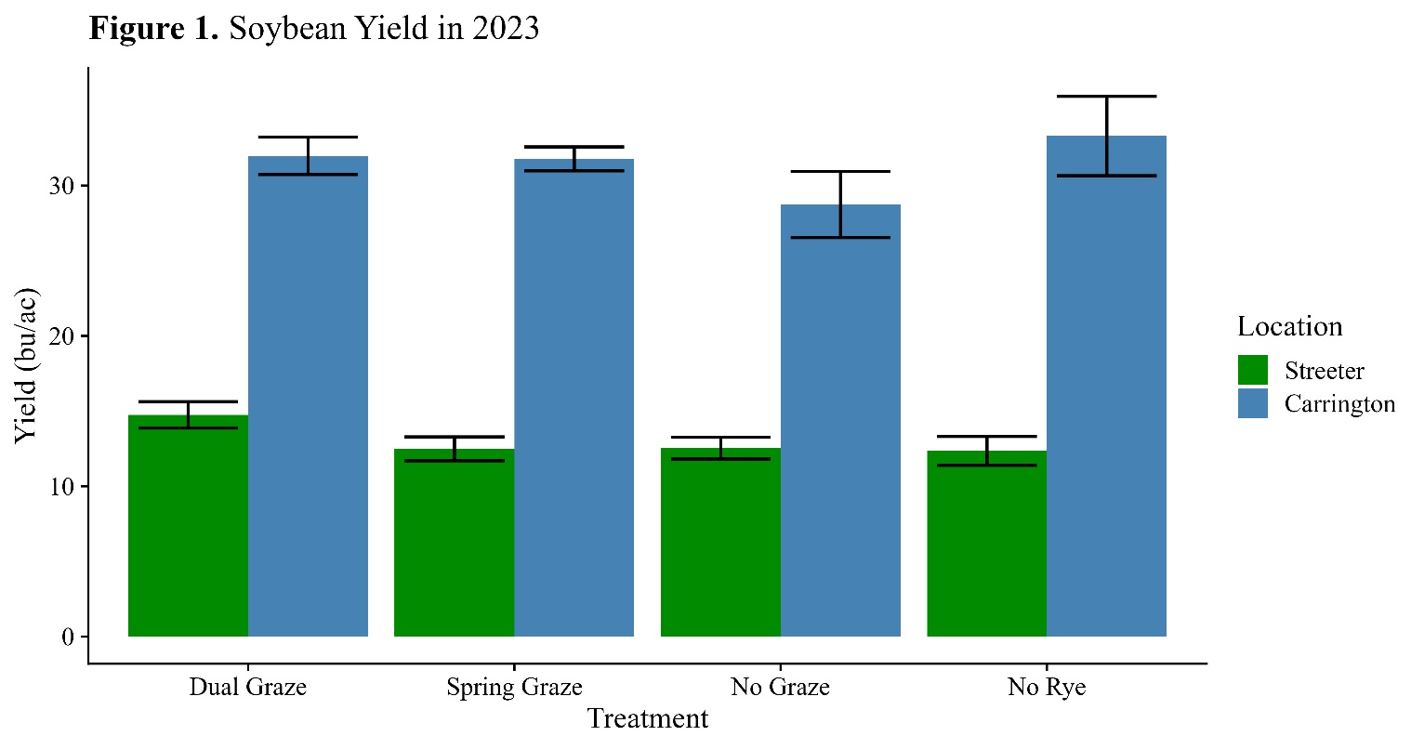

Figure 2. Remaining winter rye residue within a spring grazed paddock immediately following removal of grazing cattle at Streeter in Spring 2024.


