Resistant Palmer Amaranth Seed Production and Retention in Kansas Soybean Production

Taylor Lambert and Jeremie Kouame

Abstract
The effective management of Palmer amaranth (Amaranthus palmeri) seedbanks is a critical challenge in Kansas soybean production. This study investigates Palmer amaranth seed production and retention at the time of soybean harvest, providing insights into the weed’s seed production in Kansas soybean fields and the potential effectiveness of Harvest weed seed control tactics for its control. Data were collected from 12 counties in Kansas, where female Palmer amaranth plants were collected and seed and debris of the plant, fallen on the ground, were vacuumed. Results showed that female Palmer amaranth plants with an aboveground biomass of 0.3 and 0.4 lb produced on average 58,100 and 84,900 seeds, respectively. Moreover, approximately 97% of the seeds remained on the plant at harvest, suggesting that a Harvest Weed Seed Destruction (HWSD) strategy could be highly effective in reducing the number of Palmer amaranth viable seeds that return to the soil seedbank.

Introduction
Palmer amaranth is a highly invasive weed species that poses a significant threat to soybean production in Kansas. It has been reported to cause nearly 80% yield loss in Northeast Kansas (Bensch, et al., 2003. Also, Palmer amaranth in Kansas has developed resistance to WSSA Group 2 (chlorsulfuron, thifensulfuron, imazethapyr, and imazamox), Group 4 (2,4-D), Group 5 & 6 (atrazine and metribuzin), Group 9 (glyphosate), Group 14 (fomesafen and lactofen), and Group 27 (mesotrione and tembotrione) herbicides (Heap, 2024), leaving growers with very few postemergence options (Peterson and Jugulam, 2019). Its rapid growth and ability to produce large quantities of seed contribute to the development of persistent seedbanks, making it a challenge for farmers (Shaner and Beckie, 2014). In fact, a female Palmer amaranth plant can produce up to 600,000 seeds (Ward, 2013) with the majority of these seeds retained on the plant at the time of harvest and making them vulnerable to harvest weed seed control practices. Effective management strategies are necessary to control its spread and reduce its impact on crop yields. Harvest Weed Seed Control (HWSD) is an emerging strategy that targets weed seeds during harvest, preventing them from entering the soil seedbank (Walsh and Powles, 2014). Various methods, such as mechanical harvest weed seed destructors, chaff lining, narrow windrow burning, chaff carts have been explored and showed promising results for long-term weed management (Schwartz-Lazaro et al., 2017; Walsh & Newman, 2007; Walsh et al., 2017; Walsh et al., 2017; Walsh et al., 2018; Walsh et al., 2018; Walsh et al., 2021). However, a critical step for their use is seed-retention assessments of the most problematic weeds at crop maturity (Soni et al., 2020; Walsh et al., 2018; Walsh & Powles, 2014). This research aims to investigate the seed production and retention of Palmer amaranth at the time of soybean harvest, with the goal of evaluating the potential effectiveness of HWSD in Kansas soybean fields.

Materials and Methods
Study Area
Twelve thousand farmers plant soybeans on 4.5 million acres of Kansas production ground averaging 40.5 bushels per acre. Some regions of Kansas are better suited for soybeans due to precipitation amounts in Kansas ranging from 6-38 inches a year. In total, 22 soybean fields were visited in 12 counties within one week of harvest (Figure 1).
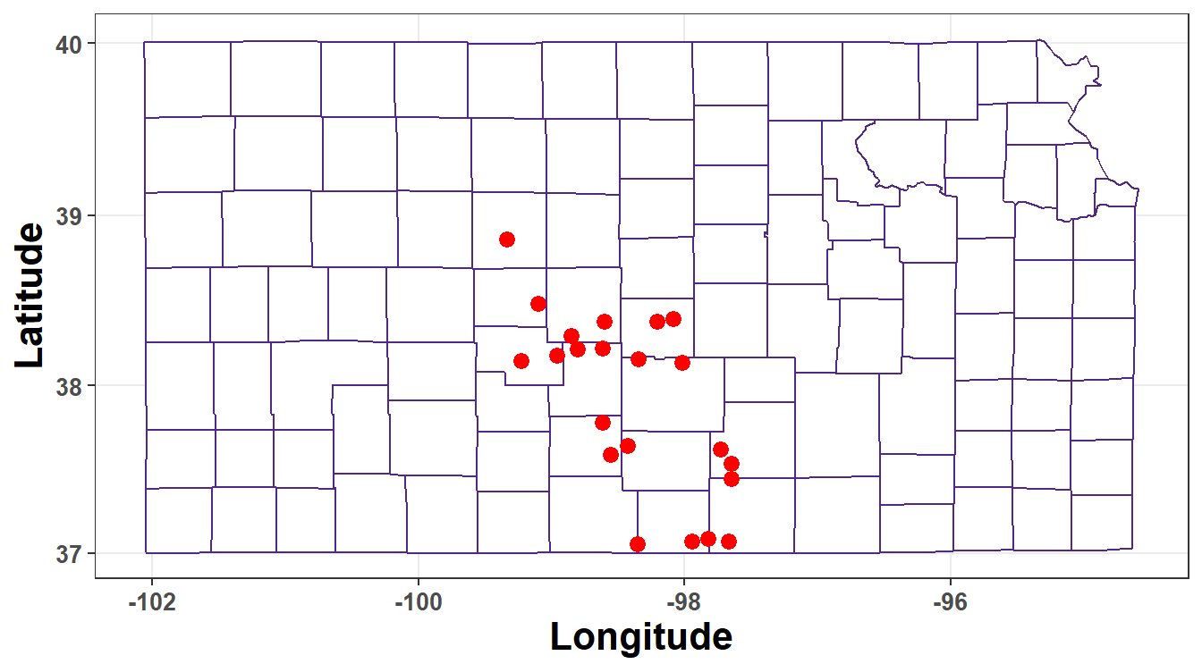Figure 1. Distribution of soybean fields visited in 2023 for evaluating Palmer amaranth seed production and retention at harvest

Palmer amaranth biomass and Seed Collection Processes
Two approaches are generally used in the scientific literature to assess weed-seed retention (field surveys and periodic monitoring) (Walsh et al., 2018). Our study used the field survey approach that involves randomly visiting fields at crop maturity as it allows an estimation of seed retention as they ‘typically’ occur in commercial production environments (Walsh et al., 2018). Palmer amaranth plants were collected from 12 counties in Kansas, where herbicide-resistant populations had been previously reported. In each county, 1 - 2 soybean fields were selected within one week of harvest. Three mature female Palmer amaranth plants were harvested from each field and bagged separately. For each plant, the surrounding ground, extending 1 ft beyond the plant’s diameter, was vacuumed to collect any seed and debris that had fallen from the plant. These materials were also bagged separately. The plants were weighed to determine their biomass, and the seed was manually removed, cleaned, and weighed to determine the total amount of seed retained on the plant. The vacuumed debris samples were sifted and cleaned to collect seeds that had shattered off the plant before harvest. The weight of the collected seeds from both the plant and the vacuumed debris was recorded. On average, 100-seed weight were recorded on 36 subsamples and used to estimate the total number of seeds in each case.

Data analysis
The relationship between Palmer amaranth seed production and its aboveground biomass was evaluated by fitting the linear model to data across counties and fields with the lm() function of the stats package in R software (v. 4.3.3; R Core Team 2024). A map of the visited fields and bar graphs of the percentage of Palmer amaranth seeds retained/shattered were also created using R software (v. 4.3.3; R Core Team 2024).

Results
Palmer amaranth biomass and seed production in Kansas
Palmer amaranth seed production showed a strong relationship with the weed’s aboveground biomass (Figure 2) with 78% of variability in seed production explained by the linear regression (R² = 0.78). It could be predicted from results that female Palmer amaranth plants with an aboveground biomass of 0.1, 0.2, 0.3, and 0.4 lb produced on average 4,600, 31,400, 58,100, and 84,900 seeds, respectively, in soybean fields in Kansas in 2023. Also, results revealed that we could expect an increase of 540 seeds for each increase in a female Palmer amaranth aboveground biomass (Figure 2).

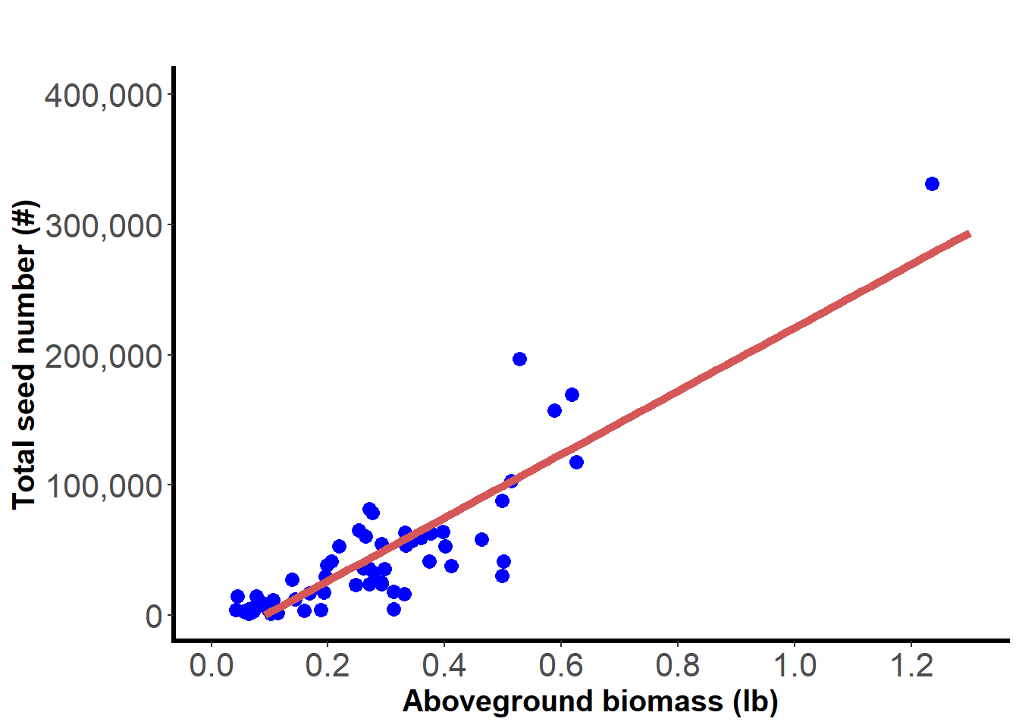
Figure 2. Relationship between Palmer amaranth seed production and aboveground biomass in Kansas in 2023

Palmer amaranth’s prolific seed production results in this study are consistent with previous research (Ward et al., 2013). Palmer amaranth plants that emerged between mid-June and late-July in 38-inch row spacing soybean fields produced 19,618 seeds ft⁻² , while those in 7.5-inc row-spacing soybean fields produced 12,924 seeds m⁻² (Jha et al., 2008). The relationship between Palmer amaranth biomass and seed production is not surprising. Previous research documented a strong relationship between the total amount of organic matter produced through photosynthesis (gross primary production) and grain yield of plants with the well-defined relationship between plant productivity and the photosynthetically active radiation absorbed by the green portion of the vegetation (Gitelson et al., 2015).

Palmer amaranth seed retention in Kansas
Palmer amaranth seed retention varied between 90 and 100% with an average of 97% of the seeds retained at harvest (Figure 3). The average number of seeds that remained on a single plant was 40,541 seeds, while 1471 seeds (3%) were lost to shattering. These findings suggest that Palmer amaranth seeds are largely retained on the plant and, if not effectively managed, are likely to enter the soybean combine, get mixed with the chaff and redistributed to the field with the potential of contributing to the increase of the soil seedbank.
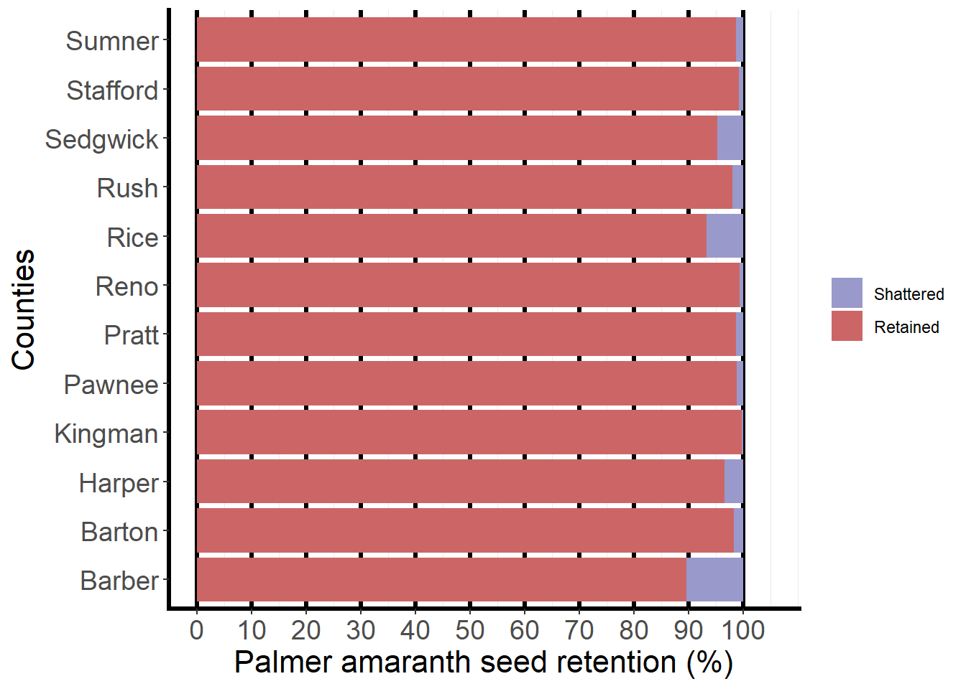
Figure 3. Palmer amaranth seed retention at harvest in 12 Kansas counties in 2023.

Palmer amaranth biomass and seed production
The findings from this study demonstrate that Palmer amaranth retains the vast majority of its seed on the plant at harvest. They are comparable to other data around the US. Previous research reported 98% seed retention at soybean maturity and 95% seed retention one month after soybean maturity (Norsworthy et al., 2014). Also, seed retention of Palmer amaranth in soybean fields was reported to range from 85%-95% (Schwartz-Lazaro et al., (2017).

Conclusion and implications
The high retention rate observed in this study makes it compelling for Kansas soybean farmers to integrate HWSC technologies into their harvest practices. The use of equipment such as the Seed Destructor or chaff carts can destroy or collect weed seeds during harvest and prevent them from contributing to the weed seedbank. By targeting the 97% of seeds that remain on the plant, HWSD offers an efficient and practical solution for managing multiple herbicide-resistant Palmer amaranth populations. While this study provides valuable insights into seed production and retention, it is limited to fields in Kansas and may not fully represent variability across different regions. Different management practices (herbicide programs, cove crops, etc.) will differently affect seed production. Future studies should explore the long-term effects of integrating HWSD strategies on Palmer amaranth seedbank dynamics and soybean yield.

Acknowledgements
This research was funded by the Kansas Soybean Commission. The authors would like to thank all the personnel at the Agricultural Research Center in Hays that helped with this study.

References
Heap I (2024). International Herbicide-Resistant Weed Database. https://www.weedscience.org/Home.aspx. Visited on November 11, 2024.
Gitelson, A., Peng, Y., Arkebauer, T., & Suyker, A. (2015). Productivity, absorbed photosynthetically active radiation, and light use efficiency in crops: Implications for remote sensing of crop primary production. Journal of Plant Physiology, 177, 100-109. https://doi.org/10.1016/j.jplph.2014.12.015
Jha, P., Norsworthy, J., Bridges, W., & Riley, M. (2008). Influence of glyphosate timing and row width on Palmer amaranth (Amaranthus palmeri) and pusley (Richardia spp.) demographics in glyphosate-resistant soybean. Weed Science, 56(3), 408-415. https://doi.org/10.1614/WS-07-174.1
R Core Team R (2024) R: A language and environment for statistical computing. Vienna, Austria: R Foundation for Statistical. Schwartz-Lazaro, L. M., Norsworthy, J. K., Walsh, M. J., & Bagavathiannan, M. V. (2017). Efficacy of the integrated harrington seed destructor on weeds of soybean and rice production systems in the Southern United States. Crop Science, 57(5), 2812-2818. https://doi.org/10.2135/cropsci2017.03.0210
Soni, N., Nissen, S. J., Westra, P., Norsworthy, J. K., Walsh, M., & Gaines, T. A. (2020). Seed retention of winter annual grass weeds at winter wheat harvest maturity shows potential for harvest weed seed control. Weed Technology, 34(2), 266-271. https://doi.org/10.1017/wet.2019.108
Walsh, M., & Newman, P. (2007). Burning narrow windrows for weed seed destruction. Field Crops Research, 104(1-3), 24-30. https://doi.org/10.1016/j.fcr.2007.05.012
Walsh, M., Ouzman, J., Newman, P., Powles, S., & Llewellyn, R. (2017). High Levels of adoption indicate that harvest weed seed control is now an established weed control practice in australian cropping. Weed Technology, 31(3), 341-347. https://doi.org/10.1017/wet.2017.9
Walsh, M. J., Aves, C., & Powles, S. B. (2017). Harvest weed seed control systems are similarly effective on rigid ryegrass. Weed Technology, 31(2), 178-183. https://doi.org/10.1017/wet.2017.6
Walsh, M. J., Broster, J. C., & Powles, S. B. (2018). iHSD mill efficacy on the seeds of australian cropping system weeds. Weed Technology, 32(2), 103-108. https://doi.org/10.1017/wet.2017.95
Walsh, M. J., Broster, J. C., Schwartz‐Lazaro, L. M., Norsworthy, J. K., Davis, A. S., Tidemann, B. D.,…Bagavathiannan, M. V. (2018). Opportunities and challenges for harvest weed seed control in global cropping systems. Pest management science, 74(10), 2235-2245. https://doi.org/10.1002/ps.4802
Walsh, M. J., & Powles, S. B. (2014). High seed retention at maturity of annual weeds infesting crop fields highlights the potential for harvest weed seed control. Weed technology, 28(3), 486-493. https://doi.org/10.1614/WT-D-13-00183.1
Walsh, M. J., Rayner, A. E., Ruttledge, A., & Broster, J. C. (2021). Influence of chaff and chaff lines on weed seed survival and seedling emergence in Australian cropping systems. Weed Technology, 35(3), 515-521, Article Pii s0890037x20001426. https://doi.org/10.1017/wet.2020.142
Ward, S., Webster, T., & Steckel, L. (2013). Palmer amaranth (Amaranthus palmeri): A review [Review]. Weed Technology, 27(1), 12-27. https://doi.org/10.1614/WT-D-12-00113.1

