Final report – May 31, 2023 MSRPC Project: 10-15-44-22012
2022 Western Minnesota Soybean IPM Survey & Ag Student Training Program
Angie Peltier, apeltier@umn.edu, O: (218) 281-8692, C: (414) 704-1931 & Anthony Hanson

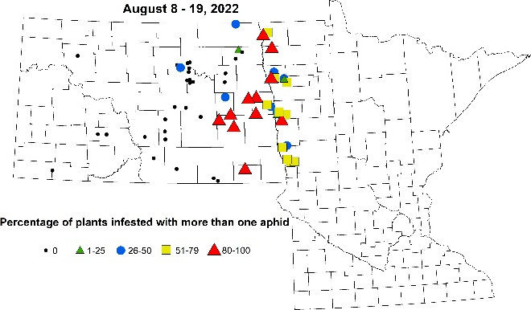
2022 program. Eight years since the soybean IPM survey began in 2015, the 2022 survey took place primarily in counties in northwestern Minnesota due to significant staffing issues detailed in the full 4th quarter report. Consequently, a single NDSU ag student working as a scout visited 108 soybean fields over 34 scouting days between June 27 and August 18; scouting time was shared between scouting wheat and soybean in her first week of scouting soybean. In each field the scout growth staged the crop, swept field edges for grasshoppers, Similar to in previous years, the Minnesota team collaborated with the NDSU Extension IPM program to produce bistate pest maps that were used for in-person Extension programs and in print (Figure 1; Soybean aphid incidence (%), Aug 8-19, 2022).

Extension efforts funded by IPM Survey. Four in-season online IPM articles related to this survey were each distributed via MN Crop News to 3,146 people and one online IPM article related to the survey was distributed via Cropping Issues in NW MN to 718 people, for a combined 1,949 page views. Two live Strategic Farming: Field Notes sessions covered IPM-related topics, including IDC on July 6 (55 webinar attendees, 59 podcast downloads) and late season insects on July 27 (61 webinar attendees, 53 podcast downloads). The Strategic Farming: Let’s Talk Crops program covered new and emerging soybean pests on Mar 22, 2023 with a total of 109 people attending live and 92 folk viewing the video on YouTube. In-person programs included the July 20 & 21 UMN Field School (St. Paul, MN, ~60 participants), Farmfest (Redwood Falls, MN, booth, ~300 people), Dec 8 Prairie Grains Conference (Grand Forks, ND, ~65 attendees), Jan 16, 30 and Feb 3 Small Grains Update programs (Morris, MN, 15 participants; McIntosh, MN, 25 participants; Roseau, MN, 21 participants, respectively) and Feb 8 & 9 Best of the Best Conferences (Grand Forks, ND, 170 participants; Moorhead, MN, 132 participants, respectively). Eight radio programs at KROX (Crookston) and KTRF (Thief River Falls) covered the survey, scouting, and IPM-related issues: May 26, June 16 & July 28 at both KTRF and KROX, Aug 18 (KTRF) and Aug 26 (KROX). Print summary report of survey was distributed at Prairie Grains Conference and at joint MSRPC & MWRPC-sponsored Small Grains Update programs in the Red River Valley.

Leveraged funding. This survey has historically leveraged other sources of funding to both provide a full-season, multiple-crop summer experience and to cover the costs of the scouting program. In 2022, similar to past years the Minnesota Wheat Research & Promotion Council (MWRPC) funded the primarily wheat portion of the scout’s salary and fringe vehicle rental and mileage costs. The 2023 IPM survey will also be covered by Minnesota Soybean Research & Promotion Council and MWRPC, and the Minnesota Rapid Agricultural Response Fund will also contribute to the scouting effort to determine the geographic range of the newest soybean pest in Minnesota – the soybean tentiform leafminer.

