Liming Impacts of Soybeans and Different Western North Dakota No-till Soils
Chris Augustin - NDSU Dickinson Research Extension Center

Background information and research gaps

Many fields in western North Dakota are decreasing in yield due to acidic soils. Historically, North Dakota has not dealt with soil acidity issues. However, decades of ammonia-based nitrogen fertilizers paired with slightly acidic soil parent materials and poorly buffered soils has lowered soil pH below 5.5 on thousands of farmable acres. These areas of strong acidity are adversely impacted and reduce crop yields from reduced nutrient availability, soil microbial activity, stunted roots from aluminum (Al) toxicity, and reduced herbicide efficacy. These areas can be improved from liming. The calcium-carbonate in lime neutralizes acidity. Lime recommendations are common in other states. However, there is little North Dakota data to guide soybean producers on acidic soil management. This data will be used to generate recommendations for liming acidic soils in North Dakota as well as provide opportunities to educate county-based Extension agriculture agents on soybean production and soil acidity. All crops are impacted by soil pH. This project was funded by the ND Wheat Commission, ND Corn Council, and ND Soybean Council for $26,780.00.

Project Objectives

- Evaluate impact of lime rates on North Dakota soils and use data to build liming recommendations for North Dakota
- Increase the knowledge base of acidic soil management in western North Dakota
  - Create a bulletin on acidic soil management
  - Host workshops to present data and answer production questions
  - Host in-service training to county extension agents
  - Use social media and other media outlets to distribute information to growers and the general public

Progress Deliverables

Ten locations were secured for the 2021 growing season and fourteen locations were secured in 2022 (figure 1). Soils were sampled then limed in April or May of each year. Year one treatments were 0, 4, 8, and 16 tons calcium-carbonate/ac. Year two treatments were 0, 0.5, 1, 2, and 4 tons calcium-carbonate/ac. Soil samples were collected in October or November. All soils were sent to the lab for analysis shortly after field collection. This data will be used to develop lime amendments for acid soil reclamation.

Project Results

Regression analysis procedure was performed for all locations (Table 1), study sites west of the Missouri River (Table 2), and areas east of the Missouri River (Table 3). The “x” variable is what someone’s desired pH is and the “y” variable is the recommended application of calcium-carbonate tons/ac. The final data was received in late June of 2023 so complete analysis has yet to be done. A step-wise regression will be performed that accounts for soil texture, organic matter, cation exchange capacity, and clay mineralogy.

Even though all lime applications were statistically significant, it appears the greatest benefit was from the 2- and 4-tons lime per acre treatment as those are the steepest areas of the regression. The soil pH increase asymptote from the 8 and 16 tons per acre treatment. This suggested that year two should have rates of lime less than 8 tons calcium carbonate/ac. Adjustments were made and applications of 0.5 and 1 calcium-carbonate/ac were added to the study and 8 and 16 tons calcium-carbonate/ac were removed.

Sugarbeet waste lime treatments impacted salinity, phosphorus, calcium, manganese, aluminum, and calcium-carbonate-equivalent at the 0.05 level. Salinity, phosphorus, calcium-carbonate, and calcium increased. However, soil extractable manganese and aluminum decreased. This suggests that surface applications of SBWL can reduce aluminum and manganese toxicity.

Sugar beet waste lime treatments did not impact soil organic matter (p-value 0.955), nitrate (p-value 0.703), potassium (p-value 0.983), magnesium (p-value 0.799), zinc (p-value 0.888), sodium (p-value 0.698), and cation exchange capacity (p-value 0.995). The 4, 8, and 16 tons calcium-carbonate/ac. Beet lime did not impact soil organic matter (p-value 0.9550), nitrates (p-value 0.703), potassium (p-value 0.9834), magnesium (p-value 0.799), sodium (p-value 0.655), zinc (p-value 0.888), and cation exchange capacity (p-value 0.996).

Beet lime may serve as a phosphorus fertilizer as lime increased Olsen phosphorus tests. Beet lime applications increased soil salinity, but all salinity tests were below yield reducing levels. There is calcium and magnesium in beet lime so the increase of soil tested calcium and magnesium were anticipated. Beet lime applications reduced soil extractable aluminum. Calcium carbonate equivalent is a way to determine the amount of lime present in a soil. As lime applications increased so did the amount of calcium carbonate. It is interesting to note the 0 and 2 tons of lime per acre treatments both contained 0.6 percent calcium carbonate equivalent. This suggests that the approximately 2 tons of calcium-carbonate per acre fully reacted with the soil from the spring lime application to the October/November final soil collection.

Soil sampling depths were compared as a side study. This was done to give guidance on where farmers with acid soil issues should be sampling. This project evaluated 215 separate soil samples. The lowest pH was observed at the 0-3 inch depth (pH of 5.21) and was statistically similar to the 0-2 inch depth (pH of 5.30). Similar soil pH’s were observed at the 0-6 (ph of 5.4), 0-2 (pH of 5.30), and 2-4 inch depths (pH of 5.38). The 4-6 (pH of 5.68) and 3-6 inch soil pH (5.63) were the greatest. This data suggests that the 0-3 inch soil test will better identify soil acidity issues. The 0-2 inch soil test was similar to the 0-3 inch soil test, but much more sampling is needed for the soil testing lab. Sampling at the 0-2 inch depth adds a lot of time to. Additionally, the shallower depth may not identify if an acidity hotspot is present. The 0-6 inch soil test depth results are diluted due to the deeper collected material.

Project Benefit to Soybean Farmers

Many Extension agents, producers, and crop consultants have been educated on soil acidity management at various workshops held at the Dickinson Research Extension Center. Ten collaborating Extension agents and one specialist have had hands-on training in soil sampling, soil acidity management, and soybean production during the implementation of this project. This boots on the ground training will have direct impacts on the people served by NDSU Extension. This research will help all producers improve their crop yields as all crops are impacted by soil pH. An Extension circular on soil acidity basics has been published. We are working on publishing a liming acid soils “Frequently Asked Questions” circular. Once this data has been more thoroughly analyzed, a lime recommendation application will be developed and published.
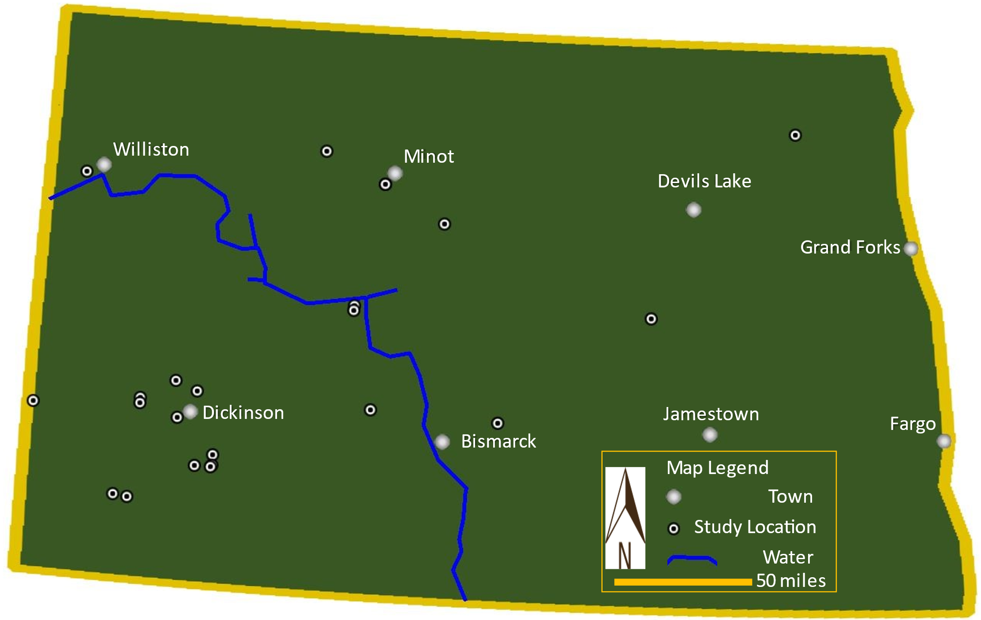
Figure 1. Location of experimental locations.

Figure 1. Lime recommendations for all site
Buffer pH | 5.5 | 6 | 6.5 | Formula* | r² | n
0-3 inch depth | -tons calcium carbonate/ac-
5.9 | 6.4 | 6.7 | 7.1 | y = 0.0591x² - 0.1216x + 4.6561 | 0.46 | 14
6.0 | 6.3 | 6.6 | 6.9 | y = 0.0563x² + 0.1153x + 4.5218 | 0.88 | 12
6.1 | 5.2 | 5.0 | 4.6 | y = -0.1334x² + 0.7616x + 4.4653 | 0.56 | 28
6.2 | 5.6 | 5.6 | 5.7 | y = -0.001x² + 0.1278x + 4.8929 | 0.37 | 31
6.3 | 5.8 | 5.9 | 6.0 | y = 0.0017x² + 0.1155x + 5.1258 | 0.06 | 25
6.4 | 6.1 | 6.2 | 6.2 | y = -0.0081x² + 0.2456x + 4.974 | 0.28 | 83
6.5 | 6.1 | 6.2 | 6.2 | y = -0.0072x² + 0.2128x + 5.1334 | 0.57 | 68
6.6 | 6.2 | 6.3 | 6.3 | y = -0.006x² + 0.1997x + 5.2846 | 0.63 | 47
6.7 | 6.9 | 7.1 | 7.2 | y = 0.0082x² + 0.2227x + 5.4131 | 0.58 | 40
6.8 | 6.7 | 6.8 | 6.9 | y = -0.0126x² + 0.3053x + 5.4265 | 0.62 | 33
6.9 | 6.8 | 6.9 | 6.8 | y = -0.009x² + 0.2318x + 5.8169 | 0.55 | 26
7.0 | 7.1 | 7.2 | 7.3 | y = -0.0153x² + 0.3289x + 5.7601 | 0.82 | 17
7.1 | 7.0 | 7.1 | 7.2 | y = -0.0183x² + 0.4107x + 5.3137 | 0.94 | 5
*"Y" is tons of lime (CCE)/ac "X" is desitered soil pH at 0-3 inch depth

Figure 2. Lime recommendations for areas west of Missouri RIver
Buffer pH | 5.5 | 6 | 6.5 | Formula* | r² | n
0-3 inch depth | -tons calcium carbonate/ac-
5.7 | Non-sufficient sample size |  |  |  |  | 1
5.8 | Non-sufficient sample size |  |  |  |  | 2
5.9 | 5.8 | 6.2 | 6.5 | y = 0.0699x² - 0.1694x + 4.6487 | 0.43 | 12
6.0 | 7.4 | 8.0 | 8.7 | y = 0.1404x² - 0.3177x + 4.8745 | 0.91 | 7
6.1 | 4.3 | 3.8 | 3.2 | y = -0.1526x² + 0.7944x + 4.5 | 0.51 | 20
6.2 | 5.3 | 5.4 | 5.4 | y = -0.0008x² + 0.1218x + 4.9175 | 0.36 | 30
6.3 | 5.4 | 5.4 | 5.5 | y = 0.003x² + 0.043x + 5.0732 | 0.05 | 19
6.4 | 6.0 | 6.1 | 6.1 | y = -0.0053x² + 0.2002x + 5.0443 | 0.47 | 49
6.5 | 6.0 | 6.1 | 6.1 | y = -0.0059x² + 0.1909x + 5.1288 | 0.60 | 41
6.6 | 6.1 | 6.1 | 6.2 | y = -0.0066x² + 0.205x + 5.1387 | 0.72 | 26
6.7 | 6.1 | 6.2 | 6.2 | y = -0.0071x² + 0.2079x + 5.1761 | 0.68 | 20
6.8 | 6.7 | 6.8 | 6.9 | y = -0.0148x² + 0.3473x + 5.2365 | 0.62 | 19
6.9 | 6.9 | 7.0 | 7.0 | y = -0.0125x² + 0.3011x + 5.5956 | 0.79 | 19
7.0 | 5.7 | 5.6 | 5.3 | y = -0.0162x² + 0.3458x + 5.7094 | 0.82 | 14
7.1 | 7.0 | 7.1 | 7.2 | y = -0.0183x² + 0.4107x + 5.3137 | 0.94 | 5
7.5 | Non-sufficient sample size |  |  |  |  | 5
*"Y" is tons of lime (CCE)/ac "X" is desitered soil pH at 0-3 inch depth

Figure 3. Lime reccomendations for areas east of Missouri River.
Buffer pH | 5.5 | 6 | 6.5 | Formula* | r² | n
0-3 inch depth | -tons calcium carbonate/ac-
5.9 | 5.5 | 5.5 | 5.5 | y = 0.1667x + 4.5333 | 0.68 | 3
6.0 | 6.6 | 6.8 | 7.0 | y = 0.0031x² + 0.3795x + 4.4141 | 0.95 | 5
6.1 | 5.8 | 5.7 | 5.6 | y = -0.0675x² + 0.6261x + 4.3921 | 0.79 | 8
6.2 | Non-sufficient sample size |  |  |  |  | 1
6.3 | 6.3 | 6.4 | 6.5 | y = 0.0012x² + 0.1389x + 5.5023 | 0.56 | 6
6.4 | 5.9 | 6.0 | 6.0 | y = -0.0035x² + 0.1456x + 5.2407 | 0.36 | 34
6.5 | 6.3 | 6.4 | 6.5 | y = 0.0115x² + 0.1321x + 5.1942 | 0.57 | 26
6.6 | 6.9 | 7.0 | 7.2 | y = 0.0071x² + 0.2216x + 5.4261 | 0.65 | 20
6.7 | 7.3 | 7.4 | 7.6 | y = -0.0093x² + 0.2259x + 5.737 | 0.60 | 19
6.8 | 6.8 | 6.9 | 6.9 | y = -0.0112x² + 0.2846x + 5.5586 | 0.65 | 13
6.9 | 2.4 | 1.1 | -0.3 | y = -0.3162x² + 1.1052x + 5.8934 | 0.79 | 7
7.0 | Non-sufficient sample size |  |  |  |  | 2
7.1 | Non-sufficient sample size |  |  |  |  | 0
*"Y" is tons of lime (CCE)/ac "X" is desitered soil pH at 0-3 inch depth

