Geddes lab final progress report to North Dakota Soybean Council:
Potential for combatting iron deficiency chlorosis with the soybean microbiome

Objective 1. Evaluate the restructuring of the soybean microbiome composition during iron deficiency chlorosis.
In summer 2021, our collaborator Dr. Carrie Miranda and her team planted and maintained four field trials throughout the state of ND designed to assess IDC contribution to the soybean microbiome through expected variable IDC response. These included Leonard, Colfax, Casselton and Prosper. At each location, four soybean varieties were planted including two IDC resistant (A11 and Rolette), and two IDC sensitive (ND16 and ND17009) varieties. Due to planting constraints at the locations, soybeans at Leonard and Colfax were grown in hill plots (Figure 1A) while plants at Prosper and Casselton were grown in rows. Plants were rated at three growth stages for IDC using a visual chlorosis rating on a 1-5 scale (1 indicates no chlorosis, 5 indicates severe chlorosis). Overall the four field sites showed a linear gradient of IDC, with Prosper showing no IDC symptoms, Colfax and Casselton showing moderate IDC symptoms, and Leonard showing strong IDC symptoms (Figure 1B). As a result these sites represented a perfect opportunity for assessing the soybean microbiome response to IDC.

When most plants were in the R1 stage of growth, rhizosphere microbiome samples were collected from plants at each of the four locations. Plants were dug and bulk soil around the roots was shaken off, with the soil directly attached to the root collected as rhizosphere soil. The rhizosphere soil was removed from the root by vortexing in a solution of 0.1M phosphate buffer with Silwet, followed by centrifugation. Overall 3 plants grown adjacent to one-another were used as an individual replicate, and 4 replicates from each variety were collected at each field location (64 total samples representing 192 total soybeans). At each location 4 bulk soil samples were also collected to allow us to measure the change in the microbiome associated with plant recruitment of microbes in the rhizosphere.

Next, we successfully optimized an in-house protocol for amplifying and sequencing of the V4 hypervariable region of the bacterial 16S gene by next-generation sequencing using the Illumina MiSeq in the Department of Microbiological Sciences. The optimized assay was used to assess the competition of the bacterial microbial community in the soybean rhizosphere and in the bulk soil at the four field locations in this study. Amplicon sequencing data was processed with Dada2 and analyzed with the Phyloseq package in R.

We first analyzed the alpha diversity of the rhizosphere microbiomes compared to the bulk soil using three different methods (Observed, Shannon and Simpson) to determine if rhizosphere recruitment was taking place in the soybeans we sampled. Overall we saw a narrowing of diversity in the rhizosphere samples compared to the bulk soil, which is consistent with selection enrichment by the soybean of specific microbes in the rhizosphere (Figure 1C). The results using each of the methods were found to be highly statistically significant using a Wicoxon rank sum test. (Observed P=0.0085, Shannon P = 0.00000079 , Simpson P = 0.000000017).

Next we analyzed the beta diversity of the rhizosphere and soil microbiomes in order to investigate the similarity of the microbial communities in each of our samples to one-another. This was done by nonmetric multidimensional scaling (NMDS) using Bray-Curtis dissimilarity. The results of the analysis are displayed in Figure 1D and 1E. In these figures, each point represents a microbial community of one sample, and the distance from other points in the graph represents the similarity (close) or dissimilarity (far) from the other samples microbial communities. The axes two unknown variables that most strongly influence the community composition. We found that the samples clustered very well according to location, and that the rhizosphere and soil samples clustered separately. Excitingly, we observed a separation of the samples across the X axis that correlated with the IDC levels at each of the field sites (Figure 1D). These data indicate that iron deficiency of the soils had a strong influence on the microbial community composition. The Y axis appeared to show the effect the soybean plants had on the microbial communities that were present in rhizosphere samples, near the root. The differences in microbial communities between each location was found to be statistically significant base on a pairwise Adonis test (P=0.001) and were able to identify specific taxa that show enrichment or depletion under IDC conditions (Figure 1F). Conversely, no clustering of samples or significant difference was observed based on soybean variety (P=0.590-0.780) (Figure 1E).

Figure 1. The soybean rhizosphere microbiome shows evidence of selection and a composition that correlates with IDC level of the soil independent of plant genotype.

Objective 2. Measure the potential for iron release by the soybean microbiome using a colorimetric Chrome Azurol S assay.
With evidence that the soybean microbiome shows a differential composition based on iron deficiency, future work to deploy microbes as a tool to alleviate IDC should focus on isolation of microbes that could be used as inoculants. Such isolation attempts are dependent on a high-throughput method for identifying microbes of interest. One of the ways microbes could solubilize iron for the plant is through the production of molecules called siderophores which function like the Soygreen fertilizer product to chelate iron in the soil and make it available for the plant. We sought to establish an assay to identify siderophore producing microbes. To do this we optimized and evaluated a Chrome Azurol S assay for its ability to identify candidate siderophore producing microbes from the high IDC (Leonard) soil. The final assay involved 1) isolation of the rhizosphere from soybean plants grown in Leonard soil as in Objective 1. 2) Plating the rhizosphere by serial dilution on TSOY agar media which is known to be highly effective at culturing plant-associated microbes. 3) Overlaying the culture plates with CAS – agar which contains the Chrome Azurol S substrate which transforms from a blue to a yellow/orange color when iron is chelated from the solution. Results from a. Successful trial are shown in Figure 2. Figure 2A shows a set of dilution plates from Leonard soil soybean rhizosphere. Orange zones are evident around colonies formed by microbes capable of siderophore production, and arrows indicate candidate microbes. Individual microbes can then be purified and verified for siderophore production using the same overlay technique as shown in Figure 2B.

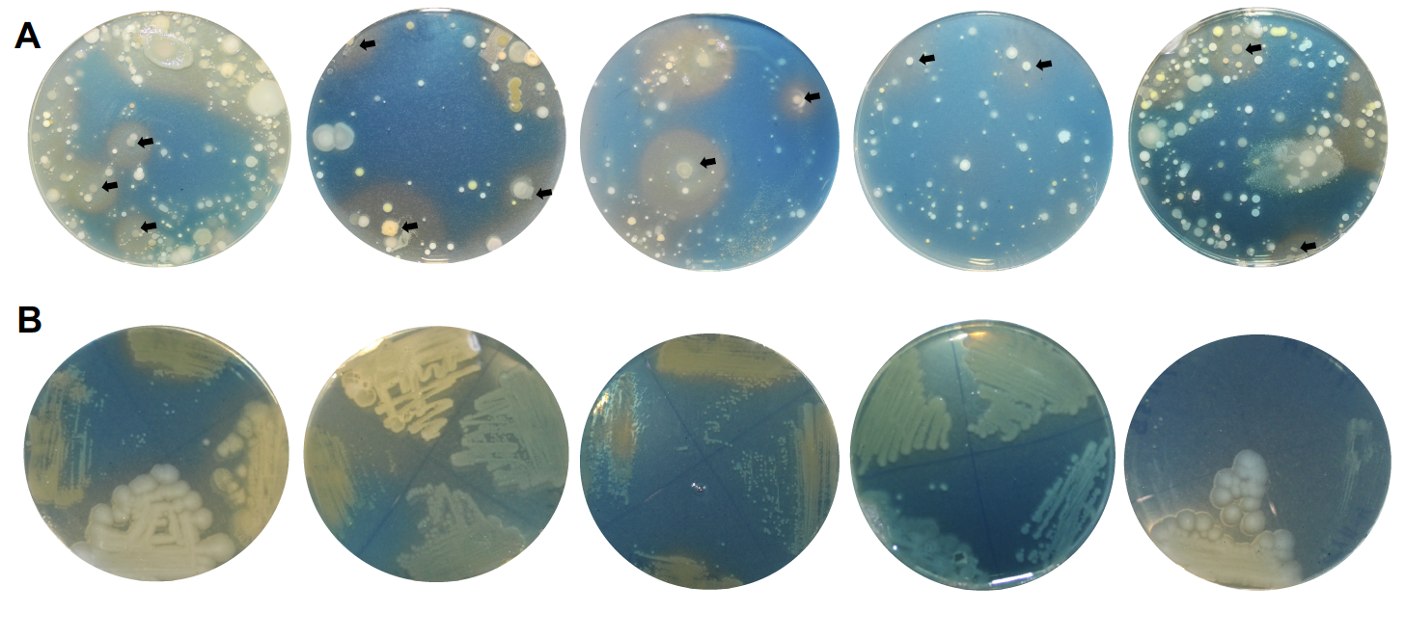
Figure 2. Examples of CAS-agar overlay plates for identifying siderophore producing microbes from the IDC soybean microbiome.

Objective 3. Optimization of a greenhouse assay for measuring reduction in IDC by microbial inoculants in soybeans.
Once candidate microbes are identified, it will be crucial to next demonstrate a benefit to the plant in a high throughput greenhouse assay before justifying field trials. To develop a suitable assay, we coordinated with Dr. Jay Goos to adapt a greenhouse IDC assay he previously developed towards measuring the microbiome effect on IDC in the greenhouse. We conducted a pilot study that included 160 soybean plants. The trial was performed with a soil that was previously optimized for this assay by Dr. Goos, and our high IDC Leonard field soil. The soybeans were first exposed to different nitrate and bicarbonate levels as these nutrients can influence levels of IDC, and data on plant growth as measured by shoot dry weight (Figure 3) and chlorosis using a SPAD chlorophyll meter (Figure 4). Overall we observed substantial chlorosis and growth reduction in all conditions tested, indicating the assay is reliable and not dependent on fertilization levels etc. to see effects. Next the chlorosis and growth penalties were shown to be IDC dependent by supplementing the 10mM Nitrate/5 mM Bicarbonate condition with the iron chelating fertilizer Soygreen at varying levels (Figure 3 and 4). Supplementation of Soygreen restored the green-ness and the growth of soybeans to robust and healthy levels. This indicates that the Leonard soil is a reliable indicator of IDC level in the greenhouse, and that growth penalties and chlorosis can successfully be reduced using soil amendments in the greenhouse assay. This sets the stage for future experiments where soils are supplemented with North Dakota microbes isolated from the IDC soybean microbiome rather than Soygreen, and should serve as a reliable indicator of these microbes potentials as products to alleviate IDC in ND field soils.
Figure 3. Growth of soybeans from optimized IDC greenhouse assay

Figure 4. Chlorosis of soybeans in optimized greenhouse IDC assay

Deliverables and benefits to farmers and researchers
Overall, we have successfully provided for the restructuring of the soybean rhizosphere microbiome composition during iron deficiency chlorosis in North Dakota soils. Observations of the combined impact of iron deficiency and the soybean rhizosphere on the soil microbial communities lend support to the possibility that these unique iron deficiency adapted rhizosphere microbiomes could be utilized in agriculture to reduce IDC. Our data also allow us to deduce a list of the identity of the microbes enriched in the soybean rhizosphere under iron deficient conditions which could be used to target the isolation of specific microbes that could contribute to plant health and resilience during IDC (Figure 1F). We have successfully developed a Chrome Azurol S assay to identify siderophore producing microbes and observed many candidate microbes from the IDC microbiome capable of siderophore production in our pilot assay. Finally we successfully adapted and optimized an IDC greenhouse assay originally developed by Jay Goos for use in screening for reduction of iron deficiency in soybeans. Together the data regarding IDC-enriched taxa, protocols for prioritizing candidate microbes for screening and a new plant assay for screening of particular microbes pave the way for harnessing the soybean microbiome recruited under iron deficiency towards reducing IDC in farmer’s fields. The two protocols have not been included in this report due to room constraints, but are available upon request.

Reliable deployment of the microbiome will take some time before benefits can be realized directly by farmers, however this project has set the stage for future work that could ultimately be translated into a microbial product that could reduce IDC using North Dakota microbes, which would be an immense benefit to North Dakota soybean farmers.

Presentations and meetings.
* Indicates presenter

Das, U.*, and Geddes, B. A. Harnessing the microbiome to combat iron deficiency chlorosis in soybean. Oral presentation and abstract presented at NDSU Student Research Day 2022, Fargo, North Dakota, USA, April 19, 2022.

Das, U.*, Towsend Ramsett, M. K., and Geddes, B. A.* Harnessing the microbiome for increased economics and resilience. Oral presentation presented at 2022 NDSU Soybean Symposium, Fargo, North Dakota, USA, May 17, 2022.

