Project Title: Improving DGLA production in soybean for pharmaceutical applications

Principle Investigator: Shaobin Zhong

Introduction

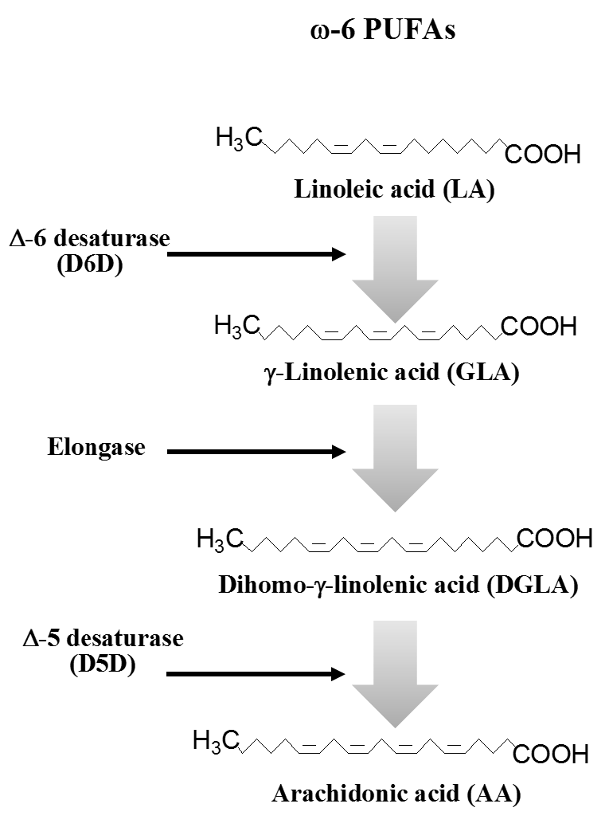
Many studies have demonstrated that ω-6 polyunsaturated fatty acids (ω-6 PUFAs), including linoleic acid (LA), gamma-linolenic acid (GLA), dihomo-gamma-linolenic acid (DGLA), and arachidonic acid (AA), play important roles in human health. LA is the main ω-6 fatty acid in the human diet. Upon taken into the human body, it can be converted to GLA by the enzyme delta-6-desaturase (D6D). GLA will then be converted into DGLA by another enzyme delta-6-elongase (D6E). DGLA is further metabolized to AA by delta-5-desaturase (D5D) (see Fig 1). Studies also indicate that arachidonic acid (AA), the downstream of ω-6 in the biochemical pathway, can generate deleterious metabolites through a series of reactions catalyzed by the enzyme cyclooxygenase (COX), thus promoting cancer invasion and growth. On the other hand, DGLA can produce a free radical byproduct (8-hydroxyoctanoic acid, 8-HOA) by the process catalyzed by the enzyme COX, and thus inhibits cancer cell/tumor growth. There are two forms of the enzyme COX: COX-1 and COX-2. COX-1 is produced by normal human tissues, while COX-2 is readily induced by all types of cancer cells. Previous studies showed that knocking down of D5D, an enzyme that mediates the conversion of DGLA into AA, promotes formation of the inhibitor 8-HOA in cancer cells, leading to halting of cancer growth and spreading. More recently, Dr. Qian’s Lab at NDSU discovered new anti-cancer drugs that can be used to effectively inhibit the enzyme D5D, leading to decrease in AA production while promoting the formation of the cancer inhibitor 8-HOA, consequently suppressing the growth and invasion of cancer cells. Therefore, a novel cancer therapy strategy can be developed by inhibiting D5D and dietary supplementation of DGLA in cancer patients.
Fig 1. Polyunsaturated fatty acid (PUFA) biosynthesis
DGLA also plays an important role in cellular senescence, a basic aging process by which cells undergo an essentially permanent proliferative arrest in response to a growing number of stressors. Senescent cells are metabolically active, releasing many secreted factors that can drive aging. In mouse models, elimination of senescent cells (senolysis) improved several age-related conditions including Alzheimer’s and Parkinson’s diseases, diabetes, hair and bone loss, blood clots, arthritis, and many other diseases. The observation that senescent cells drive age-related pathology has resulted in development of drugs called “senolytics”, that kill these cells. Dr. Wiley’s lab at the Jean Mayer USDA Human Nutrition Research Center on Aging (HNRCA) recently discovered that an endogenous lipid (DGLA) found in trace amounts in the diet can also kill senescent cells (personal communication). This research provides supporting evidence that DGLA is an important player in anti-aging process.
Unfortunately, only a few plant species (such as borage, evening primrose, black currant, liverworts, mosses) are able to synthesize GLA or DGLA, and their levels are too low to be useful for mass production. In addition, these plants are difficult to cultivate, with relatively low oil yields. On the other hand, the major vegetable oil-producing crops (sunflower, safflower, corn and soybean) produce up to 57% LA in their oil, but they are unable to synthesize GLA and DGLA due to lack of the enzymes required for their biosynthesis. As GLA-containing oils are in high demand by the nutritional supplement market, much research in the past years has focused on producing vegetable oils with significant GLA contents. With the discovery of the role played by DGLA in cancer therapy and other pharmaceutical uses, it is anticipated that the demand for DGLA will dramatically increase in near future. Soybean oil contains up to 51% LA and is the most widely used edible oil in the United States. Almost all margarine and shortenings contain soybean oil. Soybean oil is also frequently used in mayonnaise, salad dressings, frozen foods, imitation dairy and meat products and commercially baked goods. With the funding provided by ND Soybean Council for the past three years (2019-2022), we have isolated and cloned the two genes expressing the enzymes D6D and D6E required for DGLA biosynthesis, and we had introduced the two genes into soybean by gene transformation. Transgenic plants have been generated from soybean cultivar William 82 and Thorne. Fatty acids analysis showed that some of the transgenic plants produced a high level of GLA (accounting for up to 30% in the extracted oil) along with DGLA, although DGLA amount is relatively lower (accounting for up to 10% in the extracted oil). Our research showed that it is feasible to engineer soybean to produce GLA- and DGLA-enriched oil. However, further studies are required to enhance the expression of the two genes for higher DGLA production in the transgenic soybean plants. Our ultimate goal is to develop new soybean varieties that can produce DGLA-enriched oil for anti-cancer and anti-aging therapies. Therefore, the specific objectives of the current research were to:

- Develop new gene constructs to enhance expression of the gene for D6E required for converting GLA to DGLA
- Generate transgenic soybean plants with the new gene constructs
- Evaluate DGLA and other oil contents of transgenic soybean plants

Materials and Methods

Plant materials

The soybean cultivar William 82 was used for genetic transformation. This soybean variety is highly transformable and has been used in many gene transformation studies of soybean (Lee et al. 2012).

Construction of vectors for soybean transformation

We used the gene encoding the enzyme D6D in Borago officinalis and the gene encoding the enzyme D6E in Physcomitrella patens to prepare vectors for plant transformation. The cDNA sequences containing the coding gene for the two enzymes were obtained from NCBI database (GenBank: EF495160.1 for D6D and AF428243.1 for D6E). To enhance the gene expression in soybean, these two genes were codon-optimized using the soybean genome sequence and then used to make the gene constructs (vectors) for soybean transformation. The soybean β-conglycinin alpha-subunit promoter was used for driving the expression of the gene for D6D. Two different promoters (FAD2-1B and Gmubi3) were used to control expression of the gene D6E. Each gene cassette (promoter and the codon-optimized gene sequence) was synthesized by Twist Bioscience (San Francisco, CA) and then cloned into the binary vector pBAtC (Kim et al. 2016b) to make the seed-specific expression constructs pBAtC: BCA-D6D-FAD2-D6E and pBAtC:BCA-D6D-Gmubi3-D6E as shown in Fig. 2.

Soybean transformation

The two vectors, pBAtC: BCA-D6D-FAD2-D6E and pBAtC:BCA-D6D-Gmubi3-D6E, were transformed into Agrobacterium strain EHA101. The Agrobacterium strain harboring each gene construct was used to transform Williams 82 using the “half seeds method” (Paz et al, 2006). The transformation was conducted in the Plant Transformation Facility at University of Missouri, Columbus.

Molecular verification of transgenic soybean plants

To verify the transgenes in transgenic plants, DNA was extracted from seedlings of transgenic plants (T₀ and T₁). Primers designed from the coding genes for D6D and D6E were used for PCR to amplify the transgenes. DNA from non-transgenic plants was used as negative control in the PCR amplifications. The PCR products were separated in an agrose gel.

To quantify the expression of the D6D and D6E genes, RNA was extracted from individual transgenic plants and mRNA was quantified by quantitative real-time PCR.

Fatty acid analysis

To determine the fatty acids compositions, the seeds or soybean oil extracted from seeds of transgenic plants were sent to SDS (Brookings, SD) or Creative Proteomics (Shirley, NY) for fatty acids profiling. Fatty acid composition was analyzed by gas chromatography (GC) with flame ionization detection.

Results and Discussion

In a previous study, we used the same promoter (beta-conglycinin alpha subunit gene promoter) to drive the expression of both D6D and D6E genes in the vector pBAtC:Soybean-H1. When this vector was used to transform the two soybean cultivars Williams 82 and Thorne, we obtained transgenic plants from both varieties. Fatty acids analysis of T₁ seeds from some of the T0 plants showed that GLA content accounted for up to 33.3% in the soybean oil, suggesting that the D6D gene is expressed efficiently in the transgenic soybean plants. DGLA content ranged from 0 to 10.25% among the samples tested. This result indicated that the expression level of the gene for D6E varied among different transgenic plants.

To further test if other promoters could improve the expression of D6E gene and enhance DGLA production, we developed two new gene constructs (pBAtC: BCA-D6D-FAD2-D6E and pBAtC:BCA-D6D-Gmubi3-D6E) (Fig. 2). The beta-conglycinin alpha subunit promoter was used to drive the expression of D6D in each of the gene constructs. For D6E expression, two different promotors, FAD2-1B and Gmubi3, from soybean were used in the two binary vectors (Fig. 2). FAD2-1B is the promoter for the gene encoding the fatty acid desaturase-2 enzyme (FAD2-1) responsible for the conversion of oleic acid to linoleic acid in the developing soybean seeds whereas Gmubi3 is the promoter for one of the gene families encoding ubiquitin. We introduced pBAtC: BCA-D6D-FAD2-D6E and pBAtC:BCA-D6D-Gmubi3-D6E into the Agrobacterium strain EHA105 for soybean transformation. A total of 10 T0 plants and 7 T0 plants were generated from Williams 82 using pBAtC: BCA-D6D-FAD2-D6E and pBAtC:BCA-D6D-Gmubi3-D6E for transformation, respectively. Seven and five of the T0 plants derived from the genetic transformation with the two gene constructs were analyzed for presence of the transgene by PCR and all were positive for the transgene. The T0 plants were grown in the greenhouse and T1 seeds were harvested for fatty acids profiling. Eight of the T1 seed samples were analyzed for fatty acids, however, no DGLA was detected in any of the samples tested. We used qPCR to quantify the mRNA expression and found most of the T1 plants from these two vectors showed a very low level of D6E expression although the D6D expression was normal. This may be the reason that no DGLA was detected in those samples evaluated. We will test the GLA and DGLA contents of those T1 seeds which showed a high level of D6E expression.

In summary, we generated transgenic plants from soybean cultivar William 82 using two new gene vectors with the same promoter (beta-conglycinin alpha subunit gene promoter) for expression of D6D and two different promoters for expression of D6E. The transgenic plants were generated and gene expression analysis were conducted. No DGLA was detected in some of the transgenic plants that have been analyzed for fatty acids. Further research is needed to test the other T1 seed samples with a high expression of D6D and D6E.

Major references

Gu et al. 2013. The first characterization of free radicals formed from cellular COX-catalyzed peroxidation. Free Radic Biol Med. 57: 49-60.

Haslam et al. 2013. The modification of plant oil composition via metabolic engineering—better nutrition by design. Plant Biotechnology Journal. 11:157-168.

Jofuku et al. 1989. Kunitz trypsin lnhibitor genes are differentially expressed during the soybean life cycle and in transformed tobacco plants. The Plant Cell 1:1079-1093.

Kim et al. 2016a. Metabolic engineering to produce c-linolenic acid in Brassica napus using a D6-desaturase from pike eel. Plant Biotechnol Rep. 10:475-481.

Kim et al. 2016b. A simple, flexible and high-throughput cloning system for plant genome editing via CRISPR-Cas system. J Integr Plant Biol. 58:705-712.

Lee et al. 2012. An Overview of Genetic Transformation of Soybean. In: Board JE (ed) A comprehensive survey of international soybean research—genetics, physiology, agronomy and nitrogen relationships. INTECH Open Science, Rijeka, pp 489–506.

Liu et al. 2015. Cyclooxygenase-2 promotes tumor growth and suppresses tumor immunity. Cancer Cell Int 15:106.

Nykiforuk et al. 2012. High level accumulation of gamma linolenic acid (C18:3D6.9,12 cis) in transgenic safflower (Carthamus tinctorius) seeds. Transgenic Res. 21:367–381

Paz et al. 2006. Improved cotyledonary node method using an alternative explant derived from mature seed for efficient Agrobacterium-mediated soybean transformation. Plant Cell Rep. 25:206–213.

Qian et al. 2019. Compound for inhibition of delta-5-desaturase (d5d) and treatment of cancer and inflammation. US. Patent 20190070193.

Wang et al. 2012. Multiple roles of dihomo-g-linolenic acid against proliferation diseases. Lipids in Health and Disease. 11:25

Xu et al. 2014. Free radical derivatives formed from COX-catalyzed DGLA peroxidation can attenuate colon cancer cell growth and enhance 5-FU’s cytotoxicity. Redox Biology. 2: 610-618.

Xu et al. 2016. Knockdown of delta-5-desaturase promotes the anti-cancer activity of dihomo-γ-linolenic acid and enhances the efficacy of chemotherapy in colon cancer cells expressing COX-2. Free Radic Biol Med. 96:67-77.

Xu et al. 2018a. Knockdown delta-5- desaturase in breast cancer cells that overexpress COX-2 results in inhibition of growth, migration and invasion via a dihomo-γ-linolenic acid peroxidation dependent mechanism. BMC Cancer. 18:330.

Xu et al. 2018b. Dihomo-γ-linolenic acid inhibits xenograft tumor growth in mice bearing shRNA-transfected HCA-7 cells targeting delta-5-desaturas. BMC Cancer. 18:1268

Yang et al. 2016. Knockdown delta-5-desaturase promotes the formation of a novel free radical byproduct from COX-catalyzed ω-6 peroxidation to induce apoptosis and sensitize pancreatic cancer cells to chemotherapy drugs. Free Radic Biol and Med. 97: 342-350.

Yang et al. 2019. Dihomo-γ-linolenic acid inhibited growth of xenograft tumor in mice bearing human pancreatic cancer cells (BxPC-3) transfected with delta-5-desaturase shRNA. Redox Biol. 20:236-246.

Yoshino et al. 2006. The regulatory function of the upstream sequence of the beta-conglycinin alpha subunit gene in seed-specific transcription is associated with the presence of the RY sequence. Genes & Genetic Systems 81(2):135-141.

