Soil Health and Agriculture Research Extension (SHARE) Farm Research Projects in Mooreton, ND and Logan Center, ND
2022 Technical Report Submitted to the North Dakota Soybean Council

Principal Investigators: Abbey Wick, Caley Gasch, Aaron Daigh, Marisol Berti, Greg Endres, Naeem Kalwar, North Dakota State University

1. Introduction
The Soil Health and Agriculture Research Extension (SHARE) Farm project started with the original location in Mooreton, ND (2013) and expanded to a second location in Logan Center, ND (2019). Monitoring of the Mooreton site ended at the end of the 2021 cropping year, and intensive sampling was carried out. Research will continue at the Logan center site.
Each site is unique in soil type, crop rotation and climatic challenges. Both SHARE Farms provide opportunities for field-scale, long-term research associated with goals originally assigned to the project by commodity council members. Field-scale research means that cooperating farmers are heavily involved in each project, using their equipment to plant, harvest, and manage the location. Research is then conducted by NDSU using sampling and analytical approaches suited to the field variability associated with the projects. Long-term sites have high value when assessing how a combination of soil health management approaches can be used to achieve on-farm goals. After all, soil health does not change quickly and issues, such as salinity found at both sites, can take time to remediate. Multiple faculty members from NDSU’s main campus and Research Extension Centers have come together to assess systems at each SHARE Farm location. This allows us to make science-based recommendations to farmers interested in adopting soil health building practices that can be relatively high risk and require specification to each system.

2. Objectives
- Evaluate field-scale soil moisture and temperature under no-till and conventional tillage practices
- Evaluate field-scale cover crop establishment, crop yield, and soil dynamics under (a) no-till/cover crop and (b) conventional tillage/no cover crop treatments
- Evaluate changes in soil properties under (a) no-till/cover crop and (b) conventional tillage/no cover crop treatments.
- Evaluate changes in soil properties and crop productivity in (a) tile drained and (b) conventional undrained fields.
3. Methods
At both sites, the majority of each field was under no-till management with cover crops planted each year. At the Mooreton site, “conventional” tillage strips (fall chisel plow and spring field cultivation) were in place for four growing seasons. Strips are replicated three times in the tile drained (TD) portion of the field, as well as three times in the un-drained (UD) part of the field. Due to wet field conditions in fall 2019, vertical tillage was required in spring 2020 to correct equipment ruts in the UD portion of the field at the Mooreton location. At the Logan Center site, three replicate conventional tillage strips (high speed disk in spring 2019 and 2020, followed by fall chisel plowing 2020 and spring field cultivation in 2021 and 2022) were established at the field’s inception. At both locations, these strips traverse the entire length of the field [Figure 3.1], capturing a range of soil and crop conditions. Sampling and monitoring of crop and soil properties occurs at established locations distributed across the fields and spanning the management system treatments.

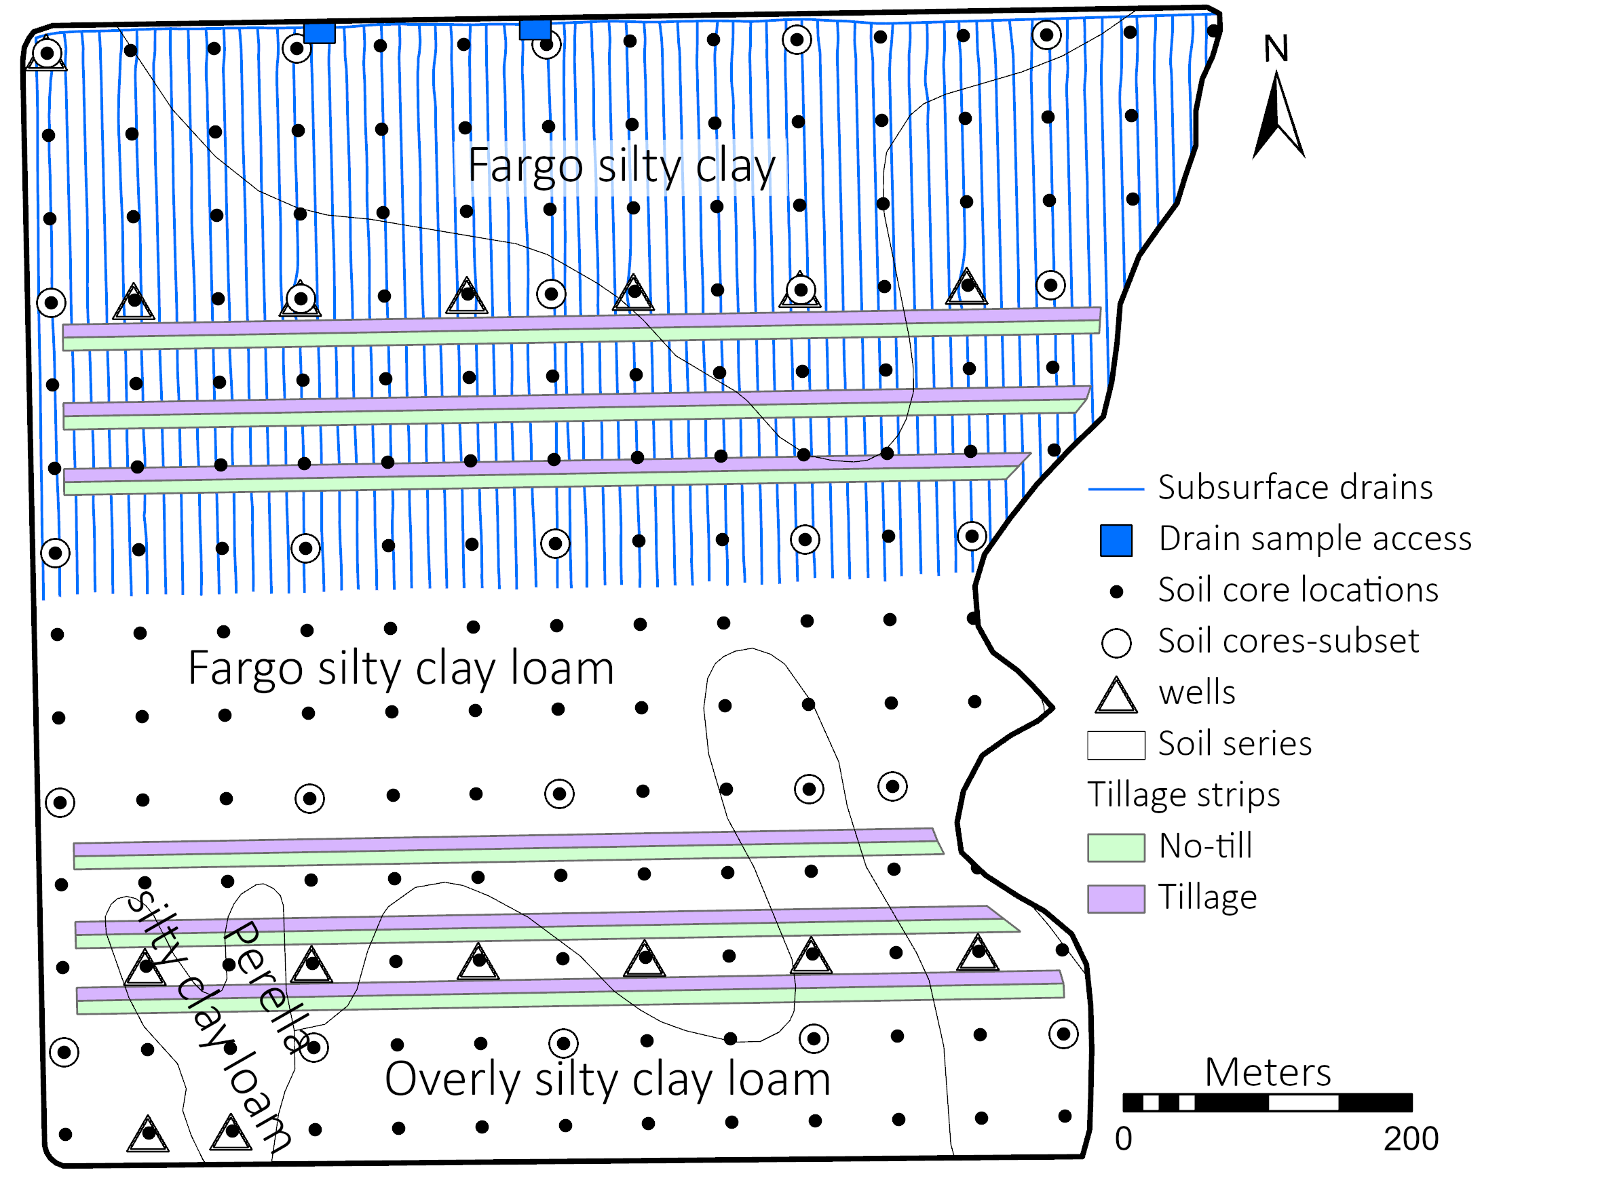 Figure 3.1. Map of the Mooreton site showing the layout of the tillage treatments, grid sampling locations, well placements, and drain tile layout.

The Mooreton site was managed under a corn-wheat-soybean rotation, ending on wheat during the 2021 cropping year. In 2022, barley was planted at the Logan Center site as part of the dry bean- corn-soybean-small grain rotation. At both sites, various cover crop mixes were planted several years of the study, including bio-strip till, inter-seeding between corn at V6-8 growth stage, aerial application into soybeans at leaf drop, and broadcast application after wheat harvest.
Research regarding soil water dynamics and drainage were also carried out at the Mooreton location. On the North 29 ha of the field, tile drainage was installed approximately 1.2 m below ground surface at 12 m spacing. To monitor the impact of the tile drainage, 15 groundwater observation wells were installed to a depth of 245 cm along two transects and at two other points of interest in the field [Figure 3.1]. These wells were monitored for water table depth and ground water composition.
Research activities were coordinated with the farmer cooperators at each location, making it seamless for research activities. Each site was continuously monitored for soil temperature and moisture at 5 cm and 15 cm. soil depths. Additionally, crop emergence and yield along with cover crop establishment and biomass were measured at both sites. At the time of establishment of each site, soil health parameters, salinity, and fertility were measured as a baseline. Each year, samples were taken to monitor changes in salinity and fertility. At the end of the 2021 cropping season, the Mooreton SHARE Farm was sampled one last time for soil health parameters, soil salinity, soil fertility, and groundwater composition to complete the study at this location.

4. Results
4.1. Soil Temperature and Water Content
The no-till treatments at each site exhibited less daily temperature fluctuation compared to the tilled treatments, especially at the 5 cm depth. Additionally, no-tilled soils also exhibited lower average temperatures at both 5 and 15 cm depths compared to the conventionally tilled treatments, helping to prevent heat induced plant stress. For example, on June 4th, 2021 at Logan Center, the soil temperature 5 cm deep was 31℃ (87℉) in the tilled treatment and 28℃ (82℉) in the no-till. These differences were attributed to the abundant surface residue in the no-tilled treatments which insulate the soil against extreme daily temperature fluctuations.
The no-till systems generally have a higher volumetric water content compared to the tilled systems. These moisture differences were most notable at the 5 cm depth [Figure 4.1], this is also attributed to the increased amount of surface reside limiting evaporation form the soil surface.

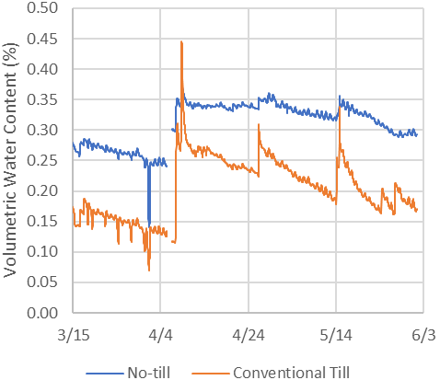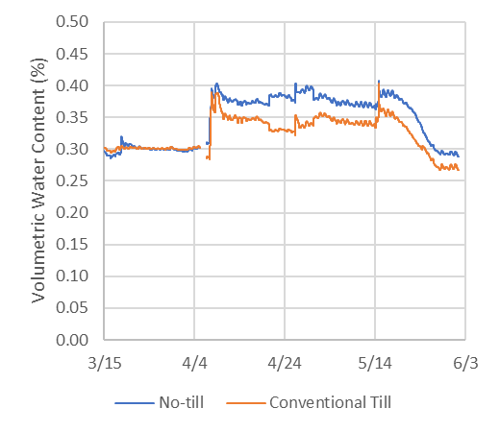
Figure 4.1. Volumetric water content of the soil in no-till versus conventionally tilled systems at 5 cm (left) and 15 cm (right) at the Mooreton site in the tile drained treatment during the 2021 growing season.

4.2. Soil Salinity
Average deep electrical conductivity (EC) decreased over the study period on the north, TD, half of the field while the EC on the south, UD half stayed relatively unchanged and slightly higher than the TD. The EC map for 2021 shows a marked decrease in EC on the TD half relative to 2013 [Figure 4.2].
Figure 4.2. Maps of apparent EC for 0-0.9-m depth measured with Veris cart EC mapper in 2013 and 2021. The chart shows yearly averages and linear regressions of Veris EC from the north (drained) and south (non-drained) sides of the field.
4.4. Water Table Management
The groundwater EC decreased 0.5 and 0.3 dS m⁻¹ y⁻¹ for TD and UD, respectively. Groundwater EC and ion concentrations decreased over time for TD, and to a lesser extent, UD. Water table levels increased slightly for TD but increased more for UD, where high water table caused wet soil conditions resulting in yield reduction in several years. Subsurface drainage at this site resulted in reduced salts in the soil profile, lower water table level, and higher corn and soybean grain yields compared to the area with no subsurface drainage.

4.5. Crop Productivity
At the Mooreton location, wheat yields increased over time at similar rates in the TD and UD areas. Soybean yield increased 180 kg ha⁻¹ for TD and 60 kg ha⁻¹ for UD. Corn grain increased slightly from 2016 to 2019 for TD, but decreased by 6200 kg ha⁻¹ from 2016 to 2019 for UD due to wet soil conditions. No statically significant differences between the tillage treatments were noted.
In 2020, the corn yield at the Logan Center site was statistically higher in the conventional till (9922 kg ha⁻¹) compared to the no-till treatment (9105 kg ha⁻¹); however, in 2019 and 2021, there were no differences between pinto bean and soybean yield in either tillage treatment.
The productivity of the cover crop at each site was highly dependent crop type, planting method, and most importantly weather conditions. Generally, broadcast cover crops had a lower rate of establishment compared to those interseeded or drilled.

5. Conclusions
- Tile-drainage can help to reduce soil salinity.
- Soil temperature is, on average, lower and has less daily fluctuation in no-tilled as compared to conventionally tilled systems.
- No-till systems help to increase soil volumetric water content under most conditions.
- No-till systems have a slightly lower or non-significant yield differences compared to conventionally tilled systems.

An important factor for farmers adopting soil health building practices to consider is the variability of soil water and temperature dynamics under various tillage practices, with differences being more predominate in coarser textured soils. The coarser textured soils at the SHARE Farm in Logan Center could have greater differences in temperature and moisture conditions and subsequent crop yield response for the tillage treatments. Experience at Mooreton has also indicated that cover crop establishment is highly dependent on current crop, timing and seeding method. Further research should continue to provide guidance on when and how to best incorporate cover crops into these crop rotations.

