Technical Report
Project Title: Cost-Effective Soy-Based Garden Pots
Sponsor Agency: North Dakota Soy Council (NDSC)
Award Date: July 1, 2020 – June 30, 2021. No-Cost Extension up to December 31, 2021
PI(s): Nita Yodo, Chiwon Lee, and David Grewell, North Dakota State University

1. Project Summary
This work developed novel bioplastic formulations that incorporated soy-based fractions to improve the performance of garden pots while being cost-competitive. The new soy-based pots are fully biobased, degradable, provide inherent fertilizer for plant growth, and also reduced root circling. The measurable objectives this research accomplished were:
- Tested plant health and yield with containers produced from four formulations for two months in the North Dakota State University (NDSU) greenhouses
- Determined degradation rates for the containers produced from the various formulations.
- Performed techno-economic analysis (TEA)

2. Methodology

2.1 Pots Formulations
Two soy-based pots formulations with different compositions of soy-hulls, soy protein isolate (SPI), and polylactic acid (PLA) were molded into 3" garden pots. These new formulations are compared with existing garden pots. The four types of pots studied were:
- Plastic: Control (Polyethylene) Purchased from a commercial source
- SelfEco: Existing formulation from SelfEco
- New Formulation 1 (70% PLA + 30% soy hulls)
- SNew Formulation 2 (65% PLA + 30% soy hulls + 5% SPI)

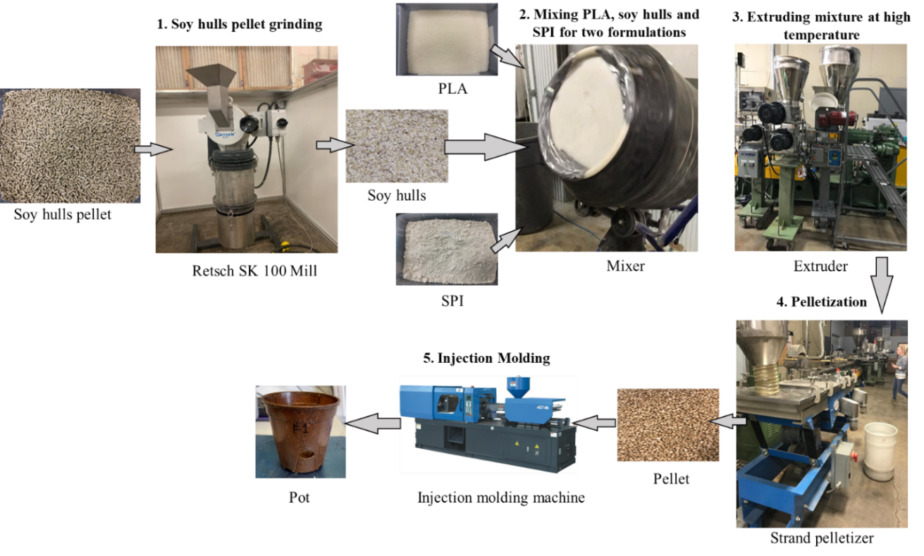
Figure 1. Process breakdown of the pots formulation
The overall activity to obtain the new garden pot formulation is shown in Figure 1. Step 1 was completed in NDSU Industrial and Manufacturing Laboratory, Step 2 – Step 4 was accomplished in C2Renew Facilities,
and Step 5 was performed by SelfEco.

Step 1 Raw Materials. Polylactic acid (PLA) was obtained from NatureWorks, and soy hulls from Carrington Research Extension Center and NDSU Northern Crops Institute (NCI) Feed Production Center. The PI(s) had SPI in hand. Soy hulls were first ground to granular size using a Retsch SK 100 mill machine to an approximately average diameter of 100 µm before compounding with the plastic.

Step 2-4 Pelleting. The pelleting process was completed in collaboration with C2Renew (Fargo, ND) in January 2021. The PLA, soy hulls, and SPI were dried in an oven for 12 hours and air-dried for an additional day. According to prespecified proportions, PLA and soy hulls were mixed thoroughly and uniformly by a mixer for approximately 10 minutes for Formulation 1. Similarly, PLA, soy hulls, and SPI were combined using the mixer for Formulation 2. In the following step, an extruder was used to blend all ingredients of both formulations at high temperatures. The three zones had temperatures varied from 280F to 330F for both formulations. The extruded strands were then pelletized into 3 mm lengths. (Figure 2). The pellets were then forwarded to SelfEco in February 2021 for injection molding to produce the 32 pots of each formulation.
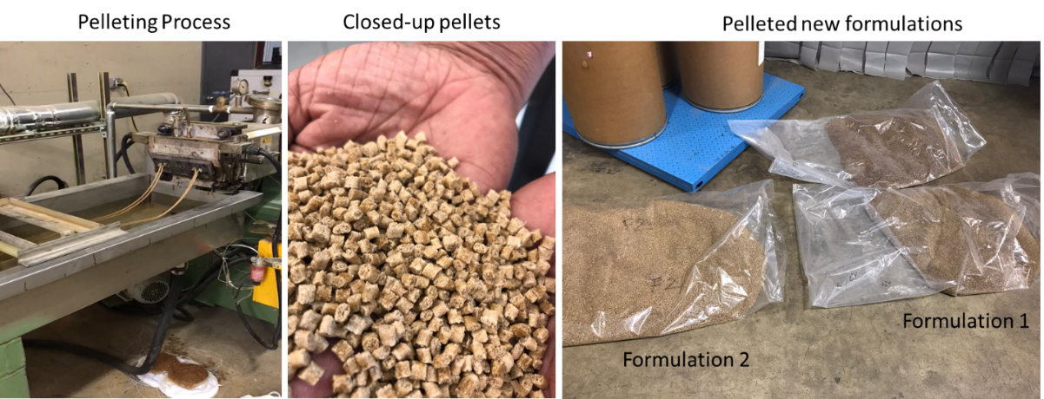
Figure 2. Snapshots from the pelleting process

Step 5 Molding. After multiple attempts on molding, the 3" pots were eventually molded. The standard pot size initially planned was 4". However, the pot sizes had to be reduced to achieve a higher quantity of molded pots because some formulation was sacrificed during the trial molding process.

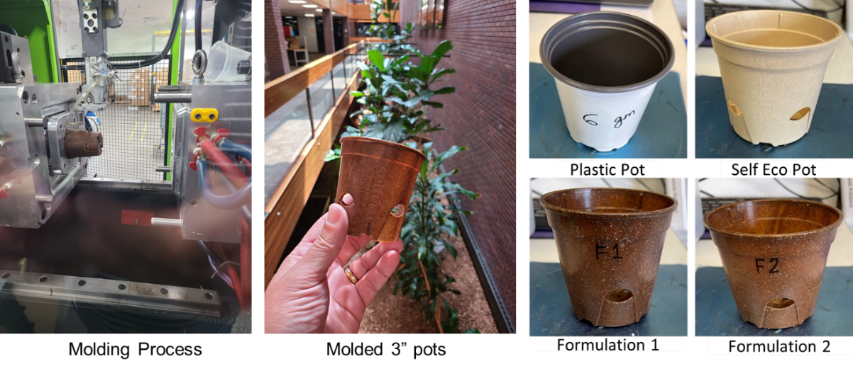
Figure 3. Snapshots from the molding process and the four pots

2.2 Plant Growth Assessment
The Department of Plant Sciences at NDSU tested the performance of selected horticultural crops in the four different formulations of garden pots. Plants to be tested include 1) non-fruit bearing vegetables (various lettuce), 2) fruit-bearing vegetables (tomato), and 3) floricultural crops (zinnia, french marigold).

Growing Medium and Fertilizer. Pro-Mix BX medium (with microbial fungicide) by Sun Gro® Horticulture was used as a growing medium for all plant types. A water-soluble fertilizer, Jacks 20-20-20 General Purpose, was used with water to prepare a 200ppm solution for providing plant nutrient elements. The fertilizer mixed water was regularly applied to the growing medium from planting the seeds to harvesting.

Plant Species. Five plant species were selected for this study based on the availability and the allowable experimental time. Seedlings of the plant species were transplanted into the four types of pots. The five plant species for this experimental study were:
- Black Seeded Simpson Lettuce - Non-fruit bearing vegetables
- Tacitus R2 Lettuce - Non-fruit bearing vegetables
- Zinnia - Floricultural crops
- French Marigold - Floricultural crops
- Sheyenne Tomato - Fruit-bearing vegetables

Growth Experiment Procedure. Seeding, transplantation, visual growth inspection, stringing, harvesting, and plant growth measurement methods were the major chronological activities in the plant cultivation step, as shown in Figure 4. Each of these activities is discussed as follows.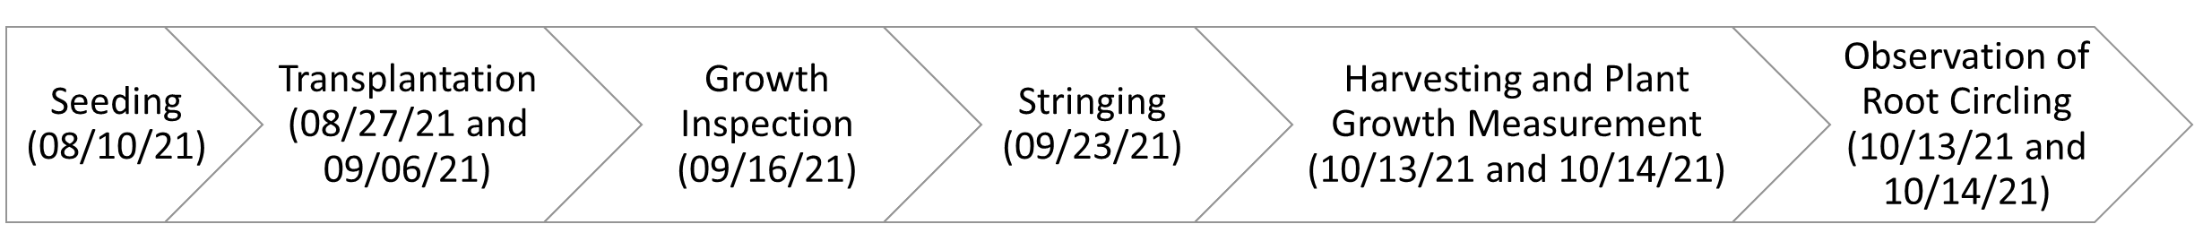
Figure 4. The activities involved in plant cultivation

Procedure 1. Seeding. Seeds for all five plant species were planted in 4-cell plastic plant seed trays at Plant Science Horticulture Greenhouse, NDSU, on August 10, 2021. The conditions of the growing medium and the seedlings' growth were monitored frequently. Seeds were grown in these 4-cell plastic plant seed trays for four weeks before being transferred to four types of 3-inch garden pots.

Procedure 2. Transplantation. After approximately four weeks of seedling growth in plastic trays, the plants were transferred to four plantation pots on two different dates: Black Seeded Simpson Lettuce on August 27, 2021, and Tacitus Lettuce, Zinnia, French Marigold, and Sheyenne Tomato on September 06, 2021. A total of sixteen seedlings are grown in the four-pot types for a plant species. However, two seedlings of the Black Seeded Simpson Lettuce plant were transplanted in every formulation of the pot, for a total of eight seedlings. Thus, a total number of 72 plants were grown in the NDSU Plant Science Horticulture Greenhouse.

Procedure 3. Growth Inspection. The plant growth, the growing medium, and water requirements were inspected regularly. Plants were periodically watered with the fertilizer mixed in the water. After three weeks of the transplantation, the following observations were made on the growth of the plants: all five plant species grew well, no visual difference in plant growth in different pots for each plant species, and no sign of plant disease. Three weeks after the transplantation, the appearance of the plants is captured and given in the following figures. The visual growth investigation for the four other plant species is shown in Figure 5.
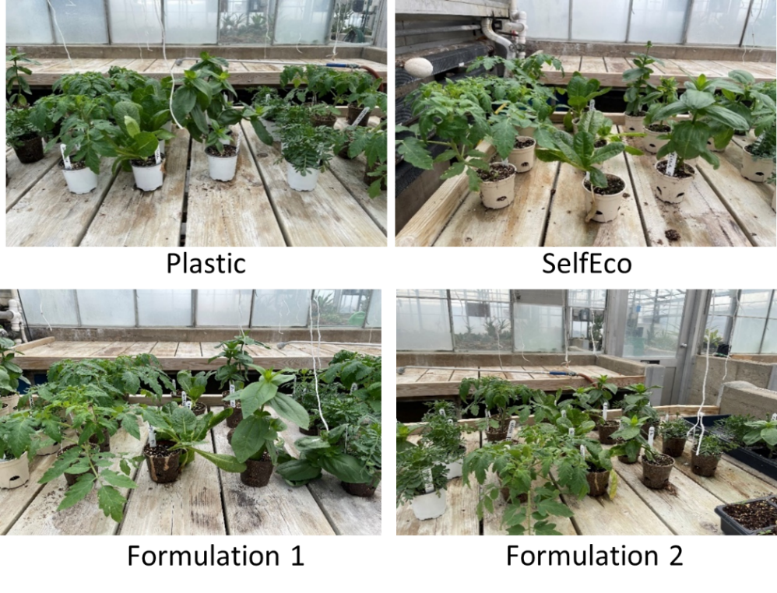
Figure 5. Photograph of visual growth inspection of Tacitus Lettuce, Zinnia, French Marigold, and Sheyenne Tomato

Procedure 4. Stringing. After four weeks of the transplantation, three plant species (Tomato, Zinnia, and Black Seeded Simpson Lettuce) grew too high to be supported by 3" pots. To provide structural support for climbing and carrying the weight of the stalks and stems, the plants of Black Seeded Simpson Lettuce, Zinnia, and Sheyenne Tomatoes were supported with a string (strining) on September 23, 2021. The stringing was not necessary for the other two plant species.

Procedure 5. Harvesting and Plant Growth Measurement. After approximately a 7-week of Black Seeded Simpson Lettuce transplantation and a 6-week of other plant species transplantation, the plant health measuring parameters and root circling were analyzed. In the plant growth assessment, both fresh and dry conditions were considered. The measurement parameters include plant height, plant width, shoot fresh weight, and shoot dry weight, fresh root weight, root dry weight. Plant growth was evaluated by employing destructive analysis, which involves removing the pots, separating root and shoot, and washing away the soil from roots. Then, the plant part that grows above the ground is separated from the roots. Also, the height and width of the fresh mass were recorded immediately (Figure 6).
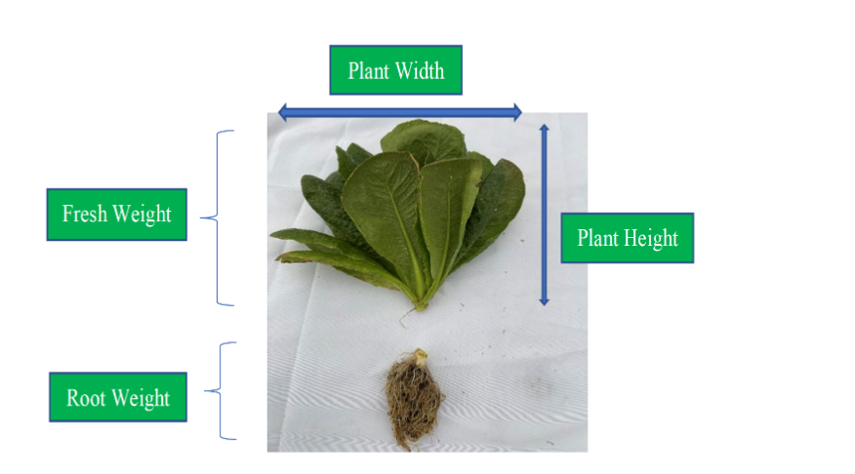
Figure 6. Measurement parameters for plant growth assessment (Tacitus Lettuce, 10/13/2021)
Procedure 6. Observation of Root Circling. It is important to note that each plant was exposed to a limited amount of growing medium because a constant pot size was used. Because of this, as a plant grows and the root ball tries to expand beyond the pot size, root hairs of the plant circle around the inner surface of the pot, and this condition of the root hairs is called root circling. Root circling often creates a root girdling problem, where one or more roots completely or partially encircle the stem and may cause bark and wood compression. These experiments were conducted to observe the root circling condition for all plant species and pot types.

2.3 Degradation Analysis
Monitoring the weight reduction of bioplastics is one of the most practical methods of evaluating their biodegradability. By measuring the dry weight of a pot before plantation and after harvesting, each pot's degradation or weight loss percentage (%) can be determined by using Eq. (1).

$$Weight loss \left(\%\right)= \frac{W_{i}-W_{f}}{W_{i}}×100 (1)$$

where, $W_{i}$ is the dry weight of a pot before starting the experiment and $W_{f}$ is the dry weight of the same pot after harvesting, washing, and drying the pot. The degradation assessment of the novel bioplastic pots is one of the objectives of this project. Formulation 1, Formulation 2, and SelfEco pots are biodegradable, but plastic pots are not biodegradable. For this reason, plastic pots are not taken into consideration for degradation assessment.

3. Results and Discussion
Statistical Analysis. One-way statistical analyses using Analysis of Variance (ANOVA) were performed for each plant growth measurement parameter to find if any pot type is responsible for significantly different plant growth. The pot type was considered a factor (categorical variable) in the analysis. The types of pots (Plastic, SelfEco, Formulation 1, and Formulation 2) were set as the four levels. For each plant growth measurement parameter, the response variable, the null hypothesis was the average measure of the response value is the same for all pot types. The alternative hypothesis was at least one pair of pot types whose average response values are significantly different.

The level of significance used in this analysis is 5% (0.05), or 95% confidence level. The null hypothesis will be rejected if the P-value associated with the analysis is lower than the significance level. If the results fail to reject the null hypothesis, it can be concluded that the average response value is the same for all types of pot. If the results reject the null hypothesis and accept the alternative hypothesis, this concludes that there is a significant difference for at least two types of pots. In this case, additional posthoc analysis, Tukey analysis, was performed to determine which pot type pairs have significantly different average response values.

Based on statistical analysis, the performance of the new two formulations in plant health and biodegradability was found to be superior to other pots in certain plant types and plant health measurements. Although new formulations pots (including SelfEco pots) are biodegradable and plastic pots are non-biodegradable, the plant health of all five plant species for new formulations can be deemed as competitive with traditional plastic pots. Due to space limitations, the results will be elaborated only for the Zinnia plant.

3.1 Zinina Plant Growth Assessment
A bar chart presentation of the average values of the measurement variables for all pot types for the Zinnia plant is shown in Figure 7. The one-way statistical ANOVA for each plant growth measurement variable and Turkey pairwise comparison results for only plant height are shown in Table 1.

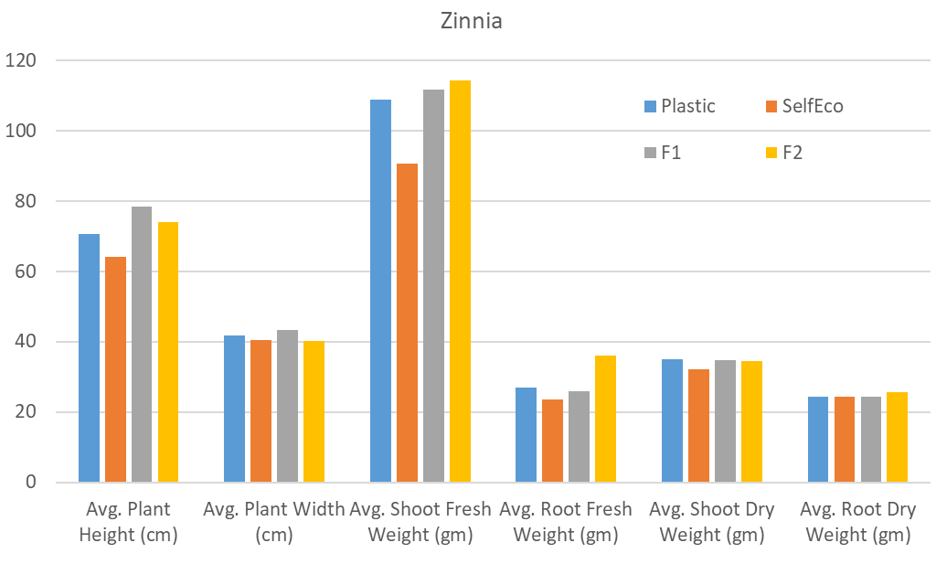
Figure 7. Bar chart for measurement variables of Zinnia

Table 1. One-way ANOVA analysis and Turkey pairwise comparison result for Zinnia
Serial No. | Response variables for one-way ANOVA | P-value | Tukey pairwise comparison
1 | Plant height | 0.031 | 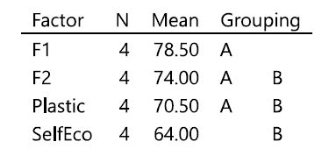
2 | Plant width | 0.825
3 | Shoot fresh weight | 0.239
4 | Root fresh weight | 0.313
5 | Shoot dry weight | 0.403
6 | Root dry weight | 0.644

Discussion. From Table 1, the P-value for the plant height response variable was found to be less than the level of significance (5%). Therefore, it can be concluded that there exists at least one pair of pot types whose response values are significantly different. For posthoc analysis, the Tukey pairwise comparison result is also shown in Table 1. From the Turkey pairwise comparison, it can be concluded that Formulation 1 (Group A only) significantly outperforms SelfEco (Group B only) in terms of plant height measurement. Formulation 1 has a mean Zinnia plant height of 78.50 cm, whereas SelfEco pots have a mean Zinnia plant height of only 64 cm. In contrast, the rest of the measures were found to be insignificantly indicated by the results that showed that Formulation 2 and Plastic pots belong to Group A and B.

3.2 Root Circling Assessment
From the visual analysis of plant roots, it can be summarized that the root circling condition was prevalent for root-bound plants. Particularly for the case of Sheyenne Tomato and French Marigold, irrespective of the pot type used for plantation, the root circling condition was observed. But the roots taken from bioplastic pots tend to show less root circling than the roots taken from plastic pots. As evidence, the root circling condition for the Black Seeded Simpson and French Marigold plant is shown in Figure 8. In summary, from the experimental outcomes, the proposed biobased formulations reduced root circling in addition to achieving biodegradability.

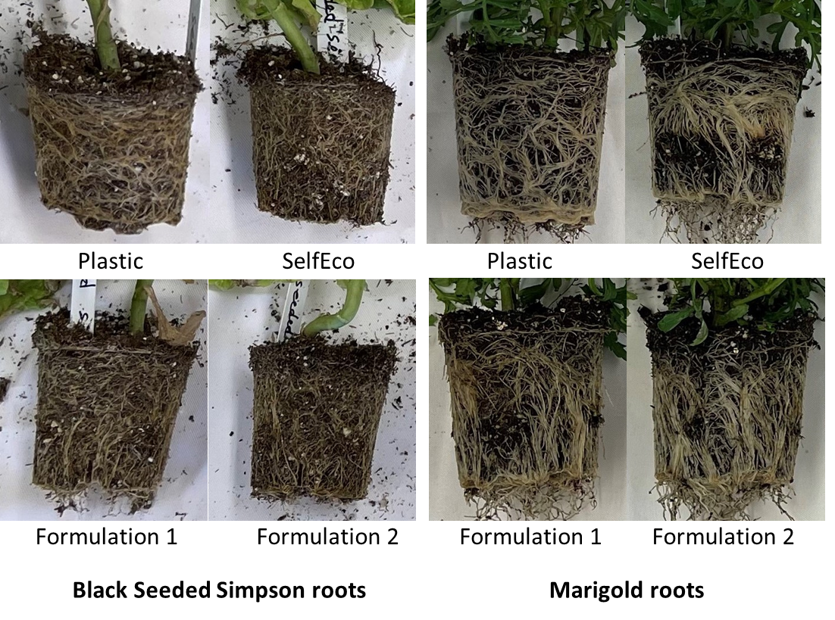
Figure 8. Root Circling Observation for Black Seeded Simpson and Marigold

3.3 Degradation Analysis
After harvesting, all pots were cleaned and oven-dried for 24 hours at 100ºC before conducting the degradation analysis. Weight loss (%) was measured using Eq. (1), same with the trial experiments. From the calculation, the average weight loss (%) for SelfEco, Formulation 1, Formulation 2, and SelfEco pot is found to be 2.815%, 3.12%, and 5.64%, respectively. Formulation 2 pots had the highest decomposition rate, and the SelfEco pots had the lowest decomposition rate throughout the cultivation. The degradation rate of Formulation 2 was approximately two times of SelfEco pot degradation. In addition, the degradation rate of Formulation 1 was about 10% more than the degradation rate of SelfEco pots. In terms of plant health and degradability, the performance of both proposed formulations is superior to SelfEco pot.

3.4 TEA Analysis
A preliminary techno-economic analysis (TEA) was performed to compare the degradation rate, market price, and their ratio. The results for all four pots, which are plastic pots, SelfEco, Formulation 1, and Formulation 2, including the paper pots from the trial experiment, are shown in Figure 9. The market price for paper and plastic pots was based on the purchased price during the project. The commercial or retail price should be much economical. Because there is no price tag for the new formulations pots, it was assumed to follow the SelfEco pots market price. The estimated market price for the new formulation may need additional analysis because the production processes have not been streamlined at this stage of development.

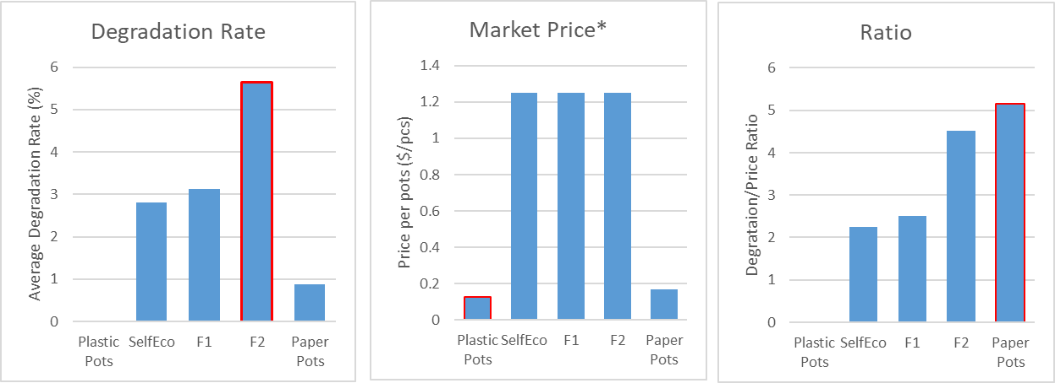
Figure 9. Comparison of degradation rate, market price, and the ratio of the five pots studied

From the TEA analysis, it was found that Formulation 2 (F2) is superior in terms of degradation rate. However, plastic pots are still dominating the low-cost market price. Comparing the ratio between degradation rate and market price, paper pots are found to be the most favorable option for now. It should be noted that Formulation 2 pots can be the next potential alternative, considering there is no additional disposal cost of waste and biobased pots promote better plant health.

4. Conclusions
Overall, the performance of soy-based pots Formulation 1 and Formulation 2 in terms of plant health and biodegradability are found to be better than plastic and SelfEco pots in several cases. On the other hand, the plant growth measurement parameters for the new formulations were found not to be significantly different from the plant growth in the plastic pots. On the other hand, the biodegradability of the new pot formulations can be deemed as a unique characteristic compared to plastic pots. One last advantage of the proposed formulation is the proposed bioplastic-based formulation significantly reduced the root circling problem.

Acknowledgments
This project is not possible with the help and supports from various groups and individuals from North Dakota Soy Council (NDSC), North Dakota State University (NDSU), C2Renew, SelfEco, NatureWorks, Carrington Research Extension Center, and NDSU Northern Crops Institute (NCI).

