The Minnesota Challenge: Interactions between SCN and IDC
2018 Final Report - GL509-7511
Seth Naeve

Introduction
Soybean cyst nematode (SCN) and iron deficiency chlorosis (IDC) are likely the two largest maladies of soybean in Minnesota. In the case of SCN, the nematodes reduce yield by penetrating and feeding on the roots robbing the plant of energy, whereas in IDC, the plants become stressed due to a lack of available iron which is important for plant photosynthesis. When yellow spots occur in fields, many farmers blame IDC, but SCN may also be playing a role as well. In fact, the two stresses may be acting together to make problems worse. We will not make significant research progress investigating either issue without controlling for the other. The highly variable nature of both makes setting up research trials difficult and often renders results difficult to interpret. It is imperative that we develop research methods to allow us to separate the effects of IDC from SCN in the field. The objectives of this research are: 1) to identify treatments that differentially affect IDC and SCN, 2) evaluate whether these treatments can be utilized to directly study IDC and SCN interactions, and 3) investigate how IDC stress and SCN stress affect yield losses independent of one another.

Materials and Methods
In the summer of 2017, a field experiment was designed to create a range of IDC and SCN stress. Through personal communication with farmers, soil samples, and historical satellite imagery, we identified three farms (“Kevin”, 45°12'06.0"N 95°41'47.0"W; “Jay”, 45°11'13.3"N 95°39'47.8"W; and “Otto”,44°26'05.0"N 94°58'02.3"W). These locations were named after the farmer that owns the land and each site had documented histories of both IDC and SCN stress. A range of treatments were added to specific plots to change the levels of IDC and SCN stress. Urea was added to a subset of plots to induce IDC stress and iron chelates were added to another subset to alleviate IDC stress. We selected varieties resistant and susceptible to SCN to create a range in SCN stress.

The soybeans were planted in 10’ by 30’ plots. The treatments were arranged in a 4x3x2 factorial design (24 total treatments) with three locations and four replications per location. The four SCN treatments included: a) a variety with Peking source of genetic resistance + Fluopyram, b) a variety with Peking source of genetic resistance, c) a variety with PI 88788 source of genetic resistance, and d) an SCN susceptible variety. There were a total of three IDC application treatments applied in-furrow at the time of planting including: a) 10 lbs Soygreen (iron chelate), b) 200 pounds urea (nitrate), and c) untreated. Genetic tolerance to IDC was also included by using an IDC tolerant variety and an IDC susceptible variety.

Data were collected throughout the summer for all locations. At the beginning and end of the season, soil samples were taken for SCN counts. Weekly measurements included visual greenness score on a 1-5 scale (Figure 1), unmanned aerial vehicle (UAV) flights, and Crop Circle normalized difference vegetation index (NDVI) measurements. Aerial data were collected with a DJI Inspire 1 equipped with a modified dual camera system, “Sentera Double 4K agricultural” (Sentera Inc, Minneapolis, MN). The images were captured in 12.3 mega-pixel (MP) red, green, blue and 12.3 MP red, green, Near Infrared (NIR) with each camera having a 60-degree field of view. The UAV was flown at an altitude of 200 feet at 5 meters/second and with 70% overlap of images. All flights were conducted within 2 hours of solar noon to limit shadow effects. The Crop Circle was used to scan the second row of every plot and actively sense and record NDVI and NDRE. At maturity, yield and quality data were collected.

Results
Treatments successfully created a range of IDC and SCN visual severity symptoms independently, and significant yield differences were recorded.

Impact of IDC treatments
The UAV imagery showed significantly different reflectance values across the range of IDC application treatments. Figure 2 displays the drone-based NDVI values (NIR - Red/ NIR + Red) for a single replication at the “Kevin” site. Blue boxes indicate those plots where urea was added at planting and green boxes indicate those plots where Soygreen was added at planting. Higher NDVI values (green pixels) were recorded for plots where the Soygreen was added and lower NDVI values (yellow and red pixels) were recorded for plots where the urea was added to the soil. This same trend was also observed at the “Jay” site, but not at the “Otto” site due to a lack of IDC pressure at ”Otto.” Temporally, the Crop Circle NDVI and drone-based imagery showed significant differences between the Soygreen and control plots compared to the urea treated plots at 9 of the 10 weeks of data collection (Figure 3). As expected, the visual greenness scores showed similar trends.

The remotely-sensed data indicated that yield differences were likely to be seen at harvest. The soybean plots with the addition of Soygreen and the control plots had significantly greater yields, on average, compared to the urea-treated plots (Figure 4). The plots with Soygreen added averaged 60.6 bu/ac and the plots with no treatment applied averaged 59.7 bu/ac. These averages were both significantly greater (p<0.05) than the urea-treated plots that yielded 55.2 bu/ac on average.

Impact of SCN treatments
The SCN treatments had no significant impact on in-season remotely-sensed data, however, did show significant yield differences. Plots with SCN treatments Peking & Peking + Fluopyram had significantly greater yields, on average, compared to plots with PI 88788 and SCN susceptible treatments (Figure 5). The Peking resistant variety yielded 61.4 bu/ac compared to 56.5 bu/ac for PI 88788 and 52.6 bu/ac for the susceptible line. The Otto location in this study showed the largest yield differences between varieties (Figure 5).
The soil samples showed this same trend. The nematode reproduction factor (RF) was calculated as the final SCN counts divided by the initial SCN counts for each plot. The nematode RF was significantly different between Peking/Peking + fluopyram, PI88788, and the SCN susceptible (Figure 6). The yield and nematode RF data show a breakdown of the PI 88788 source of resistance. HG testing partially supported our findings at Otto, where populations were virulent on both 88788 and Peking. However, soils from Jay showed HG Type 2 (virulent on 88788), and at Kevin, HG 0 (Table 1). These results highlight the complexity of SCN research and subsequent formulation of recommendations for producers.

Conclusions and Future Work
Treatments successfully created a range of IDC and SCN visual severity symptoms independently, and significant yield differences were recorded. In addition, our results showed new evidence of the importance of variety selection for these issues individually and we documented evidence of the breakdown of 88788 SCN resistance. We were able to visualize and accurately quantify these treatment effects on the soybean canopy using drone-based imagery.

Continuing this work in 2018 will allow us to validate our preliminary results and fine-tune our location selection to ensure that we have good (and concurrent) IDC and SCN pressure. We have identified and planted all 4 field locations for 2018, on which significant SCN levels have already been confirmed. The same range of treatments will be applied and data will be collected throughout the summer. Visual severity ratings as well as drone-based remote sensing data will be collected from these plots as in 2017. Overall, we hope to gain a better understanding of the relative impacts of IDC and SCN individually in order to develop comprehensive management plans. In addition, results from this study will be a great resource to researchers who wish to study IDC or SCN independently.
Figures and Tables

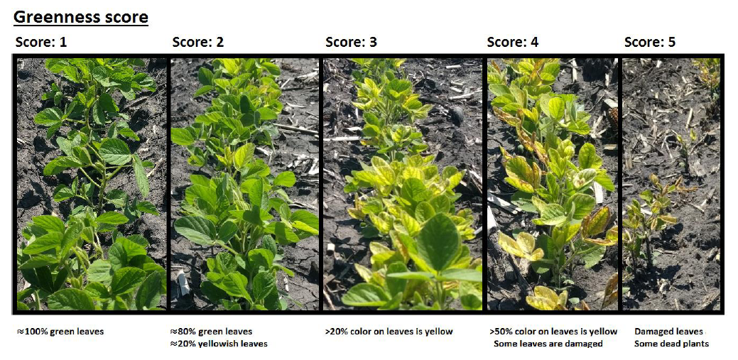
Figure 1. Greenness visual score scale. The visual symptoms were recorded weekly based on human observation of the plots. Each plot was rated on a 1-5 scale where “1” was healthy and “5” was severely affected.
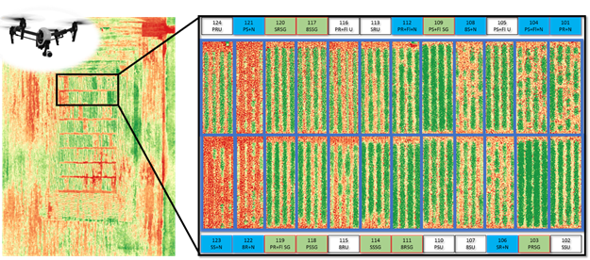
Figure 2. Aerial based normalized difference vegetation index (NDVI). An unmanned aerial vehicle equipped with a modified near-infrared sensor was flown weekly over each of the three locations in this study. This figure highlights a single replication at the “Kevin” site location. With urea (blue boxes) and iron chelates (green boxes), and genetic tolerance or resistance to IDC and SCN, we are able to investigate the contributions of IDC and SCN individually and together on soybean canopy development, greenness, and ultimately – yield.

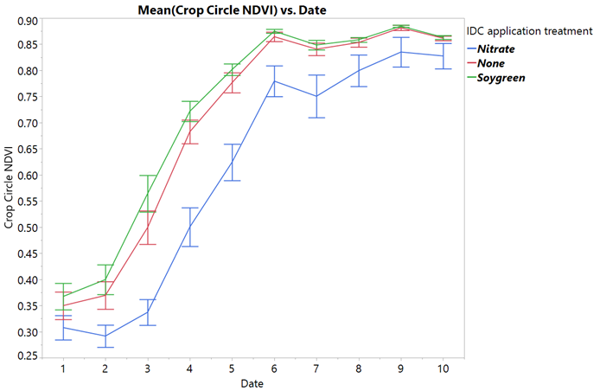
Figure 3. Crop Circle NDVI measurements across the 10 weeks of data collection. The error bars indicate the 95% confidence interval. The NDVI was significantly different between the Soygreen and control compared to the urea plots, on average, at 9 of the 10 weeks of data collection.

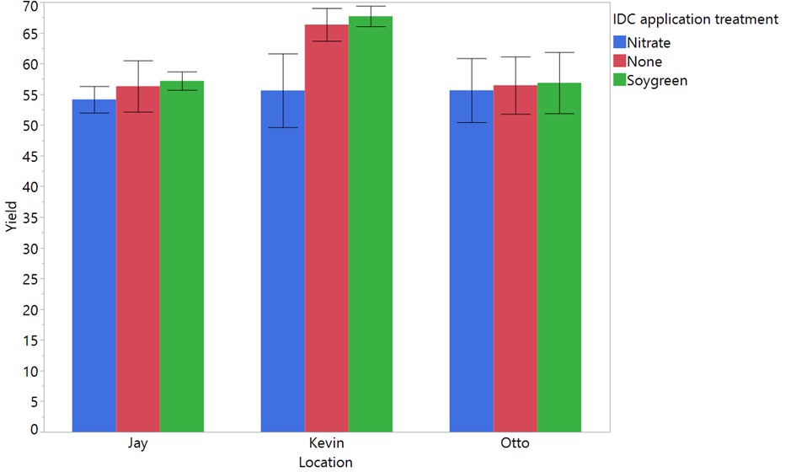
Figure 4. Yield by IDC application treatment at each of the 3 locations (Jay, Kevin, Otto). Error bars indicate the 95% confidence interval.

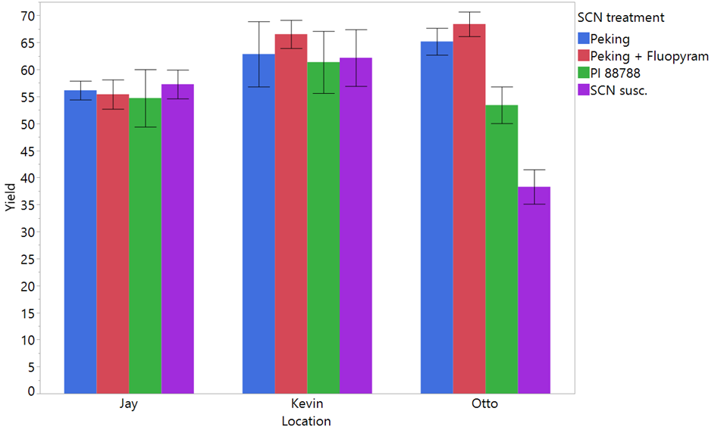
Figure 5. Yield by SCN treatment at each of the three sites (Jay, Kevin, Otto). Error bars indicate 95% confidence interval.

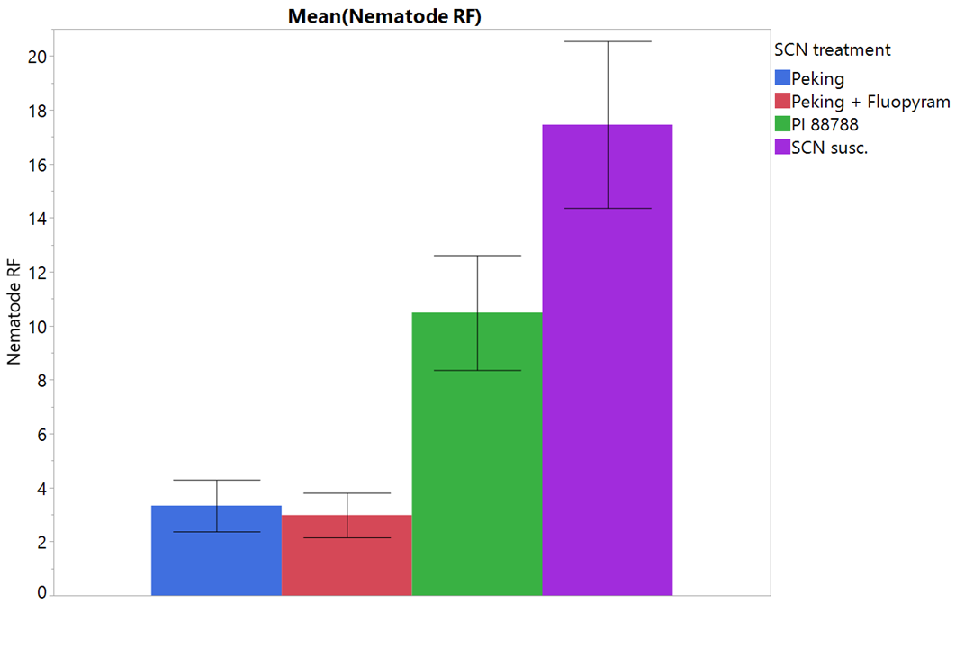
Figure 6. Nematode reproduction factor by SCN treatment. The four SCN treatments included: a) a variety with Peking source of genetic resistance + Fluopyram, b) a variety with Peking source of genetic resistance, c) a variety with PI 88788 source of genetic resistance, and d) an SCN susceptible variety. Error bars indicate the 95% confidence interval.

Table 1. HG Type test results. HG testing tests populations of SCN on known differentials in the lab. Reproduction of greater than 10% of the susceptible check warrants classification as virulent on that specific resistance source.

