Executive Summary:
Considerable effort has gone into the development and validation of high soy feed formulations for shrimp. Based on the PI’s experience with the transfer of this technology to feed manufactures, the primary constraint is a poor understanding or a lack of defined studies that pinpoint the methionine or total sulfur amino acid (methionine + cysteine) requirement of shrimp. Many feed manufactures have the methionine requirement set relatively high which favors the inclusion of expensive fishmeal vs that of soybean meal. There are several publications evaluating methionine supplements to Pacific white shrimp feeds, yet these papers do not define the requirement. This is a major constraint to feed manufactures acceptance of soy based feed formulations. Hence, the objective of the proposed research was to support a concerted effort to evaluate the efficacy of several amino acid supplements and attempt to quantify the methionine requirement of Pacific white shrimp using soy based feed formulations.
The completed research has demonstrated that the uptake of amino acids in shrimp corresponds to the digestive physiology of the animal. In that shrimp are semi-continuous feeders that process and digest foodstuffs very quickly. From the initiation of feeding, an upswing in amino acids in the hemolymph was apparent. The clearance of amino acids was also relatively fast with amino acid levels returning to overnight fasting levels within 60 minutes. This cycle of nutrient corresponds to the semi-continuous feeders habits of shrimp. Based on both absorption and clearance patterns of the amino acids, there was no indication of a synchronous absorption of supplemented amino acids.

To evaluate the growth response to various methionine sources, a series of growth trials were conducted with a range of supplements (Dl-methionine, Micro-encapsulated methionine, methionine peptide, and coated methionine) as well as dietary levels. Across four independent growth trials, increasing the level of methionine as a supplement or through the use of corn protein concentrate as an intact protein source produced very little evidence of growth enhancement. This leads to three possible conclusions: 1. The basal diet is only marginal in methionine and total sulfur amino acids making the identification of a deficiency more problematic 2. That purified sources of methionine are not absorbed and hence not utilized but that would also mean methionine in corn protein concentrate is not available 3. That there is another amino acid that is limiting.

METHODS

Diet preparation
The basal diets used in the various trials were designed to contain 36% protein and 8% lipid using primarily soybean meal and fishmeal or poultry by product meal as the primary protein sources (Table 1, 2, 3, and 4). With the exception of methionine, the basal and test diets were formulated to meet the nutritional requirements of the Pacific white shrimp. The test diets were prepared in the feed laboratory of Auburn University, Auburn, AL, USA using standard practices. In short, pre-ground dry ingredients and oil were mixed in a food mixer (Hobart Corporation, Troy, OH, USA) for 15 min. Hot water was then blended into the mixture to attain a consistency appropriate for pelleting. Each diet was pressure pelleted using a meat grinder and a 3 mm die. After pelleting, diets were dried to a moisture content of 8-10% and stored at 4 C.

Experimental system
For all the trials, Pacific white shrimp were stocked into 75-L tanks which are a component of a 2,500-L indoor recirculation system (reservoir, bead filter, fluidized biological filter and circulation pumps and heater). Each diet was offered to shrimp in three to five replicate aquaria for the length of the trial. Water temperature was maintained at around 28 C using a submerged 3,600-W heater (Aquatic Eco-Systems Inc., Apopka, Florida, USA). Dissolved oxygen was maintained near saturation using air stones in each aquarium and the sump tank using a common airline connected to a regenerative blower. Dissolved oxygen and water temperature were measured twice a day using a YSI-55 digital oxygen/temperature meter (YSI corporation, Yellow Springs, Ohio, USA) while pH, TAN and Nitrite-N measured once per week.

Free amino acids (AA) of hemolymph
To determine levels of free amino acids (AA) in the hemolymph of shrimp, replicate groups of four shrimp were utilized for each collection point. Shrimp at a given time point were netted and placed in an ice slurry to anesthetize the shrimp after which hemolymph was collected from the abdominal segments using a syringe and 25 gauge needle.
For this work a 1 ml syringe was preloaded with 0.5 ml of an anti-coagulant and used to collect approximately 0.5 ml of hemolymph. To maintain semi-quantitative data, trial one recorded the volume where as in the following trails, the weight of the anticoagulant and hemolymph were determined gravimetrically. The anticoagulant solution (Liu et al 2004) contains 30 mM Sodium Citrate Tribasic Dihydrate (Sigma S4641) ; 0.34 M Sodium Chloride (NaCl); 10 mM EDTA – Ethylene Diamine Tetraacetic Acid(Sigma, E9884);in de-ionized (DI) water. This is made by weigh 4.4115 g sodium citrate tribasic dehydrate, 9.945 g sodium chloride, 1.461 EDTA, and dissolve in 500 ml DI water. To obtain free amino samples of the hemolymph, the collected hemolymph was centrifuged and decanted. The blood samples from shrimp in a single aquaria were pooled resulting in 2 to 3 samples/treatment each with blood from 3-4 shrimp.
Three trails were conducted with the Basal Diet (BD) as well as the BD with select AA. For each trial the shrimp were preconditioned to the diets for four days. The prior evening the tanks were cleaned to remove any food sources. The next day and prior to feeding a group of shrimp were bled to determine fasted levels of free AA, the remaining shrimp were offered food for predetermined time periods and then the feed was withdrawn and shrimp fasted.

In the first trial, shrimp were fasted overnight. The shrimp were then offered and excess of feed which was then withdrawn after 30 minutes. Hemolymph samples were taken prior to feeding (-30) and 30 minutes after feed was offered (0). Feed was then withdrawn and fasted samples taken at 30, 60,120, 150, 180, 210 and 270 minutes.
In the second trial, shrimp were fasted overnight, and a fasting sample taken (-60 minutes). The shrimp were then offered an excess of feed and shrimp were sequentially sacrifices at 5, 10, 15, 20, 30 and 60 minutes. During which time food was available to the shrimp.
In the third trail, shrimp were fasted overnight, and a fasting sample taken (Time -15 minutes). Feed was then offered for 15 minutes and then removed and a sample taken (T0). Fasted samples were then taken at T15, 30, 45 and 120 minutes’ post feeding.

Growth Trials
A series of growth trail were carried out using juvenile shrimp. Diets were offered using our standard feeding protocol with 4 feedings per day. Diets were offered to shrimp at a suitable level based on historic performance as well as observed consumption of the feed. At the conclusion of the growth trials, the shrimp were weighed, enumerated, and frozen for subsequent analysis.

Biochemical analysis
Samples of hemolymph and shrimp were frozen until required. Tissue samples requiring analysis were sent to University of Missouri laboratory.

Statistical analysis.
All data was analyzed using Proc GLM in SAS and one-way analysis of variance to determine significant (P < 0.05) differences among the treatment means. Dunnett’s t-test will be used to compare each treatment with the reference diet and Student-Neuman Keuls' multiple range test to distinguish significant differences between treatment means. All statistical analyses will be conducted using SAS system for windows, (SAS Institute, Cary, NC).

Results and Discussion

Due to the limitation of available data on methionine requirements for shrimp, this project was developed to look a serum levels of methionine and to attempt to determine the dietary methionine requirements of shrimp. For this work, a preliminary trial was conducted to develop a method for collection of hemolymph samples and quantify the AA profile (Data not presented). Based on preliminary data, we develop the first trial to evaluate the long-term post feeding response. For this trial, the shrimp were fasted overnight to allow the identification of basal levels of AA. After overnight fasting the shrimp were sampled (-30 minutes), then provide feed for 30 minutes after which another sample was taken (0 minutes) and the post feeding levels of AA determined (0 to 270 minutes. The response of the shrimp is provided in figures 1a (total physiological AA), 1b (phenylalanine) 1c (methionine) and 1d (lysine). Note that these graphs are similar for other AA with the level of AAs returning to basal level after about 1 hr. It should be noted that in fish, there are asynchronous peaks for AA with that of crystalline AA occurring prior to intact proteins. As you can see from the graph, there are no asynchronous peaks.

To better define the absorption process and to evaluate if there may be an asynchronous peak during absorption, the second trial was conducted which simply looked at the uptake of AA over a 1 hr period. Again the shrimp were fasted overnight and their hemolymph sampled to determine basal levels (-60 minutes). The shrimp were offered feed for a total of 60 minutes during which time intermittent samples were taken. This data is presented for total AA (Figures 2a) and methionine (Figure 2b). Both the supplemented basal and DL-methionine supplemented diets were followed. Although, the level of AA is consistently higher in the supplemented diet, the pattern for AA uptake is similar with a clear upswing in AA levels in 10-15 minutes. This is quite different from that of fish species for which digestion and absorption is delayed several hours primarily due to holding of food in the stomach.

The third trail focused on the reduction of AA levels post feeding identify if there are different patterns that would indicate asynchronous absorption. For this trial the shrimp were fasted overnight and a basal AA level determined (-15 minutes) the shrimp were then allowed to have feed for 15 minutes at which time a sample was taken (0 minutes) and the feed withdrawn. Samples were collected after 15, 30 and 45 minutes. To confirm the basal levels, an additional sample was taken after ~1.5 hr (data not presented). The total AA and methionine levels of the hemolymph are presented in Figures 2c and 2d, respectively. Once again, the supplemented diet has higher levels of AA but there was no clear asynchronous uptake or clearance from the hemolymph.

The presented data, clearly demonstrates that AA in shrimp is much quicker than that of fish species with AA appearing in the hemolymph within 10 to 15 minutes. This is primarily due to the rapid and continual processing of food by shrimp. Based on the results of these studies there is no evidence that shrimp cannot utilize free AA or that they are asynchronously absorbed.

Presently there are few studies published on methionine requirement of the Pacific white shrimp. The few studies dealing with methionine supplements have failed to establish what would be considered a strong and convincing methionine requirement for this species. Hence, the second component of the research was designed to evaluate the efficacy of various methionine sources as well as attempt to identify a dietary requirement. Table 3a presents a series of diets which were supplemented with a range of methionine sources including: DL-methionine, coated methionine, peptide of methionine as well as a modified diet using intact proteins. Proximate and AA composition of the test diets are presented in table 3a with the basal diet analyzing at 0.49% methionine and the remaining diets at 0.64 to 0.68%. These diets were offered to 0.5 g shrimp over a 42-day growth trial after which the AA profile of the shrimps tail muscle and hepatopancreas were evaluated. Growth and survival were very good with over 1000% weight gain observed with good FCR and survival (Table 3c). However, there were no differences in the growth, feed or survival rates observed. To determine if there were shifts in tissue composition, AA levels of the shrimp muscle and hepatopancreas were determined (Table 3d and e, respectively). There were no differences or trends seeing in methionine levels of these tissues (Figure 3). These results indicate that there were no differences in deposition across all treatments.

To determine if we could induce a response to graded levels of methionine the first dose response trail utilized both DL methionine and a microencapsulated methionine (Table 4a). This trial was repeated twice with the data from the second trial reported. The analysis for proximate and AA composition of the test diets is presented in table 4b. The methionine levels ranging from 0.54% in the basal diet to 0.83 for the DL methionine supplemented diet and 0.81 for the microencapsulated methionine diet. Diet 10 was designed as an intact protein diet utilized corn protein concentrate to increase the methionine level to 0.62% of the diet. To collect data on a high soy production diet the last diet (Diet 11) was a commercially produced open formulation used at our laboratory for pond production. At the conclusion of a 42-day growth trial the shrimp grew from 0.21 g to a maximum weight of 6.26g. Survival and growth were very good in this trial and there was a large increase in weight gain or tissue replacement (2467 to 2832%). However, the response was not typical of a dose response study. That is to say there was no increase in weight gain corresponding to increases in methionine levels (Figure 4a). Proximate composition and AA profile of the whole shrimp were determined for this trial (Table 4d) with a slight decrease in the level of protein in the shrimp and significant differences in methionine levels of the whole shrimp. In this trial, the basal diet resulted in a significant depression in whole body tissue levels that was lower than most other diets (Figure 4 b). This would indicate that there was a response to methionine levels of the diet. However, the pond production diet (not presented in the graph, as dietary levels of methionine were not determine) also had low levels of methionine in the whole shrimp analysis. Excluding the pond production diet, there is a general increase as the level of methionine is increased from 0.54% of the diet albeit not a strong response.

The last growth trial the basal diet (Table 5) was similar to that used in other trials and would be expected to have a similar level of methionine. The first series of diets were formulated with increasing levels of CPC (0, 5, 10, 15, 20 and 25%) as a substitute for soybean meal allowing for an incremental increase in dietary methionine. In the second set of diets, the basal diet was supplemented with high levels of DL-methionine (0, 0.1, 0.2, 0.4, 0.6%). These diets were then offered to juvenile shrimp (0.85g) over a 42 day growth trial. In this trial, the shrimp offered the diets supplemented with DL methionine and the highest level of corn protein concentrate were significantly smaller than the shrimp offered the basal diet. Again, there was not trend in the data in terms of improved growth due to methionine supplementations. It should be noted as seen in figure 5 there are no trends in the data and the growth data is highly variable which is often a problem with shrimp.

Conclusion:

The completed research has demonstrated that the uptake of amino acids in shrimp corresponds to the digestive physiology of the animal. In that shrimp are semi-continuous feeders that process and digest foodstuffs very quickly. From the initiation of feeding, an upswing in amino acids in the hemolymph was apparent. The clearance of amino acids was also relatively fast with amino acid levels returning to overnight fasting levels within 60 minutes. This cycle of nutrient corresponds to the semi-continuous feeder habits of shrimp. Based on both absorption and clearance patterns of the amino acids, there was no indication of a synchronous absorption of supplemented amino acids.

To evaluate the growth response to various methionine sources, a series of growth trials were conducted with a range of supplements (Dl-methionine, Micro-encapsulated methionine, methionine peptide, and coated methionine) as well as dietary levels. Across four independent growth trials, increasing the level of methionine as a supplement or through the use of corn protein concentrate as an intact protein source produced very little evidence of growth enhancement. This leads to three possible conclusions: 1. The basal diet is only marginal in methionine and total sulfur amino acids making the identification of a deficiency more problematic 2. That purified sources of methionine are not absorbed and hence not utilized but that would also mean methionine in corn protein concentrate is not available 3. That there is another amino acid that is limiting.

Table 1. Composition of test diets designed to contain 36% protein and 9% lipid for use in initial blood work.
Exp 1518 – Initial blood work | Basal | B+Lys, Meth, Arg, Taur
Soybean meal | 47.20 | 47.20
Poultry by product meal | 4.00 | 4.00
Gelatin | 7.00 | 6.43
Menhaden Fish Oil | 5.70 | 5.70
Corn Starch | 2.83 | 2.83
Whole wheat | 27.09 | 27.09
Trace Mineral premix | 0.50 | 0.50
Vitamin premix | 1.80 | 1.80
Choline chloride | 0.20 | 0.20
Stay C | 0.10 | 0.10
CaP-dibasic | 2.20 | 2.20
Lecithin | 1.00 | 1.00
Cholesterol | 0.08 | 0.08
Lysine |  | 0.20
DL-Methionine |  | 0.20
Glycine | 0.30
Arginine |  | 0.20
Taurine |  | 0.20

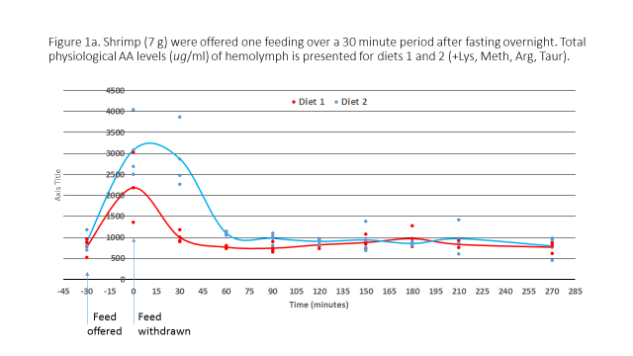
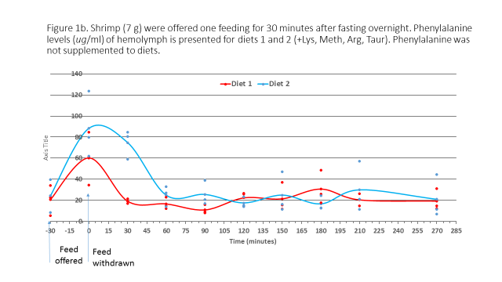

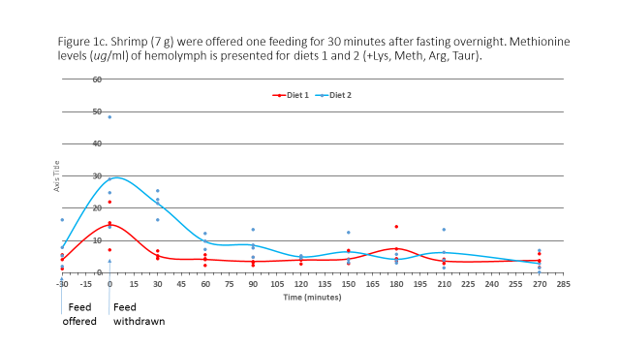
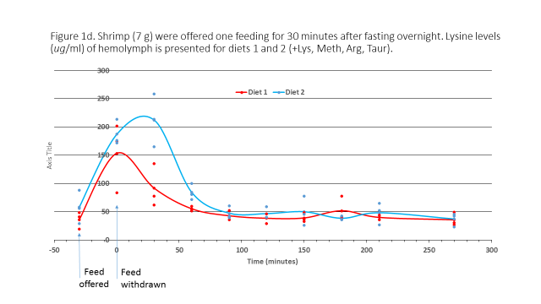

Table 2. Composition (g/100g as is) and analyzed values of test diets use to evaluate hemolymph amino acid levels of Pacific white shrimp after being fasted overnight then allowed to consume feed for varying lengths of time.
Exp1602 – blood work | Diet 1 | Diet 3
Menhaden fish meal | 5.00 | 5.00
Soybean meal | 49.10 | 49.10
Menhaden Fish Oil | 5.89 | 5.89
Corn Starch | 1.83 | 1.83
Whole wheat | 25.00 | 25.00
Trace Mineral premix | 0.50 | 0.50
Vitamin premix w/o choline | 1.80 | 1.80
Choline chloride | 0.20 | 0.20
Stay C | 0.10 | 0.10
CaP-dibasic | 2.20 | 2.20
Lecithin | 1.00 | 1.00
Cholesterol | 0.08 | 0.08
DL Methionine | 0.00 | 0.30
Gelatin | 7.00 | 7.00
Glycine | 0.30 | 0.00
Analyzed¹ values (% as is)
Crude protein | 38.65 | 37.11
Ala | 1.987 | 1.905
Arg | 2.627 | 2.531
Asp | 3.416 | 3.317
Cys | 0.445 | 0.422
Glu | 6.637 | 6.444
Gly | 3.403 | 2.93
His | 0.818 | 0.795
Ile | 1.395 | 1.352
Leu | 2.442 | 2.379
Lys | 1.955 | 1.891
Met | 0.52 | 0.836
Phe | 1.638 | 1.591
Pro | 2.885 | 2.747
Ser | 1.672 | 1.624
Thr | 1.256 | 1.224
Val | 1.582 | 1.532
¹ Analysis for diets was conducted by Evonic.

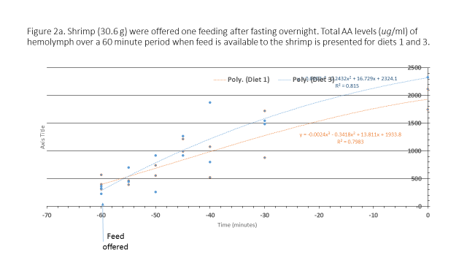
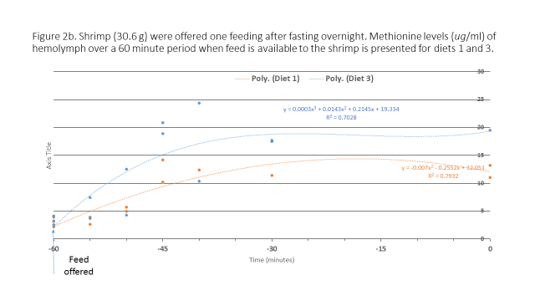

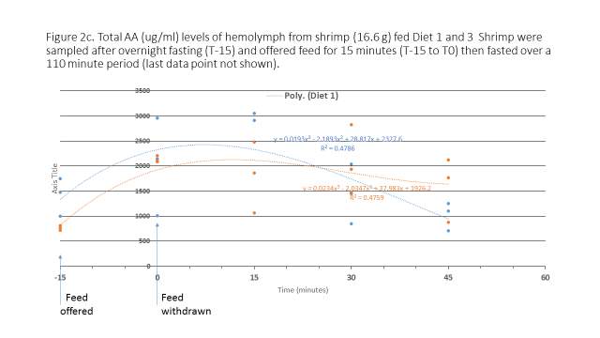
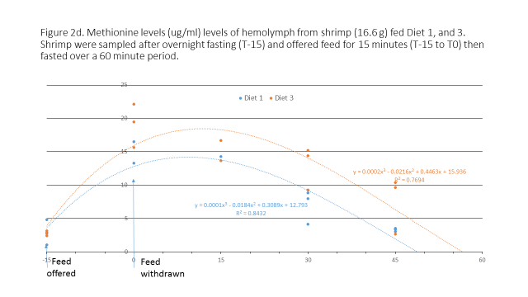

Table 3a. Composition (g/100g as is) of test diets (E1612)
 | Basal | Coated Meth (76%) | DL-Met | Peptide (95%) | Intact protein
Poultry by product meal | 4.00 | 4.00 | 4.00 | 4.00 | 4.00
Soybean meal | 48.0 | 48.00 | 48.00 | 48.00 | 33.00
Corn protein concentrate | 0.00 | 0.00 | 0.00 | 0.00 | 15.00
Gelatin | 5.00 | 5.00 | 5.00 | 5.00 | 0.00
Menhaden fish oil | 5.68 | 5.68 | 5.68 | 5.68 | 5.59
Lecithin | 1.00 | 1.00 | 1.00 | 1.00 | 1.00
Cholesterol | 0.08 | 0.08 | 0.08 | 0.08 | 0.08
Corn Starch | 3.68 | 3.64 | 3.69 | 3.68 | 8.26
Whole wheat | 27.00 | 27.00 | 27.00 | 27.00 | 27.00
Mineral premix | 0.50 | 0.50 | 0.50 | 0.50 | 0.50
Vitamin premix | 1.80 | 1.80 | 1.80 | 1.80 | 1.80
Choline chloride | 0.20 | 0.20 | 0.20 | 0.20 | 0.20
Stay C 35% active | 0.10 | 0.10 | 0.10 | 0.10 | 0.10
CaP-dibasic | 2.80 | 2.80 | 2.80 | 2.80 | 3.00
Lysine |  |  |  |  | 0.47
Methionine sources |  | 0.20 | 0.15 | 0.16 | 0.00
Glycine | 0.16

Table 3b. Analysis of test diets (Exp1612).
 | Basal | Coated Meth | DL-Met | Peptide | Intact protein
Crude Protein | 34.56 | 34.89 | 34.91 | 34.81 | 35.87
Moisture | 5.85 | 5.87 | 5.4 | 5.71 | 5.23
Crude Fat | 9.64 | 10.07 | 10.12 | 8.77 | 9.22
Crude Fiber | 3.68 | 3.88 | 3.91 | 3.45 | 3.37
Ash | 6.49 | 6.28 | 6.31 | 6.3 | 6.16
Amino Acids
Alanine | 1.72 | 1.72 | 1.73 | 1.72 | 2.01
Arginine | 2.30 | 2.32 | 2.33 | 2.34 | 1.88
Aspartic Acid | 3.06 | 3.08 | 3.11 | 3.07 | 2.84
Cysteine | 0.41 | 0.42 | 0.42 | 0.42 | 0.53
Glutamic Acid | 6.10 | 6.16 | 6.19 | 6.17 | 7.12
Glycine | 2.69 | 2.53 | 2.53 | 2.53 | 1.46
Histidine | 0.74 | 0.74 | 0.75 | 0.74 | 0.78
Hydroxy-lysine | 0.11 | 0.10 | 0.11 | 0.10 | 0.05
Hydroxy-proline | 0.65 | 0.64 | 0.65 | 0.66 | 0.12
Isoleucine | 1.34 | 1.34 | 1.34 | 1.35 | 1.49
Lanthionine | 0.03 | 0.02 | 0.01 | 0.04 | 0.02
Leucine | 2.31 | 2.32 | 2.34 | 2.33 | 3.63
Lysine | 1.83 | 1.84 | 1.86 | 1.83 | 1.83
Methionine | 0.49 | 0.67 | 0.67 | 0.68 | 0.64
Phenylalanine | 1.52 | 1.52 | 1.54 | 1.53 | 1.85
Proline | 2.32 | 2.34 | 2.36 | 2.31 | 2.47
Serine | 1.39 | 1.43 | 1.45 | 1.39 | 1.54
Taurine | 0.22 | 0.22 | 0.22 | 0.22 | 0.23
Threonine | 1.12 | 1.13 | 1.14 | 1.12 | 1.18
Tryptophan | 0.38 | 0.38 | 0.37 | 0.38 | 0.36
Tyrosine | 1.02 | 1.04 | 1.04 | 1.06 | 1.37
Valine | 1.50 | 1.51 | 1.52 | 1.52 | 1.64
Sum AA | 33.25 | 33.47 | 33.68 | 33.51 | 35.04

Table 3c. Response of juvenile shrimp (0.55 + 0.04 g) to various test diets over a 42-day growth trial. Means of three replicate groups of shrimp (Exp1612).
Diet | Final Biomass (g) | Mean Weight (g) | Weight Gain (g) | Percent Gain | FCR | Survival (%)
Basal | 65.99 | 6.60 | 6.03 | 1064.3 | 1.63 | 100.0
Coated | 68.49 | 6.85 | 6.29 | 1127.9 | 1.56 | 100.0
DL-Met | 66.04 | 6.60 | 6.07 | 1134.4 | 1.62 | 100.0
Peptide | 63.46 | 6.54 | 6.01 | 1122.3 | 1.65 | 96.7
Intact | 63.58 | 6.99 | 6.45 | 1197.6 | 1.53 | 90.0
P value | 0.9533 | 0.7205 | 0.704 | 0.6533 | 0.217 | 0.5251
PSE | 5.179 | 0.2384 | 0.2622 | 59.77 | 0.7118 | 4.71

Table 3d. Amino acid composition of tail muscle (dry wt.) of juvenile shrimp reared on the various test diets for 42-day period. Means of three replicate groups of shrimp each consisting of four pooled shrimp (Exp1612).
E1612 | Basal | Coated Meth | DL-Met | Peptide |  | Intact protein
Trt | 1 | 2 | 3 |  | 4 | 5 | P-value
Alanine | 4.89 | 4.84 | 4.84 |  | 4.83 | 4.85 | 0.9791
Arginine | 6.78 | 6.66 | 6.62 |  | 6.79 | 6.58 | 0.7787
Aspartic Acid | 8.10 | 8.08 | 7.98 |  | 8.12 | 8.09 | 0.6211
Cysteine | 0.89 | 0.89 | 0.87 |  | 0.90 | 0.89 | 0.2785
Glutamic Acid | 13.27 | 13.33 | 13.39 |  | 13.11 | 13.25 | 0.1549
Glycine | 6.31 | 6.43 | 6.02 |  | 6.79 | 6.70 | 0.1835
Histidine | 1.79 | 1.77 | 1.79 |  | 1.77 | 1.79 | 0.5425
Hydroxylysine | 0.12 | 0.12 | 0.12 |  | 0.12 | 0.13 | 0.9375
Hydroxyproline | 0.86 | 0.91 | 0.93 |  | 0.84 | 0.35 | 0.0009
Isoleucine | 3.52 | 3.43 | 3.41 |  | 3.55 | 3.47 | 0.2189
Lanthionine | 1.77 | 1.71 | 1.80 |  | 1.73 | 1.81 | 0.5705
Leucine | 6.14 | 6.09 | 6.02 |  | 6.14 | 6.16 | 0.2488
Lysine | 6.81 | 6.76 | 6.70 |  | 6.78 | 6.62 | 0.2138
Methionine | 2.10 | 2.11 | 2.08 |  | 2.14 | 2.11 | 0.2261
Ornithine | 0.27 | 0.23 | 0.25 |  | 0.27 | 0.25 | 0.2564
Phenylalanine | 3.44 | 3.39 | 3.40 |  | 3.45 | 3.45 | 0.4782
Proline | 4.46 | 4.66 | 4.64 |  | 4.42 | 4.69 | 0.5791
Serine | 2.47 | 2.67 | 2.56 |  | 2.44 | 2.49 | 0.1951
Taurine | 0.17 | 0.18 | 0.17 |  | 0.19 | 0.22 | 0.0085
Threonine | 3.02 | 3.07 | 3.04 |  | 3.05 | 3.03 | 0.8411
Tryptophan | 0.93 | 0.92 | 0.90 |  | 0.91 | 0.93 | 0.1145
Tyrosine | 2.79 | 2.83 | 2.82 |  | 2.67 | 2.84 | 0.513
Valine | 3.70 | 3.65 | 3.69 |  | 3.72 | 3.67 | 0.6902
Total | 84.60 | 84.72 | 84.06 |  | 84.71 | 84.36 | 0.7555

Table 3e. Amino acid composition of hepatopancreas (dry wt) of juvenile shrimp reared on the various test diets for 42-day period. Means of three replicate groups of shrimp each consisting of four pooled shrimp (Exp1612).
E1612 | Basal | Coated Meth | DL-Met | Peptide | Intact protein
Trt | 1 | 2 | 3 | 4 | 5 | P-value
Alanine | 1.97 | 1.68 | 1.71 | 1.89 | 1.74 | 0.138
Arginine | 2.26 | 1.96 | 1.94 | 2.23 | 2.00 | 0.0579
Aspartic Acid | 4.05 | 3.58 | 3.49 | 4.03 | 3.61 | 0.0917
Cysteine | 0.67 | 0.60 | 0.61 | 0.71 | 0.61 | 0.0882
Glutamic Acid | 4.37 | 3.80 | 3.81 | 4.23 | 3.88 | 0.1648
Glycine | 3.43 | 2.99 | 2.82 | 3.49 | 3.25 | 0.1506
Histidine | 1.11 | 0.96 | 0.92 | 1.07 | 0.97 | 0.1157
Hydroxylysine | 0.07 | 0.06 | 0.07 | 0.06 | 0.05 | 0.0208
Hydroxyproline | 0.35 | 0.35 | 0.37 | 0.33 | 0.09 | 0.0001
Isoleucine | 1.70 | 1.51 | 1.49 | 1.67 | 1.51 | 0.1406
Lanthionine | 1.24 | 1.17 | 1.12 | 1.25 | 1.17 | 0.0539
Leucine | 2.64 | 2.32 | 2.29 | 2.60 | 2.33 | 0.1417
Lysine | 2.20 | 1.97 | 1.98 | 2.15 | 1.90 | 0.2203
Methionine | 0.74 | 0.67 | 0.69 | 0.76 | 0.68 | 0.2156
Ornithine | 0.04 | 0.03 | 0.03 | 0.04 | 0.03 | 0.2957
Phenylalanine | 1.98 | 1.73 | 1.69 | 1.93 | 1.75 | 0.1423
Proline | 2.46 | 2.27 | 2.08 | 2.35 | 2.28 | 0.202
Serine | 1.41 | 1.27 | 1.28 | 1.44 | 1.28 | 0.1252
Taurine | 1.09 | 1.10 | 0.93 | 1.24 | 1.14 | 0.3054
Threonine | 1.77 | 1.56 | 1.55 | 1.76 | 1.56 | 0.1114
Tryptophan | 0.57 | 0.47 | 0.44 | 0.57 | 0.51 | 0.1928
Tyrosine | 1.68 | 1.50 | 1.47 | 1.70 | 1.53 | 0.0496
Valine | 2.22 | 1.95 | 1.95 | 2.17 | 1.96 | 0.1466
Total | 40.05 | 35.51 | 34.73 | 39.66 | 35.83 | 0.0991

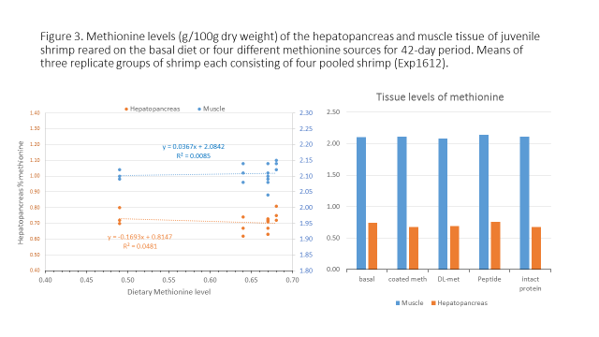

Table 4. Composition (g/100g as is) of test diets
 |  | DL- Methionine |  |  |  | Micro-encapsulated methionine
Exp 1519/1615 | 1 | 2 | 3 | 4 | 5 | 6 | 7 | 8 | 9 | 10
Poultry by product meal | 4.00 | 4.00 | 4.00 | 4.00 | 4.00 | 4.00 | 4.00 | 4.00 | 4.00 | 4.00
Soybean meal | 47.20 | 47.20 | 47.20 | 47.20 | 47.20 | 47.20 | 47.20 | 47.20 | 47.20 | 47.20
Menhaden Fish Oil | 5.70 | 5.70 | 5.70 | 5.70 | 5.70 | 5.70 | 5.70 | 5.70 | 5.70 | 5.55
Corn Starch | 2.83 | 2.83 | 2.83 | 2.83 | 2.83 | 2.78 | 2.73 | 2.63 | 2.53 | 2.08
Whole wheat | 27.09 | 27.09 | 27.09 | 27.09 | 27.09 | 27.09 | 27.09 | 27.09 | 27.09 | 27.09
Trace Mineral premix | 0.50 | 0.50 | 0.50 | 0.50 | 0.50 | 0.50 | 0.50 | 0.50 | 0.50 | 0.50
Vitamin premix | 1.80 | 1.80 | 1.80 | 1.80 | 1.80 | 1.80 | 1.80 | 1.80 | 1.80 | 1.80
Choline chloride | 0.20 | 0.20 | 0.20 | 0.20 | 0.20 | 0.20 | 0.20 | 0.20 | 0.20 | 0.20
Stay C | 0.10 | 0.10 | 0.10 | 0.10 | 0.10 | 0.10 | 0.10 | 0.10 | 0.10 | 0.10
CaP-dibasic | 2.20 | 2.20 | 2.20 | 2.20 | 2.20 | 2.20 | 2.20 | 2.20 | 2.20 | 2.20
Lecithin | 1.00 | 1.00 | 1.00 | 1.00 | 1.00 | 1.00 | 1.00 | 1.00 | 1.00 | 1.00
Cholesterol | 0.08 | 0.08 | 0.08 | 0.08 | 0.08 | 0.08 | 0.08 | 0.08 | 0.08 | 0.08
Corn protein isolate |  |  |  |  |  |  |  |  |  | 7.90
DL-Methionine |  | 0.05 | 0.10 | 0.20 | 0.30
Meth. Micro-encapsulated |  |  |  |  |  | 0.10 | 0.20 | 0.40 | 0.60
Gelatin | 7.00 | 7.00 | 7.00 | 7.00 | 7.00 | 7.00 | 7.00 | 7.00 | 7.00
Glycine | 0.30 | 0.25 | 0.20 | 0.10 |  | 0.25 | 0.20 | 0.10 |  | 0.30

Table 4b. Proximate and amino acid (AA) composition of test diets (g/100g as is)
Exp1615 | 1 | 2 | 3 | 4 | 5 | 6 | 7 | 8 | 9 | 10
Crude Protein | 37.76 | 38.05 | 37.97 | 37.54 | 37.5 | 38.03 | 37.84 | 37.93 | 38.24 | 37.68
Moisture | 5.13 | 6.48 | 6.47 | 7.41 | 7.42 | 6.65 | 7.07 | 6.61 | 6.76 | 5.89
Crude Fat | 9.32 | 8.62 | 8.86 | 8.79 | 8.64 | 9.22 | 9.29 | 10.03 | 9.21 | 9.58
Crude Fiber | 3.12 | 3.72 | 3.7 | 3.71 | 3.54 | 3.83 | 3.77 | 3.72 | 3.72 | 3.76
Ash | 5.91 | 5.83 | 5.75 | 5.72 | 5.72 | 5.75 | 5.74 | 5.72 | 5.79 | 5.84
Amino Acid
Alanine | 1.91 | 1.94 | 1.88 | 1.92 | 1.93 | 1.94 | 1.93 | 1.93 | 1.95 | 1.92
Arginine | 2.45 | 2.56 | 2.58 | 2.54 | 2.55 | 2.54 | 2.57 | 2.57 | 2.59 | 2.23
Aspartic Acid | 3.21 | 3.33 | 3.28 | 3.29 | 3.29 | 3.33 | 3.31 | 3.33 | 3.36 | 3.32
Cysteine | 0.42 | 0.42 | 0.42 | 0.42 | 0.42 | 0.43 | 0.42 | 0.43 | 0.42 | 0.53
Glutamic Acid | 6.39 | 6.5 | 6.41 | 6.42 | 6.44 | 6.5 | 6.46 | 6.49 | 6.55 | 7.22
Glycine | 3.29 | 3.26 | 3.08 | 3.11 | 3.06 | 3.26 | 3.21 | 3.12 | 3.04 | 1.95
Histidine | 0.76 | 0.78 | 0.77 | 0.77 | 0.77 | 0.78 | 0.78 | 0.78 | 0.79 | 0.86
Hydroxy-lysine | 0.12 | 0.14 | 0.13 | 0.14 | 0.14 | 0.13 | 0.13 | 0.13 | 0.13 | 0.07
Hydroxy-proline | 0.86 | 0.87 | 0.83 | 0.95 | 0.97 | 0.86 | 0.87 | 0.87 | 0.88 | 0.16
Isoleucine | 1.38 | 1.43 | 1.42 | 1.4 | 1.39 | 1.42 | 1.4 | 1.4 | 1.43 | 1.61
Lanthionine | 0.01 | 0.04 | 0.02 | 0.03 | 0.03 | 0.03 | 0.02 | 0.02 | 0.02 | 0.06
Leucine | 2.39 | 2.45 | 2.45 | 2.41 | 2.4 | 2.44 | 2.42 | 2.43 | 2.46 | 3.34
Lysine | 1.92 | 1.98 | 1.96 | 1.95 | 1.95 | 1.98 | 1.97 | 1.97 | 1.99 | 1.81
Methionine | 0.54 | 0.6 | 0.63 | 0.73 | 0.83 | 0.61 | 0.63 | 0.75 | 0.81 | 0.62
Phenylalanine | 1.58 | 1.62 | 1.63 | 1.6 | 1.6 | 1.61 | 1.61 | 1.62 | 1.63 | 1.89
Proline | 2.66 | 2.53 | 2.56 | 2.58 | 2.6 | 2.57 | 2.62 | 2.62 | 2.65 | 2.28
Serine | 1.51 | 1.53 | 1.46 | 1.51 | 1.51 | 1.55 | 1.51 | 1.53 | 1.53 | 1.59
Taurine | 0.16 | 0.19 | 0.23 | 0.22 | 0.21 | 0.21 | 0.22 | 0.21 | 0.21 | 0.21
Threonine | 1.17 | 1.2 | 1.18 | 1.18 | 1.19 | 1.2 | 1.19 | 1.2 | 1.2 | 1.29
Tryptophan | 0.41 | 0.4 | 0.37 | 0.36 | 0.37 | 0.38 | 0.38 | 0.38 | 0.37 | 0.42
Tyrosine | 0.99 | 1.1 | 1.12 | 1.09 | 1.09 | 1.08 | 1.11 | 1.11 | 1.11 | 1.38
Valine | 1.57 | 1.61 | 1.6 | 1.59 | 1.58 | 1.6 | 1.59 | 1.59 | 1.63 | 1.75
Sum AA | 35.7 | 36.48 | 36.01 | 36.21 | 36.32 | 36.45 | 36.35 | 36.48 | 36.75 | 36.51

Table 4C (Exp1615). Response of juvenile shrimp (0.21 + 0.017 g) to various test diets over a 42-day growth trial. Means of four replicate groups of shrimp. This trial was repeated twice, results of the second trial are presented. Means within the same column with different letters are significantly different based on Student-Newman-Kuels test. Dunnett’s T-test did not indicate that any of the values within a column were different from that of the basal diet.
Trt. | Diet | Final No. | Final  Biomass (g) | Mean  Weight (g) | Weight  Gain g) | Weight Gain % | FCR | Percent  Survival
1 | Basal | 15.0 | 85.70 | 5.71ab | 5.49ab | 2520.53 | 1.39ab | 100.0
2 | DL 0.05 | 15.3 | 81.70 | 5.36b | 5.15b | 2473.65 | 1.48a | 101.7
3 | DL 0.1 | 15.3 | 87.05 | 5.71ab | 5.50ab | 2591.26 | 1.39ab | 101.7
4 | DL 0.2 | 14.8 | 85.65 | 5.80ab | 5.59ab | 2582.60 | 1.37ab | 98.3
5 | DL 0.3 | 15.0 | 89.85 | 5.99ab | 5.77ab | 2623.90 | 1.32ab | 100.0
6 | Micro 0.1 | 15.0 | 85.80 | 5.72ab | 5.51ab | 2580.94 | 1.39ab | 100.0
7 | Micro 0.2 | 14.8 | 87.65 | 5.94ab | 5.72ab | 2696.31 | 1.34ab | 98.3
8 | Micro 0.4 | 15.5 | 84.10 | 5.43b | 5.22b | 2467.04 | 1.46a | 103.3
9 | Micro 0.6 | 14.8 | 86.30 | 5.85ab | 5.64ab | 2665.00 | 1.35ab | 98.3
10 | Intact Protein | 15.0 | 93.85 | 6.26a | 6.04a | 2832.37 | 1.26b | 100.0
11 | Pond production | 15.0 | 82.75 | 5.52ab | 5.31ab | 2498.43 | 1.44ab | 100.0
P-value |  | 0.3984 | 0.1303 | 0.0180 | 0.0169 | 0.7155 | 0.0193 | 0.3984
PSE |  | 0.2261 | 2.584 | 0.160 | 0.1584 | 129.98 | 0.0395 | 1.507

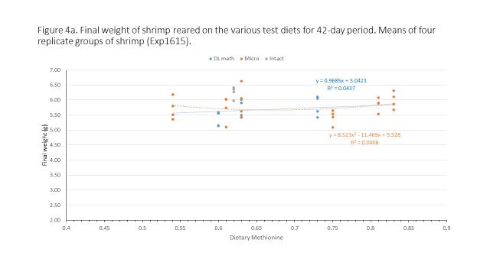

Table 4D (exp1615). Whole body amino acid composition of shrimp after being reared on the various test diets over a 42-day growth trial. Means of four replicate groups of shrimp.
 | Basal |  | DL 0.05 | DL 0.1 | DL 0.2 | DL 0.3 | Micro 0.1 | Micro 0.2 | Micro 0.4 | Micro 0.6 | Intact Protein | Pond diet
 | Diet 1 |  | Diet 2 | Diet 3 | Diet 4 | Diet 5 | Diet 6 | Diet 7 | Diet 8 | Diet 9 | Diet 10 | Diet 11 | P- Value | PSE
Protein |  | 73.64 | 73.11 | 74.45 | 73.83 | 74.00 | 73.61 | 74.12 | 74.12 | 74.16 | 72.90 | 72.20 | 0.0940 | 0.493
Fat |  | 8.29 | 8.31 | 7.61 | 7.63 | 7.34 | 8.70 | 7.54 | 6.93 | 8.30 | 8.09 | 9.14 | 0.2205 | 0.542
Fiber |  | 5.27 | 6.05 | 5.66 | 6.18 | 5.46 | 5.64 | 5.28 | 5.71 | 5.35 | 5.28 | 5.93 | 0.6307 | 0.363
Ash |  | 13.52 | 13.81 | 13.12 | 13.75 | 13.22 | 12.70 | 13.53 | 13.74 | 12.71 | 13.54 | 13.75 | 0.5884 | 0.442
Alanine |  | 4.20 | 4.32 | 4.27 | 4.31 | 4.28 | 4.22 | 4.26 | 4.26 | 4.22 | 4.34 | 4.30 | 0.8681 | 0.063
Arginine |  | 5.08 | 4.93 | 4.97 | 4.82 | 4.86 | 4.89 | 4.98 | 4.87 | 4.89 | 4.75 | 4.66 | 0.0005 | 0.054
Aspartate |  | 6.57 | 6.86 | 6.86 | 6.87 | 6.85 | 6.74 | 6.82 | 6.73 | 6.77 | 6.80 | 6.78 | 0.0623 | 0.061
Cysteine |  | 0.58 | 0.61 | 0.60 | 0.60 | 0.60 | 0.59 | 0.59 | 0.59 | 0.60 | 0.60 | 0.58 | 0.1441 | 0.008
Glutamine |  | 10.10 | 10.31 | 10.45 | 10.31 | 10.41 | 10.39 | 10.37 | 10.25 | 10.42 | 10.20 | 10.12 | 0.5329 | 0.129
Glycine |  | 4.90 | 5.05 | 5.07 | 5.15 | 5.00 | 4.82 | 5.07 | 5.19 | 5.01 | 5.06 | 4.54 | 0.0031 | 0.097
Histidine |  | 1.50 | 1.55 | 1.58 | 1.55 | 1.54 | 1.53 | 1.55 | 1.52 | 1.54 | 1.52 | 1.56 | 0.2407 | 0.019
Hyd-Lysine |  | 0.13 | 0.13 | 0.15 | 0.12 | 0.12 | 0.13 | 0.13 | 0.12 | 0.14 | 0.12 | 0.13 | 0.9166 | 0.012
Hyd-Proline |  | 0.47 | 0.68 | 0.62 | 0.68 | 0.60 | 0.61 | 0.47 | 0.42 | 0.62 | 0.08 | 0.09 | 0.0001 | 0.078
Iso-Leucine |  | 2.88 | 2.98 | 2.97 | 2.93 | 2.95 | 2.96 | 2.96 | 2.94 | 2.93 | 2.96 | 2.89 | 0.4271 | 0.031
Leucine |  | 4.74 | 4.92 | 4.93 | 4.86 | 4.89 | 4.87 | 4.90 | 4.84 | 4.87 | 4.88 | 4.80 | 0.3258 | 0.049
Lysine |  | 4.60 | 4.80 | 4.75 | 4.71 | 4.68 | 4.68 | 4.71 | 4.69 | 4.69 | 4.67 | 4.52 | 0.0517 | 0.050
Methionine |  | 1.36 | 1.44 | 1.46 | 1.48 | 1.44 | 1.42 | 1.44 | 1.44 | 1.44 | 1.43 | 1.35 | 0.0001 | 0.016
Ornithine |  | 0.23 | 0.22 | 0.23 | 0.24 | 0.24 | 0.22 | 0.22 | 0.23 | 0.22 | 0.23 | 0.19 | 0.8768 | 0.021
Phenylalanine |  | 3.06 | 3.15 | 3.21 | 3.11 | 3.12 | 3.12 | 3.14 | 3.10 | 3.16 | 3.12 | 3.08 | 0.8073 | 0.052
Proline |  | 4.03 | 4.08 | 4.14 | 3.96 | 4.14 | 4.27 | 4.12 | 4.09 | 4.19 | 4.26 | 4.26 | 0.3529 | 0.093
Serine |  | 2.25 | 2.35 | 2.35 | 2.35 | 2.34 | 2.33 | 2.35 | 2.30 | 2.41 | 2.32 | 2.34 | 0.9649 | 0.069
Taurine |  | 0.42 | 0.44 | 0.46 | 0.46 | 0.46 | 0.42 | 0.44 | 0.50 | 0.48 | 0.50 | 0.50 | 0.0272 | 0.019
Threonine |  | 2.51 | 2.62 | 2.62 | 2.61 | 2.60 | 2.59 | 2.60 | 2.55 | 2.61 | 2.57 | 2.54 | 0.0500 | 0.025
Tryptophan |  | 0.90 | 0.92 | 0.95 | 0.93 | 0.92 | 0.91 | 0.94 | 0.91 | 0.92 | 0.91 | 0.92 | 0.1631 | 0.013
Tyrosine |  | 2.36 | 2.43 | 2.48 | 2.27 | 2.23 | 2.41 | 2.45 | 2.39 | 2.44 | 2.38 | 2.38 | 0.8128 | 0.098
Valine |  | 3.76 | 4.01 | 4.08 | 4.10 | 3.96 | 4.00 | 3.97 | 3.93 | 4.09 | 3.95 | 4.04 | 0.6369 | 0.106
Sum AA |  | 66.60 | 68.78 | 69.19 | 68.40 | 68.21 | 68.11 | 68.47 | 67.83 | 68.63 | 67.62 | 66.56 | 0.0909 | 0.6195

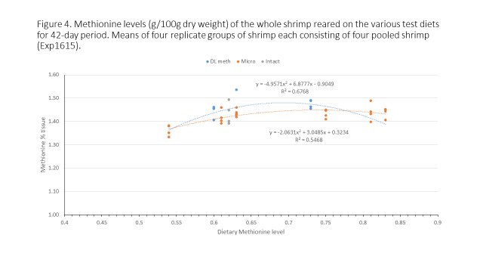

Table 5. Composition (g/100g as is) of test diets
Exp1627 | Basal | CP5 | CP10 | CP15 | CP20 | CP25 | M-0.1 | M-0.2 | M-0.4 | M-0.6
Menhaden fishmeal | 4.50 | 4.50 | 4.50 | 4.50 | 4.50 | 4.50 | 4.50 | 4.50 | 4.50 | 4.50
Soybean meal | 46.10 | 39.58 | 33.06 | 26.55 | 20.04 | 13.51 | 46.10 | 46.10 | 46.10 | 46.10
Corn protein concentrate |  | 5.00 | 10.00 | 15.00 | 20.00 | 25.00
Gelatin | 5.00 | 4.00 | 3.00 | 2.00 | 1.00 |  | 5.00 | 5.00 | 5.00 | 5.00
Menhaden fish oil | 5.43 | 5.49 | 5.55 | 5.61 | 5.67 | 5.73 | 5.43 | 5.43 | 5.43 | 5.43
Lecithin | 1.00 | 1.00 | 1.00 | 1.00 | 1.00 | 1.00 | 1.00 | 1.00 | 1.00 | 1.00
Cholesterol | 0.08 | 0.08 | 0.08 | 0.08 | 0.08 | 0.08 | 0.08 | 0.08 | 0.08 | 0.08
Corn Starch | 3.69 | 6.15 | 8.61 | 11.06 | 13.51 | 15.98 | 3.69 | 3.69 | 3.69 | 3.69
Whole wheat | 27.00 | 27.00 | 27.00 | 27.00 | 27.00 | 27.00 | 27.00 | 27.00 | 27.00 | 27.00
Mineral premix | 0.50 | 0.50 | 0.50 | 0.50 | 0.50 | 0.50 | 0.50 | 0.50 | 0.50 | 0.50
Vitamin premix | 1.80 | 1.80 | 1.80 | 1.80 | 1.80 | 1.80 | 1.80 | 1.80 | 1.80 | 1.80
Choline chloride | 0.20 | 0.20 | 0.20 | 0.20 | 0.20 | 0.20 | 0.20 | 0.20 | 0.20 | 0.20
Stay C | 0.10 | 0.10 | 0.10 | 0.10 | 0.10 | 0.10 | 0.10 | 0.10 | 0.10 | 0.10
CaP-dibasic | 3.00 | 3.00 | 3.00 | 3.00 | 3.00 | 3.00 | 3.00 | 3.00 | 3.00 | 3.00
Arginine |  |  | 0.17 | 0.35 | 0.53 | 0.70
Lysine |  |  | 0.07 | 0.24 | 0.42 | 0.59
DL-Methionine |  |  |  |  |  |  | 0.10 | 0.20 | 0.40 | 0.60
Threonine | 0.19 | 0.20 | 0.21 | 0.22 | 0.24 | 0.25 | 0.19 | 0.19 | 0.19 | 0.19
Glutamic acid | 1.41 | 1.40 | 1.15 | 0.79 | 0.41 | 0.06 | 1.31 | 1.21 | 1.01 | 0.81

Table 5a (exp1627). Response of juvenile shrimp (0.85 g) to various test diets over a 42-day growth trial. Means of four replicate groups of shrimp is presented. Means with different superscripts within a column are significantly different based on Student-Newman-Kuels test. Means with a * indicates a significant difference in the response as compared to that of the basal diet.
 | Final No. | Final | Mean | Weight | Weight Gain (%) | FCR | Percent
 | Final No. | Biomass (g) | Weight (g) | Gain (g) | Weight Gain (%) | FCR | Survival
Basal | 9 | 53.8 | 5.98 | 5.14 | 611.29 | 1.92 | 90
CP5 | 9 | 44.89 | 4.99 | 4.14 | 483.66 | 2.46 | 90
CP10 | 9 | 42.87 | 4.72 | 3.89 | 470.32 | 2.58 | 90
CP15 | 9.5 | 52.23 | 5.51 | 4.63 | 533.25 | 2.16 | 95
CP20 | 8.75 | 46.49 | 5.41 | 4.59 | 565.44 | 2.17 | 87.5
CP25 | 7.75 | 35.44* | 4.65* | 3.79* | 440.50* | 2.71 | 77.5
M-0.1 | 9.25 | 41.33 | 4.44* | 3.61* | 432.05* | 2.75* | 92.5
M-0.2 | 8.25 | 38.48 | 4.66* | 3.82* | 455.01* | 2.57* | 82.5
M-0.4 | 8 | 45.78 | 5.72 | 4.86 | 566.16 | 2.04 | 80
M-0.6 | 9.33 | 52.34 | 5.6 | 4.72 | 539.31 | 2.08 | 93.33
P-value | 0.5178 | 0.047 | 0.0162 | 0.017 | 0.0256 | 0.0330 | 0.5178
PSE | 0.6166 | 4.065 | 0.3218 | 0.3212 | 38.83 | 0.1955 | 6.165

