Sustainable Systems Approach for Improving Soil Health and Managing Soybean Production
August 2020 Final Report
Dr. Mahdi Al-Kaisi and Alex Cleveringa
Iowa State University
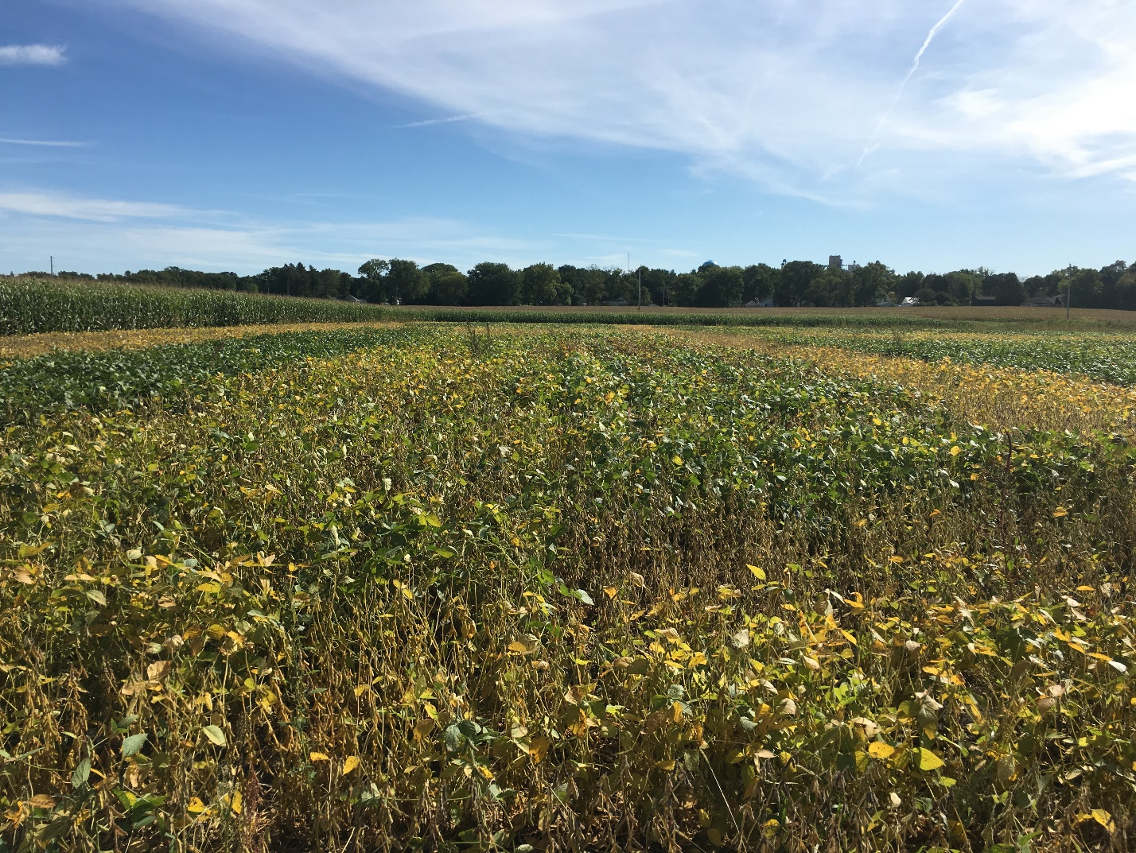
Executive Summary

This project was established in the fall of 2017 to determine the water quality, productivity, soil health and economic benefits of integrating cover crop and tillage systems (no-till, NT, and chisel plow, CP) in a soybean production system. The findings of this work demonstrate the short-term benefits of cover crop and NT in improving soil health as measured by the improvement of water infiltration and reduction in nitrate leaching under cover crop as compared to non-cover crop treatments, as well as the economic outcomes of cover crop use and NT. The seeding of cover crop before and after soybean crop in the Des Moines Lobe area is encouraged given the unique cold and wet soil conditions early in the spring. The integration of cover crop in the short-term as well as in the long-term is a good management practice for soil health and productivity, coupled with no-till. From this study, there are potential benefits to the soil health such as increase in water infiltration and reduction in nitrate loss over the short duration of the experiment. This is useful information for farmers who are considering transitioning to sustainable practices. Soybean yield was affected by tillage in 2018, with CP resulting in a 4.5 bu*ac⁻¹ higher yield than NT, and higher yield in cover crop plots compared to non-cover crop plots in 2019 by 3.4 bu*ac⁻¹. As noted in the previous progress report hyperlink, water quality is improved with the implementation of cover crops, with a reduction in water nitrate as well as soil nitrate by 29% and 44%, respectively. The economic analysis indicates increased costs associated with cover crops and decreased costs associated with NT, and when an increase in yield was obtained using cover crops, the increase in economic gains was enough to counteract the costs associated with planting cover crops.

Introduction

This report is a follow-up to the progress report in October 2019. Since that time, more data were collected and analyzed. For more information on experimental design, details, sample processing, and previous results, see hyperlink. This is the final report for this study.

The following parameters will be covered by this update:

Productivity
- Soybean Yield
- Cover Crop Aboveground Biomass
- Cover Crop Root Biomass
- Economic Analysis
Soil Health
- Soil Macro-Aggregate Stability
- Soil Bulk Density
- Soil pH
- Soil Microbial Biomass-Carbon
- Total Soil Carbon
- Soybean Residue Decomposition

Productivity

Soybean Yield

In 2018, soybean yields were slightly decreased in no-till compared to chisel plow across cover crop treatments (Fig. 1). In 2019, however, soybean yields were significantly higher in cover crop plots than non-cover crop plots by 3.4 bushels per acre (Fig. 2), and were higher than the county average for Hancock County.

Figure 1. Soybean yield following corn in 2018. Upper case letters are used for comparing cover crop treatments within each tillage system. Lower case letters are used for comparing each cover crop treatment across tillage systems. Treatment means with the same letter are not significantly different at p $≤$ 0.05. (NT = no-till; CP = chisel plow; CC = cover crop; NC = no cover crop).

Figure 2. Soybean yield following corn in 2019. Upper case letters are used for comparing cover crop treatments within tillage treatments. Lower case letters are used for comparing each cover crop treatment across tillage systems. Treatment means with the same letter are not significantly different at p $≤$ 0.05. (NT = no-till; CP = chisel plow; CC = cover crop; NC = no cover crop).

Cover Crop Biomass Analysis

Winter rye cover crop was planted in the fall of 2017 and 2018 after harvesting the cash crop and fall tillage. We collected cover crop samples in the spring just prior to termination by herbicide to evaluate the effect of tillage and cash crop on biomass growth. The aboveground biomass in 2017 was not different across tillage systems, likely because insufficient time had passed for the NT establishment to reflect changes in soil properties due to tillage in the spring of 2017 (Fig. 3). For the cover crop planted in the fall of 2018, we saw an increase in aboveground biomass in CP plots (Fig. 3). The fall tillage likely provided a better germination and growth environment in the soil by decreasing the soil moisture and increasing the soil temperature, especially in wet cold areas such as the Des Moines Lobe.
Root biomass was collected for cover crop planted in 2018. The roots grew significantly better in the CP treatments compared to the NT in the corn plots (Fig. 4), also due to a better germination and growth environment in the soil, along with increased ease of the roots to penetrate the soil.

*No biomass was collected
in Soybean 2017
Figure 3. Average winter rye aboveground biomass in different tillage systems, cash crops, and years. Crops were the cash crop preceding the cover crop planting. Treatment means with the same letters within each year and crop are not significantly different at p $≤$ 0.05 (CP = chisel plow; NT = no-till).

Figure 4. Average cover crop root biomass for cover crops planted in 2018 for different crops and tillage treatments. Crops were the cash crop preceding the cover crop planting. Treatment means with the same letters within each crop are not significantly different at p $≤$ 0.05 (NT = no-till; CP = chisel plow).

Economic Analysis

When making decisions regarding farming practices to incorporate sustainable practices into a management system, one of the driving factors is the economic costs and returns on investment. Using a variety of tools ranging from the Iowa State University Extension Ag Decision Tools, partial budgets, and on-farm data, we analyzed the input costs, economic returns, and additional financial benefits of the different cover crop and tillage practices in this study. Our results show a higher input cost for CP in comparison to NT (Figs. 5, 6, Table 1). This is caused by an increase in labor cost as well as fixed and variable costs from tillage operations (machinery, fuel, repairs, etc.). There are also higher costs associated with using cover crops (Figs. 5, 6, Table 1), driven by additional seed and planting costs. The increased costs of tillage and cover crop use persisted regardless of year. As the yield data suggest, the economic returns were higher in the soybean plots in 2019 where cover crops were used (Fig. 6, Table 1). These returns are a direct fuction of yield. An essential question is whether the net returns for the different management systems are different. The treatments where the cover crop plots had higher yields than the plots without cover crop (2019) did not show significantly different returns, which means the gains in yield were similar to the extra cost incurred by cover crop use (Table 1). When the cover crops did not improve the yield, the costs of cover crop created a loss in net returns (Table 1). Not included in this analysis are the additional potential economic benefits of grazing, which are estimated to be $30.00*ac⁻¹ by the Iowa State University Extension Ag Decision Maker.

Figure 5. Average input costs and economic return for soybean yield in 2018 under different tillage and winter rye cover crop treatments. Upper case letters are used for comparing cover crop treatments within each tillage system. Lower case letters are used for comparing each cover crop treatment between tillage systems. Treatment means with the same letter are not significantly different at p $≤$ 0.05. (NT = no-till; CP = chisel plow; CC = cover crop; NC = no cover crop).

Figure 6. Average input costs and economic return for soybean yield in 2019 under different tillage and winter rye cover crop treatments. Upper case letters are used for comparing cover crop treatments within each tillage system. Lower case letters are used for comparing each cover crop treatment between tillage systems. Treatment means with the same letter are not significantly different at p $≤$ 0.05. (NT = no-till; CP = chisel plow; CC = cover crop; NC = no cover crop).

Table 1. Average values for input cost, economic return, net return, and additional potential benefits within each year and cash crop as affected by two tillage systems and two cover crop systems. Upper case letters are used for comparing cover crop treatments within each tillage system. Lower case letters are used for comparing each cover crop treatment between tillage systems. Treatment means with the same letter are not significantly different at p $≤$ 0.05. (NT = no-till; CP = chisel plow; CC = cover crop; NC = no cover crop).

*Additional benefits represent cost share payment through USDA government programs for planting cover crops, estimated at $30 ac⁻¹. These potential benefits do not include additional benefits if cover crop is used for grazing or sold as hay product.
Soil Sampling

Macro-Aggregate Stability

As mentioned in the previous progress report, macro-aggregate stability is a test that measures the strength of soil to resist destructive forces such as rainfall and erosion. Due to the high variability of the results and the relatively short duration of the study, no significant differences between tillage or cover crop treatments were detected in either the 4 mm fraction (Fig. 7) or the 2 mm fraction (Fig. 8).

Figure 7. Average macro-aggregate stability for the 4 mm soil fraction. Upper case letters are used for comparing cover crop treatments within each tillage system and date. Lower case letters are used for comparing each cover crop treatment between cover crop treatments within each date. Treatment means with the same letter are not significantly different at p $≤$ 0.05. (NT = no-till; CP = chisel plow; CC = cover crop; NC = no cover crop).

Figure 8. Average macro-aggregate stability for the 2 mm soil fraction. Upper case letters are used for comparing cover crop treatments within each tillage system and date. Lower case letters are used for comparing each cover crop treatment between tillage systems within each date. Treatment means with the same letter are not significantly different at p $≤$ 0.05. (NT = no-till; CP = chisel plow; CC = cover crop; NC = no cover crop).

Soil Bulk Density

Bulk density was not measured in the fall of 2019 because wet soil conditions did not allow the soil to maintain its structure during sampling. While there was one significant difference in the six- to twelve-inch depth (Fig. 9), there were no consistent trends over time between tillage and cover crop treatments (Figs. 9, 10). Changes in bulk density take more time as influenced by cover crop or tillage treatments.

Figure 9. Average soil bulk density in the top six inches of soil for different tillage and cover crop treatments. Upper case letters compare cover crop treatments within each tillage system and date. Lower case letters compare each cover crop treatment between tillage systems within each date. Treatment means with the same letter are not significantly different at p $≤$ 0.05 (NT = no-till; CP = chisel plow; CC = cover crop; NC = no cover crop).

Figure 10. Average soil bulk density in the six- to twelve-inch depth of soil for different tillage and cover crop treatments. Upper case letters compare cover crop treatments within each tillage system and date. Lower case letters compare each cover crop treatment between tillage systems within each date. Treatment means with the same letter are not significantly different at p $≤$ 0.05 (NT = no-till; CP = chisel plow; CC = cover crop; NC = no cover crop).

Soil pH

Soil pH on average was 0.8 lower in the top six inches than the second six inches. Although there were a couple of significant differences (Fig. 11), there were no significant trends within treatments over time (Figs. 11, 12).

Figure 11. Average total soil pH in the top six inches of soil for different tillage and cover crop treatments. Upper case letters compare cover crop treatments within each tillage system and date. Lower case letters compare cover crop treatments across tillage systems within each date. Treatment means with the same letter are not significantly different at p $≤$ 0.05 (NT = no-till; CP = chisel plow; CC = cover crop; NC = no cover crop).

Figure 12. Average total soil pH in the six- to twelve-inch depth of soil for different crop, tillage, and cover crop treatments. Upper case letters compare cover crop treatments within each tillage system, crop, and date. Lower case letters compare each cover crop treatment between tillage systems within each date. Treatment means with the same letter are not significantly different at p $≤$ 0.05 (NT = no-till; CP = chisel plow; CC = cover crop; NC = no cover crop).

Microbial Biomass-Carbon

The amount of carbon in the soil has been slowly decreasing ever since modern cultivation practices began. One benefit of cover crops is that by growing them and returning the biomass to the soil, carbon levels have the potential to slow or reverse that trend. Soil microbial biomass is highly variable and dependent on soil moisture. Due to these confounding factors, there were no consistent differences between treatments or clear trends over the first two years of cover crop and NT treatments (Fig. 13).

Figure 13. Average soil microbial biomass-carbon in the top six inches of soil for different tillage and cover crop treatments. Upper case letters compare cover crop treatments within each tillage system and date. Lower case letters compare each cover crop treatment between tillage systems within each date. Treatment means with the same letter are not significantly different at p $≤$ 0.05 (NT = no-till; CP = chisel plow; CC = cover crop; NC = no cover crop).

Total Soil Carbon

Soil samples taken in the fall of 2017, 2018, and 2019 as well as the spring of 2018 and 2019 were dried, sieved, and sent to Ward Labs in Kearney, NE for total soil carbon analysis. In general, there was about 0.5% higher soil carbon in the top six inches than the next six inches, regardless of tillage or cover crop. While there were a few significant differences (Figs. 14, 15), there were no clear trends to indicate use of cover crops or tillage have an immediate impact on soil carbon over two years. This is widely documented due to the short-term nature of such studies.

Figure 14. Average total soil carbon in the top six inches of soil for different tillage and cover crop treatments. Upper case letters compare cover crop treatments within each tillage system and date. Lower case letters compare cover crop treatments between tillage systems within each date. Treatment means with the same letter are not significantly different at p $≤$ 0.05 (NT = no-till; CP = chisel plow; CC = cover crop; NC = no cover crop).

Figure 15. Average total soil carbon in the six- to twelve-inch soil depth for different tillage and cover crop treatments. Upper case letters compare cover crop treatments within each tillage system and date. Lower case letters compare cover crop treatments between tillage systems within each date. Treatment means with the same letter are not significantly different at p $≤$ 0.05 (NT = no-till; CP = chisel plow; CC = cover crop; NC = no cover crop).

Soybean Residue Decomposition

We grew three soybean varieties with different C:N ratios to measure how quickly each one decomposed in the field under different tillage systems. Further experimental details can be found in the 2019 Progress Report hyperlink. Based on the data collected, we created a model to predict the proportion of soybean residue mass remaining over time. Our findings show that there was no difference between the rate of decomposition between soybean varieties, but the plants in NT decomposed at a faster rate than the plants in CP (Fig. 16). As stated in the 2019 Progress Report, this may be caused by the increased soil moisture associated with NT and a lack of disruption of the biological community, both of which lead to higher microbial activity which breaks down the residue.

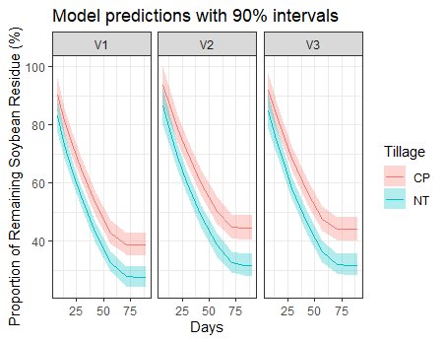
Figure 16. Soybean residue decomposition by soybean variety and tillage system. There is a significant difference in proportion of mass between tillage systems for each variety, which shows that soybeans placed in the NT plots decomposed at a faster rate than soybeans placed in the CP plots. There were no significant differences between varieties. (NT = no-till; CP = chisel plow; V1 = Variety 1, C:N =47:1; V2 = Variety 2, C:N = 38:1; V3 = Variety 3, C:N = 29:1).

