Final Progress Report 2025 Multi-Regional Soybean Board

Characterizing and Utilizing Metribuzin Tolerance in Soybeans to Improve Weed Management Strategies in Early Planted Soybeans

By

Samuel Revolinski, PhD (PI) &
Caio Vieira, PhD (Co-I)

Submitted to

Multi-Regional Soybean Checkoff
Project Period: January 1, 2025 to December 31, 2025

1. BACKGROUND AND INTRODUCTION
1.1 INTRODUCTION
Conventional soybean producers in the southern and mid-southern regions have increasingly adopted early planting systems in recent years. Many soybean producers in the southern and mid-southern regions like planting their soybneans early because it allows them to harvest earlier, making the planting of the subsequent winter-wheat rotation easier. However, metribuzin causes increased damage to soybeans and decreases weed control in early-planted soybeans (Goddard 2024). Furthermore, metribuzin applications led to significant yield losses in early planted soybeans in Mississippi (Poston et al. 2008), while 80% of metribuzin in the soil can be dissipated within 30 days (Fouad et al. 2023).
In traditional soybean production systems where soybeans are planted in mid to late May, pre-emergent herbicides like metribuzin only need to last a month to prevent the germination of pigweeds such as waterhemp or palmer amaranth that germinate in June. However, a second later dose of metribuzin on top of early planted soybeans to extend the control of pigweeds is not possible currently because post-emergence metribuzin applications heavily damage many soybean cultivars. Fortunately, a greenhouse screening of injury ratings (Figure 1) by Dr. Revolinski in conjunction with Dr. Vieira identified MGs 4, 5, and 6 soybean germplasm highly tolerant to post-emergence metribuzin applications (Table 1) and a major genetic marker explaining up to 54% of the phenotypic variation (Figure 2). While these markers and genetic resources may be useful for developing metribuzin tolerant lines for traditional soybean systems, the MGs used in the previous study are not suitable for early planted soybeans where the producers are planting soybean early so that they can harvest sooner.
To aid in the implementation of weed management strategies in early planted soybeans, QTLs associated with metribuzin tolerance need to be introgressed into late MG-3 to early MG-4 advanced breeding lines. While a large effect QTL was identified in MGs 4-6, early-planted soybeans rely on late MG-3 or early MG-4. Thus, identifying and incorporating genetic resources within these MGs are needed to develop a proper early-planted cropping system.
1.2 PROJECT RATIONALE & JUSTIFICATION
Early-planted soybeans are becoming increasingly popular among soybean growers in the south and mid-south due to the ease of moving into the next crop of the rotation. However, little consideration is made for the management of weeds in early-planted soybeans. With increasing resistance to glyphosate, glufosinate, and synthetic auxins in broadleaf weeds, growers are increasingly relying on pre-emergent herbicides such as metribuzin to manage weeds in soybean production systems.
Having the option to add a second metribuzin application on top of the soybeans would be greatly beneficial for managing troublesome pigweeds (waterhemp and palmer amaranth) in early planted soybeans because the pre-emergent applications of metribuzin are likely to be mostly degraded by June when waterhemp and palmer amaranth germinate (Figure 3). If pigweed populations are glyphosate-, glufosinate-, and synthetic auxin-resistant, then management of these pigweeds relies on metribuzin which will be inactive in early planted soybean systems by June when the weeds germinate. Our work would allow for an extended residual activity of metribuzin in the soil by allowing an over-the-top application of metribuzin in soybeans, thus maintaining the control of pigweeds through the time in which pigweeds germinate.
As such, our proposed work fits perfectly into the Nationally Integrated Weed Management research area because the project will allow for improved weed management options in early planted soybeans. Additionally, the project also fits into the Tools & Technology for Soybean Improvement research area because the project is working to improve soybean tolerance to an herbicide using natural variation. Because of multiple herbicide (glyphosate, glufosinate, group 2s and synthetic auxins) resistance in palmer amaranth and waterhemp, metribuzin is one of the only herbicides that is still effective for managing pigweeds when multiple herbicide resistance is present. Without effective metribuzin regiments in early planted soybeans, early planted soybeans will likely become economically unfeasible when multiple herbicide resistant pigweeds invade those fields.
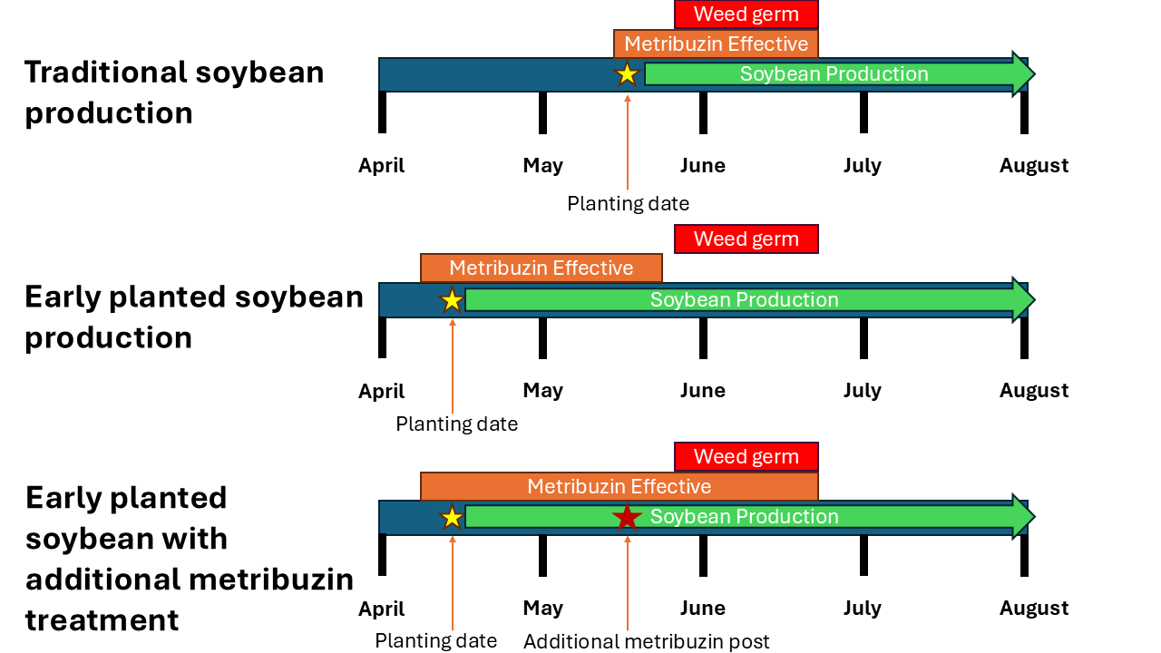
Figure 1. Timeline of soybean production in the southern United states with traditionally planted, early planted, and early planted with an additional metribuzin treatment on top of the soybean. Weed germ is the window in which the majority of palmer amaranth and water hemp emerge.

1.3. GOALS & OBJECTIVES
Goal: Using the natural genetic variation conferring post-emergence metribuzin tolerance, develop metribuzin-tolerant soybeans suitable for early planting, thus allowing for increased metribuzin use in early-planted soybeans.
Objective 1: Screen late MG-3 and early MG-4 soybeans from GRIN for tolerance and map QTL conferring the tolerance.
Objective 2: Perform full doses responses on a subset of lines that are identified as highly tolerant or highly susceptible to post-emergence metribuzin applications. Advanced breeding lines and commonly grown commercial varieties will also be included in the dose responses.
Objective 3 (Breeding): Introgress the major QTL identified in the previous study (Figure 2) and the QTL identified from objective 1 into high-yielding lines.
1.4 BENEFITS FOR SOYBEAN FARMERS
Because of multi-herbicide resistance in Palmer amaranth and waterhemp, management options to control these weeds are limited in soybean production systems. Pre-emergent residual herbicides have been essential for managing herbicide resistant pigweeds. However, early planted soybeans require residual herbicides to be effective longer than standard planted soybeans. Thus, the development of soybean lines with post-emergence metribuzin tolerance will allow for an additional post-emergent dose of metribuzin to be used to maintain metribuzin levels at high enough levels in the soil to manage pigweeds when they germinate.

2. MATERIALS & METHODS
Objective 1: 892 soybean lines that have been genotyped with the SoySNP50K iSelect BeadChip and are early MG 4 or late MG 3 were ordered from the Germplasm Resource Information Network (GRIN). Those 892 lines were screened in three metribuzin greenhouse trials, separated in time with two check lines that were used in all 3 trials (check 1: PI 556632 & check 2: PI 592547). Three replicates of those 892 lines were sprayed with 300g ai ha-1 of metribuzin postemergence in a spray chamber for each trial. Lines will be evaluated by injury rating (Figure 2). The best linear unbiased estimates of each line in the trials were used to perform a GWAS analysis to identify markers that can be used to select for metribuzin tolerance early MG4 and late MG3 in soybean lines.
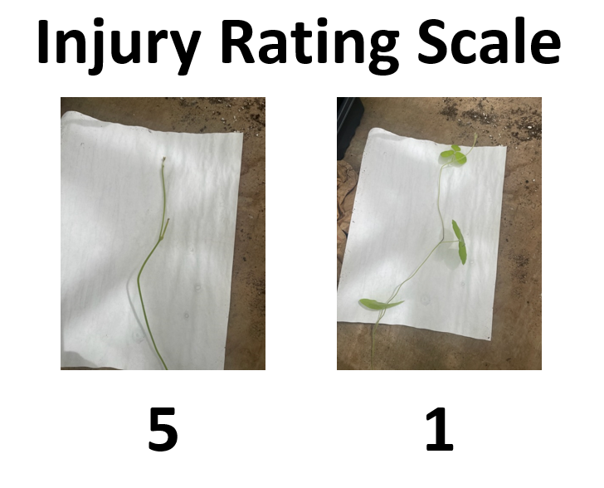
Figure 2. Examples of the injury rating scale developed for measuring soybean response to metribuzin. Images from a previous trial in MG-4, MG-5 and MG-6 soybean lines. “5” represents complete plant death while 1 is no visible damage.
Objective 2: Five highly tolerant and 5 highly susceptible lines were sprayed with 0, 50, 100, 200, 400, 800 and 1600 g ai ha-1 of metribuzin postemergence in the spray chamber and evaluated in the greenhouse. Injury ratings, fresh biomass and height were collected 21 days after treatment so that response curves could be developed.
Objective 3 (Breeding): To introgress the identified major QTL into high-yielding lines, a backcross approach supported by molecular markers was established. A total of 5 bi-parental populations were developed derived from a high-yielding, metribuzin-susceptible conventional cultivar (late MG-3 to early MG-4) and a metribuzin-tolerant genetic resource identified. These will undergo backcrosses to recover the genomic contribution of the recurrent parents (high-yielding) until reaching the BC3 stage. In each backcross cycle, progenies will be screened with molecular markers and sprayed with metribuzin. Once reaching the BC3F4 generation, roughly 50 single plants per population will be threshed individually and will be used to grow a small seed increase. Once finalized, all 250 converted lines (metribuzin, high-yielding) will enter multi-environment yield trials.
3. RESULTS
3.1 GRIN SCREENING
Screening the 892 GRIN lines revealed that post-emergence metribuzin tolerance is a heritable trait (Table 1.) that could bred for. The average BLUE for the lines was 3.59 at 300 g ai ha⁻¹ indicating that most lines screened were heavily damaged on average. However, the most tolerant soybean lines had no damage in all three replicates (Figure 3 & Table 1).
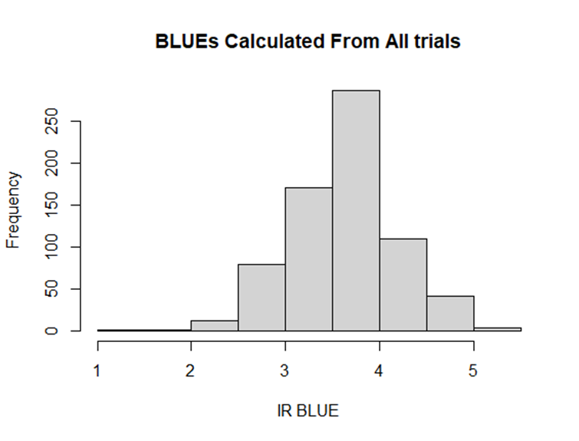
Figure 3. Histogram of Best Linear Unbiased Estimates (BLUEs) for all 892 GRIN lines which are means adjusted by trial and replicate effects.

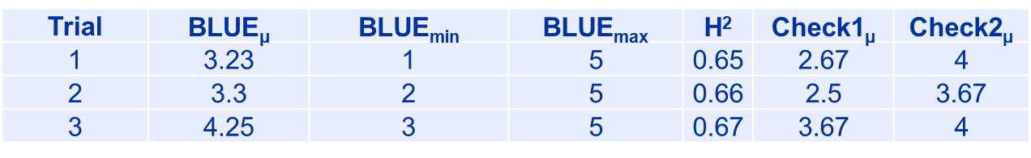
Table 1. Summary statistics of trials, Mean BLUE, Min BLUE, Max BLUE, H² (broad-sense heritability), check 1 mean, and check 2 mean.

3.2 GENOME-WIDE ASSOCIATION STUDY
The genome-wise association study on the 892 GRIN soybean lines revealed two marker-trait associations. One marker-trait association was identified on chromosome 16 at position 36328948 and explains 5.38% of the phenotypic variation with a minor allele frequency of 0.49 (Figure 4 & Table 2). The other marker-trait association was on chromosome 18 at position 11594293, explaining 48.5% of the phenotypic variation with a minor allele frequency of 0.02 (meaning 2/100 of the accessions had the variant).
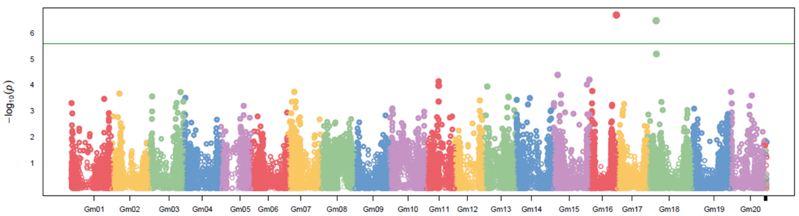
Figure 4. Manhattan plot from GWAS analysis for post-emergent metribuzin tolerance. The Y-axis is the negative log p-values, and the X-axis is the position is along each chromosome. The green horizontal line is the Bonferroni multiple-testing threshold for significance where dots above the line are significant marker trait associations.
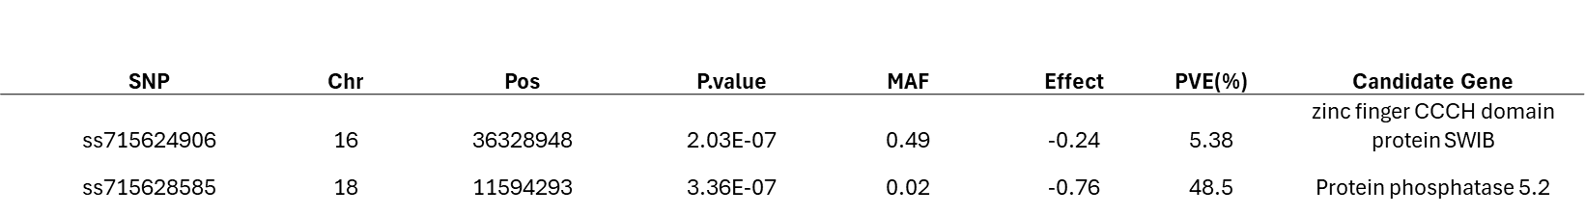
Table 2. Summary information on the markers-trait associations where SNP is the marker, Chr is the chromosome, Pos position, MAF is the minor allele frequency and PVE is the percent of the phenotypic variation explained by the marker.
3.3 CANDIDATE GENES
For the marker-trait association on chromosome 16, the closest gene on the genome (SNP is in the gene) is a zinc finger CCCH domain protein SWIB. Zinc finger CCCH domain proteins control genes related to abiotic stress and knock mutations in those genes reduce tolerance of plants to oxidative stress (Han et al. 2021), much like metribuzin.
For the marker-trait association on chromosome 18 the gene overlapping with the SNP was a protein phosphatase 5.2. Protein phosphatases remove phosphate groups on proteins thus activating them. Protein phosphatase 5.2 regulates heat-shock factor proteins which have been shown to be involved with herbicide tolerance (Revolinski et al. 2025).
3.4 DOSE REPONSE OF ADVANCED BREEDING LINES
Log-logistic curves fit to biomass after 7 days with 200, 400, 800 and 1600g ai ha⁻¹ of metribuzin sprayed post-emergence shows that tolerant versus non-tolerant lines show different patterns of tolerance. The R19C-1081, R21KB-06852 and R18C-1877-0017 lines were highly tolerant not losing much biomass until about 400 g ai ha⁻¹ while R19-1035, R20-1870, and R21C-01880 were highly susceptible to metribuzin losing considerable biomass starting at 200g ai ha⁻¹ of metribuzin (Figure 5).
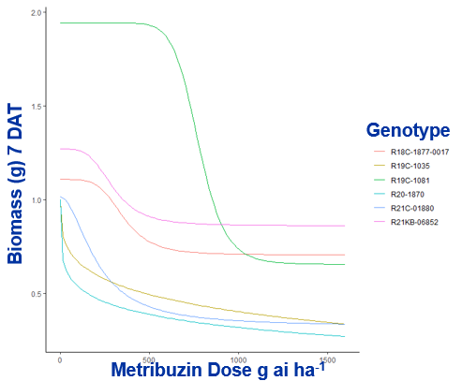
Figure 5. Dose response curves of advanced breeding lines exposed to increasing metribuzin rates.
3.5 CROSSING TO DEVELOP METRIBUZIN TOLERANT LINES
Based on a marker found by preliminary data or good agronomic traits, the following crosses were made;
K20-2470 x R21KB-05522
R19-4593 x R16-45
R16-45 x R01-581F
R16-45 x R19-45980
R16-45 x R14-1422
R16-45 x R21KB-05776
R22KB-16636 x K21-2518
TN22-4626N x R22KB-16636
R01-581F x R20-1429
R18-14502 x R20-1429
TN22-4626N x R20-1429
R19C-1035 x R23PR-00037E
R19C-1035 x R23PR-00068E
R19C-1035 x R23PR-00100E
R19C-1035 x S21-11102
R19C-1035 x R23KB-02435
S21-7836 x R19C-1035
R19C-1035 x K20-1313
R19C-1035 x R23KB-03901
R18-14693:0004 x R19C-1035
R19C-1035 x R22KB-00870
R19-4593 x R19C-1035
R19C-1035 x R22KB-09998
R19C-1035 x R96-209
S19-12537 x R19C-1035

4. FUTURE DIRECTIONS

- My staff accidentally ordered 1800 GRIN soybean lines instead of the 192 promised so we screened 892 lines for now but we are currently working on finishing the screening of all the 1800 lines we ordered so that we can provide that information as a public resource and find more marker-trait association with post-emergence metribuzin tolerance.
- We are currently working on molecularly validating the function of genes associated with metribuzin tolerance, potentially opening the door to using biotechnology directly to develop highly metribuzin tolerant soybean cultivars.
- Crossing efforts are continuing for developing post-emergent metribuzin tolerant soybean cultivars
- We are testing the application of an additional post-emergent metribuzin dose to early planted soybeans in the field and tracking the loss of metribuzin in the soil along with the impacts on rhizobium.
- CONCLUSIONS
Our project documented that soybean tolerance to post-emergence metribuzin exists in GRIN soybean germplasm and may be used to improve weed control in early-planted systems once highly metribuzin tolerant soybean lines with good agronomic qualities are developed. By screening 892 late MG-3 and early MG-4 soybean lines, we identified several lines with strong tolerance to post-emergence metribuzin applications, confirming that this trait is heritable and can be bred into commercial varieties. Genome-wide association analyses identified two key genomic regions linked to tolerance, including one rare major region explaining nearly half of the observed phenotypic variation, providing valuable markers for selection. A dose-response study confirmed that tolerant breeding lines maintain growth at metribuzin rates that severely injure susceptible lines. Using this information, multiple crosses were made to move metribuzin tolerance into high-yielding soybean backgrounds. Overall, these results lay the foundation for developing early planted soybean varieties that safely allow a second metribuzin application, helping growers manage herbicide-resistant pigweeds and protect yields in challenging weed environments.
- REFERENCES
Fouad MR, Badawy MEI, El-Aswad A and Aly MI (2023). Experimental modeling design to study the effect of different soil treatments on the dissipation of metribuzin herbicide with effect on dehydrogenase activity. Curr. Chem. Lett. 12:383-396
Goddard MS (2024) Integrated Weed Management Strategies in early planted soybean. Michigan State University
Han G, Qiao Z, Li Y, Wang C and Wang B (2021). The Roles of CCCH Zinc-Finger Proteins in Plant Abiotic Stress Tolerance. Int. J. Mol. Sci. 22:8237
Poston DH, Nandula VK, Koger CH and Griffin RM (2008). Preemergence Herbicides Effect on Growth and Yield of Early-Planted Mississippi Soybean. Crop Manag. 7:1-14
Revolinski SR, Amaral M, Savic M and Burke IC (2025). Genome-wide scan reveals CYP450 metabolism and stress response regulation underlying sulfosulfuron resistance in Bromus tectorum. Pest Manag. Sci. 82:1500-1508

