Final Report: SOYGEN3 (Year 3 of 3)
Building capacity to increase soybean genetic gain in future environments through genomics-assisted breeding and environmental characterization

Overview
Over the three-year duration of SOYGEN3, the project made substantial progress toward advancing genomics-assisted breeding in soybean, with a particular emphasis on increasing genetic gain under dynamic and unpredictable environmental conditions. By integrating genomic data, multi-environment phenotyping, and environmental characterization, the project delivered a suite of datasets, tools, and analytical frameworks that are now being actively used in public breeding programs. The final year was especially important, as it brought together earlier investments in data generation and tool development into validated systems that demonstrate clear value for breeding decisions. Collectively, these outcomes position public soybean breeding programs to more effectively select superior varieties adapted to both current and future production environments.

Below we have listed our progress according to each Key Performance Indicator

- Approximately 425 – 450 new advanced breeding lines entered into the Northern Uniform Soybean Tests (NUST) genotyped each year using low-pass sequencing technology.

Outcome: Successfully completed. Over these past three years, we generated genome-wide marker data for every breeding lines entered into NUST for a total of 1035 lines genotyped during this project period. Data from these lines has been stored in Soybeanbase and has been used to build genome-wide prediction models.

- The “SOYGEN Genomic Selection” application and/or Breedbase installation at SoyBase.org is fully operational and used by majority of participating soybean breeding programs for managing genomic selection programs.

Outcome: The database and tool development has been successful. It is estimated a portion of the project collaborators are using these tools on a regular basis, but not yet most. We are working with individual projects to increase utilization and hope to continue to make better progress on this. The “SOYGEN Genomic Selection” application was completed and renamed “GS4PB”. We published a peer-reviewed manuscript on this in The Plant Genome (https://doi.org/10.1002/tpg2.70150) last fall. It has already been downloaded over 1500 times and we have received inquiries from public breeders across the country on its use. We are continuing to find ways to improve this tool by adding additional features such as AI-based guides on how to use the tool. As outlined in the publication, we have shown that the genomic prediction workflow implemented in this tool performs at least as well (and often better than) phenotypic selection, opening up many avenues for breeders to use genomic prediction in their programs.

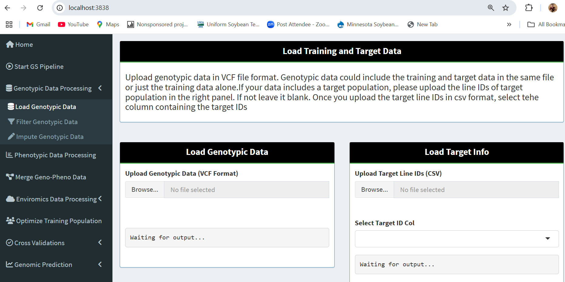

Figure 1. Screenshot of the GS4PB app page where users can load data using a graphical user interface. The steps implement in the app are available in a menu on the left of the screen.

Also in line with the KPI, Soybeanbase is fully functional. We have also continue to adopt and deposit data into Soybeanbase, a version of BreedBase that stores genome-wide marker data in a structured and organized way, tracking metadata and allowing easy inquiry of genome-wide marker data status. Data is imported and exported in standardized formats, easing the workflow of genomic prediction and allowing predictions to be made more quickly and effectively.

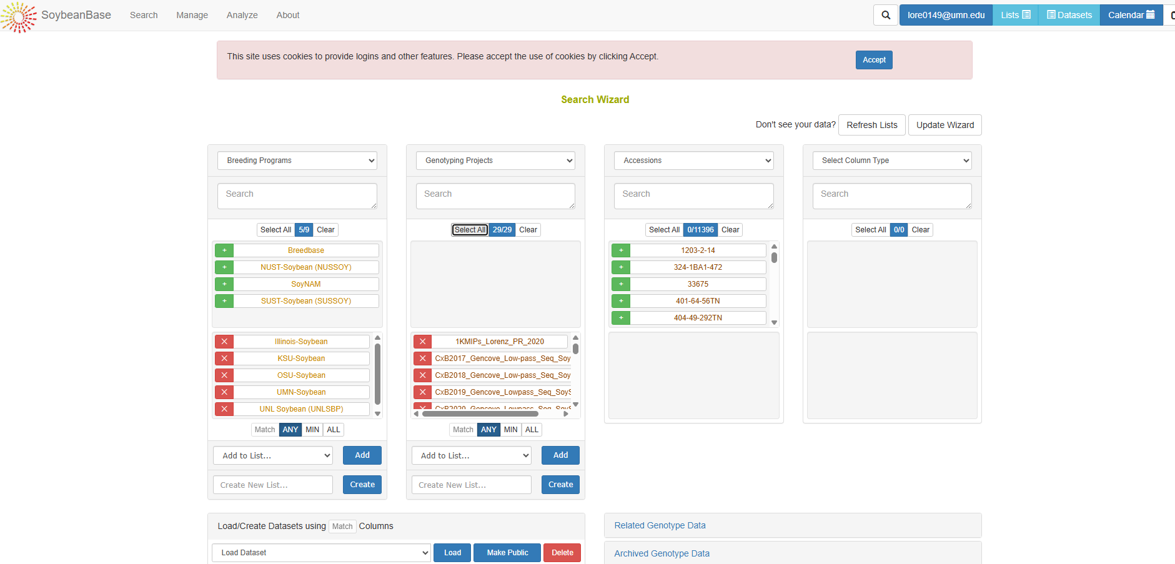

Figure 2. Screenshot of the Soybeanbase query page for easily accessing structured and standardized genome-wide marker data.

- Low density genotyping-to-high density genotyping imputation leveraging pedigrees integrated into tools described in KPI #2.

Outcome: This has also been successfully completed. As described in the GS4PB manuscript (https://doi.org/10.1002/tpg2.70150), we implemented methods in the packaged AlphaPlantImpute that can either use population-based or pedigree-based approaches to marker imputation, effectively going from low-density markers to high-density markers. The challenge of using AlphaPlantImpute is that is only available in Python, thus making it less accessible to many users. Integrating this into GS4PB allows genomic prediction practitioners to seamlessly incorporate this powerful genotype imputation method into their streamlined data workflow.

- By end of third year, majority of participating breeding programs are using genomic selection and developed GEI models routinely.

Outcome: The majority of SOYGEN cooperators are using genomic selection in their programs, and the resulting tools and data developed by this project have helped expedite this. For example, the University of Nebraska has been exploring a “sparse-testing approach” using genomic data in their selections, helping to save phenotyping resources.

- GEI panels are selected, genotyped, and phenotyped at characterized environments, and full dataset is provided to SOYGEN team members. These data will subsequently be made publicly available at SoyBase.org.

Outcome: All GEI panels of lines (4 RM sets, ~300 lines per set) were successfully selected, genotyped, and phenotyped in two years as indicated by the KPI. In total, approximately 1200 unique breeding lines were genotype using “skim sequencing” from which we extracted 36,000 SNPs corresponding to the standard 50K SNP assay. The lines were phenotyped at 21 locations in 2024 and 19 locations in 2025 for a total of 40 unique environments. Soil samples were collected at each location, and weather data has been obtained from the national weather databases. All data has been curated and deposited in our internal database. We have applied a yield adjustment for maturity date, and spatial analysis of the data to estimated breeding lines effects per environment. Data reliability measures were excellent at 90% of the environments, and quality control indicators such as flower color and pubescence color indicate data was collected correctly. We are now beginning the third year of this study which, when complete, will create an unprecedented soybean breeding dataset that both public and private breeding programs can use to model genomic prediction for genotype-by-environment interactions.

- Model developed that can predict line performance in new environments based on environmental data, and model performance exceeds baseline model in accuracy of prediction.

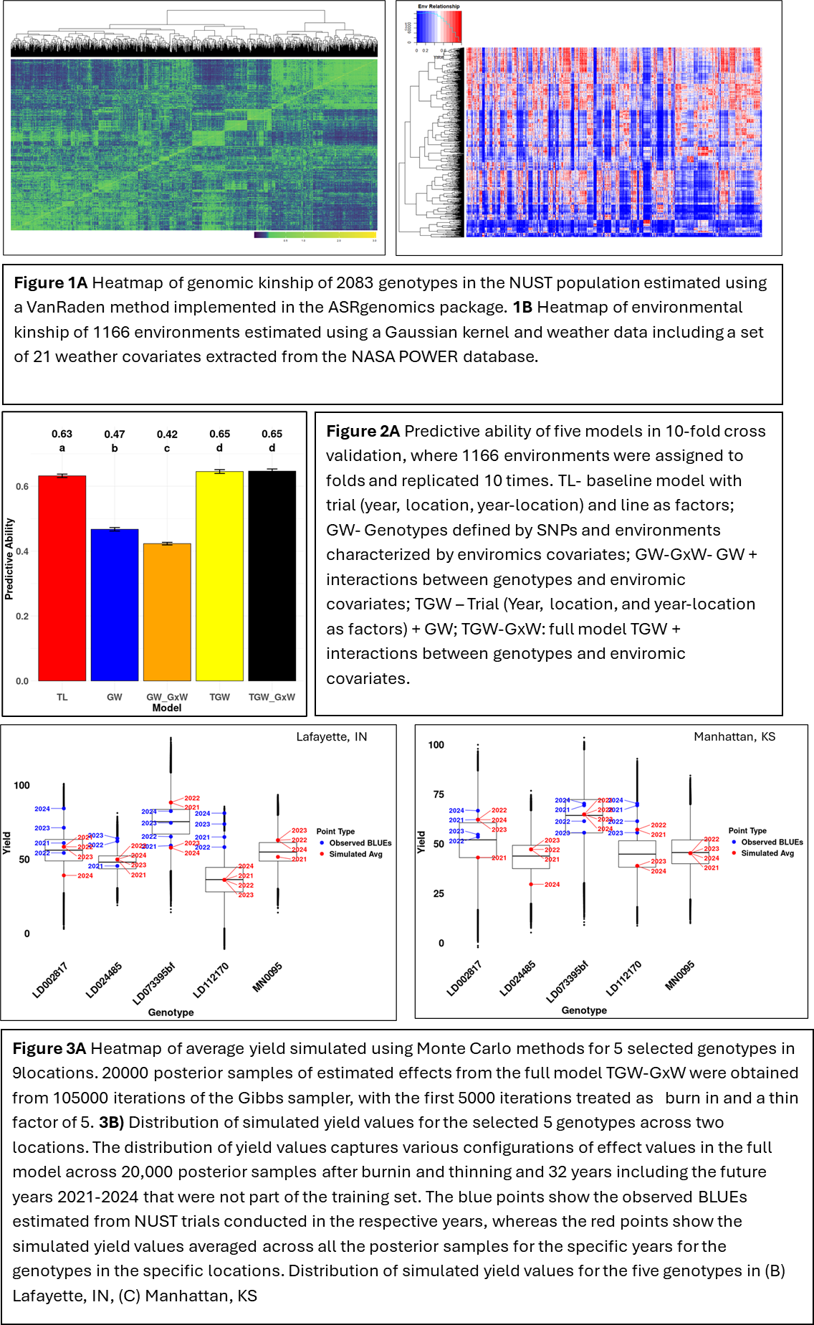
Outcome: This milestone is still in progress as we decided to add a third year of data collection to the project. The first thing we did to address this is implement the methods of de los Campos et al. (2020) as we described in the proposal. In this method, de Los Campos et al (2020) proposed a novel framework for predicting GxE interactions and assessing breeding line performance uncertainty and stability among diverse environmental conditions. We implemented these simulations using the NUST genotype and phenotype data described above. By simulating the possible environmental scenarios in over 100,000 environments for each location, modelling interactions between genotypes and environmental conditions, we predicted the performance of each line in each potential environment. The predictions were then validated using observed performance in the years 2020-24 (years left out of the training set). Unfortunately, we did not see an improvement over baseline models and we believe this is because we are not adequately modelling the environmental variables. Lovepreet Singh, a graduate student supported by SOYGEN, is spending the next couple of months in a research lab focusing on modelling genotype-by-environment interactions and we expect to apply what we learns from that experience to the SOYGEN dataset to improve predictive soybean breeding.

With respect to the SOYGEN GxE data we have collected as described above, we have begun to test and analyze genomic prediction models. Using a leave-one-line-out cross validation analysis, we determined that our ability to predict performance was quite good, with a range of 0.61 (RM Set 1) to 0.75 (RM Set 2). This indicates that our genotype and phenotype data is, as mentioned above, of good quality. However, we found that when we use data across a diverse range of environments to build a predictive model, or predictive ability dramatically falls off. This indicates that there is room to develop models capturing genotype-by-environment interactions to improve our ability to predict and thus more effectively use genomic prediction for soybean breeding.

- Forty-one SoyNAM founders are sequenced at 30x depth and structural variants scored and projected to NAM progenies.

For the sequences of the 41 SoyNAM founders, we have obtained high quality DNA from dark-adapted greenhouse-grown plants, and sequenced the whole genomes with Illumina technology to very high depth and quality. and have now effectively utilized various structural variant (SV) caller tools in tandem to identify SVs within the soybean NAM parents' dataset. Specifically, Sentieon has revealed approximately 470,000 unfiltered SVs. Delly has identified about 35,000 unfiltered SVs, and CNVnator has detected approximately 4,000 unfiltered copy number variations (CNVs).

Meanwhile, the SOYGEN group used the core of our preliminary data and research plans to lead a proposal to DOE JGI to perform a high-quality, reference-grade pangenome, consisting of 400 reference-quality soybean genomes each of similar quality to the current Williams 82 reference genome.

8. Structural variants are associated with publicly available seed yield and composition data from multi-environment trials, and genomic prediction models using structural variants are tested against baseline models.

The Hudson laboratory has so far analyzed data from the Soybean NAM population to study the influence of structural variants on accounting for genetic variation for yield. To date, they have found that when the newest genome assembly of soybean was used, modelling structural variants does account for more genetic variation in yield than only single nucleotide polymorphism data alone. This means, potentially, that further investigation of the modelling of structure variation for prediction of yield could help improve predictive ability for breeding programs.

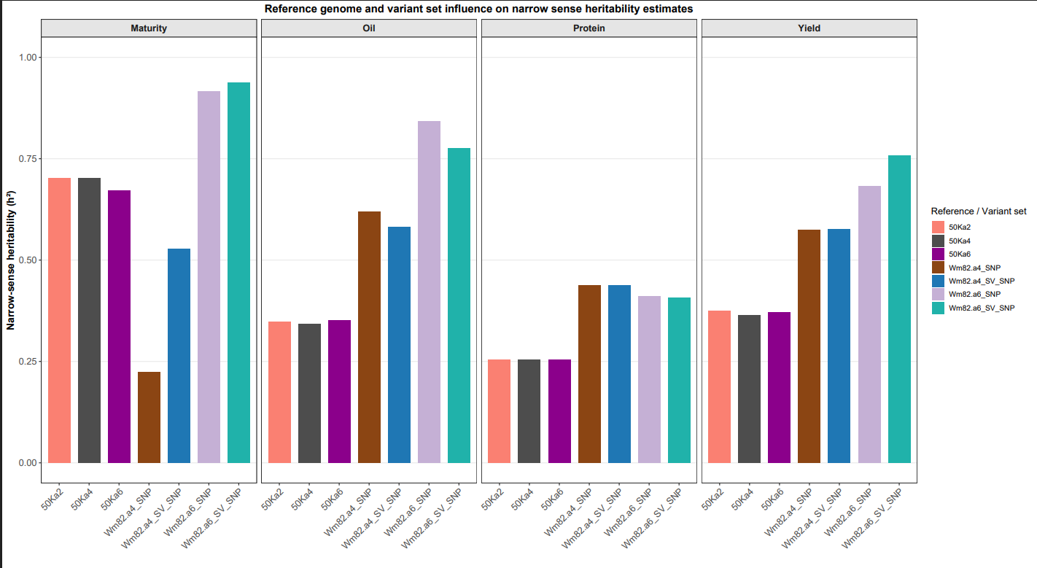
Figure 4. Genetic variation for yield accounted for by simple molecular markers (SNPs) versus structural variations (SV). The value represented by the teal bars indicates that adding information on structural variations improved ability to explain genetic variation for yield, and thus could help enhance predictive ability of genomic prediction.

To enable further discovery of structural variation, the Hudson lab is building a pangenome resource consisting of many hundreds of soybean genome assemblies. This resource will help enable this project determine the importance of structural variation on yield and genotype-by-environment interactions in soybean.

Laymen’s summary

Over the past several years, a large team of soybean breeders and researchers across the Midwest has been working together to improve how new soybean varieties are developed. The goal of this project is to help breeders make better decisions earlier in the process, so that higher-yielding and more stable soybean varieties reach farmers faster.
One of the biggest accomplishments of the project has been the development of a massive dataset that combines field performance with detailed DNA information. Researchers have now collected genetic data on more than 4,000 soybean breeding lines and paired that with decades of yield and agronomic data from regional trials. This gives breeders a much clearer picture of which genetic traits lead to strong performance in the field.
Using this information, the team has developed tools that allow breeders to predict how a soybean line will perform based on its DNA alone. Traditionally, breeders rely heavily on field trials to decide which lines to advance or discard. However, results from this project show that DNA-based predictions can perform just as well as traditional methods—and in some cases better. In particular, genomic selection has proven useful for identifying poor-performing lines early, which helps breeders avoid spending time and resources testing lines that are unlikely to succeed. At the same time, it helps prevent good lines from being accidentally discarded too soon.
To better understand how soybean varieties perform under different conditions, the project established large coordinated field trials across the Midwest. Around 1,200 breeding lines were grown at more than 20 locations per year, generating data from nearly 40 different environments across multiple growing seasons. These trials capture a wide range of weather and soil conditions, which is critical because soybean performance often depends heavily on the environment. By studying these differences, researchers are working to identify varieties that are either broadly stable or well suited to specific regions.
In addition to traditional field measurements, the project has incorporated new technologies such as drone-based imaging. These tools allow researchers to monitor crop growth throughout the season by measuring canopy coverage, plant height, and overall biomass. The results have been promising, showing strong relationships between these measurements and final yield. This approach has the potential to provide faster, cheaper, and more detailed information about crop performance during the growing season.
Another important part of the project focuses on better understanding environmental conditions and how they interact with genetics. Researchers have developed tools to track weather patterns, soil characteristics, and crop growth stages, allowing them to connect environmental conditions with yield outcomes. This information will help improve predictions of how new soybean varieties will perform in future growing seasons.
Finally, the project is exploring new types of genetic variation beyond standard DNA markers. These larger structural differences in the genome appear to play an important role in traits like yield and stress tolerance. Early results suggest that including this information could improve the accuracy of prediction models and provide new insights into how soybean traits are controlled.
Overall, this work is helping to modernize soybean breeding by combining field data, genetic information, and environmental analysis. While much of this work happens behind the scenes, the long-term benefit for farmers will be the development of soybean varieties that yield more consistently, perform better under stress, and are better adapted to local growing conditions.

