Please use this form to clearly and concisely report on project progress. The information included should reflect quantifiable results that can be used to evaluate and measure project success. Comments should be limited to the designated boxes. Technical reports, no longer than 4 pages, may be attached to this summary report.

Project Number:
Project Title: | Developing and releasing high-yielding soybean varieties /germplasm with climate-resilience and genetic diversity across maturity group 00 to VIII.
Organization: | Virginia Tech
Project Lead Name: | Bo Zhang
Report Date: | Jan 31, 2025
In the Progress Summary section below, please provide a brief summary of project progress in lay language that will be shared publicly in the National Soybean Checkoff Research Database. Do not include any confidential or proprietary information. If no lay language is provided, the contents of this entire report will be published in the National Soybean Checkoff Research Database.

Progress Summary (in non-proprietary lay language suitable to be shared publicly):
- To evaluate and release high-yielding soybean varieties with regional adaptation and climate resilience across MG 00 to VIII

Two new soybean lines were released: R19C-1012, a flood-tolerant cultivar, and R19-42848, a drought-tolerant germplasm. R19C-1012 outperformed checks by 158% under flooded conditions, while R19-42848 showed superior drought tolerance, yielding higher than the drought-tolerant check Ellis under irrigated conditions.

In the 2024 USDA Uniform Trials, many conventional and GMO breeding lines such as V18-1255, V16-1706R2, V19-1409RR, N23-6058, N23-6047, G18-8335LL, and G21-230R2X yielded above the check mean. Additionally, some lines such as N19-0829, N19-0756, and N14-7142 exhibited both high yield and increased protein content.

- To develop soybean germplasm with diverse genetic background for climate resilience

V21-0965DI (12.5% exotic pedigree from PI 290126 B, Japan) performed well in Virginia trials, yielding 62.1 bu/ac, just 0.2 bu/ac below AG 48XF2. N21-0601 and N21-0580 (from PI 416937 and PI 407859) showed strong drought resistance (wilting scores 1.5–2.0), higher protein (44.7–45.3%), and competitive yields (30 bu/ac) under drought conditions.

- To discover novel genes associated with climate resilience using emerging technologies and methodologies to support breeding efforts

Drone-based thermal imaging identified soybean accessions with low (PI 507475) and high (PI 437378) canopy temperatures, highlighting potential sources for climate resilience.

A newly developed soybean line, N19-7014, derived from wild soybean PI 407228, showed 44.1% seed protein (vs. 39.4% in the check), early maturity, and genetic stability, making it a strong candidate for high-protein meal applications.

Genomic analysis identified five SNP markers linked to early-season flood tolerance, and high-accuracy prediction models using Random Forest were developed to improve breeding efficiency for flood-tolerant soybeans.

Photosynthetic trait analysis in 300 diverse accessions revealed genetic associations with heat stress resilience, while 170 advanced lines were genotyped with 6,000 SNP markers to refine genomic prediction models for selecting high-yielding, climate-resilient cultivars.

Detailed Project Status – Expand upon the above section. What key activities were undertaken and what were the key accomplishments during this reporting period? List each key deliverable from the proposal and describe progress made (or not made) toward achieving it, including metrics were appropriate.
Deliverables

- To evaluate and release high-yielding soybean varieties with regional adaptation and climate resilience across MG 00 to VIII

Virginia Tech (Bo Zhang):

In the 2024 USDA Uniform Trials UV test, three lines demonstrated outstanding performance, yielding from 99.6 to 100.4% of the check mean (Table 1). The top-performing lines include V18-1255, a conventional variety; V16-1706R2, a Roundup Ready 2 Yield line; and V19-1409RR, a Roundup Ready line. The checks used for comparison consisted of three AGXF varieties and one conventional variety.

Table 1. Yield Performance of High-Yielding NC Breeding Lines in the 2023-24 USDA Uniform Regional Trials.
Line | 2024 |  | 2023-2024
Line | Yield | % CK* mean | Yield | % CK* mean
V18-1255 | 53.4 | 100.4 | 57.3 | 99.9
V16-1706R2 | 53.3 | 100.2 | 57.7 | 100.4
V19-1409RR | 53.0 | 99.6 | 57.4 | 99.9
*The checks used for comparison consisted of three AGXF varieties and one conventional variety.

USDA-ARS, SNFRU (Fallen and Mian):

The 2024 USDA Uniform Regional Trial results showcased continued strong performance for previously tested lines, as well as the emergence of promising new entries (Table 2). All lines showed high yield above the check mean across two years except for N19-0756 in 2023. Among these, N19-0829, N19-0756, and N14-7142 also exhibited increased protein content. The combination of high yield and enhanced protein content in these lines makes them particularly promising for breeding programs focused on both productivity and seed quality. Additionally, N23-6047, derived from drought-tolerant parent N09-13890, excelled under severe drought conditions at the Jackson Springs location, yielding 10 bu/ac higher than the average test and check mean. This result highlights its potential for drought-prone environments.

Table 2. Yield Performance of High Yielding NC Breeding Lines in the 2023-24 USDA Uniform Regional Trials.
 |  | 2023 |  | 2024
Line | Test | % Yield of  Test Mean | %Yield of  *CK Mean | % Yield of  Test Mean | %Yield of  *CK Mean
N19-0829 | UP 6 | 106% | 104% | 103% | 103%
N23-6058 | UP 6 | . | . | 107% | 107%
N23-6047 | UP 7 | . | . | 107% | 109%
NDPJE-14-217 | UT 5 | 102% | 100% | 105% | 103%
N19-0756 | UT 6 | 102% | 98% | 110% | 108%
N14-7142 | UT 7 | 106% | 102% | 107% | 101%
*Current high yielding conventional and herbicide tolerant commercial varieties were included as checks.

University of Arkansas (Caio Vieira):

2024 Releases: A flood-tolerant cultivar (R19C-1012) and a drought-tolerant germplasm (R19-42848) were released in 2024. Foundation seed was grown in Stuttgart, AR in 2024. Both materials are undergoing herbicide resistance introgression for both XtendFlex and Enlist-E3 technologies.

R19C-1012 is a high-yielding, conventional RM 4.6 soybean variety with flood tolerance at the V2-V4 growth stage. It was developed from the cross (S09-13635 × R11-328) and shares a 25% genetic background with LG04-6863 and 25% with 5601T. From 2019 to 2023, it had an average grain yield of 64.0 bu/ac, which is 93 and 99% of the relative yield of the Xtend and non-Xtend checks, respectively. Under flooding conditions, it outperformed the checks with a relative advantage of +158% (Figure 1). This variety is resistant to brown stem rot and stem canker, and it is tolerant to sulfonylurea herbicides and flooding during the early vegetative stage.

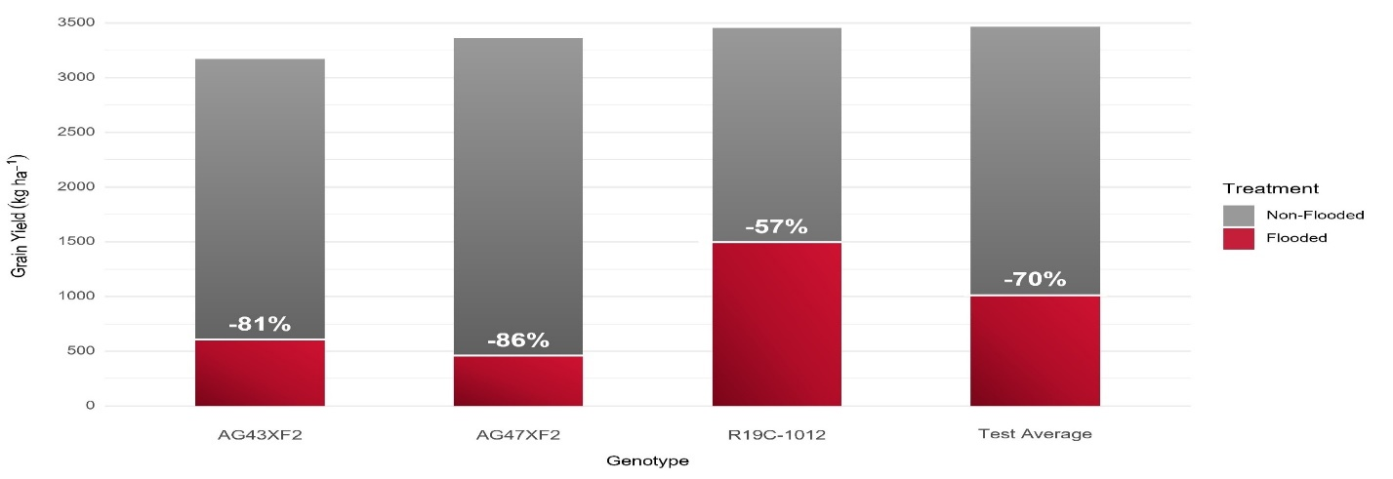
Figure 1. Average yield and yield loss (%) of R19C-1012 relative to XtendFlex® checks and test average under flooded and non-flooded conditions in the Arkansas System Division of Agriculture’s Variety Testing Program (2023).

R19-42848 is a conventional relative maturity 5.2 high-yielding soybean germplasm with drought tolerance. It was derived from the cross R12-2237 × R12-519 and has a genetically diverse background in its female lineage and a geographically diverse background in its male lineage. From 2020 to 2023, it had an average grain yield of 67.9 bu/ac, which is 93% of the checks’ mean. Under irrigated conditions, R19-42848 yielded numerically higher than drought-tolerant check Ellis (105.2%), while statistically similar in rainfed conditions (99.9%) (Table 3).

Table 3. Comparison between soybean germplasm R19-42848 and drought-tolerant check Ellis in the regional USBDT trials (2021-2023) under irrigated and rainfed conditions.
Year | Irrigated yield (bu ha⁻¹) |  |  |  | Rainfed yield (bu ha⁻¹) |  |  |  | CWS (1-5)ª
Year | R19-42848 | Ellis | #Loc | p-value | R19-42848 | Ellis | #Loc | p-value | R19-42848 | Ellis | #Loc | p-value
2021 | 57 | 61 | 4 | 0.455 | 44 | 45 | 4 | 0.842 | 1.9 | 1.7 | 4 | 0.492
2022 | 66 | 54 | 3 | 0.026 | 34 | 30 | 5 | 0.262 | - | 2.3 | 5 | -
2023 | 53 | 51 | 3 | 0.764 | 36 | 39 | 5 | 0.19 | 2.6 | 2.2 | 5 | 0.39
Combined | 59 | 56 | 10 | 0.356 | 38 | 38 | 14 | 0.985 | 2.3 | 2 | 14 | 0.344
ªCWS was rated on a 1 to 5 scale, where 1 represented plant with no visible wilting, 2 indicated slight wilting, 3 indicated moderate wilting, 4 indicated severe wilting with partial defoliation, and 5 represented severe wilting with some plant death.

2024 Yield trials: Approximately 16,900 plots were packaged, planted, managed, and evaluated during the 2024 growing season. Yield tests were conducted across four locations in Arkansas (Marianna, Pine Tree, Rohwer, and Stuttgart) and one in Fisk, Missouri. Pure seeds for all evaluated genotypes were grown at the Milo J. Shult Agricultural Research & Extension Center in Fayetteville, Arkansas. Roughly 150 genotypes were advanced to 2025 Finals, which will be grown across seven locations in Arkansas and other mid-South states. All materials have been genetically characterized for a variety of biotic and abiotic stressors, as well as for seed composition using NIR.

University of Missouri (Feng Lin):

We have received preliminary results from the USDA for the 18 lines entered in the Uniform Preliminary Yield Trials and the 6 lines in the Uniform Yield Trials. These lines were evaluated for yield performance, agronomic traits, and seed composition across multiple states. We are currently in the process of reviewing the data to decide which lines to release for 2025.

University of Georgia (Zenglu Li):

In 2024, we advanced 62 elite soybean breeding lines with competitive yields, robust disease resistance packages, and improved seed composition into the USDA Southern Preliminary or Uniform Tests across maturity groups (MGs) VI, VII, and VIII. These lines include both conventional lines and herbicide-tolerant lines with traits such as RR2, Xtend, and LibertyLink. Their performance was evaluated across multiple southeastern locations, with detailed results summarized in Tables 4–9.

USDA Uniform Test – MG VI

In the USDA Uniform Test for MG VI, two breeding lines demonstrated exceptional performance which exceeded the yield of the check means for 9.5 and 5.1% over 2022-2023 and 11 and 6.1% over 2021-2023, respectively (Table 4).

Table 4. 2022-2024 USDA Uniform Test – MG VI.
Line | 2022-23 Yield (b/a) | % CK mean | 2021-23 Yield (b/a) | % CK mean
G18-3051R2 | 57.2 | 109.5 | 56.4 | 111.0
G18-3118R2 | 54.9 | 105.1 | 53.9 | 106.1

USDA Uniform Test – MG VII-VIII

Six lines in the USDA Uniform Test MG VII-VIII exceeded the check mean by 2.9–7.3% over two years when compared to the commercial checks, with 14 lines achieving 106.8–118.3% of the check mean in 2024 (Table 5). Of those, conventional lines G19-13438 and G18-12063 are planned to be released this year.

Table 5. 2023-2024 USDA Uniform Test – MG VII-VIII.
Line | 2024 Yield (b/a) | % CK mean | 2023-24 Yield (b/a) | % CK mean
G19-13438 | 56.5 | 118.3 | 53.6 | 107.3
G20-4820R2 | 56.3 | 117.9 | n/a | n/a
G19-5469R2 | 54.6 | 114.3 | 53.6 | 107.3
G18-12063 | 54.0 | 113.0 | n/a | n/a
G20-5669R2 | 54.0 | 113.0 | n/a | n/a
G20-9576 | 54.0 | 113.0 | n/a | n/a
G20-12085LL | 53.9 | 112.8 | n/a | n/a
G19-12278 | 53.7 | 112.4 | n/a | n/a
G18-8335LL | 53.5 | 112.0 | 51.8 | 103.7
G20-9503 | 53.1 | 111.2 | n/a | n/a
G18-3311R2 | 52.6 | 110.1 | 53.1 | 106.3
G20-10022 | 52.0 | 108.9 | n/a | n/a
G21-230R2X | 51.4 | 107.6 | 52.2 | 104.5
G21-245R2X | 51.0 | 106.8 | 51.4 | 102.9

USDA Preliminary Uniform Test – MG VI

Six lines in the 2024 USDA Preliminary Uniform Test for MG VI outperformed the check mean by 100.1–107.5% (Table 6) and four lines performed better than the highest commercial check in the test. These lines will be advanced to the 2025 USDA Uniform Test for MG VI.

Table 6. 2024 USDA Preliminary Uniform Test – MG VI.
Line | 2024 Yield (b/a) | % Highest CK | % CK mean
G21-3656 | 49.5 | 103.3 | 107.5
G21-3387 | 49.3 | 102.9 | 107.0
G21-2407 | 48.9 | 102.1 | 106.2
G21-5990 | 48.2 | 100.6 | 104.6
G18-12342 | 46.9 | 97.9 | 101.8
G21-277RX | 46.1 | 96.2 | 100.1

USDA Preliminary Uniform Test – MG VII-VIII

Nine lines in the USDA Preliminary Uniform Test for MG VII-VIII exceeded the check mean by 100–113.9% (Table 7). Of these lines, two exceeded the performance of the highest check in the test. These lines will be advanced in the 2025 USDA Uniform Test for MG VII-VIII.

Table 7. 2024 USDA Preliminary Uniform Test – MG VII-VIII.
Line | 2024 Yield (b/a) | % Highest CK | % CK mean
G21-2080 | 51.6 | 103.0 | 113.9
G21-5441 | 51.1 | 102.0 | 112.8
G21-13262LL | 49.9 | 99.6 | 110.2
G21-6007 | 48.7 | 97.2 | 107.5
G21-13223LL | 48.6 | 97.0 | 107.3
G21-13035LL | 48.5 | 96.8 | 107.1
G21-8246R2 | 46.2 | 92.2 | 102.0
G21-253RX | 45.4 | 90.6 | 100.3
G21-8335R2 | 45.3 | 90.4 | 100.0

Advanced Yield Trials Under Rain-Fed Conditions

During 2024, we grew all 62 advanced lines under a rain-fed condition in Midville, GA, Of these lines tested in MG VI and MG VII-VIII, four lines in the MG VI yielded over 98.2 – 104.3% of the check mean, while 12 lines in the MG VII-VIII exceeded 1103.-125.2% of the check mean (Tables 8–9).

Table 8. 2024 UGA Advanced Yield Trials under a rain-fed condition in Midville, GA– MG VI.
Line | 2024 Yield (b/a) | % Highest Check | % Check mean
G18-3051R2 | 75.41 | 100.7 | 104.3
G20-9640 | 72.56 | 96.9 | 100.4
G21-2407 | 71.63 | 95.7 | 99.1
G19-12361 | 70.95 | 94.8 | 98.2

Table 9. 2024 UGA Advanced Yield Trials under a rain-fed condition in Midville, GA– MG VII-VII.
Line | 2024 Yield (b/a) | % Highest Check | % CK mean
G20-10022 | 69.43 | 123.8 | 125.2
G18-8335LL | 65.41 | 116.7 | 118.0
G20-12085LL | 64.32 | 114.7 | 116.0
G20-9154 | 63.83 | 113.9 | 115.1
G21-5441 | 63.12 | 112.6 | 113.8
G19-13438 | 62.83 | 112.1 | 113.3
G20-9576 | 62.51 | 111.5 | 112.7
G21-8335R2 | 62.4 | 111.3 | 112.5
G21-13035LL | 62.26 | 111.1 | 112.3
G21-2080 | 61.88 | 110.4 | 111.6
G18-3311R2 | 61.71 | 110.1 | 111.3
G19-5469R2 | 61.17 | 109.1 | 110.3

In summary, we have developed a very strong pipeline of soybean materials in MGs VI, VII, and VIII. These findings highlight the great potential of advanced soybean lines to enhance yield performance and climate resilience across different maturity groups. The continued evaluation and integration of advanced genetics will support growers in maintaining productivity under varying environmental conditions. In addition, in 2024, we have yield-tested 102 advanced breeding lines in our UGA advanced yield trials at 3 locations with 3 reps per location and selected top-performed lines (~20 lines) will be advanced to the USDA preliminary uniform tests in 2025. We also yield-tested 1200 experimental lines at 2 locations with 2 reps per location and selected top-performed lines (102 lines) will be yield-tested in our UGA advanced yield trials at 3 locations with 3 reps per location.

- To develop soybean germplasm with diverse genetic background for climate resilience

Virginia Tech (Bo Zhang):

In the 2024 USDA Uniform Preliminary Trial early IV test, V20-1478R2DI, which carries 50% exotic pedigree from PI 547616, yielded 46.8 bu/ac. Similarly, V19-0064DT, with 50% exotic pedigree from Fendou 78, yielded 50.8 bu/ac in the same trial. However, both lines performed below the test mean, indicating that a high percentage of exotic pedigree significantly reduces yield potential. In contrast, V21-0965DI, containing 12.5% exotic pedigree from PI 290126 B (Japan), performed well in Virginia trials, yielding 62.1 bu/ac, just 0.2 bu/ac lower than the check AG 48XF2. This line will enter the 2025 USDA Uniform Trial for evaluation.

In addition, three 2024 Virginia preliminary yield trials included 77 entries with at least 12.5% exotic pedigree. Maturity Group IV averaged 78.0 bu/ac with protein content above 41%, with crosses involving Shennong 027 yielding over 70.0 bu/ac. The early Maturity Group V averaged 66.0 bu/ac with a protein content of 39%, while the late Maturity Group V yielded an average of 74.2 bu/ac with a protein content of 40%. Notably, crosses with Shennong Black 9 in the late Maturity Group V achieved yields as high as 91.0 bu/ac. These results will inform the selection of top-performing lines for advancement into intermediate and final Virginia yield trials.

USDA-ARS, SNFRU (Fallen and Mian):

The breeding lines in Table 10 were developed to enhance genetic diversity, drought tolerance, and protein content while maintaining competitive yields. Incorporating drought-tolerant sources PI 416937 and PI 407859, N21-0601 and N21-0580 exhibited strong drought tolerance with wilting scores of 1.5 and 2.0, comparable to the slow-wilting check N09-13890. The commercial check (AG53X9) had the highest wilting score (3.5), reinforcing that the newly developed lines offer improved stress tolerance over existing commercial varieties. Several lines also had higher protein content than AG53X9 (40.7%), with N21-0601 (44.7%) and N21-0580 (45.3%) ranking the highest, though higher protein levels led to slightly reduced oil content in these lines, making them valuable for both agronomic and nutritional purposes. N09-13890 (MG 7) had the highest yield (33 bu/ac) but matured 10+ days later than the new breeding lines. Among the MG 5 lines, N21-0601 and N21-0580 performed the best (30 bu/ac), showing that strong drought tolerance can be achieved without compromising yield. These results highlight the potential of these new lines to improve stress tolerance, protein content, and yield, making them promising candidates for future cultivar development and commercial adoption.
Table 10. Drought screening results of top performing lines from field evaluations in 2024
 | Source of | Wilting Score | % Protein | % Oil |  | Yield
Line | Drought Tolerance | (1-5)* | (DW Basis) | (DW Basis) | Maturity | (bu/a)
N09-13890 | Slow Wilting Check | 1.5 | 40.9 | 21.6 | MG 7 | 33
AG53X9 | Commercial Check | 3.5 | 40.7 | 21.1 | MG 5 | 22
N21-0601 | PI 416937 & PI 407859 | 1.5 | 44.7 | 20.2 | MG 5 | 30
N21-0580 | PI 416937 & PI 407859 | 2 | 45.3 | 19.9 | MG 5 | 30
N21-0566 | PI 416937 & PI 407859 | 2 | 45.2 | 19.8 | MG 5 | 28
N21-0559 | PI 416937 & PI 407859 | 2 | 44.5 | 20.6 | MG 5 | 28
N21-0614 | PI 416937 & PI 407859 | 2 | 44.3 | 20.1 | MG 5 | 27

*Wilting scores were recorded on a scale of 1 (no visual wilting) to 5 (dead plants). Scores of 2, 3, and 4 indicated slight wilting, moderate wilting, and severe wilting and partial defoliation, respectively.

University of Arkansas (Caio Vieira):

2024 Progeny rows: Following visual selection for uniformity, pod load, and maturity, a total of 1,094 out of 14,310 F_{4:5} progeny rows from 140 bi-parental populations were harvested in Kibler, AR. Harvesting and threshing were conducted manually, and the seeds were transported to Fayetteville, AR. Seed cleaning and packaging are underway, alongside experiments' design and envelope printing. All selected lines will undergo genotyping with the Soy3KSNP to explore the potential of genomic prediction in identifying and selecting superior untested genotypes, as well as a proprietary molecular marker panel for multiple biotic and abiotic stressors.

2024 Crossing Block: A total of 150 crossing combinations have been carried out, resulting in over 12,000 crossing attempts conducted in Fayetteville, AR. The evaluation and hand-harvesting of plots have been completed. True crosses have been identified, threshed, and sent to an off-season nursery, enabling rapid generation advancement. In February, F_{4:5} seeds from the 2023 Crossing Block are expected to be shipped to Fayetteville, AR, where they will undergo cleaning and purification using the QSorter equipment and be prepared for packaging. These seeds will then be used for the 2025 Progeny Rows test.

University of Missouri (Feng Lin):

We made 8 different crosses this year to introduce traits related to climate resilience, such as drought and heat stress tolerance. The donor parents, which possess natural tolerance to high temperatures and low moisture conditions, were used in these crosses. The F1 seeds were sent to Costa Rica for population development, aiming to incorporate these valuable traits into our elite breeding lines.
University of Georgia (Zenglu Li):

The results are combined with objective 1. Please see Objective 1 for details

- To discover novel genes associated with climate resilience using emerging technologies and methodologies to support breeding efforts

Virginia Tech (Bo Zhang):

The soybean diverse panel was scanned by DJI Mavic 3 Thermal drone throughout four growth stages, which are reproductive stage R1 (beginning flowering), R3 (beginning pod), R4 (full pod), and R5 (beginning seed). The thermal images were then processed with orthomosaic, reflectance map generation, segmentation, feature extraction, and extracted plot-based data. The results showed a large variation of canopy temperature between germplasms (Figure 2).
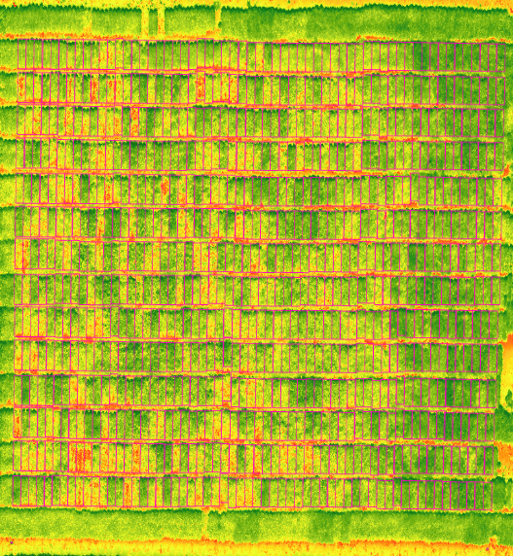
Figure 2. Whole-field reflectance with plot boundary polygons.

Noticeably, there are several accessions that consistently have a lower or higher canopy temperature, especially the accessions PI 507475 for lower temperature and PI 437378 for high temperature (Figure 3). This confers a possibility to select superior genotypes throughout the four reproductive stages.

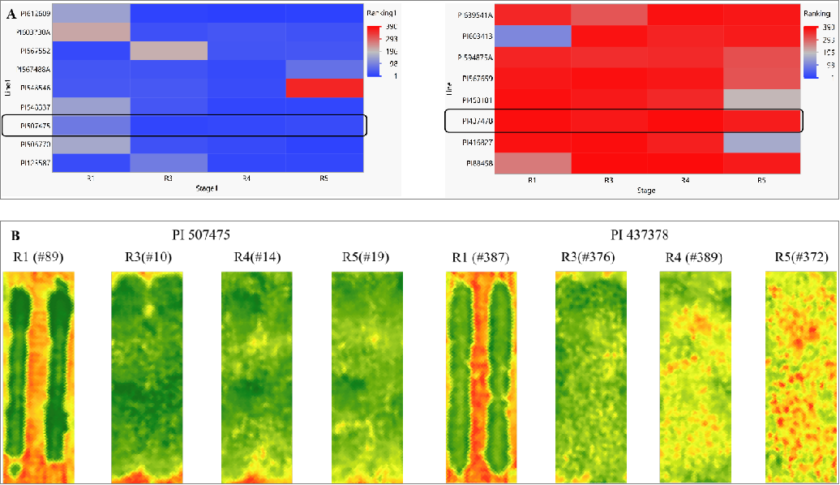
Figure 3. Accessions presented consisted of extreme canopy temperature (A) and selected reflectance map (B) of PI 507475 and PI 437378.

USDA-ARS, SNFRU (Fallen and Mian):

N19-7014 is a newly developed soybean line derived from PI 407228 (wild soybean) and NC-Raleigh, selected for its high protein content, early maturity, and genetic stability. Compared to NC-Raleigh, N19-7014 exhibits a significantly higher seed protein content (44.1% vs. 39.4%) and meal protein at 13% moisture (50% vs. 46%), making it a strong candidate for high-protein meal applications. However, N19-7014 has a lower seed oil content (18.6%) compared to NC-Raleigh (21.4%). Agronomically, N19-7014 matures 5 days earlier than NC-Raleigh) and had a smaller seed size (100-seed weight of 9.33 g) compared to NC-Raleigh (12.7 g) but maintained good lodging resistance (2.6 on a 1-5 scale). While its yield was slightly lower than that of NC-Raleigh (90%), the substantial increase in protein content makes it a valuable addition to breeding programs aimed at improving soybean meal quality.

Genetically, N19-7014 has been validated through marker analysis, matching 2662 out of 2663 monomorphic markers, confirming its stability and reliability. Additionally, this line will be screened for high-protein loci on Chromosome 20 and Chromosome 15 to further support its potential as a high-protein soybean variety for release. Given its diverse genetic background, strong protein profile, and marker data, N19-7014 represents a promising new line with applications in both soybean breeding and commercial production.

University of Arkansas (Caio Vieira):

Genomic prediction and GWAS for early season flooding tolerance: A total of 254 genetically diverse PIs were screened for flood tolerance at the early vegetative (V2) stage from 2020 to 2021 in Stuttgart, AR. Five significant SNP markers (ss715587369, ss715628153, ss715628154, ss715628155, and ss715638723) associated with flood tolerance were identified on chromosomes 4, 17, and 20. Additionally, genomic prediction models based on Random Forest were developed and demonstrated high accuracy in identifying flood-tolerant genotypes (Figure 4). This study enhances the efficiency of breeding for early-season flood tolerance and underscores the importance of developing soybean genotypes with season-long tolerance. The results of this study have been prepared for publication and are currently in review at The Plant Genome.
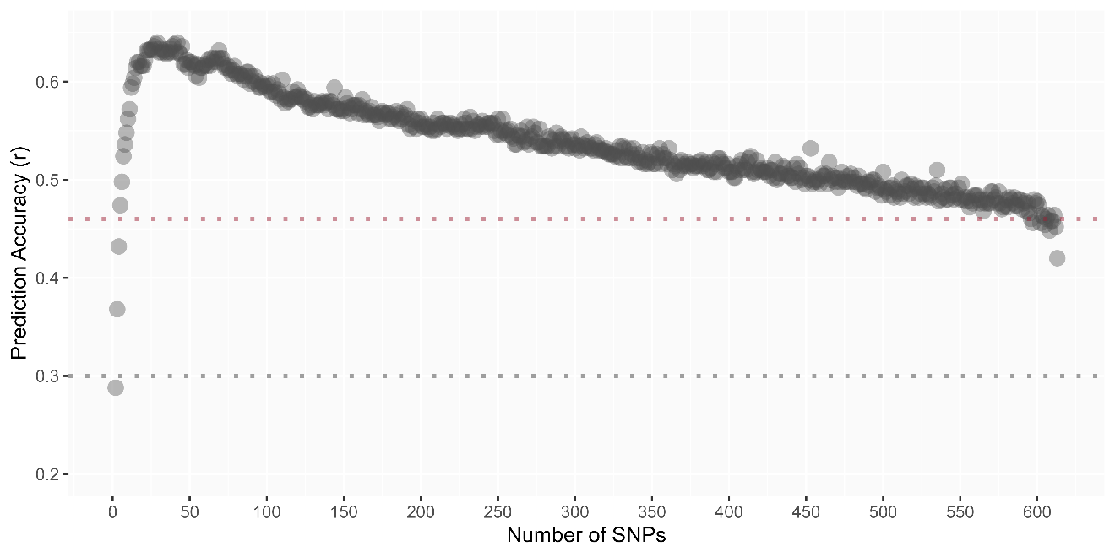
Figure 4. Prediction accuracy for early-season flood tolerance using forward stepwise random forest models. The highest accuracy at 0.64 was obtained with the model including 29 SNPs. The sharp decrease in prediction accuracy can be attributed to overfitting and multicollinearity. The dotted lines in red and gray represent the accuracy of the RR-BLUP and random forest models including 31,410 SNPs, respectively.

University of Missouri (Feng Lin):

Currently, we are conducting preliminary data analysis to assess variability in photosynthetic traits across the diverse soybean panel of 300 PI accessions. Population structure analysis has been conducted to understand genetic diversity and relatedness among accessions, which will aid in refining the genome-wide association study (GWAS). Additionally, trait correlations under varying temperature conditions are being evaluated to identify trends in photosynthetic performance linked to heat stress resilience. Preliminary findings suggest traits related to light energy utilization and photosynthetic efficiency show promising associations with stress response.

University of Georgia (Zenglu Li):

Over the past several years, we have developed genomic prediction models using genome-wide SNP markers and advanced materials, which have been successfully used to predict the superior cross combinations and select for the yield in early generations. During 2024, we genotyped 170 advanced lines using 6000 SNP markers. These lines were yield-tested at 3 locations with 3 reps per location in 2024. The data sets, including both genotypic and phenotypic data, have been added to our existing large dataset to make a total of over 2000+ lines. The dataset will be used to optimize the training set for prediction of line performance. The updated models will be used to predict superior cross combinations and select plant rows in 2025 to develop high yielding and climate resilient soybean cultivars.

