Improving our ability to detect, predict, and manage soybean sudden death syndrome in Kansas
OBJECTIVES
Objective 1: Evaluate the influence of agronomic practices on soybean sudden death syndrome (SDS) through on-farm trials evaluating row spacing, plant population, and variety selection.

Field Trials
Field experiments were established in three locations in 2022 and two locations in 2023. In 2022, experiments were conducted near Rossville and Topeka, KS and Roland, IA. In 2023, the experiments were conducted near Topeka, KS and Roland, IA. Details on cultivars, SDS ratings, seeding rates, planting dates, root rot ratings, SDS ratings, harvesting, inoculation, and irrigation are provided in Supplemental Table 1. Resistant and susceptible cultivars were planted at four population densities: 197,684, 296,526, 395,368, and 494,210 seeds per hectare. Kansas trials included both 38.1- and 76.2-centimeter row spacings, while Iowa trials were limited to 76.2-centimeter rows. To promote consistent disease pressure, Kansas plots were inoculated with F. virguliforme and irrigated, whereas Iowa trials relied on natural infection and were not irrigated.The experiment was established as a two-factorial randomized complete block design. Isolates of F. virguliforme used for inoculum preparation for Kansas followed a previously published protocol by infesting autoclaved grain sorghum (de Farias Neto et al. 2006). Each plot spanned about 5.3 m to 9.1 m long and studies included at least four replications. Rows two and three were used to assess the SDS foliar symptoms, disease severity, and yield, while rows one and four were used for root rot assessment since the soybeans had to be uprooted.

Data Collection
The plant stand was counted at the two true leaf (V2) growth stage. The number of live plants was counted from at least 3.05 m in length in the second and third rows of each plot and the number was used to estimate plant population per ha. For SCN egg population estimation, soil samples were taken between soybean rows at planting. For each replication, two soil cores were collected from each plot, bulked and sent to Iowa State University for SCN egg quantification. Within each composite sample, the soil cores were mixed, and two subsamples of 100 cm3 and 1g were taken to determine the SCN egg population. At the full pod (R4) growth stage, ten randomly selected plants were carefully dug from the first and fourth rows of each plot. The aboveground portions were removed, leaving only the roots, kept in a cooler, and were transported to the laboratory for analysis. In the laboratory, roots were rinsed thoroughly with water to remove soil residue before visual assessment. Root rot severity was estimated as a percentage based on dark brown discoloration and rot on the taproot and lateral root system. Root rot severity was recorded between 0% and 100% based on visual assessments, where 0% indicated no root rot and 100% represented complete rot of all roots. A mean root rot severity for each plot was calculated by averaging the severity values across all samples in each plot. At the full seed (R6) growth stage, foliar disease incidence was estimated as the percentage of plants with foliar symptoms in the second and third rows of each plot. Disease severity was rated on a 0-to-9 scale of SIU system based on the percentage of chlorosis, necrosis, and premature defoliation, where 0 represented no disease and 9 represented premature plant death (Gibson et al. 1994, Kandel et al. 2015). The foliar SDS disease index (FDX) was calculated as FDX = (disease incidence × disease severity)/9. At the seed maturity (R8) growth stage, the second and third rows of each plot were harvested and yield was converted to kilogram per hectare and adjusted to 13% moisture content.

Statistical Analysis
Data were analyzed in SAS (version 9.4, SAS Institute Inc., Carry, NC). A mixed-effects analysis of variance (ANOVA) was performed using PROC MIXED to evaluate the effects of plant population and cultivar in Iowa locations and plant population, row spacing, and cultivar in Kansas locations and their interactions on root rot, FDX, and yield. Cultivar and treatment were considered fixed effects, while in the Iowa location, block was included as a random effect, and in Kansas locations, location, block nested within location, and the interaction of block and row spacing nested in location were included as random effects.

Preliminary results
In Kansas, resistant cultivars with 76.2-centimeter row spacing reduced foliar SDS symptoms and improved yield, though neither factor affected root rot severity. Higher plant populations increased root rot. In Iowa, cultivar selection significantly impacted SDS index and yield in 2024, while in 2023, only plant population influenced yield. No interactions were observed between cultivar and plant population.

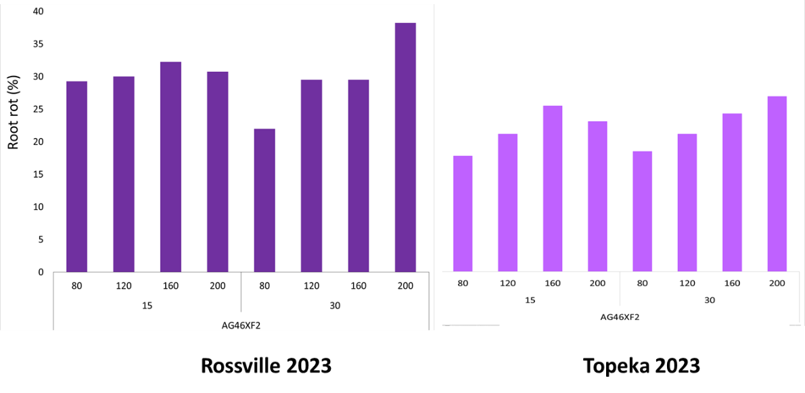
Figure1. Effect of plant population and row spacing on sudden death syndrome in field experiments conducted in Rossville, KS and Topeka, KS in 2023 by PI Onofre.

Objective 2: Develop a sudden death syndrome prediction tool for predicting disease prior planting.

SDS disease severity ratings and weather variables were obtained from Rossville and Topeka spanning from 2013 to 2022. SDS disease ratings were conducted at the R6 growth stage on a percentage scale (0-100). Weather variable data includes rainfall, soil temperature, and soil moisture. Weather data were obtained from Kansas Mesonet stations and OpenMeteo weather data. Preliminary analyzes were conducted on periods of 7, 14, 21, and 28 days before and after planting. Utilizing machine learning and regression model variable selection procedures, the variables and time periods associated with severe disease were used to create candidate models. Preliminary results show a strong correlation between soil temperature 21 days before planting and 14 days after planting is strongly associated with SDS disease severity (Figure 2). In addition, mean soil temperature observed 21 days before planting serves as a predictor of SDS disease risk. Furthermore, soil moisture and rain have the most influence on disease within the first 21 days after planting. Although these are preliminary results, there is evidence that our pre-season SDS prediction tool could direct attention to pre-season SDS risk factors that could allow growers to adjust management practices proactively (variety selections and seed treatments) for the upcoming season. This model is now being tested and validated in Kansas Soybean Fields during the 2025 season.
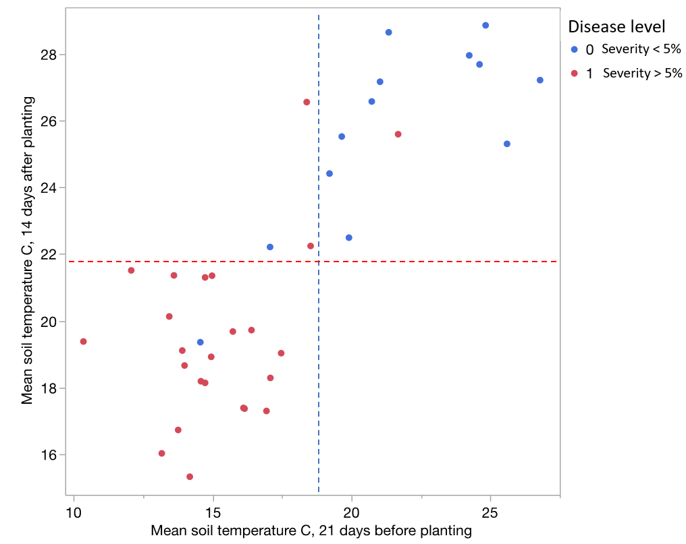
Figure 2: Clustering of SDS years and low SDS years based on soil temperature 21 days before planting and 14 days after planting.

Objective 3: Evaluate genetic diversity of Fusarium spp. from soybeans causing SDS in Kansas.

From the 2022 soybean season, 659 root samples were collected and cultured (Figure 3). From those samples, over 3000 isolation were made and 128 Fusarium spp. were isolated. The DNA of those isolates was analyzed through molecular phylogenetics and, together with morphological characteristics, 113 of the 128 isolates were identified as Fusarium virguliforme.

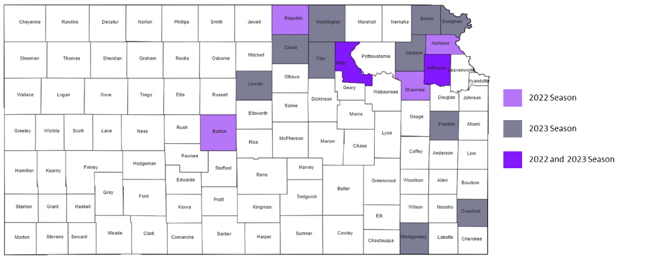
Figure 3: Distribution map of samples collected during the 2022 and 2023 soybean seasons.

During the 2023 season a total of 224 root samples were collected, cultured, and were molecular and morphology characterized (Figure 4). Isolates from both were saved in -80 F and -20 F.

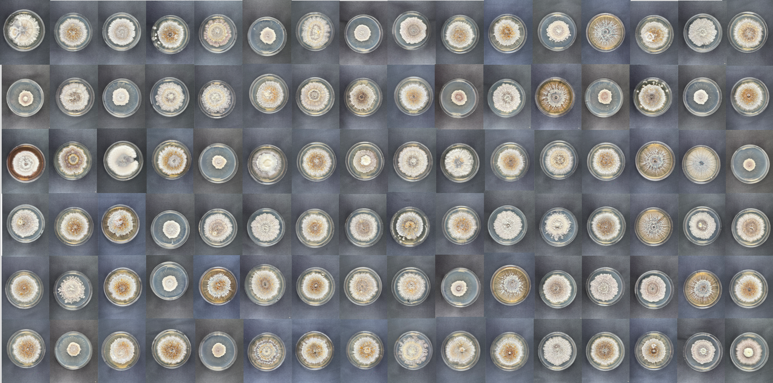
Figure 4: Fusarium strains grown on PDA at 25 ˚C with no light after 25 days

Objective 4: Validate a rapid diagnostic tool for SDS based on loop-mediated isothermal amplification (LAMP).

The LAMP assay development and validation is being conducted with isolates collected from objected 3. For LAMP validation, we tested three sets of primers, p1, p3, and p6, for their potential in LAMP diagnostics of F. virguliforme. The tests consisted of: (1) fast identification of possible false positives; (2) the possibility of running LAMP in Genie II (an isothermal reaction machine) and on QuantiStudio3 (a quantitative PCR machine); and (3) a fast test of their ability to amplify known F. virguliforme isolates and not amplify other species. We found that the primer set p6 did not amplify the DNA of healthy soybean roots, which reduces the chances of false positive results. Following these initial tests, we selected primer p6 to test it against 18 F. virguliforme isolates and 6 Fusarium spp. (Kansas isolates originated from Objective 3). The results indicated that p6 is a promising candidate for LAMP validation, as it successfully amplified only F. virguliforme isolates tested. Additionally, we were able to run LAMP on both equipment, Genie II and QuantiStudio3, improving the chances of this assay being used in laboratories across the region that do not have Genie II available. New primers were developed and are being tested on our SDS Kansas Isolate and close related species.
Objective 5: Generate and promote data-driven best management practices based on results of objectives 1, 2 and 3.

A total of 25 field days were help in several locations including Topeka, Hutchison, Parsons, Scandia, Palmer, Holton, Seneca, Manhattan, Atchison, and Clifton. In addition, preliminary data was shared on radio, local TV, Agronomy eUpdate and Social media. We are currently developing a K-State Research and Extension sudden death syndrome fact sheet publication based on previous research reports and on results generated in objectives 1, 2 and 3.

